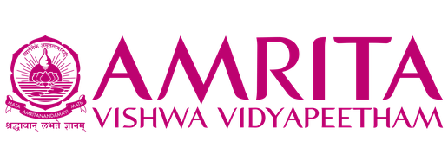
USER INTERFACE DESIGN (23CSE113)
Name | PINNABATHINA DEEKSHITHA
Roll no | AV.SC.U4CSE25143
Project Name | Youtube Website

YouTube UI Clone Project Report
Introduction
I developed a simple YouTube UI Clone using HTML, CSS, and JavaScript. The main aim of this project was to understand how websites are designed and made interactive using front-end technologies. The website is inspired by YouTube and includes features such as a navigation bar, sidebar menu, search bar, video thumbnails, and a video player.
HTML Implementation
HTML was used to create the basic structure of the website. It contains the navigation bar, sidebar, search box, video player, and video cards. Each video card includes a thumbnail image, channel icon, title, and view details. HTML acts as the foundation of the entire project.
CSS Implementation
CSS was used to make the website attractive and similar to YouTube's dark theme. Different colors, layouts, spacing, and hover effects were added using CSS. The video cards are arranged in a grid layout, and the sidebar and navigation bar are styled to provide a clean and professional appearance.
JavaScript Implementation
JavaScript was used to make the website interactive. When a user clicks on a video thumbnail, the selected video plays in the video player. The search feature allows users to find videos based on their titles. JavaScript also updates the page title when different menu options are selected.
Features of the Project
- YouTube-style user interface
- Dark theme design
- Navigation sidebar
- Search functionality
- Video playback feature
- Video thumbnails with channel details
- Interactive buttons and menus
- Hover effects on video cards
Learning Outcome
Through this project, I learned how HTML, CSS, and JavaScript work together to create a complete website. I gained practical experience in designing layouts, styling web pages, and adding interactive features. This project also helped me understand the basics of user interface design and front-end development.
Conclusion
The YouTube UI Clone project was a great learning experience. It helped me improve my web development skills and understand how modern websites are built. By combining HTML, CSS, and JavaScript, I was able to create a simple and interactive video streaming interface similar to YouTube.

