Microscale Transport Processes — Term Paper
Micro Heat Pipes and Vapour Chambers for Smartphone and Chip Cooling
A microscale-transport perspective on passive two-phase heat spreading
[Your name] · [Roll number] · [Department / Institute]

Abstract
Modern smartphone processors can generate heat faster than a sealed, fanless, few-millimetre-thick body can spread it, and because the user’s skin temperature rather than the silicon limit caps performance, thermal throttling can cut the frame rate of a demanding game by about a third. Micro heat pipes and vapour chambers address this passively: a working fluid evaporates at the hot spot, carries heat as latent heat through a sub-millimetre vapour core, condenses at a cooler region, and returns through micro-grooves or porous wicks by capillary pumping, which works in any orientation only because surface tension dominates gravity at these scales. This paper explains the working principle using the scaling arguments from the microscale transport course (the square–cube law, Bond and Knudsen numbers, and the Hagen–Poiseuille pressure drop with its strong inverse dependence on channel size). Order-of-magnitude calculations for a water-filled copper chamber show how wick pore size sets a trade-off between capillary pressure and permeability, and how the vapour-core pressure drop grows as the inverse cube of its thickness, so halving the core thickness makes the chamber about eight times more resistive. Finally, the paper discusses fabrication routes (top-down etching and bonding versus bottom-up sintered and nanostructured wicks), corrosion and fouling limits, and a recent design strategy, the biporous condenser-side wick, that reduces the peak-to-mean skin temperature difference by 37%.

1. Introduction
A flagship smartphone integrates CPU cores, a GPU, an image processor and a cellular modem on a single system-on-a-chip (SoC), and the power consumption of such chips has risen steadily with every generation (Lecture 1 of the course shows this trend). Unlike a laptop, a phone has no fan and no vents. Every watt must leave through a sealed body that is under a centimetre thick and is held in the user’s hand. As a result, the binding constraint is usually not the transistor temperature limit but the temperature of the outer surface: higher power density raises skin temperature, which degrades the user experience, so software thermal governors lower the processor frequency once preset thresholds are reached [1].
The cost of this throttling is measurable. In experiments on a Nexus 6P smartphone, Bhat et al. found that thermal throttling reduced performance by as much as 34% in popular Android applications; for the game Paper.io the median frame rate fell from 35 to 23 frames per second [1]. The thermal problem therefore has two parts: keep the chip cooler, and avoid concentrating the heat into one hot spot on the back of the phone. Both call for spreading the heat laterally, quickly and uniformly, within a very thin envelope.
Solid spreaders such as copper or graphite sheets are limited by their thermal conductivity. Two-phase devices go further: micro heat pipes and vapour chambers move heat as latent heat of vaporisation, giving effective thermal conductivities far above that of any solid [2, 4, 6]. Their operation is a textbook example of microscale transport, because the key forces are surface tension, viscous friction and phase change, not inertia or gravity. This paper reviews how they work, estimates their limits with the scaling relations taught in the course, and discusses the practical challenges of making them thin enough for mobile devices.

2. Why the microscale matters: scaling arguments

2.1 Surface-to-volume ratio
The square–cube law (Lecture 1) states that quantities that scale with area decrease more slowly than quantities that scale with volume as size shrinks. For a thin slit of thickness h, the surface-to-volume ratio is 2/h. For h = 0.2 mm this is about 10⁴ m²/m³, against about 10² m²/m³ for a 2 cm gap. In a vapour chamber the surfaces are exactly where the action is: evaporation and condensation happen at the wick surfaces, and friction on those surfaces governs the pressure drop. Surface effects dominate over bulk effects, as the course notes emphasise for microdevices.

2.2 Bond number: surface tension beats gravity
The ratio of gravitational to surface-tension forces is the Bond number, Bo = ρ g L² / σ. For water at 60 °C (ρ ≈ 983 kg/m³, σ ≈ 0.066 N/m) Bo reaches unity at the capillary length, √(σ/ρg) ≈ 2.6 mm. At a wick pore or vapour-core scale of 0.1–0.4 mm, Bo is about 10⁻³ to 10⁻² (Figure 1). Capillary forces therefore overwhelm gravity, which is why a phone can be held in any orientation and still have liquid return to the hot spot.
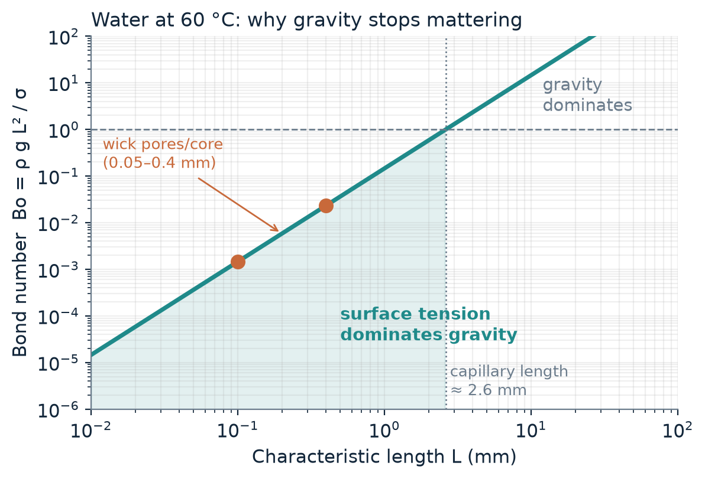
Figure 1. Bond number versus length scale for water at 60 °C. Wick pores and the vapour core lie deep in the surface-tension-dominated region.

2.3 Knudsen number and flow regime
Lecture 1 introduces the Knudsen number, Kn = λ / L, as the test for whether continuum fluid mechanics (and the no-slip condition) applies. Using kinetic theory with an assumed molecular diameter of about 0.4 nm, the mean free path of water vapour at about 20 kPa and 60 °C is roughly 0.3 µm. For a 0.1–0.2 mm vapour core, Kn is therefore about 2×10⁻³ to 3×10⁻³: the flow is still continuum, close to the lower edge of the slip regime, so standard Navier–Stokes with no-slip is a good first approximation. The Reynolds number in the vapour core is also modest. For the 5 W example in Section 4, the vapour velocity is about 2.7 m/s in a 0.2 mm core, giving Re ≈ 13 based on the hydraulic diameter (about 2h). The flow is laminar, so the laminar pressure-drop relations of Lecture 4 apply.

3. Working principle

3.1 The heat-pipe cycle
A heat pipe is a sealed, evacuated container holding a small amount of working fluid at its own saturation pressure. Heat entering the evaporator vaporises the liquid; the vapour moves toward the cooler condenser under a small pressure difference; there it condenses and releases its latent heat; and the liquid returns to the evaporator through a capillary structure [2]. The pumping pressure comes from the curvature of the liquid–vapour meniscus in the wick (Young–Laplace relation):
ΔP_{cap} = 2 σ cosθ / r_{eff} (1)
where σ is the surface tension, θ the contact angle and r_{eff} the effective pore radius of the wick. The attraction of the method is the energy density of latent heat. To carry 5 W the heat pipe must evaporate only ṁ = Q / h_{fg} ≈ 5 / (2.36×10⁶) ≈ 2.1 mg/s of water. Carrying the same 5 W as sensible heat in single-phase water with a 10 K temperature rise would need about 56 times more mass flow, and the temperature of the vapour stays nearly uniform because it is pinned to the saturation temperature.

3.2 Micro heat pipes
A micro heat pipe is a very small, non-circular channel, such as a triangular groove, in which the corners of the channel act as the wick: liquid is held in the corners by capillary forces, and the meniscus radius varies along the pipe to drive liquid from condenser to evaporator, with no separate porous wick. Peterson and Ma’s analysis of idealised triangular-groove micro heat pipes found that the maximum heat transport depends strongly on the apex angle of the liquid arteries, the contact angle, the pipe length, the vapour flow and the tilt angle [3]. Such grooves can be made by the same lithography-and-etch steps shown in Lecture 2 for V-grooves in silicon, and arrays of them can be embedded in a spreader plate directly beneath a chip.

3.3 Vapour chambers
A vapour chamber is a flat, wide heat pipe. Instead of moving heat along a line, it spreads heat in two dimensions through a thin vapour core between two wick-lined plates (Figure 2). Their low thermal resistance and uniform temperature distribution make them attractive for high-heat-flux electronics [6], and they are of particular interest where devices are thin: much recent work targets ultra-thin chambers, with sub-millimetre thickness, for mobile devices [4, 5].
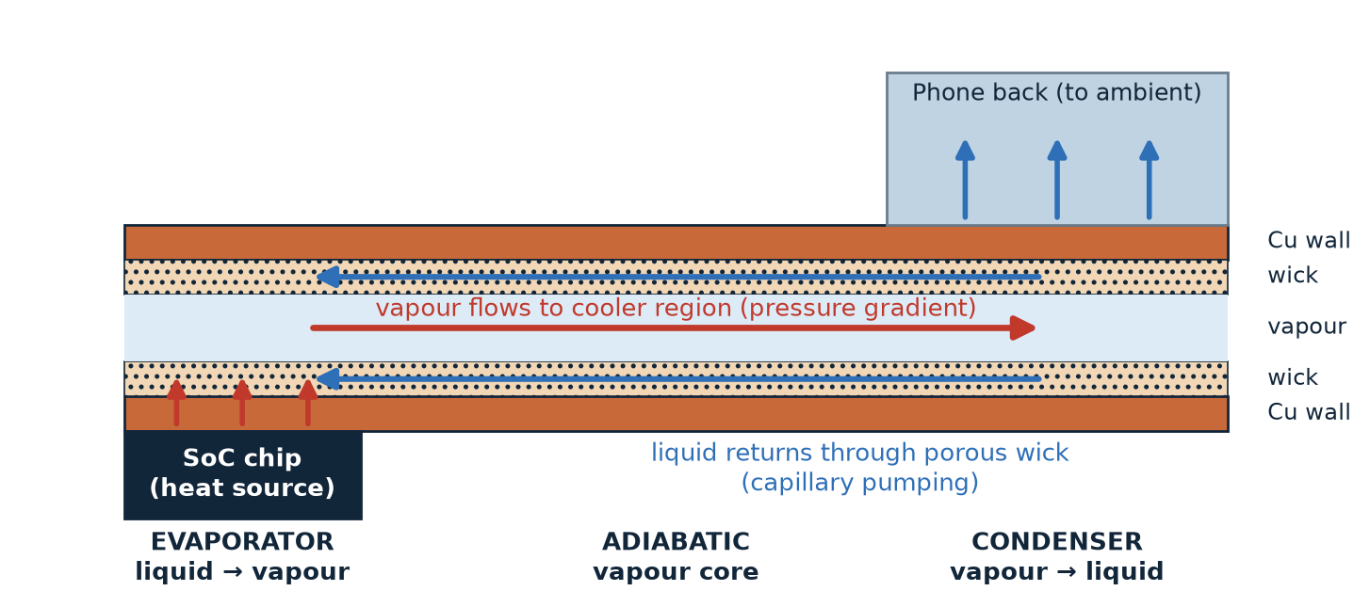
Figure 2. Cross-section of a vapour chamber under a smartphone SoC (thickness exaggerated). Heat evaporates liquid at the hot spot; vapour carries it through the core to the cooler region; condensed liquid returns through the wick by capillary action.

4. Order-of-magnitude design analysis
The estimates below use simple models from the course (Darcy flow in the wick, laminar slit flow in the vapour core) to show how the key design variables scale. They are illustrative, not predictions for a particular product: they neglect the evaporator and condenser thermal resistances, boiling and entrainment limits, and the support pillars of real devices. Assumptions are listed in Table 1.
Table 1. Assumptions for the illustrative calculations.
Quantity | Value used
Working fluid, temperature | Water, saturated at 60 °C
Properties (standard steam-table values) | σ = 0.0662 N/m; ρ_{l} = 983 kg/m³; μ_{l} = 4.66×10⁻⁴ Pa·s; h_{fg} = 2.358 MJ/kg; ρ_{v} = 0.130 kg/m³; μ_{v} = 1.12×10⁻⁵ Pa·s; dP_{sat}/dT ≈ 1.12 kPa/K (60–70 °C)
Heat load Q | 5 W (typical order for a sustained phone SoC load)
Geometry | Wick strip width W = 30 mm, wick thickness 0.1 mm, effective transport length L = 40 mm
Wick | Sintered copper powder, porosity ε = 0.5, r_{eff} = d_{p}/2, permeability K = d_{p}²ε³ / [150(1−ε)²] (Kozeny–Carman)
Vapour core | Parallel-plate slit of thickness h, same W and L, laminar flow

4.1 The wick: capillary pressure versus permeability
Liquid flows through the wick under Darcy’s law, so the liquid pressure drop for a heat load Q is
ΔP_{l} = μ_{l} L Q / (ρ_{l} K A_{w} h_{fg}) (2)
where A_{w} = W × t_{w} is the wick cross-section. Ignoring gravity (Bo ≪ 1) and the small vapour pressure drop, the wick can support a heat load up to the point where the capillary pressure of Equation (1) equals this drop:
Q_{max} = ΔP_{cap} ρ_{l} K A_{w} h_{fg} / (μ_{l} L) (3)
Because ΔP_{cap} ∝ 1/r_{eff} while K ∝ r_{eff}², the product ΔP_{cap}·K, and hence Q_{max}, grows in proportion to the pore size (Figure 3). A wick of 10 µm particles gives a high capillary pressure (about 26 kPa) but a very low permeability, and could carry only about 3 W: the 5 W load would dry out the evaporator. A 50 µm wick gives about 5.3 kPa and Q_{max} ≈ 16 W, a margin of more than three. Coarser wicks carry more heat but provide less capillary pressure to resist the vapour-side pressure gradient and any acceleration or tilt, and they thicken the evaporator layer, adding thermal resistance and a greater risk of boiling inside the wick [4]. This tension is the reason why multi-scale and biporous wicks, which combine fine pores for pumping with coarse pathways for flow, are an active research area [4, 5].
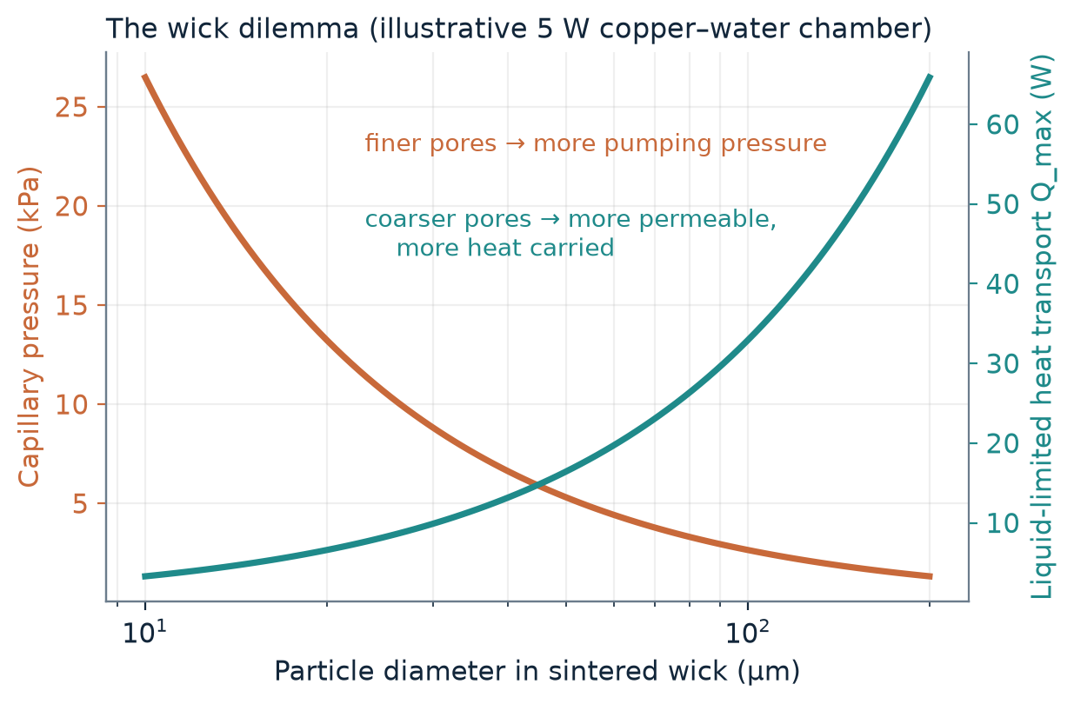
Figure 3. Capillary pressure (left axis) and the liquid-limited heat transport (right axis) versus particle diameter for the wick of Table 1.
Table 2. Wick design points (Equations 1–3). Q_{max} ignores the vapour pressure drop and boiling and entrainment limits.
Particle d_{p} (µm) | Permeability K (m²) | ΔP_{cap} (kPa) | Q_{max} (W) | vs. 5 W load
10 | 3.3×10⁻¹³ | 26.5 | 3.3 | dry-out
25 | 2.1×10⁻¹² | 10.6 | 8.2 | 1.6× margin
50 | 8.3×10⁻¹² | 5.3 | 16.5 | 3.3× margin
100 | 3.3×10⁻¹¹ | 2.6 | 32.9 | 6.6× margin
200 | 1.3×10⁻¹⁰ | 1.3 | 65.9 | 13× margin

4.2 The vapour core: why thin chambers are hard
For laminar flow between parallel plates a distance h apart, the pressure drop for vapour volumetric flow V̇ = Q / (ρ_{v} h_{fg}) over length L is
ΔP_{v} = 12 μ_{v} L V̇ / (W h³) (4)
This is the same Hagen–Poiseuille physics as Lecture 4, where the pressure loss of a channel at fixed flow rate rises steeply as the hydraulic diameter shrinks (as 1/d_{h}² at fixed velocity, and as 1/d_{h}⁴ at fixed volumetric flow for a round or square channel). For a slit of fixed width the exponent is three. In a heat pipe the vapour is at saturation, so a pressure drop appears as a temperature drop through the Clausius–Clapeyron relation, ΔT_{sat} = ΔP_{v} / (dP_{sat}/dT), which near 60 °C is about 1.1 kPa per kelvin. Figure 4 and Table 3 give the result for the 5 W load.
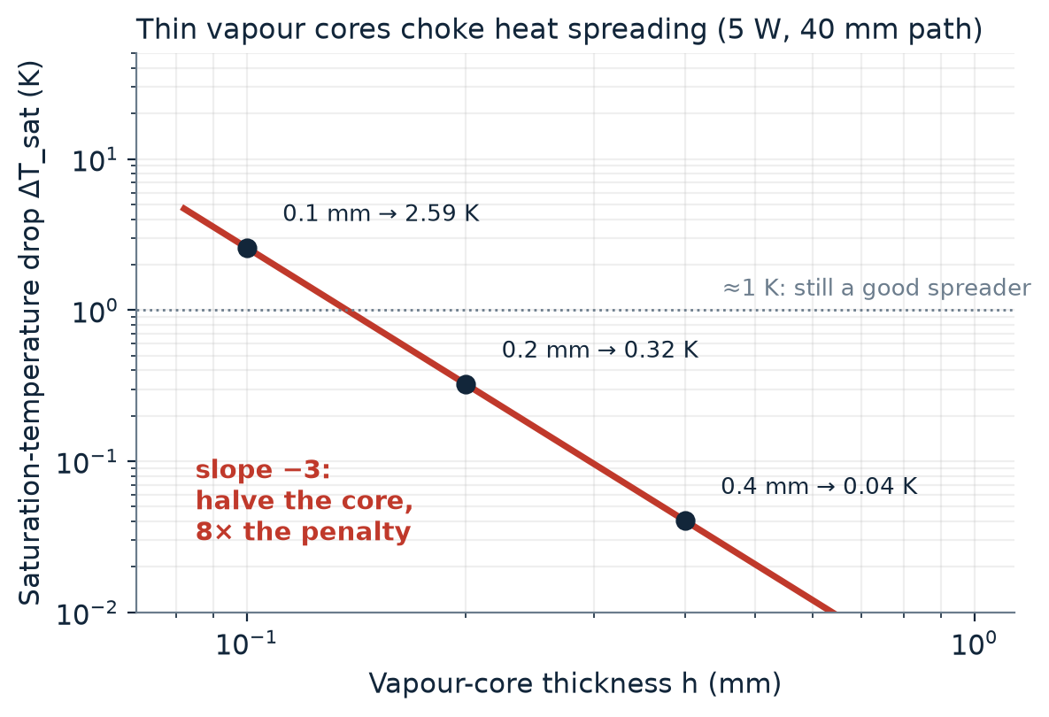
Figure 4. Saturation-temperature drop along the vapour core versus core thickness (5 W, 40 mm path, 30 mm width). The dashed part is where the linearised estimate is no longer reliable.
Table 3. Vapour-core pressure and temperature drops from Equation (4).
Core thickness h (mm) | Vapour velocity (m/s) | ΔP_{v} (Pa) | ΔT_{sat} (K)
0.4 | 1.4 | 46 | 0.04
0.2 | 2.7 | 364 | 0.32
0.1 | 5.4 | 2 914 | 2.6
0.05 | 10.8 | 23 312 | ≈ 21 (estimate no longer valid)

Halving the core thickness from 0.2 mm to 0.1 mm raises the temperature penalty from 0.3 K to 2.6 K, an eight-fold increase, and at 0.05 mm the vapour is effectively choked. This is the same limitation noted for ultra-thin vapour chambers in mobile devices: at sub-millimetre thickness their lateral thermal resistance is limited by the saturation temperature and pressure gradient in the confined vapour core [5]. As a measure of the potential, the 0.2 mm case (0.32 K over 40 mm, 0.4 mm total thickness) corresponds to an upper-bound effective conductivity of about 5×10⁴ W/(m·K), roughly 130 times that of copper (about 400 W/(m·K)). Real devices fall well below this bound because the evaporator and condenser wick layers add resistance, but the contrast with solid spreaders is clear.

5. Designing for smartphones: skin temperature
In a phone the objective is to limit the temperature that the user feels, which makes uniformity of the outer surface as important as the chip temperature. Patankar et al. noted that user comfort governs the thermal limits of mobile devices, so hot spots on the device skin must be reduced as well [5]. Earlier work mainly redesigned evaporator-side wicks. Their study patterned the condenser-side wick instead, and a three-dimensional numerical model of conjugate heat transfer, phase change and vapour-core pressurisation showed that a biporous condenser-side wick allows a thicker vapour core. The result was a reduction of the condenser surface peak-to-mean temperature difference by 37% compared with a monolithic wick [5]. Seen through Section 4, this is a design response to the two competing requirements: the wick must be thin to leave room for the vapour core, but permeable enough to return the liquid.

6. Manufacturing and reliability challenges

6.1 Fabrication: top-down and bottom-up
Both manufacturing philosophies of Lectures 2 and 3 appear in these devices. Top-down methods (photolithography with wet or dry etching, micromachining, and diffusion bonding of stacked plates, as in the stainless-steel microchannel foils of Lecture 4) form grooves and channels with precisely defined geometry. Bottom-up methods build the wick from small elements: sintering of metal powder is the standard route to porous wicks, and nanostructured wick surfaces are being studied to push the dry-out heat flux higher [4]. Lecture 3 closes by asking whether a combination of top-down and bottom-up processes can simplify fabrication, and ultra-thin vapour chambers fit that pattern: a top-down machined or etched envelope and vapour core, filled by a bottom-up grown or sintered wick.

6.2 Operating limits
Table 4. The classical heat-pipe operating limits [2, 4] and how they map to the microscale concepts of the course.
Limit | What happens | Link to course
Capillary | Wick cannot return liquid as fast as it evaporates (Equation 3); evaporator dries out | Surface tension vs. viscous drag
Boiling / dry-out | Vapour bubbles form in the wick at high heat flux and block liquid supply [4] | Phase change in microstructures
Entrainment | Fast vapour drags liquid droplets back from the wick, starving the evaporator [2] | Shear at the liquid–vapour interface
Sonic / vapour | Very thin vapour core chokes the flow and gives a large ΔT_{sat} (Equation 4) [5] | Δp ∝ 1/h³ (Lecture 4)
Viscous | At low temperature the vapour pressure is too low to drive flow [2] | Low-Re laminar flow

6.3 Material compatibility, corrosion and fouling
Lecture 4 stresses that corrosion and fouling are far more serious in microstructures: a corrosion layer of 100 µm that is tolerable in conventional equipment can be fatal in a microchannel, and particles that stick to a wall can attract more particles and block the channel. In a sealed vapour chamber the same logic applies to the pore space of the wick and the narrow vapour core. The working fluid and the envelope material must be chemically compatible for the whole life of the device, since a reaction that produces non-condensable gas collects at the condenser and blocks it. The envelope must also resist atmospheric pressure on the evacuated chamber, so ultra-thin designs need support structures, and these obstruct vapour flow and the wick, working against the thin-core trade-off of Section 4.2.

7. Conclusions
Micro heat pipes and vapour chambers solve the smartphone thermal problem by turning a microscale transport phenomenon into a spreading device: capillary pumping, which works because Bo ≪ 1, returns the liquid, and the latent heat of vaporisation moves the heat with almost no temperature drop. The scaling analysis points to two central design trade-offs. First, wick pore size trades capillary pressure (∝ 1/r) against permeability (∝ r²), which leads to biporous and multi-scale wicks. Second, the vapour-core pressure drop scales as the inverse cube of its thickness, so every tenth of a millimetre removed from the chamber has a steep thermal cost. The main open challenges are manufacturing thin, leak-tight chambers with uniform wicks, and long-term compatibility, which the course’s discussion of top-down and bottom-up fabrication and of corrosion and fouling in microstructures helps to frame. Further gains are likely to come from better wick architectures and hybrid manufacturing, with the skin temperature of the user, not the chip, as the design target.

References
[1] Bhat, G., Gumussoy, S., & Ogras, U. Y. (2019). Power and thermal analysis of commercial mobile platforms: Experiments and case studies. Proc. Design, Automation & Test in Europe (DATE) 2019. https://past.date-conference.com/proceedings-archive/2019/html/1067.html
[2] Faghri, A. (2012). Review and advances in heat pipe science and technology. Journal of Heat Transfer, 134(12), 123001. https://doi.org/10.1115/1.4007407
[3] Peterson, G. P., & Ma, H. B. (1996). Theoretical analysis of the maximum heat transport in triangular grooves: A study of idealized micro heat pipes. Journal of Heat Transfer, 118(3), 731–739. https://doi.org/10.1115/1.2822693
[4] Weibel, J. A., & Garimella, S. V. (2013). Recent advances in vapor chamber transport characterization for high-heat-flux applications. Advances in Heat Transfer, 45, 209–301. https://doi.org/10.1016/B978-0-12-407819-2.00004-9
[5] Patankar, G., Weibel, J. A., & Garimella, S. V. (2016). Patterning the condenser-side wick in ultra-thin vapor chamber heat spreaders to improve skin temperature uniformity of mobile devices. International Journal of Heat and Mass Transfer, 101, 927–936. https://doi.org/10.1016/j.ijheatmasstransfer.2016.05.093
[6] Bulut, M., Kandlikar, S. G., & Sözbir, N. (2019). A review of vapor chambers. Heat Transfer Engineering, 40(19), 1551–1573. https://doi.org/10.1080/01457632.2018.1480868
[7] DasGupta, S., & Ganguly, S. Microscale Transport Processes, Lectures 1–4 (course notes: Lecture 1, Lecture 2 – Top-Down Approach, Lecture 3 – Bottom-Up Approach, Lecture 4 – Main Issues of Successful Microstructures).

