Microscale Transport Processes — Term Paper
Micro Heat Pipes and Vapour Chambers for Smartphone and Chip Cooling
A microscale-transport perspective on passive two-phase heat spreading
[Your name] · [Roll number] · [Department / Institute]

Abstract
Modern smartphone processors can generate heat faster than a sealed, fanless body under a centimetre thick can spread it, and because the user’s skin temperature rather than the silicon limit caps performance, thermal throttling can cut the frame rate of a demanding game by about a third. Micro heat pipes and vapour chambers address this passively: a working fluid evaporates at the hot spot, carries heat as latent heat through a sub-millimetre vapour core, condenses at a cooler region, and returns through micro-grooves or porous wicks by capillary pumping, which works in any orientation only because surface tension dominates gravity at these scales. This paper reviews the working principle and the recent ultra-thin vapour chamber literature, using the scaling arguments of the microscale transport course (the square–cube law, Bond and Knudsen numbers, and the Hagen–Poiseuille pressure drop). Order-of-magnitude calculations for a water-filled copper chamber show a trade-off between wick capillary pressure and permeability, and a vapour-core pressure drop that grows as the inverse cube of its thickness, so halving the core makes the chamber about eight times more resistive. The paper then discusses fabrication routes (top-down etching and bonding versus bottom-up sintered and nanostructured wicks), corrosion and fouling limits, and design strategies such as the biporous condenser-side wick, which reduced the peak-to-mean skin temperature difference by 37% in a published simulation study.

1. Introduction
A flagship smartphone integrates CPU cores, a GPU, an image processor and a cellular modem on a single system-on-a-chip (SoC), and the power consumption of such chips has risen steadily with every generation (Lecture 1 of the course [1] shows this trend). A recent study of ultra-thin cooling devices reports that the full-load power of a phone has grown from about 1 W to over 5 W and may reach 15 W, while the phone itself has become only about 6 mm thick [2]. Unlike a laptop, a phone has no fan and no vents. Every watt must leave through a sealed body that is held in the user’s hand. As a result, the binding constraint is usually not the transistor temperature limit but the temperature of the outer surface: higher power density raises skin temperature, which degrades the user experience, so software thermal governors lower the processor frequency once preset thresholds are reached [3].
The cost of this throttling is measurable. In experiments on a Nexus 6P smartphone, Bhat et al. found that thermal throttling reduced performance by as much as 34% in popular Android applications; for the game Paper.io the median frame rate fell from 35 to 23 frames per second [3]. The thermal problem therefore has two parts: keep the chip cooler, and avoid concentrating the heat into one hot spot on the back of the phone. Both call for spreading the heat laterally, quickly and uniformly, within a very thin envelope. The wider electronics-cooling community has identified high-heat-flux cooling and site-specific thermal management as areas needing research attention for next-generation systems [4].
Several cooling options exist. Pumped single-phase liquid cooling through etched microchannels, pioneered for VLSI chips by Tuckerman and Pease [5], is very effective, but needs a pump and plumbing that a sealed phone cannot accommodate. Solid spreaders such as copper or graphite sheets are passive but limited by their thermal conductivity. Two-phase devices, namely micro heat pipes and vapour chambers, move heat as latent heat of vaporisation with no moving parts, giving effective thermal conductivities far above that of any solid [6, 7, 8]. Their operation is a textbook example of microscale transport, because the key forces are surface tension, viscous friction and phase change, not inertia or gravity.
This paper does three things. It explains, with the scaling relations taught in the course, why these devices work at sub-millimetre scale; it estimates their limits with simple models whose assumptions are stated openly; and it surveys recent reviews and studies of ultra-thin chambers [9, 10, 11] to describe the practical manufacturing and reliability challenges. Appendix A lists the literature used and the role each source plays.

2. Why the microscale matters: scaling arguments

2.1 Surface-to-volume ratio
The square–cube law (Lecture 1) states that quantities that scale with area decrease more slowly than quantities that scale with volume as size shrinks. For a thin slit of thickness h, the surface-to-volume ratio is 2/h. For h = 0.2 mm this is about 10⁴ m²/m³, against about 10² m²/m³ for a 2 cm gap. In a vapour chamber the surfaces are exactly where the action is: evaporation and condensation happen at the wick surfaces, and friction on those surfaces governs the pressure drop. Surface effects dominate over bulk effects, as the course notes emphasise for microdevices.

2.2 Bond number: surface tension beats gravity
The ratio of gravitational to surface-tension forces is the Bond number, Bo = ρ g L² / σ. For water at 60 °C (ρ ≈ 983 kg/m³, σ ≈ 0.066 N/m) Bo reaches unity at the capillary length, √(σ/ρg) ≈ 2.6 mm. At a wick pore or vapour-core scale of 0.1–0.4 mm, Bo is about 10⁻³ to 10⁻² (Figure 1). Capillary forces therefore overwhelm gravity, which is why a phone can be held in any orientation and still have liquid return to the hot spot.
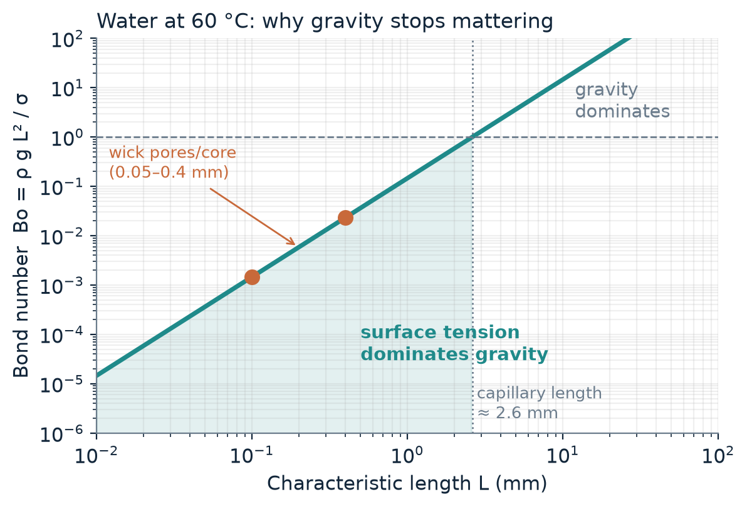
Figure 1. Bond number versus length scale for water at 60 °C. Wick pores and the vapour core lie deep in the surface-tension-dominated region.

2.3 Knudsen number and flow regime
Lecture 1 introduces the Knudsen number, Kn = λ / L, as the test for whether continuum fluid mechanics (and the no-slip condition) applies. Using kinetic theory with an assumed molecular diameter of about 0.4 nm, the mean free path of water vapour at about 20 kPa and 60 °C is roughly 0.3 µm. For a 0.1–0.2 mm vapour core, Kn is therefore about 2×10⁻³ to 3×10⁻³: the flow is still continuum, close to the lower edge of the slip regime, so standard Navier–Stokes with no-slip is a good first approximation. The Reynolds number in the vapour core is also modest. For the 5 W example in Section 4, the vapour velocity is about 2.7 m/s in a 0.2 mm core, giving Re ≈ 13 based on the hydraulic diameter (about 2h). The flow is laminar, so the laminar pressure-drop relations of Lecture 4 apply.

3. Working principle

3.1 The heat-pipe cycle
A heat pipe is a sealed, evacuated container holding a small amount of working fluid at its own saturation pressure. Heat entering the evaporator vaporises the liquid; the vapour moves toward the cooler condenser under a small pressure difference; there it condenses and releases its latent heat; and the liquid returns to the evaporator through a capillary structure [6]. The pumping pressure comes from the curvature of the liquid–vapour meniscus in the wick (Young–Laplace relation):
ΔP_{cap} = 2 σ cosθ / r_{eff} (1)
where σ is the surface tension, θ the contact angle and r_{eff} the effective pore radius of the wick. The attraction of the method is the energy density of latent heat. To carry 5 W the heat pipe must evaporate only ṁ = Q / h_{fg} ≈ 5 / (2.36×10⁶) ≈ 2.1 mg/s of water. Carrying the same 5 W as sensible heat in single-phase water with a 10 K temperature rise would need about 56 times more mass flow, and the temperature of the vapour stays nearly uniform because it is pinned to the saturation temperature.

3.2 Micro heat pipes
A micro heat pipe is a very small, non-circular channel, such as a triangular groove, in which the corners of the channel act as the wick: liquid is held in the corners by capillary forces, and the meniscus radius varies along the pipe to drive liquid from condenser to evaporator, with no separate porous wick. Peterson and Ma’s analysis of idealised triangular-groove micro heat pipes found that the maximum heat transport depends strongly on the apex angle of the liquid arteries, the contact angle, the pipe length, the vapour flow and the tilt angle [12]. Micro and miniature heat pipes have been reviewed specifically as coolers of electronic components [13]. Such grooves can be made by the same lithography-and-etch steps shown in Lecture 2 for V-grooves in silicon, and arrays of them can be embedded in a spreader plate directly beneath a chip.

3.3 Vapour chambers
A vapour chamber is a flat, wide heat pipe. Instead of moving heat along a line, it spreads heat in two dimensions through a thin vapour core between two wick-lined plates (Figure 2). Their low thermal resistance and uniform temperature distribution make them attractive for high-heat-flux electronics [8]. Ultra-thin vapour chambers, generally defined as thinner than about 2 mm, have been developed for portable devices, and the recent review literature treats their wick design, working fluids and packaging [7, 9].
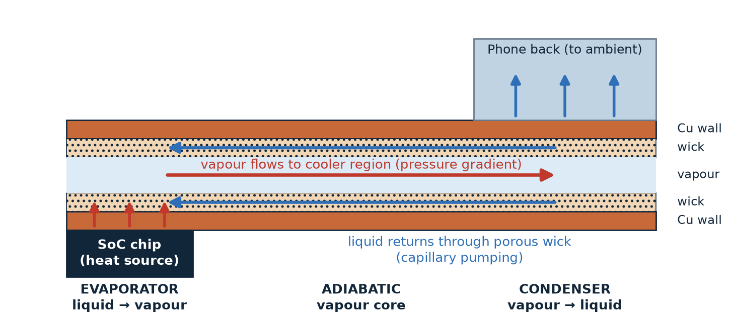
Figure 2. Cross-section of a vapour chamber under a smartphone SoC (thickness exaggerated). Heat evaporates liquid at the hot spot; vapour carries it through the core to the cooler region; condensed liquid returns through the wick by capillary action.

4. Order-of-magnitude design analysis
The estimates below use simple models from the course (Darcy flow in the wick, laminar slit flow in the vapour core) to show how the key design variables scale. They are illustrative, not predictions for a particular product: they neglect the evaporator and condenser thermal resistances, boiling and entrainment limits, and the support pillars of real devices. Assumptions are listed in Table 1.
Table 1. Assumptions for the illustrative calculations.
Quantity | Value used
Working fluid, temperature | Water, saturated at 60 °C
Properties (standard steam-table values) | σ = 0.0662 N/m; ρ_{l} = 983 kg/m³; μ_{l} = 4.66×10⁻⁴ Pa·s; h_{fg} = 2.358 MJ/kg; ρ_{v} = 0.130 kg/m³; μ_{v} = 1.12×10⁻⁵ Pa·s; dP_{sat}/dT ≈ 1.12 kPa/K (60–70 °C)
Heat load Q | 5 W (the order of the full-load phone power reported in [2])
Geometry | Wick strip width W = 30 mm, wick thickness 0.1 mm, effective transport length L = 40 mm
Wick | Sintered copper powder, porosity ε = 0.5, r_{eff} = d_{p}/2, permeability K = d_{p}²ε³ / [150(1−ε)²] (Kozeny–Carman)
Vapour core | Parallel-plate slit of thickness h, same W and L, laminar flow

4.1 The wick: capillary pressure versus permeability
Liquid flows through the wick under Darcy’s law, so the liquid pressure drop for a heat load Q is
ΔP_{l} = μ_{l} L Q / (ρ_{l} K A_{w} h_{fg}) (2)
where A_{w} = W × t_{w} is the wick cross-section. Ignoring gravity (Bo ≪ 1) and the small vapour pressure drop, the wick can support a heat load up to the point where the capillary pressure of Equation (1) equals this drop:
Q_{max} = ΔP_{cap} ρ_{l} K A_{w} h_{fg} / (μ_{l} L) (3)
Because ΔP_{cap} ∝ 1/r_{eff} while K ∝ r_{eff}², the product ΔP_{cap}·K, and hence Q_{max}, grows in proportion to the pore size (Figure 3). A wick of 10 µm particles gives a high capillary pressure (about 26 kPa) but a very low permeability, and could carry only about 3 W: the 5 W load would dry out the evaporator. A 50 µm wick gives about 5.3 kPa and Q_{max} ≈ 16 W, a margin of more than three. Coarser wicks carry more heat but provide less capillary pressure to resist the vapour-side pressure gradient and any acceleration or tilt, and they thicken the evaporator layer, adding thermal resistance and a greater risk of boiling inside the wick.
Equation (3) is only one of several failure routes. Experiments on evaporation and boiling in capillary-fed sintered powder wicks [14, 15], and the review in [7], show that boiling and dry-out at the evaporator set the practical heat-flux limit, so real designs must also be checked against those limits. This tension between pumping pressure, permeability and evaporator performance is the reason why multi-scale and biporous wicks, which combine fine pores for pumping with coarse pathways for flow, are an active research area [7, 16].
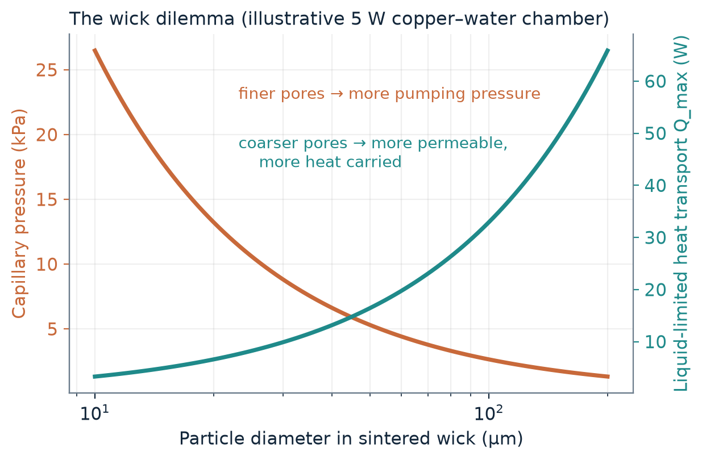
Figure 3. Capillary pressure (left axis) and the liquid-limited heat transport (right axis) versus particle diameter for the wick of Table 1.
Table 2. Wick design points (Equations 1–3). Q_{max} ignores the vapour pressure drop and boiling and entrainment limits.
Particle d_{p} (µm) | Permeability K (m²) | ΔP_{cap} (kPa) | Q_{max} (W) | vs. 5 W load
10 | 3.3×10⁻¹³ | 26.5 | 3.3 | dry-out
25 | 2.1×10⁻¹² | 10.6 | 8.2 | 1.6× margin
50 | 8.3×10⁻¹² | 5.3 | 16.5 | 3.3× margin
100 | 3.3×10⁻¹¹ | 2.6 | 32.9 | 6.6× margin
200 | 1.3×10⁻¹⁰ | 1.3 | 65.9 | 13× margin

4.2 The vapour core: why thin chambers are hard
For laminar flow between parallel plates a distance h apart, the pressure drop for vapour volumetric flow V̇ = Q / (ρ_{v} h_{fg}) over length L is
ΔP_{v} = 12 μ_{v} L V̇ / (W h³) (4)
This is the same Hagen–Poiseuille physics as Lecture 4, where the pressure loss of a channel at fixed flow rate rises steeply as the hydraulic diameter shrinks (as 1/d_{h}² at fixed velocity, and as 1/d_{h}⁴ at fixed volumetric flow for a round or square channel). For a slit of fixed width the exponent is three. In a heat pipe the vapour is at saturation, so a pressure drop appears as a temperature drop through the Clausius–Clapeyron relation, ΔT_{sat} = ΔP_{v} / (dP_{sat}/dT), which near 60 °C is about 1.1 kPa per kelvin. Figure 4 and Table 3 give the result for the 5 W load.
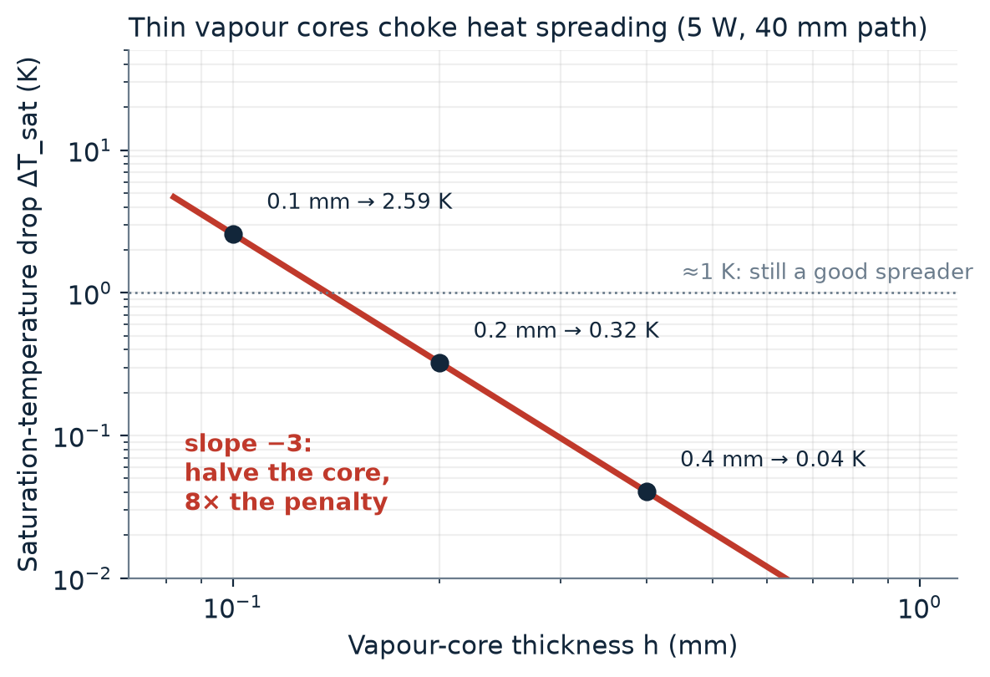
Figure 4. Saturation-temperature drop along the vapour core versus core thickness (5 W, 40 mm path, 30 mm width). The dashed part is where the linearised estimate is no longer reliable.
Table 3. Vapour-core pressure and temperature drops from Equation (4).
Core thickness h (mm) | Vapour velocity (m/s) | ΔP_{v} (Pa) | ΔT_{sat} (K)
0.4 | 1.4 | 46 | 0.04
0.2 | 2.7 | 364 | 0.32
0.1 | 5.4 | 2 914 | 2.6
0.05 | 10.8 | 23 312 | ≈ 21 (estimate no longer valid)

Halving the core thickness from 0.2 mm to 0.1 mm raises the temperature penalty from 0.3 K to 2.6 K, an eight-fold increase, and at 0.05 mm the vapour is effectively choked. This is the same limitation noted for ultra-thin vapour chambers in mobile devices: at sub-millimetre thickness their lateral thermal resistance is limited by the saturation temperature and pressure gradient in the confined vapour core [16]. The trend in the experimental literature agrees: a review of ultra-thin heat pipes reports, for different designs, a maximum heat transfer capacity of about 5 W for a 0.4 mm spiral-woven-mesh heat pipe against up to about 29 W for 1.1–1.2 mm designs [10], so the comparison is only indicative, but the direction matches Equation (4). Reviewing the ultra-thin vapour chamber literature, Zhou et al. likewise note that reducing the wick thickness reduces its capillary transport capacity [9].
As a measure of the potential, the 0.2 mm case (0.32 K over 40 mm, 0.4 mm total thickness) corresponds to an upper-bound effective conductivity of about 5×10⁴ W/(m·K), roughly 130 times that of copper (about 400 W/(m·K)). Real devices fall well below this bound because the evaporator and condenser wick layers add resistance, but the contrast with solid spreaders is clear.

5. Designing for smartphones: skin temperature
In a phone the objective is to limit the temperature that the user feels, which makes uniformity of the outer surface as important as the chip temperature. Patankar et al. noted that user comfort governs the thermal limits of mobile devices, so hot spots on the device skin must be reduced as well [16]. Earlier work mainly redesigned evaporator-side wicks. Their study patterned the condenser-side wick instead, and a three-dimensional numerical model of conjugate heat transfer, phase change and vapour-core pressurisation showed that a biporous condenser-side wick allows a thicker vapour core. The result was a reduction of the condenser surface peak-to-mean temperature difference by 37% compared with a monolithic wick [16]. Seen through Section 4, this is a design response to the two competing requirements: the wick must be thin to leave room for the vapour core, but permeable enough to return the liquid.
Experimental work points the same way. Yan et al. built an ultra-thin vapour chamber with a composite wick for portable electronics and reported that, at 10 W heating power under natural convection, it lowered the maximum temperature by 14.3 °C relative to a copper sheet [2]. This is a measured counterpart to the effective-conductivity argument of Section 4.2: even with the evaporator and condenser resistances that the idealised model neglects, a vapour chamber clearly outperforms a solid copper spreader of similar thickness.

6. Manufacturing and reliability challenges

6.1 Fabrication: top-down and bottom-up
Both manufacturing philosophies of Lectures 2 and 3 appear in these devices. Top-down methods (photolithography with wet or dry etching, micromachining, and diffusion bonding of stacked plates, as in the stainless-steel microchannel foils of Lecture 4) form grooves and channels with precisely defined geometry. Filippou et al. review microfabrication approaches for thin, flattened heat pipes and vapour chambers on rigid substrates such as metals and silicon, and on flexible polymer or composite materials. They identify the design and manufacture of the wick as the main restriction for metallic heat pipes, note that sintering is time-consuming and costly, and point out that the thermal expansion of metals does not match that of silicon, which complicates integration with semiconductor substrates [11]. Bottom-up methods build the wick from small elements: sintering metal powder is the standard route to porous wicks, and nanostructured wick surfaces are being studied to push the dry-out heat flux higher [7].
Duan et al. review ultra-thin heat pipe manufacturing together with wick shape and structure, filling rate, tilt angle, material selection and surface modification, and conclude that spiral woven mesh wicks and multi-size composite wicks have significant advantages [10]. Lecture 3 closes by asking whether a combination of top-down and bottom-up processes can simplify fabrication, and ultra-thin vapour chambers fit that pattern: a top-down machined or etched envelope and vapour core, filled by a bottom-up sintered or grown wick.

6.2 Operating limits
Table 4. The classical heat-pipe operating limits [6, 7] and how they map to the microscale concepts of the course.
Limit | What happens | Link to course
Capillary | Wick cannot return liquid as fast as it evaporates (Equation 3); evaporator dries out | Surface tension vs. viscous drag
Boiling / dry-out | Vapour bubbles form in the wick at high heat flux and block liquid supply [7, 15] | Phase change in microstructures
Entrainment | Fast vapour drags liquid droplets back from the wick, starving the evaporator [6] | Shear at the liquid–vapour interface
Sonic / vapour | Very thin vapour core chokes the flow and gives a large ΔT_{sat} (Equation 4) [16] | Δp ∝ 1/h³ (Lecture 4)
Viscous | At low temperature the vapour pressure is too low to drive flow [6] | Low-Re laminar flow

6.3 Material compatibility, corrosion and fouling
Lecture 4 stresses that corrosion and fouling are far more serious in microstructures: a corrosion layer of 100 µm that is tolerable in conventional equipment can be fatal in a microchannel, and particles that stick to a wall can attract more particles and block the channel. In a sealed vapour chamber the same logic applies to the pore space of the wick and the narrow vapour core. The working fluid and the envelope material must be chemically compatible for the whole life of the device, since a reaction that produces non-condensable gas collects at the condenser and blocks it. The envelope must also resist atmospheric pressure on the evacuated chamber, so ultra-thin designs need support structures, and these obstruct vapour flow and the wick, working against the thin-core trade-off of Section 4.2.

7. Conclusions
Micro heat pipes and vapour chambers solve the smartphone thermal problem by turning a microscale transport phenomenon into a spreading device: capillary pumping, which works because Bo ≪ 1, returns the liquid, and the latent heat of vaporisation moves the heat with almost no temperature drop. The scaling analysis points to two central design trade-offs. First, wick pore size trades capillary pressure (∝ 1/r) against permeability (∝ r²), which leads to biporous and multi-scale wicks. Second, the vapour-core pressure drop scales as the inverse cube of its thickness, so every tenth of a millimetre removed from the chamber has a steep thermal cost. Published experiments and reviews [2, 9, 10] are consistent with both. The main open challenges are manufacturing thin, leak-tight chambers with uniform wicks [11], and long-term compatibility, which the course’s discussion of top-down and bottom-up fabrication and of corrosion and fouling in microstructures helps to frame. Further gains are likely to come from better wick architectures and hybrid manufacturing, with the skin temperature of the user, not the chip, as the design target.

References
[1] DasGupta, S., & Ganguly, S. Microscale Transport Processes, Lectures 1–4 (course notes: Lecture 1; Lecture 2 – Top-Down Approach; Lecture 3 – Bottom-Up Approach; Lecture 4 – Main Issues of Successful Microstructures).
[2] Yan, C., Li, H., Tang, Y., Ding, X., Yuan, X., Liang, Y., & Zhang, S. (2023). A novel ultra-thin vapor chamber with composite wick for portable electronics cooling. Applied Thermal Engineering, 226, 120340. https://doi.org/10.1016/j.applthermaleng.2023.120340
[3] Bhat, G., Gumussoy, S., & Ogras, U. Y. (2019). Power and thermal analysis of commercial mobile platforms: Experiments and case studies. Proc. Design, Automation & Test in Europe (DATE) 2019. https://past.date-conference.com/proceedings-archive/2019/html/1067.html
[4] Garimella, S. V., Fleischer, A. S., Murthy, J. Y., Keshavarzi, A., Prasher, R., Patel, C., Bhavnani, S., Venkatasubramanian, R., Mahajan, R., Joshi, Y., Sammakia, B., Myers, B. A., Chorosinski, L., Baelmans, M., Sathyamurthy, P., & Raad, P. (2008). Thermal challenges in next-generation electronic systems. IEEE Transactions on Components and Packaging Technologies, 31(4), 801–815. https://doi.org/10.1109/TCAPT.2008.2001197
[5] Tuckerman, D. B., & Pease, R. F. W. (1981). High-performance heat sinking for VLSI. IEEE Electron Device Letters, 2(5), 126–129. https://doi.org/10.1109/EDL.1981.25367
[6] Faghri, A. (2012). Review and advances in heat pipe science and technology. Journal of Heat Transfer, 134(12), 123001. https://doi.org/10.1115/1.4007407
[7] Weibel, J. A., & Garimella, S. V. (2013). Recent advances in vapor chamber transport characterization for high-heat-flux applications. Advances in Heat Transfer, 45, 209–301. https://doi.org/10.1016/B978-0-12-407819-2.00004-9
[8] Bulut, M., Kandlikar, S. G., & Sözbir, N. (2019). A review of vapor chambers. Heat Transfer Engineering, 40(19), 1551–1573. https://doi.org/10.1080/01457632.2018.1480868
[9] Zhou, F., Zhou, J., & Huai, X. (2023). Advancements and challenges in ultra-thin vapor chambers for high-efficiency electronic thermal management: A comprehensive review. International Journal of Heat and Mass Transfer, 214, 124453. https://doi.org/10.1016/j.ijheatmasstransfer.2023.124453
[10] Duan, L., Li, H., Du, J., Liu, K., & He, W. (2022). Research on the manufacturing process and heat transfer performance of ultra-thin heat pipes: A review. Materials, 15(15), 5459. https://doi.org/10.3390/ma15155459
[11] Filippou, I., Tselepi, V., & Ellinas, K. (2024). A review of microfabrication approaches for the development of thin, flattened heat pipes and vapor chambers for passive electronic cooling applications. Micro and Nano Engineering, 22, 100235. https://doi.org/10.1016/j.mne.2023.100235
[12] Peterson, G. P., & Ma, H. B. (1996). Theoretical analysis of the maximum heat transport in triangular grooves: A study of idealized micro heat pipes. Journal of Heat Transfer, 118(3), 731–739. https://doi.org/10.1115/1.2822693
[13] Vasiliev, L. L. (2008). Micro and miniature heat pipes – Electronic component coolers. Applied Thermal Engineering, 28, 266–273. https://doi.org/10.1016/j.applthermaleng.2006.02.023
[14] Hanlon, M. A., & Ma, H. B. (2003). Evaporation heat transfer in sintered porous media. Journal of Heat Transfer, 125(4), 644–652. https://doi.org/10.1115/1.1560145
[15] Weibel, J. A., Garimella, S. V., & North, M. T. (2010). Characterization of evaporation and boiling from sintered powder wicks fed by capillary action. International Journal of Heat and Mass Transfer, 53(19–20), 4204–4215. https://doi.org/10.1016/j.ijheatmasstransfer.2010.05.043
[16] Patankar, G., Weibel, J. A., & Garimella, S. V. (2016). Patterning the condenser-side wick in ultra-thin vapor chamber heat spreaders to improve skin temperature uniformity of mobile devices. International Journal of Heat and Mass Transfer, 101, 927–936. https://doi.org/10.1016/j.ijheatmasstransfer.2016.05.093

Appendix A. Literature map
Table A1. Sources used and what each contributes.
Ref. | Source | Role in this paper
[1] | Course notes, Lectures 1–4 | Scaling laws, fabrication, pressure drop, fouling
[2] | Yan et al., Appl. Therm. Eng. 2023 | Recent ultra-thin chamber for portable electronics; phone power and thickness trends
[3] | Bhat et al., DATE 2019 | Measured throttling on a smartphone (the motivation)
[4] | Garimella et al., IEEE TCPT 2008 | Electronics-cooling challenges and research barriers
[5] | Tuckerman & Pease, 1981 | Classic microchannel liquid heat sink (the active alternative)
[6] | Faghri, J. Heat Transfer 2012 | Heat-pipe principles and operating limits
[7] | Weibel & Garimella, 2013 | Vapour-chamber transport, wicks, dry-out
[8] | Bulut et al., 2019 | Vapour-chamber review: principle and applications
[9] | Zhou et al., IJHMT 2023 | Recent review of ultra-thin vapour chambers
[10] | Duan et al., Materials 2022 | Review of ultra-thin heat-pipe manufacturing and wicks
[11] | Filippou et al., 2024 | Review of microfabrication routes (top-down and flexible)
[12] | Peterson & Ma, 1996 | Capillary limit of micro heat pipes with triangular grooves
[13] | Vasiliev, 2008 | Micro and miniature heat pipes as electronics coolers
[14] | Hanlon & Ma, 2003 | Evaporation from sintered wicks
[15] | Weibel et al., 2010 | Evaporation and boiling in capillary-fed wicks
[16] | Patankar et al., 2016 | Biporous condenser wick for mobile skin temperature

