Plugin *Certificate*

Documentation

|  |  |
| --- | --- |
| **Date of Release:** | **18.05.2016** |
| **Document-Version:** | 1.3 |
| **Plugin-Version** | 1.7 |
| **Author:** | Oskar Truffer, studer + raimann ag  Stefan Wanzenried, studer + raimann ag  Theodor Truffer, studer + raimann ag |

|  |  |  |
| --- | --- | --- |
| **Version** | **Author** | **Changes** |
| **1.0** | Stefan Wanzenried | Created |
| **1.1** | Stefan Wanzenried | Updates when using Plugin with ILIAS 5.x |
| **1.2** | Stefan Wanzenried | Describe new features introduced with plugin version 1.3 Describe meaning of different certificate status Add section on how to update the plugin |
| **1.3** | Stefan Wanzenried | Add section on custom settings Add section “Jasper Report” with some examples how to structure certificate templates |
| **1.7** | Theodor Truffer | Inserted newer screenshots, added descriptions to new features. |

Table of contents

1 Introduction 5

2 Installation 6

2.1 Preparing ILIAS Core Patches 6

2.2 Install the plugin using GIT 6

2.3 Install depending services and plugins 7

2.3.1 Plugins 7

2.4 Add MainMenu Entry 7

2.5 Installing the Cron-Job 10

2.6 Updating the plugin 11

3 User Manual 11

3.1 Plugin configuration 11

3.2 Certificate types 12

3.2.1 General settings 12

3.2.2 Template 13

3.2.3 Settings 15

3.2.4 Custom Settings 16

3.2.5 Placeholders 17

3.2.6 Signatures 20

3.3 Certificate definitions 20

3.3.1 Configure certificate for a course 21

3.3.2 Settings 21

3.3.3 Placeholders 22

3.3.4 Show certificates 23

3.3.5 Participants 23

3.4 Global certificate administration 24

3.4.1 Call back a certificate 24

3.5 Overview of received certificates for users 25

3.6 Meaning of different certificate status 25

3.7 Jasper Reports Templates 26

3.7.1 Parameters 26

3.7.2 Images 26

3.7.3 Signatures 27

# Introduction

The certificate plugin offers an enhanced support for creating and administrating certificates inside ILIAS. The main features include:

* Multiple certificate types with different layouts
* Generate pretty PDF layouts with [JasperReports](https://community.jaspersoft.com/project/jasperreports-library), the world’s most popular open source reporting engine
* Multiple languages
* Multiple settings including validity and notifications
* Certificate PDF files are stored in the ILIAS data directory
* Revision of files: Each certificate bound to a user and course can have multiple versions

After a successful installation, an administrator can create a so-called certificate type. This type defines the available placeholders, default settings and the layout (template) of a certificate.   
Inside an ILIAS course, the plugin adds a new tab “Certificate” where a course administrator can choose from available certificate types and create a “certificate definition”. If a course member passes the course, a certificate is generated. Depending on the settings of the certificate definition, the certificate-owner and other users get a notification by email when the PDF file is finished and ready for downloading.

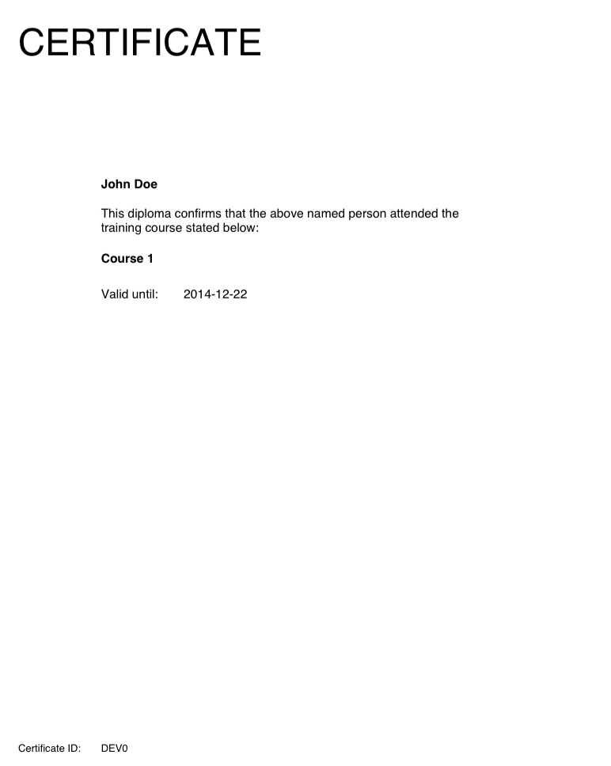 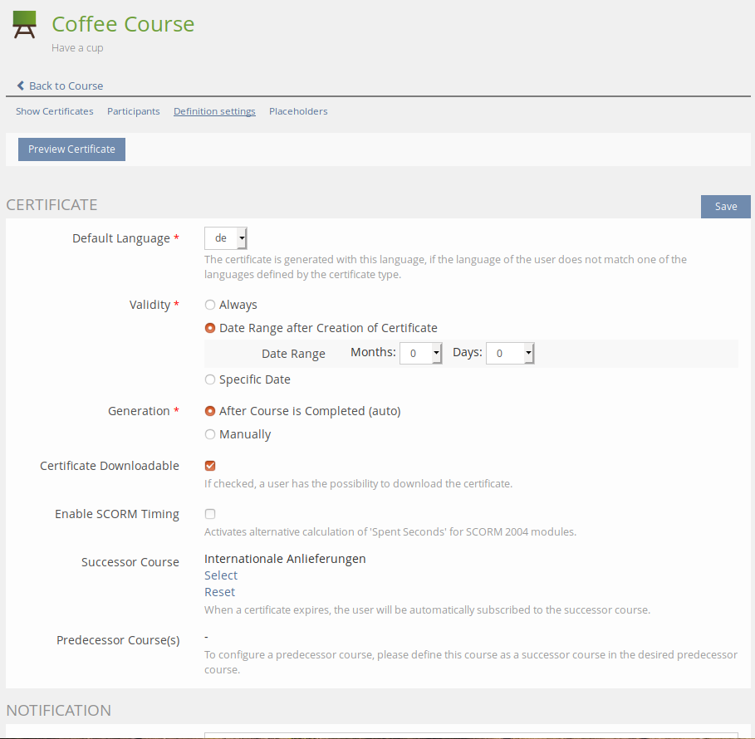

# Installation

## Preparing ILIAS Core Patches

ILIAS needs some minor patches to the code in order to work with the Certificate Plugin. Please install the patches according to the GitHub ReadMe:

[https://github.com/studer-raimann/Certificate/tree/](https://github.com/studer-raimann/Certificate/tree/dev" \l "patches)master#patches

## Install the plugin using GIT

Use the command line to locate to the root folder of ILIAS and enter the following commands:

mkdir -p Customizing/global/plugins/Services/UIComponent/UserInterfaceHook/

cd Customizing/global/plugins/Services/UIComponent/UserInterfaceHook/

git clone https://github.com/studer-raimann/Certificate.git

Go back to the root folder of ILIAS and use the following commands to install the “CertificateEvents” plugin.

mkdir -p Customizing/global/plugins/Services/EventHandling/EventHook

cd Customizing/global/plugins/Services/EventHandling/EventHook

git clone https://github.com/studer-raimann/CertificateEvents.git

If everything is set up in the back end we move to the actual installation on the ILIAS front end. Log into your ILIAS installation with an administrator user. Navigate to “Administration → Plugins”. If the steps mentioned above were executed correctly you should see the two plugins “Certificate” and “CertificateEvents”. Use the actions menu to install and activate the plugins. Make sure you activate the plugins in the following order:

1. CertificateEvents
2. Certificate

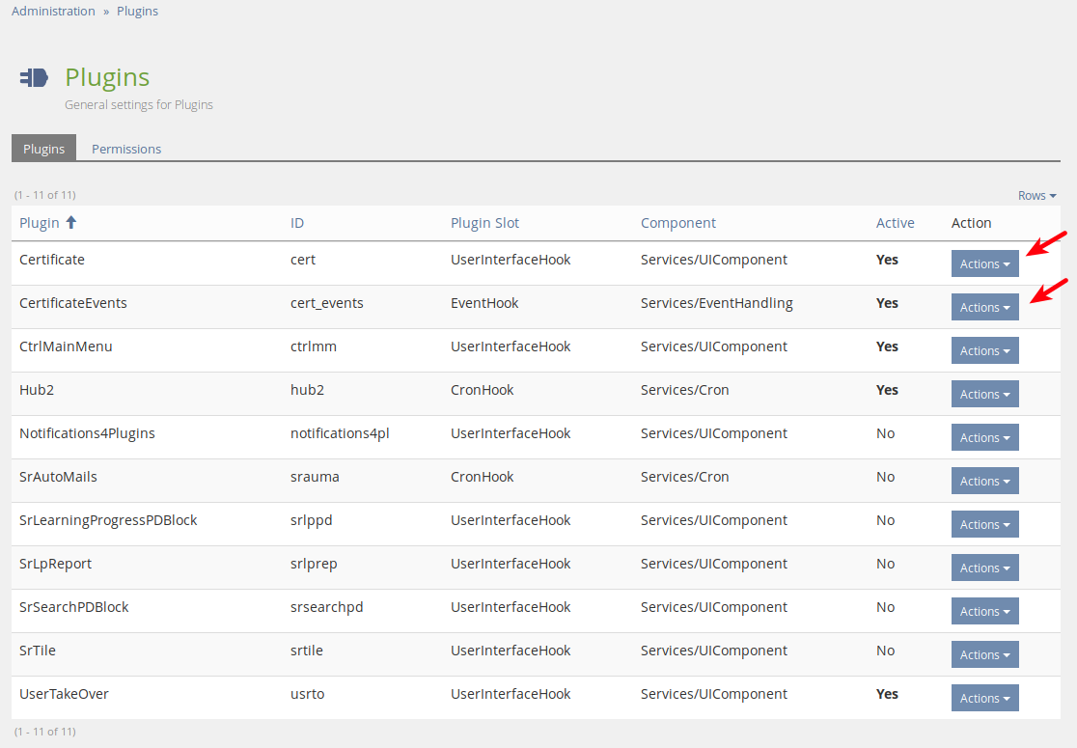

Now you have successfully installed the Certificate plugin.

## Install depending services and plugins

The Certificate plugin depends on some other plugins and services. Please install them by following the provided links.

### Plugins

|  |  |  |
| --- | --- | --- |
| **ILIAS Version** | **Service** | **Installation link** |
| **< 5.4.x** | CtrlMainMenu | <https://github.com/studer-raimann/CtrlMainMenu> |

## Add MainMenu Entry

In this chapter we are going to add the main menu entries for the additional Certificate GUIs. We will add a new dropdown menu in the ILIAS MainMenu, where users and administrators can see and manage their certificates.

First navigate into “Administration → Plugins → CtrlMainMenu Actions → Configure”. You should see something similar to the screen shot shown below.

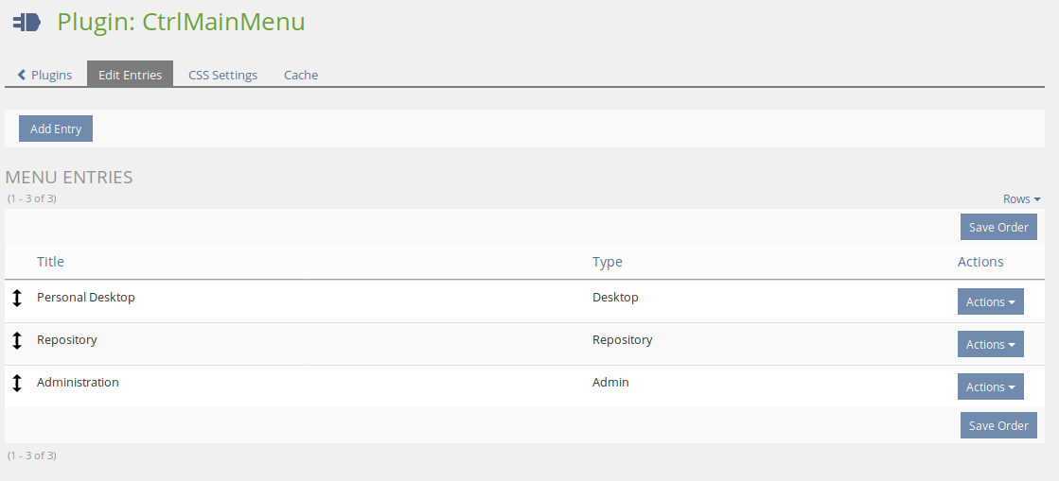

Here we click on: Add Entry and in the following form we choose the type “Dropdown”. After this we will see the settings mask of the new dropdown. We choose a name, e.g. “Certificates”, and choose the option “Use Arrow Image” afterwards use the button “Save and close”. You will be back on the CtrlMainMenu configuration page as shown above but with one additional entry.

Choose the newly created certificate entry's actions button and go to “Edit entries”. Here we will add three new entries.

First we add the entry where each user will later be able to see all his certificates: Click on “Add entry” and configure the entry according to the following table:

|  |  |
| --- | --- |
| **Setting** | **Configuration** |
| **Select Access Type** | No Access Control |
| **Title** | Something similar to “My Certificates” |
| **GUI Classes, comma-separated** | ilUIPluginRouterGUI,srCertificateUserGUI |

Hit “Save & Close” and make sure that you are back at “Certificate → Edit Entries” where you should see the newly created entry. Let’s create two more entries following the same procedure:

|  |  |
| --- | --- |
| **Setting** | **Configuration** |
| **Select Access Type** | Restrict to Role → Administrator |
| **Title** | Something similar to “Administrate Certificates“” |
| **GUI Classes, comma-separated** | ilUIPluginRouterGUI, srCertificateAdministrationGUI |

|  |  |
| --- | --- |
| **Setting** | **Configuration** |
| **Select Access Type** | Restrict to Role → Administrator |
| **Title** | Something similar to “Certificate Types“” |
| **GUI Classes, comma-separated** | ilUIPluginRouterGUI, srCertificateTypeGUI |

**Optional:** This entry is only needed if you include a digital signature on your certificate (see #3.2.5.Placeholders *DIGITAL_SIGNATURE* and *DIGITAL_SIGNATURE_QR_CODE*)

|  |  |
| --- | --- |
| **Setting** | **Configuration** |
| **Select Access Type** | No Access Control |
| **Title** | Something similar to “Signature Decryption“” |
| **GUI Classes, comma-separated** | ilUIPluginRouterGUI, certCheckSignatureGUI |

The second entry allows Administrators to administrate certificates from all users in ILIAS. The third entry is needed to create and manage additional certificate types. Feel free to change permissions and titles according to your needs.

In the following screenshot you can see an example configuration. Also take a look at the MainMenu with the newly created dropdown and the sub-entries:

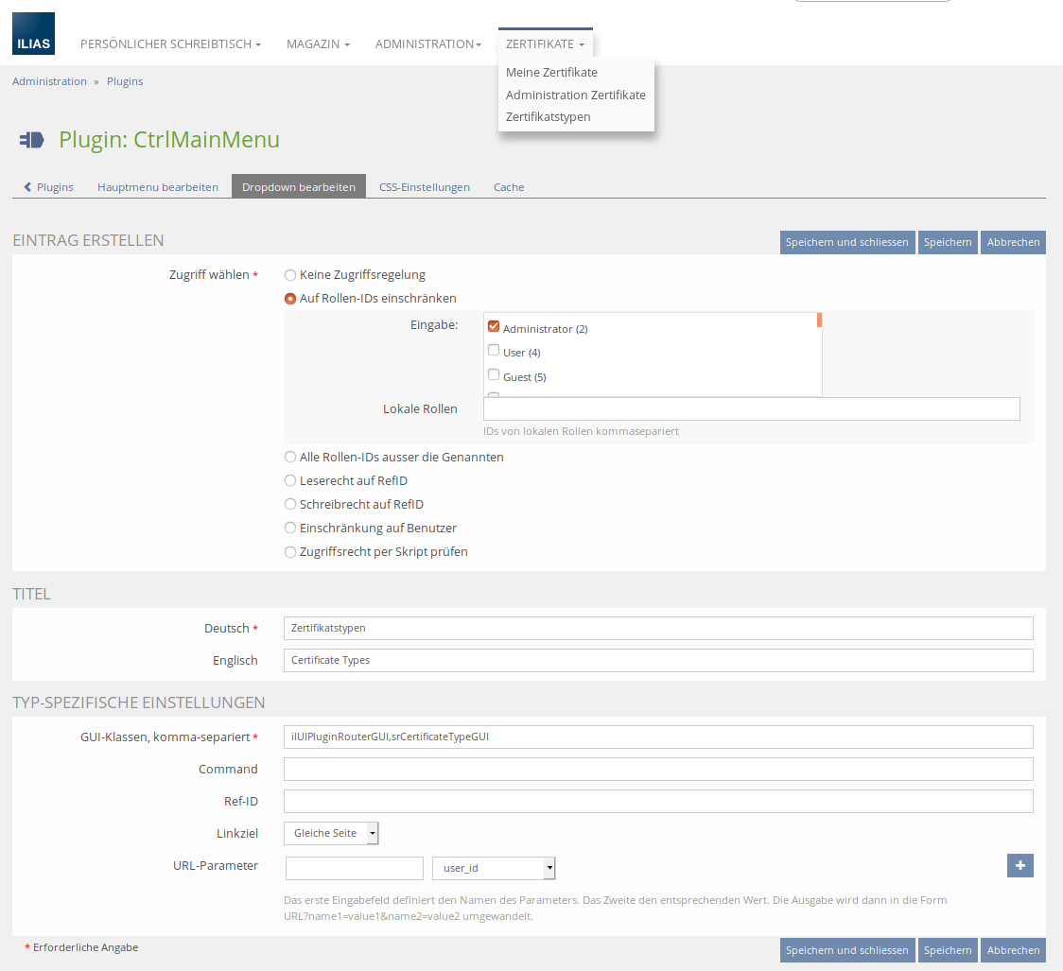

## Installing the Cron-Job

After a user of ILIAS has successfully passed a course where a certificate was defined, we want him to receive a certificate. The certificate PDF will be generated by a cron-job. This documentation will instruct you on how to install the cron-job on a Debian/Ubuntu distribution, which might also work for CentOS and some other Linux distributions. If you are working on a different OS, you might want to consult further resources in order to get your cron-job running.

1. Connect to the server via terminal
2. Create and open the file **/etc/cron.d/ilias_cert_cron** with a text-editor
3. Enter the following line

*/15 * * * * www-data php [ILIAS_ROOT_PATH]/Customizing/global/plugins/Services/UIComponent/UserInterfaceHook/Certificate/classes/class.srCertificateCron.php [USER] [PASSWORD] [CLIENT_ID]

Replace the four variables [ILIAS_ROOT_PATH], [USER], [PASSWORD] and [CLIENT_ID] according to the appropriate values of your installation. Make sure that the user has administration permissions in ILIAS, e.g. using the “root” user. If you can't remember your client ID, open the ILIAS setup (you can find it under yourdomain.com/setup/setup.php).

This script will run every fifteen minutes now in order to generate the PDFs of certificates for the users that passed a course.

## Updating the plugin

If you want to update the certificate plugin after a new release, make sure you also update the plugin “CertificateEvents” to its latest version. After updating the plugins, update them in the ILIAS plugin-administration.

# User Manual

## Plugin configuration

Navigate to the plugin administration and open the configuration for the Certificate plugin. Modify the default configuration according to your needs:

|  |  |
| --- | --- |
| **Setting** | **Description** |
| **Enable support for course templates** | If enabled, the plugin offers additional certificate settings depending if a course is marked as "course template". |
| **Print Date/Times on Certificate in UTC-Timezone** |  |
| **Date Format** | Date format used to format all dates from the standard placeholders |
| **Datetime Format** | Date format used to format all dates with time from the standard placeholders |
| **Time Range Certificate PDF generation (in seconds)** | You can set a time range in seconds to invoke the PDF generation of a certificate. If you enter zero, the PDF is generated right after the user passed the course. Note that possible notifications are also sent after the given time range. |
| **Path to Hook-Class** | Path to the class 'srCertificateCustomHooks', e.g. './Customizing/global/Certificate/'. This class can be used to modify the standard behaviour of this plugin at various points. Must extend srCertificateHooks (see class description for more information). |
| **Callback E-Mail(s)** | E-Mail will be sent to this address whenever a certificate is called back. You can add multiple e-mail addresses, comma separated. |
| **Free Space Warning (MB)** | Send a warning to the system administrator when the amount of free space for the certificate creation is lower than this value. |
| **Administrate Certificate Types** | Select roles that are able to administrate certificate types. |
| **Administrate Certificates** | Select roles that are allowed to globally search and download certificates. |
| **Locale (Unix)** | The Locale should support all characters you need in the PDF files, such as German-Umlauts. Execute "locale -a" to see a list of available locales on your unix system. Choose C.UTF-8 if you’re unsure. |
| **Path to Java executable** | Usually at /usr/bin/java |

## Certificate types

Certificate types “describe” a certificate by defining settings, placeholders and the certificate layout. They are available for course administrators when choosing a certificate for the course. The Certificate plugin comes with one pre-installed type called “Default Certificate”. You may modify this type according to your needs or create additional types. If you need multiple similar types, you can also copy an existing type.

### General settings

Open the Screen for managing the Certificate types over the previous installed MainMenu entry. Edit the “Default Certificate” type.

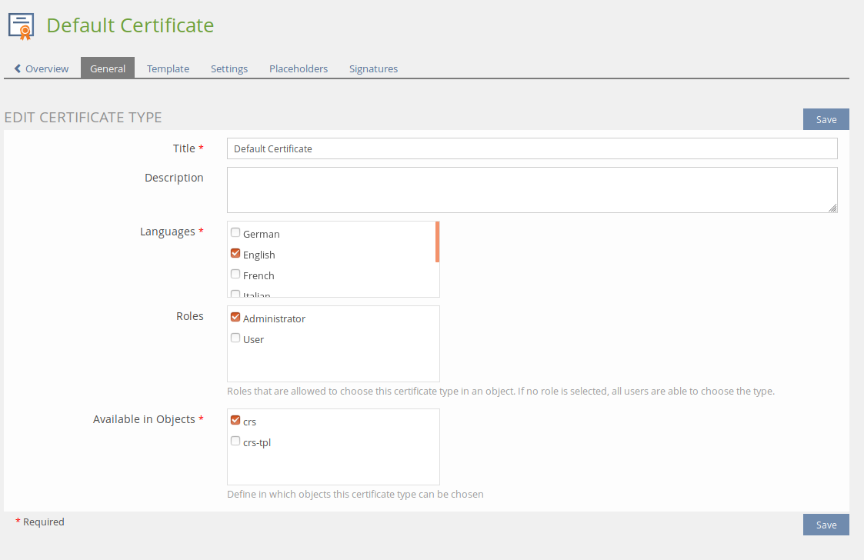

### Template

The certificate template defines the layout of the PDF file. Although the plugin is designed to support multiple template types, it is recommended to use “Jasper Report”. This type allows designing nice PDF layouts with the help of the software [Jaspersoft Studio](https://community.jaspersoft.com/project/jaspersoft-studio).

The typical procedure to create a new PDF layout looks like this:

1. Download the Default Template file. This jrxml file contains a sample XML structure which you can customize further by adding text, images and placeholders
2. Open the jrxml file with “Jaspersoft Studio”. Make your modifications and save the file.
3. Upload the jrxml file again
4. Add any referenced assets in the template file (such as images)
5. Save

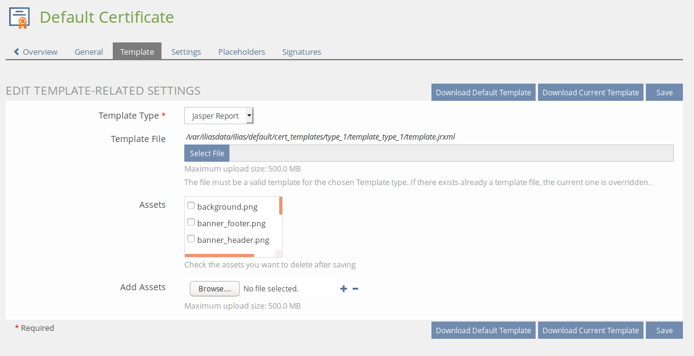

The screenshot below shows the Jaspersoft Studio with the default template:

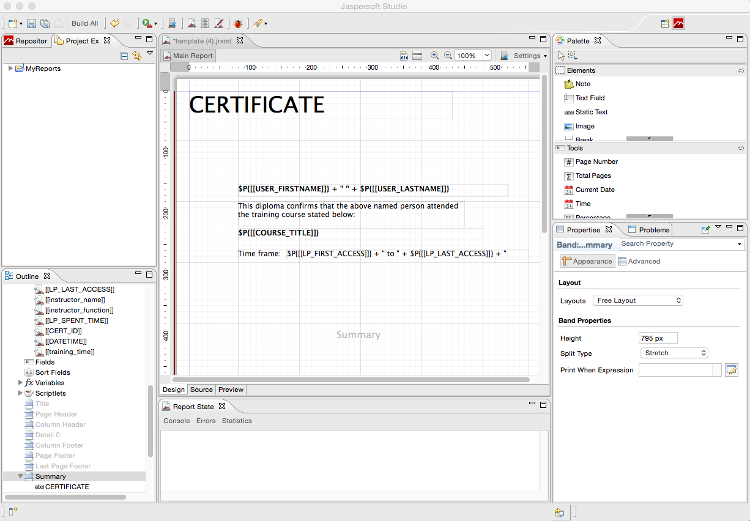

### Settings

The following settings are available:

|  |  |
| --- | --- |
| **Setting** | **Description** |
| **Certificate downloadable** | If activated, the user is able to download the certificate PDF himself. |
| **Default language** | If the Certificate type supports multiple languages, specify the one that is chosen if the language of the user obtaining a certificate doesn’t match any of the supported languages by the type. |
| **Enable SCORM Timing** | Activates alternative calculation of 'Spent Seconds' for SCORM 2004 modules. |
| **Generation** | Choose when a Certificate is generated:   * Automatically, if the user passes a course * Manually (see Participants) |
| **Notification** | Enter e-mail addresses getting notified whenever a certificate is generated (comma separated). |
| **Successor Course** | When a certificate expires, the user will automatically be subscribed to the successor course. |
| **User Notification** | Activate this setting if the user should receive the certificate by email. |
| **Validity Type** | Define the validity type of a certificate:   * Always * Date range after creation of certificate * Specific date |
| **Validity** | Choose the validity based on the validity type. |

Note that by default all settings can be overridden on course level, e.g. when a course administrator chooses a certificate type. If a setting should not be changeable, remove the checkbox “Editable In” for the appropriate object. ATM, certificates are only supported for ILIAS courses. 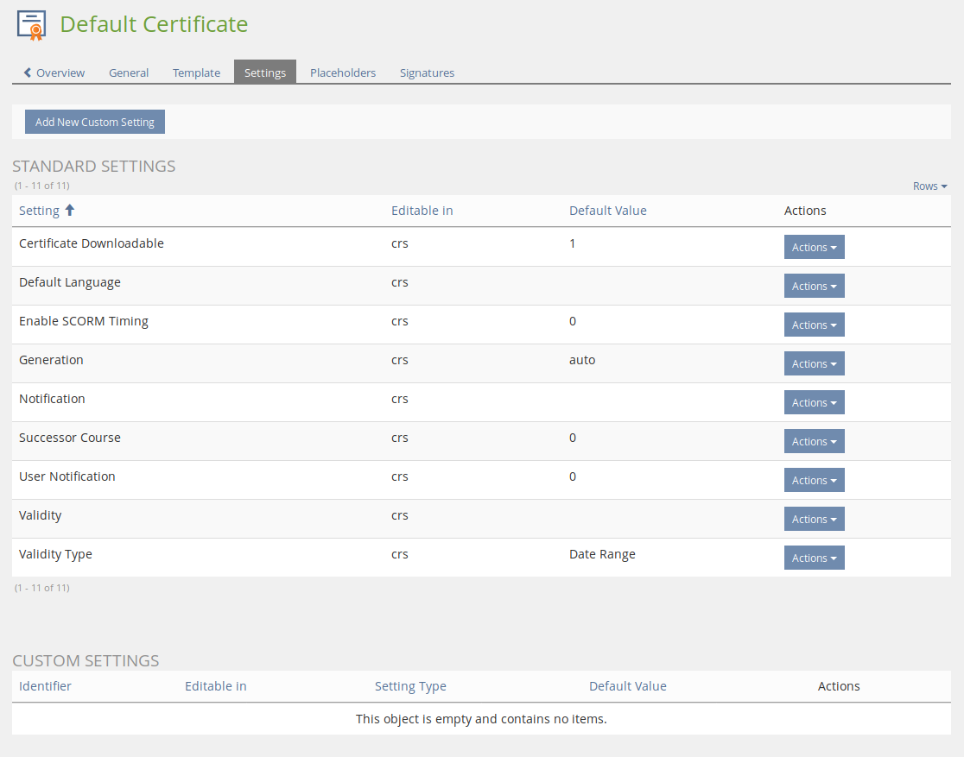

### Custom Settings

This feature allows you to create custom settings that are available when configuring a certificate definition. Two setting types are available:

1. Boolean (Checkbox): This setting appears as checkbox in the definition and can either be checked or unchecked.
2. Value (Dropdown): This setting type allows to define key-value pairs that are selectable from a dropdown

Each setting must have a unique identifier and label. When creating a setting, one can choose to update existing certificate definitions with the new setting. If this option is selected, the setting is created for all certificate definitions with its default value (see Figure 1).

The setting is passed as parameter to the certificate template. It is the developer’s responsibility to execute additional logic based on the value of a setting. The parameter is identified with a prefix “setting_” and the identifier of the setting, e.g. “[[setting_weather_forecast]]” from Figure 1.

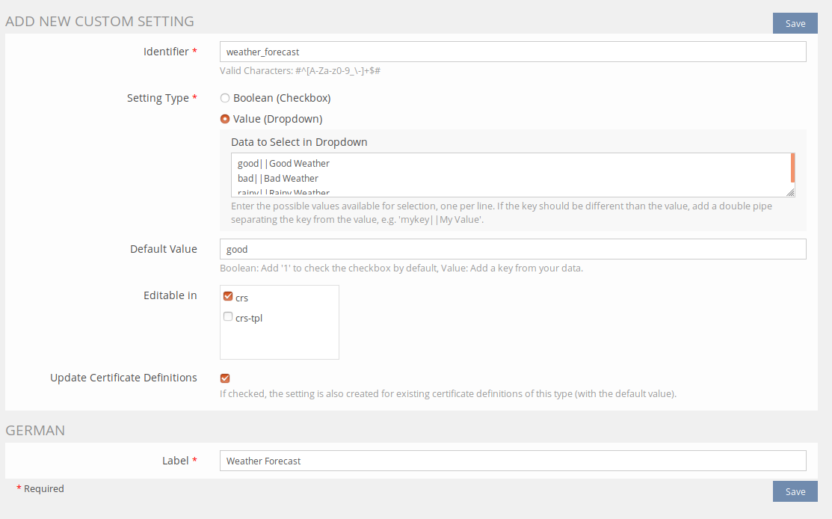

Figure 1: Creating a custom setting

### Placeholders

Placeholders are variables you can use in your certificate template, e.g. a .jrxml file for the JasperSoft Studio. A placeholder variable is replaced by a value at runtime, when generating the certificate PDF. The plugin offers a decent amount of so called “Standard placeholders”. These placeholders come out of the box. Beside those placeholders, you are also free to create your own placeholders, which are fillable by a course administrator when defining a certificate on course level.

Here are some examples of available Standard placeholders:

|  |  |
| --- | --- |
| **Placeholder** | **Description** |
| **USER_FIRSTNAME** | First name of the user |
| **USER_LASTNAME** | Last name of the user |
| **CERT_ID** | Internal ID of the certificate |
| **CERT_VALID_TO** | Date how long the certificate is valid, if the validity type is not set to “Always” |
| **COURSE_TITLE** | Title of the ILIAS course |
| **DIGITAL_SIGNATURE** | An encrypted code which can only be decrypted by the server where the certificate was created. Used to validate the certificate. |
| **DIGITAL_SIGNATURE_QR_CODE** | A QR code with a link to decrypt the digital signature. |

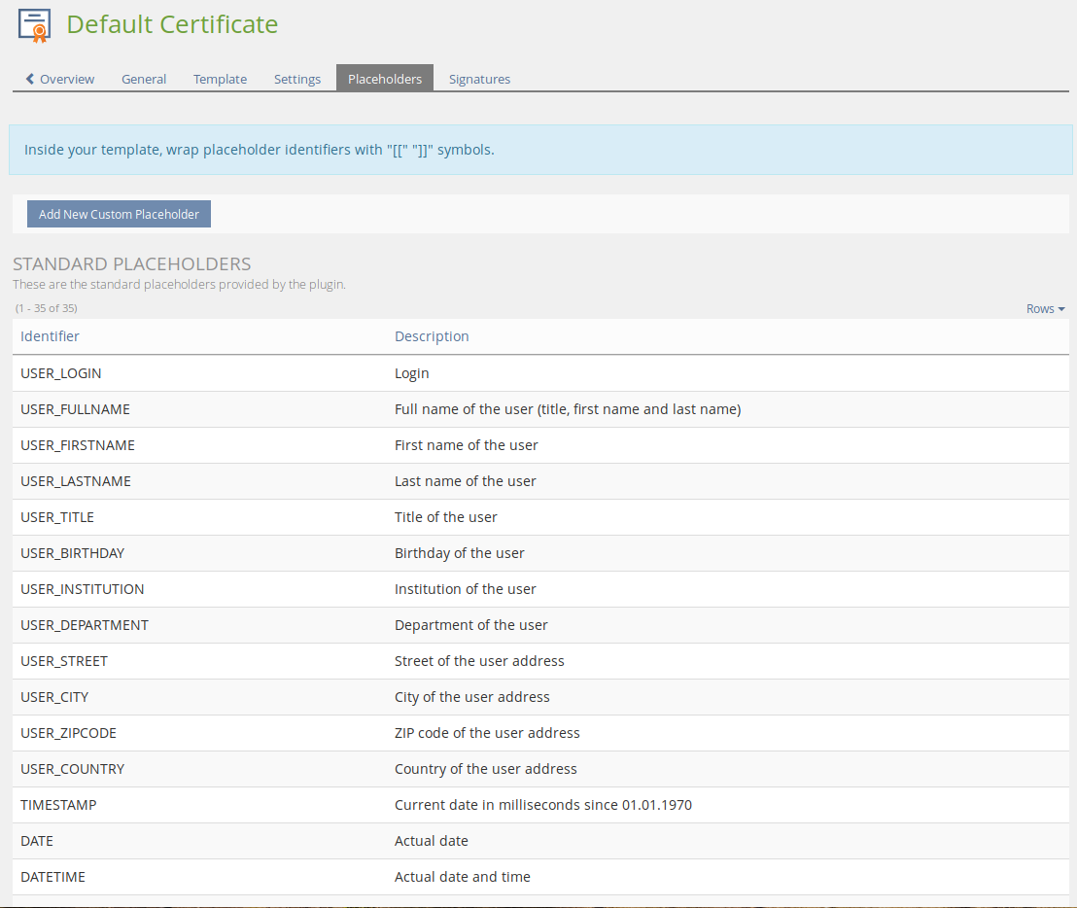

To define a custom placeholder, click on the button “Add new placeholder”. In the following example, a new placeholder “trainer” is added to the certificate. This allows the course administrators to write the name of a person that was the trainer of the course.

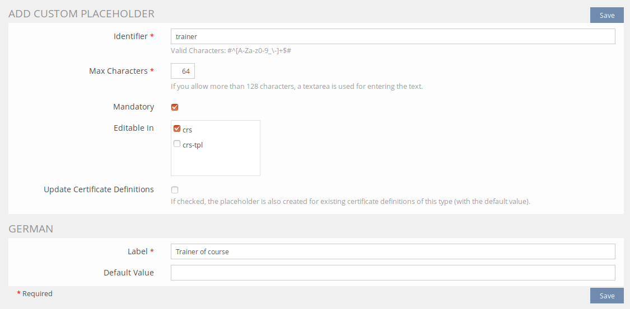

Available settings for placeholders:

|  |  |
| --- | --- |
| **Setting** | **Description** |
| **Identifier** | The variable name of the placeholder that can be referenced in the template. In this example, to print the course trainer, the template must contain the following placeholder:  [[trainer]]  This variable is then replaced with the correct value defined in the certificate definition. |
| **Max characters** | Maximum amount of characters a course administrator is allowed to enter. |
| **Mandatory** | If checked, it is mandatory to fill out this placeholder. |
| **Editable in** | Remove any checkboxes if the placeholder’s default value is not editable anymore. |
| **Label** | Label of this placeholder in the form. |
| **Default value** | Default value, pre-filled for the course administrator. |

The label and default value can be set for each language of the certificate type.

The screenshot below shows an example how placeholders can be entered in a course:

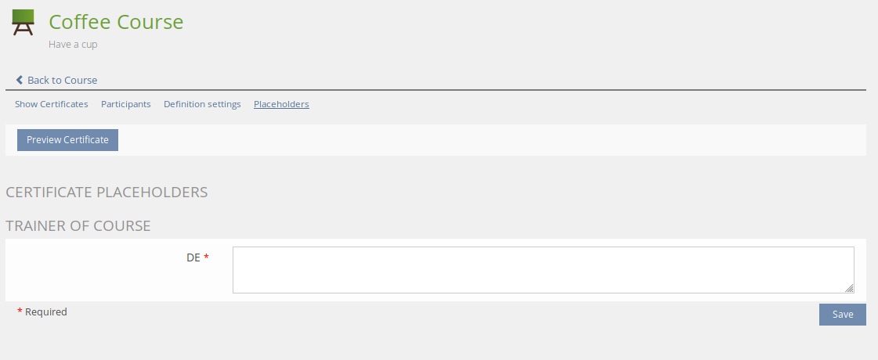

### Signatures

This feature is mainly useful if your certificate should display a signature dynamically. The certificate type can hold multiple signatures. Signatures consist of a signature image, firstname and lastname of a person. When defining a certificate, you can choose the signature that should be used. If a signature is selected in the certificate definition, the following placeholders are submitted to the certificate template:

* [[SIGNATURE_FIRSTNAME]] Firstname of the person
* [[SIGNATURE_LASTNAME]] Lastname of the person
* [[SIGNATURE_NAME]] Combines first- and lastname
* [[SIGNATURE_IMAGE]] Path to the image (without file type suffix)
* [[SIGNATURE_IMAGE_SUFFIX]] File type Suffix of the image, e.g. “jpg”, “svg”, “png”

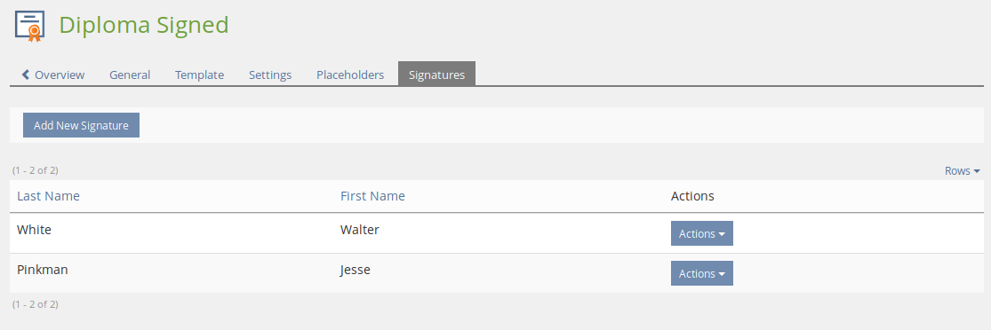

## Certificate definitions

A certificate definition is created when choosing the certificate type in an ILIAS course. Depending on the settings of the certificate type, additional placeholders can be entered. It is also possible to overwrite some of the certificate specific settings, such as validity and notifications. Note that in order to define and configure a certificate for a course, the user needs “write” access to the course. This means, the person needs the permission “Edit settings”.

### Configure certificate for a course

Open the course where members should receive a certificate when passing the course. Click on the tab “Certificate”.

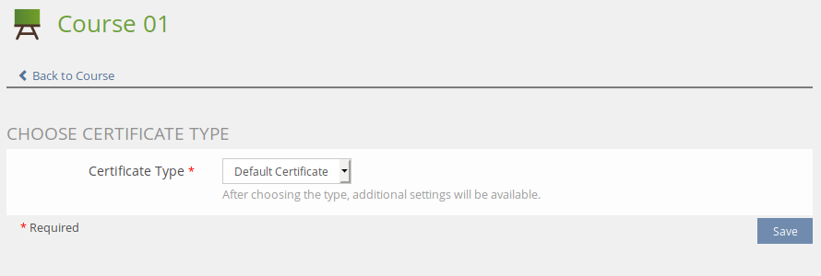

The plugin lists all the available certificate types. Choose the desired type and click on “Save”. The certificate plugin creates a new definition and the GUI displays all settings for further configuration.

### Settings

The settings of a certificate definition inherit the default value defined by the certificate type. If a setting is editable in the course object (remember that it is possible to define for each setting in which object it’s editable) you can overwrite the default value. Settings that are not editable are displayed for information purposes, but the form is not active.



**A note to the setting “Enable SCORM Timing”**: ILIAS calculates the time a user is spending inside a course based on the time difference between two mouse clicks. SCORM modules calculate this time separately and more precise. If your certificate prints the spent time of a user and your course contains SCORM modules, consider enabling this setting. If activated, the plugin will use the calculations from a SCORM module instead of the ILIAS calculation.

### Placeholders

If the certificate type has custom placeholders or signatures defined, they are now fillable by a course administrator. Again, it depends if the placeholder is marked as “editable” for the course object.

By clicking on “Preview Certificate”, a sample certificate is generated containing the real placeholder data. User related data such as name, address, etc. is printed anonymized.

If the certificate type offers signatures, the desired signature can be selected below the placeholders. If selected, additional placeholders are passed to the certificate template (see section “3.2.5 Signatures” for further information)

### Show certificates

This section displays all the members that received a certificate from the course. A course administrator has the possibility to download individual certificates and multiple PDF files compressed in a .zip file.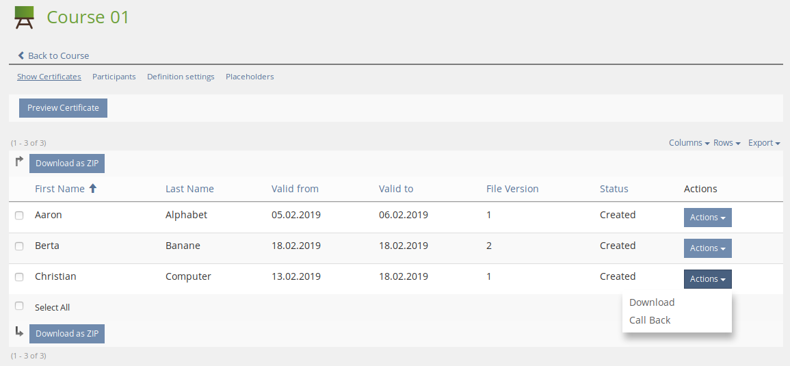

### Participants

This section contains a list of all course members and shows if and when a member has passed the course. Here, administrators are given the possibilty to manually set the passed date of a course member to trigger the (re-)creation of a certificate.

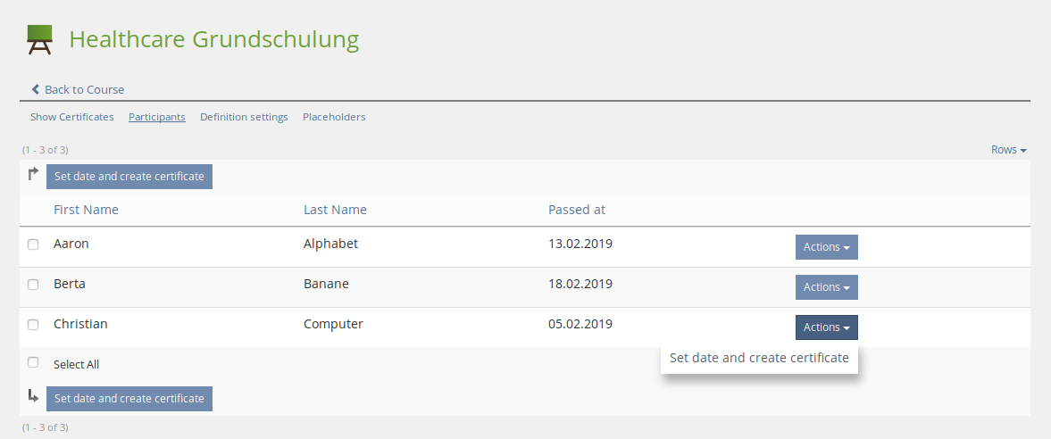

## Global certificate administration

Administrators have the possibility to globally search and download certificates. If you followed the installation section of this manual, we created some new main menu entries with the help of the CtrlMainMenu plugin. Open the certificate administration by choosing the main menu entry “Administrate Certificates”.

There exist several filters for searching certificates:

|  |  |
| --- | --- |
| **Filter** | **Description** |
| **Certificate ID** | This is a unique ID of the certificate. If printed on the PDF, you can find a certificate by this ID and check if it corresponds to the correct person. |
| **First name Last name** | First- and Last name of the certificate owner |
| **Course title** | Title of the course in ILIAS where the certificate belongs to |
| **Valid from Valid to** | Filter results depending on the validity date of the certificates |
| **Certificate type** | If your installation contains multiple certificate types, you can display only certificates with the given type |
| **Show newest version only** | By checking this option, only the newest version of a certificate is displayed. If deactivated, multiple versions of a certificate are displayed. |

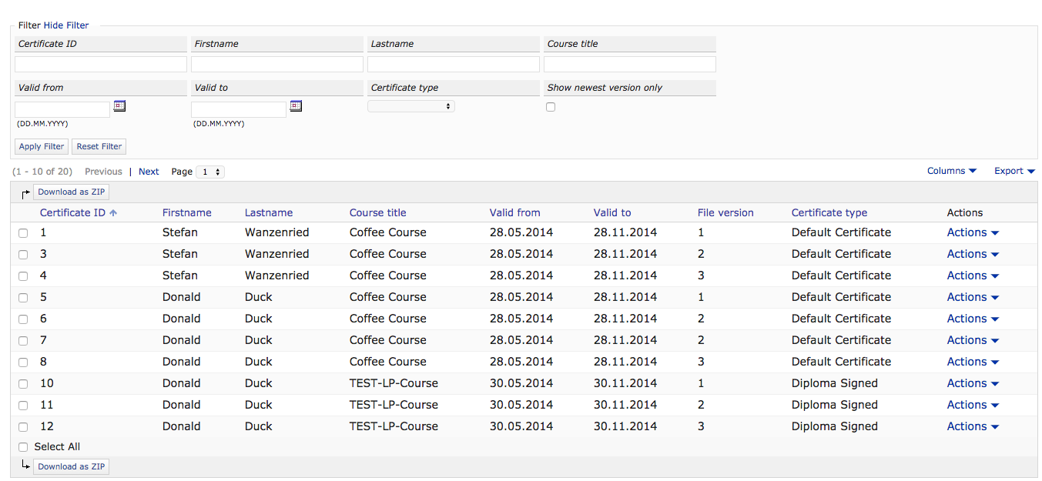

### Call back a certificate

An administrator has the possibility to “call back” a certificate, if the certificate was generated by mistake. A called back certificate is no longer downloadable by a user or administrator. Additionally, an e-mail address can be configured in the plugin configuration. Whenever a certificate is called back, a notification is sent.

## Overview of received certificates for users

Users have the possibility to view and download all received certificates. Downloading is only possible if the certificate type allows this functionality. Again, we created a main menu entry called “View Certificates” in the install section. Depending on your configuration of the certificate plugin, this entry may be missing or have another title.

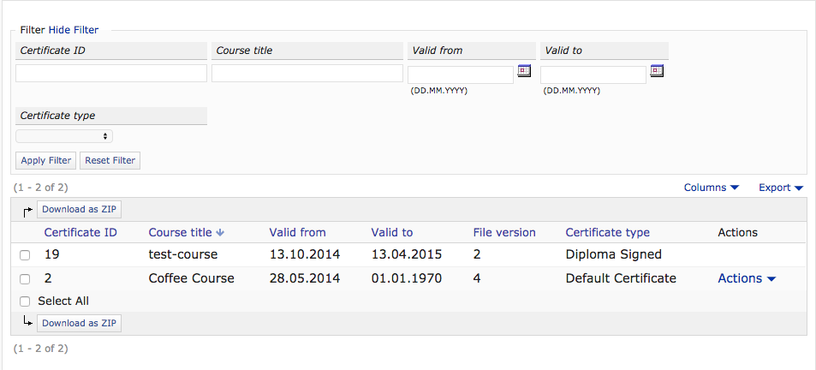

## Meaning of different certificate status

A certificate object can have one of the following statuses:

|  |  |
| --- | --- |
| **Status** | **Description** |
| **DRAFT** | Initial status when the user has passed a course and a certificate is generated. Certificates with the DRAFT status are not picked up by the cronjob to generate a PDF file. The next possible status (NEW) will be set by the cronjob according to the plugin configuration setting “Time Range Certificate PDF Generation”. |
| **NEW** | Certificates with the status NEW are picked up by the cronjob, which will try to generate a PDF file. |
| **WORKING** | This status is applied if the certificate is currently being processed (PDF generation is in progress). |
| **PROCESSED** | The PDF generation was successful and a PDF file does exist. Certificates with this status are also downloadable via the user interface. |
| **FAILED** | The system failed to generate the PDF file due to any errors. |
| **CALLED BACK** | A certificate administrator can apply this status if a certificate was created by mistake. Any certificate with a CALLED BACK status is no longer downloadable (and can therefore be seen as “invalid”) |

## Jasper Reports Templates

Use the [Jaspersoft Studio](https://community.jaspersoft.com/project/jaspersoft-studio) to design your PDF layouts. A good starting point is the default template included in the plugin. You can download it by navigating to your certificate types > edit any type > click on the tab “Template” and then “Download Default Template”. The format of these templates is XML, which gets auto-generated by using the *Jaspersoft Studio* software.

### Parameters

It is important that any certificate parameter that are referenced later in the document is declared with the corresponding type in Java, otherwise the PDF can’t be rendered.

<parameter name="[[USER_FIRSTNAME]]" class="java.lang.String">

<parameter name="[[CERT_ID]]" class="java.lang.String"/>

These parameters can also be added in the GUI of the *Jaspersoft Studio*.

### Images

You can output images (jpg, png, svg) in the PDF by following these steps:

1. Upload the image as asset in the certificate type administration.
2. When editing your template, make sure that you define the parameter [[CERT_TEMPLATE_PATH]]. This placeholder contains the absolute path to the folder where the images are stored.
3. Use an *image* element with an *imageExpression*. Inside the expression, concatenate the path placeholder with the image name you want to display, like this: $P{[[CERT_TEMPLATE_PATH]]} + “/image.jpg”

Here is an example how the generated XML code looks like for raster images (jpg, png):

<image>  
 <reportElement x="380" y="0" width="175" height="100"/>  
 <imageExpression><![CDATA[$P{[[CERT_TEMPLATE_PATH]]} + "/image.jpg"]]></imageExpression>  
</image>

Vector images (svg) need another *imageExpression* so that they are displayed in the PDF:

<image>  
 <reportElement x="380" y="0" width="175" height="100"/>  
 <imageExpression class="net.sf.jasperreports.engine.JRRenderable"><![CDATA[net.sf.jasperreports.renderers.BatikRenderer.getInstance(new java.io.File($P{[[CERT_TEMPLATE_PATH]]} + "/image.svg"))]]></imageExpression>  
</image>

### Signatures

If the certificate definition has selected a signature, additional placeholders are available in the template (see Section 3.2.6). Don’t forget to define the desired signature placeholders you want to display. The signature image can be displayed with the following code:

<image>  
 <reportElement x="50" y="50" width="175" height="100"/>  
 <imageExpression><![CDATA[$P{[[SIGNATURE_IMAGE]]}]]></imageExpression>  
</image>

As mentioned above, for vector images, the *imageExpression* needs to be changed.