INDIRA GANDHI NATIONAL OPEN UNIVERSITY
School of Management Studies • Commerce Discipline

Impact of Goods and Services Tax (GST) on Small and Medium Enterprises in India
MCOP-001: PROJECT
MASTER OF COMMERCE (M.COM)


GST in the everyday life of a small enterprise
Original schematic illustration prepared for this report; not a photograph of a studied business.
Submitted by: KAJAL
Enrolment number: 2500784584
Study Centre: 38045 • Regional Centre: 38, Delhi-3, Naraina
Guide / Supervisor: __________________________________
Submission month and year: __________________________
Secondary-data study • Core statistical period: FY 2017–18 to FY 2024–25 • Selected policy and published-survey updates through September 2026.

Certificate of originality

Unsigned template for review and completion
This page is provided for completion only after the student and supervisor have reviewed the report, verified the research and confirmed the declaration. It is not a signed certificate and does not establish synopsis approval.
This is to certify that the project titled “Impact of Goods and Services Tax (GST) on Small and Medium Enterprises in India” is the original work of the student and is submitted in partial fulfilment of the requirements for the award of the Master of Commerce degree of Indira Gandhi National Open University.
The report has not been submitted earlier to this University or to any other university or institution for the fulfilment of the requirements of a course of study.

Name of student: KAJAL
Enrolment number: 2500784584
Signature of student: ___________________________________
Place and date: ________________________________________

Name of supervisor: ____________________________________
Signature of supervisor: _________________________________
Place and date: ________________________________________
Format adapted from the MCOP-001 manual, Annexure II. The published annexure contains an apparent “Business Administration” programme-name inconsistency; this template uses M.Com. Confirm the certificate format accepted by the Regional Centre before signing. Retain any required disclosure of assistance under applicable university policy.

Acknowledgement and document note

Acknowledgement
This report draws on publications of the Ministry of MSME, the GST Council, GSTN, RBI, the Department of Economic Affairs and the other institutions cited. Their work makes it possible to examine taxation from administrative and business perspectives. Research and published surveys are used with attribution.
Personal acknowledgements may be added after the supervisor’s and other contributors’ actual assistance has been confirmed. No interviews or business visits are claimed.

Reading the report
The title, objectives and five chapters follow the supplied synopsis. The study uses secondary information. Appendices record published data, sources and calculations. Survey findings are attributed to the original investigators; no respondent-level answers are invented.
Monetary examples are expressed in Indian rupees. One lakh equals 100,000 and one crore equals 10 million. Unless stated otherwise, a financial year runs from April to March. Tables distinguish official observations, calculations from those observations and hypothetical teaching examples.

Items awaiting authentic completion
The guide’s name, submission session, approved proposal number, approval documents and signatures were not supplied. The submission assembly checklist on page 76 identifies the documents still needed. This report should be reviewed and personalised before certification or submission.

Abstract
Goods and Services Tax changed how Indian businesses document sales, claim purchase credit and organise transactions across state boundaries. For a small enterprise, invoice quality, supplier conduct and customer-payment timing can matter as much as the headline tax rate. This project examines these mechanisms and their implications for small and medium enterprises in India.
The descriptive and analytical study follows the synopsis’s secondary-data method. It combines official statistics, legislation, administrative guidance, research and published survey findings. The main statistical discussion covers the post-GST period through FY 2024–25. Later policy and survey developments are identified separately. No primary survey was conducted.
The analysis finds that a wider credit chain and more consistent transaction records can support formal supply relationships and operational discipline. These potential gains are conditional on credit eligibility, timely documentation and a firm’s capacity to manage compliance. Fixed administrative costs can weigh more heavily on smaller turnover, while differences between payment, credit availability and cash collection create liquidity pressures. National revenue growth and favourable industry sentiment do not, by themselves, establish an improvement in SME profitability.
The report recommends better invoice controls, reconciliation, cash forecasting and accessible administrative support. It concludes that GST produces different opportunities and burdens across business types. The absence of a representative SME-level dataset limits conclusions about causal effects on financial performance.
Keywords: Goods and Services Tax; SMEs; MSMEs; input tax credit; compliance costs; working capital; secondary research.

Table of contents — I
Preliminary pages | Page
Cover page | 1
Certificate of originality — unsigned template | 2
Acknowledgement and document note | 3
Abstract | 4
Table of contents | 5–6
Lists of figures and tables | 7–8
Abbreviations and conventions | 9
Chapter 1 — Introduction | 10–21
1.1 Background and research problem | 10
1.2 The enterprise behind the tax return | 11
1.3 GST’s institutional structure | 12
1.4 Input tax credit and value addition | 13
1.5 Defining SMEs and MSMEs | 14
1.6 Economic relevance and statistical boundaries | 15
1.7 Rationale of the study | 16
1.8 Objectives and research questions | 17
1.9 Scope and time boundaries | 18
1.10 Conceptual framework | 19
1.11 Stakeholders and practical significance | 20
1.12 Organisation of the report | 21
Chapter 2 — Review of Literature | 22–31
2.1 Review approach and source quality | 22
2.2 Tax design and the credit chain | 23
2.3 Evidence on revenue performance | 24
2.4 Compliance costs and firm size | 25
2.5 Transition, credit and liquidity | 26
2.6 Published industry surveys | 27
2.7 Technology and administrative guidance | 28
2.8 Comparative literature matrix | 29
2.9 Synthesis and unresolved questions | 30
2.10 Research gap and analytical propositions | 31

Table of contents — II
Chapter / section | Page
Chapter 3 — Research Methodology | 32–39
3.1 Research design and unit of analysis | 32
3.2 Selection of documentary evidence | 33
3.3 Collection and extraction procedure | 34
3.4 Operational definitions | 35
3.5 Analytical techniques | 36
3.6 Reliability, validity and comparability | 37
3.7 Research integrity and secondary survey evidence | 38
3.8 Limitations and research boundaries | 39
Chapter 4 — Analysis of Impact of GST on SMEs | 40–62
4.1 Reading the evidence | 40
4.2 Gross and net GST collections | 41
4.3 Why revenue is not a profitability measure | 42
4.4 MSME economic contribution | 43
4.5 Export-related evidence | 44
4.6 Compliance activities and costs | 45
4.7 Fixed costs and business scale | 46
4.8 Digital records and e-invoicing | 47
4.9 Input tax credit: worked example | 48
4.10 Supplier risk and reconciliation | 49
4.11 Working-capital timing | 50
4.12 Financing-cost sensitivity | 51
4.13 Pricing and commercial incidence | 52
4.14 Interstate trade and logistics | 53
4.15 Formalisation and access to finance | 54
4.16 Composition and QRMP trade-offs | 55
4.17 Manufacturing, trading and services | 56
4.18 Small exporters and refund timing | 57
4.19 Published survey responses | 58
4.20 Post-period policy and survey update | 59
4.21 Illustrative enterprise scenarios | 60
4.22 Risk and control framework | 61
4.23 Integrated assessment | 62
Chapter 5 — Findings, Suggestions and Conclusion | 63–68
5.1 Findings; 5.2 Recommendations; 5.3 Implementation | 63–65
5.4 Implications; 5.5 Limitations; 5.6 Conclusion | 66–68
References | 69–71
Appendix A — Secondary-data source register | 72–73
Appendix B — Data and calculation audit | 74–75
Appendix C — Submission assembly checklist | 76

List of figures
Figure | Title | Page
Cover illustration | Production, records and market | 1
1.1 | Simplified GST structure | 12
1.2 | The invoice and credit chain | 13
1.3 | Conceptual framework of SME outcomes | 19
3.1 | Documentary research workflow | 34
4.1 | Gross GST collections: two-year comparison | 41
4.2 | MSME GVA as a share of all-India GDP | 43
4.3 | MSME-related products’ export share | 44
4.4 | Illustrative fixed compliance-cost intensity | 46
4.5 | A possible working-capital timing gap | 50
4.6 | Illustrative financing cost by delay | 51
4.7 | Published positive GST sentiment | 58
4.8 | A practical invoice-control cycle | 61

The figures are original drawings or charts prepared for this report. Statistical charts identify their underlying source; conceptual diagrams do not represent measured relationships. The factory, computer and shop illustration is schematic and is not evidence of a site visit.
Figures are intentionally limited to those that clarify an argument. Decorative stock photographs of factories or entrepreneurs would not establish anything about the firms covered by the study. The visual emphasis is therefore on transaction flows, official data and transparent calculations.
The numerical labels in charts retain the units stated in their captions. Where a bar chart compares percentages, the bars do not represent business counts. Where a chart uses a hypothetical cost, it describes an assumed scenario rather than an observed industry average.

List of tables
Table | Title | Page
1.1 | Enterprise classification: historical and revised ceilings | 14
1.2 | Objectives and associated research questions | 17
1.3 | Stakeholder uses of the study | 20
2.1 | Comparative literature and evidence matrix | 29
3.1 | Source inclusion and exclusion rules | 33
3.2 | Variables and operational definitions | 35
3.3 | Analytical tools and limits | 36
4.1 | Annual gross revenue, refunds and net revenue | 41
4.2 | Compliance work at enterprise level | 45
4.3 | Illustrative credit-chain calculation | 48
4.4 | Illustrative invoice exception register | 49
4.5 | Illustrative financing-cost sensitivity | 51
4.6 | Two pricing cases | 52
4.7 | Regular, QRMP and composition comparison | 55
4.8 | Sector-specific mechanisms | 56
4.9 | Hypothetical enterprise profiles | 60
4.10 | Evidence and inference by objective | 62
5.1 | Implementation responsibility and indicators | 65
A.1 | Source register: official and administrative evidence | 72
A.2 | Source register: research and published surveys | 73
B.1 | Extracted observations and verification notes | 74
B.2 | Derived measures and calculation audit | 75
C.1 | Submission document status | 76

Table numbers follow chapter numbers. Appendix tables preserve the secondary-data trail; they are not a record of primary fieldwork.

Abbreviations and conventions
Abbreviation | Meaning
AATO | Aggregate annual turnover
B2B / B2C | Business-to-business / business-to-consumer
CBIC | Central Board of Indirect Taxes and Customs
CGST / SGST | Central GST / State GST
FY | Financial year
GDP / GVA | Gross domestic product / gross value added
GST / GSTIN | Goods and Services Tax / GST identification number
GSTN | Goods and Services Tax Network
IGST / UTGST | Integrated GST / Union Territory GST
IRN | Invoice reference number
ITC | Input tax credit
MSME / SME | Micro, small and medium enterprise / small and medium enterprise
NIPFP | National Institute of Public Finance and Policy
QRMP | Quarterly Return Monthly Payment
RBI | Reserve Bank of India
UAP | Udyam Assist Platform

The title uses “SMEs”, as in the synopsis. Official aggregate data frequently cover “MSMEs”, including micro enterprises; this wider population is identified whenever such data are used. GST registration is a tax status and is not equivalent to Udyam registration or an enterprise-size classification.
“Impact” is used to describe documented mechanisms and reported experiences. It should not be read as a statistically identified causal effect. “Illustrative” and “hypothetical” always indicate assumptions prepared for explanation, not observations collected from businesses.

Chapter 1 — Introduction

1.1 Background and research problem
India introduced GST on 1 July 2017, bringing several central and state indirect taxes into a coordinated system. Its broad design links taxation of supplies with credit for eligible tax paid on purchases. The reform matters to commerce because a tax system influences documentation, contracting and transaction costs, as well as the amount ultimately paid to government. The GST Council’s institutional framework provides the background for understanding this change (GST Council, n.d.).
For a small business, the practical issue is rarely confined to the headline rate. An owner must decide who will keep records, whether a purchase invoice is correct, how exceptions will be resolved and whether the bank balance will cover the next payment. A system that reduces one form of complexity can introduce another. The research problem is therefore to understand how simplification at the level of tax design translates into the daily operations of enterprises with limited resources.
The supplied synopsis proposes a balanced examination of benefits and challenges. This report retains that purpose. It asks how the credit chain, digital administration and a more integrated market affect compliance effort, cash management and business relationships. It also asks which conclusions can reasonably be drawn from published evidence and which would require enterprise-level fieldwork.
The central argument is conditional: GST can improve the quality and portability of transaction information, but the business value of that improvement depends on the firm’s customers, suppliers, capabilities and financing position. A common legal framework does not imply an identical economic experience for every enterprise.

1.2 The enterprise behind the tax return
A small manufacturer may buy materials from several suppliers, process them over a fortnight and sell the finished goods on credit. A trader may turn stock rapidly but earn a thin margin on each sale. A consultant may have few taxable purchases and a large wage bill. These businesses can have similar turnover while facing very different credit opportunities and cash requirements. Turnover is useful for classification, but it does not describe the full operating model.
The owner’s time is another scarce resource. Preparing a return may involve collecting information from a bookkeeper, correcting a customer’s details and locating a missing purchase invoice. Even when an accountant submits the form, these tasks remain inside the enterprise. The relevant economic cost includes the resources required to produce accurate information, rather than only the professional fee shown on an invoice.
Customer composition changes the commercial consequences of taxation. A registered purchaser who can use an eligible credit may evaluate an offer differently from a household buying at a tax-inclusive price. Supplier composition matters too: timely and accurate documentation can influence how smoothly a purchaser manages its records and credit position. This creates a link between tax administration and ordinary commercial selection.
The report therefore uses enterprise characteristics as analytical lenses: scale, sector, B2B or B2C orientation, accounting capability, payment terms and exposure to exports or interstate trade. These are not measured explanatory variables in a regression. They organise the reasoning and help prevent a broad claim about “small businesses” from concealing differences that are central to the question being studied.

1.3 GST’s institutional structure
GST operates within India’s federal structure. In a simplified domestic example, an intra-state taxable supply attracts central and state components, while an interstate supply attracts integrated GST. Union Territory arrangements and special cases require attention to the relevant legislation. The GST Council makes recommendations within this framework; applicable legal instruments determine the operative requirements (GST Council, n.d.).
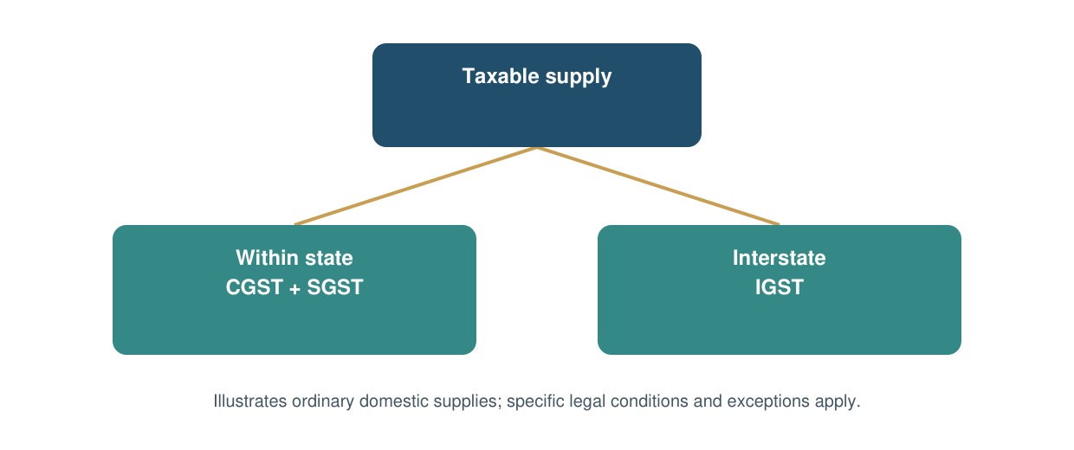
Figure 1.1. Simplified GST structure for ordinary domestic supplies.
Source: Original schematic based on the GST Council’s institutional description. Not an exhaustive legal decision tree.
For the enterprise, identifying the transaction correctly comes before calculating the tax. A business needs accurate information about the supply, the parties and the relevant place-of-supply treatment. An error at this stage can affect an invoice and later require correction. The administrative burden is therefore partly a data-quality problem.
The diagram is deliberately limited. It explains the distinction between common transaction categories, not every rule governing imports, exports, mixed supplies, reverse charge or exempt transactions. Those categories can alter the analysis. A research report should avoid converting a broad conceptual picture into advice that a firm could apply to every invoice without checking its circumstances.

1.4 Input tax credit and value addition
Input tax credit is central to the economic logic of GST. Section 16 of the Central Goods and Services Tax Act establishes entitlement subject to conditions and restrictions; section 17 also affects eligibility and apportionment. The relevant question is whether a particular credit is legally available and usable, not merely whether tax appears on a purchase invoice (CBIC, n.d.-a).
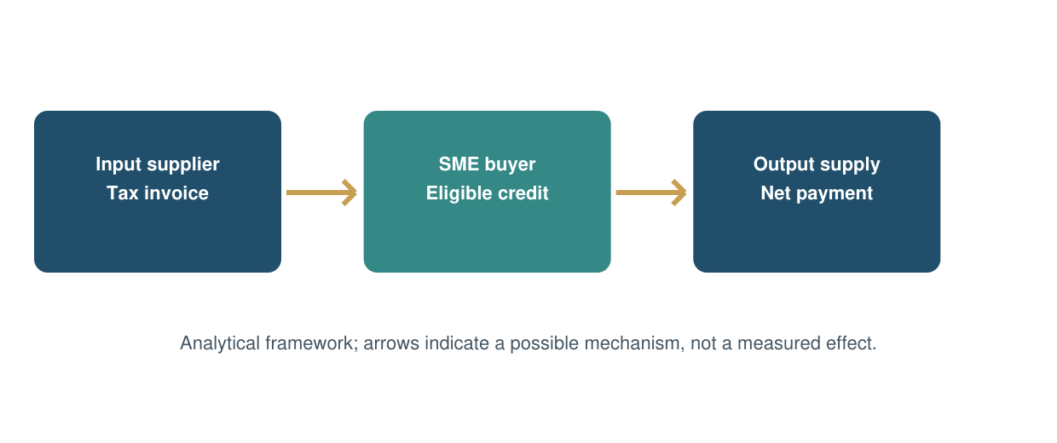
Figure 1.2. The invoice and credit chain.
Source: Original conceptual diagram. Credit is conditional; the diagram does not imply automatic or universal entitlement.
Consider the difference between a tax cost and a temporary cash outflow. If eligible input tax can be used against an output liability, it need not remain a permanent expense. However, the business may still experience a timing difference between paying its supplier and obtaining usable credit. If the credit is ineligible, the economic consequences can be different. These situations should not be merged into a single claim that GST always increases or always reduces costs.
The worked example in Chapter 4 separates output tax, eligible credit and cash payment. It holds the assumed rate constant so the arithmetic is easy to follow. Its purpose is to explain a mechanism, not to recreate the exact pre-GST tax treatment of a real product. That distinction avoids a misleading comparison between a simplified model and a complicated historical system.

1.5 Defining SMEs and MSMEs
Official enterprise classifications changed during the wider period discussed in this report. Historical data must be interpreted using the definitions applicable when they were compiled. From 1 April 2025, the investment and turnover ceilings were revised. Both dimensions are relevant; classification is not based on turnover alone (RBI, 2020; Ministry of MSME, 2026).
Table 1.1. Enterprise classification: investment / turnover ceilings, in Rs crore.
Category | From July 2020 to March 2025 | From April 2025
Micro | 1 / 5 | 2.5 / 10
Small | 10 / 50 | 25 / 100
Medium | 50 / 250 | 125 / 500

Sources: RBI (2020), revised classification circular; Ministry of MSME (2026), Annual Report 2025–26, section 1.2.4. Investment means plant and machinery or equipment; the table summarises ceilings and does not replace detailed classification rules.
A change in a category boundary can move an enterprise into a different group even when its physical production has not changed. This creates a comparability problem: an increase in the number of firms labelled “small” may partly reflect reclassification. A sound analysis should not automatically interpret such an increase as business formation or growth caused by GST.
The synopsis uses the broader everyday expression “SMEs”. Because much of the available official evidence covers MSMEs, this report includes micro enterprises when discussing aggregate data. It does not relabel an MSME statistic as a statistic for small and medium enterprises alone. Likewise, a tax registration is not assumed to represent one unique enterprise, because administrative registration units and economic enterprises need not coincide.

1.6 Economic relevance and statistical boundaries
The Ministry of MSME publishes information about the sector’s economic contribution, administrative registrations and support programmes. These categories answer different questions. A contribution to national output concerns economic activity, while an administrative registration series records participation in a particular system. The Annual Report is used as institutional context, with specific numerical series identified separately in Chapter 4 (Ministry of MSME, 2025).
This distinction matters because a report can appear precise while comparing incompatible denominators. A share of export value cannot be added to a share of GDP. An employment count reported by registered units cannot be assumed to be a fresh labour-force survey. A total that includes micro enterprises cannot be treated as if it describes only medium-sized manufacturers. Precision in labelling is part of the research method, not a presentation detail.
The role of small enterprises can also be explained without relying on a single headline percentage. They connect larger producers to local suppliers, distribute goods near consumers and provide specialised services. Their operating decisions can transmit a change in taxation along a supply chain. A purchaser’s request for complete documentation may affect a supplier’s processes even when the supplier did not initiate the change.
The sector’s importance therefore provides the rationale for investigating GST, but it does not predetermine the result. Economic significance is not evidence that a particular reform has improved business performance. The report first establishes the population and the mechanism, then evaluates the available evidence. This order is especially useful when policy debate combines national aggregates with individual experiences.

1.7 Rationale of the study
Taxation is often discussed through rates and revenue. Enterprise owners experience it through tasks, deadlines and cash decisions. The gap between these perspectives provides the rationale for the study. A reform can meet an administrative objective while leaving a group of firms with difficult adjustment costs. Conversely, a short-term compliance burden may coexist with a longer-term improvement in record quality or customer access. Both possibilities deserve examination.
The topic is relevant to commerce because it combines accounting, finance, operations and business policy. Invoice design is an accounting matter; the funding of tax-related timing gaps is a finance matter; movement and delivery are operational matters; and the design of proportionate procedures is a policy matter. Treating these as connected allows a more useful discussion than listing advantages and disadvantages without explaining how they arise.
A second reason is the risk of overgeneralisation in published commentary. A rise in collections may be interpreted as success for taxpayers, while a complaint about a delayed credit may be treated as proof of universal harm. Neither inference follows automatically. This study examines the distance between an observation and the claim made from it. That approach is particularly appropriate to a secondary-data project with no representative original survey.
Finally, the research has a practical purpose. Its recommendations should be understandable to a small business and proportionate to its resources. Suggestions such as assigning invoice responsibility, tracking unresolved exceptions and forecasting cash needs are evaluated in terms of how they address an identified mechanism. The report avoids assuming that buying more software or adding more paperwork will necessarily solve an operational problem.

1.8 Objectives and research questions
The five objectives below preserve the substance of the synopsis. Each is linked to a question that can be addressed through documentary analysis rather than through invented field observations.
Table 1.2. Objectives and associated research questions.
Objective | Research question
1. Understand GST’s concept, structure and features | How do the tax structure, credit chain and digital processes operate?
2. Examine the role and importance of SMEs | What do official MSME indicators establish, and what do they leave unmeasured?
3. Analyse effects on enterprise functioning | Through which channels can GST affect records, costs, liquidity and trade?
4. Identify advantages and challenges | How do opportunities and burdens differ by firm type and capability?
5. Suggest improvements | Which business practices and administrative measures address the identified problems?

The wording remains neutral. The project does not begin with an assumption that GST is either wholly beneficial or wholly harmful. Instead, it identifies conditions under which a particular mechanism is likely to matter. For example, the value of purchase credit depends on the composition of inputs and the relevant rules, while the burden of a fixed fee depends on the scale over which it is spread.
The objectives also determine the limits of the conclusion. Documentary evidence can explain a mechanism and report a published trend. It cannot establish an average causal change in SME profits without suitable enterprise-level evidence and a defensible comparison. Chapter 5 answers each objective within that boundary and identifies questions for further research.

1.9 Scope and time boundaries
The geographical scope is India. Delhi-3 is the student’s Regional Centre, not the location of a claimed field sample. No local visits, interviews or observations are inferred from the student’s address or study-centre details. Sectoral discussion covers manufacturing, trading and services because their input structures and transaction patterns differ in ways that are relevant to GST.
The core statistical window extends from the introduction of GST through FY 2024–25, subject to the years actually available in each source. A longer historical discussion does not mean every indicator is available for every year. The MSME contribution series ends earlier than the GST collection comparison. These different end dates are retained visibly rather than filled with estimates that the source did not publish.
Selected later developments are discussed separately. These include the revised MSME classification effective in April 2025, the September 2025 GST rate-reform announcement and a published 2026 industry survey. The later material updates the context; it is not mixed into the earlier statistical series as if the entire period used one unchanged framework.
The subject scope is operational and financial. The report considers compliance resources, tax-credit management, payment timing, pricing, supply relationships and formal records. It does not attempt a product-by-product tax classification, a legal opinion on an individual dispute or a macroeconomic estimate of the reform’s total welfare effect. These exclusions keep the analysis connected to the synopsis and make its evidential limits explicit.

1.10 Conceptual framework
The conceptual framework treats GST as a set of institutional changes whose effects pass through enterprise capabilities. The same requirement may be manageable for a business with organised records and difficult for a business that depends on a single overextended owner. The framework therefore separates the rule from the capacity needed to implement it.
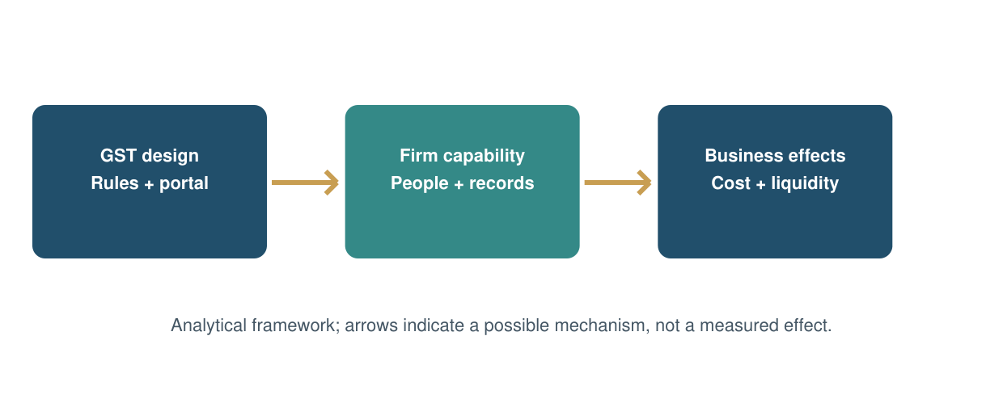
Figure 1.3. Conceptual framework of SME outcomes.
Source: Original analytical framework developed for this project; it is not an estimated causal model.
Three groups of outcomes are considered. Administrative outcomes concern effort, errors and compliance routines. Financial outcomes concern eligible credit, cash timing and the cost of funding a gap. Commercial outcomes concern pricing, supplier relationships and access to customers. These outcomes can move in different directions: better records may be accompanied by higher visible professional fees, for example.
External influences sit around the framework. Demand, inflation, credit conditions, technology adoption and shocks such as the pandemic can alter business performance independently of GST. The report therefore avoids attributing every post-2017 change to the tax reform. Its approach is to ask whether a proposed mechanism is plausible, whether a source documents it and whether the evidence supports the strength of the conclusion being drawn.

1.11 Stakeholders and practical significance
The study is intended to be useful to more than one reader. A student needs a coherent research argument, an enterprise needs a practical interpretation, and an administrator needs to understand where procedural design can impose disproportionate effort. These uses overlap, but they are not identical.
Table 1.3. Stakeholder uses of the study.
Stakeholder | Relevant use | Necessary caution
SME owner or manager | Identify record, cash and supplier-control priorities | Adapt to the firm’s actual transactions
Accountant or adviser | Explain the difference between credit, cost and cash | Verify legal eligibility separately
Policy or administrative body | Consider proportionate support and clearer processes | Do not generalise from illustrative cases
Student or researcher | Use a transparent framework and source trail | Distinguish description from causation
Lender or commercial buyer | Understand the potential value of reliable records | Registration alone is not evidence of creditworthiness

For an enterprise, a useful finding is one that changes a decision. Knowing that an invoice exception remains unresolved is more actionable than a general statement that digitalisation is beneficial. Likewise, a cash forecast that distinguishes tax-related requirements from payroll and inventory commitments can identify when a funding problem will arise.
For policy analysis, the emphasis is on the design of the process. An apparently small information request can become costly when repeated across transactions or when instructions are unclear. The report’s recommendations therefore consider the number of hand-offs, the clarity of responsibility and the predictability of resolution. It does not treat lower scrutiny as the only possible route to a lower compliance burden.

1.12 Organisation of the report
Chapter 1 establishes the problem, scope and objectives. It defines the enterprise population carefully and explains why GST should be studied through operational mechanisms as well as aggregate statistics. The chapter’s conceptual framework provides the link between the tax system, firm capabilities and business outcomes.
Chapter 2 reviews the evidence base. It distinguishes research on tax design and national revenue from material on compliance, financing and reported business experience. It also explains why policy guidance and a survey response are different kinds of evidence. The literature review ends with the questions that remain unresolved and the propositions used to organise the analysis.
Chapter 3 describes the secondary-data method. It records selection rules, operational definitions, analytical techniques and quality checks. It explains why there is no respondent sample for this study and why no significance test is reported. The appendices record source definitions and calculations, including the limits of published survey evidence.
Chapter 4 contains the substantive analysis. Official indicators provide context, while worked examples make the compliance-cost, credit and liquidity mechanisms explicit. Published survey responses are attributed to their original investigators. Sector comparisons and hypothetical cases explore how the same framework can produce different practical experiences.
Chapter 5 brings the evidence back to the five objectives. It presents findings, practical suggestions, implementation responsibilities, implications and limitations before drawing the conclusion. References and appendices complete the report. Together, these elements follow the structure of the supplied synopsis while incorporating the results-and-discussion, implications and referencing elements identified in the MCOP-001 manual.

Chapter 2 — Review of Literature

2.1 Review approach and source quality
The literature review is organised by the question a source can answer. Conceptual research explains the design of a tax system; fiscal research studies revenue performance; administrative guidance describes procedures; and surveys record the views of the respondents reached by their investigators. None of these categories can substitute automatically for the others. Their value depends on the claim being examined.
The supplied synopsis names several journal articles, but complete and reliable publication records were not established for four of those items during preparation. They are therefore not relied upon as verified evidence in this report. The identifiable 2009 paper has been cited using its verified authorship and institutional publisher: Poddar and Ahmad, Department of Economic Affairs. This corrects the attribution in the synopsis without changing the project’s objectives.
The review gives priority to materials available from the original institution. It uses the official text of legislation for the credit framework, GSTN material for return procedures, government releases for statistical observations and original research publications for analytical findings. Published industry surveys are attributed to their authors and identified as secondary evidence for this project.
This is a structured narrative review, not a claimed exhaustive systematic review. No fabricated screening count or database search total is reported. The purpose is to build an auditable argument from a focused body of relevant sources. Where a source has a limited population or an earlier reference period, that limitation travels with the finding rather than disappearing when the finding enters the report.

2.2 Tax design and the credit chain
Poddar and Ahmad (2009) examine GST reform and intergovernmental considerations in India. Their discussion provides a pre-implementation perspective on problems such as cascading and the relationship between the tax base and federal arrangements. The paper is useful for understanding reform objectives; it cannot be evidence of outcomes experienced by SMEs after 2017, because it predates implementation.
The distinction between an expected mechanism and an observed result is essential. A design may permit a more continuous credit chain, but the extent to which a firm benefits depends on its transactions and the conditions governing eligibility. The present report uses the earlier paper as a conceptual starting point and tests its relevance against later administrative and statistical material. It does not describe its expectations as measured achievements.
From an enterprise perspective, the credit-chain argument suggests three separate questions. Does the firm incur tax on purchases that can be eligible for credit? Can it document and use that credit appropriately? Does the resulting commercial advantage remain with the firm or pass to customers through prices? Answering only the first question would overstate the benefit available to the enterprise.
The literature also encourages a distinction between a broad-based tax and a single uniform outcome. A coordinated system can contain different rates, exemptions and procedural requirements. For business analysis, the relevant comparison is often between the effective treatment of a specific supply chain before and after a change. Such a comparison requires more detailed evidence than a national reform narrative can provide.

2.3 Evidence on revenue performance
Mukherjee (2023), in NIPFP Working Paper 392, compares pre- and post-GST revenue streams and studies revenue performance, collection efficiency and related gaps. The paper reports improvement in tax buoyancy while drawing attention to the care needed in comparing tax-to-GDP measures. It also treats economic disruption and the composition of revenue as relevant to interpretation. These are fiscal findings, not estimates of the return earned by an individual enterprise.
The main lesson for this project is methodological. Comparing monetary totals across time requires attention to prices, the tax base and the scope of the measure. A gross collection series includes amounts that may subsequently be refunded. A series including taxes on imports describes a broader base than domestic collections alone. Failure to distinguish these categories can create a convincing chart with an unclear economic meaning.
The present study accordingly uses a tightly defined two-year official comparison rather than combining partially comparable numbers from multiple summaries. It shows gross revenue, refunds and net revenue together. Its discussion asks what the movements establish about the aggregate tax system and why they cannot identify the distribution of costs and benefits across SMEs.
A further implication is that national fiscal improvement and enterprise difficulty can coexist. Higher aggregate revenue does not disprove a small exporter’s liquidity problem, just as a particular firm’s difficulty does not establish that the tax system is failing nationally. The appropriate unit of analysis must remain visible. Chapter 4 uses this distinction when moving from official collection data to the enterprise-level mechanisms discussed in the synopsis.

2.4 Compliance costs and firm size
Mukherjee and Badola (2022) examine VAT compliance costs of unincorporated enterprises using pre-GST NSSO data for 2015–16. Their work is relevant to measurement: it identifies the difficulty of separating ordinary business expenses from tax-compliance expenses. It also notes incomplete coverage of costs and potential offsetting benefits. Because the underlying data precede GST, the study must not be presented as an estimate of current GST compliance costs.
For this project, the important question is how a cost should be classified. An accounting package may serve stock control, customer billing and tax reporting at the same time. Allocating its entire subscription price to GST would overstate the incremental tax burden. Allocating none of it would miss the resources needed for compliance. A defensible estimate needs an explicit allocation rule.
The same issue applies to labour. A salaried employee may spend only part of the month on tax work. An owner may perform that work without recording any wage expense. Cash expenditure and economic cost are therefore different measures. A study that reports only accountant fees may be useful, but it is not measuring the complete resource burden.
The report uses a hypothetical fixed-cost calculation to explain scale effects without claiming an observed average. The calculation holds annual cost constant and changes turnover. It shows why identical expenditure can represent a much larger share of sales for a smaller firm. This arithmetic supports an analytical proposition about proportional burden; it does not estimate how much Indian SMEs actually spend or how that spending changed after GST.

2.5 Transition, credit and liquidity
The Reserve Bank of India’s February 2018 circular provided specified relief for qualifying MSME borrowers registered under GST. The circular is evidence of an institutional response during the transition period, subject to its stated conditions. It is not a current blanket relaxation and is not used here to infer that every MSME experienced financial distress (RBI, 2018).
Transition evidence needs to be read in time. A business learning a new process may incur conversion costs that later diminish, while recurring reconciliation tasks may persist. The first year of implementation can therefore be a poor estimate of mature-system costs. Conversely, later stability should not be used to deny that adjustment costs were real when firms encountered them.
Liquidity analysis also requires precision. A tax-related cash gap may arise from the timing of receivables, input credit or refunds. Ordinary slow-moving inventory and customer default can create similar pressure. A report must identify the additional mechanism it attributes to GST rather than assigning the firm’s entire working-capital requirement to taxation.
This study addresses that problem through an explicitly assumed financing example. The example begins with a specified amount and delay, then calculates the cost at an assumed annual interest rate. It demonstrates how timing matters without claiming to measure national losses. The result is interpreted as a sensitivity calculation: a longer delay raises financing cost when all other assumptions remain unchanged. The actual effect on a firm would depend on its credit terms, cash balances and ability to borrow.

2.6 Published industry surveys
Deloitte’s GST@8 publication reports a survey of 963 responses across eight industries from senior executives. Its published summary states that 85% of respondents held a positive view of GST in 2025, compared with reported positive sentiment of 59% in 2022, 72% in 2023 and 84% in 2024. These are findings of the original survey, used here as secondary information (Deloitte, 2025a).
The survey provides a useful form of evidence: reported experience can reveal whether businesses value a process and which changes they seek. It is different from an official tax collection series because its measurement concerns opinion rather than revenue. It is also different from a financial-statement analysis because a positive assessment does not quantify the respondent’s profit or cash flow.
The interpretation must respect coverage. Senior executives participating in an industry survey are not automatically representative of all owner-managed micro enterprises in India. Without a probability sampling framework and appropriate weights, the overall result cannot be converted into a national SME approval rate. Likewise, an overall percentage should not be attributed to the MSME subgroup unless that subgroup result is separately reported.
The year-to-year comparison has another boundary. Published results from successive editions may involve different respondents and composition. A rising percentage does not establish that the same firms became more positive. Chapter 4 presents the reported series with this qualification and uses it alongside administrative and conceptual evidence. The value lies in triangulation, not in treating one survey percentage as a verdict on the reform.

2.7 Technology and administrative guidance
GSTN’s QRMP guidance explains an arrangement under which eligible taxpayers can file specified returns quarterly while making monthly tax payments. The official guidance identifies a turnover ceiling of Rs 5 crore and other conditions. It is a concrete example of administrative differentiation intended to make the process more manageable for eligible taxpayers (GSTN, n.d.).
Guidance establishes what a scheme is designed to do; it does not prove the number of hours it saves. A taxpayer still needs sufficiently current information to determine obligations and support customer-facing records. The analytical question is therefore whether the scheme reduces the frequency of a specific filing task, the total workload, or both. These should not be assumed to be identical.
Notification 10/2023-Central Tax extended the e-invoicing threshold to aggregate turnover exceeding Rs 5 crore from 1 August 2023, subject to the applicable framework. This helps correct the synopsis’s broad wording that might imply all SMEs must generate statutory e-invoices. The requirement is threshold- and category-dependent (CBIC, 2023).
Technology can improve consistency when it removes duplicate entry or highlights exceptions. It can also expose weak master data more quickly. A wrong customer identifier copied automatically into several systems is still wrong. The report therefore treats digital capability as a combination of usable tools, trained people and clear review responsibility. Software adoption alone is not used as evidence of accurate compliance or higher productivity. The relevant outcome is whether reliable information reaches the right process at the right time.

2.8 Comparative literature matrix
Table 2.1. Comparative literature and evidence matrix.
Source | Evidence / contribution | Boundary for this project
Poddar & Ahmad (2009) | Conceptual design and federal considerations | Predates implementation; not SME outcome data
Mukherjee (2023) | Analysis of GST revenue performance | Aggregate fiscal outcomes, not firm profitability
Mukherjee & Badola (2022) | Compliance-cost measurement using pre-GST data | VAT period; not a current GST cost estimate
RBI (2018) | Historical transition-related borrower relief | Conditional circular; not a representative survey
GSTN (2025) | Official gross collections, refunds and net revenue | Provisional national administrative totals
Ministry of MSME (2024) | Output and export-related indicators | MSME population / product coverage, not SME-only effects
Deloitte (2025a, 2025b) | Published business sentiment and priorities | Survey coverage and subgroup denominators matter
CBIC (2023); GSTN (n.d.) | E-invoicing and QRMP requirements | Describe procedures, not measured business gains

The matrix separates contribution from limitation. A limitation does not make a source useless; it determines the kind of conclusion for which it can be used. In combination, the sources provide a stronger basis for discussing mechanisms than for estimating a single national effect on SME performance.
An important gap remains between institutional design and realised financial outcomes. The report addresses the gap through transparent analytical reasoning and labelled examples, while leaving empirical estimates to future research with appropriate business-level observations.

2.9 Synthesis and unresolved questions
The reviewed material supports a distinction between formal simplification and practical effort. A broader credit system can remove some discontinuities, yet each firm must still supply reliable transaction information. The amount of work depends on transaction volume, the quality of the starting records and how often exceptions arise. The report’s synthesis therefore focuses on the conditions that connect a policy feature to a business outcome.
Three unresolved questions are particularly relevant. First, how much of an enterprise’s accounting expenditure is additional tax-compliance cost? Second, how much of an observed cash shortage is caused by tax timing rather than ordinary commercial delay? Third, which firms gain access to customers because of formal records, and what other qualifications do those customers require? The sources reviewed do not provide a representative common dataset that answers all three.
The unresolved questions also explain why apparently conflicting accounts can be credible. An organised B2B supplier may value the documentation chain, while a small consumer-facing enterprise experiences mainly the administrative workload. A rapidly growing firm may absorb a fixed cost more easily than a stable low-turnover firm. Different findings may reflect different business populations rather than errors by the researchers.
The appropriate synthesis is therefore conditional and comparative. It identifies recurring mechanisms, states the circumstances under which they matter and avoids assigning a universal magnitude to them. This approach leaves room for disagreement in the evidence without treating every claim as equally reliable. A dated official statistic remains stronger evidence for a national total than an unattributed assertion, even though neither alone answers every question about business performance.

2.10 Research gap and analytical propositions
The main gap is the absence, within the evidence assembled for this project, of a representative linked dataset containing firm size, tax status, compliance expenditure, credit utilisation, payment timing and financial outcomes over comparable periods. Without that structure, it is difficult to distinguish the effect of GST from changes in demand, prices, technology or financing conditions.
The report uses four analytical propositions to organise its discussion. The first is that a fixed administrative cost will represent a larger proportion of turnover for a smaller business, all else equal. This is an arithmetic proposition. The second is that a credit mechanism is commercially useful only when the credit is eligible and operationally usable. This is a conditional accounting proposition.
The third proposition is that timing can matter independently of the final tax cost. A recoverable amount can still require financing while it remains unavailable. The fourth is that the value of formal transaction records depends on how they are used by customers, suppliers and lenders. Registration by itself does not guarantee additional sales or cheaper credit.
These propositions are not statistical hypotheses tested with primary observations in this project. They provide a clear route from the literature to the analysis and identify what future research would need to measure. Each proposition could be challenged with suitable evidence. For example, a firm-specific cost study might show that variable transaction work dominates fixed fees in a particular sector. The report’s framework is intended to accommodate such differences rather than conceal them behind a predetermined conclusion.

Chapter 3 — Research Methodology

3.1 Research design and unit of analysis
The study follows the descriptive and analytical design specified in the synopsis. The descriptive component explains GST’s structure, relevant enterprise categories and published indicators. The analytical component compares the meaning of those indicators, examines business mechanisms and develops reasoned recommendations. All research evidence comes from secondary sources.
The primary unit of analysis is the published document or statistical series. There is no respondent sample and no questionnaire administered by the student. The use of published survey results does not convert the project into primary research: the original investigators collected those responses, while this report evaluates their published findings.
The design is appropriate to the objectives because the project seeks to understand a policy framework and its implications across several dimensions. A documentary study can combine legal, statistical and research material without claiming access to confidential firm records. It can also identify gaps that would be obscured by a small convenience sample presented as nationally representative.
The design has limits. It is unable to estimate a causal average treatment effect or verify the experience of an individual enterprise. Accordingly, the language of the report distinguishes “the source reports”, “the calculation shows” and “the analysis suggests”. These phrases indicate different evidential foundations. Findings based on actual published data are kept separate from numerical examples prepared to explain a mechanism. No assumed number is entered into an official dataset, and no hypothetical case is described as a business that was visited or interviewed.

3.2 Selection of documentary evidence
Sources were selected purposively for relevance to the five objectives and for traceability to the original publisher. This is documentary sampling, not random sampling of enterprises. Inclusion depends on whether the source identifies its subject, period and measurement clearly enough to support the intended claim.
Table 3.1. Source inclusion and exclusion rules.
Include | Exclude or restrict
Official legislation and administrative guidance | Undated summaries treated as current law
Government series with defined units and periods | Unlabelled charts without an identifiable source
Identifiable original research publications | References whose publication details cannot be verified
Original publisher’s survey findings | Survey percentages with an unknown denominator
Historical material clearly labelled by period | Old rules presented as current requirements
Transparent calculations from cited inputs | Invented respondents, interviews or observed cases

A source can be included for one purpose and restricted for another. A historical circular helps explain the transition environment but does not describe today’s relief arrangements. A current classification document clarifies definitions but should not be used to reclassify an older time series without the underlying data.
The evidence set was designed to be manageable and auditable. It does not claim to include every study of GST. The final reference list records sources actually used, while the data appendices preserve key numbers and formulas. A reader can therefore retrace the main analytical steps without relying on an unspecified collection of websites or on inaccessible field notes.

3.3 Collection and extraction procedure
The documentary procedure begins with the research question, then selects an appropriate source type. Official data are used for national indicators; legislation and guidance establish the framework; research and published surveys provide analysis and reported experience. Each item is checked for the period and population to which it applies.
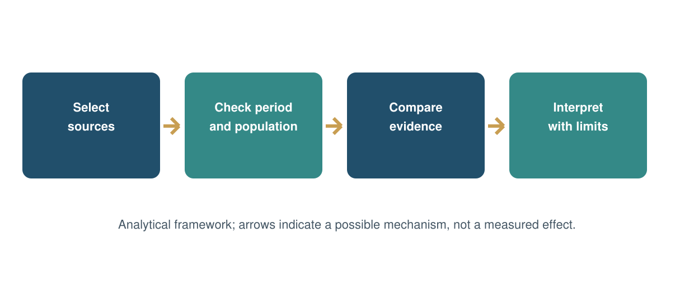
Figure 3.1. Documentary research workflow.
Source: Procedure used to organise this secondary-data project.
For numerical material, the extraction record contains the variable, value, unit, year, population and source location. Gross revenue and net revenue are stored as separate variables. A provisional flag is retained when the publisher identifies the figures as provisional. Percentage shares retain their original denominators rather than being relabelled for convenience.
After extraction, calculations are performed using the reported inputs. Derived values are marked as calculations, with the formula shown in the appendix. Rounding is applied at presentation rather than before computation. A chart uses the same numbers as its accompanying table. The final interpretive step asks whether the figure answers the research question directly or merely provides background. This prevents a descriptive statistic from becoming an unsupported claim about causation.

3.4 Operational definitions
Clear definitions are needed because terms such as burden, benefit and performance can refer to several different measurements. The project uses the following definitions to keep the analysis consistent across chapters.
Table 3.2. Variables and operational definitions.
Term | Definition used | Measurement boundary
Compliance cost | Resources used to meet tax-related information and process requirements | Distinguish cash fees from time and shared costs
Eligible ITC | Credit available under relevant legal conditions | Not every purchase tax is creditable
Cash-flow timing gap | Period in which a specified tax-related outflow precedes usable recovery or associated receipt | Not the firm’s entire working-capital need
Cost intensity | Specified annual compliance cost divided by annual turnover | Illustrative here; not an observed national ratio
Gross GST revenue | Collection before the refunds shown in the official release | National total includes defined components
Net GST revenue | Gross collection less the stated refunds | Do not compare with gross figures as if identical
Reported sentiment | Survey respondents’ published assessment | Opinion within the original survey coverage
SME performance | Operational or financial outcomes of the enterprise | No representative profit estimate is available here

These definitions reduce ambiguity in the discussion. In particular, a higher tax payment is not automatically a higher economic burden, since turnover, credits and the treatment of the transaction may have changed. Equally, a credit balance is not automatically cash available for payroll. Each measure is interpreted according to what it records and what it omits.

3.5 Analytical techniques
The project uses descriptive comparison, thematic synthesis and transparent scenario arithmetic. These techniques fit the available evidence. Statistical significance tests are not reported because the report does not possess a suitable original sample or a common micro-level dataset for estimation.
Table 3.3. Analytical tools and limits.
Tool | Application | Limit
Percentage change | Compare two annual revenue observations | Nominal change is not a causal effect
Percentage-point difference | Compare shares or sentiment percentages | Different from percentage growth
Ratio analysis | Relate an assumed fixed cost to turnover | Scenario, not an industry estimate
Sensitivity calculation | Vary delay and financing rate | Results depend on explicit assumptions
Thematic comparison | Organise compliance, liquidity and trade mechanisms | Does not establish prevalence
Triangulation | Compare sources with different evidential roles | Agreement alone does not remove shared bias

The percentage-change formula is: (new value − old value) ÷ old value × 100. A percentage-point difference is simply the newer percentage minus the older percentage. These measures answer different questions and are labelled accordingly. An increase from 20% to 25% is five percentage points, even though the relative increase is 25%.
Thematic synthesis connects evidence to an objective and identifies any missing link. A rule can establish that a procedure exists, for instance, while a time-use study would be needed to quantify its burden. The analysis explicitly records this gap rather than manufacturing an estimate to make the argument appear more complete.

3.6 Reliability, validity and comparability
Reliability concerns whether the report’s extraction and calculations can be repeated. To support it, numerical tables cite their original release, use consistent units and show calculations where needed. The same input data feed the text and charts. This makes transcription errors easier to identify and prevents a visual from silently using a different definition.
Validity concerns whether a measure represents the concept being discussed. Gross national collections are a valid measure of the collection total defined by the publisher. They are not a valid direct measure of SME profitability. A survey sentiment percentage measures the response reported by that survey; it is not a substitute for audited changes in margins or productivity.
Comparability requires attention to time and population. Enterprise classification changed in 2025. Administrative coverage can expand as registration systems reach more units. Published survey editions can contain different respondent groups. The report retains these qualifications and does not combine all available numbers into a single trend merely because they relate broadly to GST or MSMEs.
Triangulation provides a further check. An administrative rule, a research paper and a published business survey can illuminate different parts of the same problem. However, agreement among sources is not proof of causality, especially if they rely on the same underlying information. The objective is to improve the interpretation, not to count citations as votes. A conclusion is kept narrow when the supporting evidence is narrow, even if a broader statement would be more dramatic.

3.7 Research integrity and secondary survey evidence
The report uses only secondary research evidence, in accordance with the synopsis and the student’s instruction. No survey was administered, no respondent identities were created and no interview quotations were invented. Published survey findings are identified by the original investigator, year, sample description and available limitations.
The distinction also governs the appendices. They contain a source register, extracted observations, calculation notes and guidance for interpreting published survey percentages. They do not contain completed questionnaires pretending to represent fieldwork. Numerical teaching examples within the analysis are labelled hypothetical and are excluded from the empirical findings.
Citation serves two purposes: attribution and verification. It acknowledges the origin of ideas or data while allowing a reader to locate the supporting material. The report paraphrases findings in its own analytical context and avoids reproducing large passages. When a cited source supports only a limited claim, subsequent interpretation is identified as the report’s reasoning rather than attributed to the source.
The same principle applies to personal and institutional documents. A supplied synopsis does not establish approval, and a blank signature line does not establish supervision. The certificate is therefore an unsigned completion template. The student and guide must verify the final work and attach authentic approval materials before submission. This is a practical distinction between preparing a research document and certifying that all university processes have been completed; the latter cannot be inferred from the information supplied.

3.8 Limitations and research boundaries
The first limitation is the absence of representative enterprise-level observations. The report cannot quantify how many SMEs experienced a particular problem or estimate an average change in profitability caused by GST. It can identify documented issues and explain their mechanisms, but prevalence and magnitude require additional evidence.
Second, official aggregate series use populations broader than the title’s everyday use of “SMEs”. MSME figures include micro enterprises, while national GST collections include taxpayers beyond the MSME sector. These sources are useful context but do not create a direct statistical link between the two populations. No ratio of national GST revenue to MSME output is used as an estimate of the sector’s tax burden.
Third, source periods differ. Some research concerns the transition, some covers pre-GST VAT, and later surveys reflect a more mature system. Policy changes after FY 2024–25 are discussed separately. The report cannot isolate every change in rules or reconstruct the exact legal position of every transaction over the entire period.
Fourth, published surveys may reflect selection, response and recall biases. Their findings are retained as reported experience within the source’s coverage. Finally, the worked cases assume particular costs, credit conditions and delays. They demonstrate relationships but do not supply missing empirical observations. Recognising these limits does not remove the usefulness of the study; it defines its contribution as a careful synthesis and a practical analytical framework, rather than a claim to have measured the reform’s total national effect.

Chapter 4 — Analysis of Impact of GST on SMEs

4.1 Reading the evidence
This chapter uses three clearly separated forms of material. First, official observations show selected national trends. Second, published survey findings report business assessments collected by other investigators. Third, analytical examples explain mechanisms that the available aggregate data do not measure directly. The first two are secondary evidence; the third is explanatory arithmetic or reasoning.
The distinction is important because the project’s title uses the word “impact”. A national increase in collections is an observed trend. A finding that registered businesses have stronger records might be an association if supported by a suitable study. A claim that GST caused higher profits would require a credible method for estimating what would have happened without the reform. This report does not have the data needed for that last claim.
The analysis therefore moves from context to mechanism. It begins with collections and the economic position of MSMEs. It then examines compliance work, eligible credit, supplier coordination and cash timing. Later sections consider pricing, trade, formalisation, sectoral differences and published sentiment. The final assessment relates the evidence to the research objectives.
A useful way to read each section is to ask three questions: what is actually observed, what is inferred, and what remains unknown? This discipline allows the report to draw practical conclusions without overstating statistical certainty. It also makes the discussion useful to a business reader, who needs to understand the conditions under which a recommendation applies rather than receive a universal verdict detached from the enterprise’s circumstances.

4.2 Gross and net GST collections
The official March 2025 release reports the following annual totals. The figures are provisional and cover the national system, including the components defined in the release (GSTN, 2025, p. 1).
Table 4.1. Annual collections and refunds, Rs crore.
Measure | FY 2023–24 | FY 2024–25
Gross GST revenue | 20,18,249 | 22,08,861
Total refunds | 2,17,174 | 2,52,827
Net GST revenue | 18,01,075 | 19,56,034

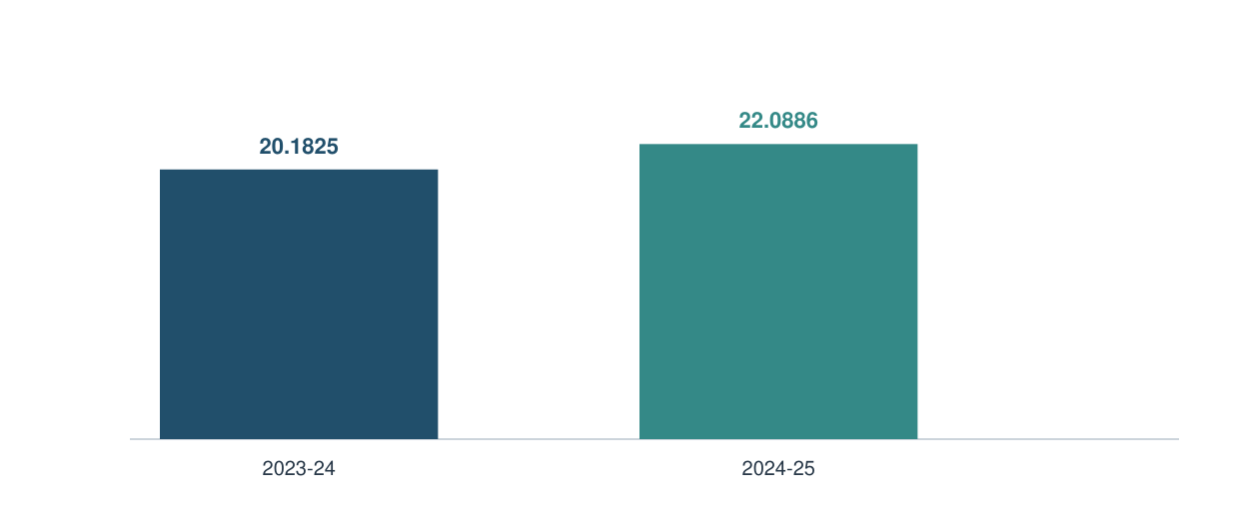
Figure 4.1. Gross GST collections, Rs lakh crore.
Source: GSTN (2025), p. 1. Chart values are the table’s gross totals divided by 100,000.
Calculated from these totals, gross revenue increased by 9.44%, refunds by 16.42% and net revenue by 8.60%. Net growth is lower because refunds grew faster than gross collections. This describes the arithmetic of the published totals; it does not establish the time taken to process an individual refund or the share attributable to SMEs.

4.3 Why revenue is not a profitability measure
The collection comparison establishes that the recorded nominal national total increased. It does not identify why the increase occurred. Possible contributors include a larger value of taxable transactions, price movements, changes in reporting, enforcement and policy. Their separate contributions cannot be recovered from two aggregate observations alone.
Nor does the total reveal who ultimately bears the economic burden. A business may collect tax from a customer and remit it after applying eligible credit. Its cash remittance is not automatically an expense that reduces profit by the same amount. On the other hand, ineligible tax, financing costs and compliance resources can affect the business economically. These channels require measures different from national revenue.
The distinction between gross and net revenue is equally important. Refunds are part of the tax system, not simply a statistical inconvenience. Comparing a gross figure in one year with a net figure in another would distort the movement. The report uses matched definitions and derives the growth rates from the same official table, which provides a cleaner basis for discussion.
For SME analysis, the practical conclusion is that collection data are context. They show the scale and recent movement of the system within which firms operate. They cannot be used to calculate the percentage of SMEs that benefited, the increase in their profits or the average cost of compliance. Those conclusions would require a dataset linking enterprise characteristics and outcomes to tax exposure, with a method capable of dealing with other changes affecting business performance.

4.4 MSME economic contribution
The published series for MSME gross value added as a share of all-India GDP records the sector’s broad economic presence. It covers MSMEs, including micro enterprises, and is not a statistic for small and medium firms alone (Ministry of MSME, 2024).
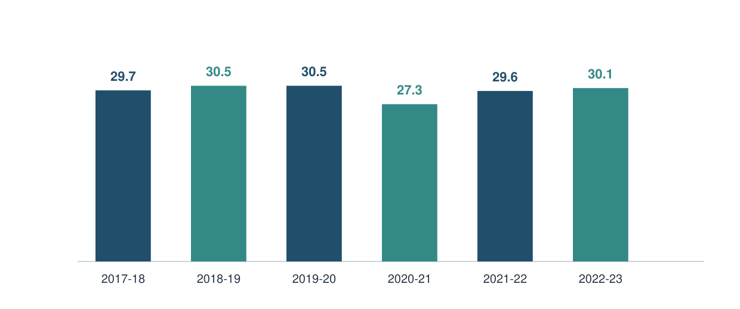
Figure 4.2. MSME GVA as a share of all-India GDP, per cent.
Source: Ministry of MSME (2024), “Contribution of MSMEs to the GDP”. Exact values are recorded in Appendix B.
The fall and subsequent recovery in the share should not be read as a clean experiment on GST. A share changes when the numerator, denominator or both change. The period also includes major disruptions to economic activity. A return towards an earlier share does not identify which policies, sectors or enterprise groups contributed to that movement.
For this report, the series establishes the relevance of studying the sector and provides historical context. It does not demonstrate that GST caused the observed pattern. A more direct investigation would need comparable enterprise outcomes, a measure of exposure and a method for separating the reform from wider economic conditions. The distinction between context and attribution remains central to the conclusion.

4.5 Export-related evidence
The Ministry’s published export indicator concerns MSME-related products as a share of all-India exports. That product-based definition is narrower and more specific than saying that the same percentage of all exports was made by currently registered SMEs (Ministry of MSME, 2024).
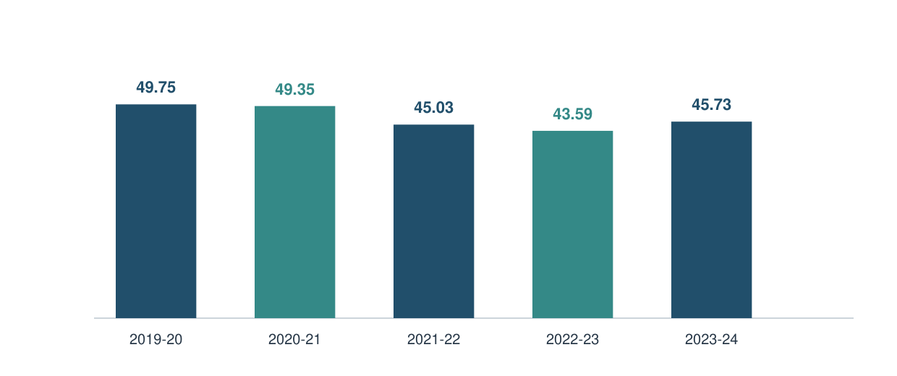
Figure 4.3. Share of MSME-related products in all-India exports, per cent.
Source: Ministry of MSME (2024). Only complete financial years in the cited series are charted; the partial FY 2024–25 figure is excluded.
The series shows a decline followed by a partial recovery. A product share can change because exports outside the identified product group grow faster or slower. It does not necessarily indicate a matching change in the absolute export value of the group. Nor does it establish a change in exporter profitability or the efficiency of refund processing.
For a GST study, the useful connection is a research question about the cash and documentation needs of exporting enterprises. Export exposure can make the timing and predictability of eligible refunds commercially important. However, evidence of that mechanism must be distinguished from evidence about its prevalence. The national product-share series cannot reveal how many small exporters encountered delayed funds or how much additional financing they required.

4.6 Compliance activities and costs
The compliance burden becomes clearer when it is divided into tasks. The following table is an analytical classification of work, not an estimate of how many hours firms spend on it. It helps identify where an owner, employee, software provider or adviser contributes resources.
Table 4.2. Compliance work at enterprise level.
Activity | Main resource | Possible operational consequence
Capture sales and purchases | Staff time and source documents | Incomplete records cause later correction
Maintain customer and supplier details | Master-data responsibility | Repeated errors can spread across invoices
Check credit-related exceptions | Reconciliation and follow-up | Unresolved differences may affect decisions
Prepare and review returns | Accounting capability and adviser time | A last-minute process raises rework risk
Arrange payments and preserve records | Cash planning and documentation | Weak hand-offs can create avoidable disruption
Track relevant changes | Training and reliable guidance | Outdated assumptions may remain in use

The economic issue is the total resource requirement, including tasks performed inside the firm. Outsourcing submission does not remove the need to provide accurate data. Conversely, not all accounting work exists because of GST. A sales register can support collection from customers and stock planning as well as taxation.
A practical assessment should therefore identify incremental tax-related work and shared business work separately. The owner can then target the source of repeated effort. If missing documents cause most corrections, purchasing a new filing package may not solve the problem. Improving the point at which information enters the system could produce a more direct benefit.

4.7 Fixed costs and business scale
Assume an annual compliance-related fixed cost of Rs 48,000. This is a teaching assumption, not an observed fee or a recommended market price. Dividing that amount by four different turnover levels shows how scale changes the proportional burden.
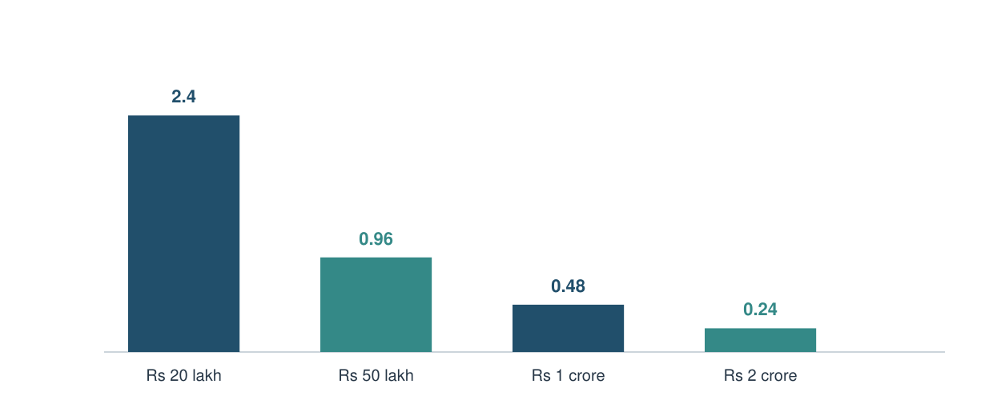
Figure 4.4. Illustrative annual fixed cost as a percentage of turnover.
Source: Author’s arithmetic. Assumed annual cost: Rs 48,000. Turnover scenarios: Rs 20 lakh, Rs 50 lakh, Rs 1 crore and Rs 2 crore.
At Rs 20 lakh turnover, the assumed cost is 2.40% of sales. At Rs 2 crore it is 0.24%. The result follows from holding the numerator constant while increasing the denominator. It does not imply that actual compliance costs remain fixed as firms grow; transaction volume and organisational complexity can add variable costs.
The example nevertheless clarifies why proportionality matters. A small absolute fee may still be commercially significant for a low-margin enterprise. Turnover alone is also incomplete: the same percentage of sales can consume a very different percentage of operating profit across sectors. Recommendations should therefore consider scale, margins and the nature of the work, rather than treating one expenditure level as equally affordable for every firm.

4.8 Digital records and e-invoicing
Digital record-keeping and statutory e-invoicing are related but distinct. A firm may use an accounting application without falling within the notified e-invoicing requirement. The threshold change effective from August 2023 is discussed in Chapter 2; it should not be expanded into a claim that every small enterprise must obtain an invoice reference number for every transaction (CBIC, 2023).
The potential operational benefit of digital records comes from consistency and reuse. Customer details entered accurately at the start can support invoices, receivables and reporting. A well-designed exception report can direct attention to differences requiring review. These are process benefits: they depend on how the tool is configured and used, not simply on the fact that the records are electronic.
The corresponding risk is concentrated error. If an incorrect tax category or customer identifier is stored in a master record, repeated transactions can reproduce the mistake quickly. Automation may reduce typing without reducing the need for judgment. A business therefore needs responsibility for master-data changes and a way to preserve evidence of corrections.
For smaller enterprises, a proportionate system can be modest. The essential features are complete source documents, a consistent naming method, backups, clear access responsibility and a regular review of unresolved items. The analysis does not assume that an expensive platform is necessary. It recommends judging a tool by whether it reduces a defined error or delay and whether the people using it can explain the information it produces.

4.9 Input tax credit: worked example
The following example assumes a single eligible domestic credit chain, a uniform illustrative 18% rate, full compliance with credit conditions and no blocked credits or timing complications. It is not a tax classification for any particular commodity.
Table 4.3. Illustrative credit-chain calculation, Rs.
Stage | Taxable sale | Output tax | Eligible input credit | Net tax payment
Input supplier | 1,00,000 | 18,000 | 0 assumed | 18,000
Manufacturer | 1,50,000 | 27,000 | 18,000 | 9,000
Retailer | 2,00,000 | 36,000 | 27,000 | 9,000
Total across the assumed chain | — | — | — | 36,000

Source: Author’s illustrative arithmetic, using the conceptual credit framework. No enterprise data are represented.
The total net payment equals 18% of the final assumed taxable value. It does not equal the sum of the output-tax column, because that would ignore credits and double-count tax moving through the chain. The example shows why an invoice’s tax amount and the seller’s net cash remittance are different concepts.
The result is conditional. If a purchase is ineligible for credit, if a legal restriction applies, or if credit cannot yet be used, the firm’s financial position can differ. The example also says nothing about how prices are negotiated or who ultimately retains a saving. Those are commercial questions examined separately. The purpose of the calculation is to make the accounting mechanism transparent before evaluating its business implications.

4.10 Supplier risk and reconciliation
The purchase process should not end when goods arrive. A business also needs to connect the order, invoice, receipt and accounting record. Reconciliation helps distinguish a missing document from a wrong amount or an issue requiring legal review. Different exceptions require different actions; treating them as one undifferentiated balance makes follow-up harder.
Table 4.4. Illustrative invoice exception register.
Exception | First check | Responsible action | Closure evidence
Invoice not in internal records | Receipt and purchase file | Accounts obtains document | Matched source invoice
Value differs from order | Quantity, price and adjustments | Buyer resolves commercial difference | Agreed corrected record
Party details inconsistent | Master data and invoice identity | Accounts verifies particulars | Documented correction
Credit treatment uncertain | Applicable rule and transaction facts | Qualified review | Recorded decision and basis

Source: Proposed control format, not an observed register from a surveyed business.
Supplier follow-up should be specific. A request identifying the invoice, discrepancy and required correction is more actionable than a general reminder to “clear GST issues”. The enterprise also needs a date for review and an owner for unresolved items. Otherwise, a difference can remain visible in a spreadsheet without anyone being responsible for resolving it.
This is a risk-management recommendation derived from the transaction mechanism. The report does not estimate how much credit is lost through supplier problems. It suggests that businesses distinguish documentation errors, timing differences and ineligible items before deciding whether a balance represents recoverable value, a cash-planning issue or a permanent cost.

4.11 Working-capital timing
A tax-related cash requirement can arise before the business receives the associated customer payment. The exact timing depends on transaction facts, applicable rules, credit availability and commercial terms. The synopsis’s broad statement that tax is always paid “at the time of supply” is therefore not used as a universal cash-payment rule.
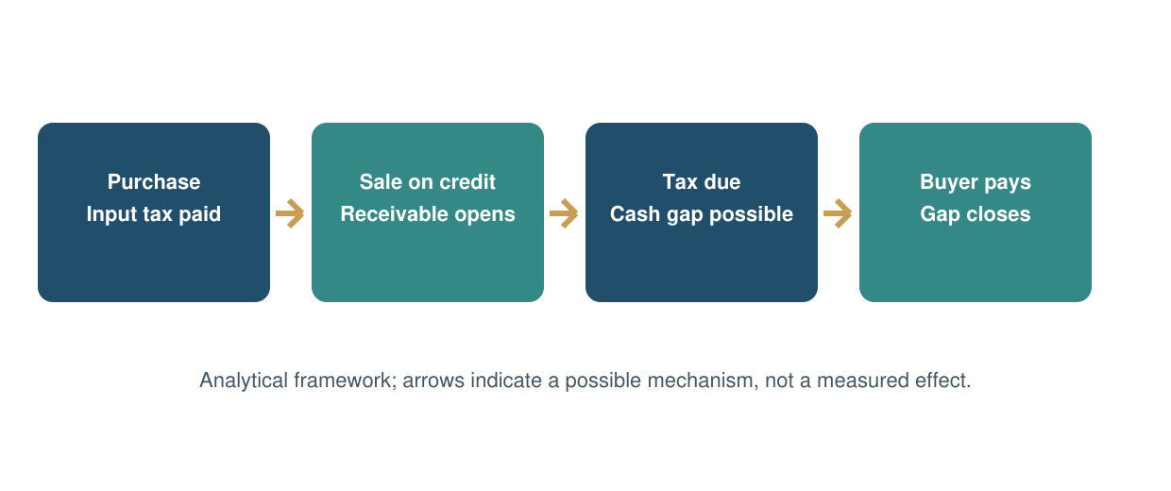
Figure 4.5. A possible working-capital timing gap.
Source: Original conceptual illustration; actual dates and amounts vary by transaction and applicable provisions.
The enterprise should distinguish three clocks: the commercial clock for customer and supplier payments, the accounting clock for recording transactions, and the tax clock for obligations and available credit. A problem arises when the cash needed under one clock is not yet available under another. Profitability over a year does not guarantee liquidity on a particular payment date.
A practical forecast records expected receipts conservatively and identifies tax-related outflows separately. It also distinguishes a legally usable credit from an amount still under review. This does not eliminate an underlying cash shortage, but it makes its timing visible. The business can then evaluate collection follow-up, payment scheduling or financing with a clearer understanding of the amount and duration of the gap.

4.12 Financing-cost sensitivity
Assume Rs 2,00,000 remains unavailable for a specified period and the firm finances that amount at 12% per year. Using simple interest and a 365-day year, the cost is principal × annual rate × days ÷ 365. All inputs are hypothetical.
Table 4.5. Illustrative financing cost, rounded to nearest rupee.
Delay | At 9% annually | At 12% annually | At 15% annually
15 days | 740 | 986 | 1,233
30 days | 1,479 | 1,973 | 2,466
60 days | 2,959 | 3,945 | 4,932
90 days | 4,438 | 5,918 | 7,397

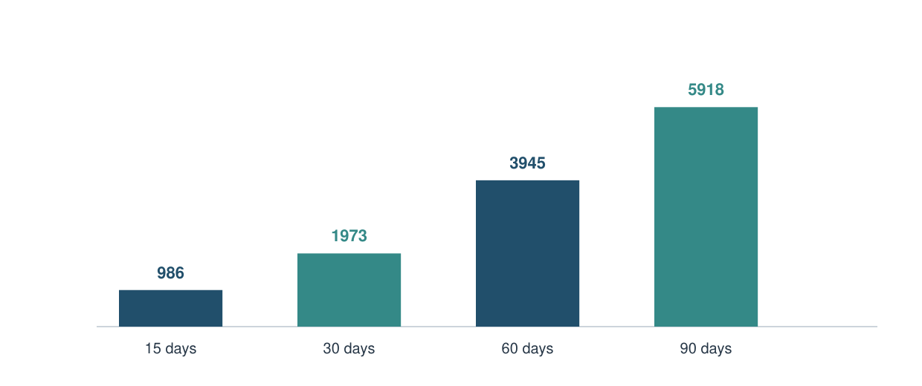
Figure 4.6. Illustrative financing cost at 12%, Rs.
Source: Author’s calculations; rounded chart labels correspond to the middle column.
A recoverable balance can therefore have a financing cost even if it is eventually recovered in full. The result is not an estimate of actual refund delays, borrowing rates or SME losses. Fees, compounding and foregone orders are excluded. Those factors would require additional assumptions or observed evidence.

4.13 Pricing and commercial incidence
Tax design and price negotiation interact. The following cases explain why the same invoice structure can matter differently to different customers. They assume a taxable price of Rs 1,000 and an illustrative tax of Rs 180; they do not assign a legal rate to a named product.
Table 4.6. Two pricing cases.
Customer situation | Initial invoice payment | Economic interpretation
Registered business with fully eligible, usable credit | Rs 1,180 | Rs 180 may be creditable, subject to conditions; timing still matters
Final consumer without such credit | Rs 1,180 | The tax-inclusive price is the relevant purchase outlay

Source: Author’s conceptual example. Freight, financing, discounts and other costs are omitted.
A B2B buyer may compare offers using the cost after eligible credit, whereas a household normally compares the total price it must pay. This can influence the commercial value of a complete invoice. It does not mean the registered supplier will always win: quality, delivery, reliability and payment terms also affect the decision.
The seller’s ability to pass on a cost depends on market conditions. A competitive market may limit the price that customers will accept, leaving the enterprise to absorb some additional resource cost. A differentiated product may provide more pricing flexibility. These are analytical possibilities, not estimated pass-through rates.
Consequently, a claim that GST “reduced prices” needs product-specific evidence and an appropriate comparison. A lower statutory rate, a better credit position and a lower final selling price are related but distinct events. The report does not treat one as automatic proof of another.

4.14 Interstate trade and logistics
An integrated tax framework can change the importance of state boundaries in commercial planning, but it does not remove all documentary or operational requirements. An enterprise still needs to identify the transaction correctly, arrange transport and meet applicable movement-document obligations. The relevant business question is whether the overall process becomes more predictable and efficient for its particular supply chain.
The potential benefit can be explained through a warehouse decision. A business would ideally compare storage, delivery time, inventory risk and customer service. If tax differences previously influenced the location decision, a more coordinated framework may allow operating considerations to play a larger role. This is an economic mechanism, not evidence that every SME closed warehouses or achieved a measured reduction in freight costs.
Smaller firms may also depend on transporters or larger customers for the information required to complete a shipment. A delay can arise from a mismatch among the invoice, destination, order and transport details. Improving these hand-offs is an operational task. It does not require the business to own the entire logistics system, but it does require clarity about who supplies each piece of information.
The report therefore recommends examining the full order-to-delivery process before claiming a tax-related saving. Useful firm-level indicators would include correction frequency, dispatch delays attributable to documentation and the number of times data are re-entered. Those indicators were not collected for this study. Their absence prevents a quantitative conclusion about logistics gains, while still allowing the mechanism and the information needed to test it to be set out clearly.

4.15 Formalisation and access to finance
Formal records can help a business explain its sales and receivables to a lender or commercial partner. GST-related records may form part of that information. However, registration does not itself establish that a firm is profitable, that its customers pay on time or that it can service a loan. The report treats access to finance as a possible channel whose outcome depends on additional conditions.
The distinction can be illustrated without inventing a loan approval. Suppose two enterprises report the same annual sales, but one can reconcile invoices, bank receipts and outstanding receivables while the other cannot. The first provides a clearer information trail. Whether a lender extends credit will still depend on its assessment of repayment capacity, risk, security where relevant and the terms of the proposed facility.
There are also costs to becoming more visible. Maintaining formal records requires effort, and the owner may need assistance to understand obligations. If the records are prepared only for filing and are never used for management, the enterprise may obtain less operational value from that effort. A useful recommendation is therefore to make the same verified information serve receivables review, cash planning and business decisions.
The historical RBI response discussed in Chapter 2 shows that formalisation and transition were part of the institutional policy context. It does not prove that GST caused easier credit for every MSME. To measure that proposition, a future study would need loan applications, approval outcomes, pricing and firm characteristics, together with a design that separates registration status from the other qualities that influence lending decisions.

4.16 Composition and QRMP trade-offs
Composition and QRMP address different issues. Composition changes the method of levy for eligible taxpayers and restricts normal tax collection and input-credit treatment. QRMP concerns the frequency of specified returns and monthly payment arrangements for eligible regular taxpayers. They are not interchangeable descriptions of one scheme (CBIC, n.d.-b; GSTN, n.d.).
Table 4.7. Conceptual comparison; eligibility must be checked separately.
Dimension | Regular monthly route | Regular taxpayer using QRMP | Composition route
Return rhythm | Applicable monthly cycle | Specified quarterly returns | Scheme-specific requirements
Payment approach | Applicable regular rules | Monthly payment structure | Composition provisions
ITC position | Subject to eligibility | Subject to eligibility | Normal ITC not available to composition taxpayer
Customer invoice effect | Tax invoice where applicable | Tax invoice where applicable | Bill of supply; no ordinary collection of GST from customer
Main business question | Capacity for regular process | Fit with payment and customer needs | Fit with eligibility and customer mix

Sources: GSTN QRMP guidance; CGST Act, section 10 and CBIC composition guidance. This table is not an exhaustive scheme-selection guide.
A business should evaluate the complete commercial position rather than choose solely on filing frequency. A B2B customer’s preference for an eligible credit chain may matter, while a consumer-facing business may evaluate the tax-inclusive selling price differently. The appropriate route depends on legally available options and the enterprise’s actual transactions. No scheme is assumed to be best for all SMEs.

4.17 Manufacturing, trading and services
Sector differences arise from how value is created and paid for. A manufacturer manages materials and work in progress; a trader manages purchase and resale margins; a service provider may depend heavily on labour. These distinctions affect the relationship among turnover, taxable inputs and cash collection.
Table 4.8. Sector-specific mechanisms to examine.
Enterprise type | Important operating feature | GST-related analytical focus
Manufacturer | Material purchases and production cycle | Eligible credit, inventory timing and documentation
Trader | Stock turnover and narrow margins | Invoice volume, customer mix and cost intensity
Service provider | Labour and contract billing | Input structure, milestone billing and receivables
Export-oriented enterprise | Cross-border documentation and settlement | Applicable zero-rating route and refund predictability

Source: Author’s analytical comparison, not survey observations or sector averages.
The table does not imply that all firms within a sector are alike. A cash retailer differs from a wholesaler selling on long credit. A consultancy differs from a service business with substantial equipment purchases. Firm size, customer concentration and bargaining power can be as important as the broad sector label.
For recommendations, this means the starting point should be the operating cycle. A manufacturer may gain most from connecting receipt records with purchase invoices, while a contract service provider may need a clearer forecast of milestone receipts. A uniform instruction to “improve compliance” is less useful than identifying the transaction stage where information or cash becomes uncertain. The project’s framework supports such diagnosis without inventing a measured sector ranking.

4.18 Small exporters and refund timing
The Integrated Goods and Services Tax Act provides a framework for zero-rated supplies, including the conditions governing relevant export and authorised SEZ supplies. The applicable route and refund entitlement depend on the legislation and prescribed conditions. Zero-rating should not be confused with a promise that every tax-related cash outflow is immediately returned (CBIC, n.d.-c).
For a smaller exporter, the analytical issue is predictability. If an eligible amount will be available later than expected, the enterprise may need to finance that interval. The final recovery and the interim funding cost are separate. Chapter 4’s sensitivity calculation shows this relationship without assigning an observed delay to the exporter population.
Documentation quality can affect how efficiently an application is prepared and followed up. An enterprise needs consistent transaction records and an organised response to any deficiency or query. Yet it would be unfair to assume that every delay is caused by the applicant. Administrative processing, interpretation and system issues can also require examination. A rigorous field study would classify causes rather than attribute the whole problem to one party.
The official total-refund series does not supply the missing timing evidence. A larger annual amount could reflect more claims, larger eligible values or other changes. It cannot reveal the median waiting time of a small exporter. Practical monitoring should therefore distinguish amounts claimed, amounts sanctioned, amounts received and elapsed time. These are proposed management measures, not observations collected by this project. They help explain what a more direct evaluation of export-related liquidity would require.

4.19 Published survey responses
The following chart reproduces reported percentages from successive Deloitte GST survey editions as summarised in GST@8. It represents the original publisher’s respondents, not respondents surveyed for this project.
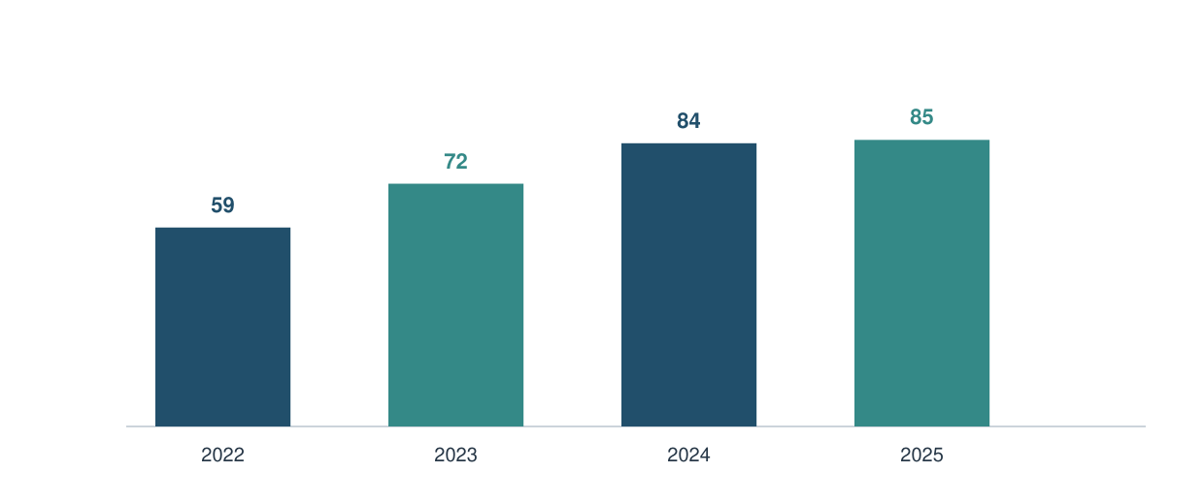
Figure 4.7. Published positive GST sentiment, per cent.
Source: Deloitte (2025a), GST@8. The 2025 publication reports 963 responses across eight industries. Different editions need not contain the same respondents.
The movement suggests more favourable reported sentiment within those survey populations. It is not a longitudinal estimate for a fixed panel and should not be presented as the proportion of all Indian SMEs benefiting from GST. No raw respondent counts are reconstructed from the rounded percentages.
The publisher also reports continuing demands for procedural improvement and identifies rate rationalisation as a priority for an MSME subgroup (Deloitte, 2025b). This illustrates why an overall positive assessment can coexist with dissatisfaction about a specific process. The survey is useful as evidence of reported priorities. Its role in this study is to complement, rather than replace, the analysis of costs, timing and transaction conditions.

4.20 Post-period policy and survey update
The core numerical analysis ends in FY 2024–25. Later developments are presented here as a dated update. The September 2025 GST Council announcement proposed a structure centred on 5% and 18%, with a special 40% rate for selected supplies and implementation arrangements from 22 September 2025. Exceptions and operative notifications matter; the older four-main-slab description should not be presented as universally current (Ministry of Finance, 2025).
The revised MSME ceilings effective from April 2025 are recorded in Table 1.1. They affect the interpretation of enterprise categories and reinforce the need to avoid combining pre- and post-revision counts without checking definitions.
Deloitte’s 2026 press release reports 1,096 responses and combines positive and neutral sentiment in its headline figure of more than 99%. That combined category is not comparable to the positive-only series in Figure 4.7. Its MSME discussion also reports continued interest in simpler compliance and liquidity support (Deloitte, 2026). These are published secondary findings, not new observations collected for this report.
The update changes the context but does not retrospectively change the earlier data. It would be premature to infer a causal effect of a later rate reform from an earlier collection series. A future evaluation should specify the actual effective rules, product exposure, transition period and comparison group. The present report retains its period boundaries while acknowledging that the framework continues to evolve.

4.21 Illustrative enterprise scenarios
The following profiles are hypothetical analytical cases. They are not surveyed firms, disguised respondents or accounts of visits. They bring together the mechanisms already discussed so that the practical differences are easier to understand.
Table 4.9. Hypothetical enterprise profiles.
Profile | Main operating condition | Likely question to investigate
A: B2B component producer | Material purchases; customers pay on credit | Are eligible credits and customer receipts available when needed?
B: Consumer-facing local trader | Many invoices; thin margins | How large is the compliance resource cost relative to margin?
C: Small professional service firm | Labour-intensive output; few material inputs | How do billing milestones and receivables affect tax-related cash planning?
D: Small exporter | Documentation and cross-border settlement | How predictable are eligible refund receipts?

No numerical outcome is attached to these profiles because the project has no observed data from such firms. The profiles identify what should be measured. For A, the invoice-to-cash timeline may be central; for B, task time and cost allocation may be more useful; for C, contract billing terms matter; for D, application and receipt dates become important.
The comparison supports a practical principle: the same compliance calendar is not a complete management plan for every enterprise. The firm needs to identify the point at which its own operating cycle creates the greatest uncertainty. That is a more defensible recommendation than claiming that one sector always benefits more than another without comparable empirical evidence.

4.22 Risk and control framework
A useful control system turns a recurring problem into an assigned task with closure evidence. The aim is not to multiply forms, but to ensure that important differences are identified early enough for action.
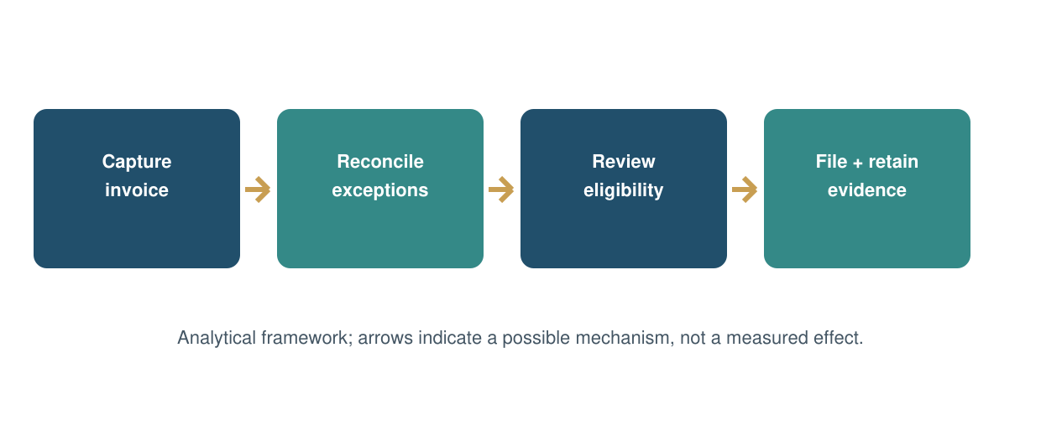
Figure 4.8. A practical invoice-control cycle.
Source: Proposed operating framework developed from the report’s analysis; no measured effectiveness is claimed.
At capture, the enterprise preserves complete source documents and verifies basic party details. At reconciliation, it separates missing records, numerical differences and treatment questions. At review, an authorised person resolves the relevant issue or seeks competent advice. At filing and retention, the business preserves the basis for the final record and payment.
The owner needs a short exception summary rather than every underlying transaction. Useful fields are amount, age, responsible person, next action and expected resolution date. A materiality approach can prioritise large or recurring issues while retaining a record of smaller ones. This is particularly valuable when one employee or adviser supports many responsibilities. The effectiveness of the framework should be judged by fewer repeated corrections and more predictable information, not by the number of spreadsheets created.

4.23 Integrated assessment
The evidence supports a differentiated assessment. GST’s institutional mechanisms are clear enough to analyse, but the available data do not establish a single national effect on SME profitability. The findings should therefore remain linked to the objectives and to the type of evidence supporting them.
Table 4.10. Evidence and inference by objective.
Objective | Supported conclusion | Remaining uncertainty
GST concept and structure | A conditional credit chain and coordinated tax framework shape transactions | Treatment of each firm’s specific supplies
SME economic role | Official MSME indicators establish substantial economic relevance | SME-only effects within broader aggregates
Operational impact | Records, reconciliation and cash timing are important channels | Average magnitude across firms
Benefits and challenges | Effects vary with inputs, customers, scale and capability | Representative distribution of gains and costs
Improvements | Targeted controls and clearer administration address identified mechanisms | Measured effectiveness of each intervention

The strongest empirical statements in the chapter concern exactly what the official data and published surveys record. The strongest practical statements concern how a business can make a mechanism visible and manage it. Neither kind of statement requires invented field observations.
The overall implication is that simplification should be assessed through the complete transaction process. A lower number of forms may help, but it is not the only relevant outcome. Accurate information, usable credit, predictable timing and clear resolution of exceptions are also part of a workable tax environment for smaller enterprises.

Chapter 5 — Findings, Suggestions and Conclusion

5.1 Major findings
The first finding concerns the structure of the reform. GST connects eligible purchase credit, output liability and digital transaction records. For enterprise analysis, these elements must be considered together. A credit mechanism can reduce tax embedded in the chain, but its practical value depends on eligibility, documentation and usability. The existence of the mechanism does not establish an identical financial benefit for every firm.
The second finding is that national indicators establish context more securely than firm-level outcomes. The official collection comparison records nominal growth in gross and net GST revenue, while the MSME indicators establish the sector’s economic relevance. These observations do not identify the causal effect of GST on SME profit, employment or survival. The report therefore does not claim such an estimate.
The third finding is that resource burden and cash timing are distinct. Compliance work includes internal tasks as well as external fees. A fixed resource cost can be proportionately heavier at smaller scale. Separately, a recoverable amount can create a financing requirement before it becomes usable or before the associated customer receipt arrives. Neither mechanism should be confused with the full tax shown on sales invoices.
The fourth finding is that reported business sentiment and unresolved process difficulties can coexist. Published surveys offer useful evidence about their respondents’ assessments, but their populations and question categories limit generalisation. Finally, enterprise characteristics matter: customer mix, input structure, payment terms and accounting capability provide a stronger basis for practical recommendations than a universal judgement that GST is simply favourable or unfavourable to all SMEs.

5.2 Recommendations for enterprises and administration
Enterprises should begin with the quality of information entering the accounting process. Responsibility for customer and supplier details should be explicit, source invoices should be retrievable, and recurring exceptions should have an assigned owner. This targets the causes of correction rather than relying on last-minute effort before a filing date. The recommendation follows from the report’s transaction analysis; it is not a claim of a measured percentage saving.
Cash planning should distinguish customer receipts, supplier payments, tax-related outflows and amounts awaiting review or recovery. A rolling forecast can make the duration of a possible gap visible. The forecast should use realistic receipt dates and should not count an unresolved balance as readily available cash. Where financing is considered, the enterprise should compare its actual cost with the consequences of delay.
Training should focus on common tasks and exceptions. A short exercise using the firm’s normal invoice flow may be more useful than broad awareness material that never reaches the employee doing the work. Software should be selected to solve a defined problem, such as duplicate entry or poor document retrieval, with attention to cost, usability and continuity when an employee is absent.
For administration, the report recommends clearer task-based guidance, consistent communication and transparent tracking of unresolved applications or queries. Assistance should be accessible to firms with limited specialist capacity. Any policy change should be evaluated against both revenue safeguards and the effort required from the taxpayer. These are proposed improvements whose effectiveness should be assessed through real process indicators, rather than presumed from the announcement alone.

5.3 Implementation responsibilities and monitoring
Recommendations become more useful when they specify who acts and what outcome is monitored. The following plan is proposed for adaptation by an enterprise; it is not evidence that these actions have already been implemented.
Table 5.1. Implementation responsibility and indicators.
Action | Suggested owner | Timing | Indicator
Clean customer and supplier records | Accounts lead with sales / purchase staff | Initial review, then on change | Repeated master-data errors
Maintain invoice exception list | Bookkeeper or accounts staff | Regular operating review | Unresolved items by age and value
Prepare cash forecast | Owner / finance lead | Rolling review aligned to obligations | Forecast-versus-actual shortfall
Review credit treatment questions | Adviser with firm’s authorised reviewer | Before relevant filing decision | Items awaiting documented decision
Improve document storage and backup | Administrative owner | Initial setup and periodic check | Ability to retrieve a sample record
Review process effectiveness | Owner and accounts team | After several operating cycles | Rework, delay and recurring exceptions

The indicators are deliberately operational. They can show whether information arrives earlier and whether the same mistakes recur. A business should establish its own baseline before claiming improvement. A fall in unresolved items may reflect actual resolution, but it might also reflect a change in how items are recorded; definitions should remain consistent.
Cost should remain proportionate. A small firm may operate this plan with a clear checklist and a controlled spreadsheet, while a larger enterprise may need integrated systems. The principle is the same: the control should address a specific risk and produce evidence that the risk has been handled.

5.4 Implications of the study
For business management, the study suggests that tax information can be more valuable when it also supports ordinary decisions. A reliable sales record helps identify receivables; an organised purchase record helps explain costs and outstanding liabilities. The benefit is conditional on accuracy and use. Merely generating a return does not ensure that the owner receives information useful for managing the enterprise.
For accounting practice, the report underlines the need to communicate distinctions clearly. Tax charged, eligible credit, net remittance, economic cost and cash required are not interchangeable quantities. Explaining them separately can improve discussion between an owner and an adviser. It also helps avoid a misleading impression that every tax-related balance has the same effect on profit or liquidity.
For policy, proportionality should include capability as well as turnover. Firms may have similar sales but very different transaction complexity and access to trained support. The design of assistance, instructions and correction procedures should account for the work needed to produce reliable information. Predictability and clarity can be valuable even when the statutory liability is unchanged.
For academic research, the study demonstrates the importance of matching the claim to the evidence. Administrative totals, product-based export indicators and executive sentiment surveys each have a legitimate role. Problems arise when their denominators or populations are ignored. A carefully bounded secondary study can make a useful contribution by organising mechanisms and identifying unanswered questions, even though it cannot estimate every outcome. This is the contribution of the present project: a source-based explanation with transparent limits and practical avenues for further investigation.

5.5 Limitations and directions for further research
The conclusions remain limited by the available secondary evidence. The project does not observe a representative sample of enterprises before and after GST, nor does it identify a credible untreated comparison group. Other influences on business performance cannot be separated statistically. National aggregate movements should therefore remain descriptive findings rather than causal estimates.
Future research could collect comparable information on compliance fees, staff and owner time, transaction counts and the allocation of shared accounting costs. A consistent time-use instrument would help distinguish conversion effort from recurring work. Researchers should report response rates and missing data, because firms experiencing the greatest difficulty may be either more likely or less able to respond.
A second direction is the measurement of liquidity timing. Firm records could link invoice dates, eligibility decisions, customer receipts, application dates and actual receipt of eligible refunds. The purpose would be to separate different causes of delay and quantify their financing consequences. Such a study should avoid treating every working-capital shortage as tax-induced.
A third direction is the evaluation of later policy changes. The revised classification and rate framework require clearly dated exposure measures. Researchers could examine affected and less-affected product groups while controlling for demand and other relevant factors, subject to the assumptions of their design. Finally, field research should include smaller owner-managed businesses alongside professionally staffed firms. This would help determine how far the experience reported in executive surveys extends across the wider enterprise population. These proposals are future work, not research claimed to have been completed here.

5.6 Conclusion
GST should be understood as a change in the organisation of taxation and transaction information, with consequences that differ across enterprises. Its credit framework can support a more continuous treatment of eligible business inputs, while its documentation requirements create work that must be managed. Whether the balance is favourable for a particular SME depends on the firm’s operating cycle, customer and supplier relationships, available skills and financial capacity.
The study answers the synopsis’s five objectives within a secondary-data design. It explains the GST framework, establishes the relevance of MSMEs through correctly labelled official indicators, examines the operational and financial channels, identifies conditional benefits and challenges, and proposes practical improvements. It does not claim a primary survey or a statistically identified national profit effect.
The most useful practical conclusion is that information quality and timing deserve attention together. Accurate invoices, clear responsibility for exceptions and realistic cash forecasts can help an enterprise understand its position. At the administrative level, accessible guidance and predictable resolution processes can make compliance more manageable without abandoning the need for reliable records.
The published evidence supports neither an unqualified celebration nor a universal rejection of GST for SMEs. It supports a more specific judgement: the framework offers opportunities, but their realisation depends on the conditions under which firms operate and on the quality of implementation. Continuing evaluation should measure those conditions directly. A tax system that works well for smaller enterprises must be assessed through the complete business process, including the resources and time needed to comply, rather than through revenue totals alone.

References — I
Central Board of Indirect Taxes and Customs. (2023, May 10). Notification No. 10/2023–Central Tax: E-invoicing threshold. GST Council repository.
https://www.gstcouncil.gov.in/node/4365
Central Board of Indirect Taxes and Customs. (n.d.-a). Central Goods and Services Tax Act, 2017: Section 16, eligibility and conditions for taking input tax credit. Tax Information Portal. Retrieved September 22, 2026.
https://taxinformation.cbic.gov.in/content-page/explore-act/1000285/1000001
Central Board of Indirect Taxes and Customs. (n.d.-b). Composition rules. Retrieved September 22, 2026. Read with section 10 of the CGST Act and applicable amendments; older website examples are not treated as current thresholds.
https://cbic-gst.gov.in/composition-rules.html
Central Board of Indirect Taxes and Customs. (n.d.-c). Integrated Goods and Services Tax Act, 2017: Section 16, zero-rated supply. Tax Information Portal. Retrieved September 22, 2026.
https://taxinformation.cbic.gov.in/content-page/explore-act/1000624/1000001
Deloitte. (2025a). GST@8: Learning from the past, defining the future. Survey publication webpage.
https://www.deloitte.com/in/en/services/tax/services/gst-at-8.html
Deloitte. (2025b, June 23). India Inc. embraces GST: 85 percent of respondents show positive sentiment as industry charts path for GST 2.0—Deloitte GST@8 Survey [Press release].
https://www.deloitte.com/in/en/about/press-room/india-inc-embraces-gst.html

References — II
Deloitte. (2026, June 23). India Inc. backs GST as a trusted digital ecosystem; calls for continued structural and operational GST 2.0 reforms: Deloitte GST@9 survey [Press release].
https://www.deloitte.com/in/en/about/press-room/india-inc-backs-gst-as-a-trusted-digital-ecosystem-calls-for-continued-structural-and-operational-gst-2-0-reforms-deloitte-gst-9-survey.html
Goods and Services Tax Council. (n.d.). About us. Retrieved September 22, 2026.
https://www.gstcouncil.gov.in/about-us
Goods and Services Tax Network. (2025). GST gross and net collections as on 31/03/2025 [Statistical release].
https://tutorial.gst.gov.in/downloads/news/approved_monthly_gst_data_for_publishing_mar_2025.pdf
Goods and Services Tax Network. (n.d.). Frequently asked questions on QRMP scheme. Retrieved September 22, 2026. Used for the scheme’s core distinction between quarterly returns and monthly payment.
https://tutorial.gst.gov.in/downloads/news/faq_on_qrmp_iff.pdf
Indira Gandhi National Open University. (n.d.). MCOP-001: Project course—Guidelines for submission of synopsis and project report. Commerce Discipline, School of Management Studies. Retrieved September 22, 2026.
https://egyankosh.ac.in/bitstream/123456789/93698/1/Final%20Project%20Guidelines%20MCOP-001%20for%20students.pdf
Ministry of Finance. (2025, September 3). Recommendations of the 56th Meeting of the GST Council held at New Delhi [Press release]. Press Information Bureau.
https://www.pib.gov.in/PressReleasePage.aspx?PRID=2163555

References — III
Ministry of Micro, Small and Medium Enterprises. (2024, July 22). Contribution of MSMEs to the GDP [Parliamentary reply / press release]. Press Information Bureau.
https://www.pib.gov.in/Pressreleaseshare.aspx?PRID=2035073
Ministry of Micro, Small and Medium Enterprises. (2025). Annual report 2024–25. Government of India.
https://www.msme.gov.in/sites/default/files/MSME-ANNUAL-REPORT-2024-25-ENGLISH.pdf
Ministry of Micro, Small and Medium Enterprises. (2026). Annual report 2025–26. Government of India. Section 1.2.4, revised enterprise classification.
https://msme.gov.in/sites/default/files/MSMEANNUALREPORT2025-26ENGLISH_0.pdf
Mukherjee, S. (2023). Revenue performance assessment of Indian GST (Working Paper No. 392). National Institute of Public Finance and Policy.
https://www.nipfp.org.in/media/documents/WP_392_2023.pdf
Mukherjee, S., & Badola, S. (2022, November 29). Estimation of VAT compliance costs of unincorporated enterprises in India: Unit level analysis [Presentation]. National Institute of Public Finance and Policy.
https://www.nipfp.org.in/media/medialibrary/2022/12/SB.pptx.pdf
Poddar, S., & Ahmad, E. (2009). GST reforms and intergovernmental considerations in India (Working Paper No. 1/2009–DEA). Department of Economic Affairs, Ministry of Finance.
https://www.dea.gov.in/files/working_papers_documents/GST_Reforms_Intergovernmental_Considerations_India.pdf
Reserve Bank of India. (2018, February 7). Relief for MSME borrowers registered under Goods and Services Tax (GST) (RBI/2017–18/129).
https://www.rbi.org.in/CommonPerson/English/Scripts/Notification.aspx?Id=2629
Reserve Bank of India. (2020, July 2). Credit flow to micro, small and medium enterprises sector (RBI/2020–2021/10). Revised classification circular.
https://rbi.org.in/SCRIPTS/BS_CircularIndexDisplay.aspx?Id=11934

Appendix A — Secondary-data source register

A.1 Official and administrative evidence
Table A.1. Sources, extraction locations and uses.
Source | Location / variable | Use in this report | Restriction
GSTN, March 2025 release | Page 1, annual gross, refunds and net totals | Table 4.1; Figure 4.1; growth calculations | Provisional national totals
Ministry of MSME, July 2024 reply | GVA / GDP table | Figure 4.2; historical context | Includes micro enterprises
Same Ministry reply | Export-product share table | Figure 4.3 | Product-based coverage; no partial year in chart
Ministry annual report 2025–26 | Section 1.2.4 | Revised classification in Table 1.1 | Effective date retained
RBI, July 2020 circular | Revised classification | Historical ceilings in Table 1.1 | Not the current ceilings
CBIC, Notification 10/2023 | E-invoicing threshold change | Clarify applicability | Other applicable conditions remain relevant
GSTN, QRMP FAQs | Scheme description and eligibility | Explain return/payment distinction | Not a measured time-saving study
GST Council / Ministry of Finance | September 2025 recommendations | Post-period policy update | Operative notifications govern actual treatment

The register provides the route back to the original evidence. Website titles and reference entries identify the publisher; table and figure notes identify the specific variable used. The report preserves the official release’s provisional status rather than implying that downloaded numbers can never be revised.
The extracted figures should not be silently replaced with a newer release during editing. If data are updated, revise the source date, comparison, calculations, charts and interpretation together so that the report continues to describe a consistent evidence set.

A.2 Research and published-survey register
Table A.2. Research evidence and appropriate interpretation.
Source | Evidence type | Extracted use | What is not claimed
Poddar & Ahmad (2009) | Pre-reform conceptual research | Design and federal context | Measured post-2017 SME outcomes
Mukherjee (2023) | Fiscal performance study | Revenue interpretation | Firm-level profit effect
Mukherjee & Badola (2022) | Pre-GST cost methodology | Shared-cost measurement problem | Current GST compliance-cost average
RBI (2018) | Historical policy circular | Transition context | Current universal borrower relief
Deloitte (2025a, 2025b) | Published executive survey | Reported sentiment and priorities | Representative primary survey by the student
Deloitte (2026) | Later published executive survey | Dated contextual update | Comparability of positive-plus-neutral with positive-only responses

Published survey percentages are used at the level the original publisher reports. An overall sample size does not establish the denominator for every subgroup question. A question may allow multiple responses, exclude non-applicable cases or use rounded percentages. Without the relevant base, an exact respondent count should not be calculated.
The report contains no raw questionnaire responses because none were provided by the original investigators for this project. This does not reduce the authenticity of the secondary evidence: the published result is the evidence being analysed. It simply prevents an aggregate statistic from being turned into a fictional respondent-level dataset.

Appendix B — Data and calculation audit

B.1 Extracted observations
Table B.1. Values used in the historical context charts.
Series | Year | Published value
MSME GVA / all-India GDP | 2017–18 | 29.7%
Same series | 2018–19 | 30.5%
Same series | 2019–20 | 30.5%
Same series | 2020–21 | 27.3%
Same series | 2021–22 | 29.6%
Same series | 2022–23 | 30.1%
MSME-related products / all-India exports | 2019–20 | 49.75%
Same series | 2020–21 | 49.35%
Same series | 2021–22 | 45.03%
Same series | 2022–23 | 43.59%
Same series | 2023–24 | 45.73%

Source: Ministry of MSME (2024). Percentages retain the source’s definitions. The source’s partial FY 2024–25 export observation is not charted as a complete year.
Verification note: the GDP-related series and export-related series have different denominators. Their values should not be added, averaged together or used interchangeably. The table supplies context for the research problem; it does not measure a GST treatment effect. Administrative coverage and enterprise definitions should be checked before extending the series with later publications.

B.2 Derived measures and calculation audit
Table B.2. Reproducible calculations used in Chapter 4.
Measure | Formula from stated inputs | Result
Gross GST growth | (22,08,861 ÷ 20,18,249 − 1) × 100 | 9.44%
Refund growth | (2,52,827 ÷ 2,17,174 − 1) × 100 | 16.42%
Net GST growth | (19,56,034 ÷ 18,01,075 − 1) × 100 | 8.60%
FY 2023–24 net check | 20,18,249 − 2,17,174 | 18,01,075 crore
FY 2024–25 net check | 22,08,861 − 2,52,827 | 19,56,034 crore
Illustrative cost intensity | 48,000 ÷ 20,00,000 × 100 | 2.40%
Illustrative 30-day funding cost | 2,00,000 × 0.12 × 30 ÷ 365 | Rs 1,973 rounded

Sources: First five rows calculated from GSTN (2025), p. 1. Last two rows use explicitly assumed inputs and are not empirical observations.
Percentages are rounded to two decimal places after calculation. Financing examples use simple interest and nearest-rupee presentation; they exclude fees and compounding. The cost-intensity example holds annual cost constant and varies turnover. The credit-chain example assumes eligible credit and a uniform rate. These assumptions are explanatory devices only.
No calculation converts a published survey percentage into an invented number of individual respondents. No test statistic or significance level is reported. This preserves the distinction between reproducible descriptive arithmetic and statistical inference requiring an appropriate dataset.

Appendix C — Submission assembly checklist
This report follows the five-chapter synopsis and the MCOP-001 manual’s report structure. The official manual also requires authentic supporting documents. The status below reflects the material available during preparation; it does not certify approval or submission.
Table C.1. Submission document status.
Item | Current status / action needed
Title and student particulars | Included from the supplied synopsis; verify spelling and numbers
Supervisor name and submission session | Blank; complete with confirmed details
Synopsis approval communication / approved proforma | Not supplied; attach the authentic approved document
Approved synopsis | A 25-page synopsis was supplied, but approval was not established; attach the approved version
Guide’s signed bio-data | Not supplied; obtain the authentic document
Certificate of originality | Unsigned template on page 2; review and complete truthfully
Project evaluation fee receipt | Not supplied; attach the actual receipt
Pagination and contents | Prepared for the 76-page report; update after adding authentic enclosures
Current submission channel and session notice | Check the applicable IGNOU / Regional Centre notice

Source: IGNOU MCOP-001 manual, report checklist and submission notes, pp. 6–8.
The 76 pages refer to this report file. Required authentic enclosures are additional and may change the final bound or uploaded page count. Do not substitute blank approval forms for an approved proposal or create signatures. Review any programme-name inconsistency in the manual’s certificate template with the Regional Centre. Retain a complete copy of the final submitted document and the submission acknowledgement.

