**SQL Project**

**Name:** Deepak Puri

**Email Id: deepak31875@gmail.com**

Link:

**Dataset 1:** 39_Specific_purpose_of_kidnapping_and_abduction

**Q 1.** What is the major reason people being kidnapped in each and every state?

Ans: for marriage, for other purposes & for ransom

--creating a table "purpose_of_kidnap" in which total cases of all states category(Group_Name)-wise from year 2001 to 2010

--is presen twithout category "Kidnap - Total"

Queries used:

create table purpose_of_kidnap as SELECT Area_Name, Group_Name,

sum(K_A_Grand_Total) as total_cases FROM Specific_purpose_of_kidnapping_and_abduction

where group_name not like "%Total"

group by area_name,group_name;

--this is the code for major reason people being kidnapped in each and every state

select DISTINCT(max(area_name)) as area, group_name, max(total_cases) as total_no_cases from purpose_of_kidnap

group by area_name

order by total_cases desc;

Output:

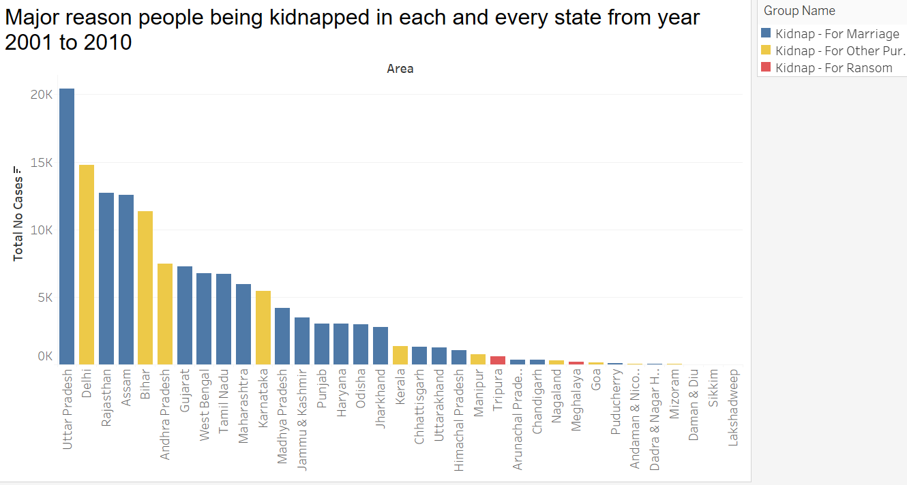

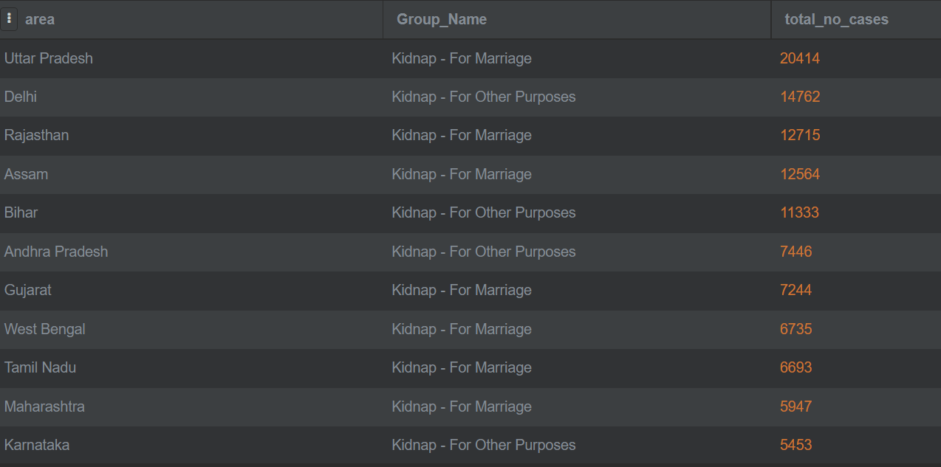

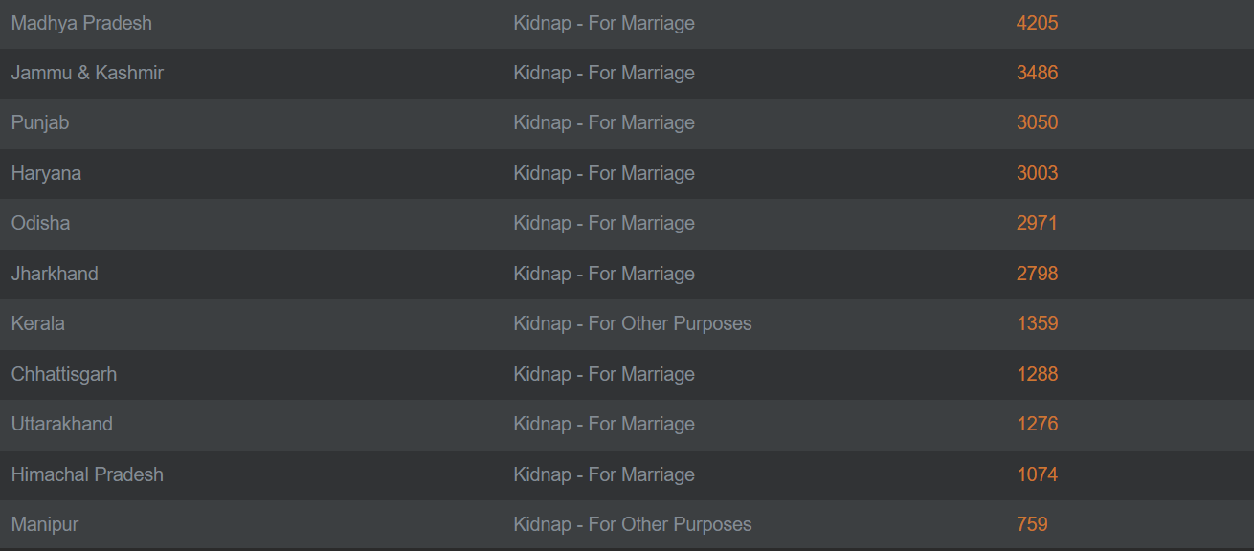

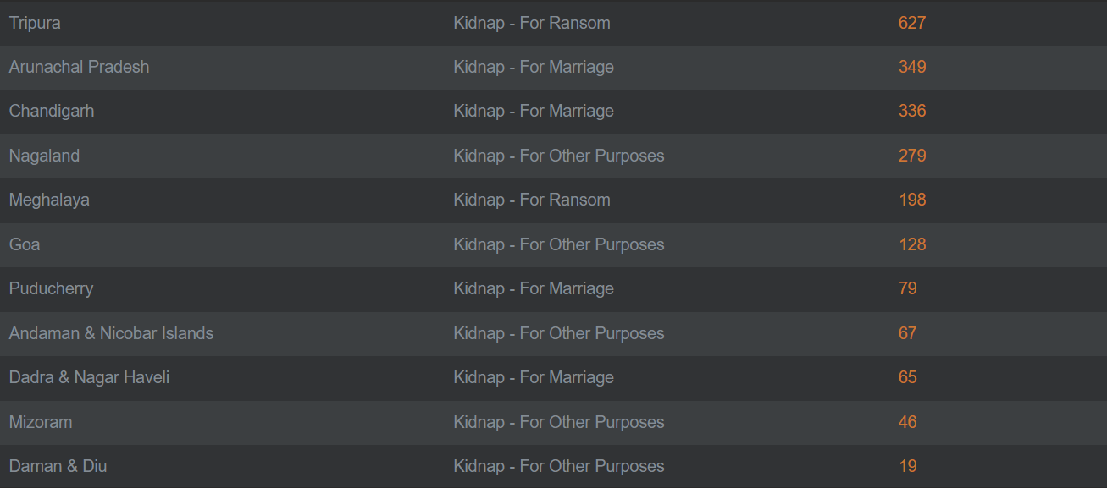



**Dataset 2:** 25_Complaints_against_police

**Q 2.** Which state has more number of complaints against police?

Ans: Madhya Pradesh

-- changed names for two columns as they were giving error

-- number of cases and complaints against police from year 2001 to 2010 in each state of india.

Queries used:

select area_name, sum(complaints_received) as total_complaints_ag_pol

from Complaints_against_police group by area_name order by total_complaints_ag_pol desc;

Output:

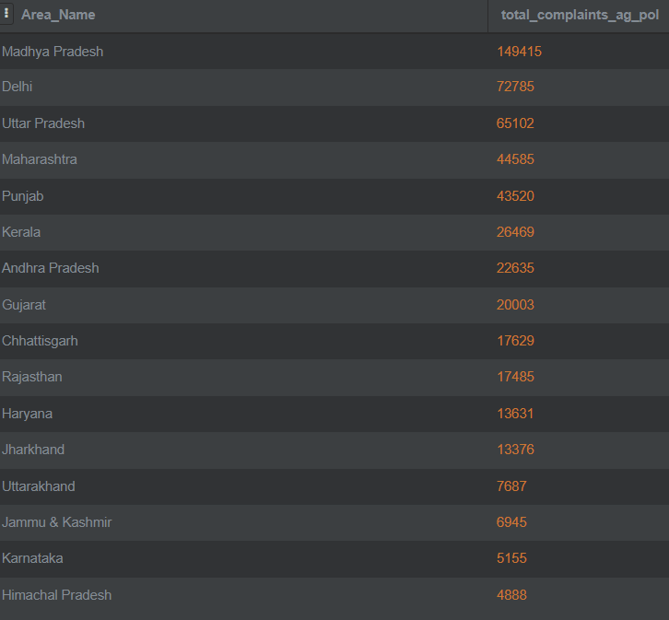

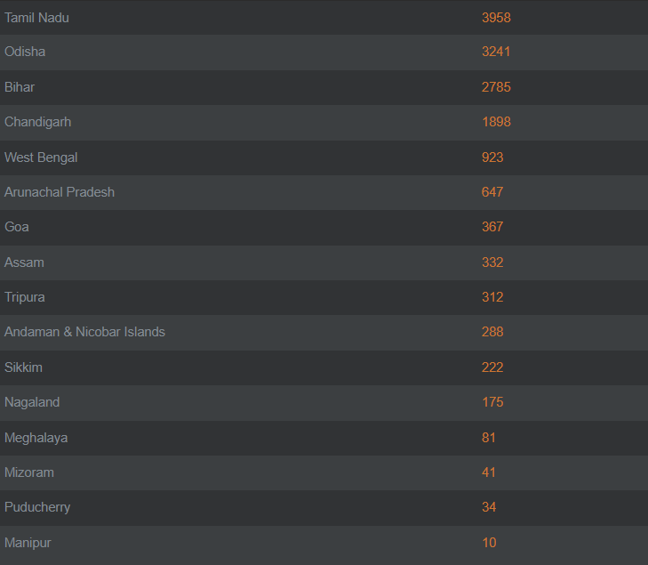



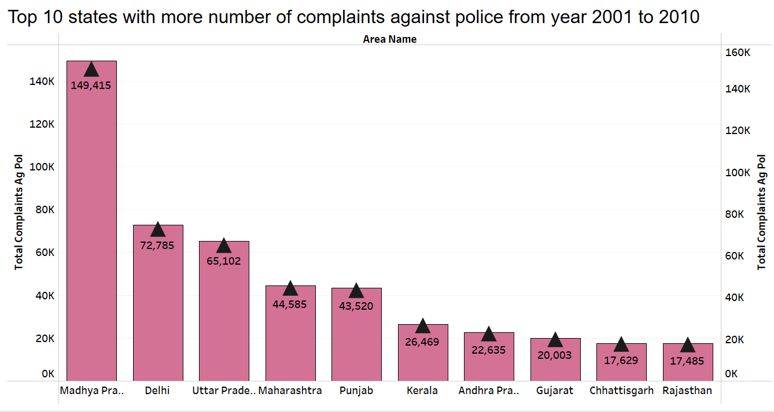

**Dataset 3:** 24_Anti_corruption_arrests & 23_Anti_corruprion_cases

**Q 3.** Anti corruption cases vs arrests

Ans:

--created table “a_vs_c_pres_year”

--then created table “cases_arrest_2001_2010” for better analysis

Queries used:

Create table a_vs_c_pres_year as

SELECT c.area_name, c.ac02_no_of_cases_registered_during_the_year as cases_registered,

c.ac03_total_no_of_cases_for_investigation_during_the_year as cases_for_investigation,

c.ac04_no_of_cases_investigated_during_the_year as cases_investigated,

c.ac20_total_no_of_cases_for_trial_during_the_year as cases_for_trial,

c.ac22_no_of_cases_in_which_trials_were_completed_during_the_year as case_completed_trials,

a.aca02_no_of_persons_arrested_during_the_year as persons_arrested,

a.aca06_no_of_persons_under_trial_at_the_beginning_of_the_year as persons_under_trial,

a.aca10_no_of_persons_in_whose_cases_trials_were_completed_during_the_year as persons_whose_cases_trials_completed,

a.ACA11_No_of_persons_convicted_during_the_year as persons_convicted

from Anti_corruprion_cases c join Anti_corruption_arrests a on c.area_name= a.area_name and c.year= a.year

GROUP by c.Area_Name, c.year order by c.area_name;

create table cases_arrest_2001_2010 as select area_name,sum(cases_registered) as total_cases_registered,

sum(persons_arrested) as total_persons_arrested,

sum(persons_convicted) as total_persons_convicted

from a_vs_c_pres_year group by area_name;

select * from cases_arrest_2001_2010;

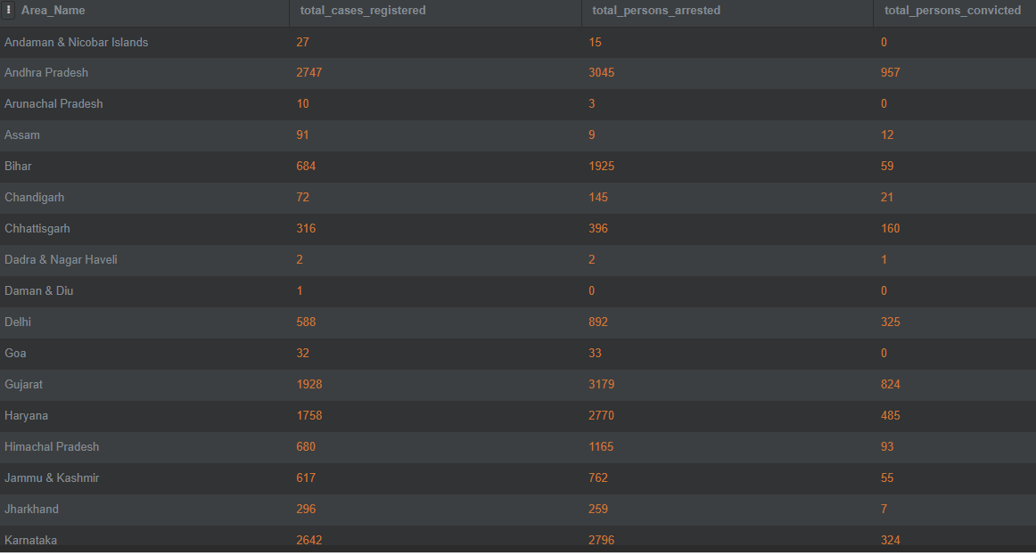

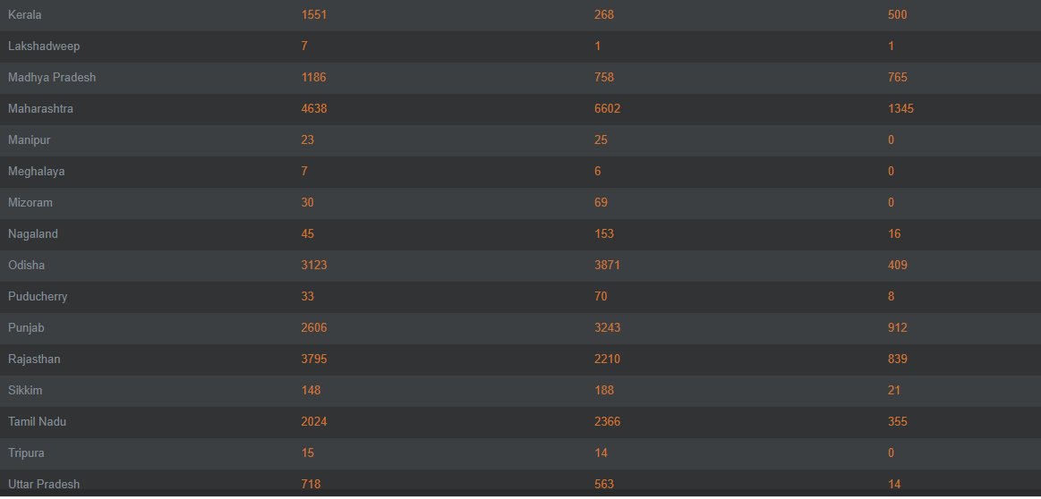



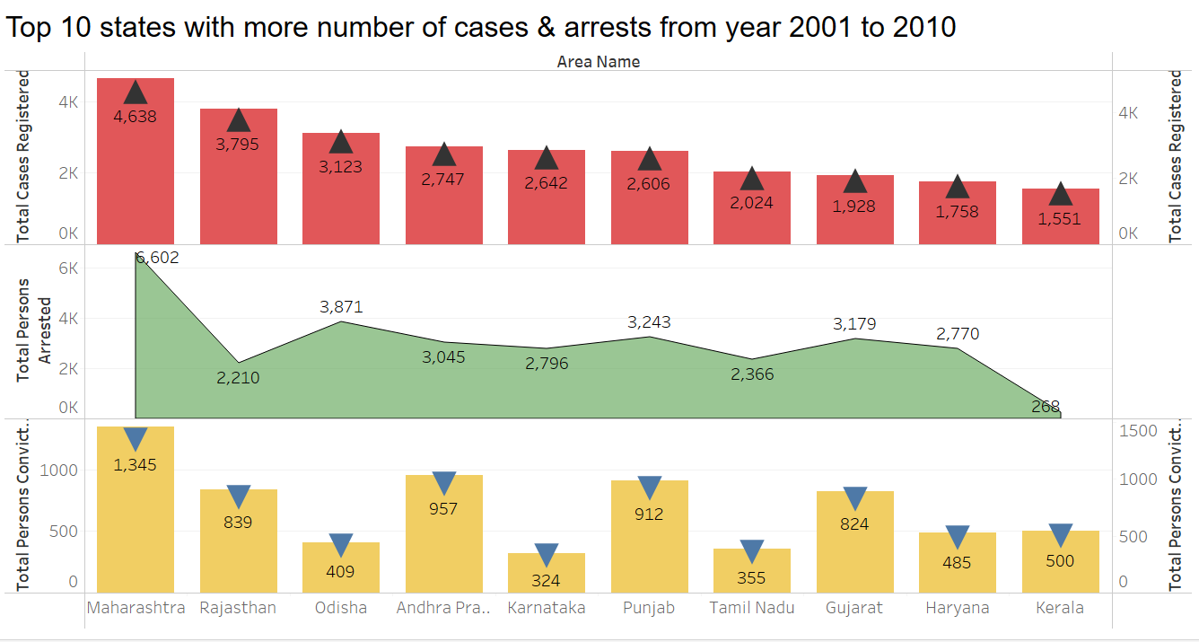

**Dataset 4:** Which state has more crime against children and women

**Q 4.** Which state has more crime against children and women?

Ans: Andhra Pradesh

Queries used:

/*

ALTER TABLE District_wise_crimes_committed_against_children_2013

RENAME COLUMN "STATE/UT+RA1:O2" TO states_ut;

ALTER TABLE District_wise_crimes_committed_against_children_2001_2012

RENAME COLUMN "STATE/UT" TO states_ut;

*/

/*

CREATE TABLE District_wise_crimes_committed_against_children_2001_2013 as

SELECT states_ut, total FROM District_wise_crimes_committed_against_children_2013

UNION

SELECT states_ut,total FROM District_wise_crimes_committed_against_children_2001_2012;

*/

-- SELECT states_ut, sum(total) as total_no_crimes_against_children from District_wise_crimes_committed_against_children_2001_2013 group by states_ut;

/*

ALTER TABLE District_wise_crimes_committed_against_women_2001_2012

RENAME COLUMN "STATE/UT" TO states_ut;

ALTER TABLE District_wise_crimes_committed_against_women_2013

RENAME COLUMN "STATE/UT" TO states_ut;

ALTER TABLE District_wise_crimes_committed_against_women_2014

RENAME COLUMN "STATE/UT" TO states_ut;

*/

/*

CREATE TABLE District_wise_crimes_committed_against_women_2001_2014 as

SELECT states_ut,total FROM District_wise_crimes_committed_against_women_2001_2012

UNION

SELECT states_ut,total FROM District_wise_crimes_committed_against_women_2013

UNION

SELECT states_ut,total FROM District_wise_crimes_committed_against_women_2014;

*/

/*

CREATE TABLE crimes_against_children_women as

SELECT states_ut, sum(total) as total_no_crimes_against_children_women from District_wise_crimes_committed_against_children_2001_2013

UNION

SELECT states_ut, sum(total) as total_no_crimes_against_children_women from District_wise_crimes_committed_against_women_2001_2014

group by states_ut;

*/

select states_ut, sum(total_no_crimes_against_children_women) from crimes_against_children_women group by states_ut ORDER by sum(total_no_crimes_against_children_women) DESC;

Output:

