This section presents the output screens of the project, demonstrating different scenarios encountered during the URL analysis process. The following cases are covered:

### **1. Legitimate URL Detection**

The system correctly identifies a safe and valid URL, classifying it as legitimate. This output ensures that the given website poses no security threats.

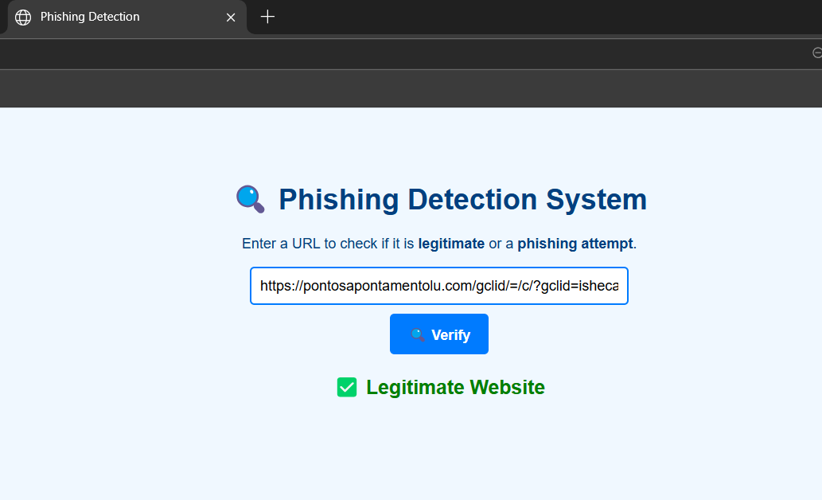

**Figure 7** : **Legitimate URL Output Image**

### **2. Phishing URL Detection**

The system detects a phishing attempt, marking the URL as malicious or potentially harmful. This result warns users about fraudulent sites attempting to steal sensitive information.

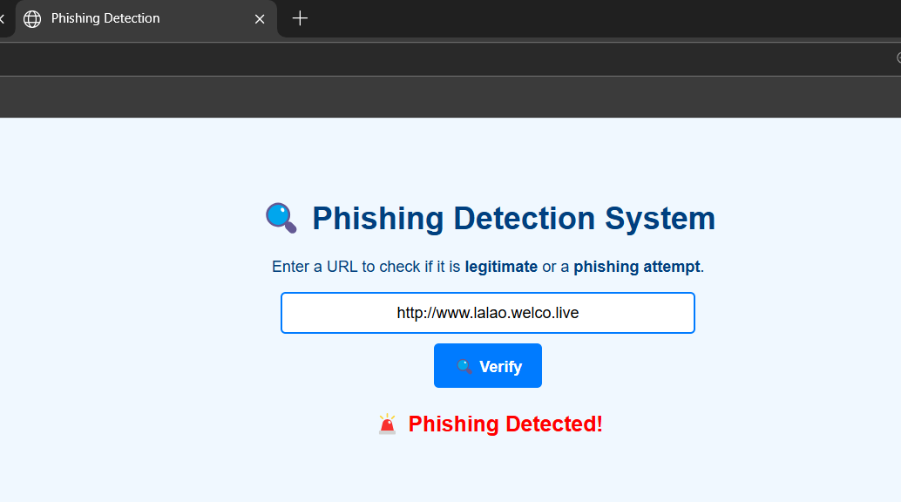

**Figure 8** : **Phishing URL Output Image**

### **3. Invalid URL Detection**

When an improperly formatted or non-existent URL is entered, the system returns an "Invalid URL" response, ensuring robustness in input validation.

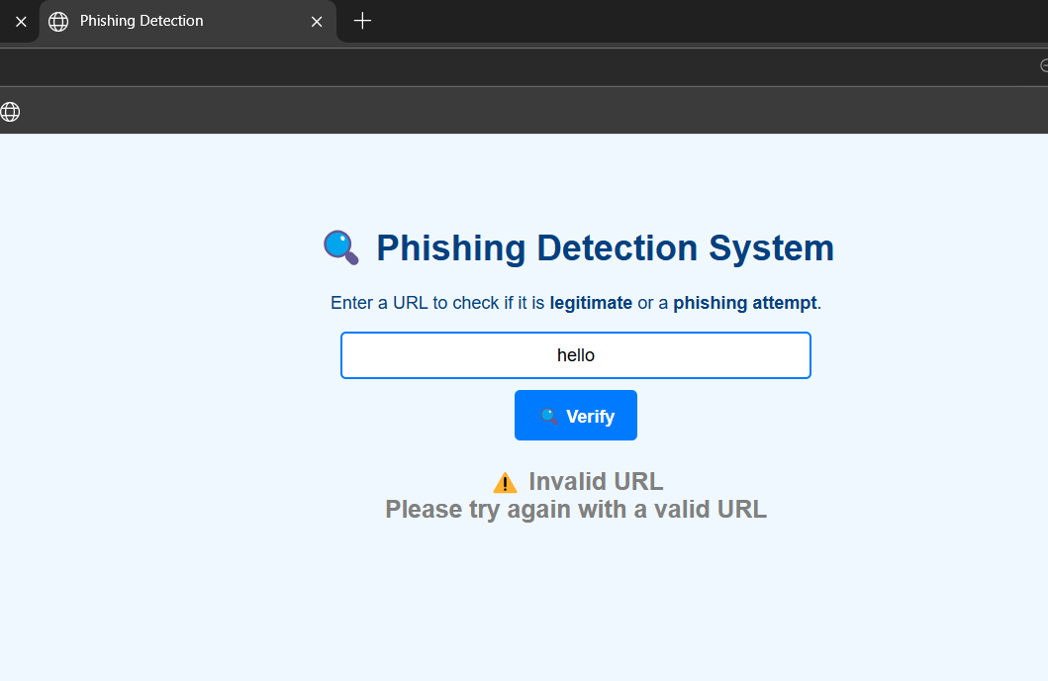

**Figure 9** : **Invalid URL Detection Output Image**

These output screens illustrate the effectiveness of the URL classification system in handling different cases, ensuring accurate and reliable web safety analysis.