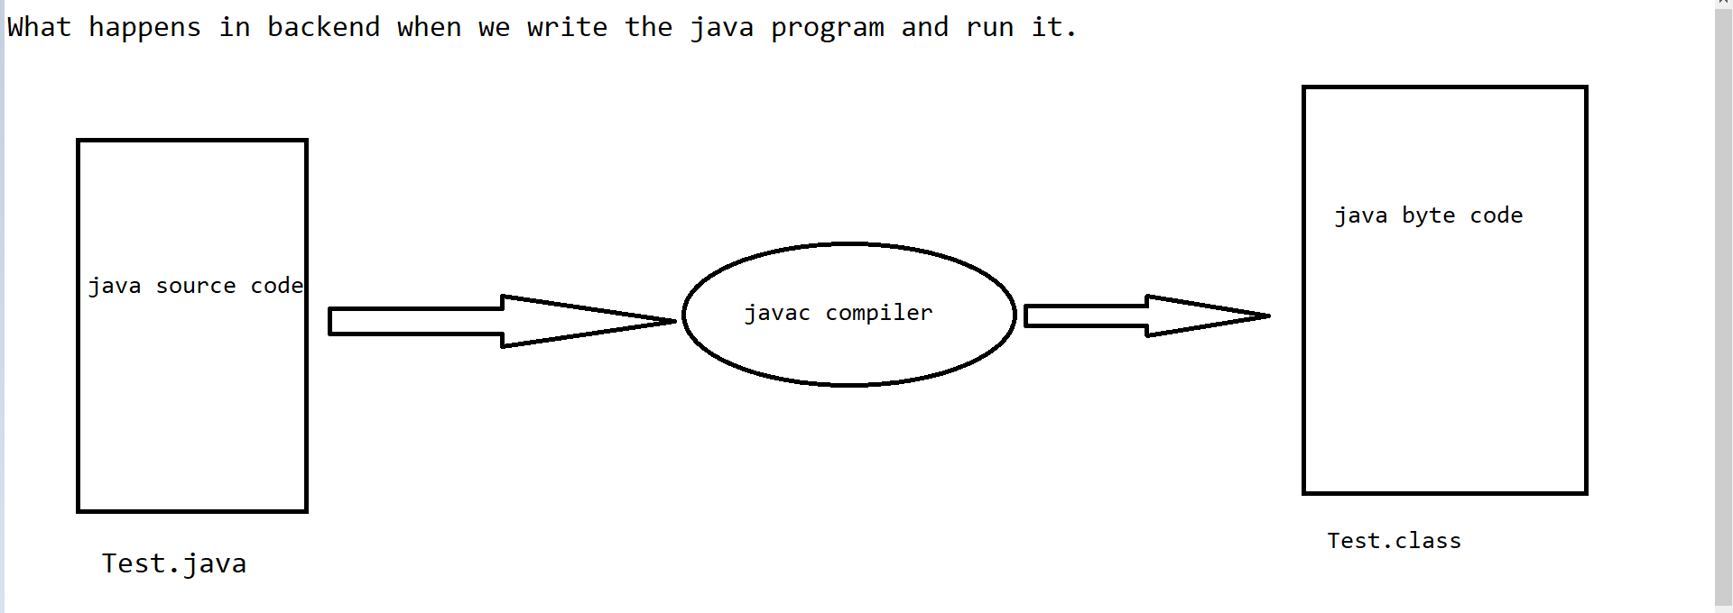

Parameters Used in First Java Program:-

#. package : keyword

#. javapackage : package name

#. ; ( semicolon ) : Completion of statement.

#. public : keyword

#. class : keyword

#. Test : classs Name

#. {} : Body

#. static : keyword

#. void : keyword/returnType

#. main() : method name

#. String : class

#. System : class

#. out : out is a PrintStream Object.

#. println() : method name

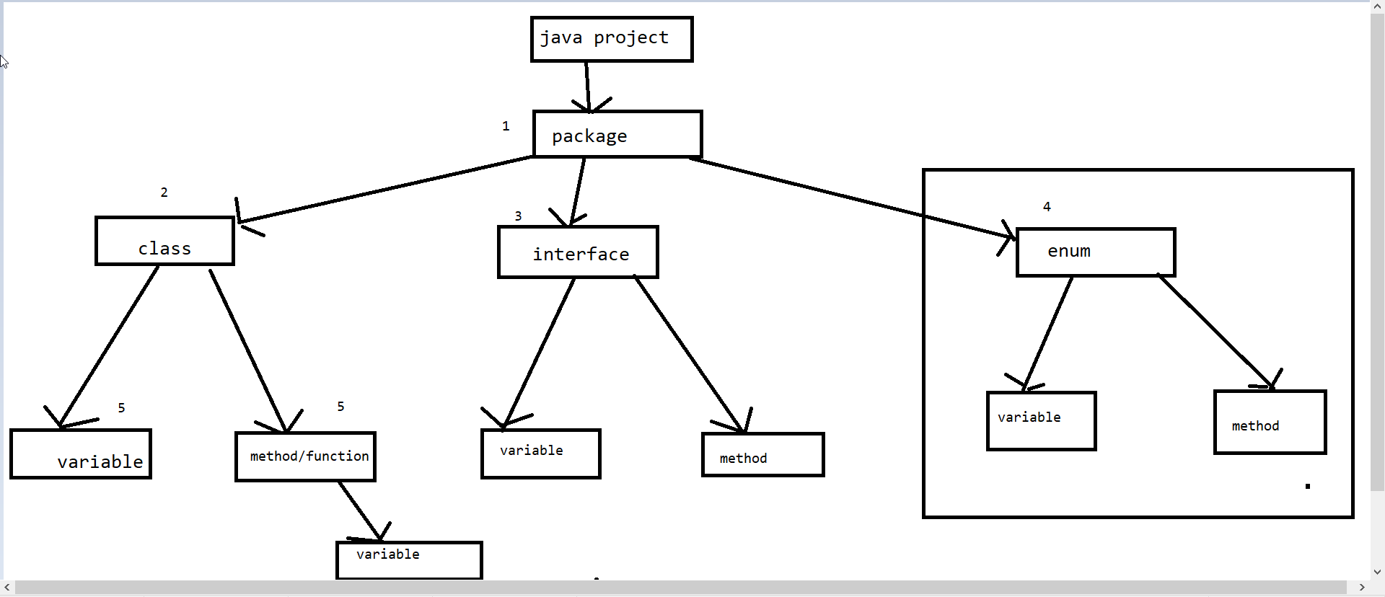

println() :-

print():-

#. ln is the difference.

#. ln stands for next line.

#. println() method places the cursor in the next line after printing the current output.

#. print() method places the cursor in the same line after printing the current output.

so that the next coming output will be printed in the same line.

Comments:-

#. Comment is the description about the basic programming element.

#. Comment are mesnt for developer/automation test engineer to understand the purpose of code.

Types of Comments:-

1. Single Line Comment - //

2. Multiline Comment - /\*code\*/

3. Document Comment - /\*\*\*\*\*/