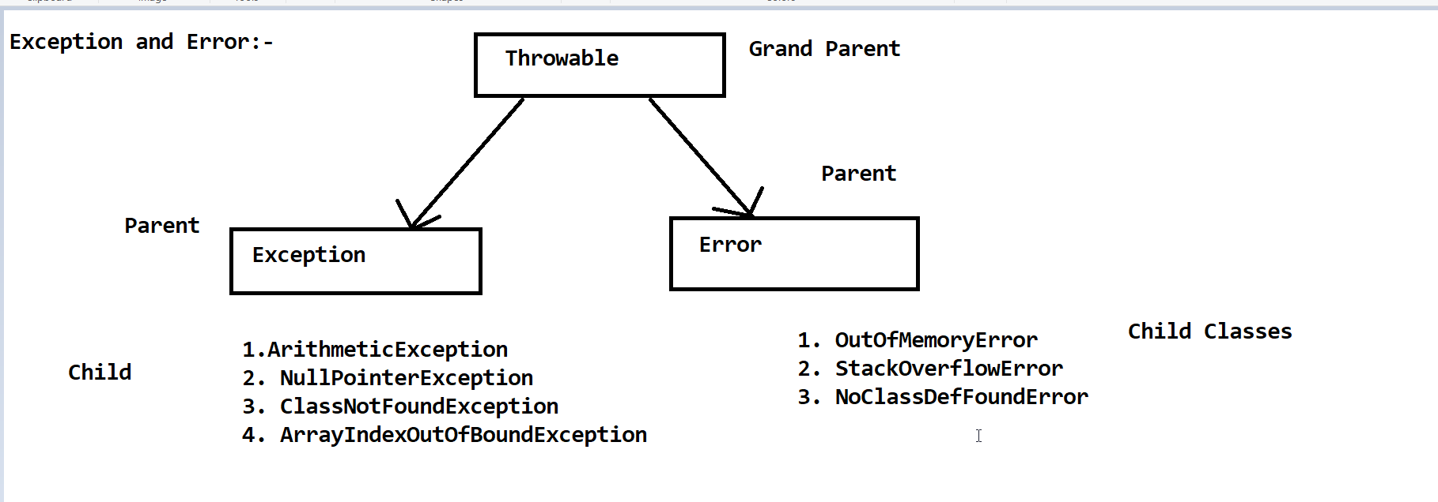

**Exception:-**

**#. An Exception is unexpected/unwanted/abnormal situation that occured at RunTime is called Exception.**

**Exception Handling:-**

**#. In Exception Handling , we should have an alternate source through which we can handle the exception.**

**#. We are having the below keywords to handle the Exception.**

**1. try**

**2. catch**

**3. throw**

**4. throws**

**5. finally.**

**Exception Hierarchy:-**

**#. Throwable class is the super class of java Exception Hierarchy which**

**contains two sub classes :-**

**1. Exception**

**2. Error**

**#. try block**

**#. Whenever we write a statement and if the statement is error suspecting statement or risky code**

**then put that code inside the try block.**

**#. catch block**

**#. The main purpose of catch block is to handle the exception which are throws by the try block.**

**Note:-**

**#. catch block will not be executed if there is no exception inside the try block.**

**finally block:-**

**#. finally block will execute always.**

**#. Multiple try catch Block:-**

**#. Multiple Catch Block**

**#. Nested try block:-**

**#. A try block which contain inside another try block called nested try block.**

**nested catch block:-**

**#. A catch block which contain inside another catch block is called nested catch block.**