**JDK :- Java Development Kit**

**JRE :- Java Runtime Environment**

**JVM :- Java Virtual Machine**

**Create a Project in Eclipse IDE:-**

**#. Go to File>New>Other>Expand Java Folder > Select Java Project > Click on the Next Button>**

**Enter the Project Name > Click on Finish Button.**

**#. Java Project Gets Created.**

**Create Java Package:-**

**#. Go to Java Project > Right Click on src Folder > New > package > Enter Package name > click on Finish.**

**Note:-**

**#. if java package color is white ,means package is empty.**

**#. if java package color is brown, means package is not empty.**

**Create Java Class:-**

**#. Right click on package >New >class >Enter the class Name > select main method ( check box ) > Click on Finish button.**

**#. JDK:- Java Development Kit**

**#. JDK needed to compile the java source code because javac compiler exists there.**

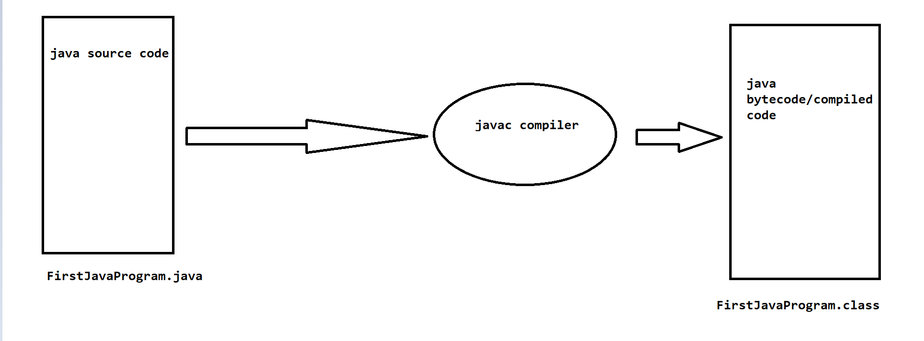

**Java Program Analysis:-**

**package : keyword**

**javapackage :- package name**

**semicolon (; ) :- Compeltion of statement.**

**public : keyword**

**class : keyword**

**FirstProgram : Class Name**

**{}:- body**

**static :- keyword**

**void :- keyword/ return type**

**main():- method name**

**String :- class**

**System :- class**

**out:- out is a printStream object**

**println():- method name**