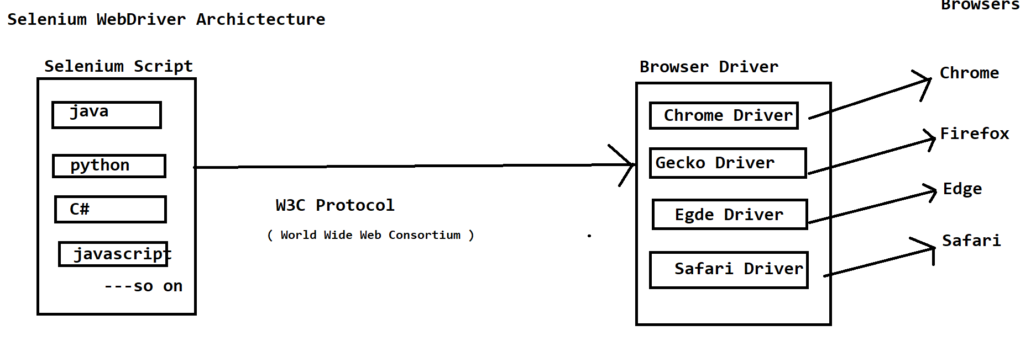

WebElement:-

#. Anything Present on Webpage is called as Web Element.Such as Textbox, Button,Link/Hyperlink,Checkbox,Radio Button,etc...

#. Web Elements are Created using HTML. ( Hyper Text Markup Langauge )

#. Each Element contains TAG,ATTRIBUTE NAME, ATTRIBUTE VALUE and TEXT.

#. Example:-

<html>

<body>

<a

href="https://www.facebook.com/login/">Facbook</a>

</body>

<html>

Here:-

html,body,a is a TAG.

href is ATTRIBUTE NAME

https://www.facebook.com/login/ is ATTRIBUTE VALUE

Facebook is TEXT

In Order to see HTML Code for Specific Web Element:-

1. Right Click on the Web Element and Select the option ' Inspect'.

2. If Right Click is disabled on the page,then Press CTRL+SHIFT+I.

3. PRESS F12

4. Go to More Tools> Developers Tool

#. In Selenium Before Performing any action such as Clicking,Typing,Selecting etc...

#. We should find the elements using 'Locaters'.

#. Locaters are used to find the elements.

#. In Selenium there are 8 types of locaters.

1. id

2. name

3. className

4. linkText

5. partialLinkText

6. cssSelector

7. xpath

8. tagName