**Java:-**

**1. JDK :- Java Development Kit**

**2. JRE :- Java Runtime Environment**

**3. JVM :- Java Virtual Machine**

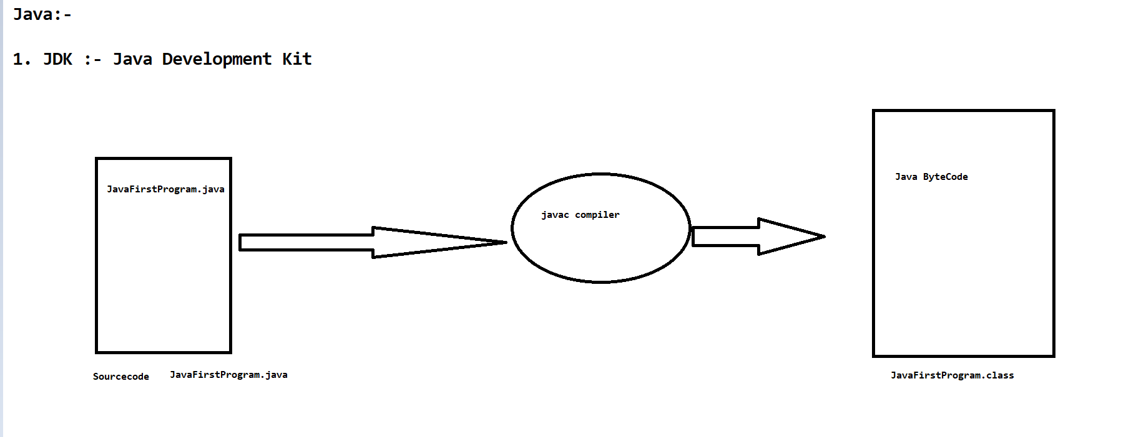

**#. When we compile any java program using javac compiler ,javac compiler converts the source code into bytecode.**

**#. Source Code :- Automation Test Engineer/Developer written code will be known as Source Code.**

**#. Compiled Code :- javac compiler generated code will be known as compiled code.**

**#. javac complier Present under java>jdk>bin folder.**

**#. Compiler :- It is a Translation Program that converts the source code into byte code.**

**.java file :- It is called as Source code**

**.class file :- It is called as Compiled code./ Bytecode**