**Parameters used in FirstJavaProgram:-**

**#. package :- keyword**

**#. javapackage :- pacakge name**

**#. ; ( semicolon ) :- Completion of Statement.**

**#. public :- keyword**

**#. class :- keyword**

**#. FirstJavaProgram :- class name**

**#. {} :- body**

**#. static :- keyword**

**#. void :- returnType/keyword**

**#. main():- method name /function**

**#. String :- Class**

**#. System :- Class**

**#. out :- out is a PrintStream Object**

**#. println() :- Method name / function**

**#. "Hello World" :- String**

**Class Loader:- It is used to load the class file.**

**ByteCode Verifier :- It is used to verify the byte code.**

**Interpreter :- It is used to provide instructions for execution for each line of code.**

**JVM :- Will act as an Intermediate between interpreter and OS.**

**OS:- Actually execute the Program**

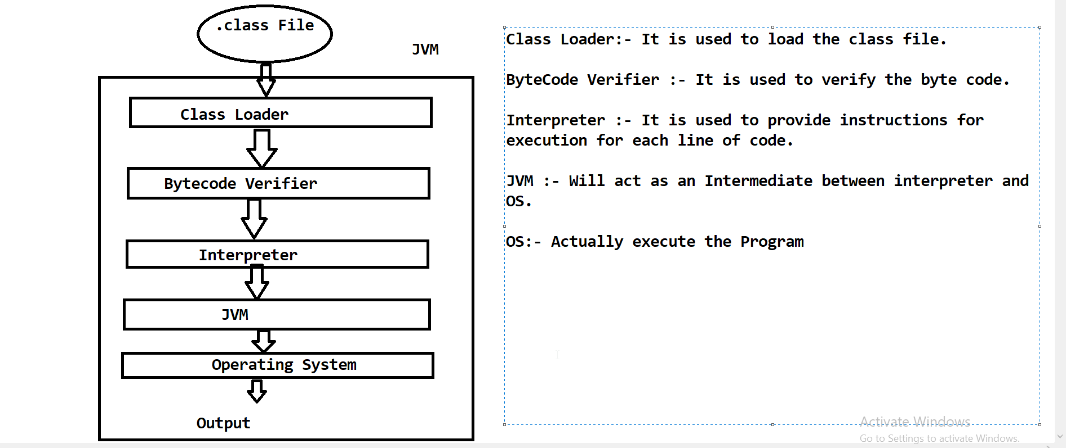

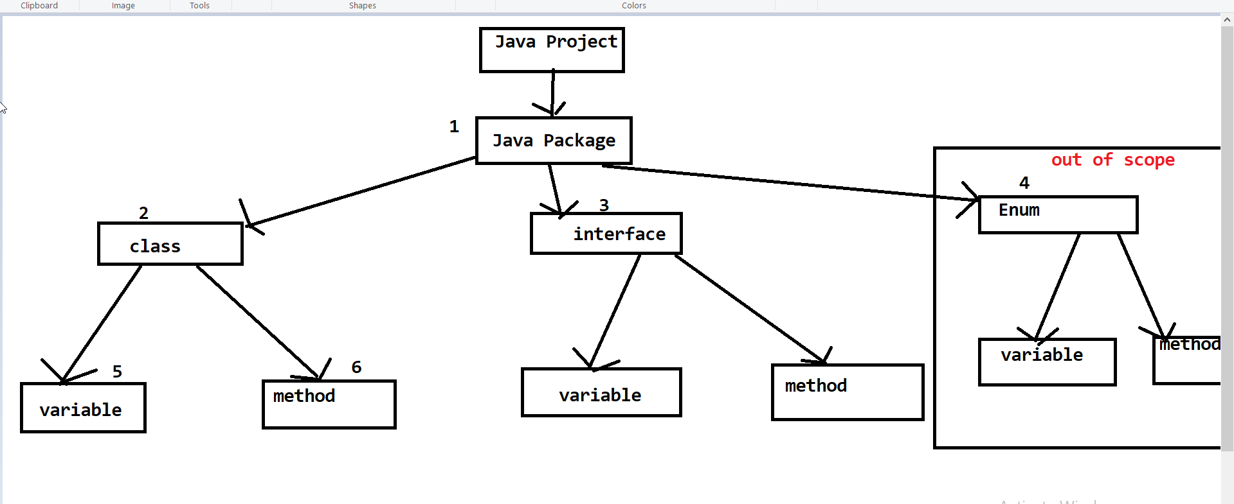

**Notes:-**

**#. Program will execute from top to bottom order.**

**#. We need main() method always to run our program.**

**#. Java Compiler compile the source code into byte code in Eclipse , when we save the Program.**