**OOPs Concept:- ( Object Oriented Programming )**

**1. Inheritance**

**2. Abstraction**

**3. Encapsulation**

**4. Polymorphism.**

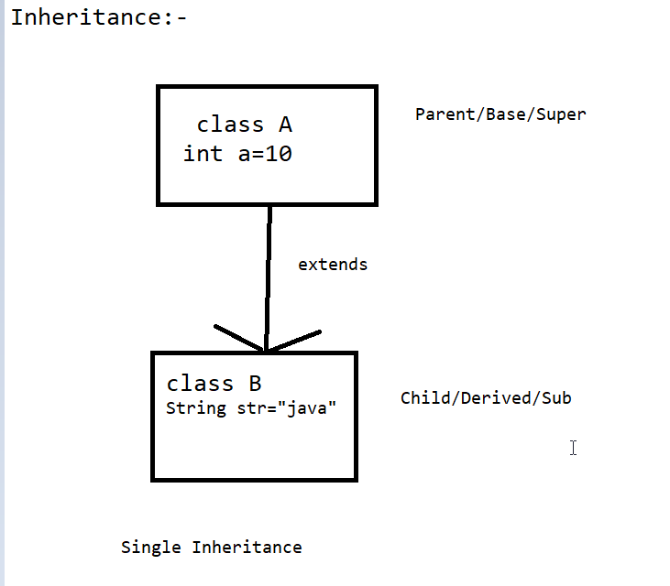

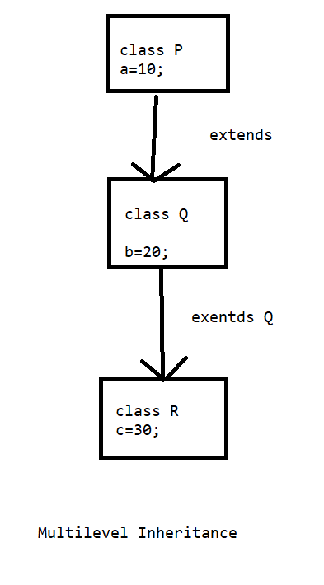

**Polymorphism:-**

#. When we perform one task in multiple ways , that is known as Polymorphism.

1. Method Overloading / Compile Time Polymorphism

2. Method Overriding / Run Time Polymorphism.

1. Method Overloading:-

#. In case of Method Overloading ,method name will be same but parameter will be different.

#. Method Overloading can happen within the same class.

2. Method Overriding:-

#.In case of method overriding, method name and parameter both will be same.

#.In Method Overriding , Child class method will be execute.

#.Method Overriding can happen in-between parent class and child class.

#. We have to use **super keyword ( super.methodName() )**

To call the parent class method.

Encapsulation:-

#. Encapsulation is a mechanism through which we can wrapping the data member (Variable)

and Member Function (Method) of a class in a single unit called Encapsulation.

Note:-

1. Declare the class variable as private.

2. Declare the class method as public.

Example:- class is the best example for Encapsulation.

Note-

We can access the private variables through public methods.

Abstraction :-

#. It is the process of hiding the implementation of code and showing only the functional behavior.

#. We can have abstract class, abstract method etc.

#. will use abstract keyword to deal with abstraction.

#. By the help of abstraction we can achieve 0 to 100% abstraction.

#. We can have abstract as well as non abstract method in a abstract class.