**DBMS ( Database Managment System )**

**#. DBMS is a software or list of programs which is used to maintain and manage the database.**

**#. We use 'QL' ( Query Language) to communicate with DB.**

**#. Security and Authorization are the two main features provided by the DBMS.**

**RDBMS ( Relational Database Managment System )**

**#. It is a type of DBMS software in which we store the data in form of tables or Relations.**

**#. If Any DBMS system follows 'Relational Model' it becomes RDBMS.**

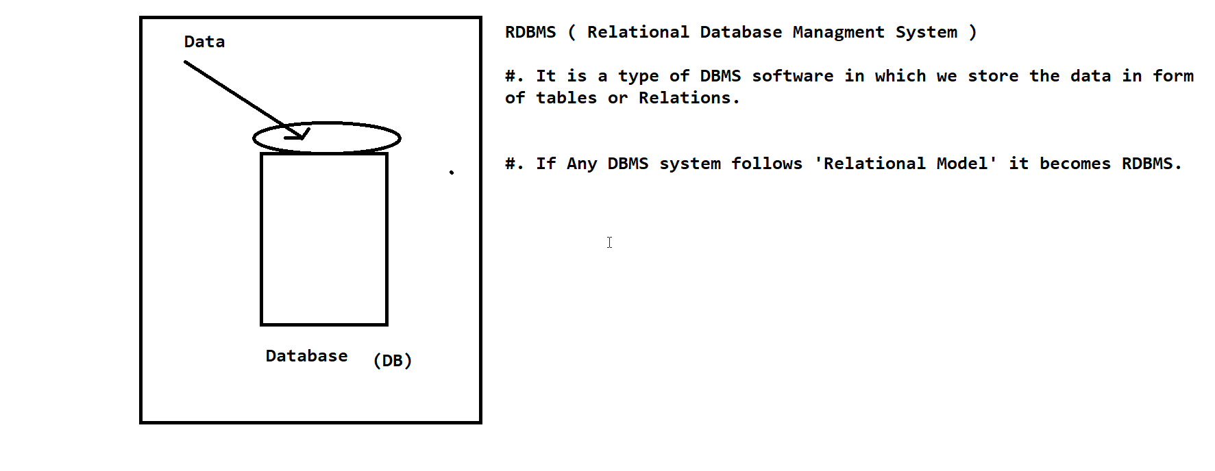

**Relational Model:-**

**#. In Relational Model the data is logically arranged and stored in the form of tables/relations.**

**#. In RDBMS ,Even the metadata is stored in the form of tables.**

**#. Metadata is nothing but information about data.**

**#. Relational Model was designed by 'E-F- CODD'.**

**Table:-**

**#. Table is a logical organization of data which consist of Rows and Columns.**

**Column:-**

**#. A Column is used to represent property of all the entities.**

**#. Column is also known as Attribute or fields.**

**Row:-**

**#. Row is used to represent all the of a single entity.**

**#. Row is also known as Records or Tuples.**