

Hotel Management System

Project Report
Submitted in Partial Fulfillment for the Degree of Master of Computer Applications


Under the Supervision of Submitted By
Arpita Jain Deepak Sharma
Designations VGU23ONS3MCA--

CENTRE OF DISTANCE & ONLINE EDUCATION
VIVEKANAND GLOBAL UNIVERSITY, JAIPUR
(2024-25)

Contents
CERTIFICATE 3
TRAINING CERTIFICATE 4
BONAFIDE CERTIFICATE 5
DECLARATION 6
ACKNOWLEDGEMENT 7
PREFACE 8
EXECUTIVE SUMMARY 9
Chapter 1: Introduction 10
Chapter 2: Objectives and Scope 13
Chapter 3: System Analysis and Feasibility Study 15
Chapter 4: Requirement Specification 18
Chapter 5: System Design 22
Chapter 6: Description of Modules 26
Chapter 7: Database Design 30
Chapter 8: Input and Output Design 34
Chapter 9: Coding and Implementation 39
Chapter 10: Testing and Validation 77
Chapter 11: Limitations and Future Scope 81
Chapter 12: Conclusion 84
Chapter 13: Bibliography 86
Chapter 14: Appendices 87
List of Abbreviations 97

CERTIFICATE

Certified that this Project Report entitled “Hotel Management System” is a record of project done independently by Mr. Deepak Sharma under my guidance and that it has not been previously submitted for the award of any degree, fellowship or associate-ship to any institute or organization.

Signature
(Arpita Jain )
Vivekanand Global University, Jaipur

TRAINING CERTIFICATE

BONAFIDE CERTIFICATE

Certified that this project report titled "Hotel Management System" is the bonafide work of Mr. Deepak Sharma who carried out the project work under my supervision in the partial fulfilment of the requirements for the award of the MCA degree.

Signature
Arpita Jain
Guide Registration Number: [ID]

DECLARATION

I hereby declare that this Project Report entitled "Hotel Management System" is a bonafide record of work done by me during the course of MCA and that it has not been previously submitted for the award for any degree/diploma, associate ship, fellowship or other Similar title of any other institute/organization.

Signature
Deepak Sharma
Vivekananda Global University, Jaipur

ACKNOWLEDGEMENT

It is not often in life that we get a chance of appreciating and expressing our feelings in black and white to thank the people who have been a crucial part of our successes, our accomplishments, and our being what we are today. I take this opportunity to first of all thank the Faculty at Vivekananda Global University, especially Dr. Arvind Kumar Singh, Director, CDOE, Ms. Arpita Jain, Program Coordinator for inculcating and instilling the knowledge, learning, will-power, values and the competitiveness and professionalism required by me as a Post Graduate learner. I would like to give special thanks to Arpita Jain for his enduring efforts, guidance, patience and enthusiasm which has given a sense of direction and purposefulness to this Project Report and ultimately made it a success. Last but not the least, I would like to thank my family, my parents and friends, for supporting me spiritually throughout the completion of the Project Report. The errors and inconsistencies remain my own.

Name of the Learner: Deepak Sharma
Roll No.: VGU23ONS3MCA

PREFACE

The project report entitled 'Hotel management System' is a sincere attempt to automate and streamline the conventional method of hotel management through the application of software engineering and Java-based technology stack. It is developed as part of the academic requirement of the Master of Computer Applications (MCA) program at Vivekananda Global University, Jaipur. This report encapsulates the journey of design, development, testing, and deployment phases of the system. It highlights the challenges faced, the methodologies applied, and the outcomes achieved. The system is built to enhance the transparency, efficiency, and user experience in hotel management for both customers and administrators.

EXECUTIVE SUMMARY

Title: Hotel Management System
Objectives of the Study:
1. To ………………………………………………………………………………………….
…………………………………………………………………………………………….
.
Research Methodology:
………………………………………………………………………………………….
…………………………………………………………………………………………….

Major Findings / Outcome:
- ………………………………………………………………………………………….
…………………………………………………………………………………………….
- ………………………………………………………………………………………….
…………………………………………………………………………………………….

Suggestions:
- ………………………………………………………………………………………….
…………………………………………………………………………………………….
.

Chapter 1: Introduction

1.1 Background
In modern times, ………………………………………………………………………………………….
………………………………………………………………………………………………………………………………………………………………………………………………………………………………………………………………………………………………………………………………………………………………………………………………………………………………………………………………………………………………………………………….

1.2 Project Overview
The Hotel Management System is ………………………………………………………………………………………….
………………………………………………………………………………………………………………………………………………………………………………………………………………………………………………………………………………………………………………………………………………………………………………………………………………………………………………………………………………………………………………………….
reservations, and viewing booking history or bills.

1.3 Need for the System
The need for an automated Hotel Management System arises due to the following ………………………………………………………………………………………….
……………………………………………………………………………………………………………………………………………………………………………………………………………………………………………………………………………………………………………………………………………………………………………………………………………………………………………………………………………………………………………………………………………………………………………………………………………………………………………………………
1.4 Purpose of the System
The Hotel Management System aims to provide:
………………………………………………………………………………………….
……………………………………………………………………………………………………………………………………………………………………………………………………………………………………………………………………………………………………………………………………………………………………………………………………………………………………………………………………………………………………………………………………………………………………………………………………………………………………………………………

1.5 Features Summary
- Some of the major features of the proposed Hotel Management System include:
- ………………………………………………………………………………………….
- ……………………………………………………………………………………………………………………………………………………………………………………………………………………………………………………………………………………………………………………………………………………………………………………………………………………………………………………………………………………………………………………………………………………………………………………………………………………………………………………………

1.6 Tools and Technologies Used
- Frontend: ……………………….
- Backend: ………………………..
- Middleware: ……………………
- Development Tools: ………………..
- Testing: ………………….
- Reporting: ……………….
- Security: ………………………

1.7 Conclusion
The ………………………………………………………………………………………….
…………………………………………………………………………………………………………………………………………………………………………………………………………………………………………………………………………………………………………………………………………………………………………………………………………………………………………………………………………………………………………………………………………………………………………………………………………………………………………………………….

Chapter 2: Objectives and Scope

2.1 Objectives of the Project
The core objective of the Hotel Management System is to develop a platform that ………………………………………………………………………………………….
……………………………………………………………………………………………………………………………………………………………………………………………………………………………………………………………………………………………………………………………………………………………………………………………………………………………………………………………………………………………………………………………………………………………………………………………………………………………………………………………
Excel and PDF formats for management and audit purposes.

2.2 Scope of the Project
- The scope of the Hotel Management System includes:
- ………………………………………………………………………………………….
- ……………………………………………………………………………………………………………………………………………………………………………………………………………………………………………………………………………………………………………………………………………………………………………………………………………………………………………………………………………………………………………………………………………………………………………………………………………………………………………………………
- Information System
Both admins and guests can view and update their personal information (contact details, preferences).
- Report Generation
The system supports generation of printable invoices and downloadable reports (occupancy, revenue summaries) using JasperReports.
- ………………………………………………………………………………………….
- ……………………………………………………………………………………………………………………………………………………………………………………………………………………………………………………………………………………………………………………………………………………………………………………………………………………………………………………………………………………………………………………………………………………………………………………………………………………………………………………………
- independence and easy deployment across different operating systems.

2.4 Out of Scope
- ………………………………………………………………………………………….
- ……………………………………………………………………………………………………………………………………………………………………………………………………………………………………………………………………………………………………………………………………………………………………………………………………………………………………………………………………………………………………………………………………………………………………………………………………………………………………………………………

Chapter 3: System Analysis and Feasibility Study

3.1 System Analysis
The first step in designing any software is to thoroughly analyze the current system or problem domain. In the case of the Hotel Management System, ………………………………………………………………………………………….
…………………………………………………………………………………………………………………………………………………………………………………………………………………………………………………………………………………………………………………………………………………………………………………………………………………………………………………………………………………………………………………………………………………………………………………………………………………………………………………………….
and improve the guest and staff experience.

3.2 Feasibility Study
Feasibility ………………………………………………………………………………………….
…………………………………………………………………………………………….
- :

3.2.1 Technical Feasibility
- ………………………………………………………………………………………….
- ……………………………………………………………………………………………………………………………………………………………………………………………………………………………………………………………………………………………………………………………………………………………………………………………………………………………………………………………………………………………………………………………………………………………………………………………………………………………………………………………

3.2.2 Operational Feasibility
The system ………………………………………………………………………………………….
……………………………………………………………………………………………………………………………………………………………………………………………………………………………………………………………………………………………………………………………………………………………………………………………………………………………………………………………………………………………………………………………………………………………………………………………………………………………………………………………

3.2.3 Economic Feasibility
………………………………………………………………………………………….
……………………………………………………………………………………………………………………………………………………………………………………………………………………………………………………………………………………………………………………………………………………………………………………………………………………………………………………………………………………………………………………………………………………………………………………………………………………………………………………………

3.2.4 Schedule Feasibility
- ………………………………………………………………………………………….
- ………………………………………………………………………………………………………………………………………………………………………………………………………………………………………………………………………………………………………………………………………………………………………………………………………………………………………………………………………………………………………………………………………………………………………………………………………………………………………

3.3 SWOT Analysis
Strengths | Weaknesses
Real-time and automated booking & billing | Initial training required for staff
Secure login and data handling | No current mobile interface
User-friendly and intuitive UI | Requires basic digital literacy

Opportunities | Threats
Integration with payment gateways and APIs | Security vulnerabilities
Integration with payment APIs | Hardware/system failures
Expansion into multi-branch or franchise hotel management | Resistance to change from staff

3.4 Conclusion
The feasibility study confirmed that the Hotel Management System is viable, ………………………………………………………………………………………….
…………………………………………………………………………………………………………………………………………………………………………………………………………………………………………………………………………………………………………………………………………………………………………………………………………………………………………………………………………………………………………………………………………………………………………………………………………………………………………………………… …...

Chapter 4: Requirement Specification

4.1 Introduction
Requirement Specification is the foundational stage of software development ………………………………………………………………………………………….
……………………………………………………………………………………………………………………………………………………………………………………………………………………………………………………………………………………………………………………………………………………………………………………………………………………………………………………………………………………………………………………………………………………………………………………………………………………………………………………………
.

4.2 Functional Requirements
These ………………………………………………………………………………………….
……………………………………………………………………………………………………………………………………………………………………………………………………………………………………………………………………………………………………………………………………………………………………………………………………………………………………………………………………………………………………………………………………………………………………………………………………………………………………………………………:

Admin Panel:
- Admin Login:
Only authenticated admin users (e.g., hotel manager, front desk staff) should be able to log in.
- Add New Guest:
………………………………………………………………………………………….
………………………………………………………………………………………………………………………………………………………………………………………………………………………………………………………………………………………………………………………………………………………………………………………………………………………………………………………………………………………………………………………………………………………………………………………………………………………………………………………………

- Generate Reports:
Admin can generate reports related to room occupancy, revenue, guest history, and service usage.
Customer Panel:
- Customer Login:
- ………………………………………………………………………………………….
- ……………………………………………………………………………………………………………………………………………………………………………………………………………………………………………………………………………………………………………………………………………………………………………………………………………………………………………………………………………………………………………………………………………………………………………………………………………………………………………………………
- Generate Invoice Slip:
Guests can generate a detailed invoice slip showing itemized charges for room rent, services (e.g., dining, laundry), taxes, and other applicable fees.
- Update/View Profile Info:
Guests can view and update their contact information, such as address, phone number, email, and password for their account.
Common Features:
- Utilities Access:
Admin Full Access:
Admins can access all system features, including:
- Guest login management
- Guest check-in / check-out handling
- Bill generation for bookings and services
- Viewing and updating guest records
- Generating and exporting reports
- Payment tracking
- Secure logout from any screen

4.3 Non-Functional Requirements
These ………………………………………………………………………………………….
……………………………………………………………………………………………………………………………………………………………………………………………………………………………………………………………………………………………………………………………………………………………………………………………………………………………………………………………………………………………………………………………………………………………………………………………………………………………………………………………
Portability:
As the system is built using Java, it can run on Windows, Linux, or macOS, allowing flexible deployment across various hotel infrastructures.

4.4 Hardware Requirements
- Processor: Intel i3 or above
- RAM: 4 GB minimum
- Disk: 500 MB free space
- Display: Minimum 1024×768 resolution
- Others: Java Runtime Environment (JRE), MySQL Server

4.5 Software Requirements
- Operating System: Windows/Linux/macOS
- Development IDE: NetBeans or Eclipse
- Database: MySQL Server
- Java Version: JDK 17 or higher
- Other Tools: Jasper Reports, JDBC, JUnit, PDF viewer

Chapter 5: System Design

System design is the blueprint of the system to be built. It involves transforming the functional requirements into a structured solution that can be developed and implemented efficiently. ………………………………………………………………………………………….
……………………………………………………………………………………………………………………………………………………………………………………………………………………………………………………………………………………………………………………………………………………………………………………………………………………………………………………………………………………………………………………………………………………………………………………………………………………………………………………………
.

5.1 System Architecture
The system uses a 3-tier layered architecture, comprising the following layers:

1. Presentation Layer (Frontend):
- Developed using Java Swing/JavaFX.
- Allows user interactions via GUIs.
- Contains login forms, admin dashboards, billing input forms, etc.
2. Business Logic Layer:
- Handles bill calculation, login validation, data formatting, etc.
- Interacts with both frontend and backend.
3. Data Access Layer:
- Interacts directly with MySQL database using JDBC.
- Handles queries like INSERT, UPDATE, DELETE, and SELECT.

5.2 Architecture Diagram (Descriptive)
+----------------------------+
| Presentation Layer |
| (Java Swing / JavaFX) |
+----------------------------+

+----------------------------+
| Business Logic Layer |
| (Java Classes & Methods) |
+----------------------------+

+----------------------------+
| Data Access Layer |
| (JDBC - SQL Queries) |
+----------------------------+

+----------------------------+
| MySQL Database |
| (Customer, Billing, Tariff)|
+----------------------------+
5.3 Entity-Relationship (ER) Diagram
Entities and Relationships:
- Guest → Has one or more Bookings
- Booking → Assigned to one Room
- Room → Can have multiple Bookings over time
- Billing → Linked to Booking, Calculated per Stay
- Payment → Tracks bill paid or pending for Booking
- Admin → Manages Guest, Room, Booking, Billing, and Payments

[Guest] ─── (1:M) ─── [Booking] ─── (M:1) ─── [Room]
| |
└─── <Managed by> ─── [Admin]└── (1:1) ─── [Billing] ─── (1:1) ─── [Payment]
5.4 Data Flow Diagram (DFD)
Level 0 – Context Diagram:
- System takes input from Admin or Customer and gives output such as bills, reports, or notifications.
0-LEVEL

Registration confirmed
ADMINISTRATOR

Checks for confirmation
Upload info
Login & reservation
Registers
NEW USER
OLD USER
VISITOR
HOTEL SERVER
HOTEL RESERVATION SYSTEM

Visits the site
Online Payment
& billing

5.5 Module-wise Design
Admin Modules:
- New Customer Registration
- Guests Detail View/Edit
- Room Configuration
- Bill Calculation and Entry
- Report Generation
Customer Modules:
- Bill Viewing and Payment
- Information Update
- Generate Bill Slip

5.6 Input Forms & Interfaces
- Login Form (dropdown to select Admin/Receptionist )
- New Customer Form (Name, Identity Proof, Email, Contact, Room Type)
- Bill Calculation Form ((Booking ID, Room Charges, Services, Duration)
- Payment Form (View Due Amount, Select Booking, Process Payment)
- Reports Page (Filter by month, booking ID, guest)

5.7 Output Design
- Bill Summary ((room charges, service charges, tax, total, due date)
- Receipt / Bill Slip (formatted printable output using JasperReports)

Chapter 6: Description of Modules

The Hotel Management System is divided into multiple modules, each responsible for a specific set of functionalities. This modular design ensures separation of concerns, better maintenance, and improved scalability. Below is a detailed description of each module.

6.1 Authentication Module
Purpose: ………………………………………………………………………………………….
……………………………………………………………………………………………………………………………………………………………………………………………………………………………………………………………………………………………………………………………………………………………………………………………………………………………………………………………………………………………………………………………………………………………………………………………………………………………………………………………

- .

6.2 Admin Dashboard Module
Once logged in, the admin user has access to the following features:

6.2.1 New Guest
- Allows Receptionist to register a new guest.
- Automatically generates a unique ID .
- Inputs include name, identity proof, city, state, email, and phone number.
- Saves the data into the customer table in MySQL.

6.2.2 Guest Information
Receptionist selects room type and location (e.g., floor, wing) when registering a new guest.
Option to define:
Room Type (Single, Double)
Booking Type (Online, Offline)

6.2.3 Employee Details
- ………………………………………………………………………………………….
- ……………………………………………………………………………………………………………………………………………………………………………………………………………………………………………………………………………………………………………………………………………………………………………………………………………………………………………………………………………………………………………………………………………………………………………………………………………………………………………………………
- .

6.2.4 Deposit Details
- View, search, and print bill deposit data.
- Receptionist can filter by identity proofs.
- Shows billing status (paid/unpaid), tax, and total amount.

6.2.5 Calculate Bill
- Receptionist selects guest details and booking reference.
- Enters stay details (e.g., number of nights, additional services used).
- System calculates the total bill using pre-defined room rates and service charges.
- Option to add taxes and generate the final bill or receipt.

6.2.6 Reporting
Receptionist can generate billing reports based on guest stay details.

6.3 Receptionist Dashboard Module
After login receptionist can use the following features:
Add Guest: Register new guests with personal details, ID proof, contact ………………………………………………………………………………………….
……………………………………………………………………………………………………………………………………………………………………………………………………………………………………………………………………………………………………………………………………………………………………………………………………………………………………………………………………………………………………………………………………………………………………………………………………………………………………………………………
- Make Billing: Generate and finalize bills including room charges, additional services, taxes, and discounts.

6.4 Error Handling Module
- Displays receptionist alerts for:
  - Missing input fields
  - Invalid login credentials
  - Failed database transactions
- Logs internal exceptions for admin debugging.

6.5 Future Integration Modules (Planned)
- Mobile App Extension using Java Android SDK:
Develop a mobile app for guests to make bookings, check-in/check-out, view bills, and request services.

- Smart Room Integration (IoT):
Integrate with IoT-enabled devices for real-time monitoring of room conditions.

- Payment Gateway API Integration:
Enable online payments for room bookings, services, and billing through secure payment gateways.

Chapter 7: Database Design

The Hotel Management System uses a relational database model implemented using MySQL. The design ensures data normalization, referential integrity, and optimized retrieval. The database schema is structured into several interrelated tables corresponding to system modules.

7.1 Entity Tables Overview
- Customer
Field | Datatype | Constraint
id | Varchar(30) | NN
number | Numeric(30) | PK
name | Varchar(30) | NN
gender | Varchar(30) | NN
country | Varchar(30) | NN
Room number | Numeric(30) | NN
Status | Varchar(30) | NN
Deposit | Numeric(30) | NN

- Room
Field | Datatype | Constraint
Room_number | Numeric(30) | PK
availability | Varchar(30) | NN
Clean status | Varchar(30) | NN
Price | Number(30) | NN
BedType | Varchar(30) | NN

- Employee

Field | DataType | Constraint
Name | Varchar(30) | NN
Age | Numeric(30) | NN
Gender | Varchar(30) | NN
Job | Varchar(30) | NN
Salary | Number(30) | NN
Phone | Number(30) | NN
ID proof | Number(30) | PK
Email | Varchar(30) | NN

- Driver

Field | DataType | Constraint
Name | Varchar(30) | NN
Age | Numeric(30) | NN
Gender | Varchar(30) | NN
Company | Varchar(30) | NN
Modal | Varchar(30) | NN
Available | Varchar(30) | NN
Location | Varchar(30) | NN

5.Login
Field | DataType | Constraint
Username | Varchar(30) | PK
Password | Varchar(30) | NN

6.Department
Field | DataType | Constraint
Department | Varchar(30) | PK
Budget | Numeric(30) | NN

7.2 Table Structures

7.2.1 Table: admin
create table login(username varchar(25), password varchar(25));
7.2.2 Table: employees
create table employee (name varchar (20), age varchar (20), gender varchar (20), job varchar (20), salary varchar (20), phone varchar (20), email varchar (20), aadhar varchar (20));
7.2.3 Table: Driver
create table driver (name varchar (20), age varchar (20), gender varchar (20), company varchar (20), carname varchar (20), available varchar (20), location varchar (20));
7.2.4 Table: receptionist
create table login2(user_name varchar(25), password varchar(25));
7.2.5 Table: department
create table department( department varchar(80), budget varchar(30));

7.2.6 Table: customer
create table customer(document varchar (30), number varchar (30), name varchar (30), gender varchar (20), country varchar (30), room varchar (20), checkintime varchar (80), deposit varchar (30));
7.2.6 Table: room
create table room (roomnumber varchar(20), availability varchar(20), cleaning_status varchar(20), price varchar(20), bed_type varchar(20));
7.3 Relationships (ER Concepts)
guest ↔ room info → One-to-One
Each guest is assigned a specific room during their stay.

guest ↔ billing → One-to-Many
A guest may have multiple bills (room charges, pickup services).

billing ↔ payment → One-to-One
Each bill corresponds to a single payment record.

Room type ↔ billing → Many-to-One (room type)
Multiple bills may be linked to the same room type (Single, Double).

7.4 Security Measures in Database
- ………………………………………………………………………………………….
- …………………………………………………………………………………………….
- views.

Chapter 8: Input and Output Design

The ………………………………………………………………………………………….
…………………………………………………………………………………………….

8.1 Input Design
………………………………………………………………………………………….
…………………………………………………………………………………………….

8.1.1 Admin Inputs
Form | Input Fields | Validations
Login | Username, Password | Mandatory, case-sensitive
New employee Registration | Name, ID proof, Age, State, Email, Phone, Salary, Type of worker | Email format, phone length, uniqueness of ID proof
New driver Registration | Name, Age, ID proof, Mobile No., Car Company & Model | Dropdown options, dependent on Cars
Room Add | Room No., Type of Room (Single/ Double Bed) | must be positive integers, room no. must exist

8.1.2 Receptionist Inputs
Form | Input Fields | Validations
Login | Username, Password | Must match existing customer
New Guest Form | ID proof, Name, Age, Country, Room no. | Basic field validations
Room | Address, City, State, Email, Phone | Basic field validations
Department | Department, budget | Must exist in billing table
All Employee info | Name, ID Proof, Type of work | Show Details of existing Employee
Customer info | ID Proof, Mobile No, name | Must match existing customer
Manger info | Manger ID | Show Details
Check out | Customer ID, Room No | Must exist in Guest table
Update check in details | Id, Room No, | Update and Check details
Pick up in Service | Type of Car | Show available cars
Search room | Room Bed Type (Single, Double) | Basic field validations

8.1.3 Input Controls Used
TextFields: ………………………………………………………………………………………….
…………………………………………………………………………………………….
- Buttons: Submit, Update, Check-in, Check-out, Generate Bill, Back, Logout
8.2 Output Design
Output design focuses on presenting processed information to users in a readable, printable, and exportable format.

8.2.1 Types of Output
Output Type | Description
Bill Summary | Displays room charges, service charges (e.g., dining, pickup), tax applied, and total amount.
Guest Details View | Lists registered guests with search, sort, and print options for quick reference.
Reports | Receptionist can generate reports by month, guest, or room type
Confirmation Messages | Alerts for successful guest registration, check-in/check-out, billing, or error notifications

8.2.2 Sample Output Layout – Bill Slip
--------------------------------------------------------
Hotel Management System – Guest Bill Slip
--------------------------------------------------------
Hotel Management System – Guest Bill Slip
--------------------------------------------------------
Guest Name : Anil Sharma
Room Number : 205
Room Type : Double
Check-in Date : 05-June-2025
Check-out Date : 10-June-2025
Stay Duration : 5 nights
Service Charges: ₹ 12500.00
Tax : ₹ 275.00
Total Amount : ₹ 12,775.00
Status : Paid
--------------------------------------------------------
8.2.3 Output Delivery Channels
- On-screen display (JTable, JLabel, etc.)
- Printer-friendly layouts
- Confirmation pop-ups

8.3 User Interface Design Principles Applied
- Consistency: All guest, receptionist, and admin screens follow a uniform design style, color scheme, and layout.

- Navigation: Clear menus and buttons for functions like guest registration, check-in, check-out, room status, and billing.
- Feedback: Dialog messages displayed for actions such as successful guest check-in/out, bill generation, or error handling.
- Accessibility: High-contrast interface, large readable fonts, and intuitive icons to support diverse users, including staff with varying digital skills.
- Responsiveness: Quick screen transitions, minimal input lag during operations like room allocation, service addition, and report generation.
Chapter 9: Coding and Implementation

This chapter focuses on the actual implementation of the Hotel Management System, highlighting the key classes, methods, and logic used in building the software. The system is developed using Java with Swing GUI, integrated with a MySQL backend via JDBC.

9.1 Development Environment
Tool/Tech | Description
Language | Java (JDK 17)
GUI | Java Swing
Database | MySQL
Connector | JDBC
IDE | NetBeans / Eclipse
Testing | JUnit
Reporting | JasperReports

9.2 Package Structure
/src
├── main
│ ├── Login.java
│ ├── AdminDashboard.java
│ ├── ReceptionistDashboard.java
│ ├── RegisterGuest.java
│ ├── GenerateBill.java
│ └── Utilities.java
├── db
│ ├── DBConnection.java
└── report
├── GenerateReport.java

9.3 Admin Details Code : Paste your code here

9.10 Implementation Methodology

Chapter 10: Testing and Validation

10.1 User Acceptance Testing (UAT)

10.2 Conclusion

Chapter 11: Limitations and Future Scope

11.1 Limitations of the Current System

11.3 Future Enhancements
The following improvements are suggested to make the system more robust and scalable:

1. Integration with IoT Smart Devices
2. Web-Based Version
3. Mobile App Interface
4. Dynamic RoomTariff Management
5. Payment Gateway Integration
6. Cloud Storage
7. Notification System
8. Bi-lingual or Multi-lingual Support

11.4 Long-Term Vision

Chapter 12: Conclusion

The Hotel Management System is a ………………………………………………………………………………………….
……………………………………………………………………………………………………………………………………………………………………………………………………………………………………………………………………………………………………………………………………………………………………………………………………………………………………………………………………………………………………………………………………………………………………………………………………………………………………………………………

………………………………………………………………………………………….
……………………………………………………………………………………………………………………………………………………………………………………………………………………………………………………………………………………………………………………………………………………………………………………………………………………………………………………………………………………………………………………………………………………………………………………………………………………………………………………………

Final Recommendation:
………………………………………………………………………………………….
……………………………………………………………………………………………………………………………………………………………………………………………………………………………………………………………………………………………………………………………………………………………………………………………………………………………………………………………………………………………………………………………………………………………………………………………………………………………………………………………

Chapter 13: Bibliography

Chapter 14: Appendices

Appendix A: Sample Login Screen (Description)
- Dropdown to select Admin or Receptionist
- Input fields for username and password
- Login and Cancel buttons
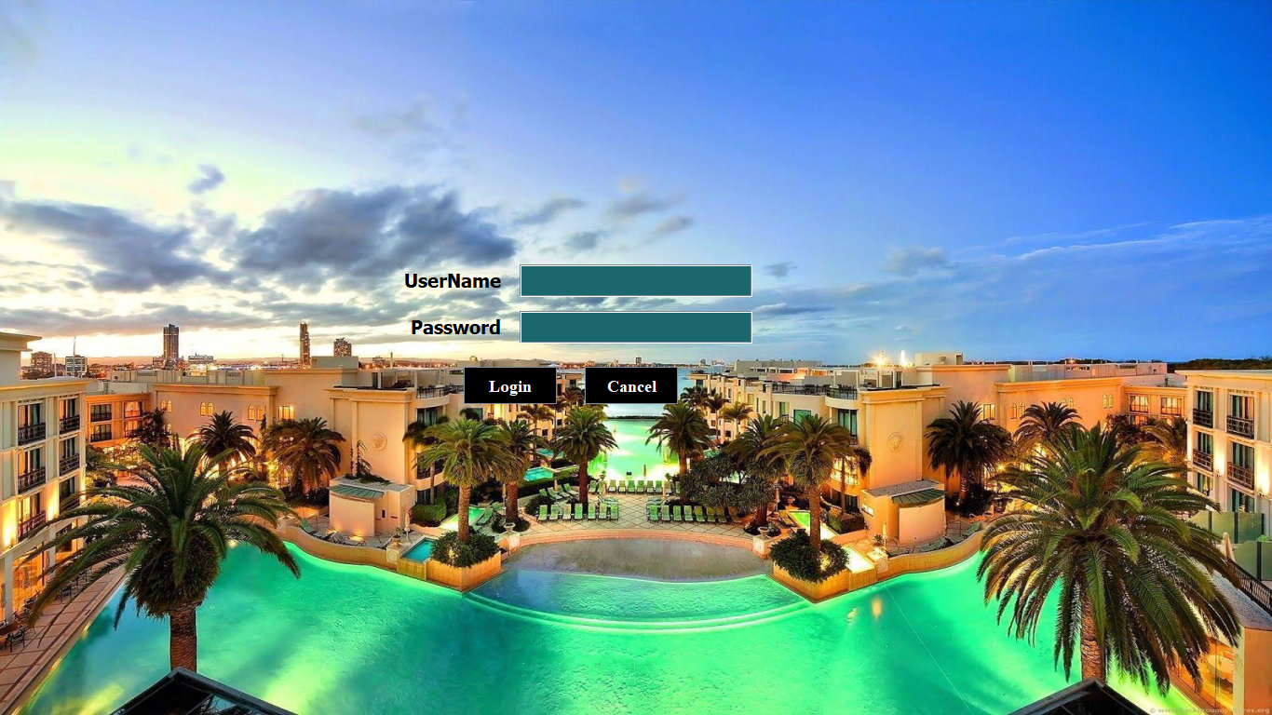

Login Screen for Admin & Receptionist

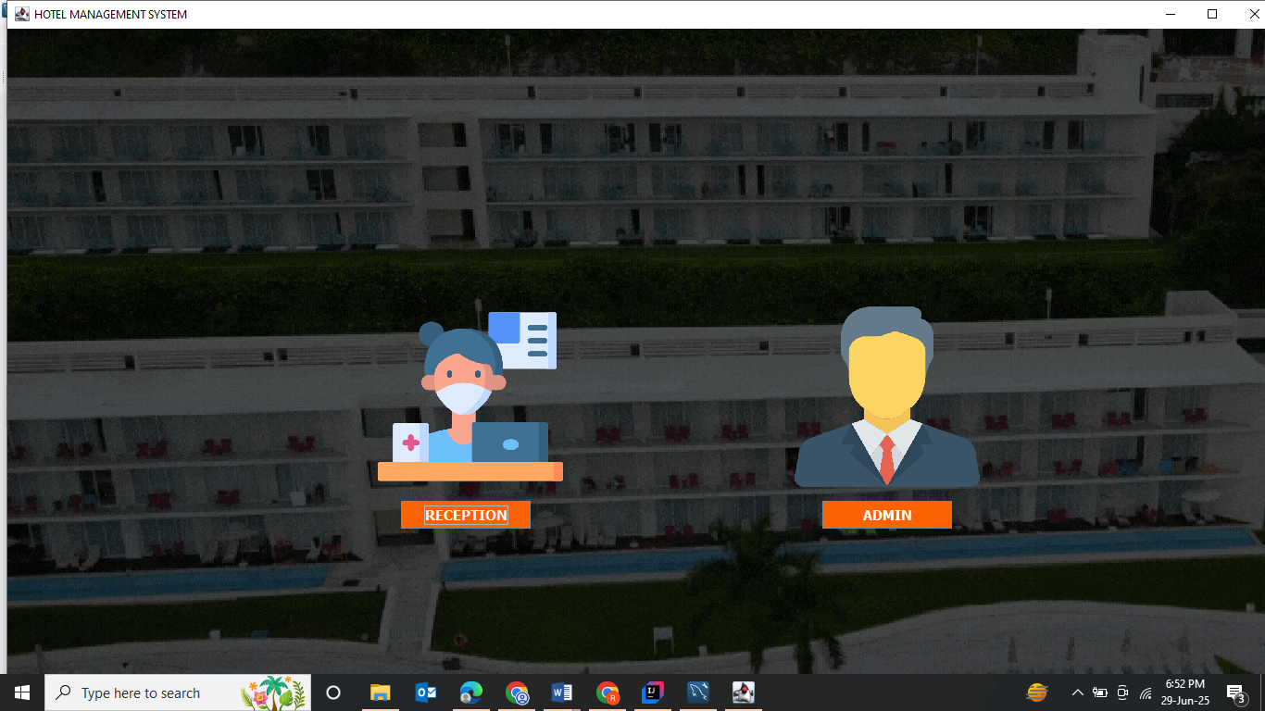

Add information by Admin of Employee, Room and Drivers:

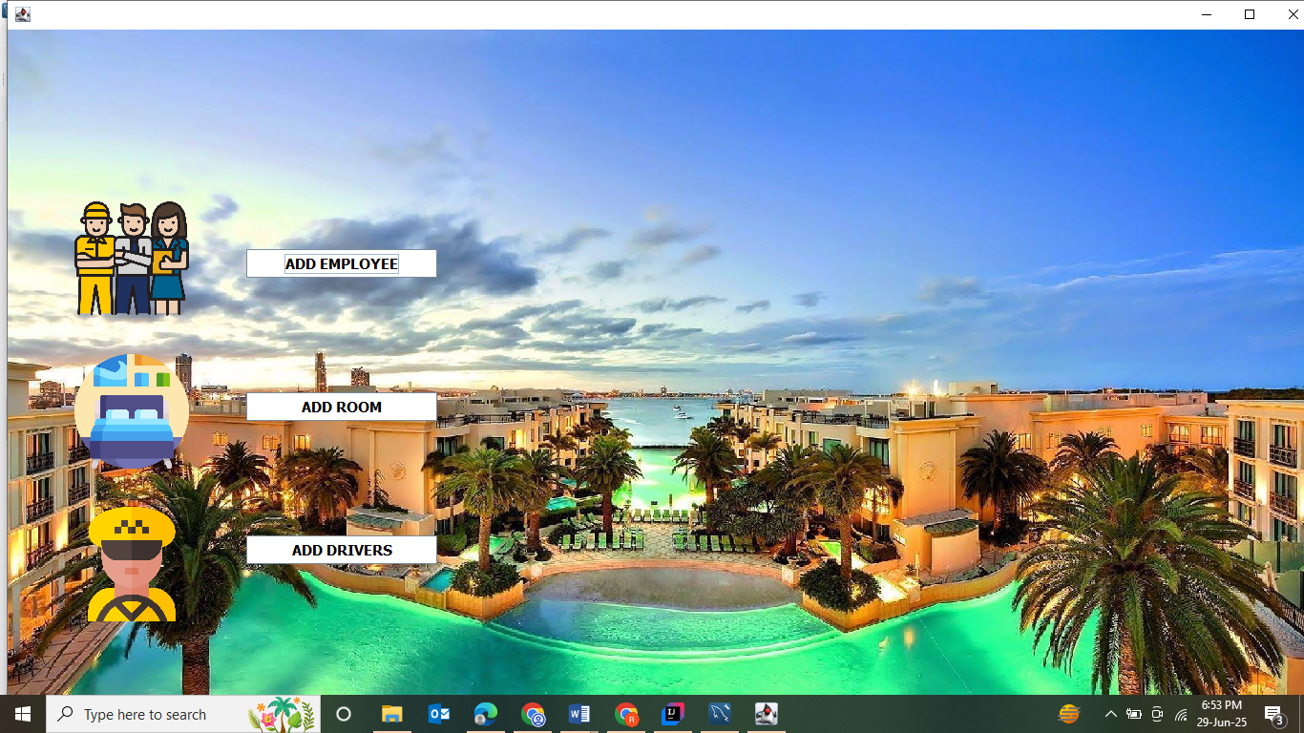

Add information by Admin of Employee

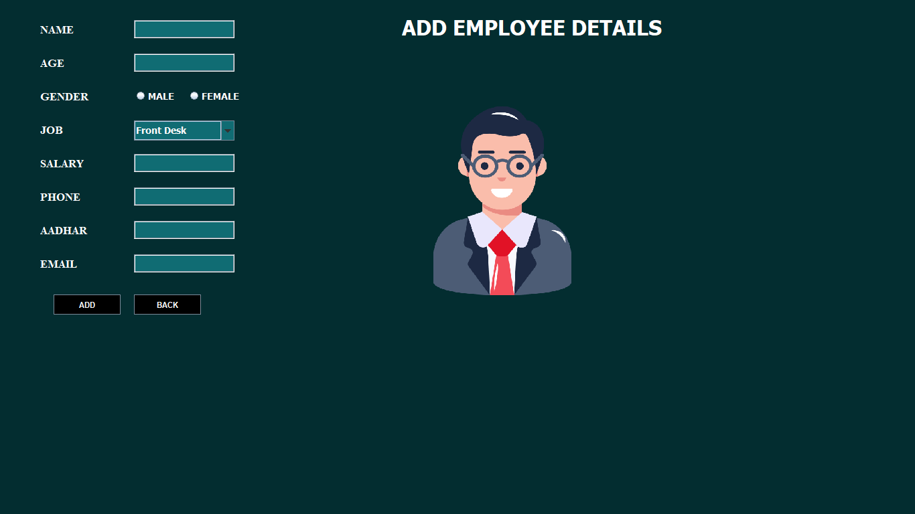

Add information by Admin of Rooms
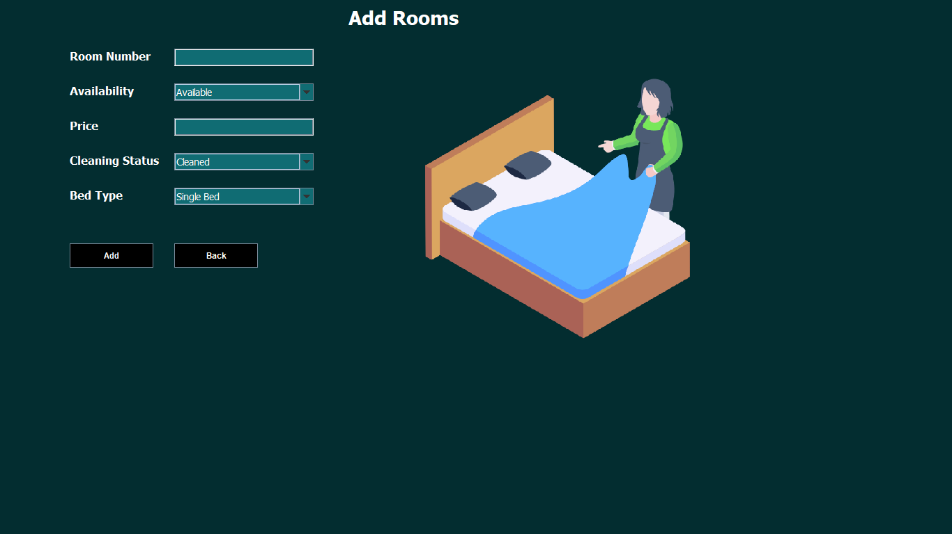

Add information by Admin of Drivers

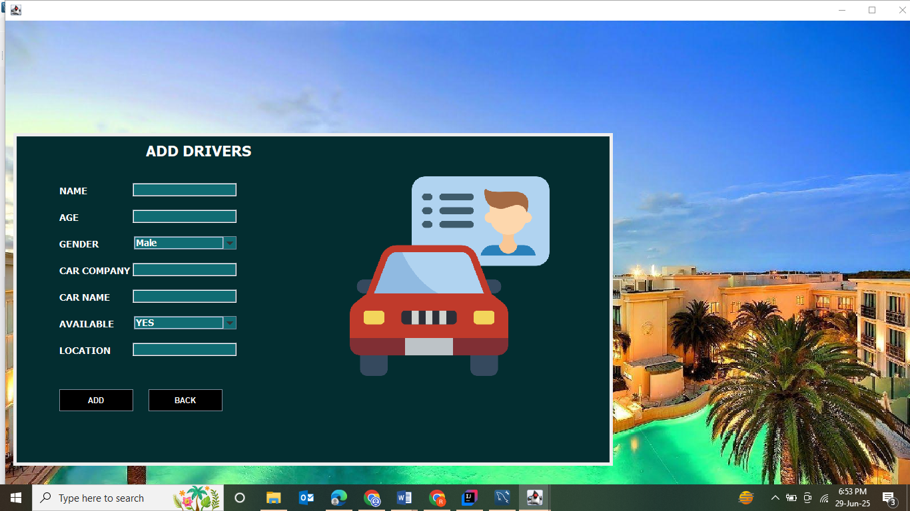

Page controlled by Receptionist
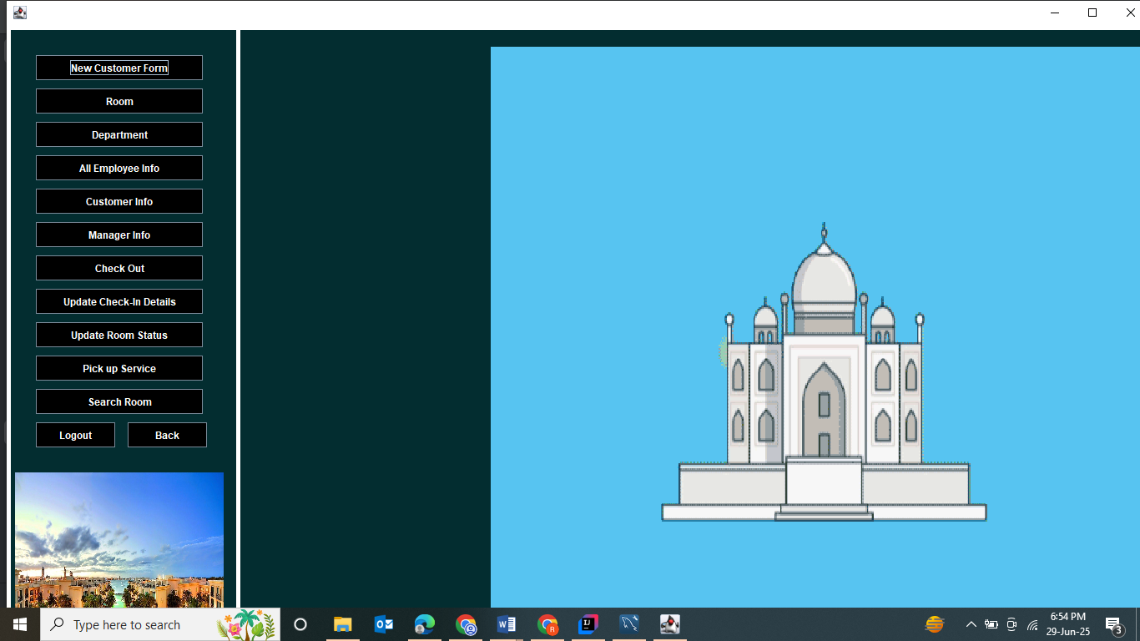

Add information by Receptionist of New guest
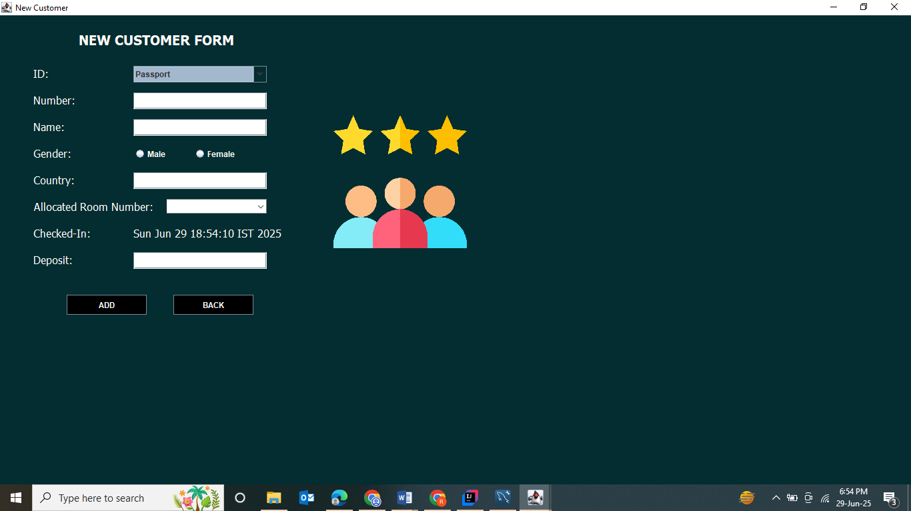

Room Information Tables
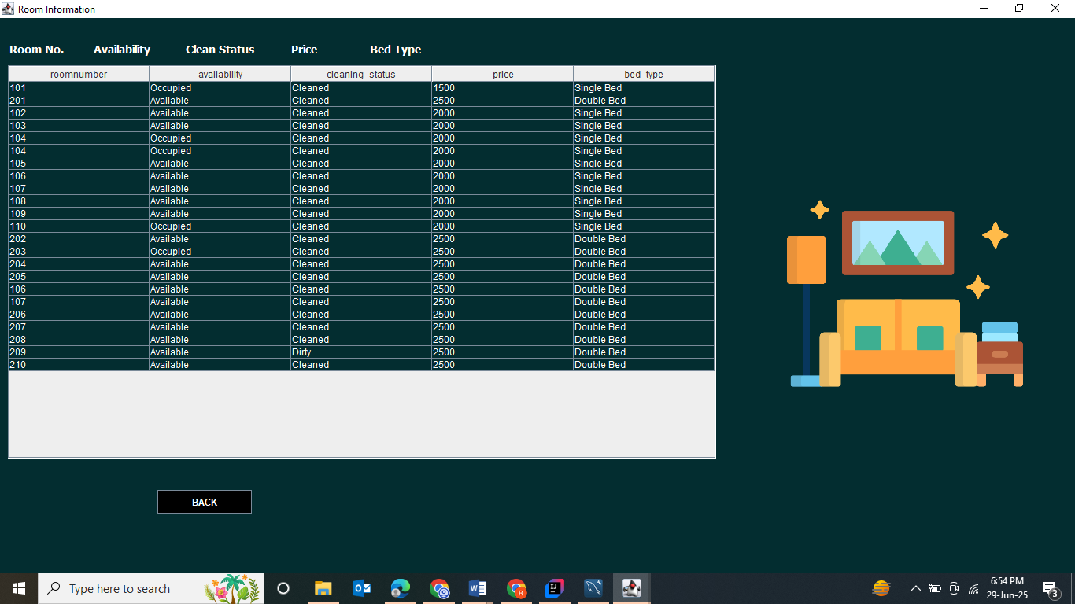

Department Budget Information Tables
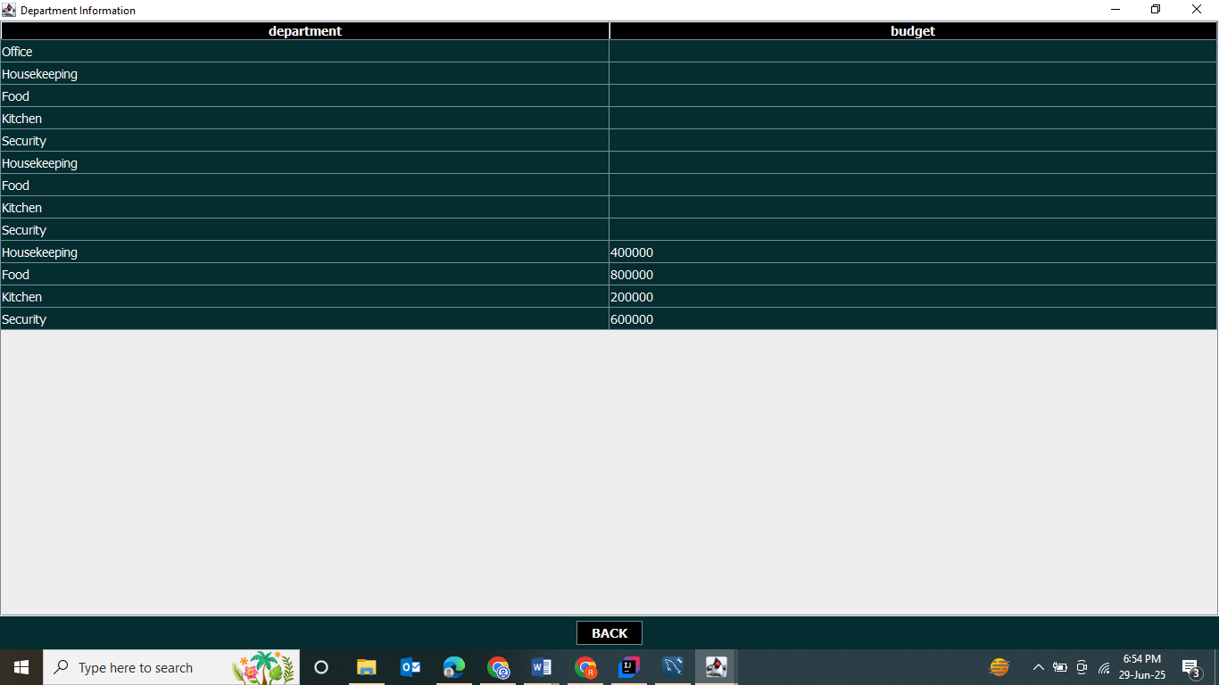
Employee Information Tables
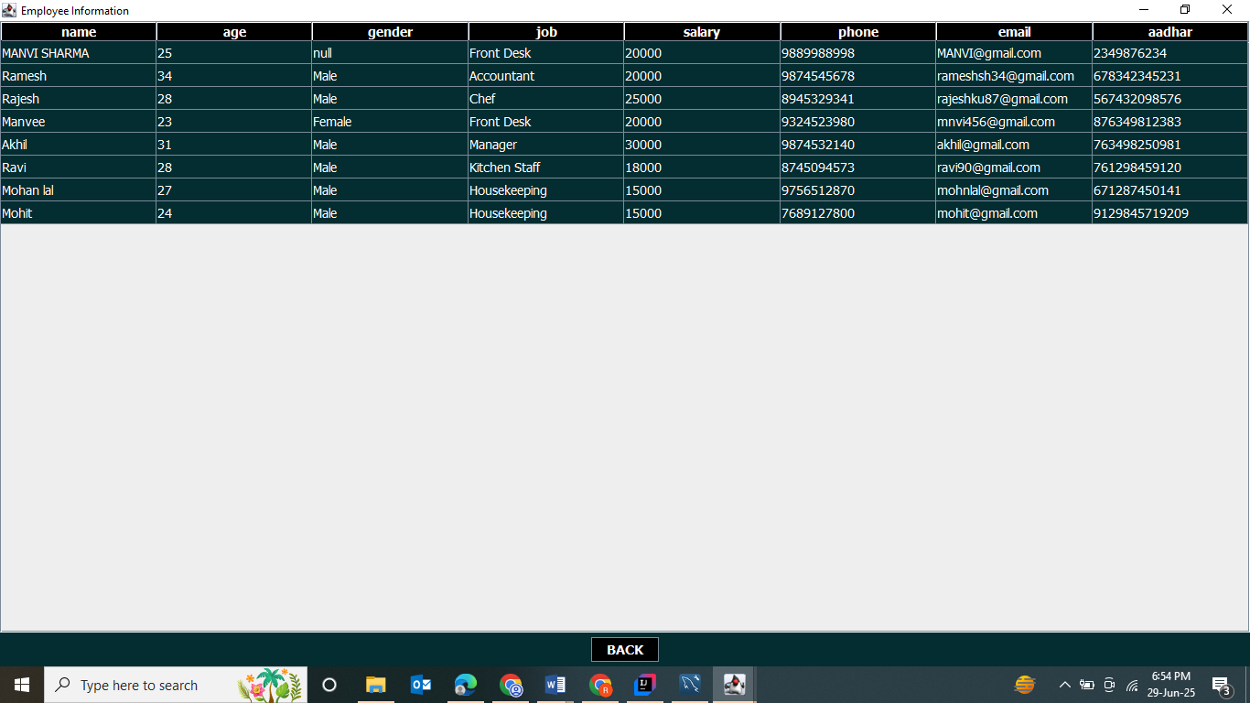
Guest Information Tables
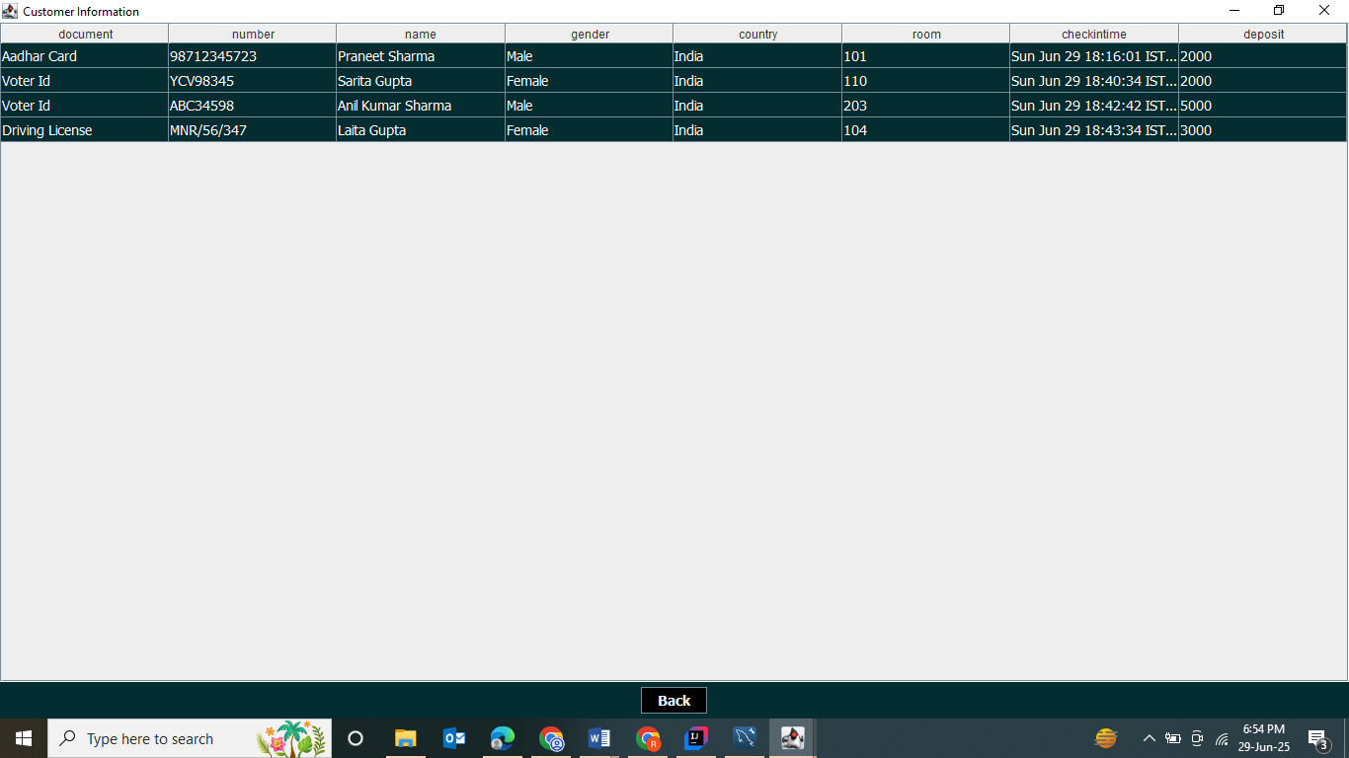 Check-In Page
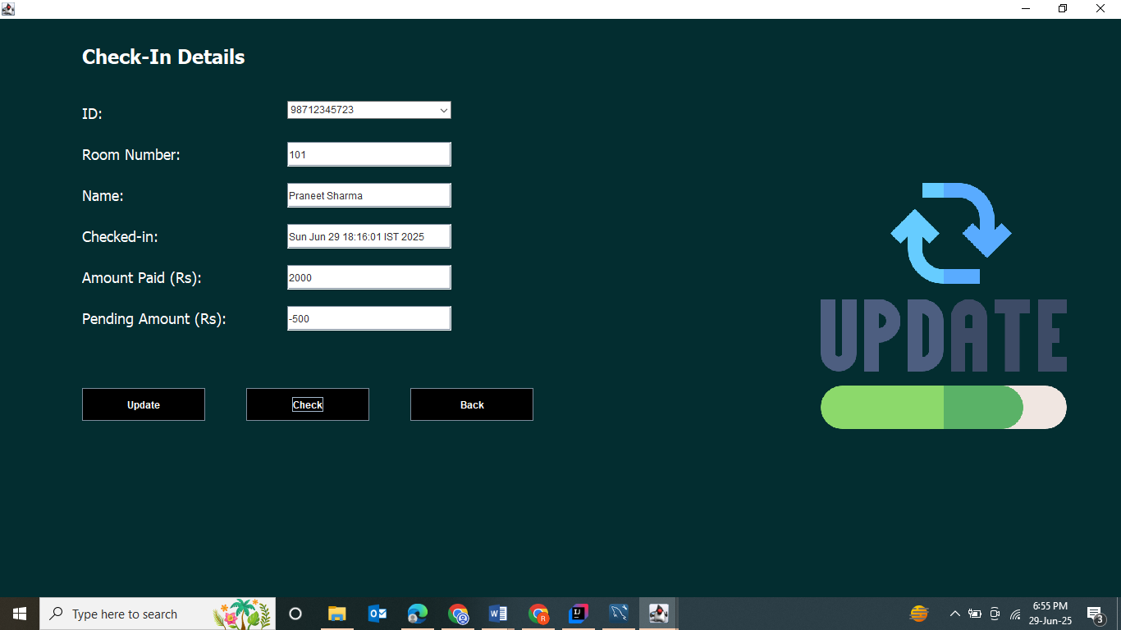

Update Room Page 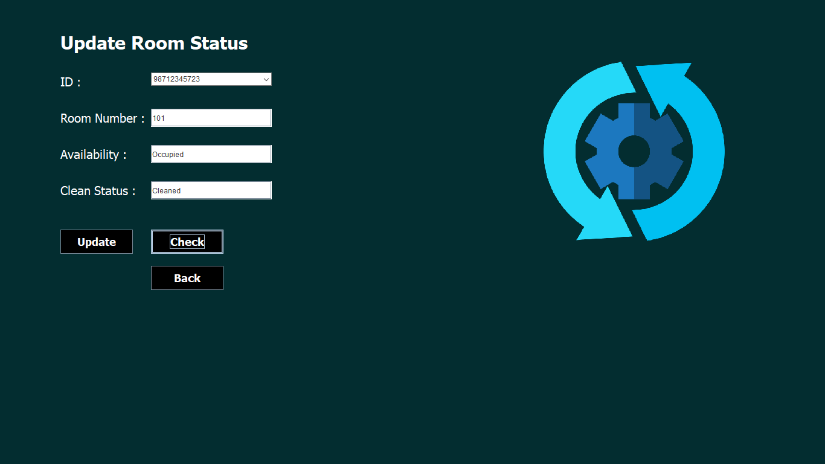

Pick up Services Page 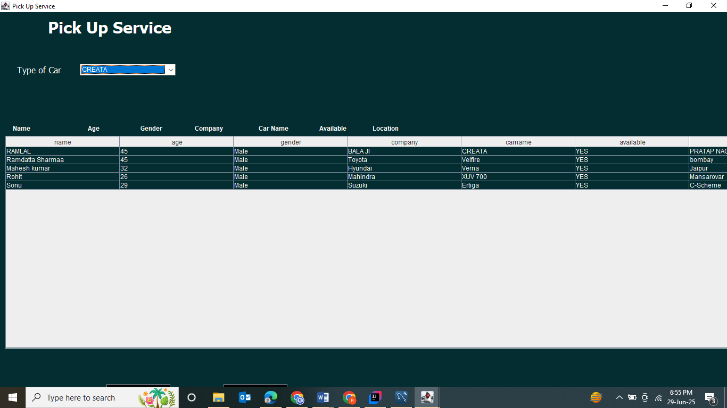

Room Searching Page 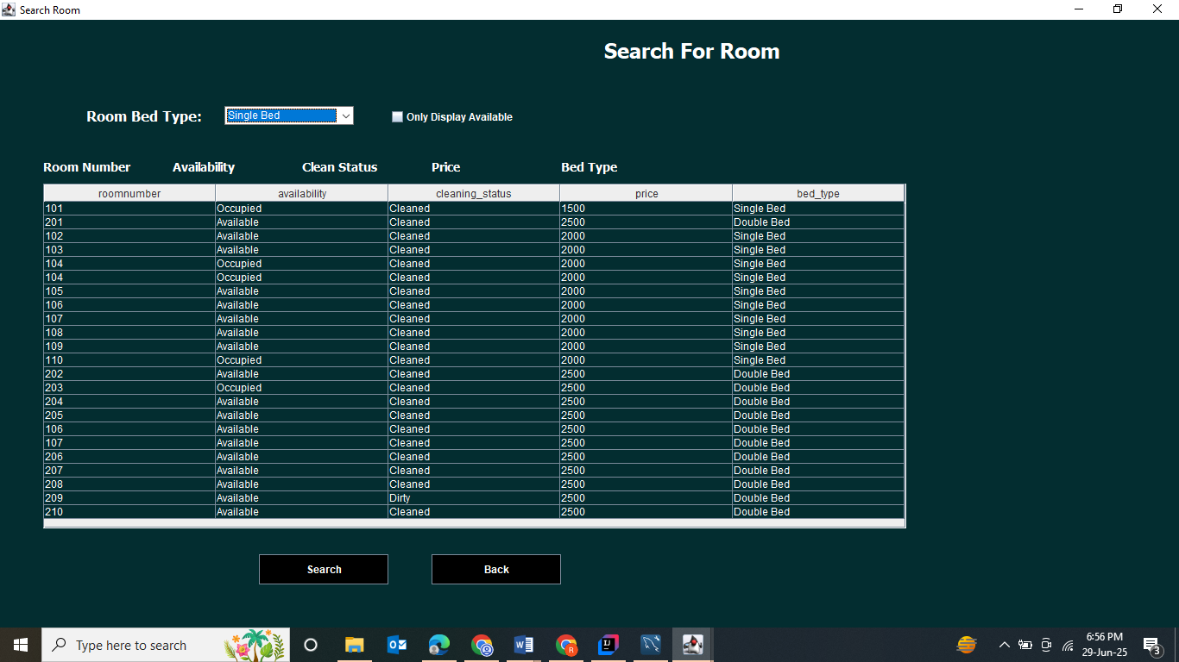

Manager Information Page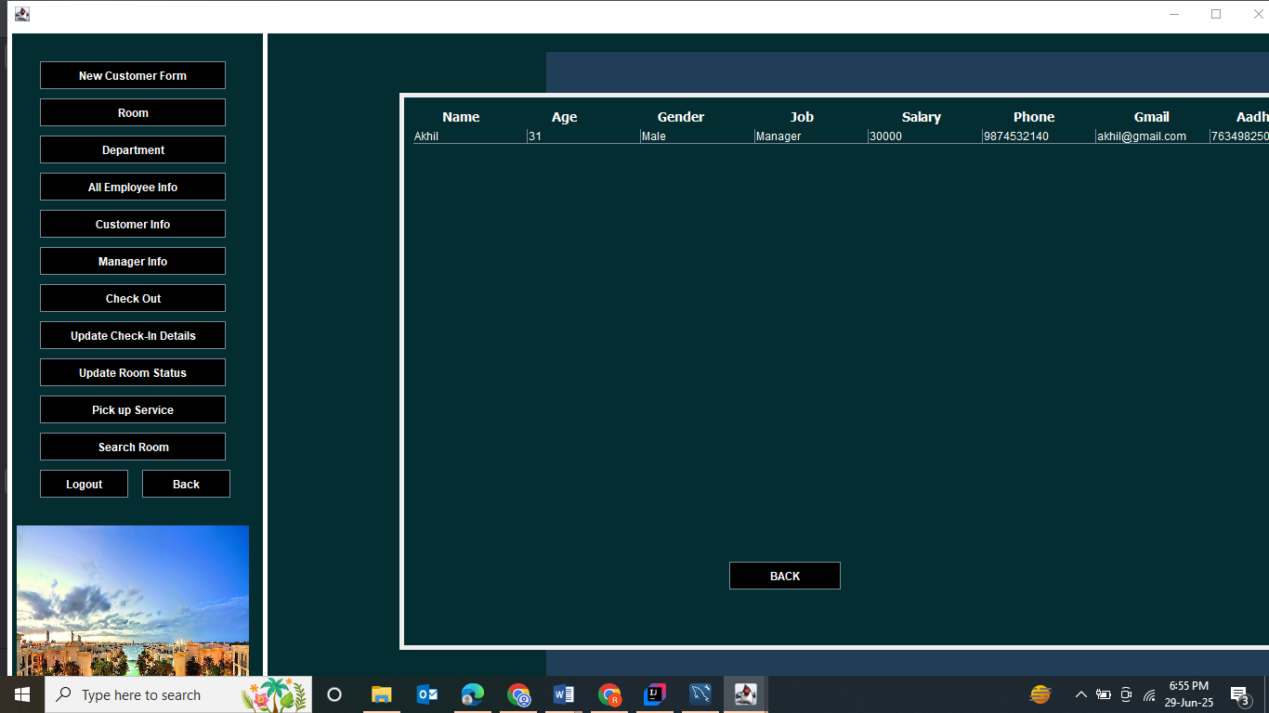

Check-Out Page
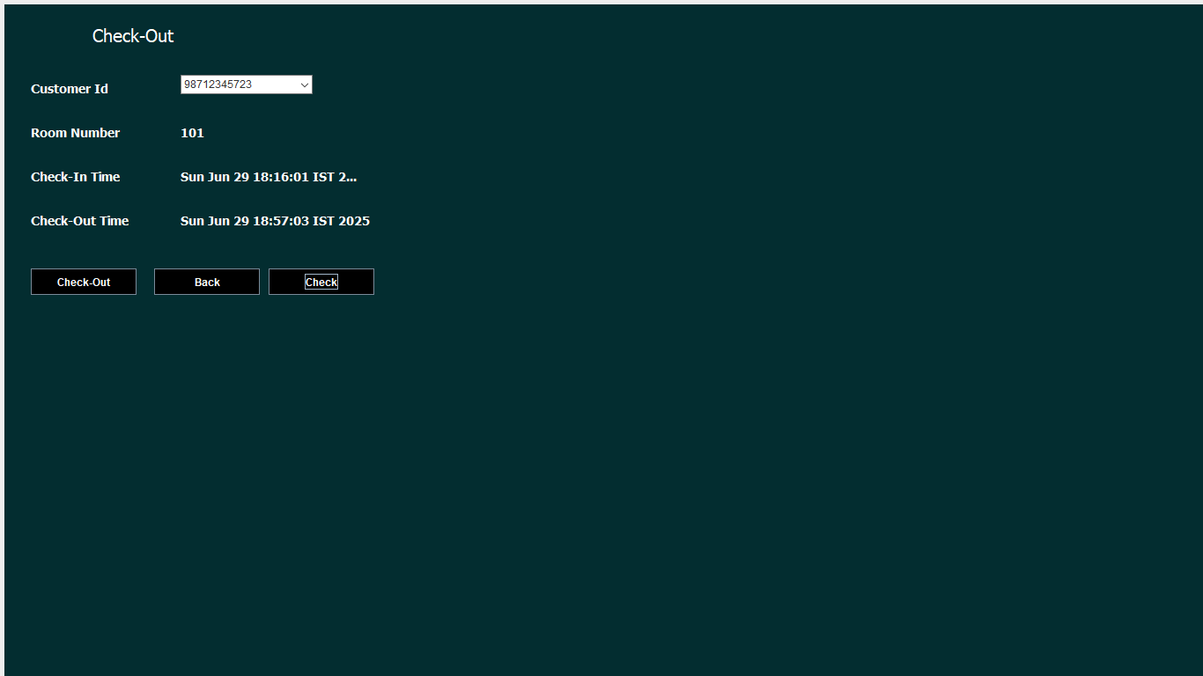

List of Abbreviations

Abbreviation | Full Form
GUI | Graphical User Interface
DBMS | Database Management System
JDBC | Java Database Connectivity
API | Application Programming Interface
UAT | User Acceptance Testing
UPI | Unified Payments Interface
JDK | Java Development Kit

