**727721euit027-DEEPIGA N**

**Cia1**

**TASK-1:**

**1.**public class cia1_1 {

public static void main(String args[]) {

WebDriverManager.*chromedriver*().setup();

ChromeOptions co=new ChromeOptions();

co.addArguments("--remote-allow-origins=*");

WebDriver driver=new ChromeDriver(co);

driver.get("https://www.amazon.in/Tecno-Spark-Storage-Expandable-Processor/dp/B0B56YRDDT/ref=sr_1_1_sspa?crid=W20EXV7YDNEO&keywords=mobile&qid=1681288028&sprefix=mo%2Caps%2C623&sr=8-1-spons&sp_csd=d2lkZ2V0TmFtZT1zcF9hdGY&th=1");

driver.manage().window().maximize();

String c=driver.getTitle();

System.*out*.println(c);

if(c.equals("Tecno Spark 9 (Sky Mirror, 4GB RAM,64GB Storage) | 7GB Expandable RAM | Helio G37 Gaming Processor : Amazon.in: Electronics")) {

System.*out*.println("validated");

}

JavascriptExecutor js=(JavascriptExecutor) driver;

js.executeScript("window.scrollBy(0,500)", "");

driver.findElement(By.*id*("add-to-cart-button" )).click();

}

}

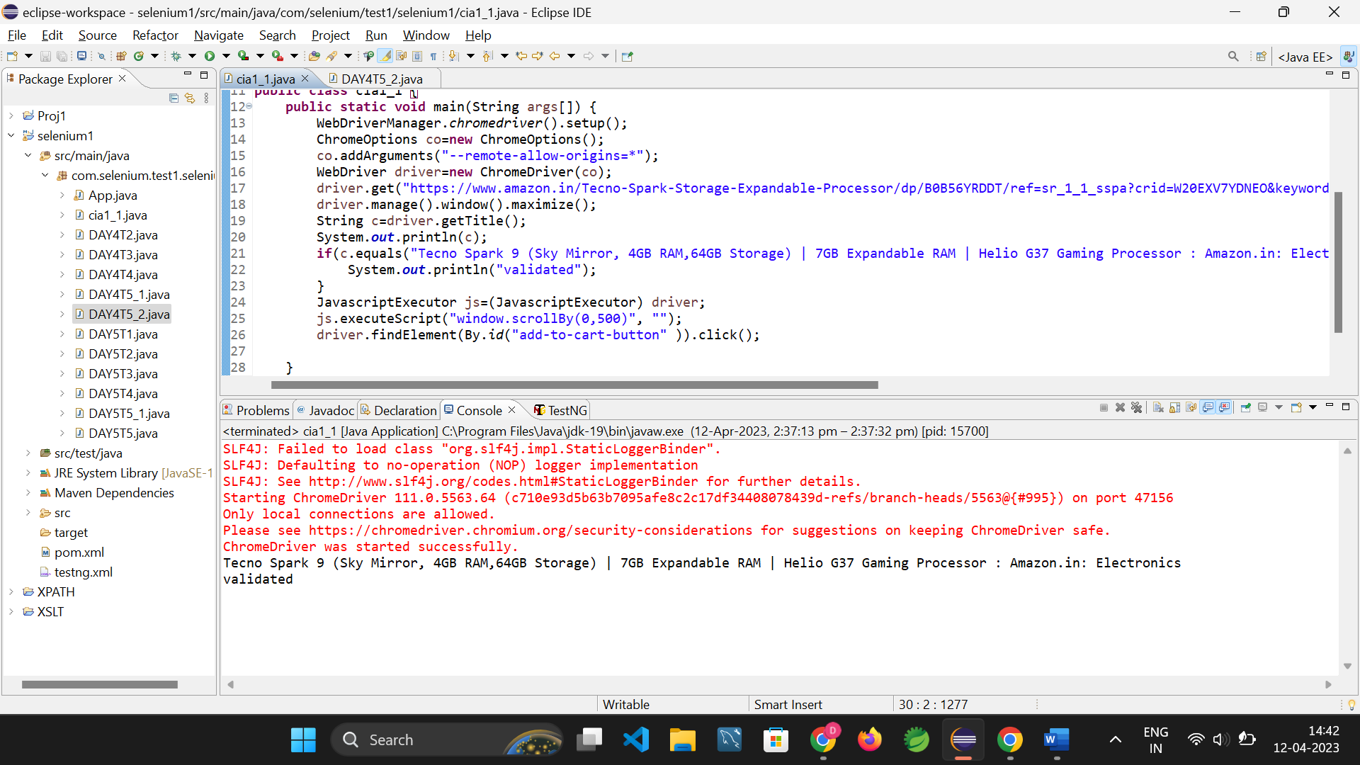

2.public class cia1_1_2

{

public static void main( String[] args ) throws InterruptedException

{

WebDriverManager.*chromedriver*().setup();

ChromeOptions co=new ChromeOptions();

co.addArguments("--remote-allow-origins=*");

WebDriver driver=new ChromeDriver(co);

driver.manage().window().maximize();

driver.get("https://www.amazon.in/Tecno-Spark-Storage-Expandable-Processor/dp/B0B56YRDDT/ref=sr_1_1_sspa?crid=W20EXV7YDNEO&keywords=mobile&qid=1681288028&sprefix=mo%2Caps%2C623&sr=8-1-spons&sp_csd=d2lkZ2V0TmFtZT1zcF9hdGY&th=1");

String c=driver.getTitle();

System.*out*.println(c);

if(c.equals("Tecno Spark 9 (Sky Mirror, 4GB RAM,64GB Storage) | 7GB Expandable RAM | Helio G37 Gaming Processor : Amazon.in: Electronics")) {

System.*out*.println("validated");

}

JavascriptExecutor js=(JavascriptExecutor) driver;

js.executeScript("window.scrollBy(0,500)", "");

driver.findElement(By.*id*("add-to-cart-button" )).click();

Thread.*sleep*(1000);

driver.get("https://www.amazon.in/gp/cart/view.html?ref_=nav_cart");

String t=driver.getTitle();

System.*out*.println(t);

Thread.*sleep*(1000);

driver.findElement(By.*cssSelector*("[value='Delete']")).click();

String t1=driver.getTitle();

System.*out*.println(t1);

System.out.println(“deleted”);

}

}

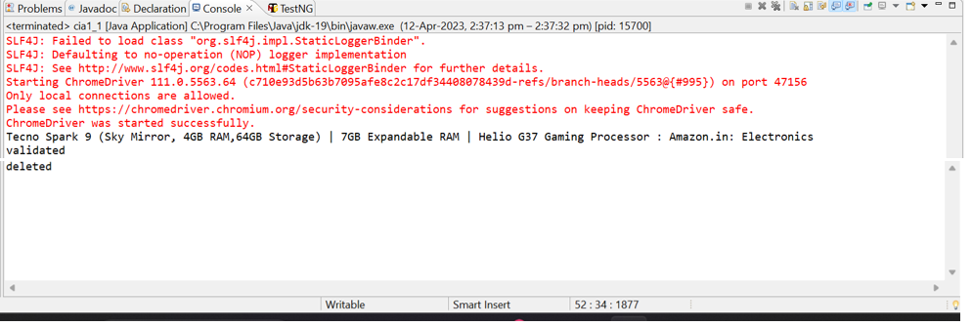

3.public class cia1_1_3 {

public static void main(String args[]){

WebDriverManager.*chromedriver*().setup();

ChromeOptions co=new ChromeOptions();

co.addArguments("--remote-allow-origins=*");

WebDriver driver=new ChromeDriver(co);

driver.manage().window().maximize();

driver.get("https://www.amazon.in/Tecno-Spark-Storage-Expandable-Processor/dp/B0B56YRDDT/ref=sr_1_1_sspa?crid=W20EXV7YDNEO&keywords=mobile&qid=1681288028&sprefix=mo%2Caps%2C623&sr=8-1-spons&sp_csd=d2lkZ2V0TmFtZT1zcF9hdGY&th=1");

JavascriptExecutor js=(JavascriptExecutor) driver;

js.executeScript("window.scrollBy(0,500)", "");

driver.findElement(By.*id*("add-to-cart-button" )).click();

driver.get("https://www.amazon.in/gp/cart/view.html?ref_=nav_cart");

WebElement sort1=driver.findElement(By.*className*("a-buttontext a-declarative"));

sort1.click();

Select select=new Select(sort1);

select.selectByIndex(1);

System.out.println("Verified that Product is updated to cart ");

}

}

}

TASK 2

1.

package com.selenium.test1.selenium1;

import org.openqa.selenium.By;

import org.openqa.selenium.Keys;

import org.openqa.selenium.WebDriver;

import org.openqa.selenium.WebElement;

import org.openqa.selenium.chrome.ChromeDriver;

import org.openqa.selenium.chrome.ChromeOptions;

import io.github.bonigarcia.wdm.WebDriverManager;

public class TASK_2_1 {

public static void main( String[] args ) throws InterruptedException

{

WebDriverManager.chromedriver().setup();

ChromeOptions co=new ChromeOptions();

co.addArguments("--remote-allow-origins=*");

WebDriver driver=new ChromeDriver(co);

driver.get("https://www.amazon.in/");

driver.manage().window().maximize();

String actualTitle=driver.getTitle();

System.out.println("Page title is : " + driver.getTitle());

String expectedTitle = "Online Shopping site in India: Shop Online for Mobiles, Books, Watches, Shoes and More - Amazon.in";

if(actualTitle.equalsIgnoreCase(expectedTitle))

System.out.println("Title Matched");

else

System.out.println("Title didn't match");

WebElement txt1=driver.findElement(By.id("twotabsearchtextbox"));

txt1.sendKeys("LAPTOP");

driver.findElement(By.id("twotabsearchtextbox")).sendKeys(Keys.ENTER);

}

}

2.import java.util.List;

import org.openqa.selenium.By;

import org.openqa.selenium.JavascriptExecutor;

import org.openqa.selenium.WebDriver;

import org.openqa.selenium.WebElement;

import org.openqa.selenium.chrome.ChromeDriver;

import org.openqa.selenium.chrome.ChromeOptions;

import io.github.bonigarcia.wdm.WebDriverManager;

public class QNo2 {

public static void main(String args[]) {

WebDriverManager.chromedriver().setup();

ChromeOptions co=new ChromeOptions();

co.addArguments("--remote-allow-origins=*");

WebDriver driver=new ChromeDriver(co);

driver.get("https://www.amazon.in/deal/2c2d3a50/?_encoding=UTF8&showVariations=true&_ref=dlx_gate_sd_dcl_tlt_2c2d3a50_dt&pd_rd_w=YgMyt&content-id=amzn1.sym.a532052b-26f3-4811-a261-3b35ffa57237&pf_rd_p=a532052b-26f3-4811-a261-3b35ffa57237&pf_rd_r=SWJFXC5PAM03PF4G0AWT&pd_rd_wg=6zviy&pd_rd_r=1f436e7b-ab36-4c27-9e50-8f8c69db422a&ref_=pd_gw_unk");

driver.manage().window().maximize();

JavascriptExecutor js=(JavascriptExecutor) driver;

js.executeScript("window.scrollBy(0,1000)","");

String title = driver.getTitle();

System.out.println(title);

String title2="Budget Laptops under INR 45000; Mega Electronic Days";

//title2=driver.getTitle();

if(title2.equals(title)) {

System.out.println("It is corret page title");

}

List<WebElement> li=driver.findElements(By.xpath("//*[@id=\"octopus-dlp-asin-stream\"]/ul/li[3]/span/div/div[2]/div[1]/a"]"));"

for(WebElement link:li) {

System.out.println(link.getText());

}

driver.navigate().back();

driver.navigate().forward();

driver.navigate().refresh();

driver.quit();

}

}