TASK-1:

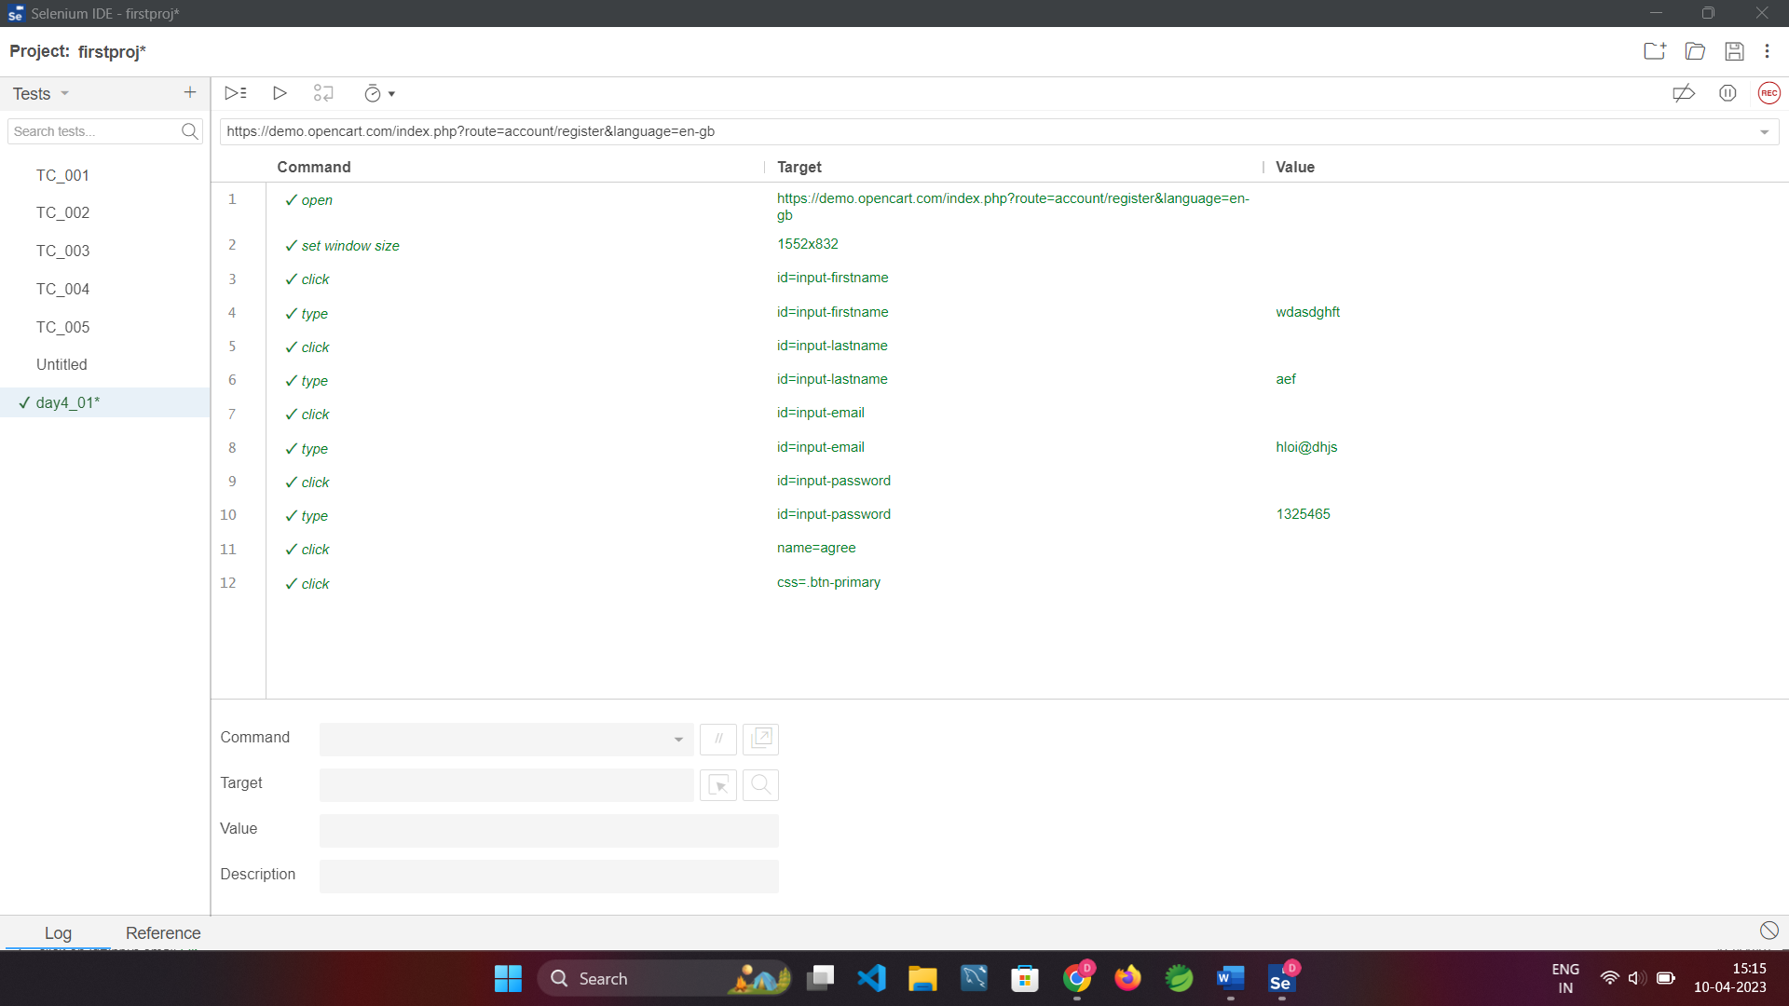

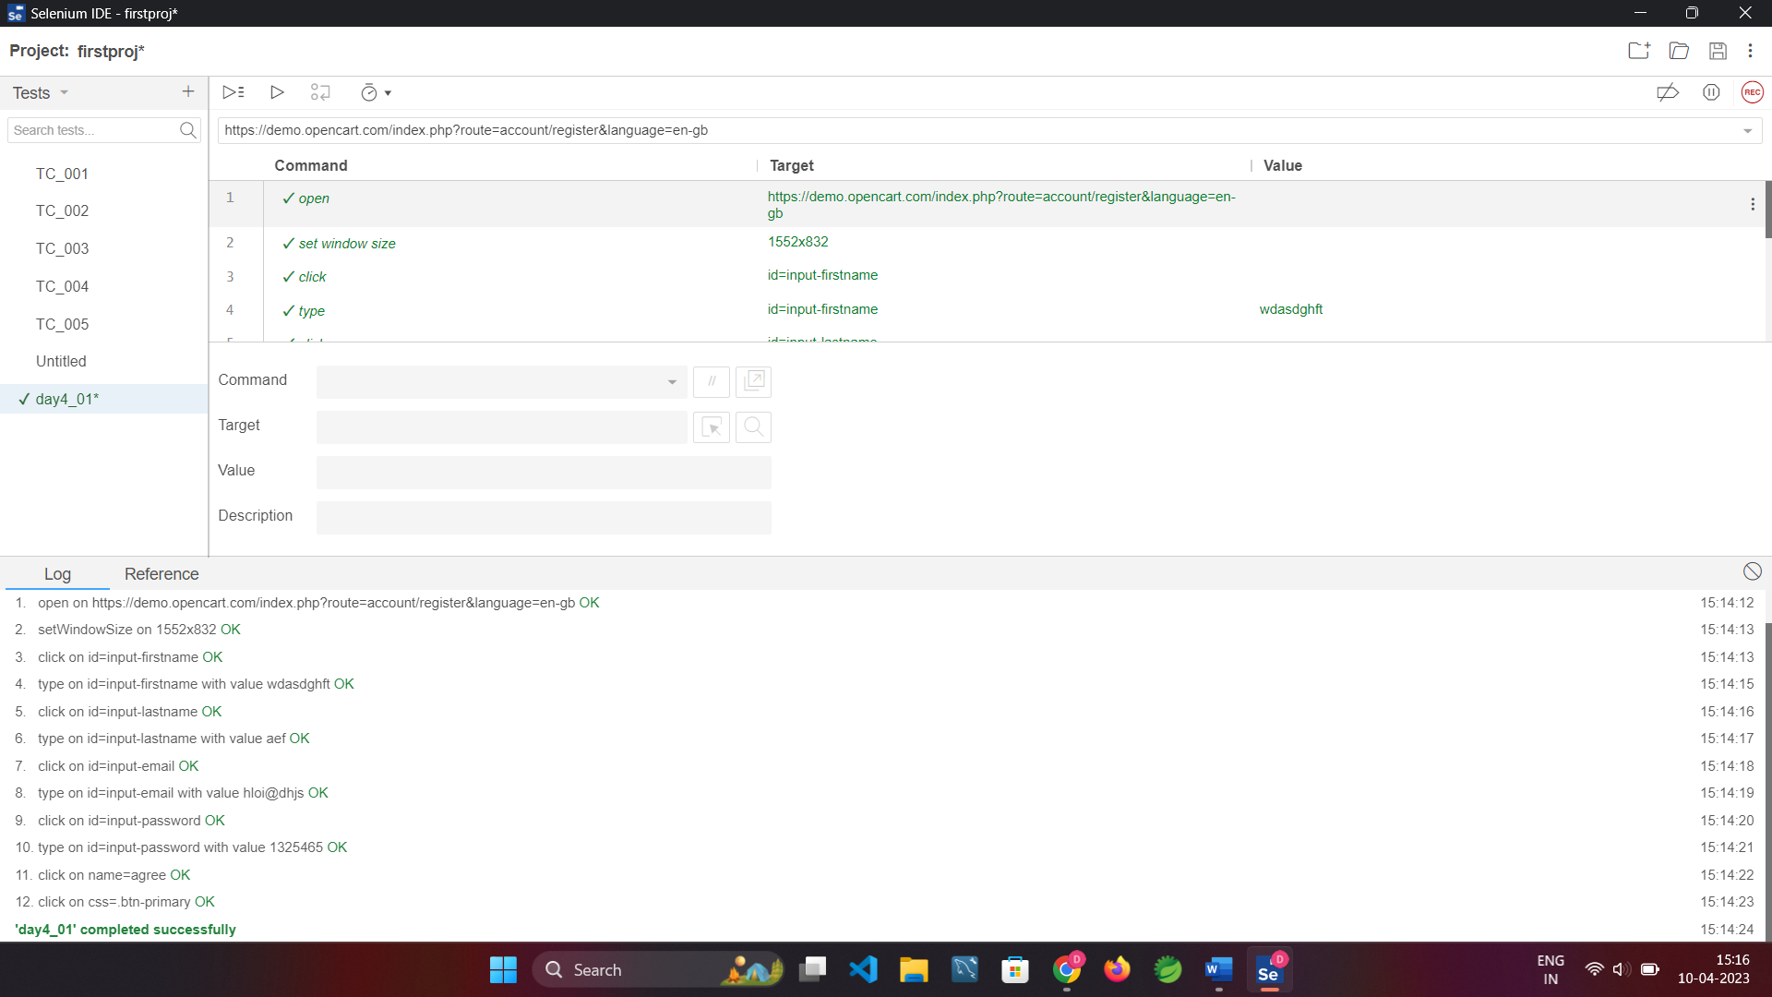

TASK-2:

**public** **class** DAY4T2 {

**public** **static** **void** main( String[] args )

{

WebDriverManager.*chromedriver*().setup();

ChromeOptions co=**new** ChromeOptions();

co.addArguments("--remote-allow-origins=*");

WebDriver driver =**new** ChromeDriver(co);

driver.get("https://demo.opencart.com/index.php?route=account/register&language=en-gb");

driver.manage().window().maximize();

WebElement fn=driver.findElement(By.*id*("input-firstname"));

System.***out***.println(fn);

WebElement ln =driver.findElement(By.*id*("input-lastname"));

System.***out***.println(ln);

WebElement em =driver.findElement(By.*id*("input-email"));

System.***out***.println(em);

WebElement pwd =driver.findElement(By.*id*("input-password"));

System.***out***.println(pwd);

WebElement sb=driver.findElement(By.*id*("input-newsletter-yes"));

System.***out***.println(sb);

}

}

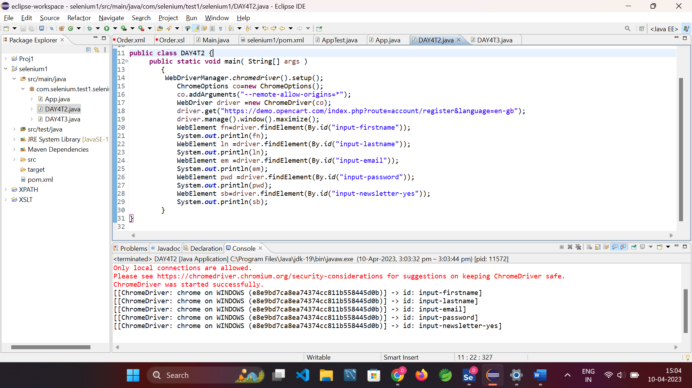

TASK-3:

**public** **class** DAY4T3 {

**public** **static** **void** main(String args[]) {

WebDriverManager.*chromedriver*().setup();

ChromeOptions co=**new** ChromeOptions();

co.addArguments("--remote-allow-origins=*");

WebDriver driver =**new** ChromeDriver(co);

driver.get("https://demo.opencart.com/index.php?route=checkout/voucher&language=en-gb");

driver.manage().window().maximize();

WebElement rn=driver.findElement(By.*xpath*("//*[@id=\"input-to-name\"]"));

System.***out***.println(rn);

WebElement rem=driver.findElement(By.*xpath*("//*[@id=\"input-to-email\"]"));

System.***out***.println(rem);

WebElement n=driver.findElement(By.*xpath*("//*[@id=\"input-from-name\"]"));

System.***out***.println(n);

WebElement em=driver.findElement(By.*xpath*("//*[@id=\"input-from-email\"]"));

System.***out***.println(em);

WebElement gct=driver.findElement(By.*xpath*("//*[@id=\"input-theme\"]/div[2]"));

System.***out***.println(gct);

WebElement msg=driver.findElement(By.*xpath*("//*[@id=\"input-message\"]"));

System.***out***.println(msg);

WebElement am=driver.findElement(By.*xpath*("//*[@id=\"input-amount\"]"));

System.***out***.println(am);

}

}

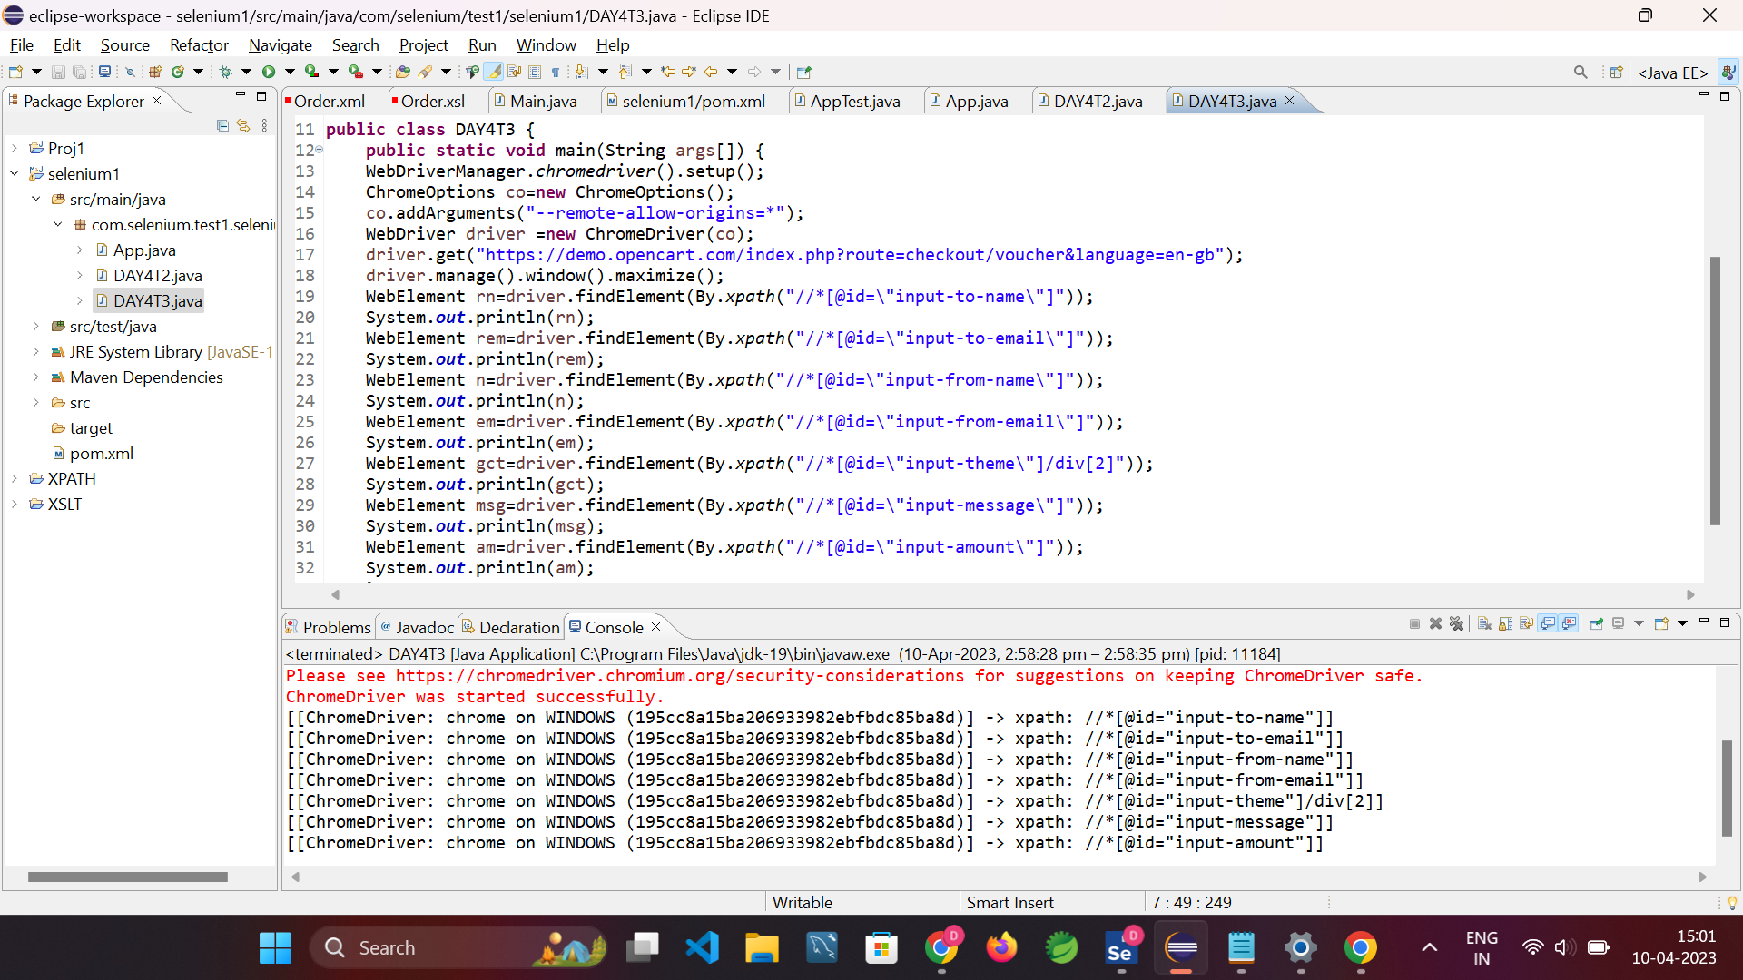

TASK-4:

**public** **class** DAY4T4 {

**public** **static** **void** main(String args[]) {

WebDriverManager.*chromedriver*().setup();

ChromeOptions co=**new** ChromeOptions();

co.addArguments("--remote-allow-origins=*");

WebDriver driver =**new** ChromeDriver(co);

driver.get("https://j2store.net/free/");

driver.manage().window().maximize();

JavascriptExecutor js=(JavascriptExecutor) driver;

js.executeScript("window.scrollBy(0,1000)", "");

driver.findElement(By.*linkText*("Clothing (5)")).click();

driver.navigate().back();

driver.navigate().forward();

driver.navigate().refresh();

driver.quit();

}

}

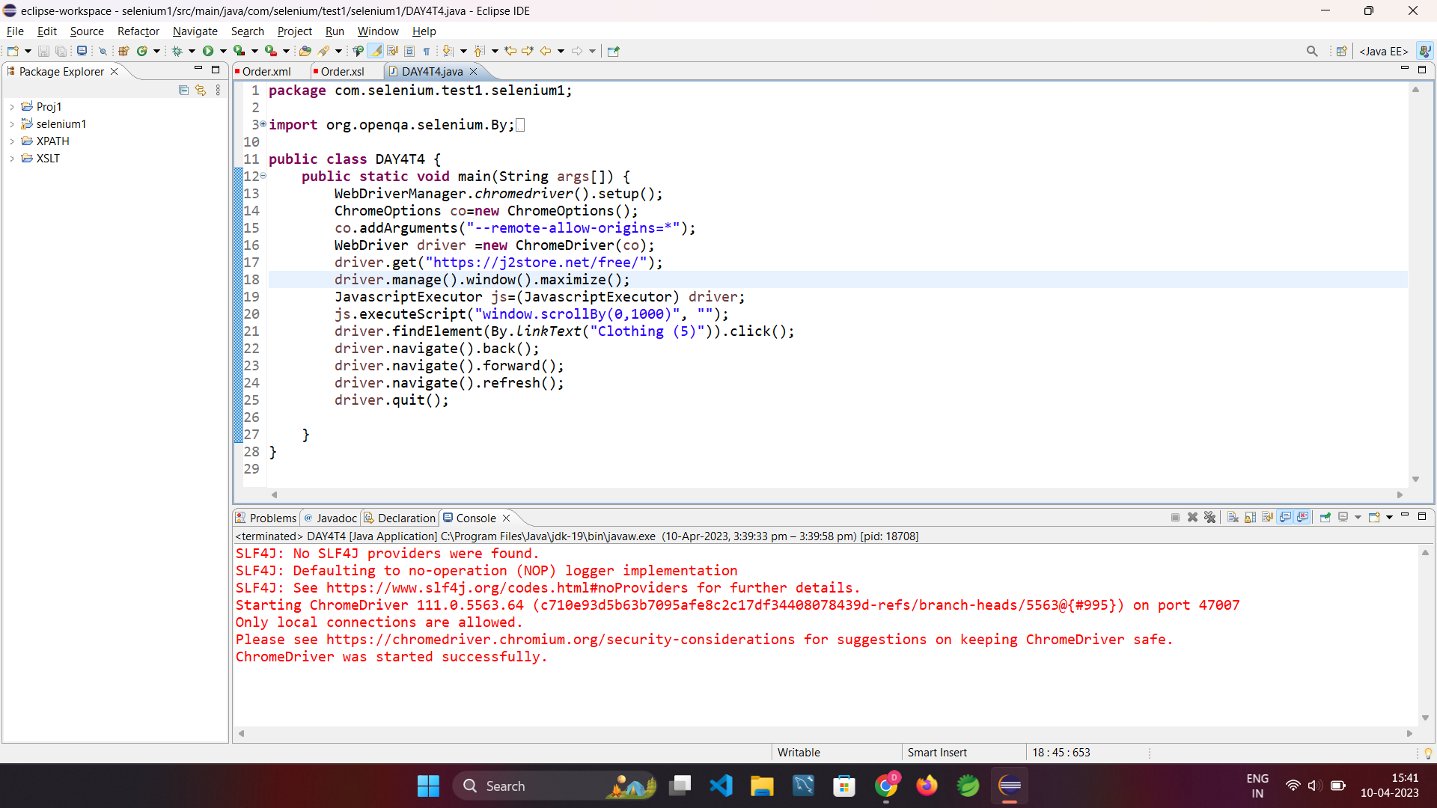

TASK-5.1:

**public** **class** DAY4T5_1 {

**public** **static** **void** main(String args[]) {

WebDriverManager.*chromedriver*().setup();

ChromeOptions co=**new** ChromeOptions();

co.addArguments("--remote-allow-origins=*");

WebDriver driver =**new** ChromeDriver(co);

driver.get("https://j2store.net/free/");

driver.manage().window().maximize();

JavascriptExecutor js=(JavascriptExecutor) driver;

js.executeScript("window.scrollBy(0,1000)", "");

String url1="https://j2store.net/free/";

String url2="";

url2=driver.getCurrentUrl();

**if**(url1.equals(url2))

System.***out***.println("Correct 1st page");

driver.findElement(By.*linkText*("Clothing (5)")).click();

url1=driver.getCurrentUrl();

**if**(url1.equals("https://j2store.net/free/index.php/shop?filter_catid=11"));

System.***out***.print("Correct 2nd page");

}

}

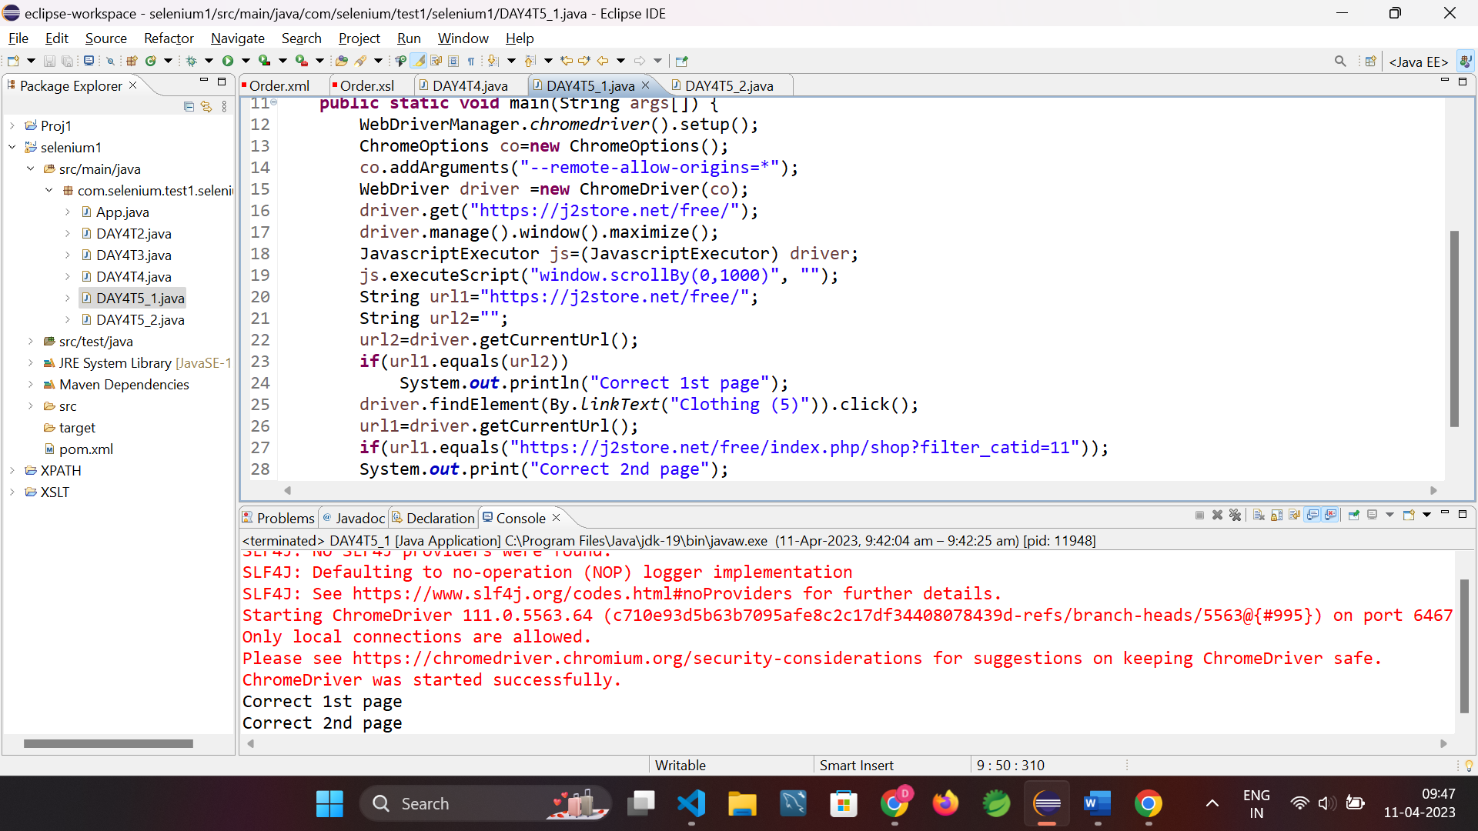

TASK-5.2:

**public** **class** DAY4T5_2 {

**public** **static** **void** main(String args[]) **throws** InterruptedException{

WebDriverManager.*chromedriver*().setup();

ChromeOptions co=**new** ChromeOptions();

co.addArguments("--remote-allow-origins=*");

WebDriver driver =**new** ChromeDriver(co);

driver.get("https://j2store.net/free/");

driver.manage().window().maximize();

JavascriptExecutor js=(JavascriptExecutor) driver;

js.executeScript("window.scrollBy(0,1000)", "");

driver.findElement(By.*linkText*("Clothing (5)")).click();

Thread.*sleep*(5000);

List<WebElement> l1=driver.findElements(By.*xpath*("//h2[@class='product-title']"));

**for**(WebElement link:l1) {

System.***out***.println(link.getText());

}

}

}

