**DAY-1**

**INTRODUCTION:**

In day one I have concentrated on choosing a project on image processing or NLP(Natural Language Processing) using CNN or LSTM .I have chosen project based on NLP.

**NATURAL LANGUAGE PROCESSING(NLP)**

Natural language processing is the capability of a computer system to understand human language - as it is both written and spoken. This is commonly referred to as natural language. Natural language processing is a technical component or subset of artificial intelligence.

**CNN and LSTM FOR NLP**

CNN stands for Convolutional Neural Networks. CNNs are neural network models that were originally used for analyzing images.To use CNNs in NLP, we need to represent the text as numerical data. This is usually done by converting words into vectors called word embeddings.LSTM stands for Long Short-Term Memory. LSTMs are a special type of neural network that can understand and process sequences of data, like sentences or paragraphs.

**PROJECT: IMAGE CAPTION GENERATOR**

The image caption generator model is typically trained on a large dataset of images with their corresponding captions. During training, the model learns to associate the visual features extracted by the CNN with the textual information in the captions. It is trained using a combination of image-caption pairs and optimized using techniques like gradient descent and backpropagation.

Once trained, the model can generate captions for new unseen images. Given an input image, the model first extracts its visual features using the CNN. Then, the LSTM takes these features as input and generates captions word by word, predicting the most likely word at each step based on the previous words generated.

**REFERENCE:**

kaggle kernels pull zohaib123/image-caption-generator-using-cnn-and-lstm

**SCREENSHOTS:**

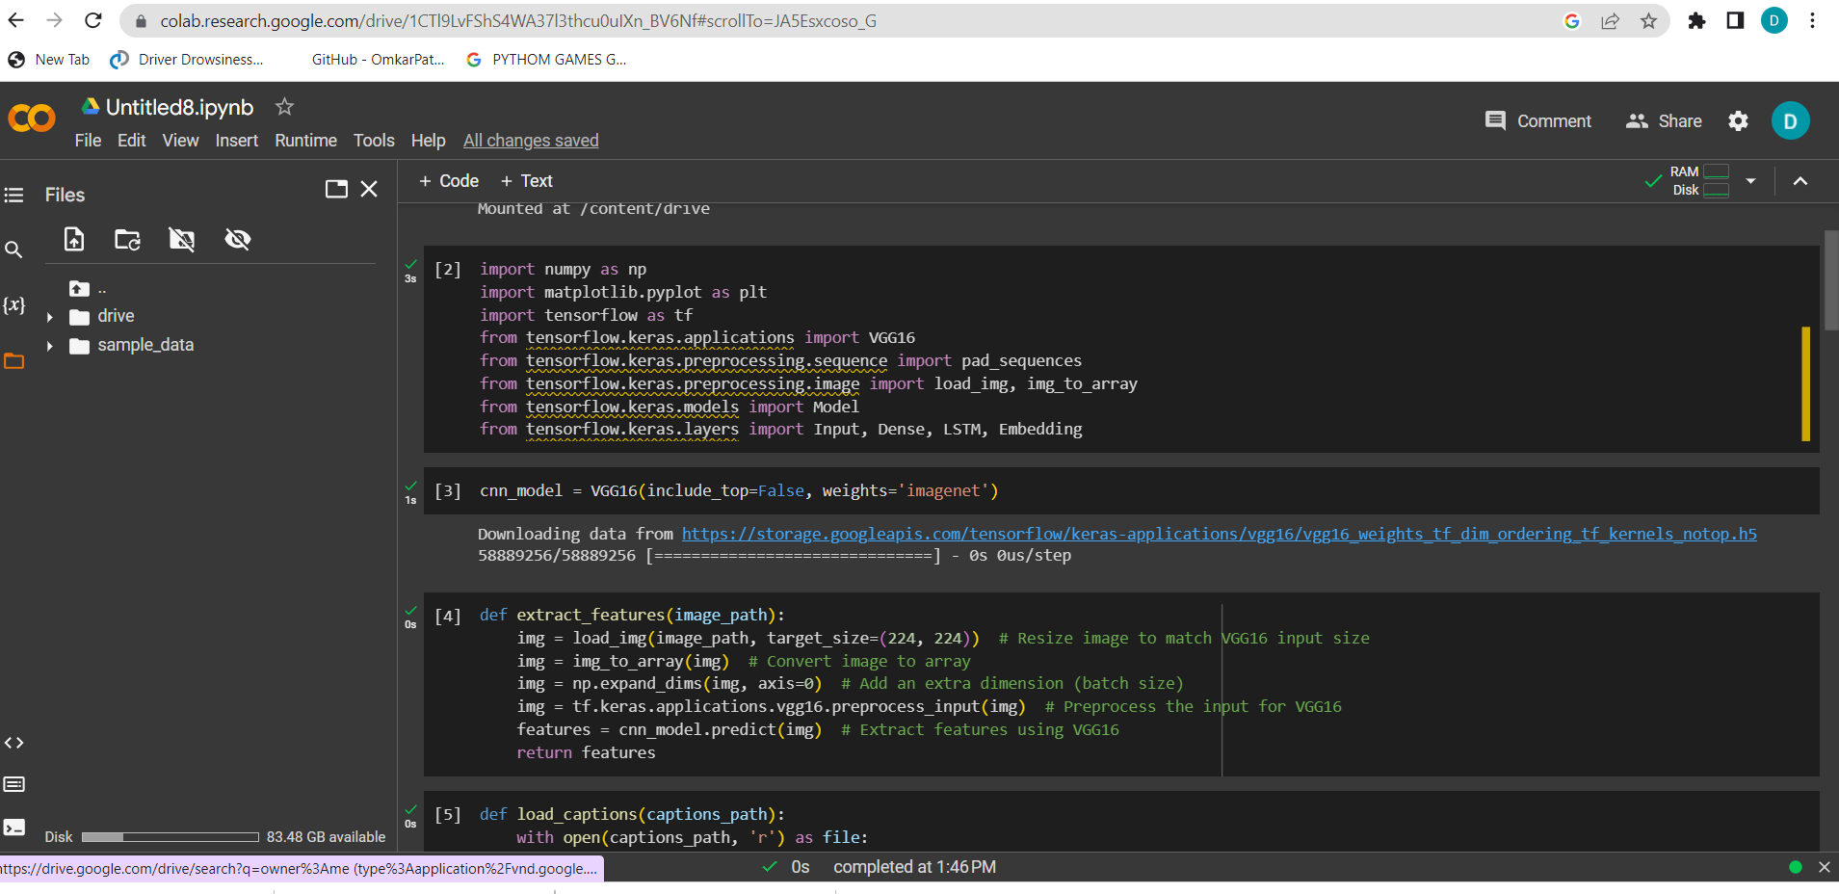

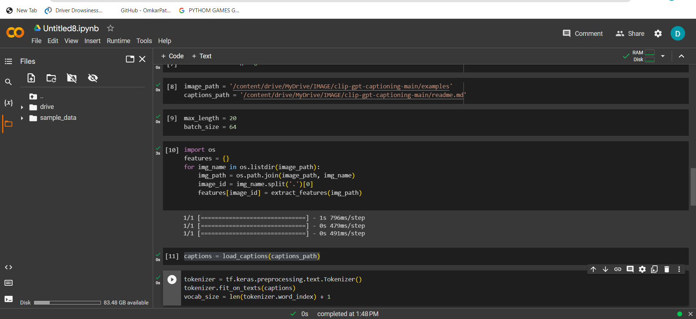

**CONCLUSION:**

I have learnt about how the algorithm works on data.