**DAY-3**

**INTRODUCTION:**

In third day, I have uploaded the “EXAM-DATASET” in my drive and started working on it. The dataset is about identifying malpractices during examination. It is multi-class as it contains three classes as phone , paper seeing and normal. After uploading the dataset I mounted the drive to google colab and started running the CNN model based code. I have runned 20 epoch and the graph is plotted. Then the image is predicted correctly and the confusion matrix is build.

**CHALLENGES:**

* Uploading the dataset took long time as it had 1.5GB.
* Running the epoch takes long duration of time.

**SCREENSHOTS:**

DATASET UPLOADED:

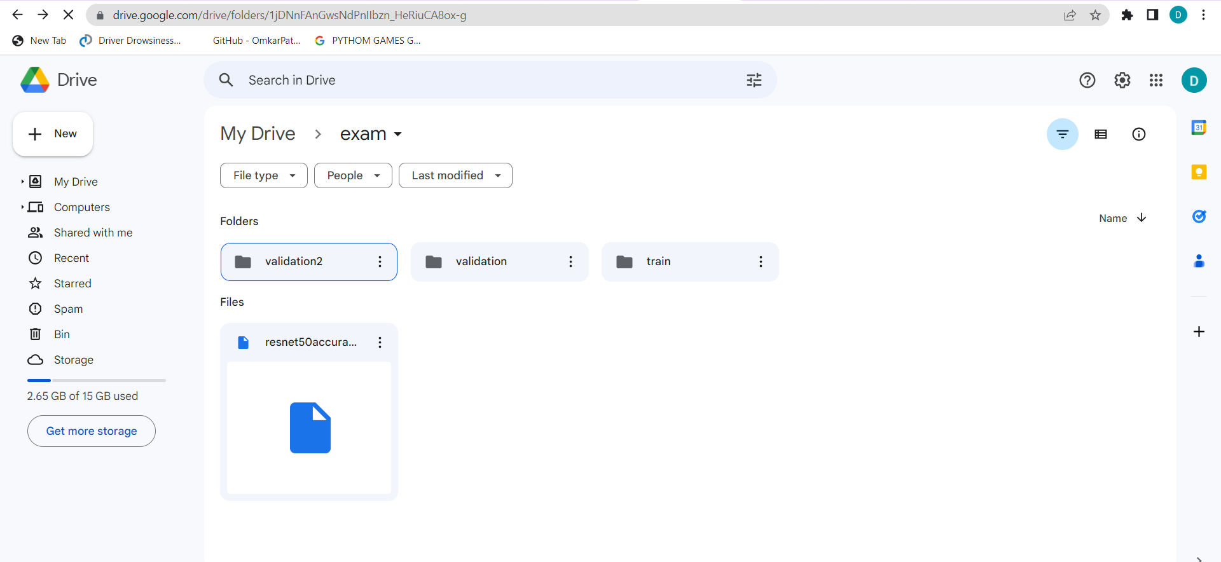

OUTPUT:

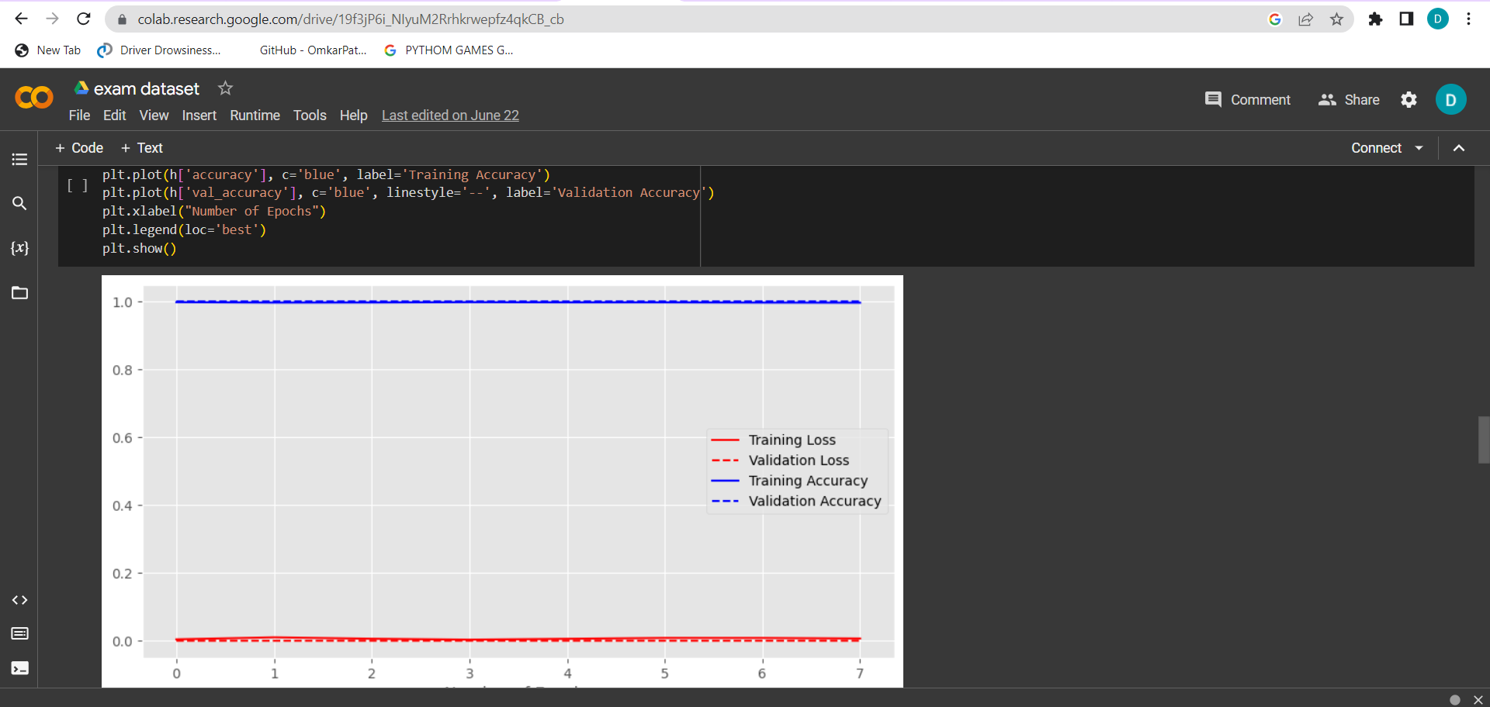

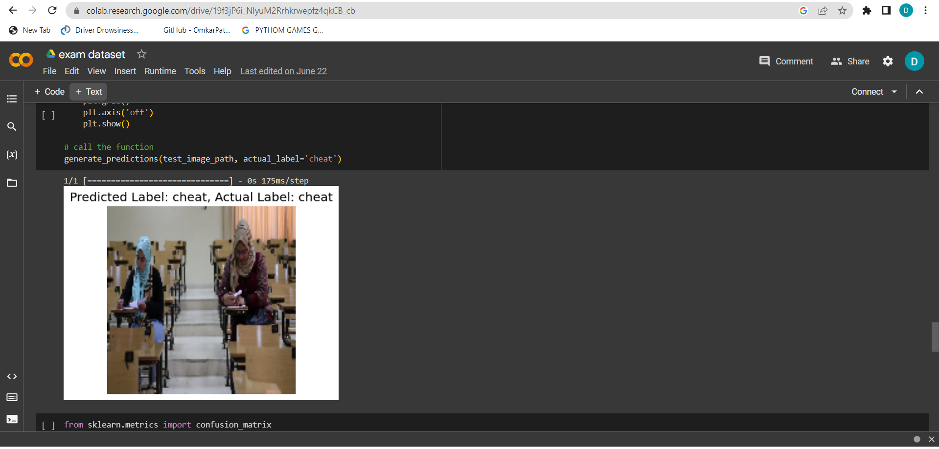

CONFUSION MATRIX:

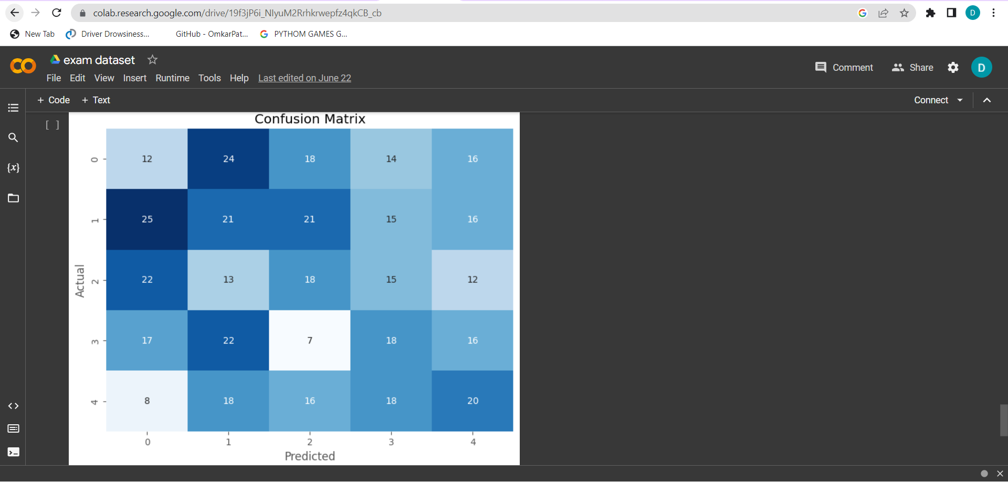

**CONCLUSION:**

I have learned about how the model was build and running the epoch.