**DAY-4**

**INTRODUCTION:**

In fourth day we have discussed about what are the difficulties faced during the execution of code. After that I came to know about how the accuracy , loss and validation works.

**TOPICS LEARNED:**

* How should the loss and accuracy should vary.
* Confusion matrix
* Under-fitting and over-fitting

**UNDERFITTING:**

Underfitting occurs when a model is too simple to capture the underlying patterns in the data. It usually results in poor performance both on the training data and on unseen data. Signs of underfitting include high bias and low variance.

**OVERFITTING:**

Overfitting occurs when a model becomes too complex and starts to memorize the training data instead of learning the underlying patterns. It typically leads to excellent performance on the training data but performs poorly on unseen data. Signs of overfitting include low bias and high variance.

**CONFUSION MATRIX:**

Confusion matrix works based on model build and it is in the form of a matrix form. It contains actual and predicted values. If the actual and predicted values are same, then the confusion matrix will be perfect.

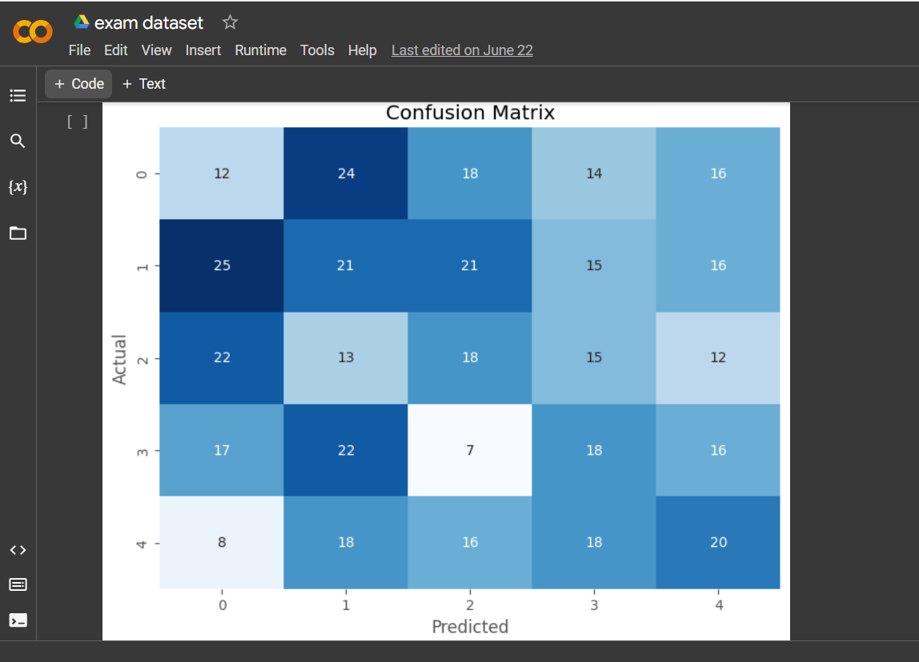

Confusion matrix I got while executing the code

**TASK COMPLETED:**

* + Uploaded the dataset into my drive.
  + Found CNN code and runned using given dataset.
  + Confusion matrix was build.

**CHALLENGES:**

The model was not learned properly and the confusion matrix was not proper.

**CONCLUSION:**

I have learned about confusion matrix, and I understood what is underfitting and overfitting.