**DAY-2**

**INTRODUCTION:**

In second day, I have learnt about multi class and binary class. By understanding the concept of binary and multi class classification, I have created my own dataset on musical instrument classification. In musical instrument classification, I have chosen veena and guitar.

**BINARY CLASS:**

Binary class classification contains only two classes.

**MULTI CLASS:**

Multi class classification contains more than two class.

**DATASET:**

My dataset is an binary class classification as I have chosen two classes veena and guitar. First I have downloaded all images for veena and guitar and cleaned the data. Then I have uploaded the dataset in my drive as folder which contains veena and guitar. Then, I have created test, train and validation models separately for veena and guitar.

**COUNT OF IMAGES IN MY DATASET ARE:**

TEST : Veena-50 , Guitar-50

TRAIN : Veena-223, Guitar-401

Validation : Veena-30 , Guitar-30

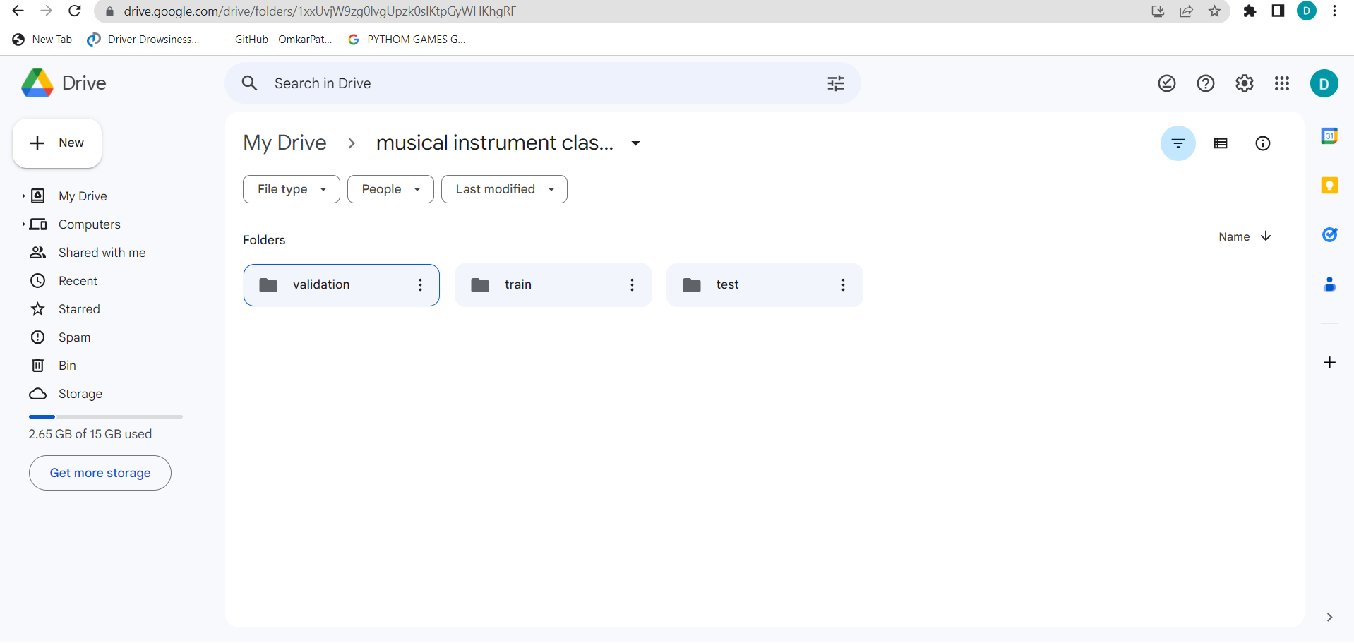

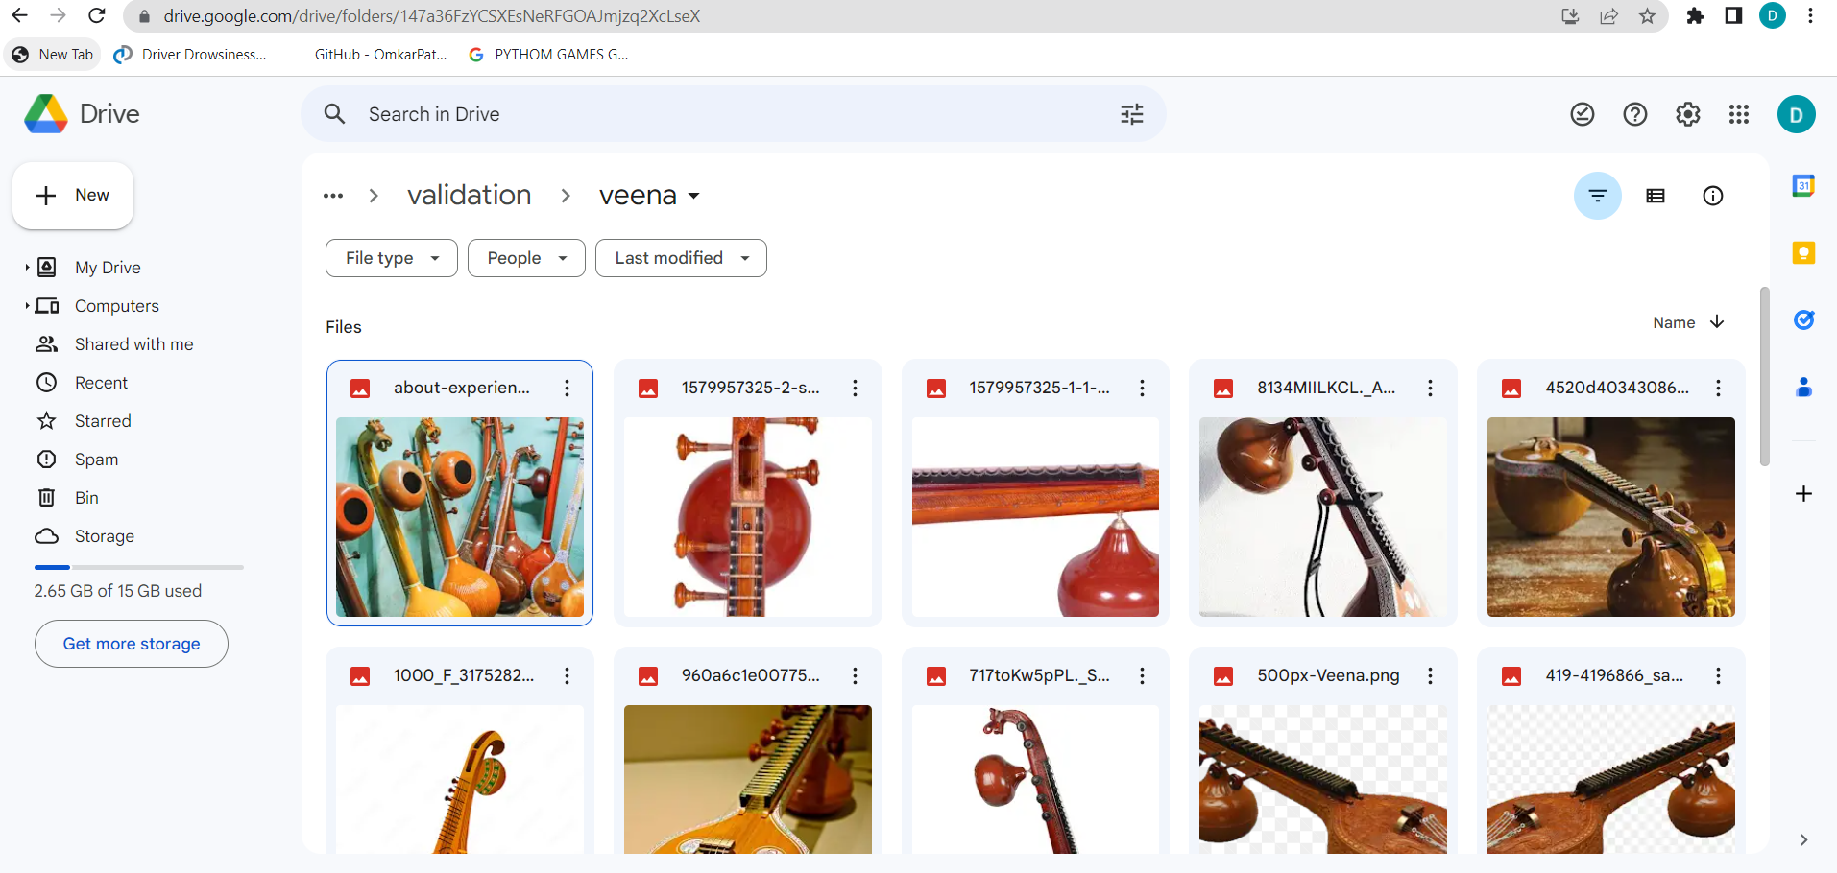

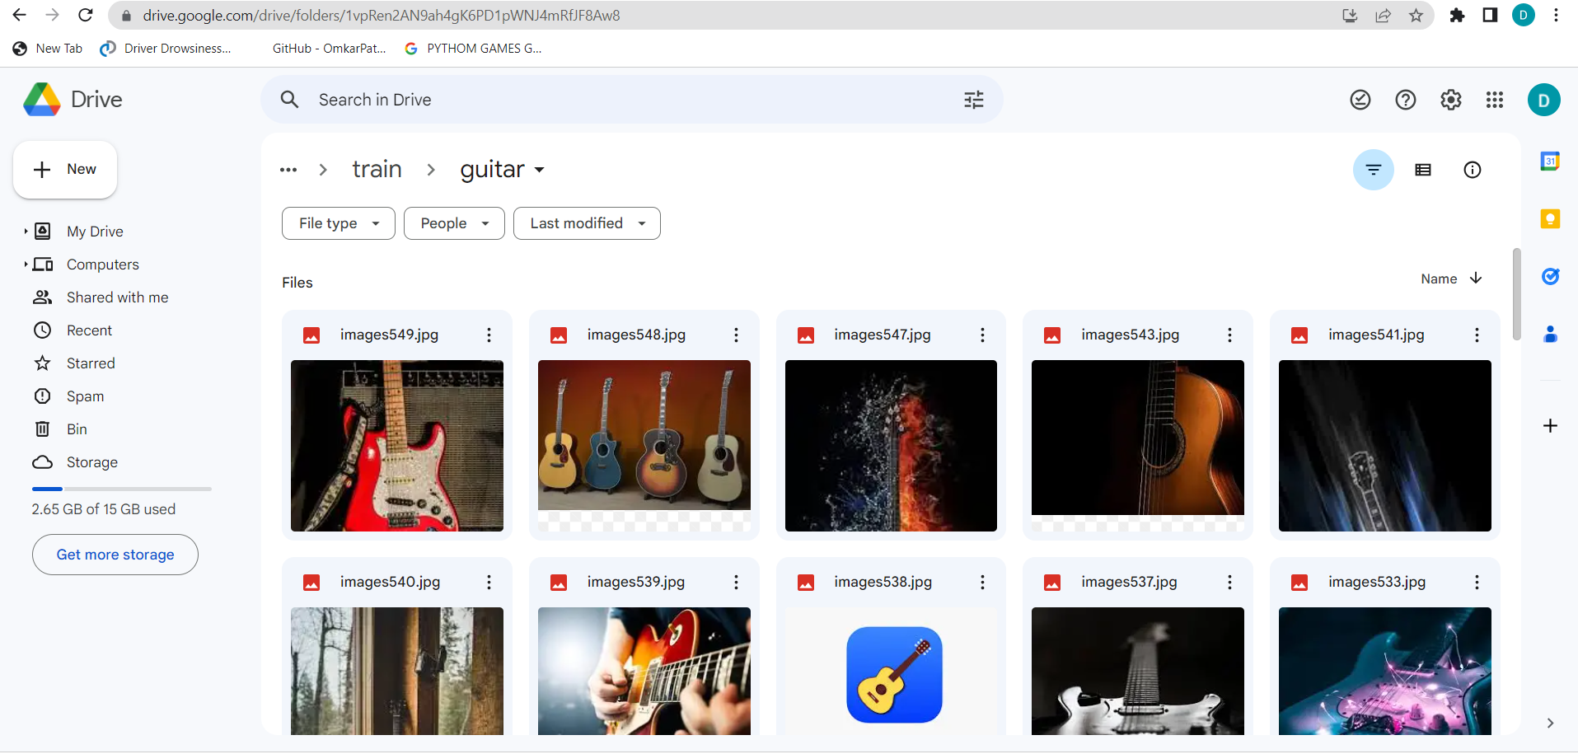

**CONCLUSION:**

I have learnt how to create my own dataset.