**DAY-5&6**

In day five and six different algorithms was given and the code was executed with respect to the algorithms.

**TASK GIVEN:**

* Download the dataset and start working for the code.
* Run the code in pre-trained model.
* Run 100 epoch and construct confusion matrix.

**TASK COMPLETED:**

* Downloaded the dataset and worked on pre-trained model.
* Runned 100 epoch and the confusion matrix was constructed.

**DIFFICULTIES:**

* Epoch runned for long time and the execution of the epoch was terminated and again runned from beginning so the epoch took long time for execution.
* Confusion matrix was not good.

**SCREENSHOTS:**

1.Vgg

Lr=0.01

Batch size=64

Epoch=100

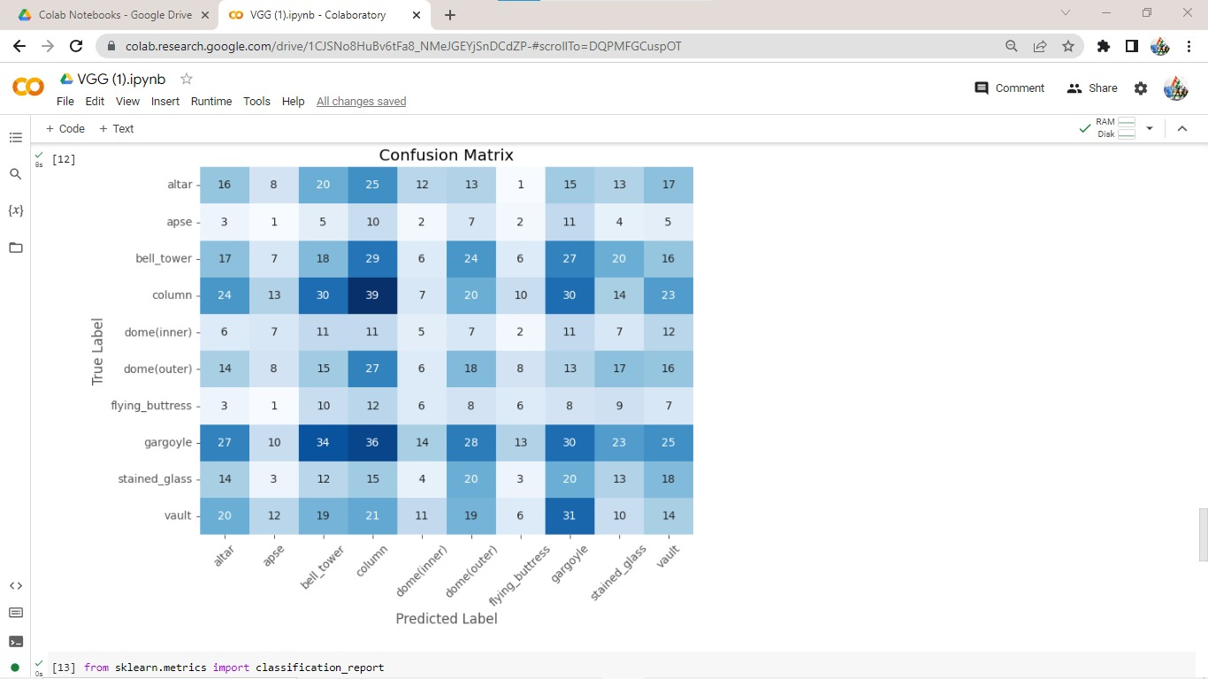

2.ResNet

Lr=0.001

Batch size=128

Epoch =100

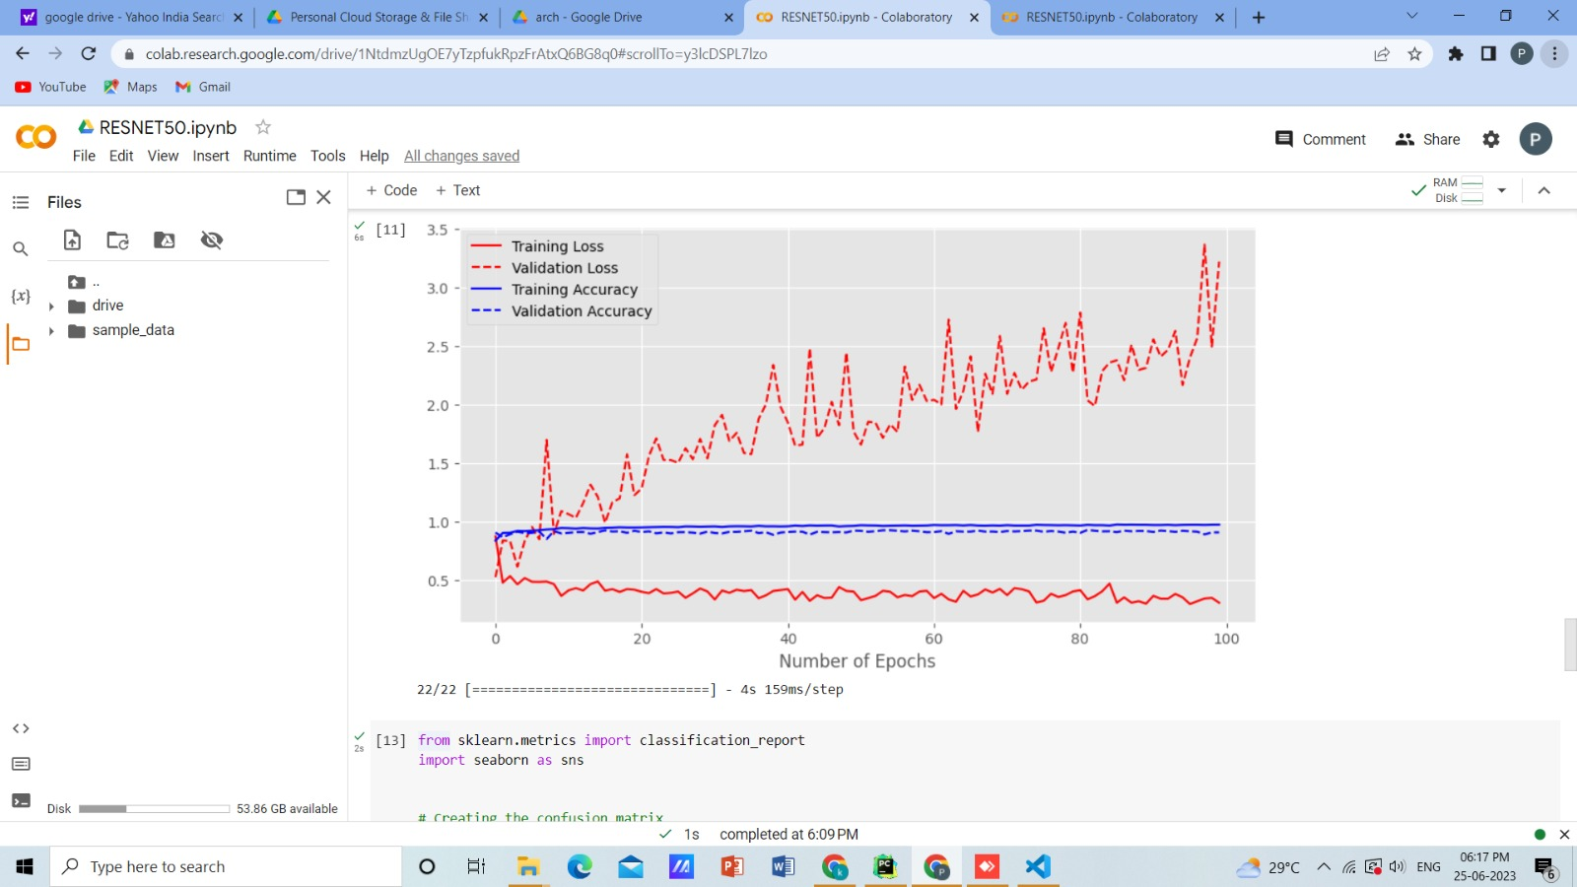

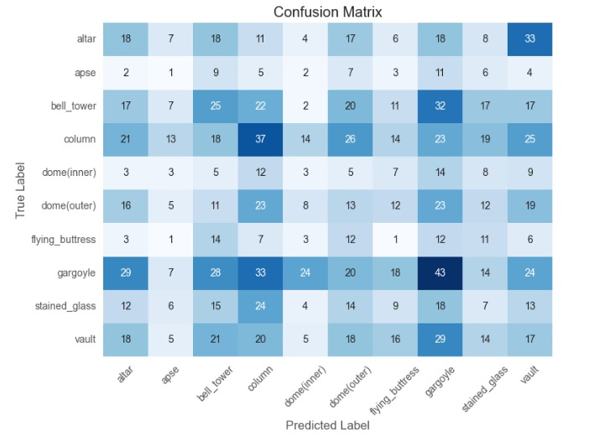

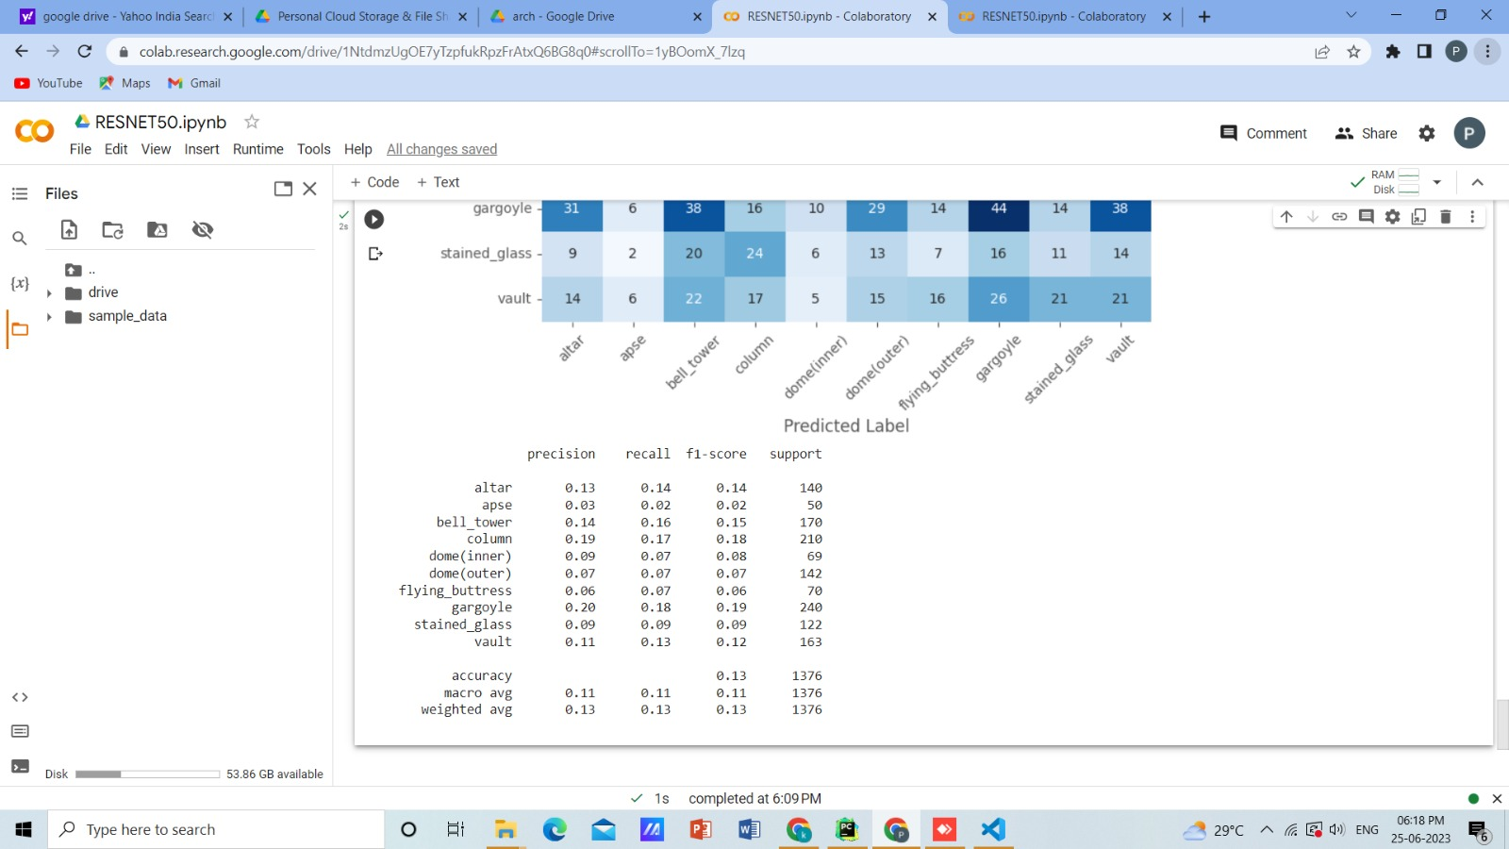

**CONCLUSION:**

I have implemented vgg and resnet algorithms.