Front-End UI/UX Mini Project  
  
Course: UI/UX Design Fundamentals

Project Title

Online Resume Builder

Submitted By~

**Team Members:**

* 1. Deepika Grace T T(2460357) [deepika.grace@btech.christuniersity.in](mailto:deepika.grace@btech.christuniersity.in)
  2. Eliza Miriam Paul(2460363) [eliza.miriam@btech.christuniversity.in](mailto:eliza.miriam@btech.christuniversity.in)
  3. Ridhi M Chabbria(2460433) ridhi.m@btech.christuniversity.in

**Instructor Name:** Ms Nagaveena **Date of Submission**:26/09/2025

**Institution:** Christ University ,Bangalore

**1. Abstract:**

This Online Resume Builder is a responsive web application that enables users to build, preview, and export professional resumes in real time. The core goal is to provide a simple, friendly interface where users can enter personal details, education, work experience, and skills, and immediately see a formatted resume in a live preview panel. The frontend uses HTML5, CSS3, Bootstrap for responsive layout, and JavaScript/jQuery for dynamic behavior and live updates. The application supports adding multiple education and experience entries, reordering sections, and exporting the final resume as a printable PDF via the browser's print functionality. This project is useful for students and professionals who want a fast, no-fuss way to generate clean, print-ready resumes without needing backend infrastructure.

**2.Objectives:**

• Design a user-friendly, accessible interface for entering resume data.

• Implement live preview so users can see formatted results as they type.

• Allow multiple entries for education and work experience with add/remove controls.

• Provide a clean, printable layout that prints well to PDF.

• Ensure the site is responsive using Bootstrap and mobile-first principles.

• Use jQuery for DOM manipulation and small UI enhancements.

**3.Scope of the Project:**

**Includes:**

* Frontend application implementing form input, live preview, and client-side export (print to PDF).
* Responsive layouts for desktop, tablet, and mobile using Bootstrap.
* Client-side validation and dynamic UI using JavaScript/jQuery.

**Excludes / Boundaries:**

* No backend persistence (no server-side DB or user accounts).
* No long-term storage — data is not saved between sessions unless user manually exports.
* Advanced resume templates (only one primary template with minor variations).

**4.Tools and Technologies used:**

|  |  |
| --- | --- |
| **Tool/Technology** | **Purpose** |
| **H**TML5 | **Markup and structured form + preview layout** |
| **CSS3** | **Styling, print stylesheet, responsive tweaks** |
| **Bootstrap 5** | **Grid system, responsive components** |
| **JavaScript** | **Live preview logic, DOM manipulation** |
| **jOuery** | **Simplify DOM updates and event handling** |
| **VS Code** | **Development editor** |
| **Chrome**  **DevTools** | **Testing, layout and responsive debugging** |

**5.HTML Structure Overview:**

• Used semantic tags: <header>, <main>, <section>, <aside>, <footer>.

• Two-column layout inside <main>: left column for the form, right column for the live preview.

• Reusable components: Education entry template, Experience entry template, Skill chips.

• Buttons to add/remove entries and to trigger Print/Export.

**6.CSS Styling Overview:**

• Single external stylesheet style.css plus a print.css for print-specific rules.

• Organize CSS with comment sections: Variables, Layout, Components, Utilities, Print.

• Techniques used:

* CSS Variables for color palette and spacing.
* Bootstrap for grid and base responsiveness, then custom overrides for preview.
* Flexbox for arranging header and items inside preview cards.
* Media queries for small-screen stacking and font-size adjustments.
* Print rules to hide form controls and scale preview to A4-like width.

**7.Key Features:**

The Online Resume Builder comes with several powerful features to make the resume-building process smooth and efficient. It provides a **personal information form** where users can enter their name, contact details, and a short professional summary. The **education and work experience sections** allow users to add multiple entries with years, titles, and detailed descriptions, ensuring flexibility in representing their academic and career history. A **skills section** lets users add skill tags dynamically, giving them the ability to showcase both technical and soft skills. The standout feature is the **live preview panel**, which instantly reflects all changes made in the form, allowing users to visualize their resume in real time. Once satisfied, users can make use of the **download/print option**, which generates a clean and professional PDF version of the resume. Additionally, the application is designed with a **fully responsive layout** using Bootstrap, ensuring that the resume builder works seamlessly across desktops, tablets, and smartphones.

**8.Challenges faced and Solution:**

During development, several challenges were encountered. One of the key issues was **synchronizing form data with the live preview**. Initially, updates were delayed or inconsistent, but this was resolved by using **jQuery event listeners** to capture input changes in real time and update the DOM instantly. Another difficulty was **layout inconsistencies while printing resumes**, as elements would overlap or break alignment. This was solved by implementing a dedicated **@media print CSS stylesheet** to optimize the print layout. Adding and removing multiple education or work experience entries dynamically also posed a challenge, which was overcome by using **event delegation in jQuery** to handle newly created form fields. Lastly, **maintaining responsiveness on smaller screens** was tricky, but a combination of **Bootstrap’s grid system and Flexbox** adjustments ensured that the design adapted properly across different devices.

**9.Outcome:**

• Successfully built a **responsive Online Resume Builder**.

• Live preview works seamlessly with user inputs.

• Resume can be downloaded/printed in a clean layout.

• Gained deeper understanding of **Bootstrap, DOM updates, and print styling**.

**10.Future Enhancement:**

* Add multiple resume template styles (Modern/Classic).
* Save resume data using Local Storage or Database.
* Export as DOCX format.
* Add drag-and-drop section reordering.
* Implement theme toggler (light/dark mode).

**11.Sample Code:**

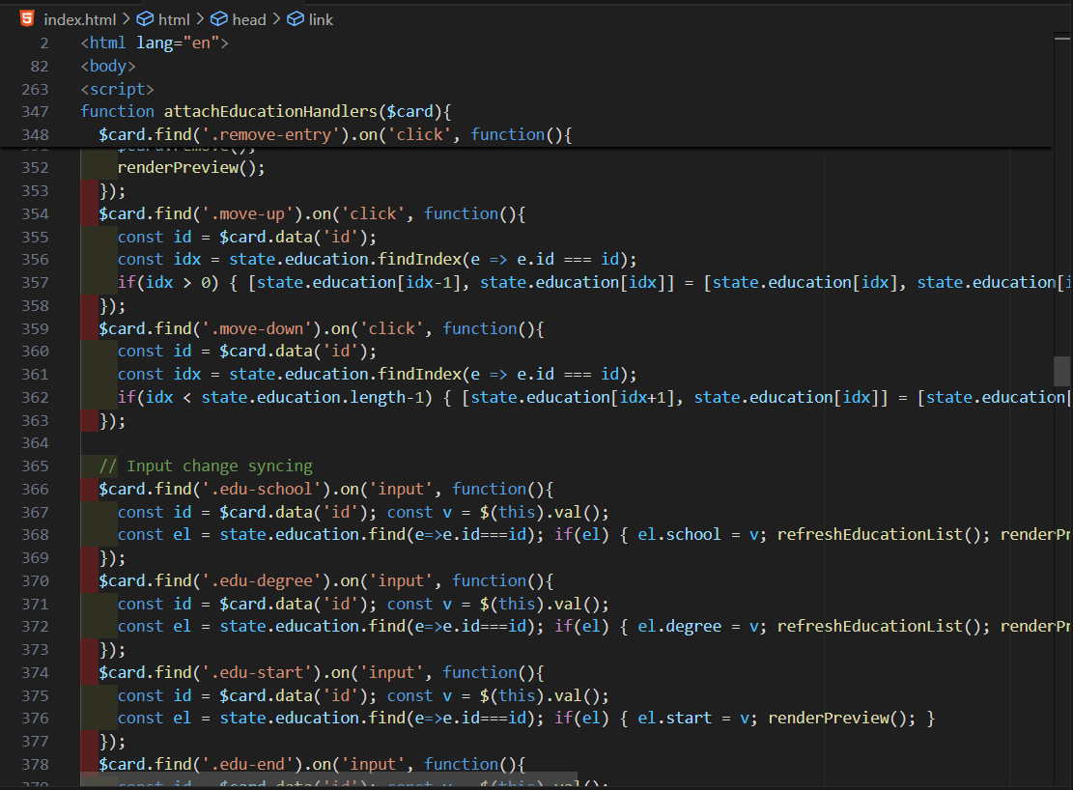

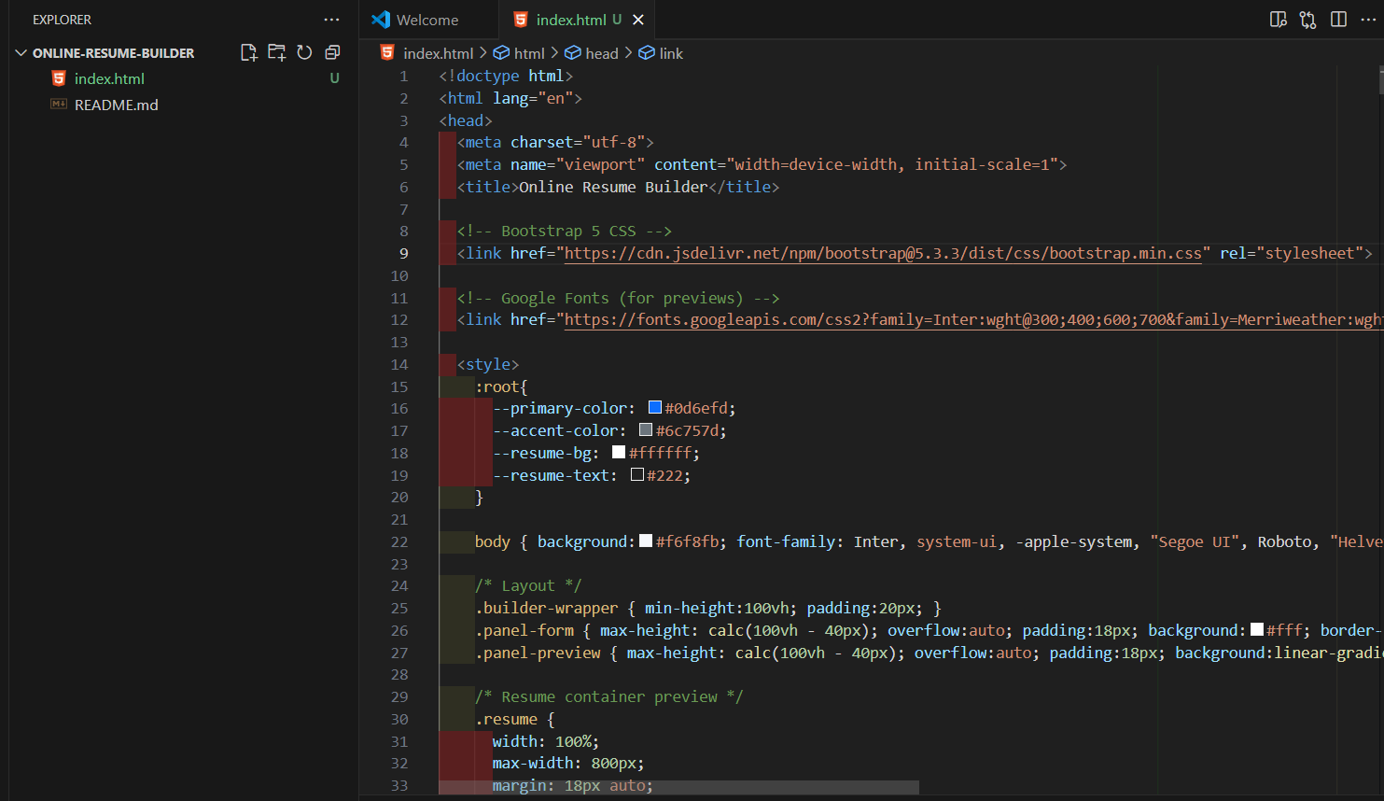 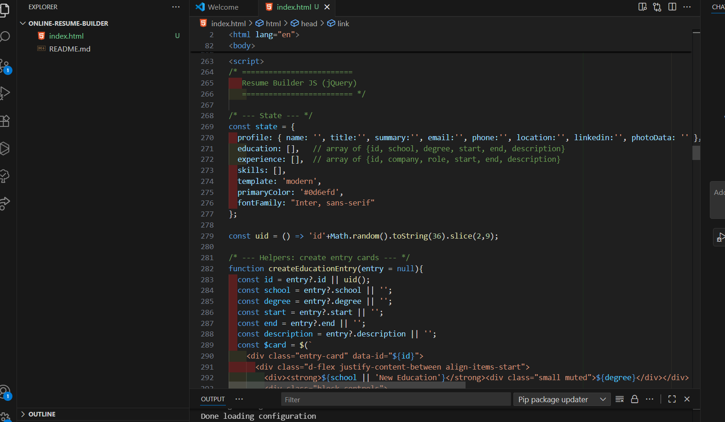

**12.Screenshots and final Output:**

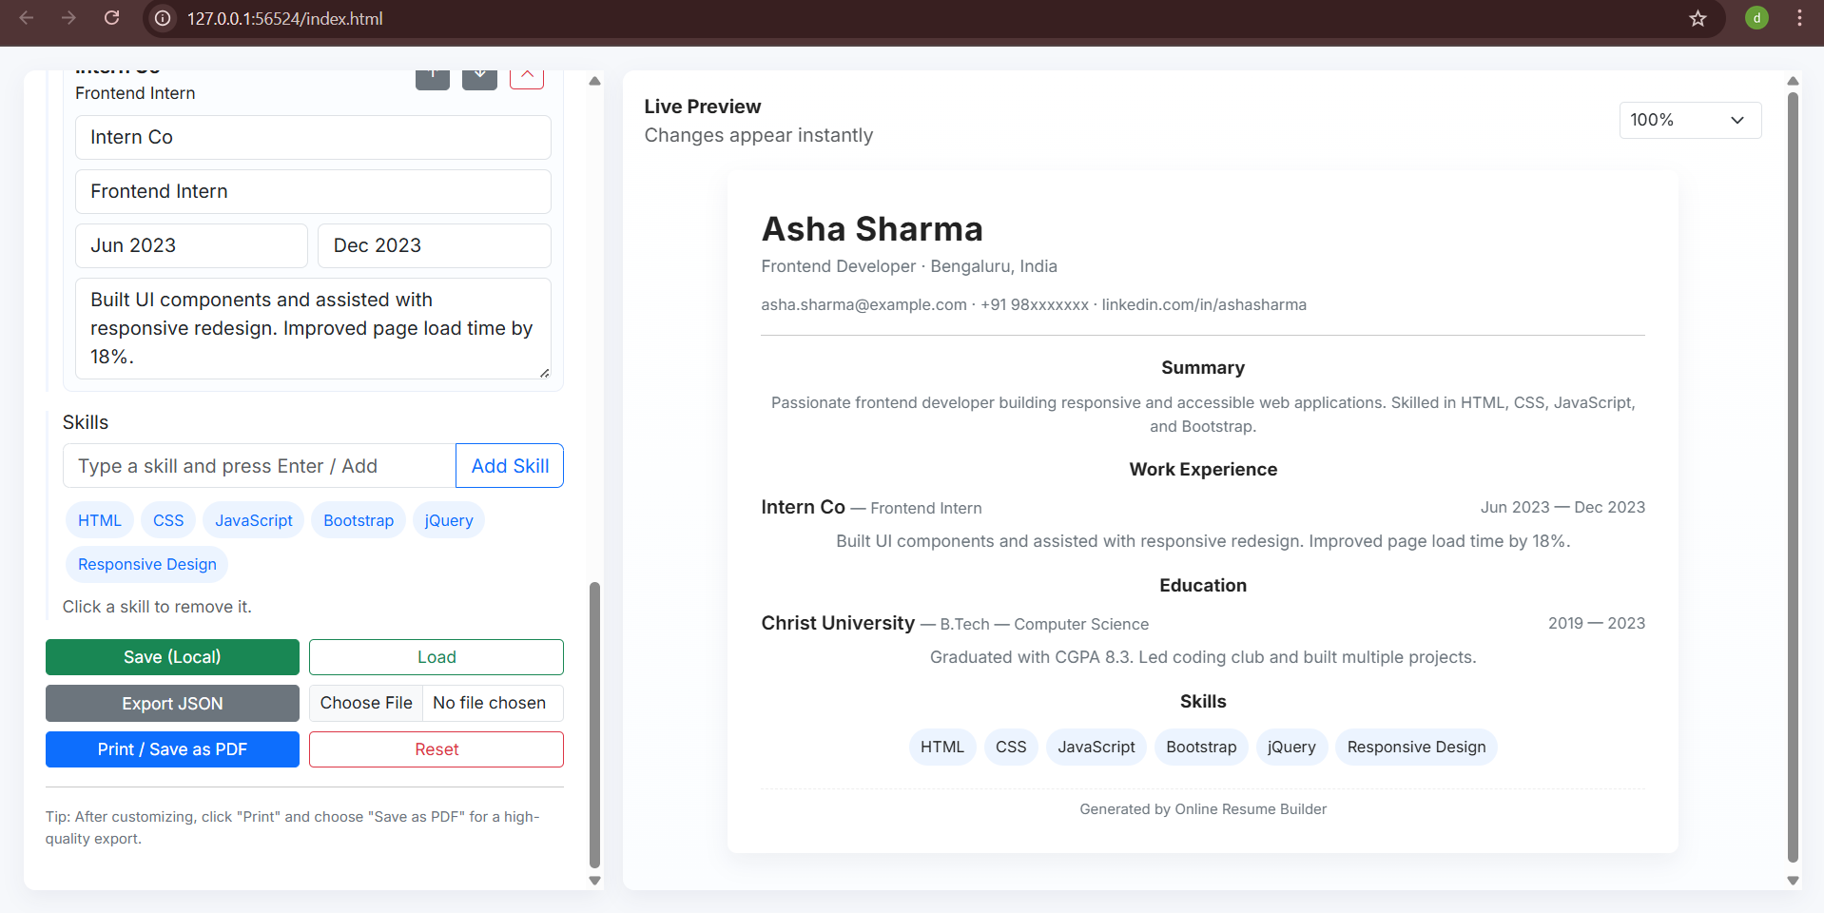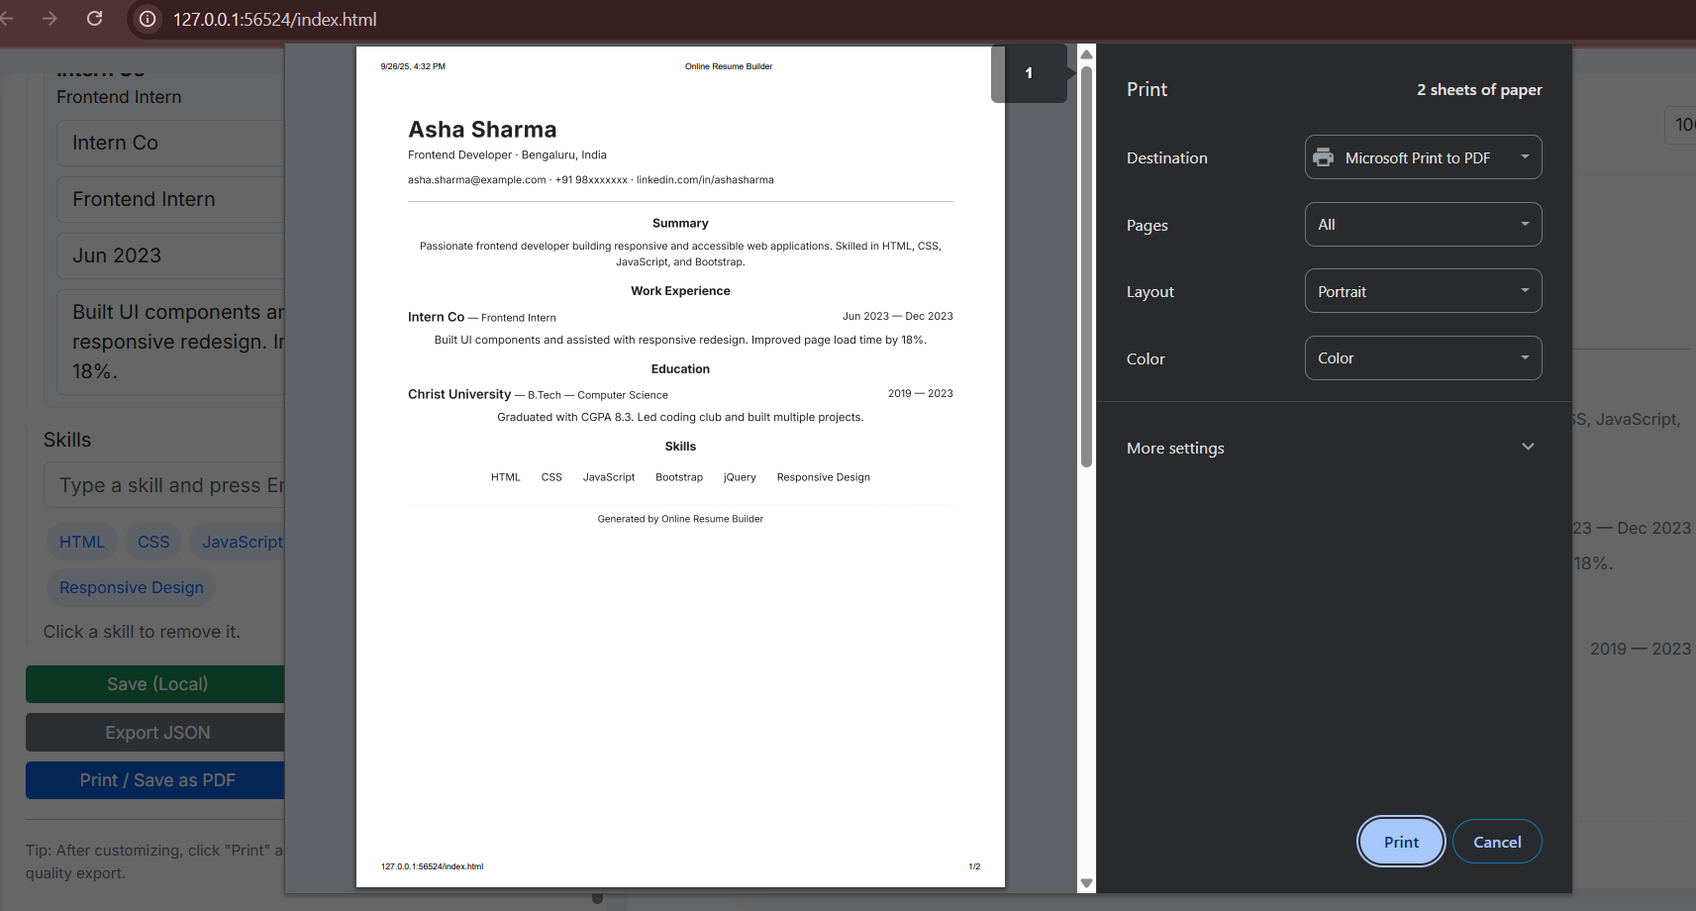

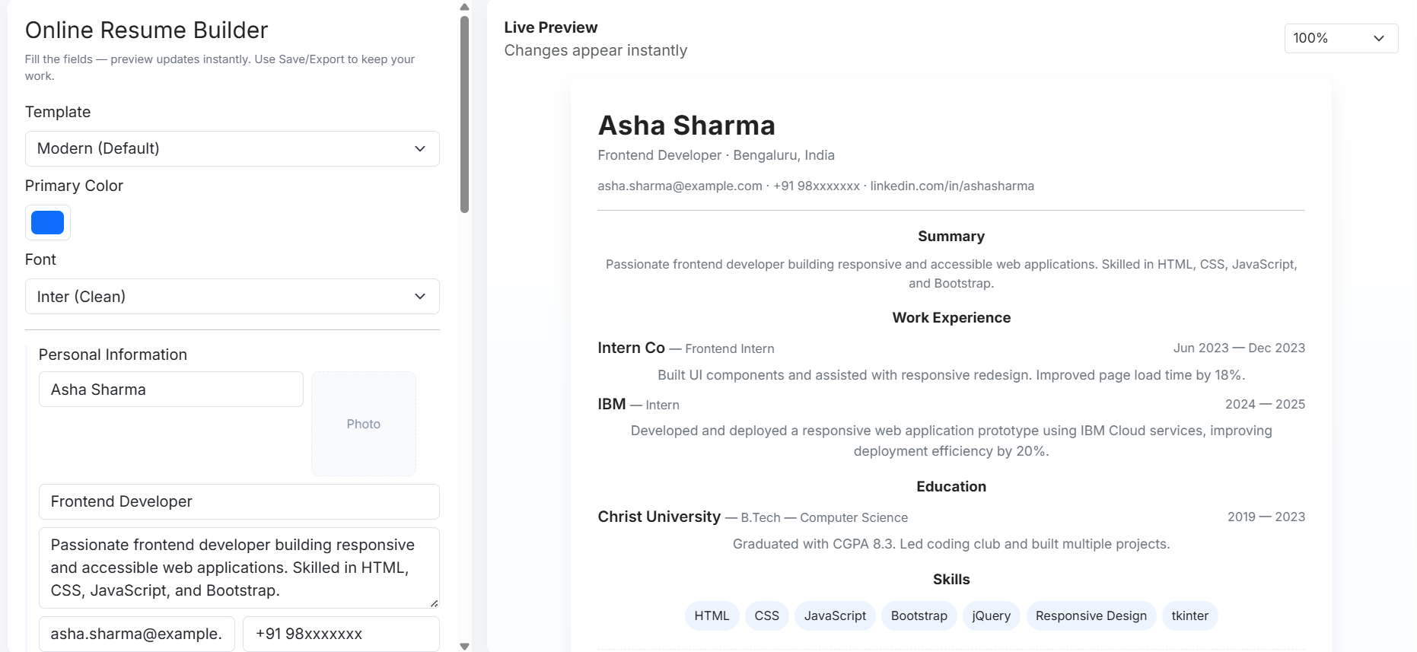

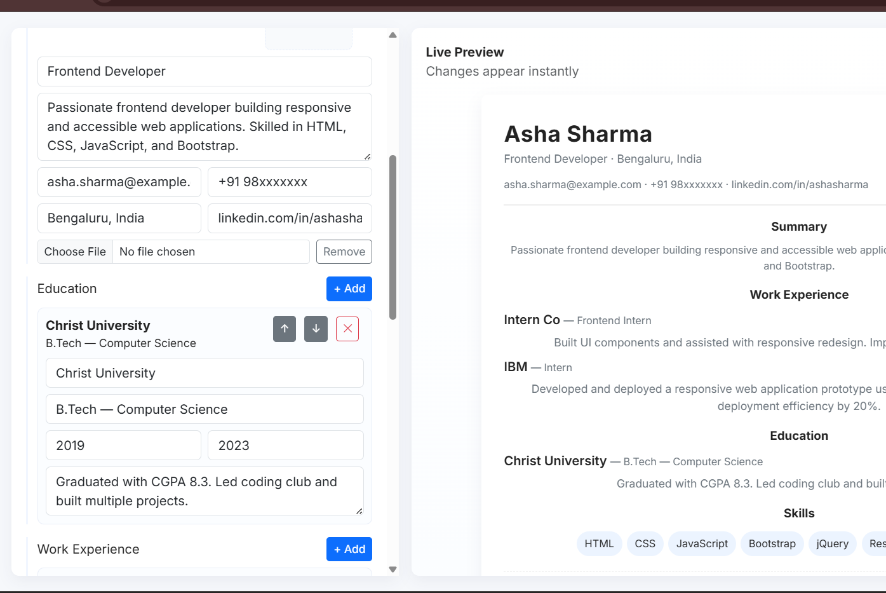

**13.Conclusion:**

The Online Resume Builder project successfully demonstrates the development of a **responsive, interactive, and print-friendly web application** using HTML, CSS, Bootstrap, JavaScript, and jQuery. It provides an efficient way for users to create professional resumes quickly and conveniently. Through this project, I strengthened my skills in responsive web design, dynamic DOM handling, and user-centric UI/UX design principles.

**14.Reference:**

• L&T LMS: <https://learn.lntedutech.com/Landing/MyCourse>

• Bootstrap Documentation: https://getbootstrap.com

• jQuery Documentation: https://api.jquery.com