DATASET AND ANNOTATION AUDIT REPORT
Project: IBM × MAH Quantum – PS-7: AI-Assisted Quality Inspection
Role: Member 1 – Dataset and Annotation Audit
Dataset: NEU-DET (Northeastern University Surface Defect Database)

1. Introduction
Dataset and annotation auditing is an important step in developing a reliable AI-based quality inspection system. This audit examines the NEU-DET dataset for image and annotation consistency, missing files, bounding-box validity, duplicate images, and class-wise image distribution. The checks were performed using Python in Google Colab.

2. Dataset Overview
The NEU-DET dataset contains six categories of steel surface defects: Crazing, Inclusion, Patches, Pitted Surface, Rolled-in Scale, and Scratches.
Dataset attribute | Details
Total images | 1,800
Training images | 1,440
Validation images | 360
Image dimensions | 200 × 200 pixels
Annotation format | Pascal VOC XML
Number of defect classes | 6

3. Class-wise Image Distribution
Defect class | Training images | Validation images | Total
Crazing | 240 | 60 | 300
Inclusion | 240 | 60 | 300
Patches | 240 | 60 | 300
Pitted Surface | 240 | 60 | 300
Rolled-in Scale | 240 | 60 | 300
Scratches | 240 | 60 | 300
Total | 1440 | 360 | 1800

The dataset is balanced across all six defect classes. Each class contains 240 training images and 60 validation images.
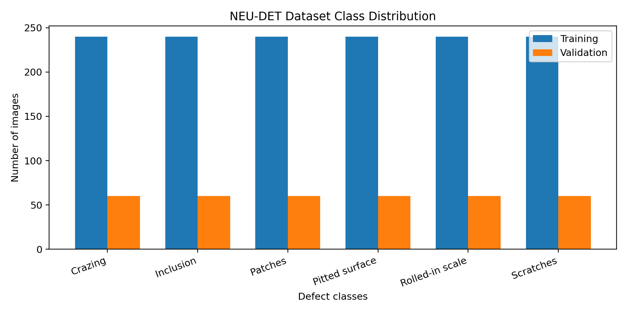
Figure 1. Class distribution of the NEU-DET dataset.

4. Dataset Audit and Validation
The following validation activities were performed:
- Checked the availability of image files and corresponding XML annotation files.
- Checked annotation labels against the six expected defect categories.
- Validated bounding-box coordinates against image dimensions and checked that boxes had positive width and height.
- Visually inspected one sample image from each defect class with its original XML bounding boxes.
- Compared image file contents across training and validation splits using SHA-256 hashes to identify exact duplicates.

5. Initial Audit Findings
Audit parameter | Initial result
Total images | 1,800
Total XML files | 1,800
Images without matching XML | 1
XML files without matching image | 1
Invalid bounding boxes | 0
Unknown class labels | 0

One image–annotation mismatch was identified. The image crazing_240.jpg was present in the training images folder, while its corresponding file crazing_240.xml was located in the validation annotations folder. The validation split did not contain the corresponding image.

6. Annotation Correction
The misplaced annotation file crazing_240.xml was moved from the validation annotations folder to the training annotations folder in a separate corrected copy. The original dataset was not modified. The three bounding boxes in the XML were visually checked against the training image and appeared to cover the relevant defect regions.
Corrected annotation split | XML files
Training | 1,440
Validation | 360
Total | 1,800

The corrected annotation folders were packaged into a ZIP archive for submission and GitHub upload.

7. Duplicate Image Audit
Duplicate audit parameter | Result
Total images checked | 1,800
Unique image contents | 1,799
Duplicate groups within the same split | 1
Duplicate groups across training and validation | 0

SHA-256 hashing identified one exact duplicate pair within the training split: patches_101.jpg and patches_105.jpg. Both belong to the patches class. The duplicate pair was documented and not removed from the original dataset. No exact duplicate-image leakage was detected between the training and validation splits. This hash-based check detects exact file-content duplicates and does not rule out visually similar images with different file contents.

8. Tools and Technologies Used
Python, Google Colab, KaggleHub, OpenCV, Matplotlib, Pillow (PIL), XML ElementTree, and hashlib (SHA-256).

9. Deliverables
- Dataset audit report documenting dataset structure, validation results, and identified issues.
- Corrected annotation files containing the reorganized training and validation XML annotations.
- Class distribution chart showing the number of images in each defect category.
- Duplicate-image audit findings documenting the duplicate pair and cross-split comparison.

10. Conclusion
The NEU-DET dataset was audited for image and annotation consistency, class-label correctness, bounding-box validity, duplicate images, and class-wise distribution. One image–annotation placement mismatch was identified and corrected in a separate copy of the dataset. The automated checks found no invalid bounding-box coordinates or unknown class labels. The dataset has a balanced distribution across all six defect classes. One exact duplicate image pair was identified within the training set, while no exact duplicates were detected between training and validation. The audit findings and corrected annotation files are prepared for the subsequent stages of the AI-assisted quality inspection project.

