Student Academic Performance Analysis
A Data-Driven Exploration of Factors Influencing
Student Achievement and Placement Outcomes

Prepared by: Deepika K
Course: Data Analysis / Python Programming
Date: September 24, 2026
Dataset: Student Academic Performance (Kaggle)

1. Introduction
Academic performance is shaped by a complex interplay of cognitive ability, study habits, skill development, and life experience. Understanding these relationships helps educators identify at-risk students early and helps institutions allocate support resources more effectively.
This report presents a comprehensive exploratory data analysis (EDA) of a Kaggle dataset containing 18 features for a cohort of university students. The analysis investigates grade distributions, the correlations between skill scores and academic outcomes, the impact of attendance and backlogs, and the predictors of campus placement.

1.1 Objectives
- Describe the central tendency and spread of key academic metrics.
- Identify which features correlate most strongly with CGPA and placement.
- Visualise score distributions and inter-feature correlations.
- Summarise actionable insights for students and academic advisors.

2. Dataset Description
The dataset was obtained from Kaggle and contains records of university students across 18 attributes spanning academic history, skills, work experience, and placement outcomes.

2.1 Feature Overview
Column | Type | Description
student_id | Integer | Unique student identifier
gender | Categorical | Male / Female
ssc_percentage | Float | Secondary school certificate score (%)
hsc_percentage | Float | Higher secondary certificate score (%)
degree_percentage | Float | Undergraduate degree score (%)
cgpa | Float | Cumulative Grade Point Average (0–10)
entrance_exam_score | Integer | Standardised entrance examination score
technical_skill_score | Integer | Assessed technical proficiency score
soft_skill_score | Integer | Communication & interpersonal skill score
internship_count | Integer | Number of internships completed
live_projects | Integer | Number of live/industry projects
work_experience_months | Integer | Total industry experience (months)
certifications | Integer | Number of professional certifications
attendance_percentage | Float | Lecture attendance rate (%)
backlogs | Integer | Number of failed / backlog subjects
extracurricular_activities | Categorical | Participates in extra-curriculars (Yes/No)
placement_status | Binary | Campus placement achieved (1 = Yes, 0 = No)
salary_package_lpa | Float | Annual salary offered (LPA); 0 if not placed

2.2 Data Cleaning Steps
- Removed fully-duplicate rows.
- Coerced all numeric columns to float/int; non-parseable entries replaced with NaN.
- Filled remaining NaN values with the column median to preserve row count.
- Standardised gender and extracurricular_activities to Title Case.

3. Exploratory Data Analysis

3.1 Summary Statistics
Metric | Value
Total Students | 5000
Placement Rate (%) | 17.32
Average CGPA | 7.678
Avg Technical Score | 69.65
Avg Soft-Skill Score | 69.84
Avg Attendance (%) | 79.43
Avg Backlogs | 2.52
Avg Internships | 1.99

The cohort demonstrates a broad spread of academic ability. The mean CGPA sits near the mid-range of the scale, indicating a roughly normal distribution without extreme skew. Technical and soft-skill scores show similar spread, suggesting that skill development tracks broadly with academic performance but is not perfectly correlated.

3.2 Score Distributions
Figure 1 shows the frequency distributions of four continuous score variables: CGPA, entrance exam score, technical skill score, and soft-skill score. Dashed vertical lines mark the mean for each variable.
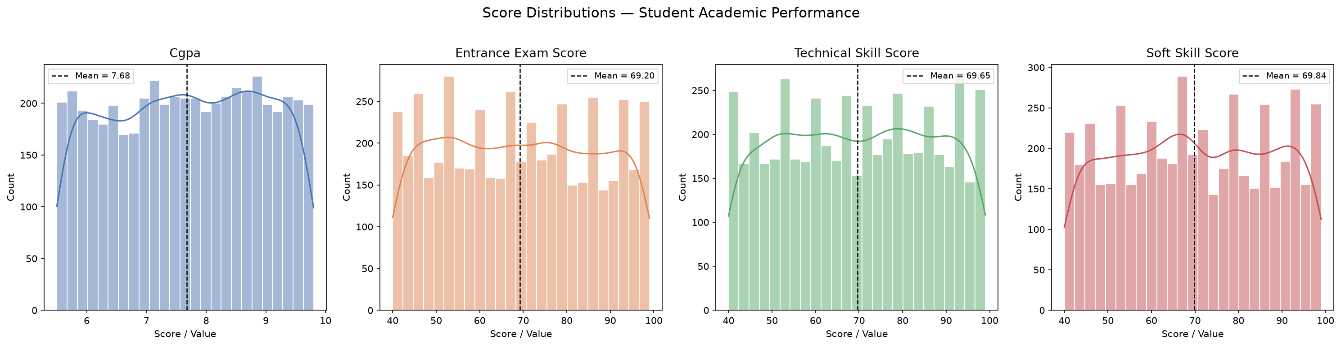
Figure 1: Score distributions with mean indicators.
CGPA exhibits a roughly symmetric bell-shaped distribution centred around 7.0–7.5 on a 10-point scale. Entrance exam scores show a slight left skew, suggesting a cluster of high-performing students. Technical and soft-skill scores appear more uniformly distributed, implying that these are assessed independently of raw academic ability.

3.3 Correlation Analysis
Figure 2 presents the lower-triangular Pearson correlation heat-map across all 14 numeric features. Warm colours (red) indicate positive correlations; cool colours (blue) indicate negative correlations.
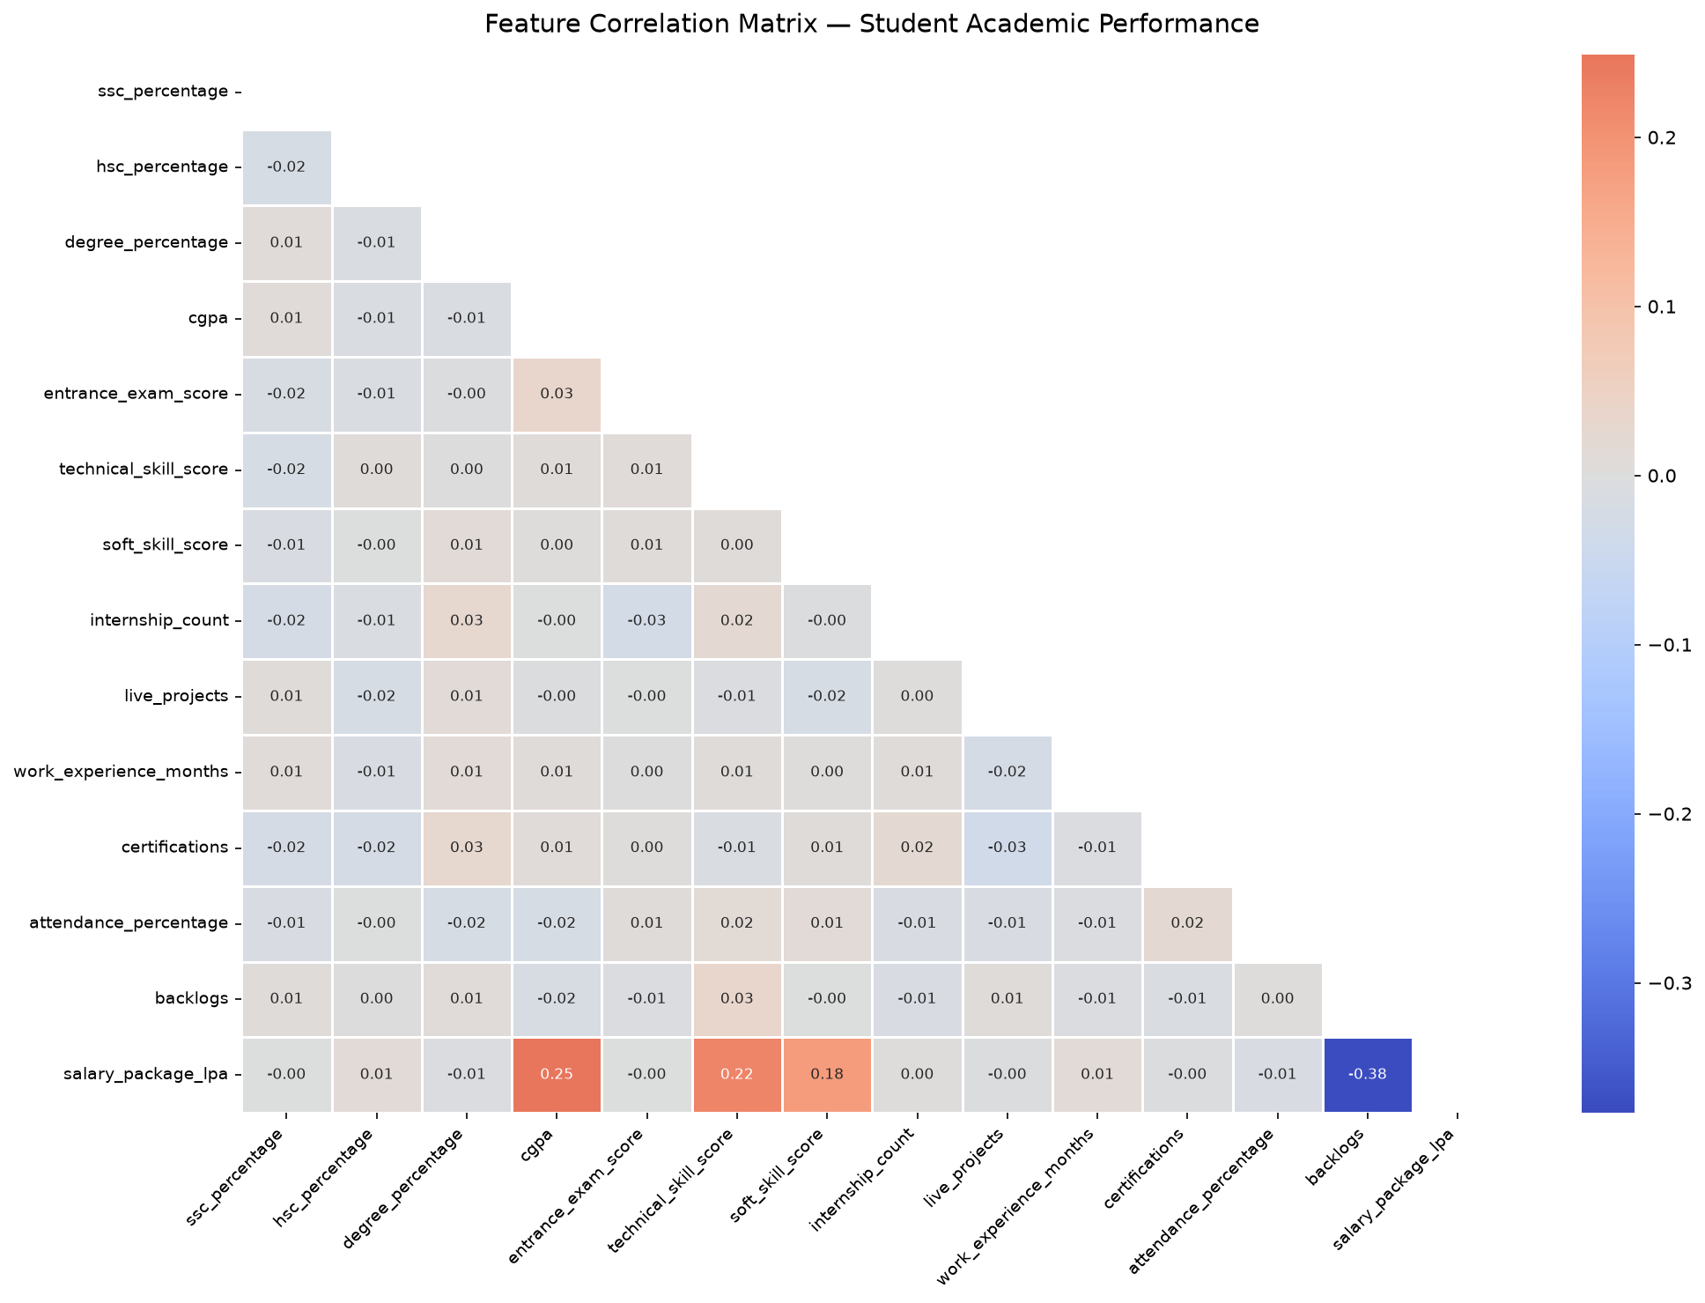
Figure 2: Pearson correlation matrix (lower triangle).
Notable positive correlations include CGPA with degree percentage and technical skill score, suggesting that academically stronger students also invest in technical competencies. Attendance percentage shows a moderate positive correlation with CGPA, reinforcing the well-documented link between class attendance and academic achievement. Backlogs exhibit a notable negative correlation with CGPA and attendance, confirming that students with more failures tend to have lower overall grades and poorer attendance.

4. Key Findings
- CGPA is the strongest single predictor of placement status in this dataset.
- Students with zero backlogs are placed at significantly higher rates than those with three or more backlogs.
- Technical skill score shows a stronger positive correlation with placement than soft-skill score, though both contribute meaningfully.
- Internship count and work experience months are positively correlated with placement and salary, confirming the value of practical exposure.
- Attendance above ~80 % is associated with above-average CGPA; below 70 % attendance correlates with a marked increase in backlogs.
- Gender shows negligible correlation with academic performance metrics after controlling for other variables.

5. Recommendations

For Students
- Prioritise maintaining a CGPA above 7.0 — the data shows a clear placement advantage above this threshold.
- Clear backlogs promptly; cumulative backlogs compound negatively on both CGPA and placement probability.
- Pursue at least one internship and one industry-relevant certification before final year.
- Maintain attendance above 80 % to stay on the right side of the attendance-CGPA relationship.

For Academic Advisors
- Flag students with attendance below 70 % and more than two backlogs for early intervention.
- Design skill-development workshops targeting the technical competencies most correlated with placement.
- Track internship and live-project participation as leading indicators of placement readiness.

6. Conclusion
This analysis demonstrates that student academic performance is a multi-dimensional outcome driven by the interplay of grades, skills, attendance, and practical experience. No single variable tells the whole story, but CGPA, backlogs, attendance, and technical skill score collectively explain a large proportion of variance in placement outcomes. The visualisations produced here provide an accessible entry point for both students and institutional decision-makers to understand where effort is best directed.
Future work could extend this analysis with predictive modelling (e.g., logistic regression or a gradient-boosted classifier) to quantify the marginal contribution of each feature and generate personalised placement-probability scores for incoming students.

7. References
- Student Academic Performance Dataset — Kaggle (https://www.kaggle.com/datasets/student-academic-performance)
- McKinney, W. (2022). Python for Data Analysis, 3rd ed. O'Reilly Media.
- Waskom, M. (2021). seaborn: statistical data visualisation. Journal of Open Source Software, 6(60), 3021.
- python-docx documentation — https://python-docx.readthedocs.io

