Aqua Surface Cleaner Bot

Project Report

Submitted by:

D Deepika Shree

Team Members: Nitheesh (E&I), S Niranjana (EEE), Karthik Prasanna

Institution: Hindusthan College of Engineering and Technology

Year: 2025

# Abstract

The Aqua Surface Cleaner Bot is a mobile-controlled robot designed to collect floating waste from the water surface using Bluetooth or Wi-Fi technology. This bot uses Arduino Uno for control, DC motors for movement, and an LED for navigation indication. The bot can be directed remotely using a mobile application, providing an efficient and cost-effective solution for water surface cleaning.

# Introduction

Water pollution due to floating waste is a growing environmental concern. Manual cleaning is labor-intensive and inefficient. This project aims to automate the process of cleaning water surfaces by deploying a mobile-controlled bot that can be operated remotely to collect waste efficiently.

# Objective

To design and develop a Bluetooth/Wi-Fi-controlled robotic system that collects floating waste from the surface of water bodies efficiently and affordably.

# Components Used

- Arduino Uno

- L298N Motor Driver

- DC Motors

- HC-05 Bluetooth Module / Wi-Fi Module

- LED (Headlight)

- Power Supply (Battery Pack)

- Wires and Connectors

- Frame/Chassis

# Wiring Diagram

Below is the wiring diagram of the Aqua Surface Cleaner Bot:

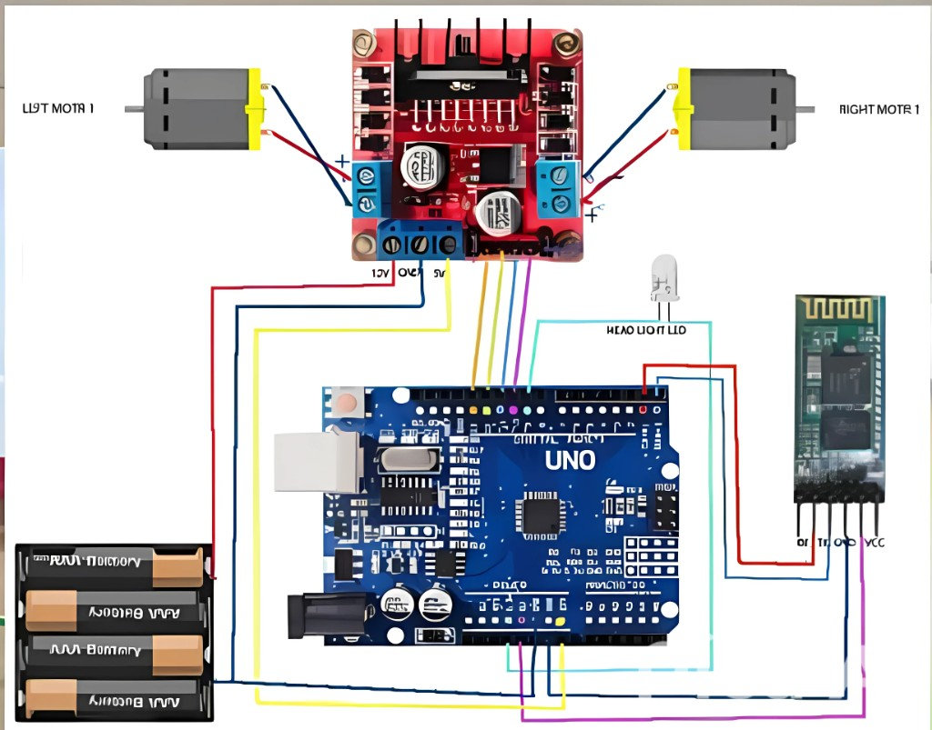

# Working Principle

The bot receives control commands via Bluetooth/Wi-Fi from a mobile device. The Arduino interprets these commands to control the motor driver (L298N), which in turn powers the DC motors. The bot can move forward, backward, turn left or right, and also turn a headlight LED ON or OFF for navigation in low light.

# Arduino Code Explanation

The Arduino code defines motor directions and reads serial input from the Bluetooth/Wi-Fi module. Based on the character received, it moves the bot accordingly:  
- 'F': Forward  
- 'B': Backward  
- 'L': Turn Left  
- 'R': Turn Right  
- 'W': LED ON  
- 'w': LED OFF  
- 'S': Stop all motors

# Applications

- Cleaning floating waste in ponds, lakes, and pools

- Environmental monitoring and maintenance

- Educational robotics projects

- Remote-controlled cleaning solutions

# Conclusion

The Aqua Surface Cleaner Bot offers a practical solution to the issue of floating waste in water bodies. It demonstrates the effective use of automation and remote control in environmental applications. This project highlights how simple electronic components can be combined to address real-world problems.