**Renewable Energy Capacity and Production in World**

**Rabadiya Deep Vinodbhai**

**(Student Id:- daiict202319029)**

**Submission date:- 17/01/2024**

**Submitted To:-**

**Mr. Prasun Kumar Gupta**



**Indian Institute of Remote Sensing**

**(M.Sc. Agriculture Analytics)**

**Module Name: - Programming for Geodata Processing**

**INDEX**

|  |  |  |
| --- | --- | --- |
| **Sr. No.** | **Name** | **Page No.** |
| 1 | Abstract | 3 |
| 2 | Introduction and Dataset | 4 |
| 3 | Research Question | 6 |
| 4 | Analysis | 7 |
| 5 | Conclusion | 10 |
| 6 | Reference | 11 |

**ABSTRACT**

This project examines the dynamic global renewable energy environment, with a particular emphasis on the notable expansion that has been recorded in the last year and extending into 2022. The world gained 50% more capacity for renewable energy last year compared to 2022. With the use of Python programming and key libraries including NumPy, Matplotlib, and Pandas, the research seeks to identify patterns and trends related to renewable energy capacity.

Data on renewable energy gathered from the International Renewable Energy Agency's official website and another data source from, our world in data.

The world's capacity for renewable energy has been rising over the past few years, according to data from the International Renewable Energy Agency. 50% more renewable energy capacity was produced last year than in 2022, from 2013 to 2022.

A Times of India story states that the global capacity for renewable energy increased by 50% in 2022 compared to the previous year. Based on my data, I have calculated a steady growth from 1567206 MW to about 3381758 MW between 2013 and 2022. The world gained 50% additional capacity for renewable energy after 2022 to 2023.

# Additionally, according to a different Nasdaq article, the installed capacity of solar photovoltaic (PV) systems globally by the end of 2022 was 1,046.61 GW, up from 136.57 GW at the end of 2013. In fact, my dataset of rising solar energy production attests to the veracity of the information in the article. Additionally, the article lists the Top Five Countries for Solar Energy Generation.

1. **Introduction and Datasets:**

The world of renewable energy has grown at a rate never seen before in the search for cleaner, more sustainable energy sources. The most recent year's noteworthy developments are projected to continue into 2022.

The goal of this research is to identify significant trends and patterns in the dynamic evolution of the world's renewable energy capacity. Using Python programming and key libraries like NumPy, Matplotlib, and Pandas, our investigation aims to offer insightful information about the global transformation of renewable energy.

* **Data Source:-** I obtain my statistics from the International Renewable Energy Agency, a reliable source. Information on Renewable Energy Capacity by Country from 2013 to 2023. And a Times of India piece that claims that global renewable energy capacity increased by 50% in 2022 compared to last year. And yet another dataset from the data website from our world. The second article is a Nasdaq product. global transformation in the use of renewable energy.
* **Data Source link: -**

1. First dataset taken from International Renewable Energy Agency which provides an actual data of Capacity and Production of Renewable Energy.

* <https://www.irena.org/Publications/2023/Jul/Renewable-energy-statistics-2023>

Another Renewable Energy Production Dataset. From our world in data website.

[https://ourworldindata.org/renewable-energy](https://ourworldindata.org/renewable-energy )

**2)** And articles taken from times of India and second one is taken from nasdaq respectively talk about Capacity and Production of All Renewable Energy and also Solar Energy.

* <https://timesofindia.indiatimes.com/business/india-business/world-added-50-more-renewable-energy-capacity-last-year-over-2022-iea/articleshow/106724185.cms?from=mdr>
* <https://www.nasdaq.com/articles/top-five-nations-in-solar-energy-generation>

Our collection includes data on the capacity of renewable energy sources (solar, wind, hydro, and other) per country. Data shows that the production and capacity of renewable energy have continued to rise. And the leading countries for solar photovoltaic (PV) installation include "China," "United States," "India," "Japan," "Germany," etc.

* **Hypothesis: -**
* The article states that the world installed 50% more renewable energy capacity last year compared to 2022, and that there has been a significant increase in renewable energy over the previous year, extending into 2022.
* To test the hypothesis, we need to clean and also filter the data accordingly.
* **Data Filtering: -**

A certain number of NR (not registered) value exists in the datasets; however, we change such values to nan by using the Replace function. Then, we extract the data and use the pandas library to plot the data on a year-by-year graph showing the world's capacity for renewable energy. Additionally, employ conditional filtering to extract particular years and nations from the data.

We also create a new Excel sheet that shows the overall capacity and production of renewable energy broken down by year.

1. **Research Questions:**

**News Article**: - The first article, from Times of India, and the second, from Nasdaq, discuss the capacity and production of renewable energy, including wind, solar, hydro, and other sources.

**Claim: -**

1. As reported by times of India on January 2024, The amount of renewable energy capacity added to energy systems around the world grew by 50 percent in 2023.

**2)** And another article of Nasdaqon Aug 2023, which is states that Solar Energy grew year by year and nations which are top in Solar Energy Production.

* **Research Question**: - Renewable Energy Capacity in the past years, extending into 2022 and World added 50% more renewable energy capacity last year over 2022.

And some higher producers of solar energy in world.

* The article reports that in 2023, the global addition of renewable energy capacity to energy systems increased by 50% to about 510 gigawatts, with solar photovoltaics (PV) accounting for three-quarters of these additions.
* Our data shows that, up until 2022, the capacity of renewable energy expanded continuously; but, from 2022 to 2023, the global energy capacity increased significantly.
* Additionally, based on another dataset, we may determine that the top five countries in the world for solar energy deployment are, in order, China, the United States, Japan, India, and Germany. Furthermore, China is the world's largest manufacturer.
* According to the report, China experienced the biggest increase, adding wind power at a rate of 66 percent annually and commissioning as much solar PV in 2023 as the entire globe did in 2022.

1. **Analysis: -**

We create a data frame from production data first. We take the years 2001 to 2022 and a few nations, such as "India," "China," "South Africa," "United States," "France," "Japan," "Germany," and so on, out of this data frame. We then draw a line chart to show the trend of renewable energy in those various countries.

We are unable to observe additional changes in a graph if we plot all countries for the entire year.

Year-over-year variations in production are common in most countries. However, data from countries like China and the USA shows that production increased significantly between 2013 and 2022.

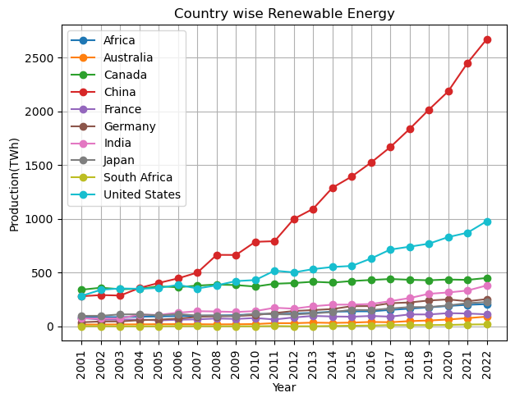

Here chart clearly show that the continuously increase in Renewable energy in the all countries.

The first Article (Times of India) shows that, compared to 2022, the world added 50% more renewable energy capacity last year.

In order to do this, we first create a data frame with capacity data, extract the years 2013 through 2023, and then extract the first row of the data frame, which contains global data.

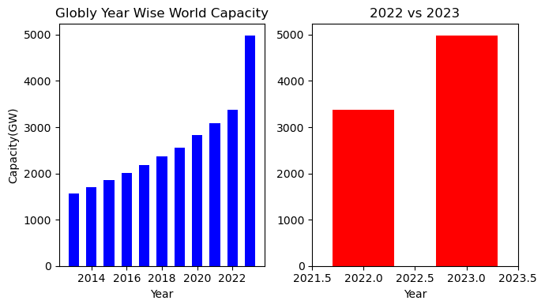

The graph shown (2022 vs. 2023) shows that, compared to 2022, the world added around 50% more renewable energy capacity last year. This article is accurate on this subject, hence.

Additionally, I have plotted the renewable energies in this chart, including wind, solar, hydro, and other sources of energy. Thus, we are able to distinguish between the global contributions of various forms of renewable energy generation. - (TWh)

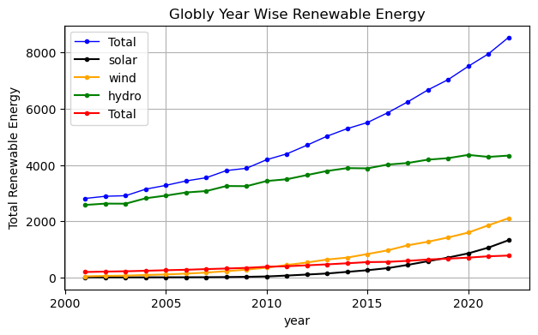

The article's second assertion dealt with the creation of solar energy. According to the Second Article (Nasdaq), the number of countries producing the most solar energy increased annually.

The top 5 nations in the world for solar energy generation are shown in this graph.

According to the article, the top countries in the world for solar energy generation are China, the United States, India, Japan, and Germany.

First, we filter the data according to the necessary criteria, such as extracting the years 2020, 2021, and 2022 in addition to the countries.

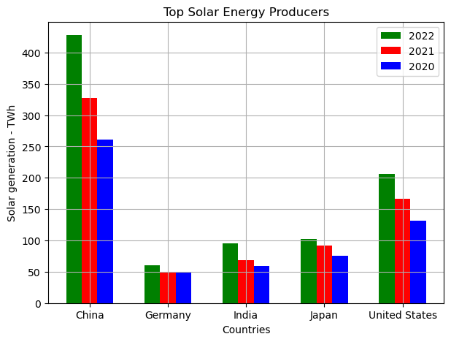

As per Article the top five producer of solar energy are 1st= 'China', 2nd= 'United States', 3rd='Japan', 4th='Germany', 5th='India'. But from my data 5th='Germany', 4th='India'.

**Only for Information: Capacity vs Production (**Renewable energy**)**

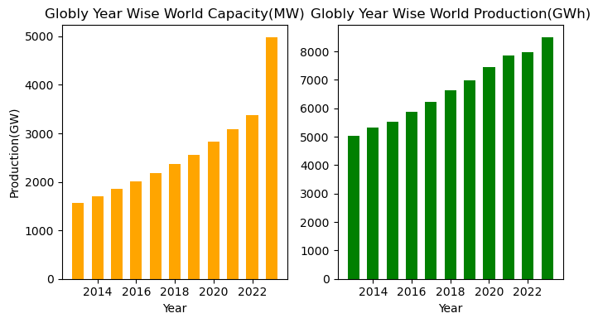

1. **Conclusion: -**

Our examination of the data reveals a steady increase in Renewable Energy Capacity, as seen by the strong trend in graph three. There has been a noticeable overall growth in the generation of renewable energy, indicating that the shift to sustainable energy sources is moving in the right direction. Additionally, as seen in graph two, the world added 50% more renewable energy capacity last year than it did in 2022.

Regarding the second assertion about solar energy output, the evidence shows that solar energy production has been steadily increasing year over year. The key countries making substantial contributions to this expansion are clearly displayed, with China leading the world in solar energy generation, closely followed by the US. Additionally, the top three producers of solar energy are Japan, Germany, and India, as demonstrated in Fourth Graph.

According to the second article, Germany is ranked fourth and India is ranked fifth for solar energy generation; however, based on our data and research, Germany is ranked fifth and India is ranked fourth.

According to Article One, the globe added 50% more capacity for renewable energy last year than it did in 2022, but our statistics and analysis show that this increase in capacity was not precisely 50%. Nevertheless, we can still conclude that our claim is true and that our theory is moderately accepted.

**REFRENCES**

1. **World and Country wise yearly Renewable Energy Capacity and Production Data.**

[**https://www.irena.org/Publications/2023/Jul/Renewable-energy-statistics-2023**](https://www.irena.org/Publications/2023/Jul/Renewable-energy-statistics-2023)

1. **As a reported by times of India on January 2024, World added 50%**

**More Renewable Energy Capacity last year over 2022.**

[**https://timesofindia.indiatimes.com/business/india-business/world-added-50-more-renewable-energy-capacity-last-year-over-2022-iea/articleshow/106724185.cms?from=mdr**](https://timesofindia.indiatimes.com/business/india-business/world-added-50-more-renewable-energy-capacity-last-year-over-2022-iea/articleshow/106724185.cms?from=mdr)

1. **As reported by Nasdaq on Aug 2023, which is states that Solar Energy grew year by year, and nations which are top in Solar Energy Production.**

**[https://www.nasdaq.com/articles/top-five-nations-in-solar-energy-generation](https://www.nasdaq.com/articles/top-five-nations-in-solar-energy-generation )**

1. **Another Renewable Energy Production Dataset.**

**[https://ourworldindata.org/renewable-energy](https://ourworldindata.org/renewable-energy )**