Enhancing Bone Fracture Detection in Radiology: Leveraging Machine Learning and Explainable AI
Krishnav Deka  School of Computer Engineering  KIIT Deemed to be University  Bhubaneswar, Odisha, India  deka.krishnav2003@gmail.com | Madhurjya Rabha  School of Computer Engineering  KIIT Deemed to be University  Bhubaneswar, Odisha, India  madhurjyarabha1@gmail.com | Deepratim Saikia  School of Computer Engineering  KIIT Deemed to be University  Bhubaneswar, Odisha, India  deepratimsaikia19@gmail.com
Junali Jasmine Jena  School of Computer Engineering  KIIT Deemed to be University  Bhubaneswar, Odisha, India  junalijasmine3811@gmail.com | Mahendra Kumar Gourisaria  School of Computer Engineering  KIIT Deemed to be University  Bhubaneswar, Odisha, India  mkgourisaria2010@gmail.com | Dayal Kumar Behera  School of Computer Engineering  KIIT Deemed to be University  Bhubaneswar, Odisha, India  dayalbehera@gmail.com

Abstract— Bone fractures, caused by impacts, trauma or conditions such as osteoporosis, require timely and precise detection for effective medical care. Traditional approaches rely on radiologists' interpretations of X-rays, which are labor-intensive and prone to errors. Machine learning (ML) presents a promising solution for enhancing fracture identification. However, the opacity of ML models presents challenges in their integration into healthcare, necessitating transparency and interpretability. This paper examines the use of ML in fracture detection and incorporates Explainable AI (XAI) techniques to clarify decision-making processes and bolster model reliability. In this paper, Local Directional Pattern (LDP) and Local Binary Pattern (LBP) have been used for extracting the features and it is found that the Random Forest Classifier achieved the highest accuracy of 95 %. By assessing both the accuracy and interpretability of ML models in identifying fractures, this study aims to promote wider acceptance and application of AI-driven diagnostic tools in medical settings.
Keywords—Bone Fracture Detection, Image Processing, Random Forest, Explainable AI, Medical Diagnostics.

Introduction
Bones are the rigid frameworks that constitute the skeleton, offering support, safeguarding internal organs, and facilitating movement through their interaction with muscles. They are primarily composed of collagen and calcium phosphate, which confer strength and sufficient flexibility to endure stress. Nonetheless, fractures or breaks in bones can be caused by trauma, misuse, or bone-weakening disorders such as osteoporosis etc. Prompt and precise detection of bone fractures is essential for effective treatment and recovery, highlighting its importance in medical diagnostics [1].
Bone fractures are a major medical problem that impact millions of people annually worldwide. Conventional fracture detection techniques mostly depend on radiologists to interpret X-rays, which can be a laborious and prone to human error procedure. Recent developments in computational and medical imaging technologies have made machine learning (ML) a viable method for improving and automating fracture identification [2]. Accurate interpretation of X-rays and other imaging techniques is a complex task that requires extensive training and experience. Radiologists often face high workloads and time constraints, which can lead to fatigue and an increased risk of errors. Moreover, subtle fractures or atypical presentations can be easily missed, particularly in busy clinical settings. The variability in individual radiologist expertise and the inherent subjectivity in image interpretation further complicate the diagnostic process. Given these difficulties, there is a critical need for proper radiology diagnostics to ensure high standards of patient care. This research investigates the applicability of machine learning models in diagnosing bone fractures, capitalizing on their capacity to analyse large volumes of imaging data with high precision and efficiency. However, a significant challenge in adopting ML models in healthcare is their "black box" nature. For clinicians to trust and effectively use these models, it is essential to understand how they reach their conclusions. This requirement led to the incorporation of Explainable AI (XAI) techniques, which are intended to clarify the decision-making processes of ML models, making them transparent and interpretable. Explainable AI seeks to clarify intricate algorithms, allowing humans to comprehend the decisions of AI systems. It prioritizes transparency, offering insights into how models reach conclusions. This builds trust and empowers users to validate outcomes, particularly vital in sensitive fields such as healthcare and finance [3]. Nowadays, machine learning is extensively utilized in the medical field for tasks such as mental health assessment and disease diagnosis [4, 5].
This study does not just focus on the accuracy of the machine learning model in classifying bone fractures, but also delves into the underlying mechanisms of its predictions using explainable AI techniques. By visualizing and interpreting how the model makes decisions, the study aims to reveal which factors and features are crucial for fracture identification. This dual strategy ensures that the model is both reliable and understandable for medical professionals by improving the models' readability and hence contributing to the wider adoption and trust in AI-driven diagnostic tools in healthcare. The organization of this paper is as follows: Section II. Related Work, provides a summary of the findings from past studies, Section III. Materials and Methods, outlines the technology utilized and the methodology followed in the study, The results and their analysis have been outlined in Section IV. Results and Discussion and Section V. iConclusion and Future Work, concludes the paper along with explaining possible directions for further research followed by References.

Related Work
This section provides the review of research various works performed in the field of bone fracture detection. Alkhatib et al. [6] (2024) examined the efficacy of convolutional neural networks (CNNs) and region-based convolutional neural networks (RCNNs) in fracture detection in their paper. As they discussed the findings, the outcomes continually highlighted the supremacy of the RCNN algorithm, which performed exceptionally well in a variety of experimental configurations. In the end, the study's conclusions stressed how crucial it is to choose the right optimization algorithms and hyper-parameters for deep learning systems based on bone fracture detection. The improved performance of algorithms that were trained using the Adam optimizer demonstrated that it was appropriate for this use case. According to their research, they were able to use the Adam optimiser and RCNN to get up to 99% accuracy.
Verma et al. [7] (2024) investigated the viability and efficacy of applying the YOLO algorithm for bone fracture detection. They talked about the difficulties posed by fracture identification, the possible advantages of automated methods, and the contribution of deep learning algorithms like YOLO to these problems. Their goal was to demonstrate the usefulness of the YOLO-based fracture model in the medical area. Additionally, they were able to demonstrate that YOLOv4 gives greater precision than YOLOv3. They used the YOLOv4 model to obtain a precision of 63.5%.
Research by Ma et al. [8] (2021) introduced CrackNet, a new classification network that could detect fractures more precisely and was sensitive to fracture lines. Their suggested method was able to locate the broken bone in an X-ray image in addition to identifying it as such. The effectiveness of the proposed system was proven by extensive tests on the Radiopaedia dataset, where it outperformed alternative approaches on the bone fracture diagnosis job with 88.39% accuracy, 87.5% recall, and a precision of 89.09%.
Yadav et al. [9] (2022) created a new multimodal feature fusion hybrid SFNet that required less processing time and had a high efficiency level when compared to current cutting-edge CNN models. Notably, the hybrid SFNet combined with Canny edges achieved the highest classification accuracy in their research. This demonstrated that incorporating the Canny edge algorithm enhanced CNN performance. The hybrid SFNet attained an accuracy of 99.1% and a precision of 99%, indicating that the inclusion of Canny edge images significantly improves performance.
Yao et al. [10] (2021) devised a three-step procedure to detect rib fractures in a patient population ranging from minor to severe fractures. (1) All skeletal features from chest CT scans were captured using a trained semantic segmentation algorithm. (2) A rib localization model was developed to isolate ribs while excluding sternum, scapulae and the vertebrae. (3) A classification model was developed to detect fractures in isolated ribs, and its performance was tested against an independent dataset. They discovered that their deep-learning model detected rib fractures with higher recall and equivalent diagnostic precision to both young and experienced radiologists. Their study achieved a precision of 87%, Recall of 91% and a F1 score of 89%.
Achawale et al. [11] (2024) concentrated on creating an automated system for detecting bone fractures using convolutional neural networks (CNNs). In their medical imaging analysis, the use of convolutional neural networks (CNNs) for bone fracture identification produced encouraging results. The CNN model showed impressive accuracy in distinguishing fractures from non-fracture images after undergoing extensive training on a varied dataset. The evaluation metrics used by them included recall, accuracy, precision, and F1 score. They were able to achieve a precision score of 87% in their study. Basha et al. [12] (2020) created a machine learning model to diagnose bone fractures. The model starts by using a Gaussian filter to enhance the quality f X-ray images. Next, the Canny edge algorithm is used to detect edges, followed by the Harris corner detection method to identify regions with fractures. The feature extraction process is refined using various image processing methods, including image pixel intensity analysis, image projection integration and adjustable filters. This technique achieves a 92% accuracy rate in identifying fractures. Table I presents an overview of the literature evaluated in this section.
- REVIEW OF LITRATURE SURVEY
Year | Method/Model | Dataset Used | Performance
2024 [6] | Region-based convolutional neural networks (RCNNs) with the Adam Optimizer | Bone X-ray image data-sets, collected from the Kaggle | Accuracy- 99% Precision- 97% Recall- 97%
2024 [7] | YOLOv4 model | MURA Dataset | Precision-63.5%
2021 [8] | Faster R-CNN and ResNet | X-ray image Data-set | Accuracy- 88.39%
2022 [9] | Fusion-based hybrid SFNet | Bone X-ray image datasets from Cancer Imaging Archive | Accuracy- 99.12% Precision- 98% Recall- 98%
2021 [10] | Deep learning Rib Fracture Detection System | Chest CT scans of 1707 patients from the Second Affiliated Hospital of Zhejiang University. | Precision- 87% Recall- 91% F1-score- 89%
2024 [11] | Convolutional Neural Networks (CNNs) | X-ray image Data-set | Precision- 87%
2020 [12] | Harris  Corner | X-ray and CT images collected  from hospitals | Accuracy- 92% Sensitivity- 88% Specificity- 85%

Materials and Methods
Subsequent sections comprehensively highlight the variety of resources utilized and provide detailed descriptions of the methods and procedures employed in the development of this research work.

Dataset Used
The dataset utilized in this study was obtained from Kaggle and is a real-world Bone Fracture Classification Dataset [13]. This comprehensive dataset of medical images is tailored to support research and advancements in diagnosing and categorizing bone fractures. With a focus on accuracy and diversity, the dataset comprises images of various fracture types, organized into 12 distinct categories. Each image corresponds to a specific type of bone fracture, including Compression-Crush fracture, Avulsion fracture, Oblique fracture, Spiral fracture, Longitudinal fracture, Impacted fracture, Greenstick fracture, Hairline fracture, Pathological fracture, Fracture Dislocation, Comminuted fracture, and Intra-articular fracture.

Data Processing
The dataset for this research consisted of images of bone fractures, organized into separate directories for training and testing sets. Each set included images classified by specific fracture types. These images were resized to a uniform size of 128x128 pixels to ensure consistency throughout the dataset. This standardization was critical for reliable feature extraction and to improve the performance of classifiers in later stages of the research. Additionally, the exploration included analyzing the distribution of images across various categories to maintain a balanced dataset. Data augmentation was conducted to enhance the models' performance.

Feature Extraction
In this section, the focus was to extract meaningful features from the images to be used as inputs for various classifiers. The images were converted into various colorspaces namely: Greyscale, RGB, HSV, YCBCR, LAB.
Greyscale consists solely of grey shades, from black to white, capturing light intensity without any color information. The red channel in the RGB colorspace measures the intensity of red light, the green channel measures the green light intensity and the blue channel detects the strength of blue light. In the HSV colorspace, the hue channel aids in color identification and distinction, while the saturation channel investigates color intensity and the value channel assesses brightness. YCBCR is another colorspace where, the Y channel represents the brightness (luma) component, the Cb channel detects the chroma blue difference and the Cr channel evaluates the chroma red difference. The L channel in the LAB color space shows lightness, the A channel evaluates the color spectrum from green to red, and the B channel investigates the complete color spectrum from blue to yellow.
The Local Directional Pattern (LDP) and Local Binary Pattern (LBP) techniques were implemented to capture texture details from the images. LBP captured local texture by comparing each pixel with its neighbors, while LDP used gradient directions to provide additional texture information. Histograms of these patterns were calculated and normalized to create feature vectors. First LBP features were extracted and converted to feature vectors via histograms. Then same process was followed for LDP and the extracted feature were concatenated.

Technology Used
Local Directional Patterns (LDP) [14] is an advanced texture descriptor extensively employed in computer vision and image processing for its capability to capture intricate texture details. It operates by examining how pixel intensities relate directionally to their neighbouring pixels, thereby creating a binary pattern that accurately reflects the local texture properties of an image. LDP finds widespread application in tasks such as texture classification, face recognition, image segmentation, and medical image analysis. Its resilience against noise and changes in illumination, coupled with its ability to emphasize edges and corners, establishes LDP as a potent technique for extracting features in diverse machine learning applications. Fig. 1 demonstrates how the LDP works.
Local Binary Pattern (LBP) [15] is a powerful texture descriptor widely utilized in computer vision and image processing due to its simplicity and effectiveness. LBP operates by comparing each pixel with its neighboring pixels to create a binary pattern that captures the local texture characteristics of an image. This technique is extensively applied in image segmentation, texture classification, medical image analysis and face recognition. Its ability to handle grayscale variations and its low computational overhead make LBP an essential tool in many machine learning applications, enabling efficient and precise feature extraction from images. Fig.1 demonstrates how the LBP works.
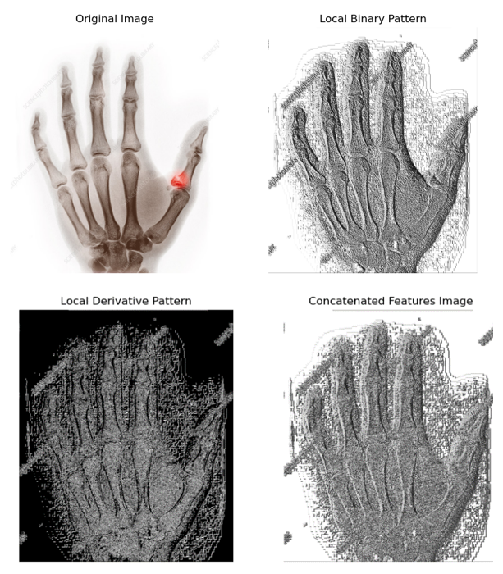
- Depiction of LDP and LBP
The Support Vector Classifier (SVC) is a supervised machine learning algorithm used for classification tasks. Its main purpose is to determine the optimal hyperplane that best separates different classes within the feature space. SVC strives to maximize the margin between these classes, making it effective for both linear and non-linear classification problems.
Adaboost, short for Adaptive Boosting, is an ensemble learning method designed to minimize bias and variance in classification tasks [16]. It is considered a meta-algorithm that enhances performance beyond traditional algorithms. Adaboost achieves superior results by iteratively focusing on the examples that previous models struggled with, thereby avoiding overfitting issues.
XGBoost (Extreme Gradient Boosting) is a widely recognized and highly efficient open-source library that offers robust machine learning algorithms [16]. Renowned for its high performance, XGBoost employs gradient boosting to build strong decision trees sequentially, ensuring exceptional speed and accuracy. Its effectiveness has made XGBoost a popular choice for predictive modelling tasks across various domains.
CatBoost (Categorical Boosting) [17] is a well-respected and highly efficient open-source library that offers sophisticated machine learning algorithms. Known for its outstanding performance, CatBoost excels at handling categorical features with minimal preprocessing. It uses gradient boosting to create robust decision trees sequentially, ensuring excellent speed and accuracy. The library is capable of processing large datasets and supports both classification and regression tasks. CatBoost's ability to deliver high predictive accuracy has made it a preferred tool for numerous predictive modelling applications across various sectors.
Gradient Boosting is a robust ensemble learning technique extensively utilized in machine learning for tasks involving regression and classification [18]. It constructs a robust predictive model by sequentially incorporating weak learners that rectify the errors of preceding models. Using gradient descent optimization, each successive model focuses on improving the predictions by minimizing the residuals left by the preceding models, thereby enhancing the overall accuracy of predictions.
The K-Nearest Neighbors (KNN) Regressor is a non-parametric regression technique utilized in machine learning to forecast continuous variables. This method predicts the target variable by calculating the average values of its k nearest neighbors within the feature space. While straightforward and effective, KNN Regressor achieves optimal performance when certain assumptions about the data distribution are satisfied.
Naive Bayes is a straightforward yet powerful probabilistic machine learning algorithm applicable to classification and regression tasks. It uses Bayes' theorem to compute the likelihood of an event given the probabilities of its potential causes. Naive Bayes assumes that features in the data are conditionally independent of each other, although this assumption may not always be realistic in practical scenarios. Despite this, Naive Bayes often demonstrates strong performance in real-world applications, particularly with high-dimensional data. It is straightforward to understand and implement, capable of handling both numerical and categorical data. However, it can be sensitive to data noise and may pose challenges in accurately estimating model parameters.
Random Forest stands out as a highly regarded ensemble learning technique in machine learning, celebrated for its robustness and exceptional predictive accuracy across diverse fields. It works by consolidating predictions from multiple decision trees that are trained on random subsets of the dtaset and features, effectively reducing overfitting while ensuring consistent performance. Its capability to handle both classification and regression tasks makes it a preferred method among researchers and practitioners, producing dependable results across various predictive modeling applications.
Decision Trees [19] are extensively utilized in machine learning for both regression and classification tasks, among numerous available algorithms. In the context of solar radiation prediction systems, decision trees can forecast the amount of solar radiation expected at a specific location and time of day. These trees operate by recursively splitting the data into smaller subsets based on feature values, thereby segregating homogeneous data points within each subset. resulting tree structure enables predictions for unseen datasets based on learned patterns.
Logistic regression [20] is a highly regarded and commonly employed statistical technique for binary classification problems. It forecasts the likelihood of a binary result based on one or more predictor variables, utilizing the logistic function to transform predicted values into probabilities. Praised for its straightforwardness and clarity, logistic regression is widely used in numerous areas, including medical research, social sciences, and finance, making it an essential tool for data scientists and analysts.

Methodology
A number of machine learning classifiers were used to evaluate the efficacy of the retrieved features. The classifiers included Decision Tree, K-Nearest Neighbors (KNN), AdaBoost, Gradient Boosting, Support Vector Machine (SVM), Random Forest, and Naive Bayes. The dataset was divided into training and testing subsets, with 20% of the data reserved for testing purposes. Each classifier was trained using the training set and assessed on the test set, with accuracy used as the metric to measure performance. The results showed different levels of accuracy among the classifiers, offering insights into the strengths and limitations of each approach for classifying bone fractures. Fig.2 illustrates the workflow of the proposed methodology.
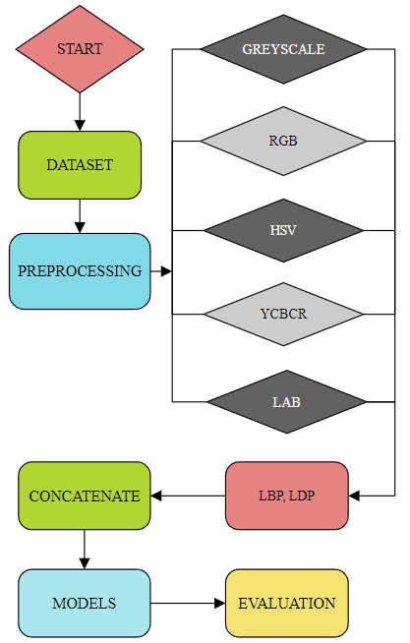
- Workflow Representation

Results And Discussion
This section provides the results and the derived inferences which are briefly explained and analysed. All machine learning models were developed and assessed using Python 3 with Anaconda Navigator for Jupyter notebooks. Following data processing and feature extraction, the previously mentioned machine learning techniques were implemented. Hyperparameter tuning was performed using Grid Search for all models. Evaluating the outcomes is critical to identify the optimal classifier. The primary performance metric used for evaluating the machine learning models was Accuracy. Table II below shows the accuracy of the machine learning models across different color spaces.
The results indicated that Random Forest classifier consistently outperformed all the other models across all the color spaces. Random Forest achieved an accuracy of 95% in the HSV color space, while it consistently achieved an accuracy of 94% across the other color spaces.
Next, the Random Forest classifier was executed using different bin sizes within the HSV color space.
- Model Performances
MODELS | RGB | GREY  SCALE | LAB | YCBCR | HSV
SVM | 0.80 | 0.80 | 0.80 | 0.78 | 0.81
Random Forest | 0.94 | 0.94 | 0.94 | 0.94 | 0.95
KNN | 0.93 | 0.92 | 0.94 | 0.94 | 0.94
Decision Tree | 0.89 | 0.90 | 0.91 | 0.91 | 0.91
Naïve  Bayes | 0.49 | 0.65 | 0.45 | 0.48 | 0.50
AdaBoost | 0.75 | 0.73 | 0.70 | 0.72 | 0.68
Gradient Boosting | 0.89 | 0.90 | 0.90 | 0.92 | 0.91
XGBoost | 0.94 | 0.93 | 0.94 | 0.94 | 0.94
CatBoost | 0.93 | 0.93 | 0.94 | 0.94 | 0.94
Logistic Regression | 0.74 | 0.71 | 0.76 | 0.76 | 0.76

Analysis of different bin sizes in the HSV colorspace revealed that the optimal performance occurred with bin sizes of 16. XGBoost also demonstrated strong performance, achieving 94% accuracy across RGB, LAB, YCBCR, and HSV colorspaces. The performance of Random Forest with the different bin sizes in the HSV colorspace is showed in Table III and inferred that the ideal bin size for detection of bone fracture by Random Forest classifier is 16.
- Performance of Random Forest in Different Bins
Model | Bin Size | Accuracy
Random Forest | 8 | 0.94
 | 16 | 0.95
 | 32 | 0.94
 | 64 | 0.94
 | 128 | 0.94
 | 256 | 0.94

After Random Forest, XG Boost also performed relatively well with an accuracy of 94% in the RGB, LAB, YCBCR and the HSV colorspaces.
Finally, explainable AI techniques were utilized to gain understanding into how the model makes the decisions. Feature importance analysis was utilized to identify and quantify the most influential features contributing to the predictions. This approach improved comprehension of the model's behavior, ensuring transparency and trustworthiness in the results, and allowing for more informed decisions based on the key drivers of the outcomes. Fig.3 shows the plot for the feature importance of Random Forest classifier in the HSV colorspace as it performed the best in this color space. Feature importance would help us to know the contribution of individual features in performance of the classifier.
In the study, it was observed that the LBP features consistently exhibit higher importance compared to LDP features. This suggests that LBP captures more descriptive information for bone fracture detection. The ‘V’ channel in HSV is particularly prominent, indicating it carry crucial information for classifying fractures.
Each channel within the HSV colorspace contributes distinct and valuable information for image analysis and machine learning. The hue channel facilitates color identification and differentiation, while the saturation channel assesses color intensity, and the value channel evaluates brightness.
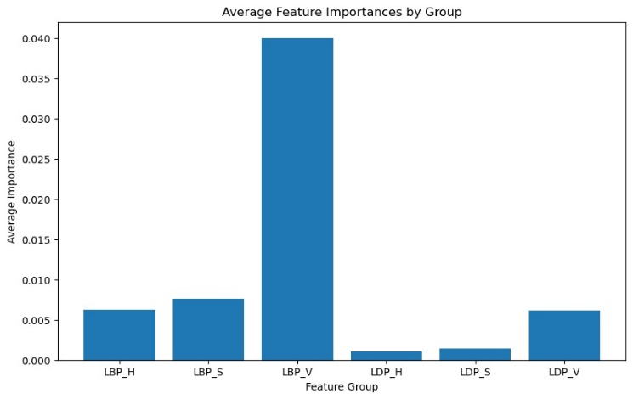
- Plot for Feature Importance of Random Forest in HSV
Value channel had the significant contribution because in this work, X-Ray images have been taken, which are devoid of colors. So main distinction is done through brightness value. Fig.4 shows the different HSV channels from which it can be deduced that V channel provides the significant segmentation result.
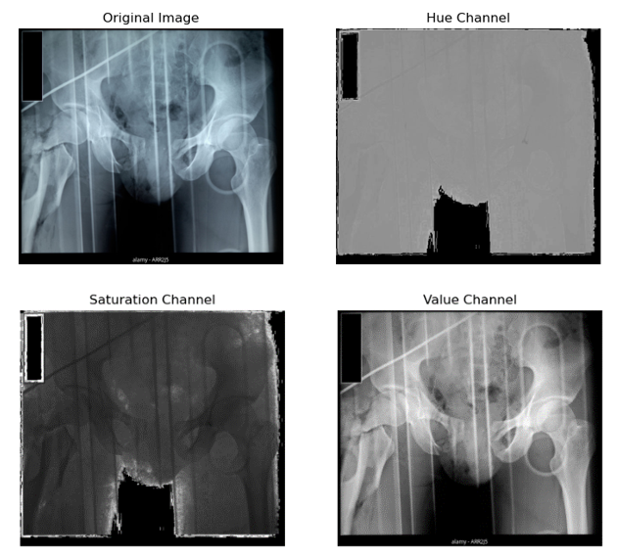
- Depiction of the HSV Channels

Conclusion And Future Work
This study demonstrated the effectiveness of machine learning techniques, particularly the Random Forest and XGBoost classifiers, in detecting bone fractures. Notably, the Random Forest classifier achieved the highest accuracy, reaching 95% in the HSV colorspace. Explainable AI techniques were employed, offering valuable insights into the models' decision-making processes. These techniques revealed that LBP features consistently held greater importance compared to LDP features and V channel of HSV colorspace showed the accurate segmentation result because it highlights the brightness value of the image and in X-Ray images, it is the prominent visual feature which needs to be processed.
Future research should focus on enhancing feature extraction methods to improve classification accuracy by exploring other improved variants of local pattern capturing techniques. Additionally, exploring other colorspaces and channels could reveal new information dimensions, potentially boosting model performance. Investigating the integration of other advanced machine learning algorithms and hybrid approaches may also bring additional improvements. Finally, broadening the dataset to encompass a broader range of fracture types and imaging conditions could enhance the robustness and applicability of the models, thereby advancing the development of reliable and accurate diagnostic tools in clinical practice.

ACKNOWLEDGMENT
The author expresses profound gratitude and appreciation to Dr. Junali Jasmine Jena and Dr. M. K. Gourisaria for providing the invaluable opportunity to engage in this research field. The consistent support and direction offered at each stage were crucial in enabling the success of this research endeavor.

REFERENCES
- M. J. Olszta, X. Cheng, S. S. Jee, R. Kumar, Y. Y. Kim, M. J. Kaufman, ... & L. B. Gower. “Bone structure and formation: A new perspective. Materials Science and Engineering” R: Reports, 58(3-5), pp. 77-116, 2007.
- K. D. Ahmed, & R. Hawezi. “Detection of bone fracture based on machine learning techniques”. Measurement: Sensors, 27, p. 100723, 2023.
- R. R. Hoffman, S. T. Mueller, G. Klein, & J. Litman. “Metrics for explainable AI: Challenges and prospects”. arXiv preprint arXiv:1812.04608, 2018.
- R. Pramanik, S. Khare, G. M. Harshvardhan, & M. K. Gourisaria. “A comparative study for depression prediction using machine learning classification models”. In Advances in Data and Information Sciences: Proceedings of ICDIS 2021 pp. 233-246. Singapore: Springer Singapore, 2022.
- U. Singh, M. K. Gourisaria and B. K. Mishra, "A Dual Dataset approach for the diagnosis of Hepatitis C Virus using Machine Learning," 2022 IEEE International Conference on Electronics, Computing and Communication Technologies (CONECCT), Bangalore, India, pp. 1-6, 2022
- A. J. Alkhatib, M. Alharoun, and A. AlZoubi. "A Deep Learning Framework for Timely Bone Fracture Detection and Prevention". Information Sciences with Applications 1 pp-52-61, 2024.
- A. Verma, V. Kumar, & R. K. Yadav. “Humerus Bone Fracture Detection Utilizing YOLOv4 Algorithm: A Deep Learning Approach”. In 2024 2nd International Conference on Disruptive Technologies (ICDT) pp. 1191-1196, 2024.
- Y. Ma, & Y. Luo. “Bone fracture detection through the two-stage system of crack-sensitive convolutional neural network. Informatics in Medicine Unlocked”, 22, 100452, 2024.
- D. P. Yadav, A. Sharma, S. Athithan, A. Bhola, B. Sharma, & I. B. Dhaou. “Hybrid SFNet model for bone fracture detection and classification using ML/DL”. Sensors, 22(15), 2022.
- L. Yao, X. Guan, X. Song, Y. Tan, C. Wang, C. Jin, ... & M. Zhang “Rib. fracture detection system based on deep learning. Scientific reports”, 11(1), 23513, 2021.
- M. A. Achawale, Y. More, M. A. Bankar, M. P. Ghuge, & M. G. Zole. “Bone Fracture Detection Using Convolutional Neural Network (Cnn)”. Journal Of Basic Science And Engineering, 21(1), pp. 323-333, 2024.
- C. Z. Basha, M. R. K. Reddy, K. H. S. Nikhil, P. S. M. Venkatesh, & A. V. Asish. “Enhanced computer aided bone fracture detection employing X-ray images by Harris Corner technique”. In 2020 Fourth International Conference on Computing Methodologies and Communication (ICCMC), pp. 991-995. IEEE, 2020.
- S. Gupta, “Bone Fracture Split Classification”, Available: https://www.kaggle.com/datasets/shyamgupta196/bone-fracture-split-classification/data, Retrieved on 5th July, 2024.
- T. Jabid, M. H. Kabir, & O. Chae. “Local directional pattern (LDP) for face recognition”. In 2010 digest of technical papers international conference on consumer electronics (ICCE), pp. 329-330. IEEE, 2010.
- M. Pietikäinen. “Local binary patterns”. Scholarpedia, 5(3), 9775, 2010.
- S. S. Azmi, & S. Baliga. An overview of boosting decision tree algorithms utilizing AdaBoost and XGBoost boosting strategies. Int. Res. J. Eng. Technol, 7(5), pp. 6867-6870, 2020.
- A. A. Ibrahim, R. L. Ridwan, M. M. Muhammed, R. O. Abdulaziz, & G. A. Saheed. “Comparison of the CatBoost classifier with other machine learning methods”. International Journal of Advanced Computer Science and Applications, 11(11), 2020.
- C. Bentéjac, A. Csörgő & G. Martínez-Muñoz. “A comparative analysis of gradient boosting algorithms”. Artificial Intelligence Review, 54, pp. 1937-1967, 2021.
- S. Suthaharan, & S. Suthaharan. Decision tree learning. “Machine Learning Models and Algorithms for Big Data Classification: Thinking with Examples for Effective Learning”, pp. 237-269, 2016.
- M. P. LaValley. “Logistic regression”. Circulation, 117(18), pp. 2395-2399, 2008.

