Deploying BNG to Azure infrastructure

This is a rough step by step guide to document the process of deploying the https://github.com/DEFRA/biodiversity-net-gain-service to Azure. This is to aid as a reference for trying to script Azure Devops Pipelines to carry out the CI/CD automated deployments.

Services needed for environments

Assumptions

- Local development environment running Linux with git, docker, vscode, azure cli installed
- Azure portal access with subscription providing sufficient permissions to create the services in the guide
- You have latest code from https://github.com/defra/biodiversity-net-gain-service
- The code has been installed via `npm i` and completed bootstrapping successfully.
- Environment variables/secrets, although most of these are attained from the azure services the guide is going to create.
- Services are all created using the same resource group and location, in my case UK South.

Applications

Application | Azure Service
Redis | Azure Cache for Redis
Postgres | Azure Database for Postgresql
SignalR | SignalR
Blob storage | Azure Storage Account
Queues | Azure Storage Account
Application-to-register-functions | Azure Function App
Application-to-register-webapp | Azure Container App

(Ordered by installation)

Note: Private virtual network (Azure vnet) for the time being the following services are to be created with default settings for public availability, protected via username and password/keys. However once moving into CI/CD pipeline they will need to be created without public access through an Azure vnet. (TODO)

Pre-requisites

Az cli login

$ az login

Resource Group

Create a new resource group under which all of the following services will need creating, via azure cli.

$ az group create --name {resource group} --location uksouth

Rename the resource group as appropriate

Azure container repository

$ az acr create --resource-group {resource group} --name {container registry} --sku Basic

## Note, not sure if login necessary after creating, but it is if already created resource group previously

$ az acr login --name {container registry}

Applications

Redis

Create an Azure Cache for Redis of appropriate sizing via the Azure portal.

For the time being access will be public via username and password using SSL. Make a note of the cache host, username and key/password.

Postgres

Currently there is no need for the Postgres database, however there will be later on in the development of the services.

Presumably this will be a case of deploying an instance of Postgres including Postgis extension through Azure Database for Postgresql.

SignalR

Create a new SignalR instance via the Azure portal.

Choosing service mode as serverless:

Blob storage and queues

Create a new Azure storage account through the azure portal. Once created under the portal go data storage > containers and create two new containers named:

trusted
untrusted

Under Data Storage > Queues create the following two queues:

trusted-file-queue
untrusted-file-queue

Application-to-register-functions

Create a new Azure Function App on the Azure portal with the following settings:

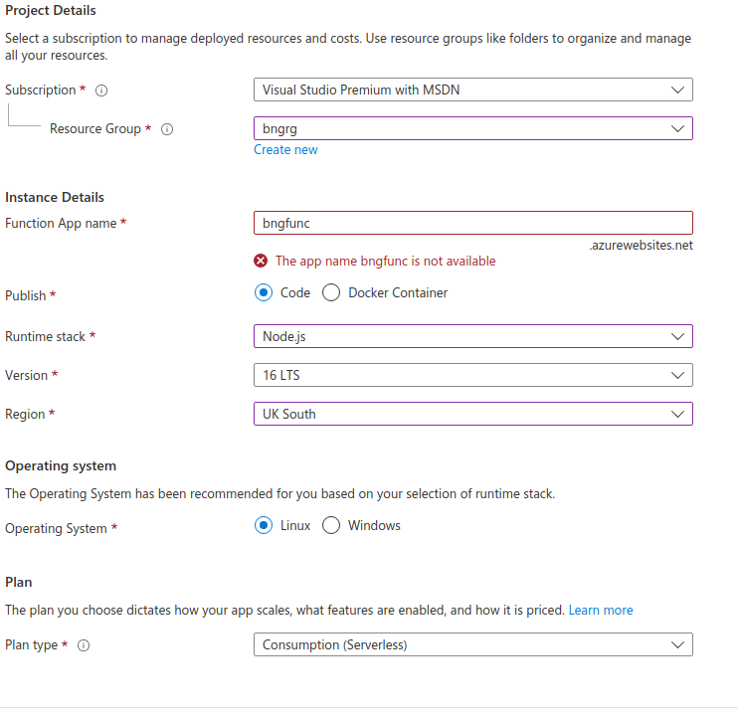
Remember to select the storage account created earlier in the guide as the function storage account

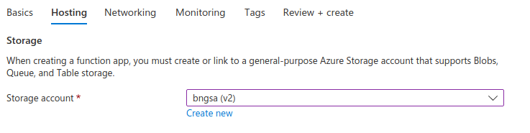
and enable application insights with a new instance.

Now that we have the application created all the deployment and configuration is now handled from azure cli.
Either open up the biodiversity-net-gain-service workspace or the package/application-to-register-functions in vscode. In the terminal move working directory to the application-to-register-functions root dir.

Dependencies

Todo! Note that this dependencies information is based on early development progress, and long term this workaround should be unnecessary having had the packages deployed to npm.

Currently our app has local dependencies pointing at local packages, via:

"@defra/bng-connectors-lib": "0.0.1",
"@defra/bng-errors-lib": "^0.0.1",
"@defra/bng-geoprocessing-service": "0.0.1",

When we bootstrapped the entire workspace (in assumptions) Lerna will have added some symbolic links to the node_modules dir that point at these packages. If we deploy to azure function apps the functions will throw errors not finding the modules, so we need to replace the symbolic links with physical copies of the local packages prior to deploying to Azure.

There are various ways to do this, but the most basic method I used was in node_modules directory, strip out the symbolic links under `node_modules/@defra` and create 4 directories of the same name. And within each of these copy in the contents of each of the appropriate packages root directory. Use this script to delete the sym links and copy across the local packages:

rm node_modules/@defra/* -rf && \
cp ../azure-storage-test-utils/ ./node_modules/@defra/bng-azure-storage-test-utils -r && \
cp ../connectors-lib/ ./node_modules/@defra/bng-connectors-lib -r && \
cp ../errors-lib/ ./node_modules/@defra/bng-errors-lib -r && \
cp ../geoprocessing-service/ ./node_modules/@defra/bng-geoprocessing-service -r

This won’t clear out all the symbolic links, but it will make the code runnable when deployed. However the azure function deployment command doesn’t like any symbolic links so in this case the zip must be manually created and deployed directly.

Environment Variables

Use the following multi lined command to updated the function app variables, update all the {{func-app-name}}, {{rg}} and {{value}} according to your own services.

$$$

az functionapp config appsettings set --name {{func-app-name}} --resource-group {{rg}} --settings "AZURE_SIGNALR_HUB_NAME={{value}}" && \
az functionapp config appsettings set --name {{func-app-name}} --resource-group {{rg}} --settings "AZURE_STORAGE_ACCOUNT={{value}}" && \
az functionapp config appsettings set --name {{func-app-name}} --resource-group {{rg}} --settings "AZURE_STORAGE_ACCESS_KEY={{value}}" && \
az functionapp config appsettings set --name {{func-app-name}} --resource-group {{rg}} --settings "AzureSignalRConnectionString={{value}}"

$$$

All values can be found on the appropriate services on Azure Portal created earlier.

Run the command and check that it has created 4 unique environment variables, and hasn’t clumped them into the first.

Zip the package

$ zip -r deploy.zip .

Deploy the package

$ az functionapp deployment source config-zip -g {{rg}} -n {{func-app-name}} --src ./deploy.zip

There is not much console output from this deployment, you can add --verbose or--debug to the above command to add some output.

Note that if the packages symbolic link issue is sorted we should be able to used the following command `$ func azure functionapp publish bng-func-2` to deploy, that creates the zip archive itself.

Tip, that if you need to see what has been deployed to the function app you can find the zip files in the blob storage account set up for the function app as per this screenshot, using Azure Storage Explorer
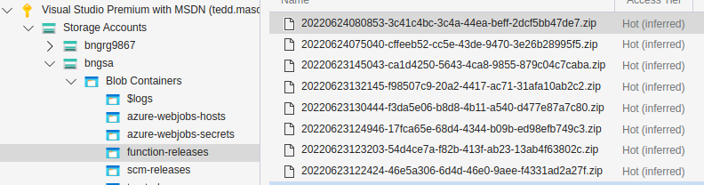

You can check the function app on the portal to see that the functions have been created correctly, although testing at this point is difficult until the web app is running as well.

There are various logs and metrics that can be used once the web app is running, if there are any issues to resolve, or not.

Application-to-register-webapp

Open up the project workspace at the project root (as we will be using docker files from the root).

Add the following local environment variables for deployment use:

export CONTAINER_REGISTRY={{container registry name from earlier}}

Create a container app environments

$ az containerapp env create \
--name {{ environment name }} \
--resource-group {{resource group}} \
--location UKSOUTH

Build and deploy the container to registry

$ az acr login –name $CONTAINER_REGISTRY

$ npm run docker:azure:build

Note: Environment variables are quite awkward with Azure Container Apps at the moment, and must be added to the application at creation via cli. TODO, would be to add Azure key vault and pull them in via managed identity.

Create and deploy container app

However update the following command with necessary environment variable values:

$ az containerapp create \
--resource-group {{resource group}} \
--name {{app name}} \
--environment {{environment name}} \
--image ${CONTAINER_REGISTRY}.azurecr.io/application-to-register-webapp:latest \
--ingress external \
--target-port 3000 \
--env-vars SERVER_PORT=3000 REDIS_HOST="{redis host}" REDIS_PORT={redis SSL port} REDIS_PASSWORD="{redis password}" SESSION_COOKIE_PASSWORD="the-password-must-be-at-least-32-characters-long" AZURE_STORAGE_ACCOUNT="{storage account name}" AZURE_STORAGE_ACCESS_KEY="{storage account key}" ORDNANCE_SURVEY_API_KEY="{ordnance survey api key}" ORDNANCE_SURVEY_API_SECRET="{ordnance survey api secret}" MAX_GEOSPATIAL_LAND_BOUNDARY_UPLOAD_MB=50 SIGNALR_URL="https://{function app name}.azurewebsites.net/api" \
--registry-server=${CONTAINER_REGISTRY}.azurecr.io \
--registry-username={registry username} \
--registry-password={registry password}

This command will give you a url to hit for the webapp. Either that or go to the portal and retrieve it from the container app that the command created and give it a test.

