Olympics Report 2008

Sue Wallace

09/09/2018

## Which nation won the most medals in the 2008 Beijing Olympics?

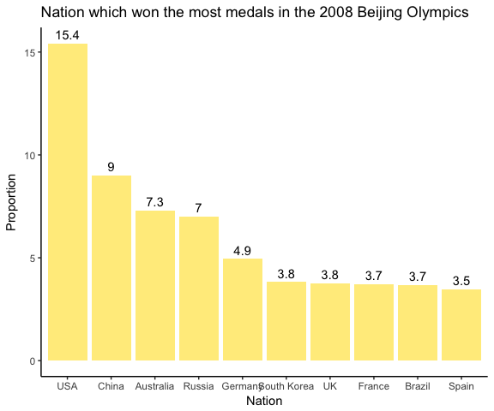

The USA collected the highest proportion of medals at 15.4. Let’s do a bit more analysis on the Unites States.

## Which gender collected more medals, male or female?

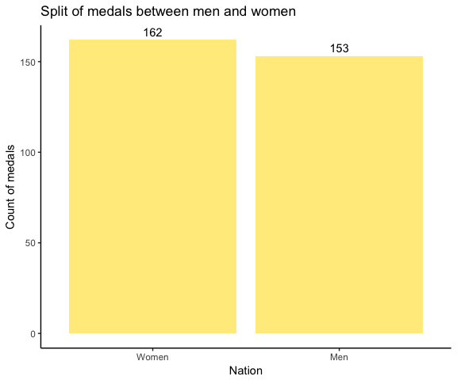

We can see here that women collected 162 medals for the US Olympics team in the 2008 Beijing Olympics compared to 153 for men.

We’ve seen that more women won medals in comparison to men, but which discipline brought home the most medals for the United States?

## Which discipline brought home the most medals?

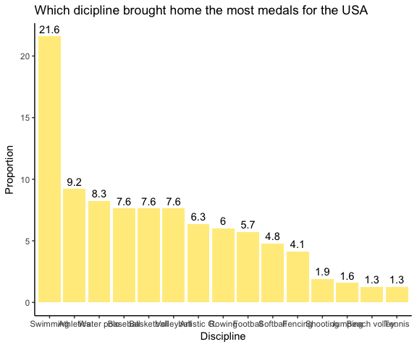 It looks like the most medals were won by the US swimming team, with 21.6% of medals being collected within the swimming discipline.