|  |  |  |  |  |  |  |
| --- | --- | --- | --- | --- | --- | --- |
| Habitats Directive: Form for recording likely significant effect (Stage 2) | | |  | | | |
| For information | | | | | | |
| **Part A**  **Permitting officer to complete this section in consultation with Conservation/Ecology section and Natural England/Countryside Council for Wales (CCW)** | | | | | | |
| Type of permission/activity: | | Discharge Consents | | | | |
| **Environment Agency reference no:** | | EPR/ZP3821GK | | | | |
| **National grid reference:** | | ST 58142 60252 | | | | |
| Site description: | | Sewage pumping station at Bishop Sutton, Ham Lane, Bishop Sutton, Bristol, BS39 5TY. | | | | |
| Brief description of proposal: | | Wessex Water Services Limited have applied for a permit for an existing intermittent discharge of storm sewage and sewage discharged in an emergency from a Pumping Station at Bishop Sutton. The location of the discharge is approximately 130m upstream of Chew Valley Lake (see attached map).  The Emergency Overflow (EO) and Combined Sewer Overflow (CSO) have been in place and operating for many years. The discharge will consist of domestic sewage effluent with no trade component. Wessex Water are improving the facility by increasing the volume of storm storage and providing improved screening of the discharge. The proposed improvements will reduce spill frequencies and volumes and improve screening/asthetic impacts considerably. | | | | |
| **European site name(s) and status**: | | **Chew Valley Lake SPA** | | | | |
| **List of interest features (relevant to this type of permission):** | | 3.9 Birds of estuarine habitats (Shoveler (3.9)) | | | | |
| **Is this application necessary to manage the site for nature conservation?** | | No | | | | |
| **What potential hazards are likely to affect the interest features (relevant to this type of permission?** | | | | | | |
|  |  |  | |  | |  |
|  | **Sensitive interest feature**: | **Potential hazard:** | | **Potential exposure to hazard and mechanism of effect/impact if known:** | |  |
|  | 3.9 Birds of estuarine habitats (Shoveler (3.9)) | Changes in thermal regime | | No exposure, the discharge is intermittent and consists of domestic sewage only, it will be at ambient temperature. | |  |
|  | Nutrient Enrichment | | No exposure, shoveler have a low sensitivity to nutrient enrichment (see below). The proposals will reduce the input of nutrients into the lake from the EO and CSO. | |  |
|  | Physical Damage | | No exposure, the pumping station and associated pipework are outside the SPA. The discharge will not cause any physical damage or disturbance to habitats which support the birds or impact on their food supply. | |  |
|  | Salinity | | No exposure, the discharge is of domestic sewage only to a freshwater environment. | |  |
|  | Siltation | | No exposure, shoveler have a low sensitivity to water quality (see below). The improvements proposed will reduce the input of suspended solids from the EO and CSO and reduce the level of siltation. | |  |
|  | Toxic contamination | | No exposure, the discharge is of domestic sewage only. | |  |
|  | Turbidity | | No exposure, shoveler have a low sensitivity to water quality (see below). The improvements proposed will reduce the input of suspended solids from the EO and CSO and reduce turbidity levels. | |  |
|  |  |  | |  | |  |
| Is the potential scale or magnitude of any effect likely to be significant? | | | | | | |
| **Alone?** | | No.  Shoveler are present on the lake during the autumn and winter months. Whilst spills are more likely to take place in the autumn/winter period when adverse weather conditions are more likely, the storm conditions will mean the effluent will be well diluted in both the sewer and the receiving watercourse before it reaches the lake and within the lake itself. Owing to the high levels of dilution at this time, a significant adverse impact on water quality is considered unlikely.  Furthermore, the proposals will result in an improvement in water quality; there will be fewer spills and reduced spill volume, and the better screening will improve the level of treatment.  The conservation objectives for the SPA refer to requirements for extent of open water and extensive shallows <25cm, food availability and low levels of disturbance in feeding and roosting area, but do not indicate a requirement for any water quality standard.  The Site Action Plan for Chew Valley SPA concluded that shoveler have a low sensitivity to water quality. This is because the shoveler’s plant and invertebrate food requirements are not highly specialised or restricted to particular species, and so not dependent on water quality. Potential vegetation or invertebrate community changes as a result of nutrient enrichment would not compromise their food supply, unless there was excessive eutrophication. This discharge would not cause excessive eutrophication. | | | | |
| In combination with other Environment Agency permissions, plans or projects? | | No.  The discharge was covered by a previous permit (011482); however this permit was mistakenly revoked by Wessex Water in 2008 as they incorrectly believed there was no EO or CSO at the site. It has since been established that there is an EO and CSO at the site and it has been in place, unchanged, for many years.  Permit number 011482 was included in the Review of Consents assessment for Chew Valley SPA. It was found ‘not likely to cause a significant effect alone or in combination’.  The Review of Consents did not identify any known water quality problems at the site as a result of the permitted discharges either alone or incombination.  There are a number of abstraction licences at the lake for the purpose of public water supply. The EO and CSO will not discharge when water levels are low and the discharge will not have any impact on overall water levels in the lake. There will be no in combination effects as a result of this proposal. | | | | |
| **In combination with** permissions, plans or projects with competent authorities? | | As Chew Valley Lake is a public water supply storage resevoir, Bristol Water have been consulted on these proposals, to date no response has been received (deadline for response is 28/02/2013). As the proposals represent an improvement it is anticipated there should not be any adverse impact on the potable water supply.  As a result of this risk assessment, the Environment Agency can conclude:  **No Likely Significant Effect** - this application could not act in combination with permissions and/or plans/projects of other competent authorities. | | | | |
| Conclusion: **Is there likely to be a significant effect ‘alone and/or in combination’ on a European site?** | | No, a significant effect ‘alone and/or in combination’ is not likely as a result of this discharge, indeed an overall improvement in water quality is anticipated. | | | | |
| **EA Officer:** | | **Jessica Liebig** | | | Date: 06/02/2013 | |

**Site map**

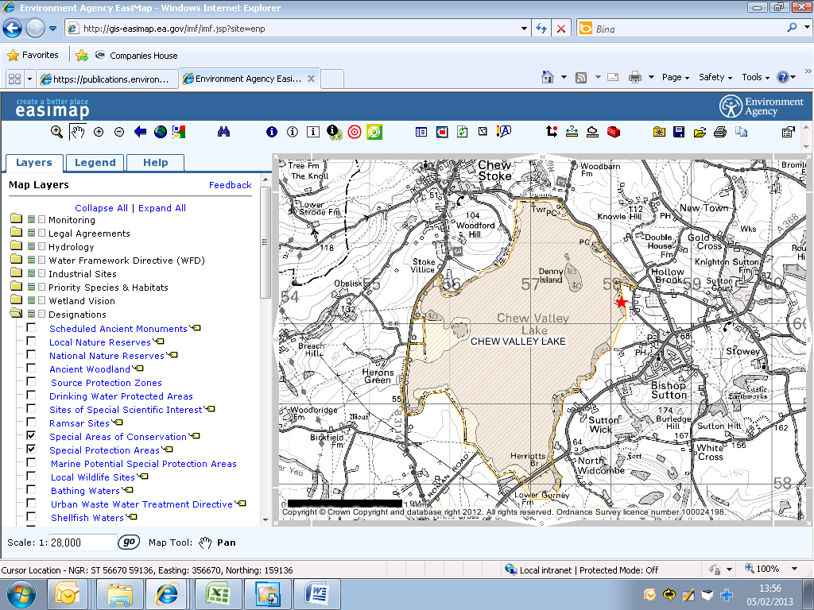

Point of discharge

**SPA**