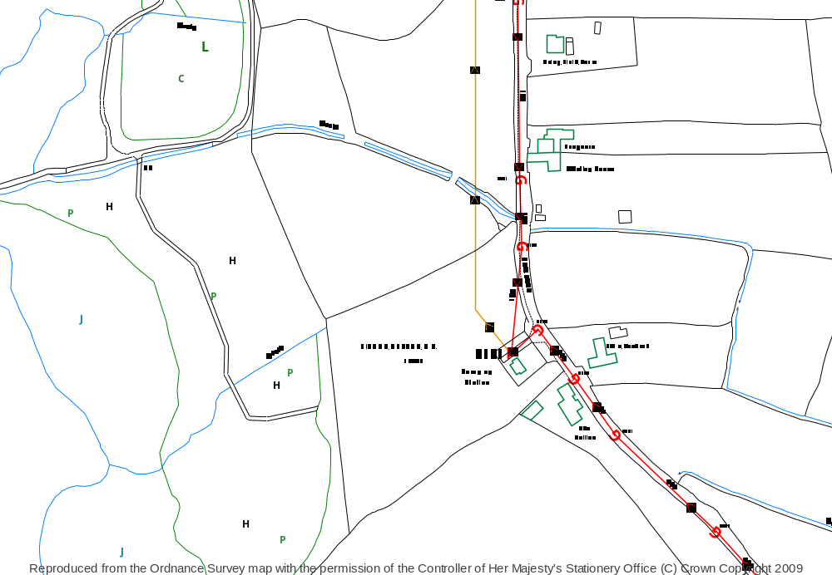
A
B
A: Outfall
ST 58142 60252

B: SPS
ST 58284 60143

Scale - 1: 1,250

WW Site ID - 14431

C9167 – Bishop Sutton SPS
Permit Application

Site Plan


SPS
Scale - 1: 25,000

WW Site ID - 14431
C9167 – Bishop Sutton SPS
Permit Application

Location Plan

