Our Ref: 65519

Date: 5th January 2011

Saman Rohitha Moderanakethagie
11 Axdane
Hull
N. Humberside
HU6 9AE,

Attn:

Dear Sirs

Change to waste return reporting period
Site On Trevor Street
PERMIT/LICENCE No: 65519

SITE TYPE: A19a : ELV Facility

We are writing to you about your waste management licence for the site detailed in the attached informative.

Your waste permit currently requires you to submit a waste return every financial year (April – March).

We have to change it to calendar year (January – December) because of our responsibility to report information to Government and the European Commission in this way.

We would be grateful if you could now amend your procedures accordingly. A calendar year return is due by the end of January the following year.

If you have any concerns about this or need any further clarification please do not hesitate to contact us by email at NWRTT@environment-agency.gov.uk or telephone 08708 506 506. We will be happy to assist you in any way we can.

Yours faithfully

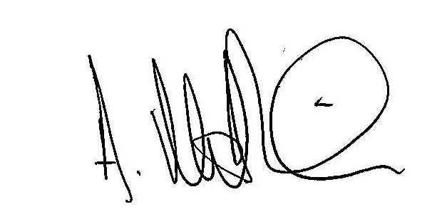

MATTHEW PARKIN

WASTE MANAGEMENT LICENCE

Informative regarding waste returns

LICENCE REF No: EAWML 65519  LICENCE HOLDER:  Saman Rohitha Moderanakethagie  11 Axdane  Hull  N. Humberside  HU6 9AE, | SITE TYPE: A19a : ELV Facility  Site Address:  3 Trevor Street  Hull  Humberside  HU2 0HR

The Environment Agency hereby only requires the above licence holder to submit waste returns as specified below:-

A summary report of the waste types and quantities accepted and removed from the site shall be made for each calendar year (Jan-Dec). It shall be submitted to the Agency within one month of the end of the calendar year, and shall be in the format required by the Agency.

This requirement supersedes any requirement to submit annual financial year records (Apr-Mar) under the conditions of this licence from the date given below.

Signed:

Name: Matthew Parkin (Team Leader, Regulatory)

Dated: 5th January 2011

