CRoW Appendix 4 (140_10_SD02)  CRoW Act 2000: Environment Agency application for permission - Formal Notice |  | 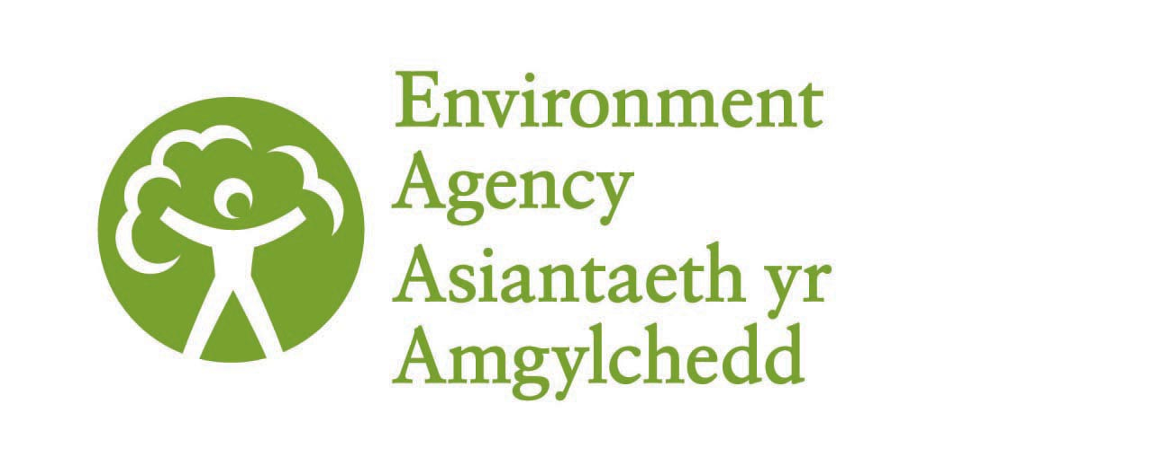
Environment Agency Formal Notice to Natural England (NE) / Countryside Council for Wales (CCW).
Requirements of Section 28I of the Wildlife & Countryside Act 1981 as amended by the Countryside and Rights of Way Act (CRoW) 2000.
Duty in relation to granting any consent, licence or permit for activities likely to damage Sites of Special Scientific Interest (SSSI).
- Environment Agency area/region/NPS hub: | South West, Exeter
- Name of SSSI: | Chew Valley
- Type of permission: | Discharge permit
- Date for Environment Agency permit determination: | 29/04/2013
- Predicted 28 day date for NE/CCW response (under S28 I(4)): | N/A, saved for audit only
- Environment Agency reference no: | EPR/ZP3821GK
- National grid reference: | ST 58142 60252
- Description of proposal: | Wessex Water Services Limited have applied for a permit for an existing intermittent discharge of storm sewage and sewage discharged in an emergency from a Pumping Station at Bishop Sutton. The sewage effluent discharges intermittently to a watercourse approximately 130m upstream of Chew Valley Lake (see attached map).  The Emergency Overflow (EO) and Combined Sewer Overflow (CSO) have been in place for many years. The discharge is of domestic sewage only, there is no trade component. Wessex Water are improving the facility by increasing the volume of storm storage and providing improved screening of the discharge. The proposed improvements will reduce spill frequencies and volumes and improve screening considerably.
- Is the proposed activity within (wholly or partially) the SSSI boundary? | Yes, the point of discharge is approximately 10m from the edge of the SSSI.
- Has there been any pre-application discussion or correspondence with NE/CCW? | No.
- What aspect(s) of the proposed permission may damage the features which are of special interest for the SSSI?

The SSSI consists of an expanse of open water (the largest artificial freshwater lake in South West England) with sparse submerged vegetation and peripheral areas of reedbed, carr, woodland and neutral grassland. The site is an internationally important staging post for migratory birds, especially waders, terns, warblers and hirundines. The grasslands and reedbeds are a critical autumn feeding ground for birds and the lake is one of the most important inland waters in Britain for wintering wildfowl.

The following ‘Operations Requiring Consent’ (or other activities associated with the permission) that may cause damage) are relevant to the proposed permission:
- ‘Dumping, spreading or discharge of any materials’.

The EO and CSO have been in place for many years and the Environment Agency is not aware of any pollution incidents relating to the discharge.
The storm storage capacity at the pumping station will increase from 0.6m³ to 57.0m³ following the improvements. The estimated spill frequency is three spills per year of an estimated volume of 145 m³ per year. This is in comparison to an estimated >10 spills per year of 215 m³ per year prior to the improvements.
The proposal is a significant improvement on the current situation and will result in fewer spills and reduced spill volumes. New fine screens (6mm mesh) will be installed which will considerably improve the level of treatment of the effluent.
The improvements specified above will result in a decrease in the amount of nutrients and suspended solids discharged into the lake from the storm/emergency overflows.

- Decision
The proposed permission is not likely to damage any of the flora, fauna or geological or physiological features which are of special interest.
The existing EO and CSO have not caused any known significant adverse impacts on the habitats or species of special interest. It is therefore considered that the improvements to the facility can only beneficial to the features of special interest.

The Environment Agency is minded to issue the permission.
The SSSI is also a SPA; an Appendix 11 has been completed for the Chew Valley SPA and sent to Natural England for Information.

- Name and job title of Environment Agency officer: | Jessica Liebig  Permitting Officer, Water Quality
- Date form sent to NE/CCW: | N/A, saved for audit only.

