

Permit
The Environmental Permitting (England & Wales) Regulations 2010

Mr Andrew Cobb

A J Spares
Wortley Road
Rotherham
South Yorkshire
S61 1LZ

Permit number

EPR/KB3337RL
Permit
The Environmental Permitting (England and Wales) Regulations 2010

Permit

Permit number

EPR/KB3337RL

The Environment Agency hereby authorises, under regulation 13 of the Environmental Permitting (England and Wales) Regulations 2010

Mr Andrew Cobb (“the operator”),

of

33 Middlefield Road

Moorgate

Rotherham

S60 3JJ

to operate waste operations described in standard rules SR2011 No3 at

A J Spares

Wortley Road

Rotherham

South Yorkshire

S61 1LZ

to the extent authorised by and subject to the conditions of this permit.

Under regulation 27(2) of the Regulations, standard rules SR2011 No3 are conditions of this permit.

Name | Date
Rob McHale | 13/11/2012

Authorised on behalf of the Environment Agency

Schedule 1 - Site plan

This is the plan referred to in the standard rules SR2011No 3

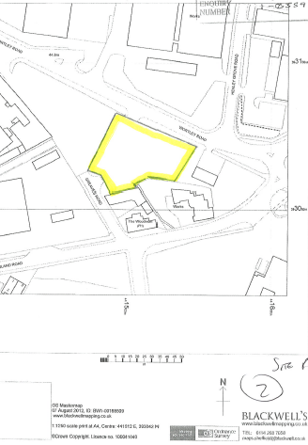

Crown Copyright. All rights reserved. Environment Agency, 100026380, 2010.

