PII Screener — High-Level Design Document
Version: 0.1
Status: Current
Scope: Architecture, component responsibilities, data flows, and extension points

1. Purpose and Problem Statement
Source code repositories routinely accumulate sensitive data in the wrong places — configuration files, test fixtures, hardcoded credentials, seed data, and comments. This creates two distinct risk categories:
- Secrets exposure — API keys, passwords, and tokens that grant access to live systems. Once committed to Git they are permanently retrievable from history even after deletion.
- PII in code — Real email addresses, phone numbers, names, and financial data embedded as test values or hardcoded constants. This creates GDPR Article 5 compliance obligations and potential Article 83 penalties.
PII Screener addresses both risk categories through a unified pipeline: it orchestrates multiple specialised scanning engines in parallel, merges and deduplicates their results, maps every finding to a regulation and remediation guide, and optionally redacts sensitive values directly in the source files.

2. Entry Points
The system exposes two independent entry points sharing the same core scanning pipeline:
Entry Point | File | Purpose
CLI | cli.py | Interactive use, CI/CD pipelines, scripted scans
MCP Server | server.py | VS Code Copilot Chat integration via the Model Context Protocol
Both entry points create a ScanConfig, call orchestrator.run_scan(), and receive a Report object. Neither contains scanning logic.

3. High-Level Architecture
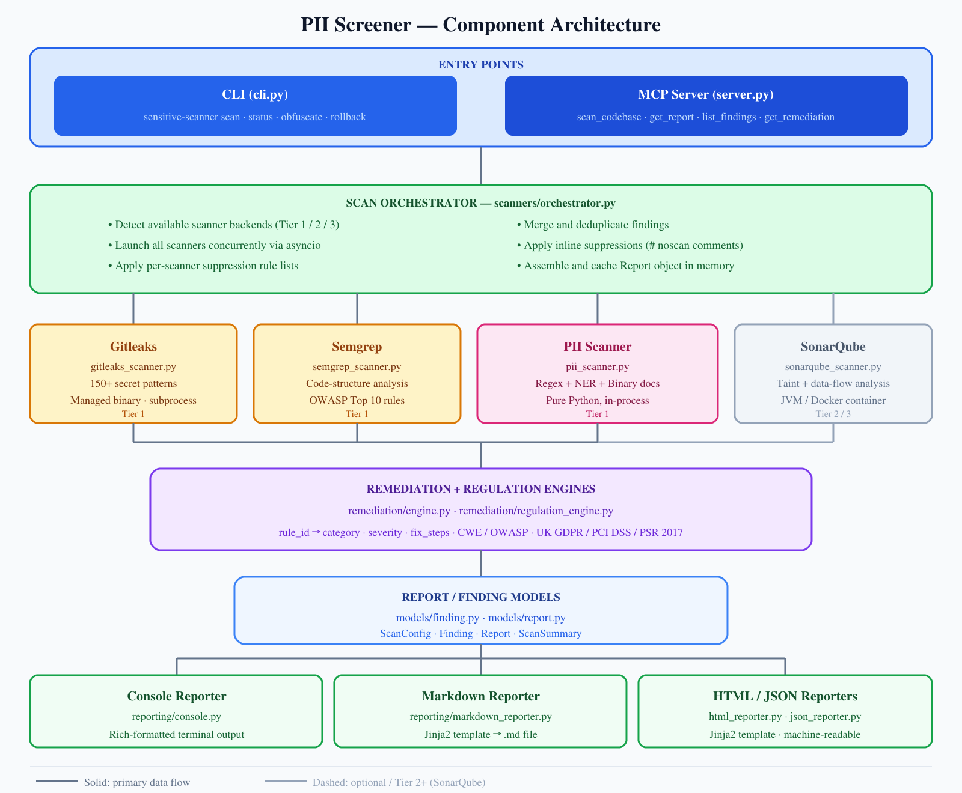
Component Architecture

4. Component Descriptions

4.1 Scan Orchestrator (scanners/orchestrator.py)
The central coordinator. Its run_scan(config: ScanConfig) function:
- Calls detect_available_scanners() to determine which scanner backends are reachable and assigns a tier (1 = native binary, 2 = container, 3 = SonarCloud API).
- Launches all requested scanners concurrently using asyncio.gather.
- Applies per-scanner suppression rules from ScanConfig.suppress_by_scanner.
- Deduplicates findings: when two scanners flag the same (file, line, rule_id), they are merged into a single Finding with both scanner names listed.
- Filters findings whose source line contains a # noscan or # noscan: rule_id comment.
- Builds a Report, triggers report.build_summary(), and caches it in memory for MCP re-use.

4.2 Scanner Backends
Scanner | Type | What it detects | Execution model
PII Scanner (pii_scanner.py) | Pure Python | Structured PII (regex), person names (NER), decoded payloads, binary document content | In-process async
Gitleaks (gitleaks_scanner.py) | Managed binary | 150+ service-specific secret patterns | Subprocess
Semgrep (semgrep_scanner.py) | pip package or container | Code-structure-aware secret / OWASP rules | Subprocess
SonarQube (sonarqube_scanner.py) | Local JVM or container | Deep taint analysis, inter-procedural data flow | HTTP API
Binary management (binary_manager.py): Gitleaks and the Sonar scanner CLI are downloaded automatically on first use from GitHub Releases and stored under ~/.sensitive-scanner/. The BinarySpec dataclass records the expected version, download URL template, and checksum strategy for each tool.

4.3 PII Scanner Detail
The PII scanner is the project’s primary differentiator. It operates entirely in-process with no external dependencies beyond optional NLP libraries.
Detection pipeline per file:
- Extension / size gating — skip binary files above 2 MB; allow extensionless files (e.g. Dockerfile).
- Regex matching — 40+ patterns covering email, phone (US/UK/international E.164), SSN, credit card (with Luhn check), IBAN, passport, private keys, JWT, DB connection strings, UK postcode, NHS number (modulus-11 validated), sort codes, and more.
- Decoded payload scanning — URL-decoded strings, JWT payload (base64), generic base64 blobs.
- NER-based person detection — Presidio AnalyzerEngine (threshold 0.70) or spaCy en_core_web_sm fallback; applied to string literals and comments.
- CSV/TSV/PSV context analysis — header-column name determines whether all Title-case values in a column are flagged (strict columns: “name”, “full name”) or only NER-confirmed names (broad columns: “operator”, “assigned_to”).
- Binary document extraction — .docx, .xlsx/.xls, .pdf, .rtf, .eml, .msg, .parquet, .orc, .avro via optional extras.
- Archive recursion — .zip, .tar, .gz, .bz2 up to depth 10.

4.4 Remediation Engine (remediation/engine.py)
Maps any scanner’s raw rule_id to a standardised internal category key and returns structured remediation guidance.
Resolution order: 1. Exact key match in rules.yaml 2. Substring match against known category keys 3. Keyword heuristics (_KEYWORD_MAP) 4. Fallback: generic_secret
rules.yaml defines 50+ categories, each with severity, description, fix_steps (ordered action list), and references (CWE identifiers, OWASP links, GDPR articles).

4.5 Regulation Engine (remediation/regulation_engine.py)
Loads config/regulations.yaml and builds an inverted index from PII category to applicable regulations (UK GDPR, PCI DSS, PSR 2017). Called during report assembly to populate Finding.regulations.

4.6 Models
Model | File | Description
ScanConfig | models/finding.py | Input parameters for a scan run
Finding | models/finding.py | A single detected issue (see §5)
Report | models/report.py | Full scan output including all findings and summary
ScanSummary | models/report.py | Aggregated counts by severity, category, and scanner

4.7 Reporters (reporting/)
All reporters are stateless functions receiving a Report object:
Module | Output format
console.py | Rich-formatted terminal table
markdown_reporter.py | Markdown via Jinja2 template (templates/report.md.j2)
html_reporter.py | Self-contained HTML via Jinja2 template (templates/report.html.j2)
json_reporter.py | Machine-readable JSON (single file or per-source-file mode)

4.8 Obfuscation Module (obfuscation/)
An optional post-scan remediation workflow:
- reviewer.py — presents each finding interactively, records decisions (approve / skip / manual) into a ReviewSession.
- session.py — ReviewSession and ReviewItem dataclasses persist decisions as JSON, including replacement token, skip reason, and applied_at UTC timestamp.
- engine.py — ApplyEngine reads approved items, backs up original files, performs in-place string substitutions. Non-substitutable findings (binary/archive/decoded-payload) are flagged manual.
- Rollback — the rollback CLI command restores from the backup directory.

5. Core Data Structures

5.1 ScanConfig
path : str — target directory
scanners : list[str] — ["gitleaks", "semgrep", "pii"]
project_name : str
include_git_history : bool
exclude_paths : list[str]
exclude_files : list[str]
exclude_patterns : list[str]
suppress_by_scanner : dict[str, list] — {scanner: [rule_ids]}
show_secrets : bool — default False
skip_comments : bool
sonar_* : str — SonarQube connection params

5.2 Finding
id : str — SHA256[:16] of "file:line:rule_id"
scanners : list[str]
file : str — relative path from scan root
line : int — 1-based
category : str — internal category key
severity : str — critical | high | medium | low | info
rule_id : str — scanner-native rule identifier
match : str — first4**** (default) or raw value (--show-secrets)
message : str
remediation_description : str
fix_steps : list[str]
references : list[str]
regulations : list[str]

5.3 Report
scan_id : str — 8-char UUID
target_path : str
project_name : str
scanned_at : datetime
duration_seconds : float
tier_used : int — 1=native, 2=container, 3=cloud
scanners_run : list[str]
findings : list[Finding]
summary : ScanSummary

6. Data Flow: Scan to Report
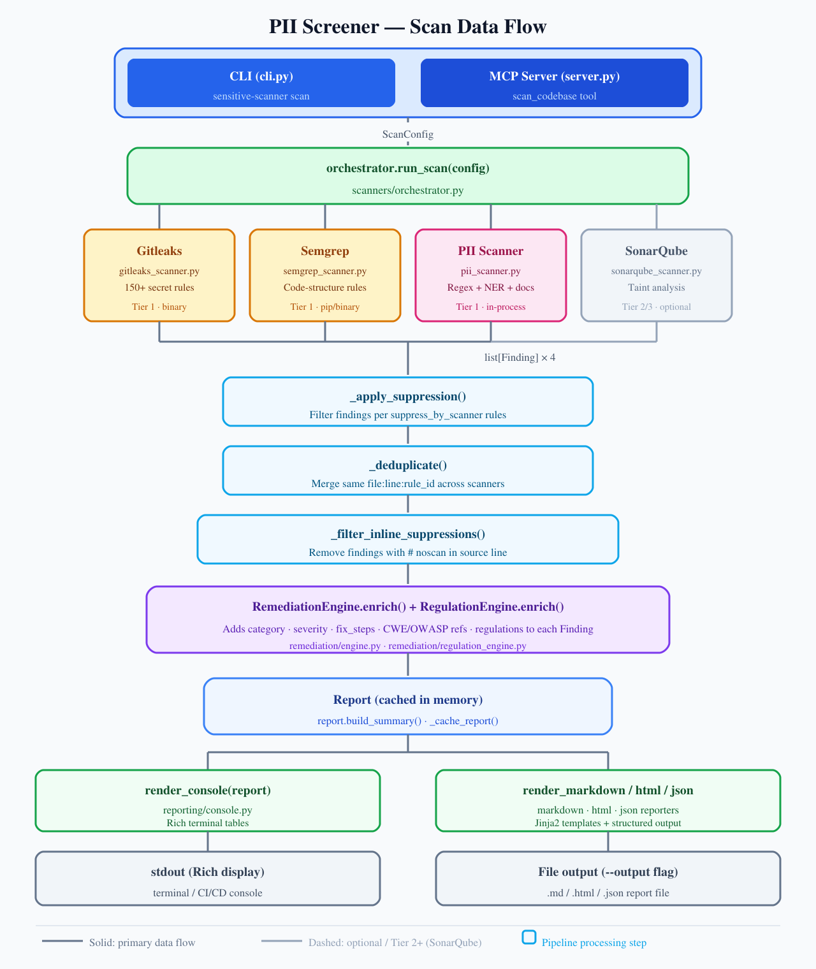
Scan Data Flow

7. Suppression Hierarchy
Suppression rules are merged in priority order (lowest → highest):
Level | Source | Scope
1 | ScanConfig._DEFAULT_EXCLUDE | Always-excluded paths (.git, node_modules, etc.)
2 | sensitive-scanner.yaml in scan target | Project-level scanner config (auto-discovered)
3 | config/suppress.txt (global install) | Organisation-wide suppressions
4 | Project suppress.txt | Per-project suppressions
5 | .scannerignore in scan target | Per-project file excludes
6 | --suppress CLI flag | Ad-hoc run-time overrides
7 | # noscan inline comments | Per-line source suppressions
Global suppress rules apply to all scanners. Per-scanner sections ([pii], [gitleaks], [semgrep], [sonarqube]) apply only to that engine. Matching is by exact rule_id or by reference prefix (e.g. CWE-798 suppresses any rule whose references start with CWE-798).

8. Scanner Tier Model
The orchestrator automatically selects the best available execution tier:
Tier | Condition | Scanners available
1 — Native | Binary / pip package installed or auto-downloaded | Gitleaks, Semgrep, PII
2 — Container | Docker or Podman running | All Tier 1 + SonarQube CE
3 — Cloud | sonarcloud.io token configured | All + SonarCloud API
The sensitive-scanner status command shows which tier is active and which backends are reachable.

9. MCP Server Interface
server.py exposes five MCP tools to VS Code Copilot Chat or any MCP-compatible client:
Tool | Description
scan_codebase | Run all scanners against a local directory path
get_report | Return the cached report in json, html, markdown, or console format
list_findings | Filter cached findings by severity, scanner, category, or file
get_remediation | Return full remediation detail for a specific finding ID
check_scanner_status | Show available backends; optionally start SonarQube
The MCP server shares the same orchestrator, models, and reporters as the CLI. Scan results are cached in process memory across calls within a session.

10. Configuration Files
File | Purpose
config/regulations.yaml | Regulation catalogue (UK GDPR, PCI DSS, PSR 2017) with article references
config/suppress.txt | Global suppression rules (global + per-scanner sections)
config/gitleaks.toml | Custom Gitleaks rule overrides
remediation/rules.yaml | 50+ category definitions (severity, fix_steps, references)
sensitive-scanner.yaml | Per-project scanner configuration (auto-discovered in scan target)

11. Optional Dependencies
Optional pip extras control which detection capabilities are available at runtime:
Extra | Packages | Capability unlocked
spacy | spacy, en_core_web_sm | NER-based person name detection
semgrep | semgrep | Semgrep code-structure analysis (Tier 1)
docs | python-docx, openpyxl, pdfminer.six, extract-msg, pyarrow, fastavro, etc. | Binary document content extraction
all | All of the above | Full capability
The PII scanner degrades gracefully: regex detection always runs regardless of which extras are installed.

12. Security Design Decisions
Decision | Rationale
Match redaction by default | Finding.match shows only first4**** to prevent secrets from appearing in reports committed to source control. --show-secrets opt-in for local investigation only.
SHA-256 finding IDs | Deterministic id = SHA256(file:line:rule_id)[:16] enables stable cross-run deduplication without storing raw secret values.
Relative file paths | All Finding.file values are relative to the scan root, preventing absolute path leakage in reports.
No outbound network at scan time | The scan pipeline makes no network calls. Binary downloads (first-run only) are explicit and checksummed. SonarCloud integration is opt-in.
Backup before obfuscation | The obfuscation engine always creates a full backup before modifying any source file, enabling rollback to a clean state.

13. Planned Extension: Air-Gap Bundle
A package CLI command is planned (not yet implemented) to produce a self-contained ZIP bundle for offline deployment:
- Downloads all tool binaries (Gitleaks, Semgrep, SonarQube CE, sonar-scanner-cli), pip wheels, and the spaCy model wheel.
- An install.ps1 bootstrap script and a companion install-offline CLI command place everything under ~/.sensitive-scanner/ on a machine with no internet access.
- binary_manager.py, semgrep_scanner.py, and sonarqube_manager.py will check the bundle path before attempting any network download.
Estimated bundle size: ~820 MB. Windows x64 only in the initial release.

14. Module Summary
cli.py — CLI entry point (Typer)
server.py — MCP server entry point (FastMCP)
config_loader.py — suppress.txt parser
models/
finding.py — ScanConfig, Finding, RemediationRule
report.py — Report, ScanSummary
scanners/
orchestrator.py — Parallel scan coordination, deduplication
pii_scanner.py — Pure-Python PII + secret detection
gitleaks_scanner.py — Gitleaks binary wrapper
semgrep_scanner.py — Semgrep binary/pip wrapper
sonarqube_scanner.py — SonarQube/SonarCloud integration
sonarqube_manager.py — SonarQube lifecycle management
binary_manager.py — Managed binary download + caching
base.py — Scanner base class
remediation/
engine.py — rule_id → category + fix guidance
regulation_engine.py — category → regulation mapping
rules.yaml — 50+ category definitions
reporting/
console.py — Rich terminal output
markdown_reporter.py — Markdown via Jinja2
html_reporter.py — HTML via Jinja2
json_reporter.py — JSON output
obfuscation/
engine.py — In-place file replacement with backup
reviewer.py — Interactive finding review
session.py — ReviewSession / ReviewItem persistence
strategies.py — Replacement token strategies
config/
regulations.yaml — Regulation catalogue
suppress.txt — Global suppressions
gitleaks.toml — Gitleaks rule overrides
templates/
report.html.j2 — HTML report template
report.md.j2 — Markdown report template

