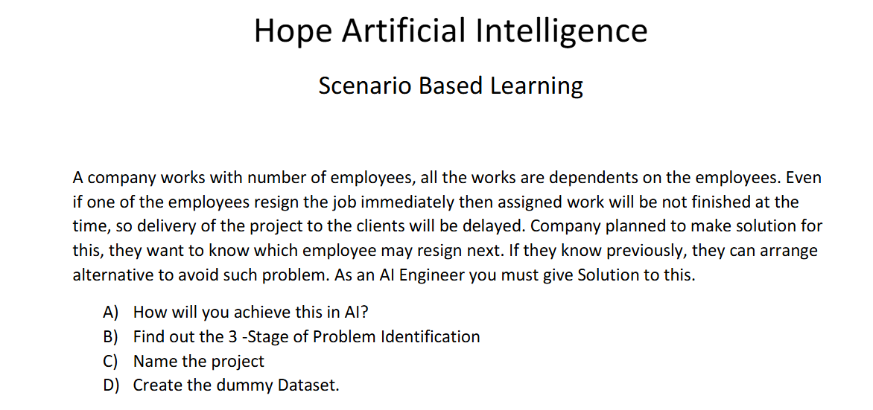

A) Use Machine Learning to analyze employee data and predict which employee is likely to resign. This helps the company take action in advance.
B) 3 Stages of Problem Identification
- Problem: Predict employees who may resign.
- Goal: Reduce project delays by predicting resignations.
- Solution: Build an AI model using employee data.
C) Project Name
AI Employee Resignation prediction System
D) Dummy Dataset
Employee ID | Age | Department | Salary | Experience | Attrition
E001 | 25 | IT | 30000 | 2 | Yes
E002 | 30 | HR | 45000 | 5 | No
E003 | 28 | Sales | 35000 | 3 | Yes
E004 | 35 | Finance | 70000 | 8 | No
E005 | 27 | IT | 40000 | 4 | Yes

