NATIONAL UNIVERSITY OF COMPUTER AND EMERGING SCIENCES
Chiniot – Faisalabad Campus

CL2005 – Database Systems Lab

Field | Details
Section | BSCS
Session | Spring 2026
Lab Instructor | Shahzad Tanveer
Member 1 | Muhammad Talha – 24F0793
Member 2 | Khizar Hayat – 24F0812

Contents
Project Overivew 1
Scope of the System 1
Objectives of the System 2
List of Entities: 2
Strong Entities 3
Weak Entity 3
Associative Entity 3
Business Rules 4
ERD……………………………………………………………………………………………………….. 5
EERD………………………………………………………………………………………………………6
First Normal Form (1NF) 7
Second Normal Form (2NF) 8
Third Normal Form (3NF) 8
Final Conclusion 9
Sample Data………………………………………………………………………………………………9
Query Results……………………………………………………………………………………………12
Index……………………………………………………………………………………………………..16
DCL……………………………………………………………………………………………………….19
PQSL……………………………………………………………………………………………………..22
Bonus Full Stack Integration…………………………………………………………………………..25
Conclusion 26
What We Learned: 26
Challenges Faced: 26
Future Enhancements: 26
Contribution Table 27

Project Overview

Title & Domain:
The project titled “Telecom Billing & Subscription Management System” is a database-driven application designed to manage telecom customers, their subscription plans, usage activities, billing invoices, and payment transactions. The system is designed to replicate real-world telecom operations where customers consume services such as calls, SMS, and data, and are billed based on usage or subscription plans. It ensures efficient management of customer accounts, accurate billing, and real-time financial tracking.

Problem Statement
The telecom industry handles a large number of customers who subscribe to various service plans and consume services such as calls, SMS, and mobile data. Managing this data manually or through disconnected systems leads to several issues such as billing inaccuracies, difficulty in tracking usage, delayed invoice generation, and inefficient payment monitoring.
There is a need for a centralized and automated database system that can efficiently manage customer information, subscription plans, service usage, billing invoices, and payment transactions in a structured and reliable manner. This system aims to eliminate redundancy, ensure data integrity, and provide accurate and real-time billing information.
The proposed Telecom Billing & Subscription Management System addresses these challenges by integrating all telecom operations into a single relational database system.

Scope of the System
The scope of the system is limited to the backend database management of a telecom billing environment. It covers the complete lifecycle of a telecom customer within the system, including:
- Customer registration and account management
- Management of prepaid and postpaid customer types
- Subscription to telecom service plans
- Recording of call, SMS, and data usage
- Generation of monthly or periodic invoices
- Recording and tracking of customer payments
- Reporting and analytical queries for business insights

Objectives of the System
The main objectives of the Telecom Billing & Subscription Management System are:
- To design a structured relational database for telecom operations
- To store and manage customer, subscription, usage, billing, and payment data efficiently
- To ensure data consistency and integrity using primary and foreign key constraints
- To eliminate redundancy through normalization techniques
- To automate billing by generating accurate invoices based on usage and subscription plans
- To provide fast data retrieval using indexes for frequently queried fields
- To support reporting through views for management and operational use
- To ensure secure and role-based data access for different types of users
- To enable analytical queries for revenue tracking and customer behavior analysis
- To simulate a real-world telecom billing environment using Oracle SQL

List of Entities:
- CUSTOMER: Stores personal and account details of telecom users
- PREPAID_CUSTOMER: Stores prepaid-specific balance and recharge information
- POSTPAID_CUSTOMER: Stores credit limit and billing cycle information
- SUBSCRIPTION_PLAN: Defines available telecom packages and pricing
- CUSTOMER_SUBSCRIPTION: Junction table linking customers with plans
- USAGE_RECORD: Records call, SMS, and data usage details
- INVOICE: Stores billing information generated for customers
- PAYMENT: Records payment transactions against invoices

Strong Entities
The strong entities are CUSTOMER, PREPAID_CUSTOMER, POSTPAID_CUSTOMER, SUBSCRIPTION_PLAN, INVOICE, and PAYMENT because each possesses its own primary key and can be uniquely identified within the database. These entities represent the core independent objects of the system.

Weak Entity
USAGE_RECORD is modeled as a weak entity because it does not have an independent primary key. Its identification depends on the parent entity CUSTOMER through a composite partial key consisting of customer_id, usage_timestamp, and service_type. This reflects that usage records cannot exist without an associated customer.

Associative Entity
CUSTOMER_SUBSCRIPTION is an associative entity used to resolve the many-to-many relationship between CUSTOMER and SUBSCRIPTION_PLAN. It depends on both entities for existence and is identified through a composite key formed by customer_id, plan_id, and start_date.

Relationships Description of Entities:
The system includes the following relationships:
- A CUSTOMER can have multiple USAGE_RECORDS (one-to-many)
- A CUSTOMER can have multiple INVOICES (one-to-many)
- An INVOICE can have multiple PAYMENTS (one-to-many)
- A CUSTOMER can have multiple subscriptions through CUSTOMER_SUBSCRIPTION (many-to-many with SUBSCRIPTION_PLAN)
- A SUBSCRIPTION_PLAN can be assigned to many customers
- CUSTOMER has specialization into PREPAID_CUSTOMER and POSTPAID_CUSTOMER (ISA relationship)
All relationships are enforced using foreign key constraints in the database to maintain referential integrity.

Business Rules
- A customer must belong to either prepaid or postpaid category
- Each customer has a unique CNIC and phone number
- A customer can have multiple subscriptions over time
- A subscription must reference a valid customer and plan
- Usage records are always linked to one customer
- Each invoice belongs to exactly one customer
- Payments are always linked to a valid invoice
- Invoice amounts must be non-negative
- Payment amounts must be greater than zero
- Only valid status values are allowed for subscriptions, invoices, and accounts

10 System Queries:
- Retrieve all customers in the system
- Display subscription plans for each customer
- Show usage history of a specific customer
- Calculate total billing per customer
- List all unpaid or overdue invoices
- Display payment history of customers
- Show monthly revenue generated by the system
- Find customers with highest usage charges
- List customers grouped by subscription plan
- Display all active subscriptions in the system

Entity-Relationship Diagram
The standard ERD establishes the foundational architecture of the Telecom Billing System by mapping out its core components and their interactions. It defines strong, independent entities like CUSTOMER, SUBSCRIPTION_PLAN, INVOICE, and PAYMENT, while resolving complex data structures through an associative entity (CUSTOMER_SUBSCRIPTION) for many-to-many plan enrollments, and a weak entity (USAGE_RECORD) that relies entirely on the customer for its existence. This baseline model effectively captures the essential business rules, primary/foreign key links, and standard relationship cardinalities required to track service usage and billing cycles.

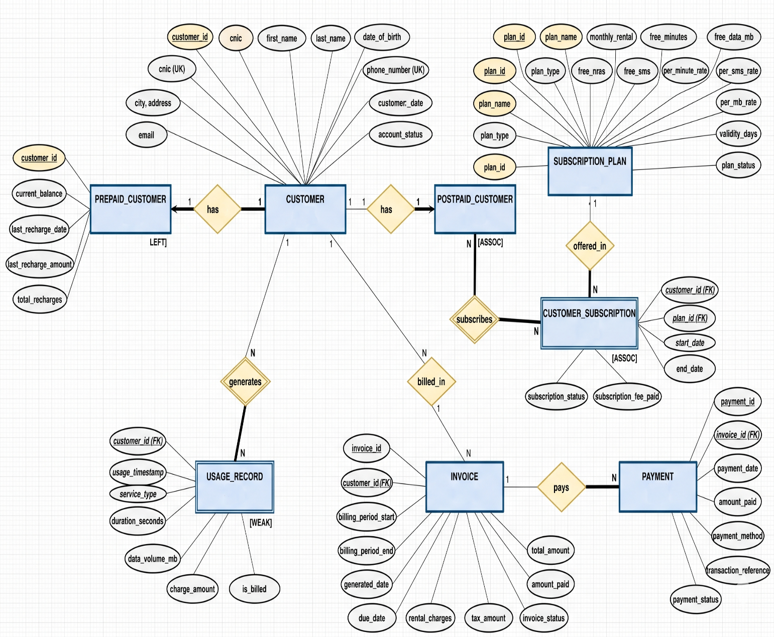

Drawio Link: click here
Enhanced Entity-Relationship Diagram
The Enhanced ERD elevates the foundational model by introducing an advanced ISA Specialization hierarchy to accurately represent different customer types. It designates CUSTOMER as a generic superclass that branches into PREPAID_CUSTOMER and POSTPAID_CUSTOMER subclasses, allowing them to inherit shared attributes (like name and phone number) while holding distinct billing data (such as current balance versus credit limit). Crucially, the EERD applies a Disjoint ("d") and Total participation constraint to this hierarchy, explicitly enforcing the business rule that every single customer in the system must be exclusively categorized as either prepaid or postpaid.
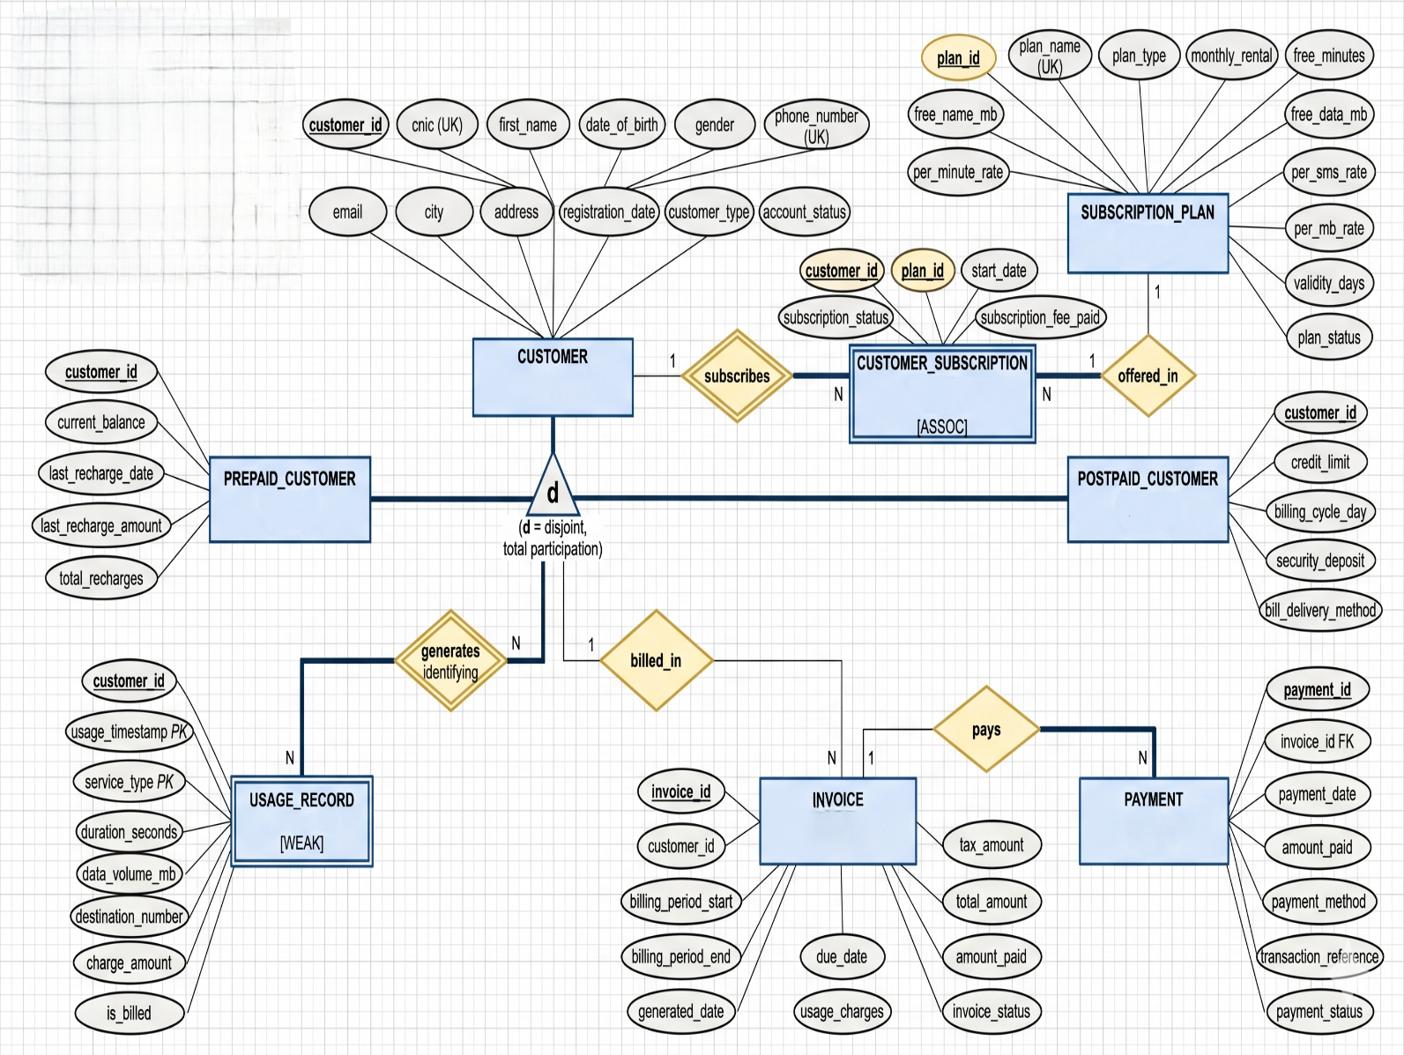

Normalization

First Normal Form (1NF)
Customer_Billing (UNF):
CustomerID | Name | PhoneNumber | Plan | CallsMinutes | SMS
1 | Ali | 0300-111 | Basic, Data | 120, 80 | 30, 20
2 | Sara | 0301-222 | Premium | 200 | 50
Multi-valued attributes:-
- Packages = Basic, Data
- CallsMinutes = 120, 80
- SMSCount = 30, 20
Issue: One column has multiple values
Solution: Separate Tables
Customer Table
CustomerID | Name | PhoneNumber
1 | Ali | 0300-111
2 | Sara | 0301-222
Customer_Plan Table
CustomerID | Plan
1 | Basic
1 | Data
2 | Premium
Usage Table

CustomerID | CallMinutes | SMSCount
1 | 120 | 30
1 | 80 | 20
2 | 200 | 50

Second Normal Form (2NF)
Rule:
- Must be in 1NF
- Remove partial dependency
Problem:
CUSTOMER_SUBSCRIPTION(customer_id, plan_id, start_date, plan_name, customer_name)
Issue:
- plan_name depends only on plan_id
- customer_name depends only on customer_id
Solution:
CUSTOMER(customer_id, name, phone, city)
SUBSCRIPTION_PLAN(plan_id, plan_name, plan_type, monthly_rental)
CUSTOMER_SUBSCRIPTION(customer_id, plan_id, start_date, status, fee_paid)
Result: No partial dependency remains.

Third Normal Form (3NF)
Rule:
- Must be in 2NF
- Remove transitive dependencies
Problem Example:
CUSTOMER(customer_id, city, city_zip_code)
Issue:
- city_zip_code depends on city, not customer_id
Solution:
Remove derived attributes or separate into lookup tables.
Final 3NF Schema:
CUSTOMER
SUBSCRIPTION_PLAN
CUSTOMER_SUBSCRIPTION
USAGE_RECORD
INVOICE
PAYMENT
PREPAID_CUSTOMER
POSTPAID_CUSTOMER
Result:
Fully normalized relational database with no redundancy.

Final Conclusion
The telecom system is fully normalized up to Third Normal Form (3NF),
ensuring:
- No redundancy
- No partial dependencies
- No transitive dependencies
- Efficient and scalable database design

Sample Data

Customers:
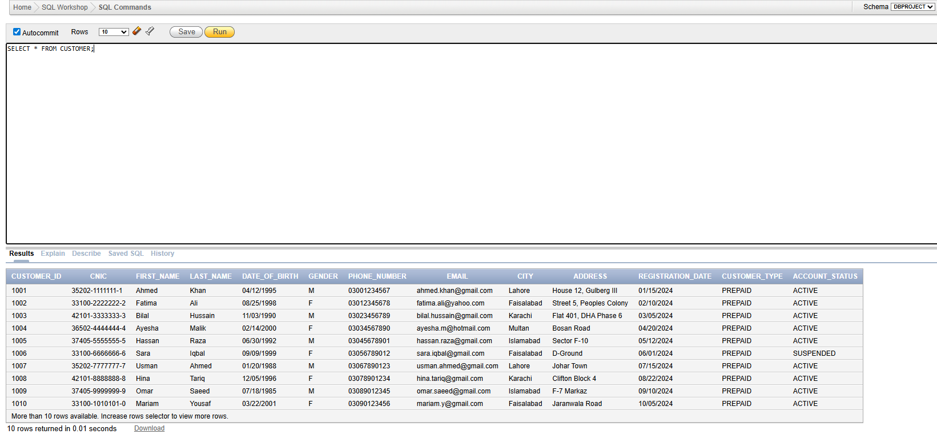

Total revenue from payment: 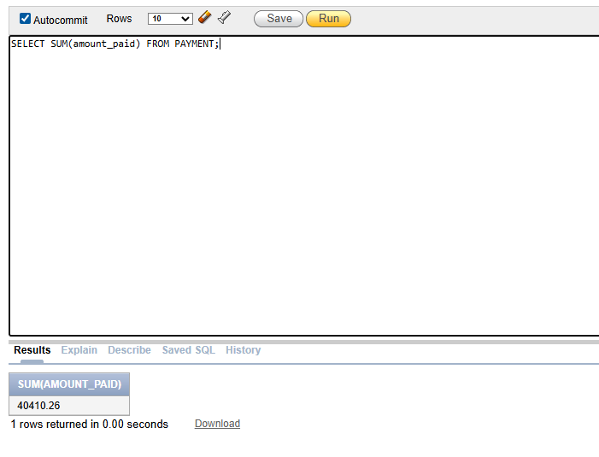

Payment method breakdown:

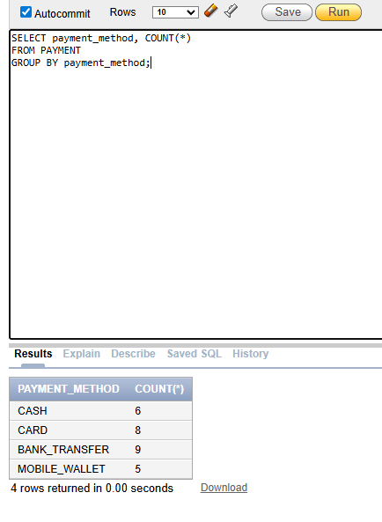
List all unpaid or overdue invoices:

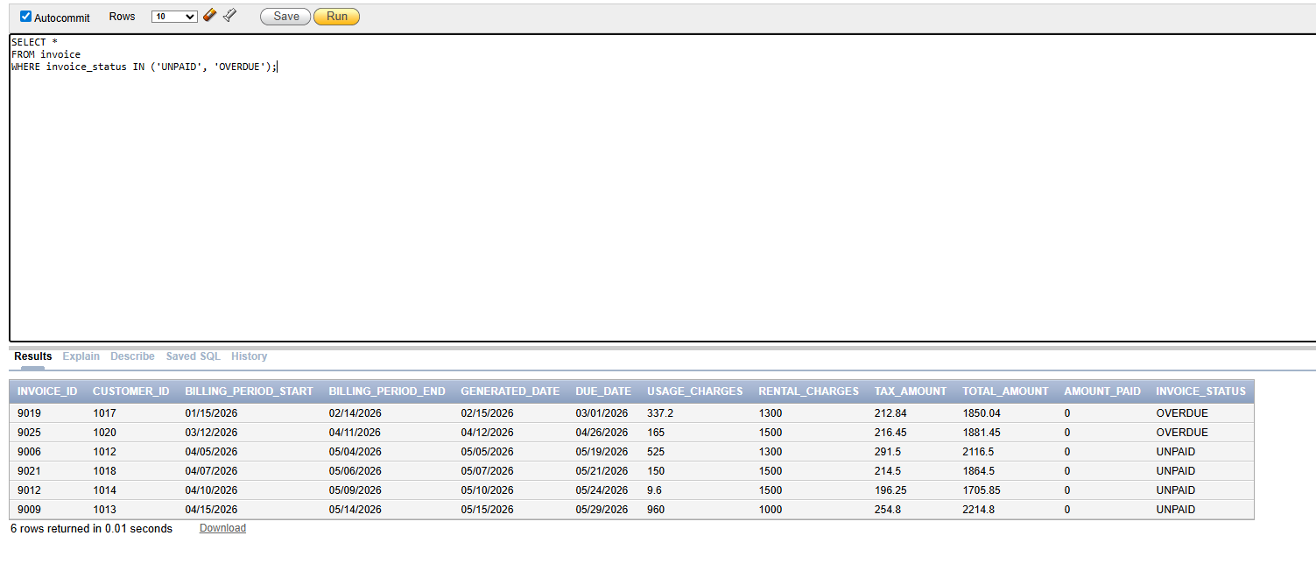

Query Results

Usage Record:

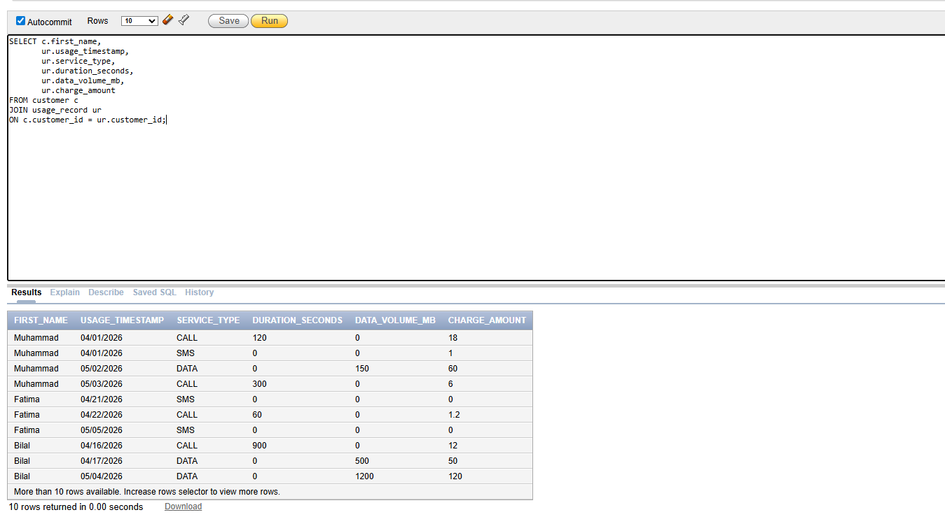

Payments:-
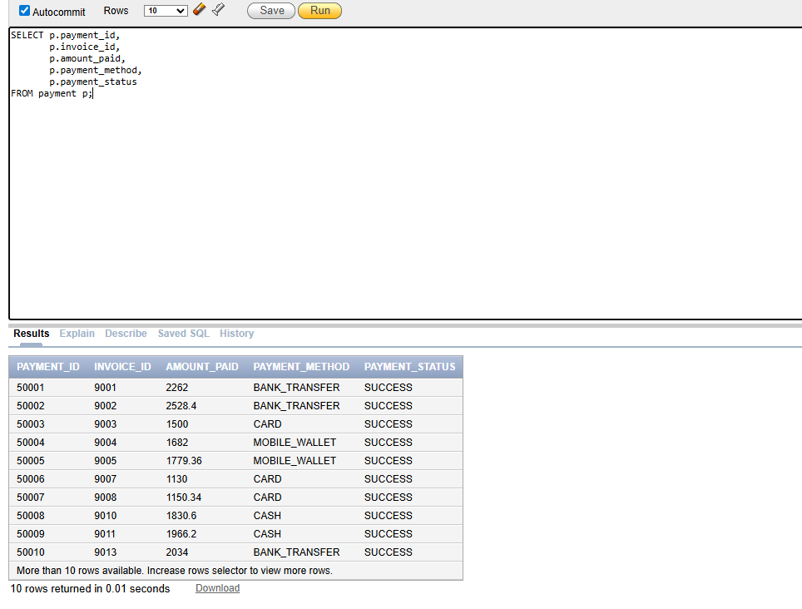

Customer – Plan - Usage – Invoice - Payment
of a single Customer:-

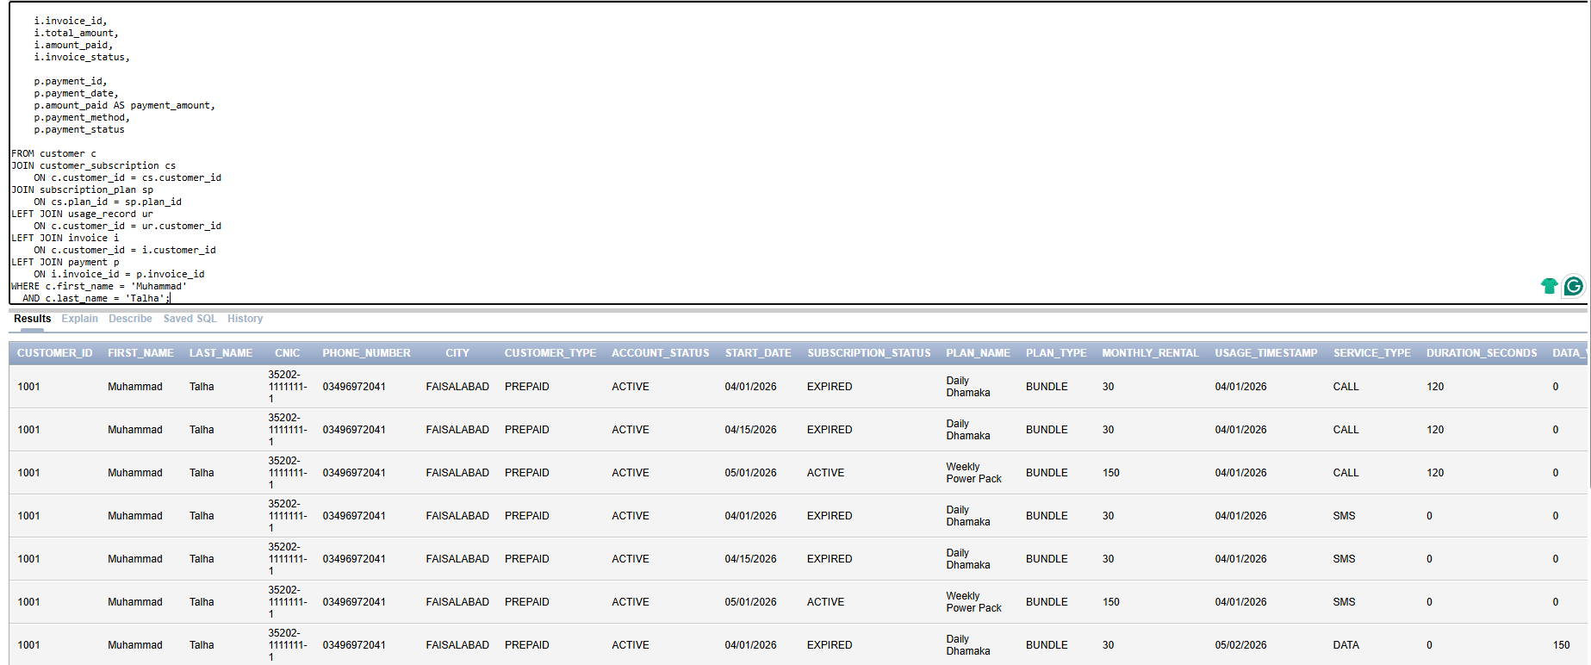

High Usage Users:-
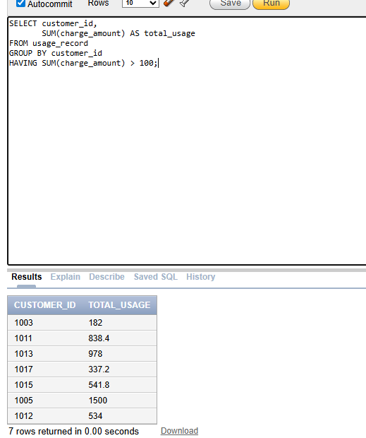

Index

Show all Indexes:-
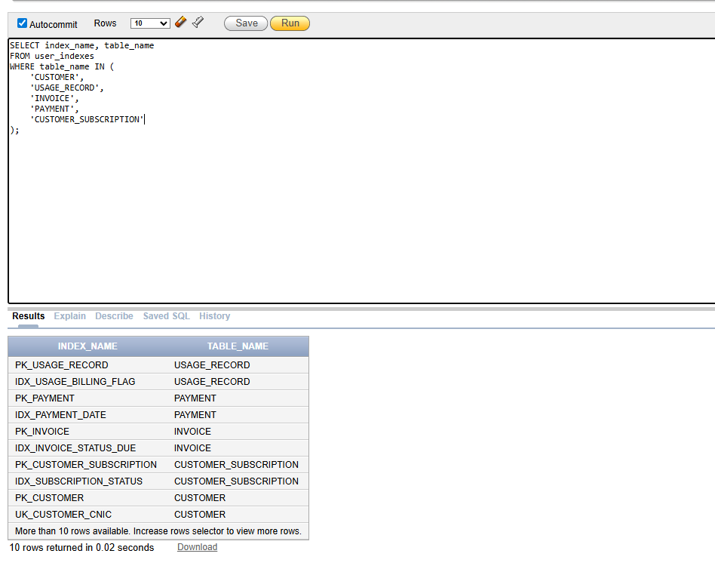

City search (idx_customer_city):

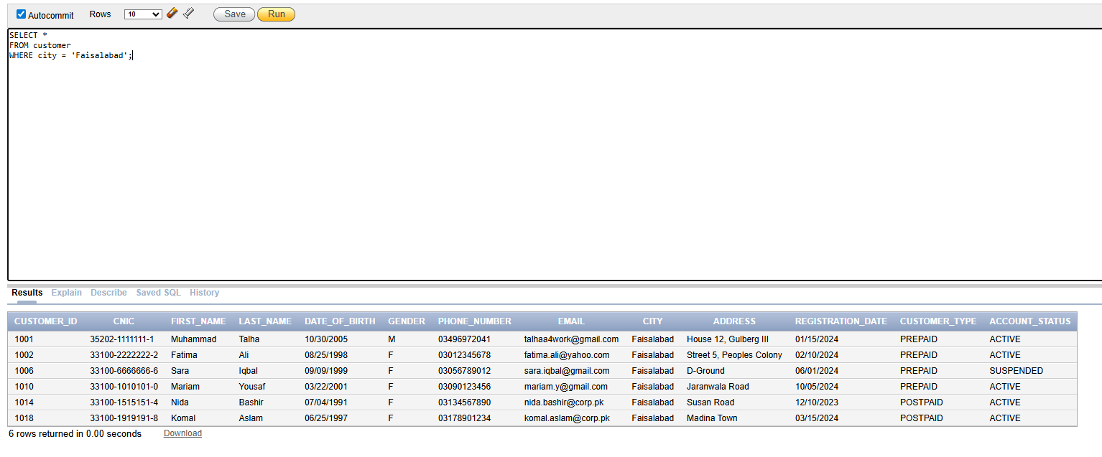

Views

Show all Views:-
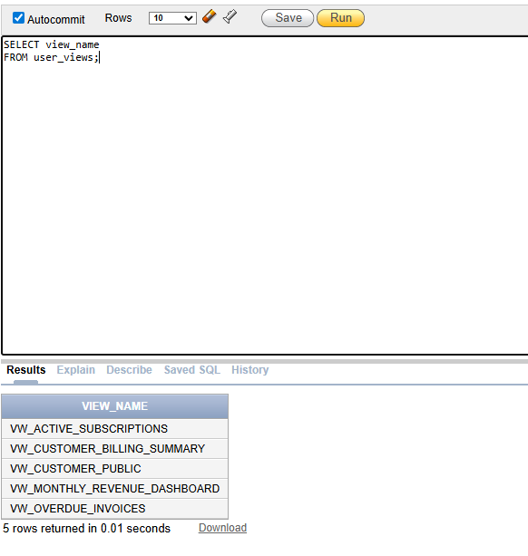

Customer Billing Summary View:-

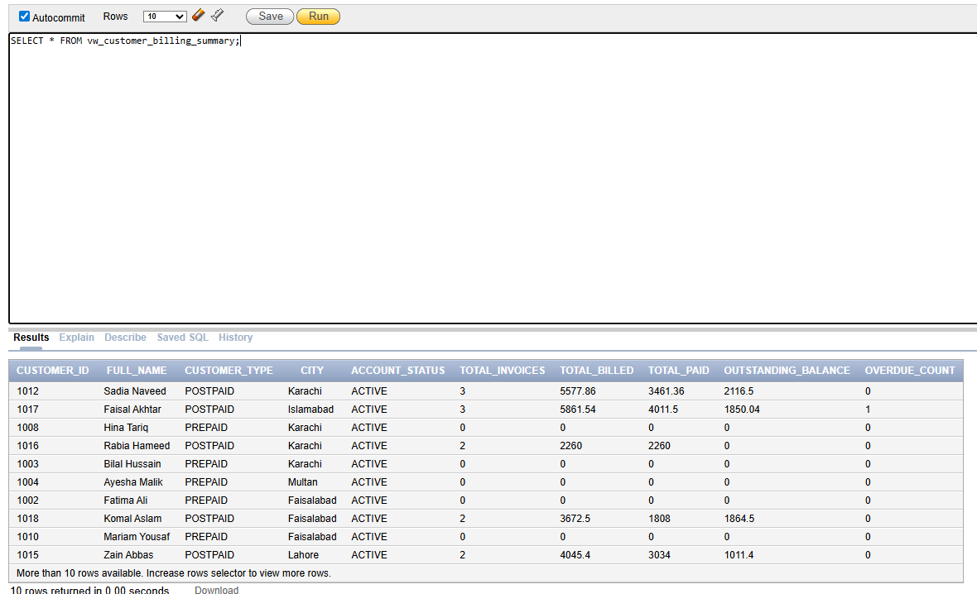

Active Subscriptions View:
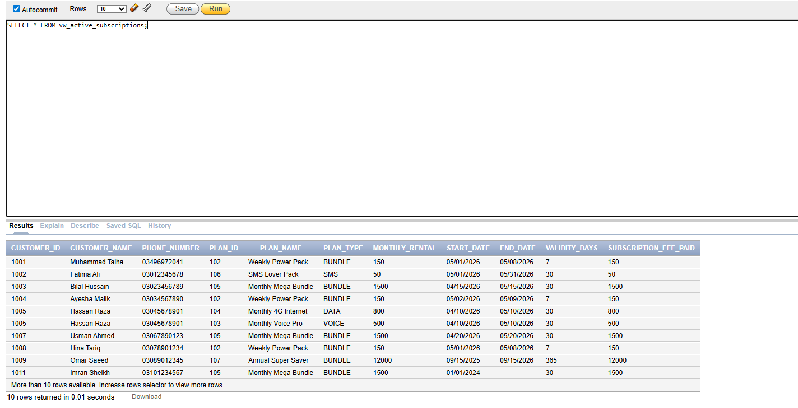
DCL

USER CREATION (SYSTEM)

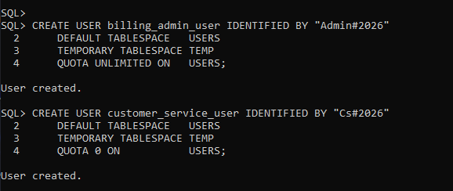

billing_admin_user:
QUOTA UNLIMITED ON USERS;
- Can store unlimited data
- Can create large tables
- No storage restriction
Good for admin users

customer_service_user:
QUOTA 0 ON USERS;
- Cannot store any data
- Cannot create tables
- Read-only user

GRANT CREATE SESSION:

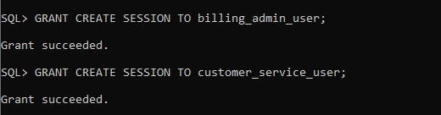

CREATE ROLES :
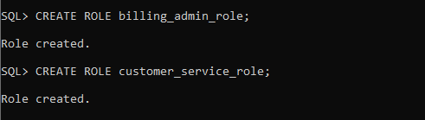

GRANTS privileges TO the roles (DBPROJECT SCHEMA):

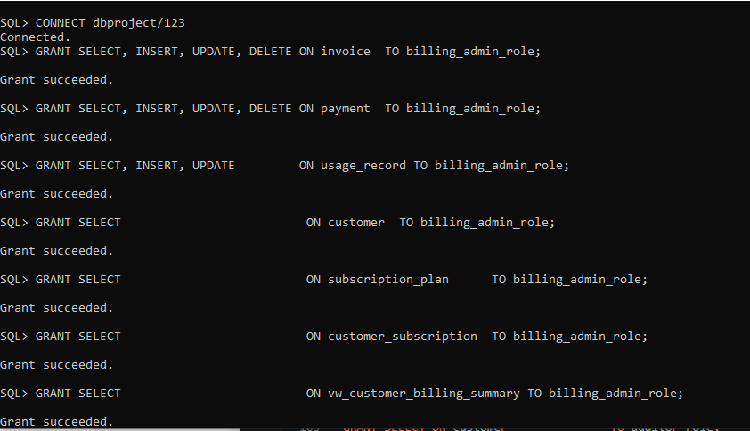

READ ONLY PRIVILEGE:
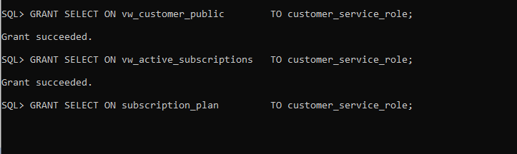

GRANTS Roles to the USERS (SYSTEM):

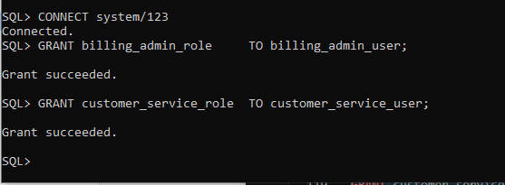

REVOKE FROM CUSTER_SERVICE(DBPROJECT):

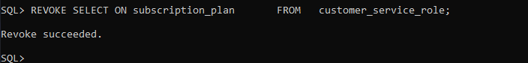

PRIVILEDGE CHECK:

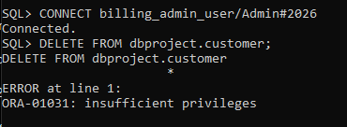

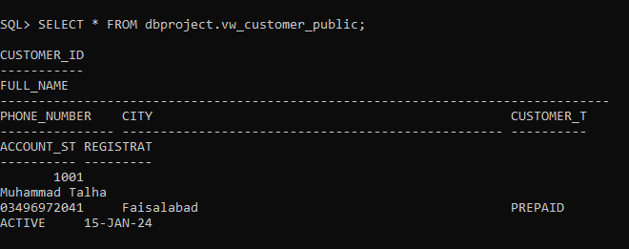

PQSQL

Test 1 : invoke the billing procedure for month:

This PL/SQL block generates monthly customer invoices for April 2026 by processing billing and usage data within the given date range.
It is used to automate bill creation, saving time and ensuring accurate invoice generation for all customers.

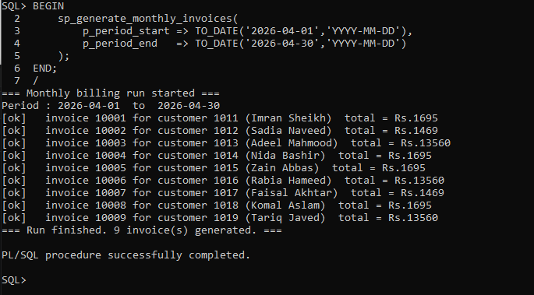

Test 2 : check outstanding balance via the function:

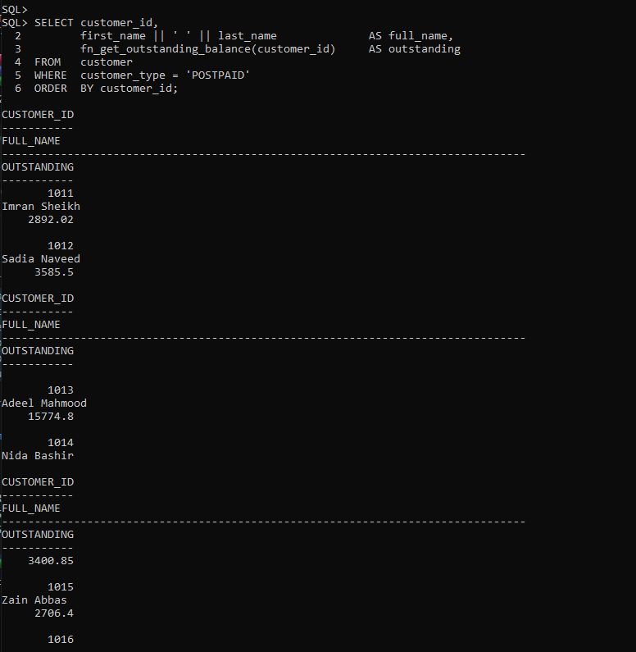

Test 3:- TRIGGER IGNORES FAILED PAYMENTS, INSERT A FAILED PAYMENT MANUALLY, THEN CHECK THE INVOICE REMAINS UNCHANGED

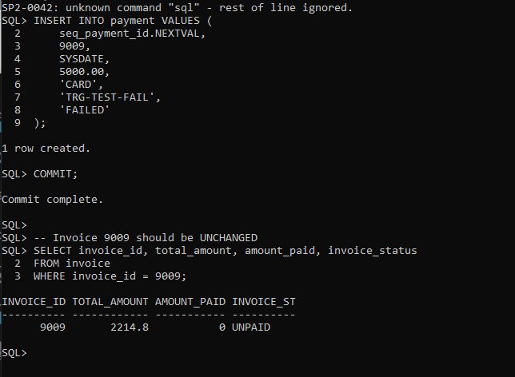

Bonus: Full Stack Integration

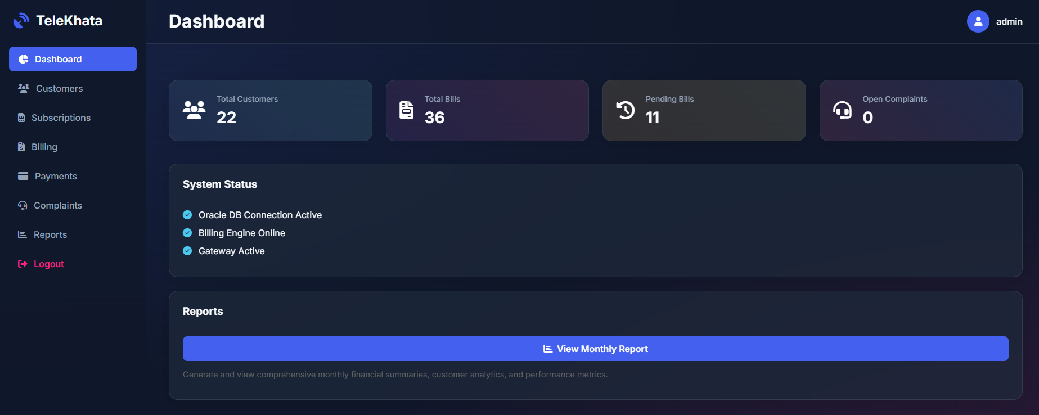

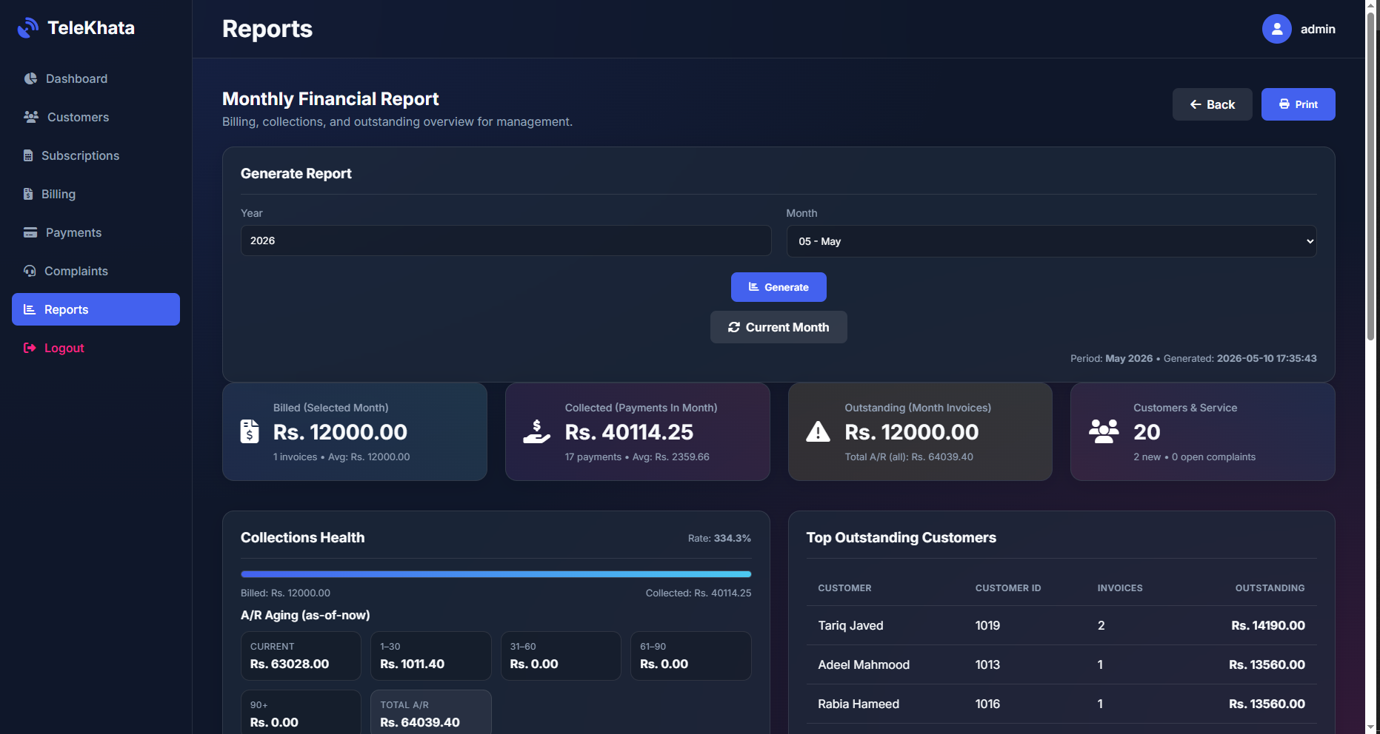

Conclusion

What We Learned:
This project helped us understand how to design and implement a complete relational database using Oracle 11g XE. We learned how normalization improves database structure by removing redundancy and improving data consistency.
We also gained practical experience in creating tables, applying constraints, designing relationships, writing PL/SQL procedures, and implementing role-based access control.
The project showed us how database design decisions directly affect performance, security, and data integrity. Overall, it gave us hands-on experience of building a real-world telecom billing database system.

Challenges Faced:
During development, we faced several challenges such as:
- Oracle 11g XE not supporting identity columns, so sequences had to be used
- Date format errors during data insertion
- Managing composite primary keys
- Constraint violations while testing sample data
- Testing user permissions using multiple database connections
These challenges helped us better understand Oracle database behavior and improved our problem-solving skills.

Future Enhancements:
This system can be improved in the future by adding:
- Automated monthly billing scheduler
- Value-added service modules
- Audit logging for tracking changes
- REST API integration for mobile/web apps
- Multi-currency support
- Migration to newer Oracle versions like Oracle 19c
These enhancements would make the system more scalable, secure, and suitable for real-world telecom operations.

Contribution Table
Phase | Deliverable | Muhammad Talha  24F0793 | Khizar Hayat 24F0812
Phase 1 — Requirements & Domain Analysis | Problem statement, stakeholder analysis, functional & non-functional requirements, business rules | 50% | 50%
Phase 2 — ERD / EERD / Normalization | Entity catalogue, Chen ERD, EERD with ISA specialization, UNF→1NF→2NF→3NF walkthrough | 50% | 50%
Phase 3 — DDL Implementation | 01_create_tables.sql, 02_constraints.sql, 03_sequences.sql, 04_indexes.sql | 50% | 50%
Phase 4 — Data Population & Queries | 05_insert_data.sql (167 sample rows), 06_queries.sql (18 queries) | 50% | 50%
Phase 5 — Views, Indexes & DCL | 07_views.sql (5 views), 08_dcl.sql (users, roles, grants, privilege testing) | 50% | 50%
Phase 6 — PL/SQL Logic | 09_plsql.sql (procedure, function, trigger), test execution, DBMS_OUTPUT screenshots | 50% | 50%
Final Report & Documentation | Phase documents, normalization write-up, viva Q&A bank, submission checklist | 50% | 50%
Total |  | 50% | 50%

FINE

