Feedback for Adriano

For my work:
-Windows system
-Gitbash
-10 cores only (I had to work on this computer for confidentiality reasons)
-11 fastq files (3.5-40GB)

Feedback:
Manuscript/Instructions:
-Version needed for Python: 3.12 exactly (can be clearer in manuscript)
-differences between the draft and the git-hub repository (delt-hit / delt-cli) to be homogenized
-indicate in paper how to name a “no BB”. Eg. I have 95BBs encoded + 1 empty position encoded
-specific way to write paths in Gitbash, could be clearer in your manuscript
-Phase 4: Statistical analysis and hit identification - set up of config file very unclear - please provide examples with explanation of what you want to do

Installation:
# Create dedicated environment (only needed once)
conda create -n delt-hit python=3.12 -y
deactivate VPN if needed

# Install DELT-Hit package
Wrong link provided in manuscript: pip install git+https://github.com/DELTechnology/delt-core.git

Code:
-more than 1 reaction per step is needed for many libraries. E.g. Fmoc-AA addition + Fmoc deprotection. Or BB addition + reduction on another site of the scaffold.
-ideally, it would be nice to be able to work on fastq files on a server and not saved on computer. I could not make that work.
-at the moment, it is mandatory to have S0 and S1: could we have only S0 as an option too?
-excel file prep: each S0 has to be unique 1 excel file / fastq file is needed (even if S0 is demultiplexed with PCR2 / Illumina primers)
-problem with report command Fix: change in report.py line 89 as save_path.write_text(console.export_text(), encoding='utf-8')
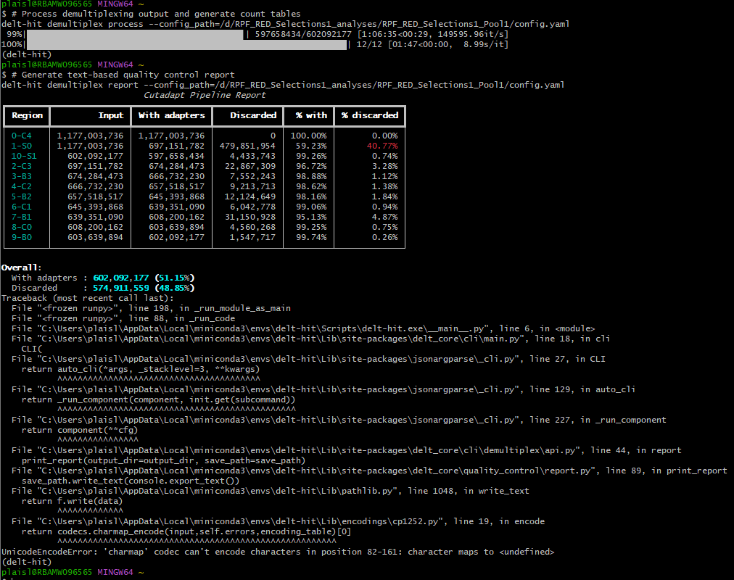

-running the script: need to do conda activation when opening gitbash, hidden folder
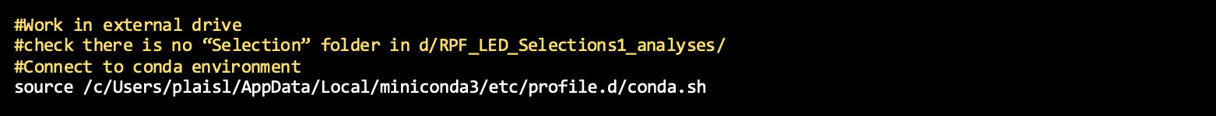
-execute demultiplexing: very long (>8h for 40GB fastq files) check points / intermediate saves would be nice
-when running the script, creation of a “Selection” folder next to the results folder this one stays empty and needs to be deleted to start another run. what is it for, can it be suppressed?

Excel file preparation:
-excel file prep: no spaces allowed (need to TRIM to be sure, date must be in date format…)
-how to deal with random region in the DNA? Temporary fix: treat it like a cst region, assign bases but specify error rate=no of bases, indels=false
(I have a random region, then the S0. Initially all S0 sequences were discarded (100%), now only 20%, which is still not ideal and weird because the other codes are much better)
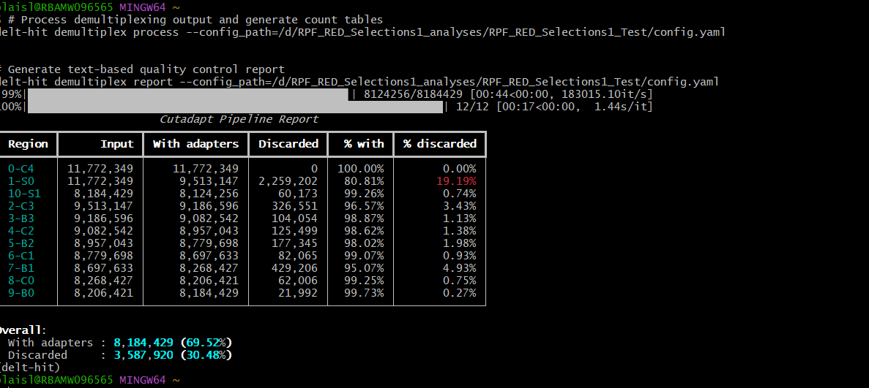

Data analysis:
-quite unclear to me how should I proceed with comparison of selections that are coming from different fastq files (so not mapped in the same config.yaml)

