**1**Utwórz zestawienia roczne zawierające ilość zrealizowanych zamówień oraz średni czas ich realizacji (dla wszystkich lat w układzie miesięcznym).

Przykładowy wygląd zestawienia:

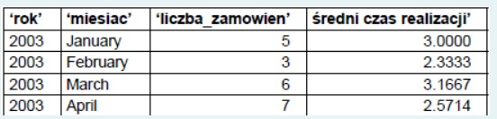

SELECT YEAR(orderDate) AS rok, MONTHNAME(orderDate) as miesiac, COUNT(orderNumber) AS liczba_zamowien, AVG(DATEDIFF(shippedDate, orderDate)), AS sredni_czas_realizacji FROM orders WHERE shippedDate IS NOT NULL GROUP BY YEAR(orderDate), MONTH(orderDate), MONTH(orderDate)

Comment: GROUP BY YEAR(orderDate), MONTH(orderDate), MONTH(orderDate) -> GROUP BY YEAR(orderDate), MONTH(orderDate),

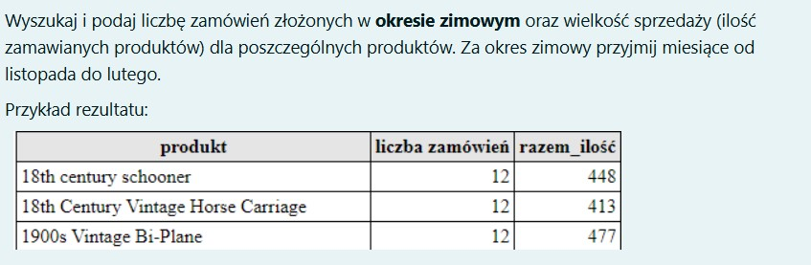

SELECT p.productName AS produkt, COUNT(o.orderNumber) AS liczba_zamowien, SUM(od.quantityOrdered) AS razem_ilosc FROM orders o JOIN orderdetails od ON o.orderNumber = od.orderNumber JOIN products p ON od.productCode = p.productCode WHERE MONTH(o.orderDate) IN (11, 12, 1, 2) GROUP BY p.productName

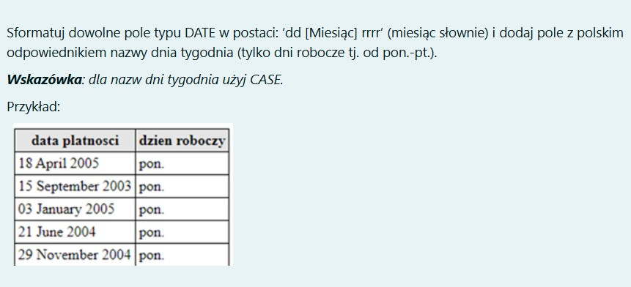

SELECT DATE_FORMAT(orderDate, '%d %M %Y') AS data_platnosci, CASE WHEN WEEKDAY(orderDate) = 0 THEN 'pon.' WHEN WEEKDAY(orderDate) = 1 THEN 'wt.' WHEN WEEKDAY(orderDate) = 2 THEN 'sr'. WHEN WEEKDAY(orderDate) = 3 THEN 'czw.' WHEN WEEKDAY(orderDate) = 4 THEN 'pt.' END AS dzien_roboczy FROM orders ORDER BY WEEKDAY(orderDate)

Comment: orderDate->paymentDate Brakuje ELSE "weekend.". FROM orders ORDER BY WEEKDAY(orderDate)-> FROM payments WHERE (...) ORDER BY DAYOFWEEK(paymentDate), paymentDate

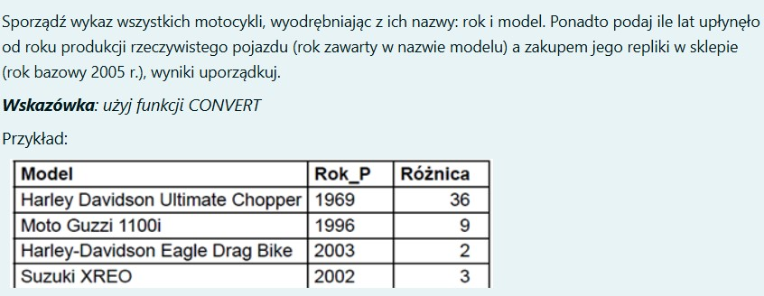

SELECT SUBSTR(productName, 5, LENGTH(productName)) AS "Model", LEFT(productName, 4) AS "Rok_P", CONVERT(2005 - LEFT(productName, 4), UNSIGNED) AS "Roznica" FROM products WHERE productLine = "Motorcycles" ORDER BY 2

Comment: ORDER BY 2-> ORDER BY 3 DESC