<header>

<u1>

<img> </img>

</u1>

</header>

<div>

<img> </img>

<div>

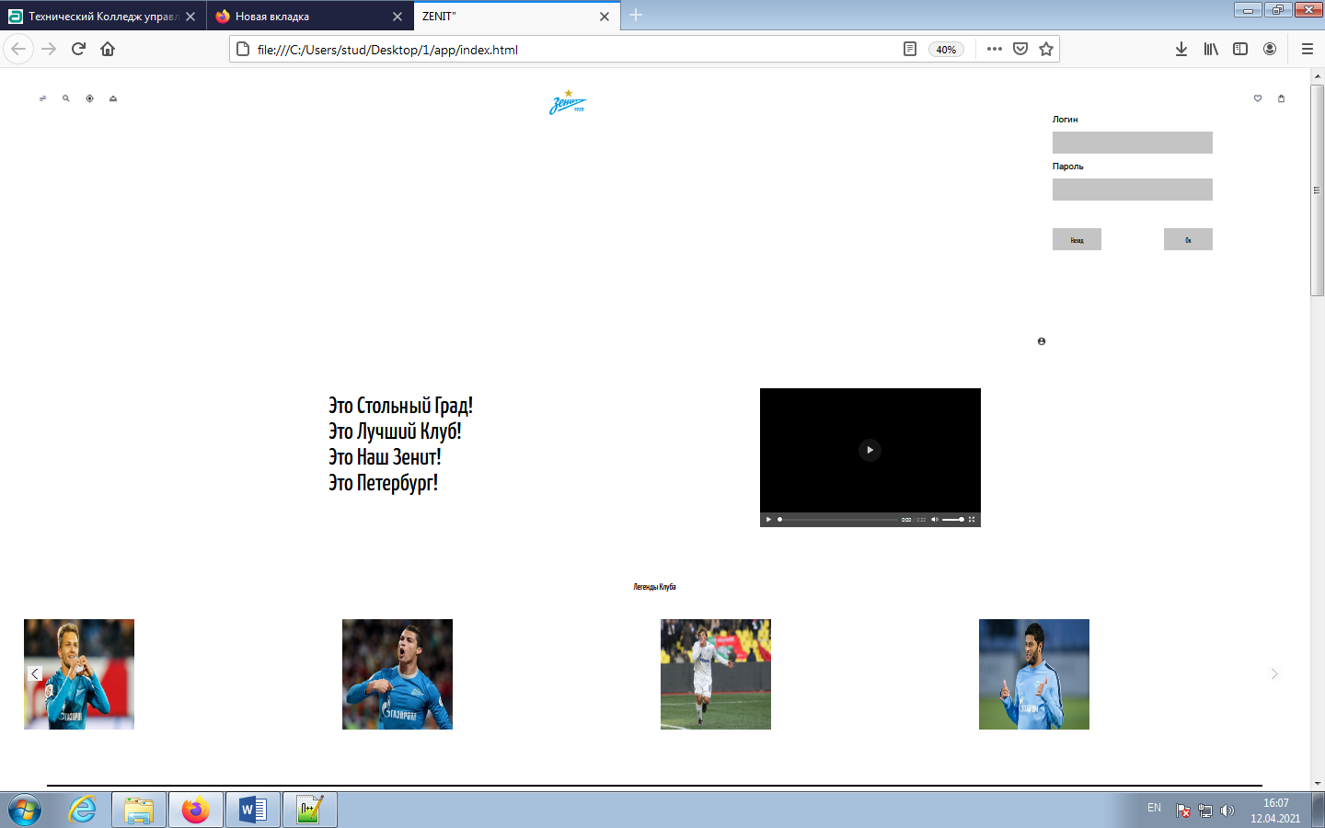

<div>

<img> </img>

<div>

<button> </button>

<section> </section>

<div>

<img></img>

<h3></h3>

<p><p>

<a></a>

<div>

Схема 2 – Разметка макета 1

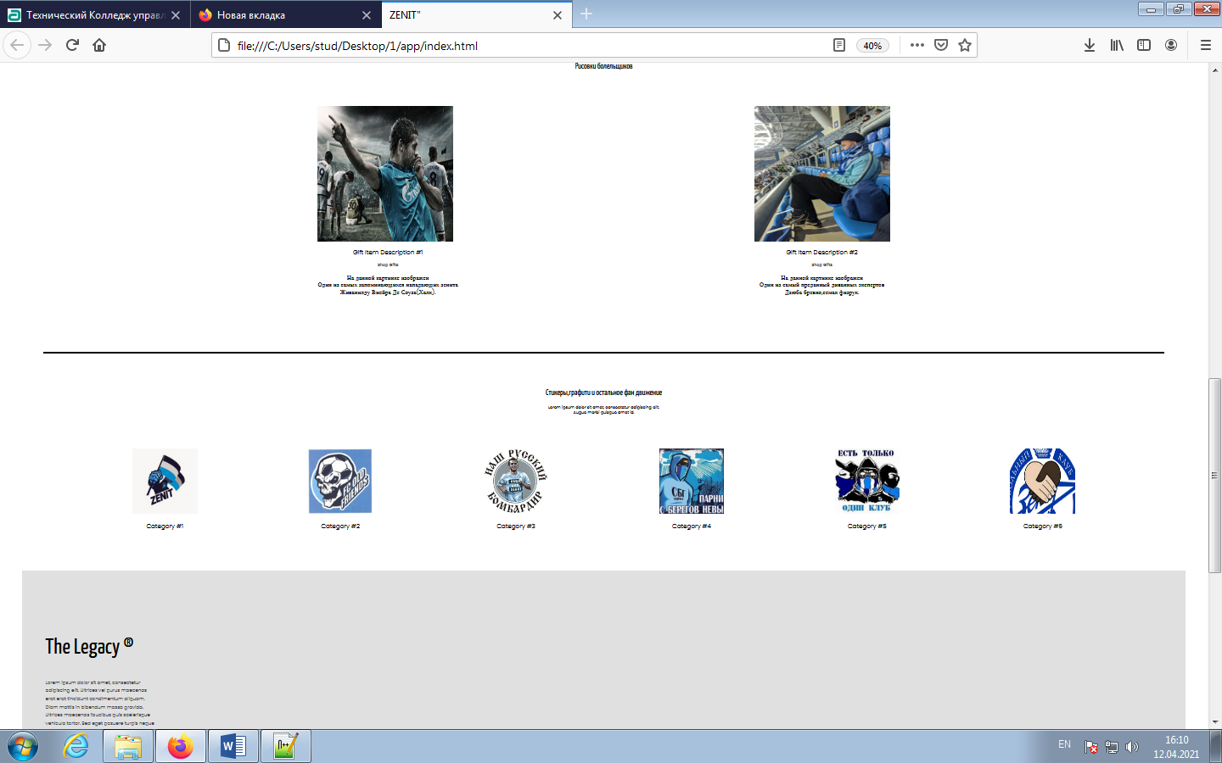

<h5> </h5>

<div>

<img></img>

</div>

<button> </button>

<h1></h1>

<p></p>

Схема 3 – Разметка макета 2

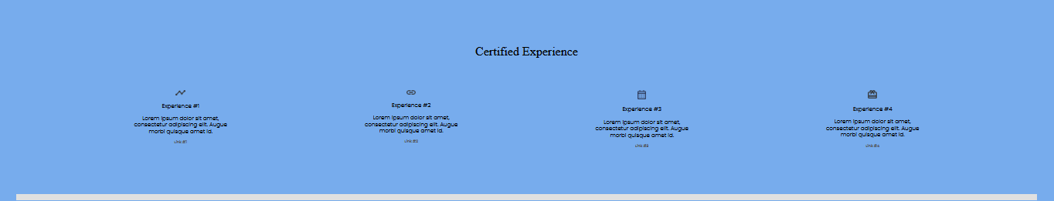

<div>

<h3> </h3>

<p> <p>

<a> </a>

<div>

<div>

<a>

<h5></h5>

</a>

</div>

<img></img>

<h3></h3>

Схема 4 – Разметка макета 3

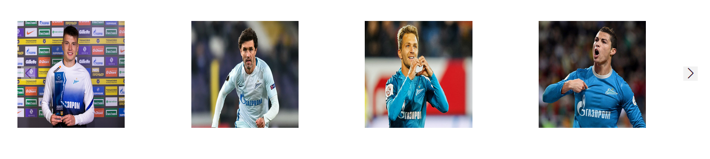

Рисунок 1 - Слайдер

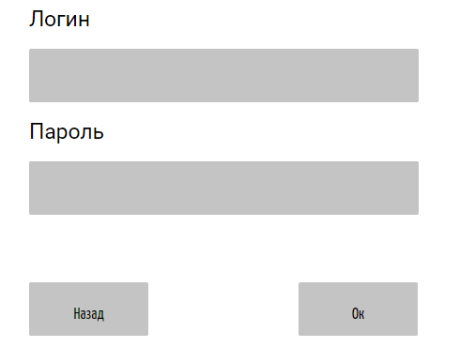

Рисунок 2 – Модальное окно

# Часть 4

1. Результат работы сервера по адресу: <http://localhost>:<port>

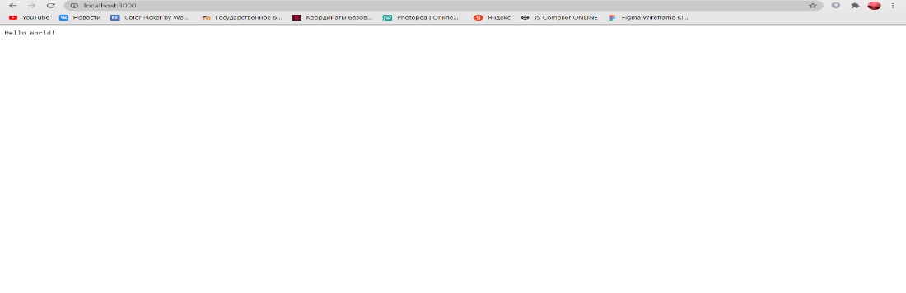

Рисунок 3 – Начальный этап

1. Результат работы сервера по адресу: <http://localhost>:<port>/app

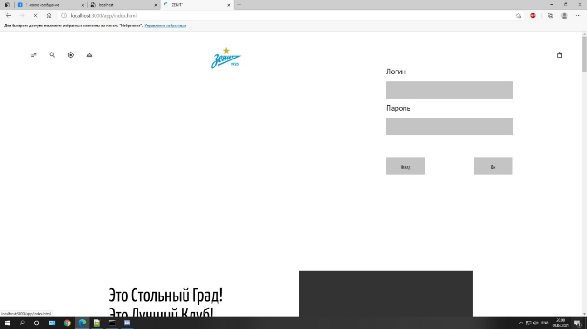

Рисунок 4 – Вход через /app

1. Результат работы сервера по адресу: <http://localhost>:<port>/user

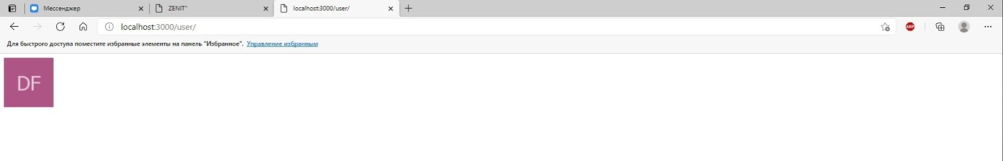

Рисунок 5 – Вход через user

# Приложение А листинг кода файл index.html

<!DOCTYPE html>

<html lang="en">

<head>

<meta charset="utf-8">

<title>ZENIT"</title>

<link rel="shortcut icon" href="images//Spartak.png" type="image/x-icon">

<link rel="preconnect" href="https://fonts.gstatic.com">

<link href="https://fonts.googleapis.com/css2?family=Poppins:wght@300;400;500&family=Yanone+Kaffeesatz&display=swap" rel="stylesheet">

<link rel="stylesheet" type="text/css" href="form.css">

<link rel="preconnect" href="https://fonts.gstatic.com">

<link href="https://fonts.googleapis.com/css2?family=Poppins:wght@300&family=Roboto&display=swap " rel="stylesheet">

<link rel="stylesheet" href="node_modules/swiper/swiper-bundle.min.css">

<link rel="stylesheet" type="text/css" href="css.css">

<script src="server.js"> </script>

</head>

<body>

<div class="fons">

<header>

<div class="allpart">

<div class ="onepart">

<ul class="spisok">

<a href=""><img src ="menu_alt_05.jpg"></a>

</ul>

<ul>

<a href=""><img src ="search.jpg"></a>

</ul>

<ul>

<a href=""><img src ="my_location.jpg"></a>

</ul>

<ul>

<a href=""><img src ="room_service.jpg"></a>

</ul>

</div>

<a href=""><div class="logo"><img src="zenit.png"></div></a>

<div class="twopart">

<ul>

<div id="app" class="account">

<div v-show="fair">

<section>

<div class="acform">

<h2 class="shrift">Логин</h2>

<input class="vvod"></input>

<h2 class="shrift">Пароль</h2>

<input class="vvod"></input>

<div class="knopki">

<button v-on:click="fair=!fair" class="shrift2">Назад</button>

<button v-on:click="fair=!fair" class="shrift2">Ок</button>

</div>

</div>

</section>

</div>

<button v-on:click="fair=!fair" class="acc"><img src ="account_circle.jpg"></button>

</div>

</ul>

<ul>

<a href=""><img src ="heart_outline.jpg"></a>

</ul>

<ul>

<a href=""><img src ="shopping_bag.jpg"></a>

</ul>

</div>

</div>

</header>

<section class="onelevelall">

<div class ="onelvl">

<h1 class ="zagolovok"> Это Стольный Град!<br>

Это Лучший Клуб! <br>

Это Наш Зенит! <br>

Это Петербург!

</h1>

</div>

<div class="onevid" controls >

<video src="голхалкаборуссии.mp4" controls width="600" height="417">

</div>

</section><section>

<h2 class="h22">Легенды Клуба</h2>

<div class = "zenitall swiper-container">

<div class="swiper-wrapper">

<div class = "zenit swiper-slide">

Приложение Б листинг кода файл css.css

body{

margin-right: 64px;

margin-left: 64px;

margin-top: 54px;

}

.shrift2{

font-family: Yanone Kaffeesatz;

font-style: normal;

font-weight: 300;

font-size: 18px;

line-height: 70px;

align-items: flex-end;

color: #000000;

}

.fons2{

background-color:#77ACED;

}

li{

list-style-type: none;

}

.tristarazm{

font-family: Poppins;

font-style: normal;

font-weight: 300;

font-size: 18px;

line-height: 30px;

color: #000000;

}

.zagolovok{

font-family: Yanone Kaffeesatz;

font-style: normal;

font-weight: normal;

font-size: 65px;

line-height: 70px;

color: #000000;

}

hr{

border: 1px solid #000000;

height: 0px;

margin-top: 150px;

margin-right: 64px;

margin-left: 64px;

}

.hrfot{

height: 0px;

border: 10px solid #E0E0E0;

}

onepart{

display: flex;

justify-content: flex-start;

}

.twopart{

display: flex;

justify-content: flex-end;

}

.logo{

display: flex;

width: 343px;

height: 74px;

justify-content: center;

}

.allpart{

display: flex;

justify-content: space-between;

}

button{

border: 1px solid #333333;

box-sizing: border-box;

font-family: Poppins;

font-style: normal;

font-weight: 300;

font-size: 14px;

line-height: 30px;

color: #000000;

background-color: Transparent;

display: block;

margin-top: 25px;

}

.onelvl{

display: flex;

flex-direction: column;

}

.onevid{

display: flex;

}

.onepic{

width: 500px;

height: 350px;

}

.onelevelall{

display: flex;

justify-content: space-evenly;

padding: 50px;

}

.h22{

font-family: Yanone Kaffeesatz;

font-style: normal;

font-weight: normal;

font-size: 24px;

line-height: 30px;

color: #000000;

text-align: center;

margin-top: 100px;

}

.butcenter{

position: relative;

left: 50%;

transform: translate(-50%, 0);

margin-top: 70px;

}

.h33{

font-family: Poppins;

font-style: normal;

font-weight: 300;

font-size: 18px;

line-height: 25px;

color: #000000;

text-align: center;

margin-top: 20px;

}

.hp3{

font-family: Poppins;

font-style: normal;

font-weight: 300;

font-size: 18px;

line-height: 21px;

text-align: center;

}

.hp31{

font-family: Poppins;

font-style: normal;

font-weight: 300;

font-size: 12px;

line-height: 15px;

text-align: center;

}

.h33a{

font-family: Poppins;

font-style: normal;

font-weight: 500;

font-size: 12px;

line-height: 15px;

color: #4F4F4F;

text-align: center;

text-decoration: none;

display: block;

}

.podzag{

font-family: Poppins;

font-style: normal;

font-weight: 300;

font-size: 14px;

line-height: 24px;

color: #4F4F4F;

}

.experince{

font-family: Didot LT Pro;

font-style: normal;

font-weight: normal;

font-size: 40px;

line-height: 50px;

color: #000000;

text-align: center;

margin-top: 150px;

}

.foottext{

font-family: Poppins;

font-style: normal;

font-weight: 500;

font-size: 18px;

line-height: 25px;

color: #000000;

margin-left: 40px;

}

.latest{

font-family: Poppins;

font-style: normal;

font-weight: 500;

font-size: 18px;

line-height: 25px;

color: #000000;

}

.foota{

font-family: Poppins;

font-style: normal;

font-weight: normal;

font-size: 18px;

line-height: 25px;

color: #000000;

text-decoration: none;

}

.foottext2{

font-family: Poppins;

font-style: normal;

font-weight: normal;

font-size: 18px;

line-height: 25px;

color: #000000;

margin-top: 50px;

}

input, textarea{

outline: none;

border: none;

border: solid 1px #f2f2f2;

font-family: Poppins;

font-style: normal;

font-weight: normal;

font-size: 18px;

line-height: 25px;

color: #828282;

}

.zenitblock{

display: flex;

flex-direction: column;

}

.zenblockall{

display: flex;

justify-content: space-evenly;

margin-top: 100px;

}

.audio-container{

display: flex;

justify-content: center;

align-items: center;

margin-top: 50px;

}

.category{

justify-content: center;

}

.categall{

display: flex;

justify-content: space-evenly;

margin-top: 100px;

}

.categimg{

width: 192px;

height: 192px;

}

.imgexp{

display: block;

margin-left: auto;

margin-right: auto

}

.ulblock{

display: flex;

flex-direction: column;

}

.ulblockall{

display: flex;

justify-content: space-evenly;

}

.legac{

background: #E0E0E0;;

height: 550px;

margin-top: 100px;

}

.textlegacy{

margin-bottom: 50px;

padding-top: 140px;

padding-left: 70px;

}

.logo2{

display: flex;

justify-content: center;

height: 74px;

margin-top: 70px;

}

.otstup{

margin-top: 70px;

}

.socialceti{

display: flex;

justify-content: space-evenly;

margin-left: -50px;

margin-top: 20px;

}

.emailline{

width: 369px;

height: 0px;

border: 1px solid #000000;

margin: auto;

}

.zenit{

display: flex;

width: 300px;

height: 300px;

}

.zenitall{

display: flex;

justify-content: space-evenly;

margin-top: 70px;

}

.swiper-button-next::after, .swiper-button-prev::after{

font-size: 30px;

color:#28021b;

}

.swiper-button-prev{

width: 40px;

height: 40px;

background: #F2F2F2;

}

.swiper-button-next{

width: 40px;

height: 40px;

background: #F2F2F2;

}

.account{

margin-top: -25px;

}

.acc{

border: none;

}

Приложение В листинг кода файл package.js

<script src="https://unpkg.com/vue"></script>

<script>

const app = new Vue({

el: '#app',

data: {

fair: true,

},

});

</script>

<div id="app" class="account">

<div v-show="fair">

<section>

<div class="acform">

<h2 class="shrift">Логин</h2>

<input class="vvod"></input>

<h2 class="shrift">Пароль</h2>

<input class="vvod"></input>

<div class="knopki">

<button v-on:click="fair=!fair" class="shrift2">Назад</button>

<button v-on:click="fair=!fair" class="shrift2">Ок</button>

</div></div>

# Приложение Г листинг кода файл server.js

const http = require("http");

const fs = require("fs");

let avatarholder = require('avatarholder');

http.createServer(function(request, response){

if(request.url.startsWith("/app/")){

// получаем путь после слеша

const filePath = request.url.substr(1);

fs.readFile(filePath, function(error, data){

if(error){

response.statusCode = 404;

response.end("Resourse not found!");

}

else{

if (filePath.includes(".css")) {

response.setHeader("Content-Type", "text/css")

}

else{response.setHeader("Content-Type", "text/html");}

response.end(data);

}

})

}

else{

if(request.url.startsWith("/user/")){

let image = avatarholder.generateAvatar('Daniil XoLoDkOfF');

response.setHeader("Content-Type", "text/html")

response.end("<img src="+image+">");

}

// во всех остальных случаях отправляем строку hello world!

}

}).listen(3000);

# Приложение Д листинг кода файл server.json

const http = require("http");

const fs = require("fs");

let avatarholder = require('avatarholder');

http.createServer(function(request, response){

if(request.url.startsWith("/app/")){

const filePath = request.url.substr(1);

fs.readFile(filePath, function(error, data){

if(error){

response.statusCode = 404;

response.end("Resourse not found!");

}

else{

if (filePath.includes(".css")) {

response.setHeader("Content-Type", "text/css");

}

else{response.setHeader("Content-Type", "text/html");}

response.end(data);

}

})

}

else{

if(request.url.startsWith("/user/")){

let image = avatarholder.generateAvatar(holod');

response.setHeader("Content-Type", "text/html")

response.end("<img src="+image+">");

}

response.end("Hello World!");

}

}).listen(3000);