What is <!DOCTYPE> Declaration?

The declaration is not an HTML tag. It is an "information" to the browser about what document type to expect.

represents the document type, and helps browsers to display web pages correctly.

Not case sensitive

The <!DOCTYPE html> declaration defines that this document is an HTML5 document

===================================================

- HTML describes the structure of a Web page when creating web pages
- HTML derived from xml
===================================================
The difference between <head> and <body> ?

Head – meta data about the page
- giving instructions to search engines and browsers

body – container for all the visible content

=======================================================================
Two types of html elements?

Most of the elements can insert to the catgories of inline level element and block level element.

As well as Replace and non-replace is also correct.

element whose representation is outside the scope of CSS; they're external objects whose representation is independent of the CSS formatting model. hey're elements whose contents are not affected by the current document's styles.
Ex:- like an image
All boxes are active in replace elements whether it is inline or block (for both)
Example:- replace elements
the content that embedded to the html page
audio, canvas, embed, iframe, img, math, objectk, svg, video

all the other elements are non-replace
the content of those can be change from the current document styles
Most of the elements are non-replace(95-98% of)
=================================================================

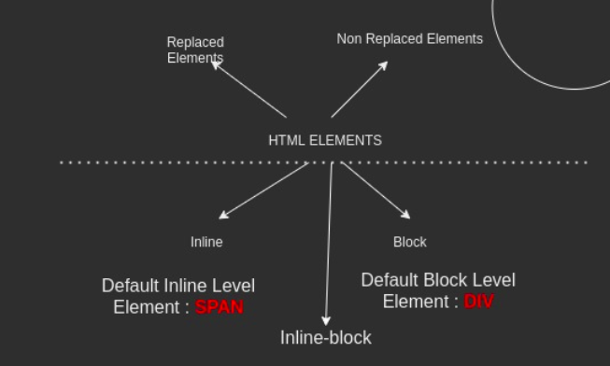

====================================================================

html positioning?

Static, relative, absolute, fixed

Static positioning is the default that every element gets — it just means "put the element into its normal position in the document layout flow — nothing special to see here."
relative - This is very similar to static positioning. Relative to static. Activate TOP, BOTTOM, LEFT, RIGHT. we can then modify its final position, including making it overlap other elements on the page.

Absolute - An absolutely positioned element no longer exists in the normal document layout flow. Instead, it sits on its own layer separate from everything else. the gap where the positioned element should be in the document flow is no longer there . It will be filled by the next element in the normal layout. Activate top. Bottom , left, right. And position is relative to nearest position element.

Fix - This works in exactly the same way as absolute positioning, with one key difference. fixed positioning usually fixes an element in place relative to the visible portion of the viewport,

=======================================================================
Key changes in html5 elements?
Video
audio
semantics - clearly describes its meaning to both the browser and the developer.
<article>
- <aside>
- <details>
- <figcaption>
- <figure>
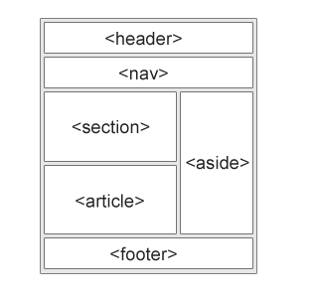
- <footer>
- <header>
- <main>
- <mark>
- <nav>
- <section>
- <summary>
- <time>

=======================================================================
Difference between section and article tags ?
Both are used to represent content.
Section
defines a section in a document.
article
specifies independent self contain content
havent connection with remain content of the page
it may have h1 (not mandotory)
Ex:- news story, blog post, comment, forum post
sections is not like that.
=====================================================================
Forms
=====================================================================
what is action ?
The action attribute defines the action to be performed when the form is submitted./ The url that processes the form submission
Usually, the form data is sent to a file on the server when the user clicks on the submit button.
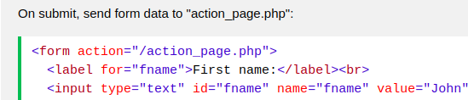

=====================================================================
what is method?
The method attribute specifies the HTTP method to be used when submitting the form data.
The form-data can be sent as URL variables (with method="get") or as HTTP post transaction (with method="post").
The default HTTP method when submitting form data is GET.
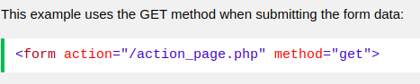

=====================================================================
what is enctype?
The enctype attribute specifies how the form-data should be encoded when submitting it to the server.
- application/x-www-form-urlencoded: The default value.
- multipart/form-data: Use this if the form contains <input> elements with type=file.
- text/plain: Introduced by HTML5 for debugging purposes.

===================================================
button types ?
Button, submit, reset
submit: The button submits the form data to the server. This is the default if the attribute is not specified for buttons associated with a <form>, or if the attribute is an empty or invalid value.
reset: The button resets all the controls to their initial values, like <input type="reset">. (This behavior tends to annoy users.)
button: The button has no default behavior, and does nothing when pressed by default. It can have client-side scripts listen to the element's events, which are triggered when the events occur.

Submit and reset are non-useful → if not wrap up from <form>
=================================================================
name attribute in forms ?
used to reference elements in a JavaScript, or to reference form data after a form is submitted.
Create unique behaviour for radio button
=================================================
query string ?
String part after “?” in url
query string have query parameters
connect query parameters using “&” sign
query parameters have the name and the value
=====================================================================
what are the three types of styling ?

1. Inline
2. Internal
3. External

Inline
----------
use property value pairs

<h1 style="color:blue;">A Blue Heading</h1>

<p style="color:red;">A red paragraph.</p>

Internal - for single html page
---------------------------------
use css rules
define in the <head>

<html>
<head>
<style>
body {background-color: powderblue;}
h1 {color: blue;}
p {color: red;}
</style>
</head>

External - as css files
-------------------------
use css rules

<html>
<head>
<link rel="stylesheet" href="styles.css">
</head>
=======================================================================

Priority order of three style types?

1. Inline
2. nearest one from external or internal – the one executed at last
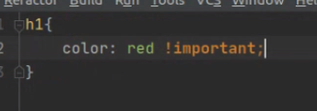

if use “!important” → it is the first priprity

=======================================================================
New introduces of CSS3 ?

- Media queries – do responsive web design, include css properties only for certain conditions

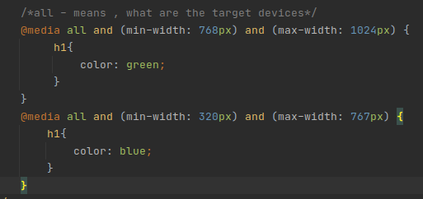
- transform property
- animations and transitions
- flex

- flex-grow
This property specifies how much of the remaining space in the flex container should be assigned to the item (the flex grow factor).
The main size is either width or height of the item which is dependent on the flex-direction value.
The remaining space is the size of the flex container minus the size of all flex items' sizes together. If all sibling items have the same flex grow factor, then all items will receive the same share of remaining space, otherwise it is distributed according to the ratio defined by the different flex grow factors.

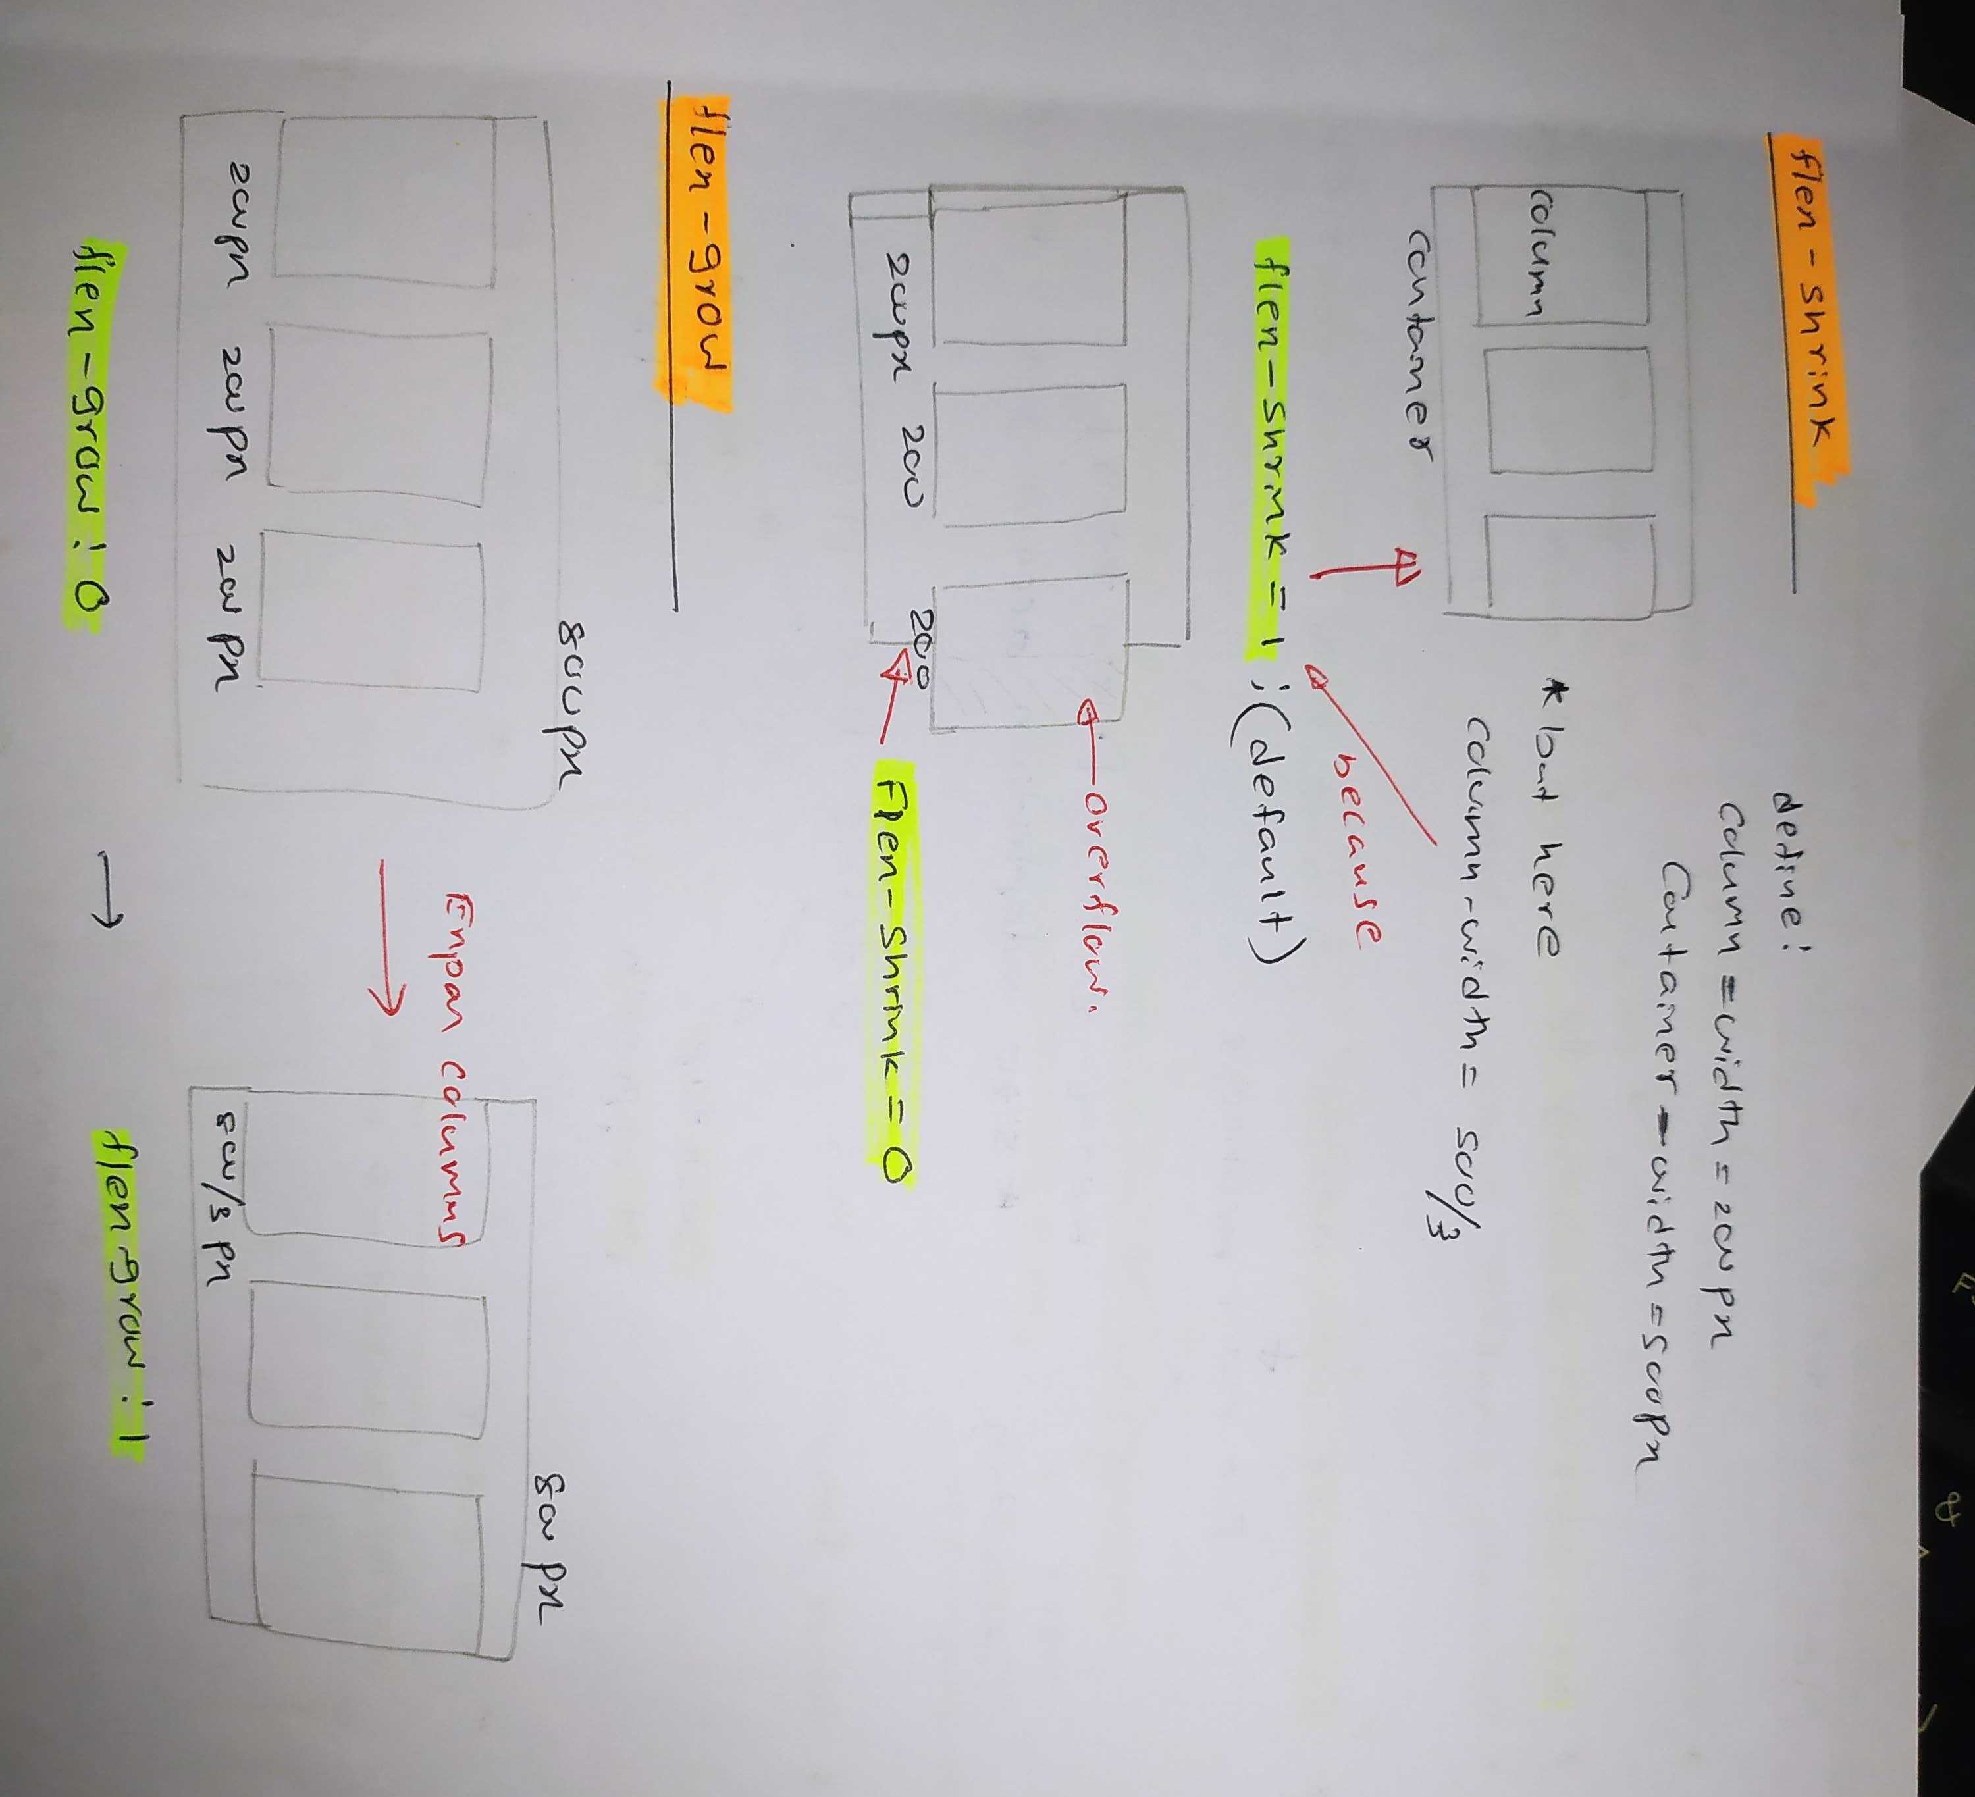
- flex-basis – set the initial size of the flex item,
pixels percentage of relative units
default value is auto

align – content → align several fles lines
align – item → align content of single flex line
=====================================================================
Box model ?

Inline elements, box elements both have these boxes
all boxes are active for box elements

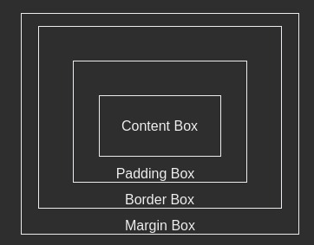

for inline elements:-
content box is not active for inline elements (cannot ser width, height)
padding box works for all sides, but get space only left and right sides
border box works for all sides
margin box alson like padding

=================================================================

Box-sizing ?

Initialy height and width are set to content box
box-sizing: border-box → padding and border are included in width and height

=================================================================
float ?

The float CSS property places an element on the left or right side of its container, allowing text and inline elements to wrap around it. The element is removed from the normal flow of the page, though still remaining a part of the flow

It is shifted to the left, or right, until it touches the edge of its containing box, or another floated element.

==============================================================
clear

The clear CSS property sets whether an element must be moved below (cleared) floating elements that precede it. The clear property applies to floating and non-floating elements.

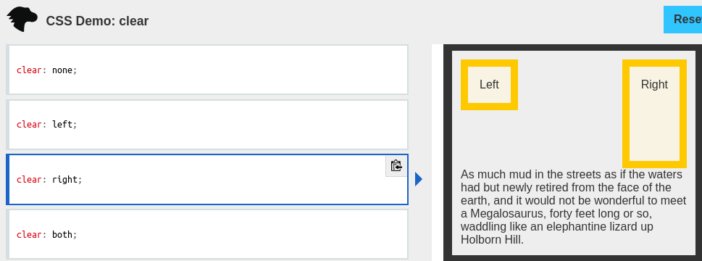

======================================================================

JavaScript
======================================================================
01. is javaScript case sensitive ?
Yes, because of develop based on java

02. is it C base language ? Yes

03. OOP language?

ESP5 → prototype base
ESP6 → class base (but internally prototype base, we are seen class base when coding)

04. Strongly type or loosly type ?
Loosly type – doesn’t consider strickly its type

05. Statically or dynamicaly type?
Dynamically type

maeaning:-
statically type:- type checking during compiling
dynamically type:- type checking during run time

06. is TypeScript statically or dynamically type?
Statically type

TypeScript
ECMAScript
TS compiler
statically
dynamically

07. Java Script is compile, intepreted or imtermediate ?
Interpreted language
must need source file
intepreter = javascript engine

08. Typescript is compile, intepreted or intermediate?
Intermediate (like java – with compiler and jvm)

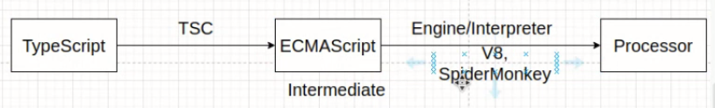
09. What are the primitive data types in ECMAScript5?

 | boolean | number | string | null | undefined
literals | True, false | All number types except binaries | ‘’  “”

