# VolMon Grab Data Processing

1. Create a working copy of the data submission file
2. Add Submission ID to the VolMon2 SQL DB – SQL script
   1. Need help with batch type and project!
3. Verify existing or create new station – Station Creation Tool SOP
4. Format Template – Grab data processing
5. Run R code
6. Upload to VolMon2
7. Manual Review in VolMon DB app
8. Generate AWQMS upload
   1. Delete raw data from DB?

## Creating Working Copy

The submitted dataset file should be renamed with “OriginalCopy”. Save a copy of the data with “WorkingCopy” prefix.

## Submission ID

Use the SQL code to create a new submission and get the ID. Store this in the tracking form.

INSERT INTO [VOLMON2].[dbo].[t_Submission] (

[SubDescription]

,[SubOrganizationID]

,[Continuous]

,[Project]

,[SubFileName]

,[SubDate]

,[OriginalFileName]

,[SubStatusID]

,[DupBatchType]

)

values

('2020_VolWQGrabDataSub_RRK',

43,

0, -- 0= no, 1= yes

22, -- this was an assumption

'\\deqlab1\Vol_Data\RogueRK\2020\',

'2020-10-19 00:00:00.000',

'\\deqlab1\Vol_Data\RogueRK\2020\OriginalCopy_VolWQGrabData_SubmittalFormat3.0_RRK_10.14.2020.xlsx',

10, -- Data has been accepted but no DEQ processing has occurred

448 -- 448 = day, 449 = DayCrew, 450 = sampler

)

## Stations

1. What do we need to add here???

## Formatting the Excel file

1. Project tab – May need to rename **ProjectInfo**
   1. Rows 1-5 are accounted for in the Submission ID – ignore
   2. Row 6 - Use exact column headers from example
   3. Update CharID (column A) to align with VolMon2 valid values - see example for common parameters
   4. Update Method Short Name (Column B) to align with VolMon2 valid values - see example for common parameters
   5. Update Units (Column D) to align with VolMon2 valid values - see example for common parameters
   6. Update Limit of Quantitation (Column H) - see example for common parameters
      1. All lab parameters typically have an LOQ.
      2. Conductivity is always 0.
      3. Turbidity is always 1.
      4. TSS is 1
      5. % oxygen saturation is 5.
   7. Delete this section

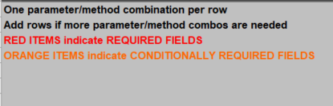

1. Data - Might need to rename **Data**
   1. Results and result metadata –
      1. Each parameter must have at least 8 columns. These contain the result, duplicate result, and metadata information. All will likely have to be renamed to match the CharID (parameter) name used on the project tab.
         1. See existing SOP for definitions of columns.
         2. See example for actual format and copy and paste options.
         3. Note - Charid**_qual** and Charid**d_qual** areoften missingfrom submission files. This will need to added to each parameter (CharID)**.** The qualifier (< or >) will need to be deleted from the numeric result and added to the corresponding _qual column.
   2. The list below contains the columns outside of the results/result metadata used in the R script. These need to be exact name matches. If the column is missing from the template, add it to the working copy.
      1. LASAR_ID
      2. StartDate
      3. StartTime
      4. SampleDepth
      5. SampleDepthUnit
      6. SampleMedium
      7. SampleColMthd
      8. SampleColEquip
      9. SampleColEquipID
      10. SampleColEquipCmnt
      11. samplers
      12. DEQ_Comment
      13. Org_Comment

## R Processing

1. Go to <https://github.com/DEQlmerric/DEQVOLMON_Grab> - download zip file of the VolMon

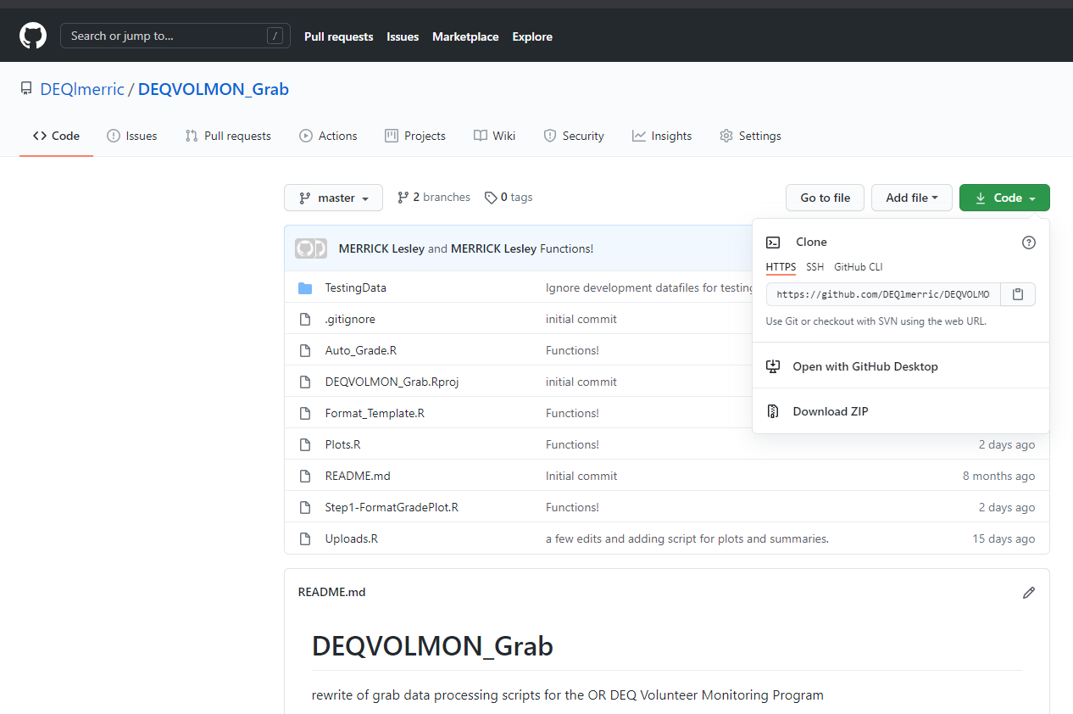

1. Navigate to folder data you are working on and create an Rgrab folder. Extract the zip repository to the Rgrab folder.

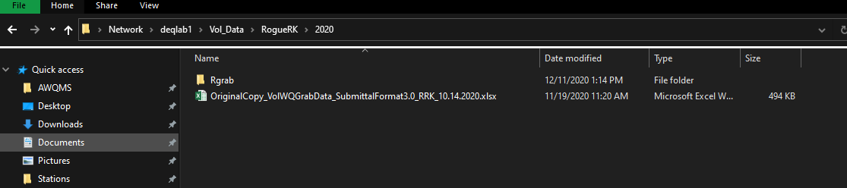

This is your working folder and should look like this.

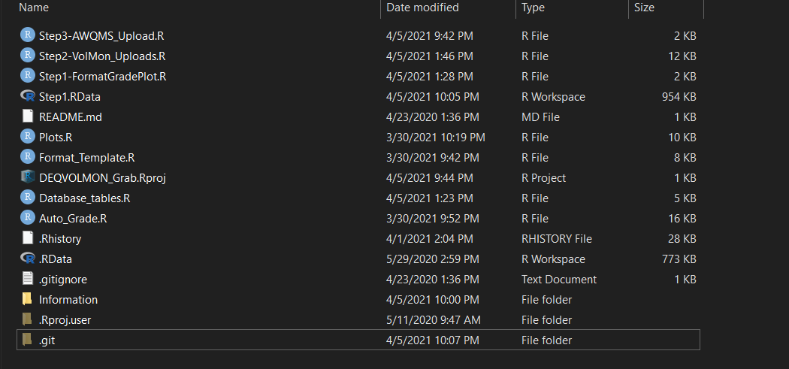

1. Open the DEQVOLMON_Grab.Rproj from the working folder
2. From the Files pane, open the .R file - **Step1 – FormatGradePlot**

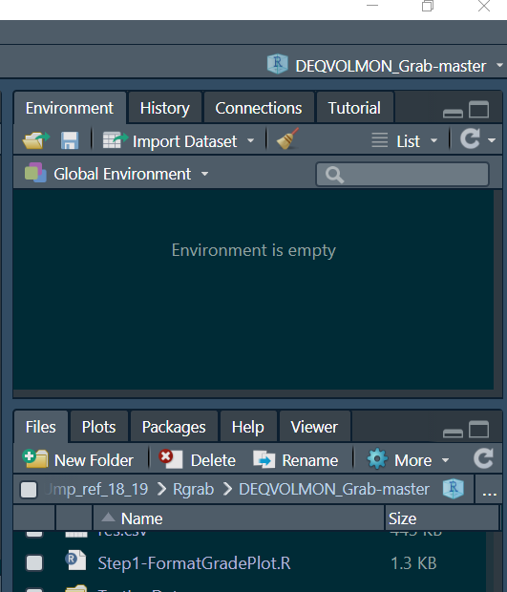

1. Run lines 2-8 to bring in required packages – new users may need to install some or all of the packages.
   1. If installation is needed, go to the packages tab, click install and type the package name

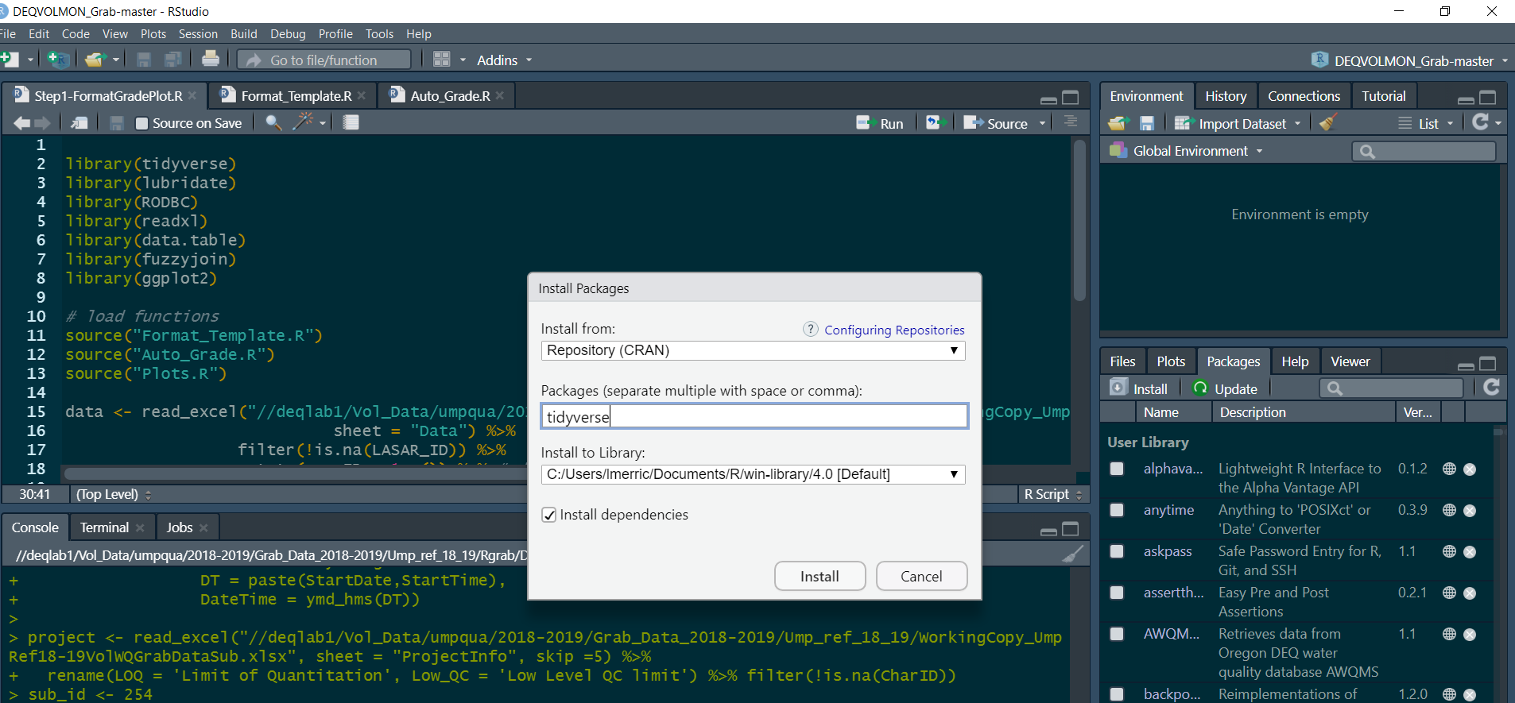

1. Run lines to 11-14 to source functions (these are .R scripts located in the project folder)
2. Update and run line 17 – **this is critical** – the file path needs to be updated to match the “WorkingFile” formatted in the previous step. Notice R uses slashes in the opposite direction as windows. If you copy from windows file explorer, change the direction of the slash.
   1. **Windows format** - \\deqlab1\Vol_Data\umpqua\2018-2019\Grab_Data_2018-2019\Ump_ref_18_19\WorkingCopy_UmpRef18-19VolWQGrabDataSub.xlsx
   2. **R format** - //deqlab1/Vol_Data/umpqua/2018-2019/Grab_Data_2018-2019/Ump_ref_18_19/WorkingCopy_UmpRef18-19VolWQGrabDataSub.xlsx
3. Update and run line 18 – **this is critical** – with submission ID from the tracking form (column J)
4. Run lines 21-29 to bring in data and project information
5. Run line 32 to format the submission file from wide format to long format
   1. Ensure QC checks are zero – If they aren’t zero, try to figure out why by going back to the WorkingFile

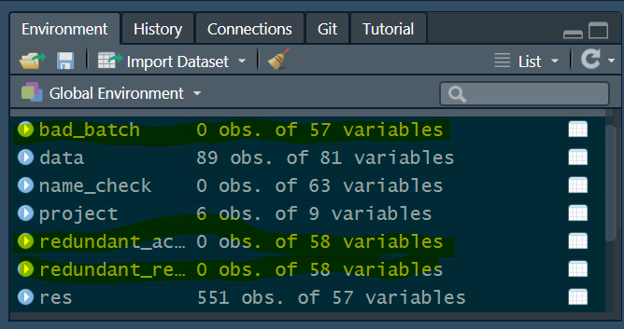

1. Run line 34 to auto assign a DQL based on the duplicate samples – you may get some warning messages - see below – these are fine.

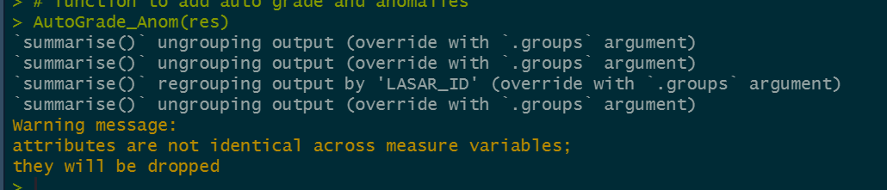

1. Run line 36 to generate data summaries and plots used in the manual review process – you may get some warning messages - see below – these are fine. Plots and summaries will be saved in the Rgrab working folder you created in. Check out the files and see if anything looks odd.

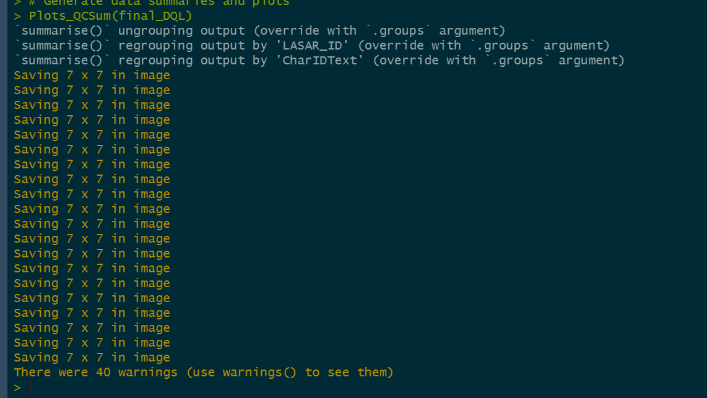

1. Run line 38 to create and review the database tables
   1. ActGroup (Activity Group) – typically a sample day (can incorporate multiple stations)
   2. Act (Activity) – DateTime/Station/type combo (individual sample or group of field measurements)
   3. Res_t (Results) - DateTime/Station/type/charid combo (individual sample or group of field measurements for each parameter sampled)
   4. Anom – flags results that are outside of expected ranges and should be manually reviewed
      1. OutOfRange
      2. BelowLOQ
      3. Lowest1%AmbientValues
      4. Highest99%AmbientValues
      5. Lowest5%AmbientValues
      6. Highest95%AmbientValues
      7. ViolatesWQStandard
      8. ViolatesLessProtectiveWQStandard
      9. Lowest5%SubmValues
      10. Highest95%SubmValues
      11. Lowest10%SubmValues
      12. Highest90%SubmValues
      13. Lowest5%SubmStnValues
      14. Highest95%SubmStnValues
2. Run line 41 this saves the R environment so if needed the person running step 2 and 3 can start from there
3. Open **Step2-VolMon_Uploads.R** –run each section line by line carefully to append to the database tables
4. **Step3-AWQMS_Uploads.R** -