Analysis of dissolved oxygen dynamics on the Siletz River, Oregon

Ryan Shojinaga, Water Quality Analyst, Watershed Management Section, Environmental Solutions Division

April 2018

# Abstract

The middle reach of the Siletz River with the Siletz-Yaquina subbasin (USGS HUC8 17100204) in the Oregon Mid-Coast region has been included on the ODEQ 2012 303(d) Category 5 list as water quality limited for dissolved oxygen (DO). The listing, which occurs from September 1 to June 15, relates to the beneficial use of salmonid spawning with a standard of 11.0 milligrams per liter (mg/L) or 95% saturation.

To verify this listing and to investigate potential causes for violations of the water quality standard, the Oregon Department of Environmental Quality (DEQ) conducted detailed monitoring in September of 2017. DEQ conducted water quality monitoring during this period because historical data suggest that DO standard violations are most likely to occur during this time of year. Additionally, DEQ collected data during low-flow conditions (July) outside of the spawning period based on consultation with local stakeholders. DEQ collected data at three monitoring sites over a 43 km reach. Parameters analyzed for include:

* Continuous readings at 15-minute intervals of DO, temperature, pH, specific conductivity, and turbidity;
* Grab sample data (twice daily for 3 – 5 days) of biological oxygen demand (BOD), nutrients (total nitrogen and phosphorus, ammonium, nitrate, soluble reactive phosphate, total organic carbon), and suspended solids.
* Field measurements using hand-held water quality probes, including temperature, specific conductivity, pH, turbidity, and DO; and
* Additionally, DEQ collected flow data and channel dimensions during the sampling period.

Across the entire monitoring, DO concentrations and saturation rose above the spawning criteria (11.0 mg/L or 95% saturation) at the three upstream sites in the two days prior to the first of two major fall storm events. Following the first storm event, DO concentrations remained 0.5-1.0 mg/L below the spawning criteria of 11.0 mg/L at all but the most upstream monitoring site. DO levels were lowest during the highest flow events during the monitoring period.

Based on correlations of field parameters (e.g., temperature and specific conductivity) and nutrients (e.g., nitrate and phosphate) with stream flow suggests that storm flows flushed shallow, well oxygenated groundwater into the XXXXXXXX. With highly oxygenated water (>9.5 mg/L of DO) flushed through stream sediments, we believe the intergravel DO standard of 8.0 mg/L was met during the high flow events; thus the surface water standard of 9.0 mg/L of DO applies during these flow conditions. The TMDL for DO spawning criteria should thus focus on conditions that reflect base flow conditions before the start of storm flow events in the XXXXXXXX.

# Introduction

The Siletz River is a small coastal watershed that drains into the Pacific Ocean on Oregon’s Mid-Coast region. The contributing watershed is within the Siletz-Yaquina subbasin hydrologic unit (HU) with a hydrologic unit code (HUC) 17100204. The contributing area for the Siletz River is comprised of four watersheds: The Lower Siletz River (HUC10 1710020407), Middle Siletz (1710020405), Upper Siletz (1710020404), and Rock Creek (1710020406).

The Siletz River and its tributaries provide crucial habitat to Chum, Coho, Pacific Lamprey, Steelhead, and Chinook salmon. Chinook salmon are present in the watershed in both fall and spring, and steelhead in both winter and summer. Other additional beneficial uses include public and private water supply, aquatic life habitat, fishing and harvesting, recreation, and aesthetics.

With regard to the beneficial use of fish and aquatic habitat, The Siletz River is listed on the ODEQ 2012 303(d) Category 5 list as water quality limited for DO[1]. The Siletz River reach from river miles (RM) 21.6 to 65.3 is listed for violating the spawning season DO criteria of 11 mg/L or 95% saturation[2] (Figure 1) from September 1 to June 15. The Siletz River and many of the contributing tributaries are also designated as cold-water aquatic life outside of the spawning season. The basic DO standard for supporting cold-water aquatic species is 8 mg/L or 90% saturation. The violations of the DO criteria observed on the Siletz River in the past impact the state-designated beneficial uses of salmon and steelhead spawning and cold-water aquatic life.

To address the 2012 303(d) Category listing, DEQ has engaged in the process of developing a TMDL for DO to assist in the management of the Siletz River as a resource for the aforementioned beneficial uses. Ultimately, the TMDL will attempt to quantify all of the contributing factors affecting DO in the Siletz River and determine appropriate load and wasteload allocations of those factors where possible. As part of that process, DEQ conducted water quality monitoring on the Siletz River and issued a call for voluntary data from the local stakeholders.

During the summer of 2017, DEQ collected two “seasons” of data representative of (1) cold-water aquatic life (June 16 – Aug 31) and (2) salmonid spawning habitat (Sept 1 – June 15). The Lincoln County Soil and Water Conservation District (LSWCD) contributed time and resources to collect and submit to DEQ voluntary monitoring data in addition to the data collected by DEQ. The LSWCD data consists of nearly 3 months of continuous DO and temperature data collected at 12 sites along the 303(d) listed reach, including the characterization of upstream and downstream boundary conditions.

This report presents a thorough examination of the data collected in the summer and fall of 2017 to ascertain the level of DO impairment, if any, with respect to the applicable criteria. DEQ will use the data and analysis from this study as a first step in developing the TMDL. Additionally, it is DEQ’s intent the data in analysis presented herein can be used in the interim to address concerns from the Siletz River community.

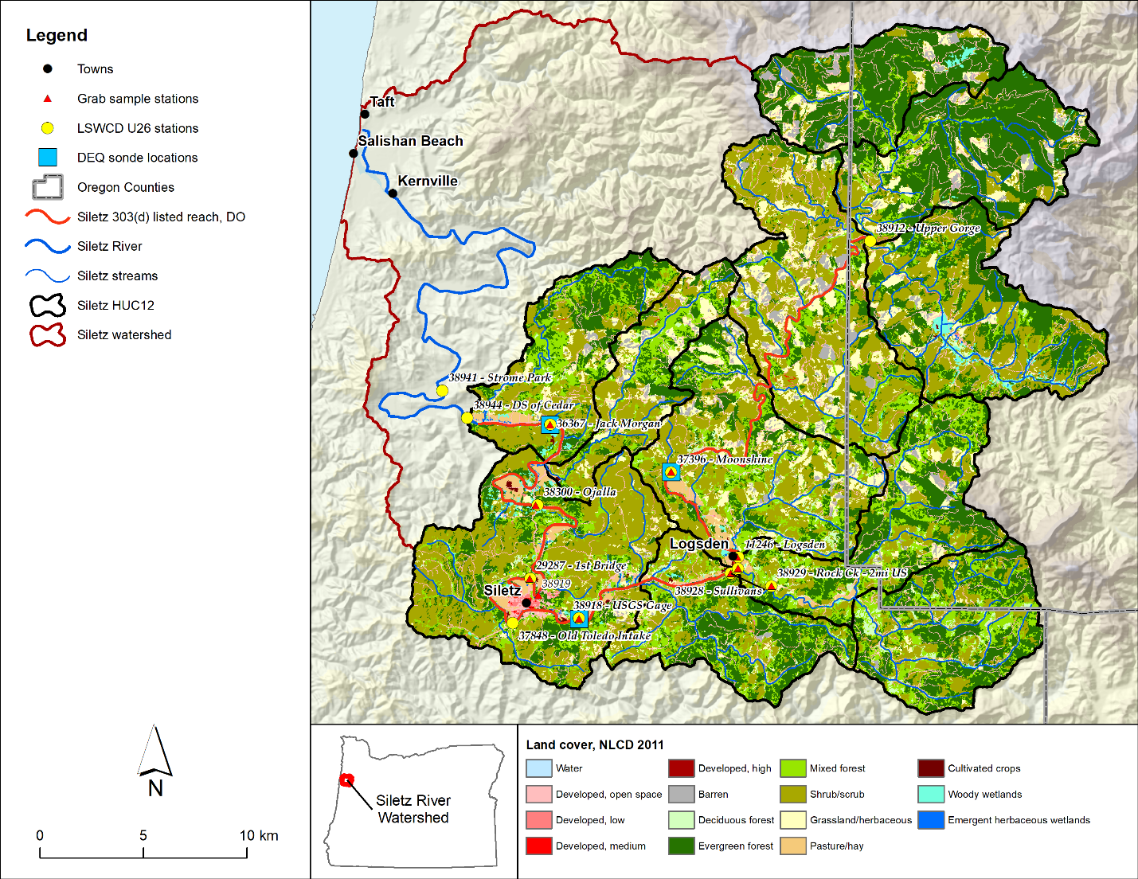

Figure 1. The Siletz watershed, land cover and field monitoring sites

# Study Area

This section presents a summary of the Siletz River watershed and predominant landscape and human factors that impact water quality in the River and its tributaries. These factors generally include physical characteristics, hydrology, climate, hydrodynamics, geology, land cover and vegetation; some consideration in this section is given to anthropogenic factors such as land use, forestry, livestock, and water use. The discussion presented herein will form that primary basis of information for the subsequent discussion of water quality in Sections 4 and 5.

## Physical Characteristics

The Siletz River watershed is 955 square kilometers (km2) located in primarily in Lincoln County, Oregon, with smaller portions of the eastern watershed in Polk County. The area of the watershed upstream of the listed reach is 685 km2 (Figure 1). The reference point established within this report is from where the Siletz Bay estuary ends, approximately 4 km from the Pacific at Highway 101 in Kernville. This established reference point is at RM 0.0 for the Siletz River. The beginning of the 303(d) listed reach begins at approximately RM 34 relative to the beginning of the Siletz River.

Watershed elevations range from near mean sea level (MSL) to 1080 m above MSL.

## Estuary and River Transitions

In addition to the Siletz Bay/River transition, there are two other natural transitions related to estuary/ river interfaces that form significant boundaries: estuary/freshwater boundary and the head of tide.

The boundary between estuary and the freshwater reach is nominally the upstream-most extents of salt intrusion. The Draft Methodology for Oregon’s 2018 Water Quality Report and List of Water Quality Limited Waters (DEQ 2018) uses the Coastal and Marine Ecological Classification Standard (CMECS; FGDC 2012) to define the limits of the estuaries along the Oregon Coast. The CMECS boundary for the Siletz River occurs at approximately RM 19.7. The head of tide is farthest point upstream in a river that is controlled, in some part, by tidal fluctuations (Davis and Dalrymple 2011). This boundary occurs at the downstream locations of the 303(d) listing, RM 21.6 (Oregon Coastal Atlas 2018). These boundaries are important in defining where the dissolve oxygen criteria are applied. See Section 4.4.1 for more detail.

## Climate and Hydrology

The Siletz River catchment is nominally within the warm, dry summer (Csb) and cool summer (Csc) Mediterranean Köppen-Geiger classification system depending on elevation (Kottek et al. 2006). Based on conditions from the previous three decades (1980 – 2010), mean annual precipitation within the watershed ranges from 1740 mm in the lowlands (south and west) to 4070 mm in the mountainous terrain (north and east) (Di Luzio et al. 2007). Mean annual temperatures vary within the Siletz River watershed. The mean annual minimum temperatures range from 40°C in the northeast corner to 45°C in the northwest corner. The mean annual maximum temperatures range from 55°C in the northeast corner to 62°C in the southeast corner of the watershed (Di Luzio et al. 2007).

Flow data within the watershed are currently recorded at two sites: (1) the USGS flow gage 14305530 at Siletz, Oregon (US Geologic Survey 2018) and (2) the OWRD flow gage 14304350 on Sunshine Creek (Oregon Water Resources Department 2018). The USGS gage corresponds to DEQ sampling station 38918 (Figure 1). Figure 2 provides a sample of flows recorded at the USGS gage from July to November 2017, with concurrent monitoring campaigns.

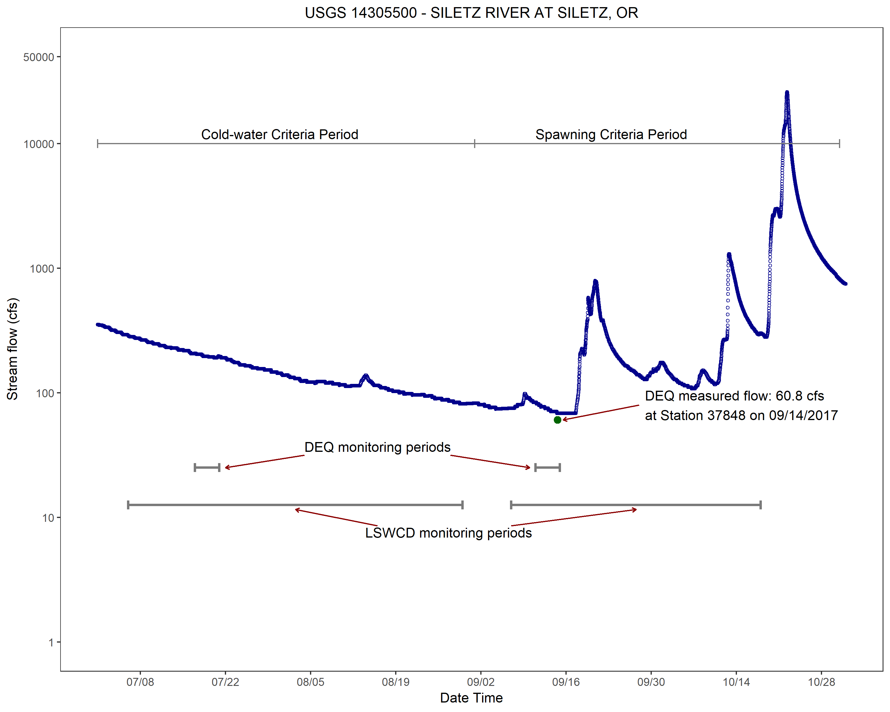

Figure 2. Flow data at USGS gage 14305530, including monitoring periods and DEQ measured flow on 09/14/2017

## Geophysical Settings

Siletz River Volcanics Formation (basalt) dominates the northern portion of the watershed, forming much of the mountains and higher elevations, while the Tyee Formation (marine sandstone and carbonaceous siltstone) dominates the southern portion of the watershed (Walker and Duncan, 1989).

Soils in the watershed vary significantly in terms of soil types, with the Tolovana-Reedsport complex, Preacher-Bohannon-Slickrock complex, and Formader-Klistan-Hemcross complex comprising 28 percent of the total soils within the watershed (US Department of Agriculture 2016). Overall, there are 67 different soils classifications. The predominant hydrologic soils consist of group B soils (62 percent) and C soils (27 percent). These soils are generally classified as well-drained.

## Land Cover

Land cover varies significantly within the watershed, particularly with respect to elevation and distance upstream. Forests and regenerating forest areas predominating in upland areas while rural residential, paved roads, and agricultural land are more prevalent in lowland areas, particularly along the middle and lower reaches of the Siletz River. Table 1 presents the total area and percent of total area for the watershed of the 303(d) listed reach (MLRC 2017).

Hay/pasture and cultivated cropland area made up only a small fraction of land cover in the watershed (1.3 percent combined), however, more than 93 per cent of the area comprised by these classes were clustered within 1 kilometer of the mainstem of the river. Remaining land cover classes that made up small fractions of watershed cover included open water, barren land, woody wetland, and emergent herbaceous wetlands.

Table 1. Siletz River land cover data, 2011

## Agriculture and Rural Runoff

Rural land management has the potential to impact water quality in the Siletz River and tributaries through runoff of nutrients and sediment that become mobilized in storm events or leaching from the surface into shallow alluvial aquifers and discharging to surface water via subsurface pathways.

Livestock present in the Siletz River watershed primarily include beef cattle, dairy cows, and horses. Cattle and dairy cows are likely to be significant sources of organic matter and nutrients to the watershed. Because of the topography, most livestock operations group near the mainstem river with access to the channel (personal observation).

Other rural impacts to surface water quality within the watershed could include runoff from rural residential lands and septic leakage and runoff during and after timber harvest. The former is likely to occur downstream of RM 51.1 at Moonshine Park where the watershed contains from predominantly forestry to more mixed land use including rural residential.

## Waste Management

One NPDES permitted point source, the Siletz Sewage Treatment Plant (STP), discharges to the Siletz River at RM 38.1. The STP is classified as Minor Domestic using a sequencing batch reactor and has an average dry weather design flow (ADWF) of 0.157 million gallons per day (MGD). The Siletz STP has permit limits for carbonaceous oxygen demand (CBOD), total suspended solids (TSS), pH, *Escherichia coli* (*E. coli*), and removal efficiency for CBOD and TSS.

Biosolids application occurs within the Siletz River watershed, particularly on pasture and cultivated crop areas. Class B biosolids are tracked from creation (at STPs) to destination (land application), however Class A biosolids may be applied without reporting location, rates and times. Currently this issue is being investigated in more depth and will be the subject of subsequent analysis (including the TMDL), and are not reported on at this time.

There is a historical landfill site near Moonshine Park. The Logsden Transfer Station was decommissioned in January 2016. We will investigate the landfills potential to impact Siletz River dissolved oxygen with more detail provided in subsequent analysis.

## Water Rights

In the contributing Siletz watershed encompassing the 303(d) listed reach, there are 668 water rights for surface water diversion or storage. There are no water rights for groundwater appropriation. Included in the diversions and storages, the Cities of Siletz, Newport, and Toledo, as well as Georgia-Pacific withdraw water within the vicinity of the City of Siletz for a total permitted diversion rate of 14.4 cfs. There are 11 water rights for livestock and 56 diversions for irrigation.

The Oregon Water Resources Department has multiple in-stream water rights in the Siletz and its tributaries for aquatic and salmonid habitat. Water diversions will be a component of the analysis and TMDL development moving forward.

# Methods

This section describes the methods used to collect and analyze data on the Middle Reach of the Siletz River. The monitoring and analysis were conducted with the intention of determining if and to what level the listed reach is water quality impaired for dissolved oxygen.

## DEQ Monitoring

The focus of the DEQ monitoring program on the Siletz River was to capture diel dissolved oxygen dynamics and variation during critical periods and at key locations within the listed reach of the Siletz River. Collection of the data generally corresponded with the critical periods during both the cold-water and spawning periods. Those periods are shown in Figure 2 and Table 2.

DEQ deployed YSI multiparameter sondes[3] to collect data at three sites between Moonshine Park and Jack Morgan Boat Ramp (see Figure 1). These sites are as follows:

* 36367 – Siletz River at Jack Morgan Park at RM 23.7. This site characterizes the lower section of the listed reach in terms of the DEQ data.
* 38918 – Siletz River at the USGS flow gage 14305500 at RM 41.3. This site is upstream of the town of Siletz.
* 37396 – Siletz River at Moonshine County Park at RM 51.1. This site is immediately downstream of the boundary of areas of forest management.

The sondes collected DO concentration in milligrams per liter (mg/L) as well as continuous supporting chemistry data including temperature, pH, specific conductivity and turbidity. DO as a percent of saturation was calculated using the DO concentration, temperature, atmospheric pressure at each site.

To understand the possible factors affecting DO dynamics, grab samples were collected twice daily (morning and afternoon) on three consecutive days during each critical period. DEQ collected water samples at nine sites (See Figure 1). The objective was to characterize diel variation in water quality parameters that have the potential to influence DO concentrations (Pelletier, et al., 2006). Grab sample data included: ammonia (NH3-N), nitrate/nitrite (NO3-N)[4], total Kjeldahl nitrogen (TKN), total phosphorus (TP), orthophosphate (SRP), 5-day Carbonaceous Biological Oxygen Demand (CBOD), total suspended solids (TSS), and total organic carbon (TOC).

## Volunteer Monitoring

As part of the call for data process in support of the Siletz TMDL development process, the Lincoln County Soil and Water Conservation District (LSWCD) implemented a monitoring program to collect continuous DO data for a longer period of time and at more sites than what DEQ collected. The periods for data collection are shown in in Figure 2 and Table 2.

The LSWCD monitoring program, while longer in deployment, was focused only on collection of continuous DO and temperature data. The LSWCD monitoring program involved deployment of 13 U26 DO data loggers[5], including 2 sites on Rock Creek. Figure 1 presents the locations of the U26 sites. These sites are described as follows:

* 38941 - Siletz River at Strome Park at RM 16.3. This site is located outside of the listed reach and within the estuary defined by the CMECS data. This site has been included for information within this report, but is not included in the analysis and will not be used in the development of the TMDL.
* 38944 – Siletz River downstream of the Cedar Creek confluence at RM 21.1. Only a brief period of data were collected at this site. This site will be used to characterize the downstream boundary conditions of the TMDL modeling.
* 36367 – Siletz River at Jack Morgan Park. Same as the DEQ site.
* 38300 – Siletz River at the Ojalla Boat Ramp at RM 29.8. Two full periods of data were collected at this site.
* 29287 – Siletz River at the first bridge north of the town of Siletz. The U26 logger was lost during the spawning period deployment, hence only one season of LSWCD data exists at this site.
* 37848 – Siletz River at the old Toledo water intake at RM 38.9. DO and temperature data were collected during the cold-water period but could not be incorporated into the analysis due to unacceptable quality resulting from instrument biofouling. Only the spawning season data are valid for use.
* 38918 – Siletz River at the USGS Gage. Same as the DEQ site.
* 38928 – Siletz River downstream of the Rock Creek confluence at RM 46.6. LSWCD collected data for two full periods at this site.
* 11246 – Siletz River at the Logsden Bridge at RM 47.2. LSWCD collected data for two full periods at this site.
* 37396 – Siletz River at Moonshine County Park. Same as the DEQ site
* 38912 – Siletz River in the Upper Gorge at RM 65.3. This site is at the upstream boundary of the listed reach for DO. The data collected at this site will be used to inform the boundary conditions of the TMDL modeling.
* 38930 – Rock Creek upstream of the confluence with the Siletz River, RM 0. This site represents a large tributary inflow to the Siletz River and will be used to calibrate and characterize lateral inflows to the TMDL model. LSWCD collected data during the spawning period only.
* 38929 – Rock Creek 2 miles upstream. Similar to the Rock Creek confluence site, but data collected for the cold-water period. These data will be used to calibrate and characterize lateral inflows to the TMDL model.

Table 2. Mid Siletz monitoring activities in 2017

|  |  |  |
| --- | --- | --- |
| **Period** | **Cold-water** | **Spawning** |
| Regulatory Timeframe | 06/16 - 08/31 | 09/01 - 06/15 |
| DEQ Monitoring | 07/17/2017 - 07/20/2017 | 09/11/2017 - 09/14/2017 |
| LSWCD Monitoring | 07/17/2017 - 07/20/2017 | 07/17/2017 - 07/20/2017 |

## Quality Assurance

All data collection, sampling procedures, and chemical analyses, including the LSWCD data, were conducted in accordance with the LAB Data Validation and Qualification manual (DEQ 2017). Only data with “A” and “B” grades were included for data analysis.

## Data Analysis

### DO Criteria

The main method of analyzing the data to determine if the Siletz River is water quality impaired is to compare the relevant data to the applicable water quality criteria. The water quality criteria are established based on the beneficial uses of the water body. For the Siletz River and with regard to DO, the beneficial uses are salmonid spawning from September 1 to June 15, and core cold water habitat from June 16 to August 31.The full set of criteria associated with dissolved oxygen are in Oregon Administrative Rules (OAR) 340-041-0016, and summarized as follows:

1. For water bodies identified as active spawning areas…the following criteria apply:
   1. The dissolved oxygen may not be less than 11.0 mg/l measured as seven-day mean minimum[6]. However, if the minimum intergravel dissolved oxygen, measured as a spatial median, is 8.0 mg/l or greater, then the DO criteria is 9.0 mg/l;
   2. Where conditions of barometric pressure, altitude, and temperature preclude attainment of the 11.0 mg/l or 9.0 mg/l criteria, dissolved oxygen levels must not be less than 95 percent of saturation;
   3. The spatial median intergravel dissolved oxygen concentration must not fall below 8.0 mg/l.
2. For water bodies identified by the Department as providing cold-water aquatic life, the dissolved oxygen may not be less than 8.0 mg/l as an absolute minimum. Where conditions of barometric pressure, altitude, and temperature preclude attainment of the 8.0 mg/l, dissolved oxygen may not be less than 90 percent of saturation. At the discretion of the Department, when the Department determines that adequate information exists, the dissolved oxygen may not fall below 8.0 mg/l as a 30-day mean minimum[7], 6.5 mg/l as a seven-day minimum mean[8], and may not fall below 6.0 mg/l as an absolute minimum;

The metrics of evaluating compliance with the criteria are to assess weekly or monthly averages of daily statistical values (e.g., mean or min).

Additionally, while temperature analysis is not an explicit objective of this report, its impact on dissolved oxygen concentrations and saturations is significant. Indeed, the caveat in the DO criteria accounts for conditions where temperature and atmospheric pressure preclude the attainment of the numeric DO concentration. As such we assessed the available temperature data against the applicable criteria to determine if DO saturation is the applicable instead of DO concentration. The applicable temperature criteria are given OAR 340-041-0028, paraphrased as follows:

* The seven-day-average maximum[9] temperature of a stream identified as having salmon and steelhead spawning use may not exceed 13°C; and
* The seven-day-average maximum temperature of a stream identified as having core cold water habitat use may not exceed 16°C.

### Data Analysis

While the DO criteria for the Mid Siletz outlines the numeric or statistical criteria, we will first present the data descriptively to understand the dynamics of DO more holistically. To this end, we will present the following graphical analysis of the DEQ and LSWCD data:

* Time series of the DEQ sonde data at the three sites. The DEQ time series are plots of the sonde data collected as a function of time. These plots show the diurnal variation of each parameter, and provide some understanding of the seasonal variation of each parameter.
* DEQ Grab sample data multiple sites for both cold-water and spawning. We attempted to collect two samples at the grab sample sites in order to show the potential diurnal fluctuation of each parameter. The data also demonstrate seasonal variations as shown in the comparison of the two monitoring periods.
* Time series of the LSWCD U26 data at the 12 sites. The data collected for DO and temperature are long enough with these data sets to facilitate the statistical analysis required in Section 4.4.1 for each period.
* Box plots of the LSWCD as a function of the longitudinal distance from the start of the river. Given the spatial and temporal extents of the LSWCD data, we have plotted the DO and temperature data as a function of river mile.

Following the presentation of the abovementioned data, we calculated the descriptive statistics on each time series based on the applicable portion of the criteria outlined in Section 4.4.1. That is we calculated the following statistics the cold-water and spawning periods:

* DO during cold-water period
  + 30-day mean minimum DO concentration – the 30 consecutive-day floating averages of the calculated daily mean dissolved oxygen concentration
  + Seven-day mean minimum – the minimum of the seven consecutive-day floating average of the calculated daily mean dissolved oxygen concentration.
  + Seven-day minimum mean – the minimum of the seven consecutive-day floating average of the daily minimum concentration. For application of the criteria, this value is the reference for diurnal minimums
  + 30-day mean minimum DO saturation – the 30 consecutive-day floating averages of the calculated daily mean dissolved oxygen saturation
* DO during salmonid spawning
  + 7-day mean minimum concentration – the 7 consecutive-day floating averages of the calculated daily mean dissolved oxygen concentration
  + 7-day mean minimum saturation – the 7 consecutive-day floating averages of the calculated daily mean dissolved oxygen saturation
* Temperature for both cold-water and spawning – 7-day average daily maximum temperatures
* For the DO saturation calculations the assumed maximum percent saturation is 100 percent. That is, DO concentration and saturation measurements used in the daily mean calculations that were in excess of 100%, were valued at the saturation (100%) concentration as per OAR 340-041-0002(15).

Finally, we make a comparison of the DEQ and LSWCD data for the concurrent periods and common parameters with both graphic analysis and student’s t-tests.

# Results

## DEQ Continuous Data

Figure 3 shows the time series plots of the continuous DO data collected by DEQ. In examination of the data, the general details of the data show:

* For DO, the typical range of concentrations during the cold-water period was 8.4 to 10.6 mg/L and the range during the spawning period 8.5 to 11.0 mg/L. Moonshine demonstrated the smallest range of diurnal variation, and Jack Morgan Park (36367) the greatest. The daily maxima typically occurred from 1 P.M. to 6 P.M., with Moonshine Park (37396) peaking earliest and Jack Morgan Park (36367) latest. Daily minimum concentrations typically occurred between 10pm to 6am, again Moonshine Park (37396) dipping the earliest. The data for Jack Morgan Park (36367) and the USGS Gage (38918) mimic each other closely in diurnal variation, range and time of maxima and minima. This is likely due to similarities in landscape and channel slope.
* For DO Saturation, the typical diurnal range during the cold-water period was from 91 to 120 percent saturated, and during the Spawn period from 90 to 122 percent saturation. Otherwise, DO saturation data demonstrated similar time-series behavior to that of the DO concentrations.
* For temperature, the typical diurnal range during the cold-water period was from 15 to 23°C, and during the spawning period 15 to 21°C. Moonshine Park (37396) showed the greatest diurnal swing, with a mean of 4.3°C per day during the cold-water period. The USGS Gage (38918) showed the greatest diurnal swing during the spawning period with a mean of 2.44°C per day. Jack Morgan Park (36367) demonstrated the hottest water temperatures on average, then USGS Gage (38918), and Moonshine Park (37396) demonstrating the coolest water temperatures. This could be possibly linked to a combination of factors including effective shading, geomorphology and channel slope.
* Specific conductance and turbidity did not demonstrate any particular diel fluctuation, which is typical with of parameters less affected by variations in atmospheric or water temperature.

A minor storm event in the morning of 07/20/2017 (NCDC 2018) is likely the cause of rapid changes in water physicochemical characteristics toward the end of the monitoring periods during the cold-water period.

The graphs include the water quality criteria for applicable periods, however because the standards generally require comparison with calculated values (e.g., 30-day mean minimum), and because those statistics have not been calculated for these data, we have not commented on the data relative to the criteria in this section.

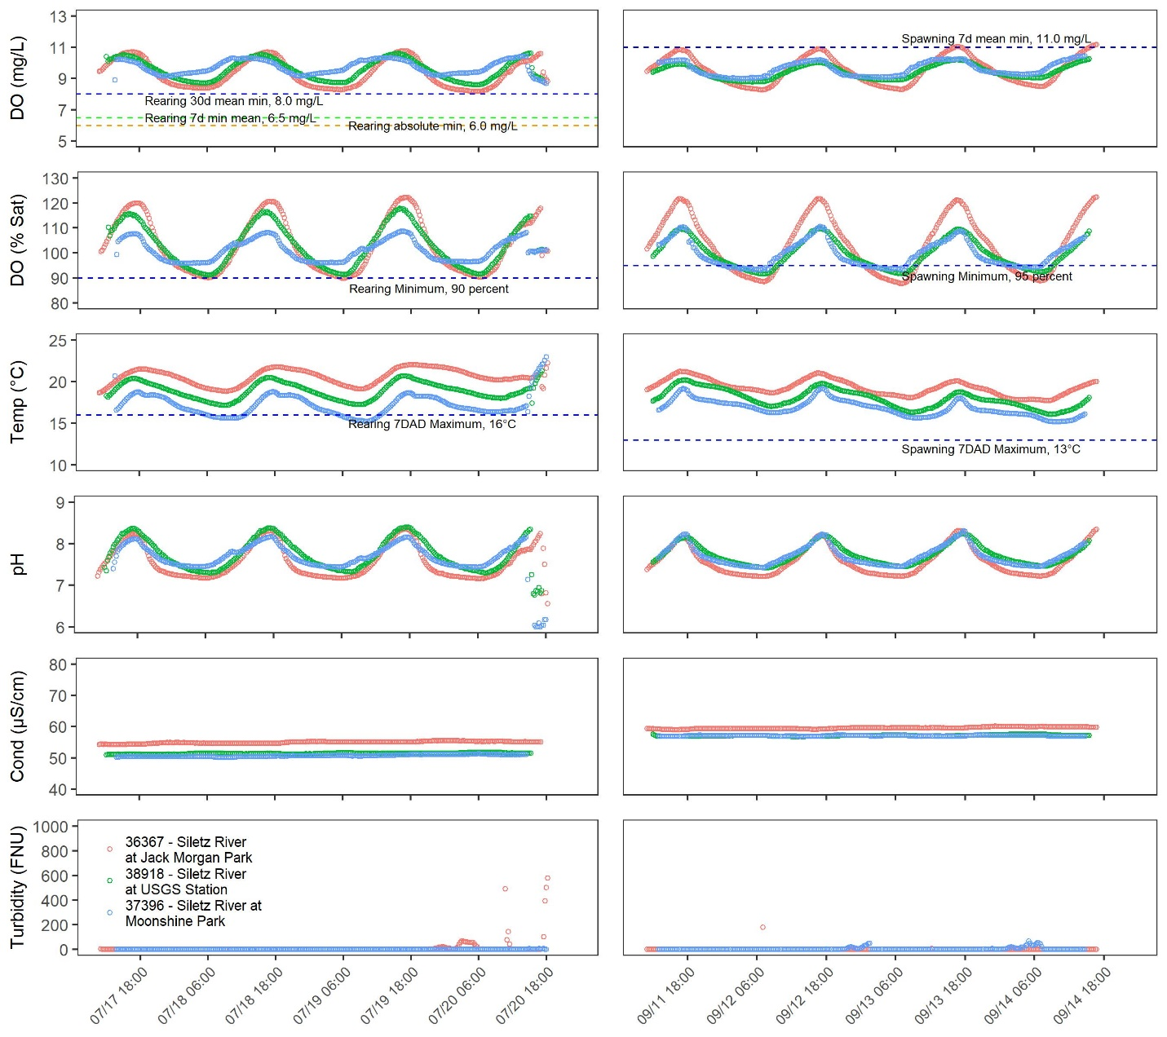

Figure 3. Continuous DEQ sonde data cold-water (left panels) and spawning (right panels)

## DEQ Grab Sample Data

This section discusses the grab sample analysis of water quality from selected sites during the cold-water and spawning monitoring periods. For display purposes the 8 constituents were divided into two sets and presented in two figures. The first figure () shows cold-water and spawning period data for total Kjeldahl nitrogen (TKN), ammonia (NH3-N), nitrate/nitrite (NO3-N), and 5-day Carbonaceous Biological Oxygen Demand (CBOD). The second figure (Figure 5) shows cold-water and spawning period data for orthophosphate (PO4), total phosphorus (TP), total organic carbon (TOC) and total suspended solids (TSS). Data samples not detected at the detection limits for a given parameter were assumed to be equal to half of the method detection limit (MDL). Those data are represented in the figures a circles, and detected values as triangles.

In general, the data demonstrate the following patterns and water quality characteristics:

* Nitrate, represented as combined nitrate and nitrite, is an important nutrient for production. Nitrate was detected during all sampling events at all sites during both periods. Rock Creek (demonstrated the highest concentrations during both the cold-water period (0.46 mg/L at 38928) and the spawning period (0.26 mg/L). At Moonshine Park (37396) had the lowest mean cold-water nitrate concentration at 0.12 mg/L and the highest mean spawning nitrate concentration at 0.08 mg/L. The mean spawning nitrate concentration (0.06 mg/L) for all sites (aggregated) was less than half of the mean cold-water nitrate concentration 0.17 mg/L). Nitrate concentrations in the morning were slightly higher (0.0119 mg/L) than those collected in the afternoon (0.11 mg/L).
* Orthophosphate was detected in 14 of the 45 samples (31 percent) collected with a typical method detection limit (MDL) of 0.005 mg/L. Each of the samples collected in Rock Creek (one in cold-water and one in spawning) were detected at concentrations greater than the MDL. The highest concentrations of orthophosphate was 0.009 mg/L, measured during at spawning period in Rock Creek (38930) and the first bridge (29287). Thirteen of the 14 detected samples were observed during the spawning period, with Rock Creek (38929) the only sample detected above the MDL during the cold-water period. Six of the 14 detected samples were collected at the first bridge (29287).
* Ammonia was detected in three of the 56 samples collected at concentrations greater than the MDL (0.01 mg/L). The three samples detected at concentrations greater than the MDL were collected during the spawning period, one in Rock Creek (38930) and two at Ojalla Boat Ramp (38300).
* Total Organic Carbon was detected in more than 50 percent of the samples (24 of 46 total), and of those 24, 21 were collected in the spawning period. During the spawning period, Moonshine Park demonstrated the lowest TOC in the water column with no samples detected at concentrations above the MDL. The mean concentrations for the remainder of the sites during the spawning period was 1.3 mg/L. The highest TOC concentration was observed at Jack Morgan Park (36367) at 1.57 mg/L.
* Overall, the concentrations of nutrients and sediment are low in July likely representative of baseflow conditions. Elevated concentrations during September relative to July are likely due to storm events from 09/07/2017 to 09/09/2017. Even though the flows were receding during the sampling events during the spawning period, residual runoff could have been carrying sediment and associated nutrients with it.

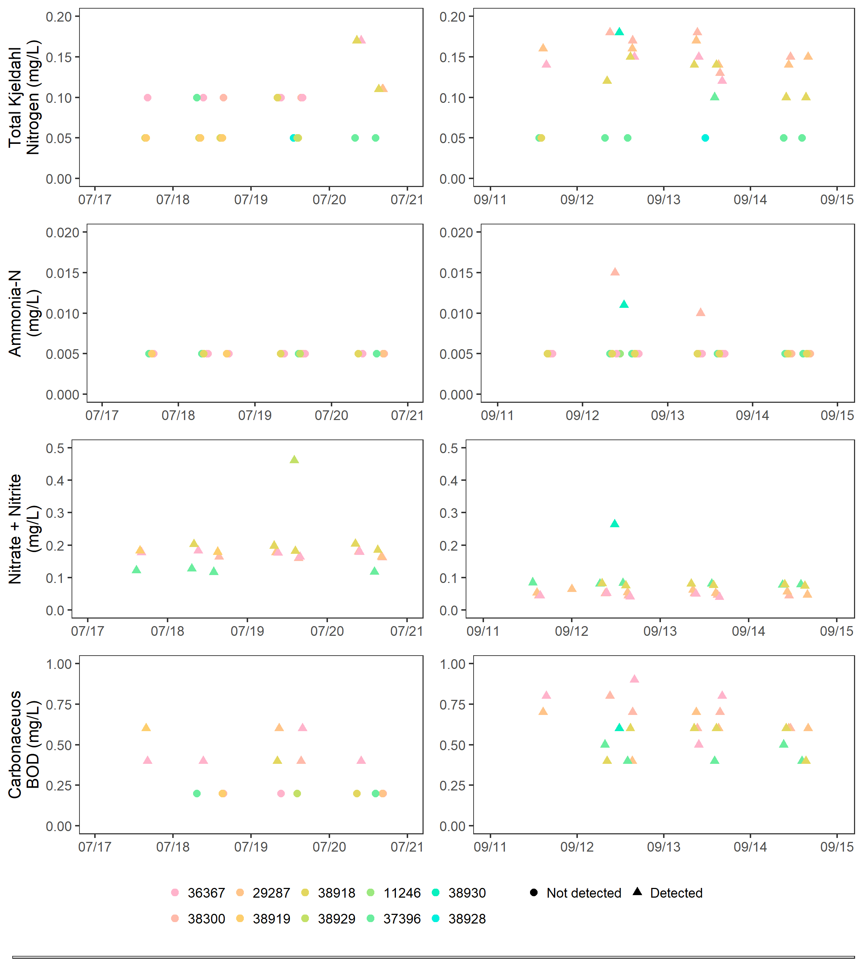

Figure 4. Water quality grab samples – constituent set 1: TKN, NH3, NO3/NO2, and CBOD

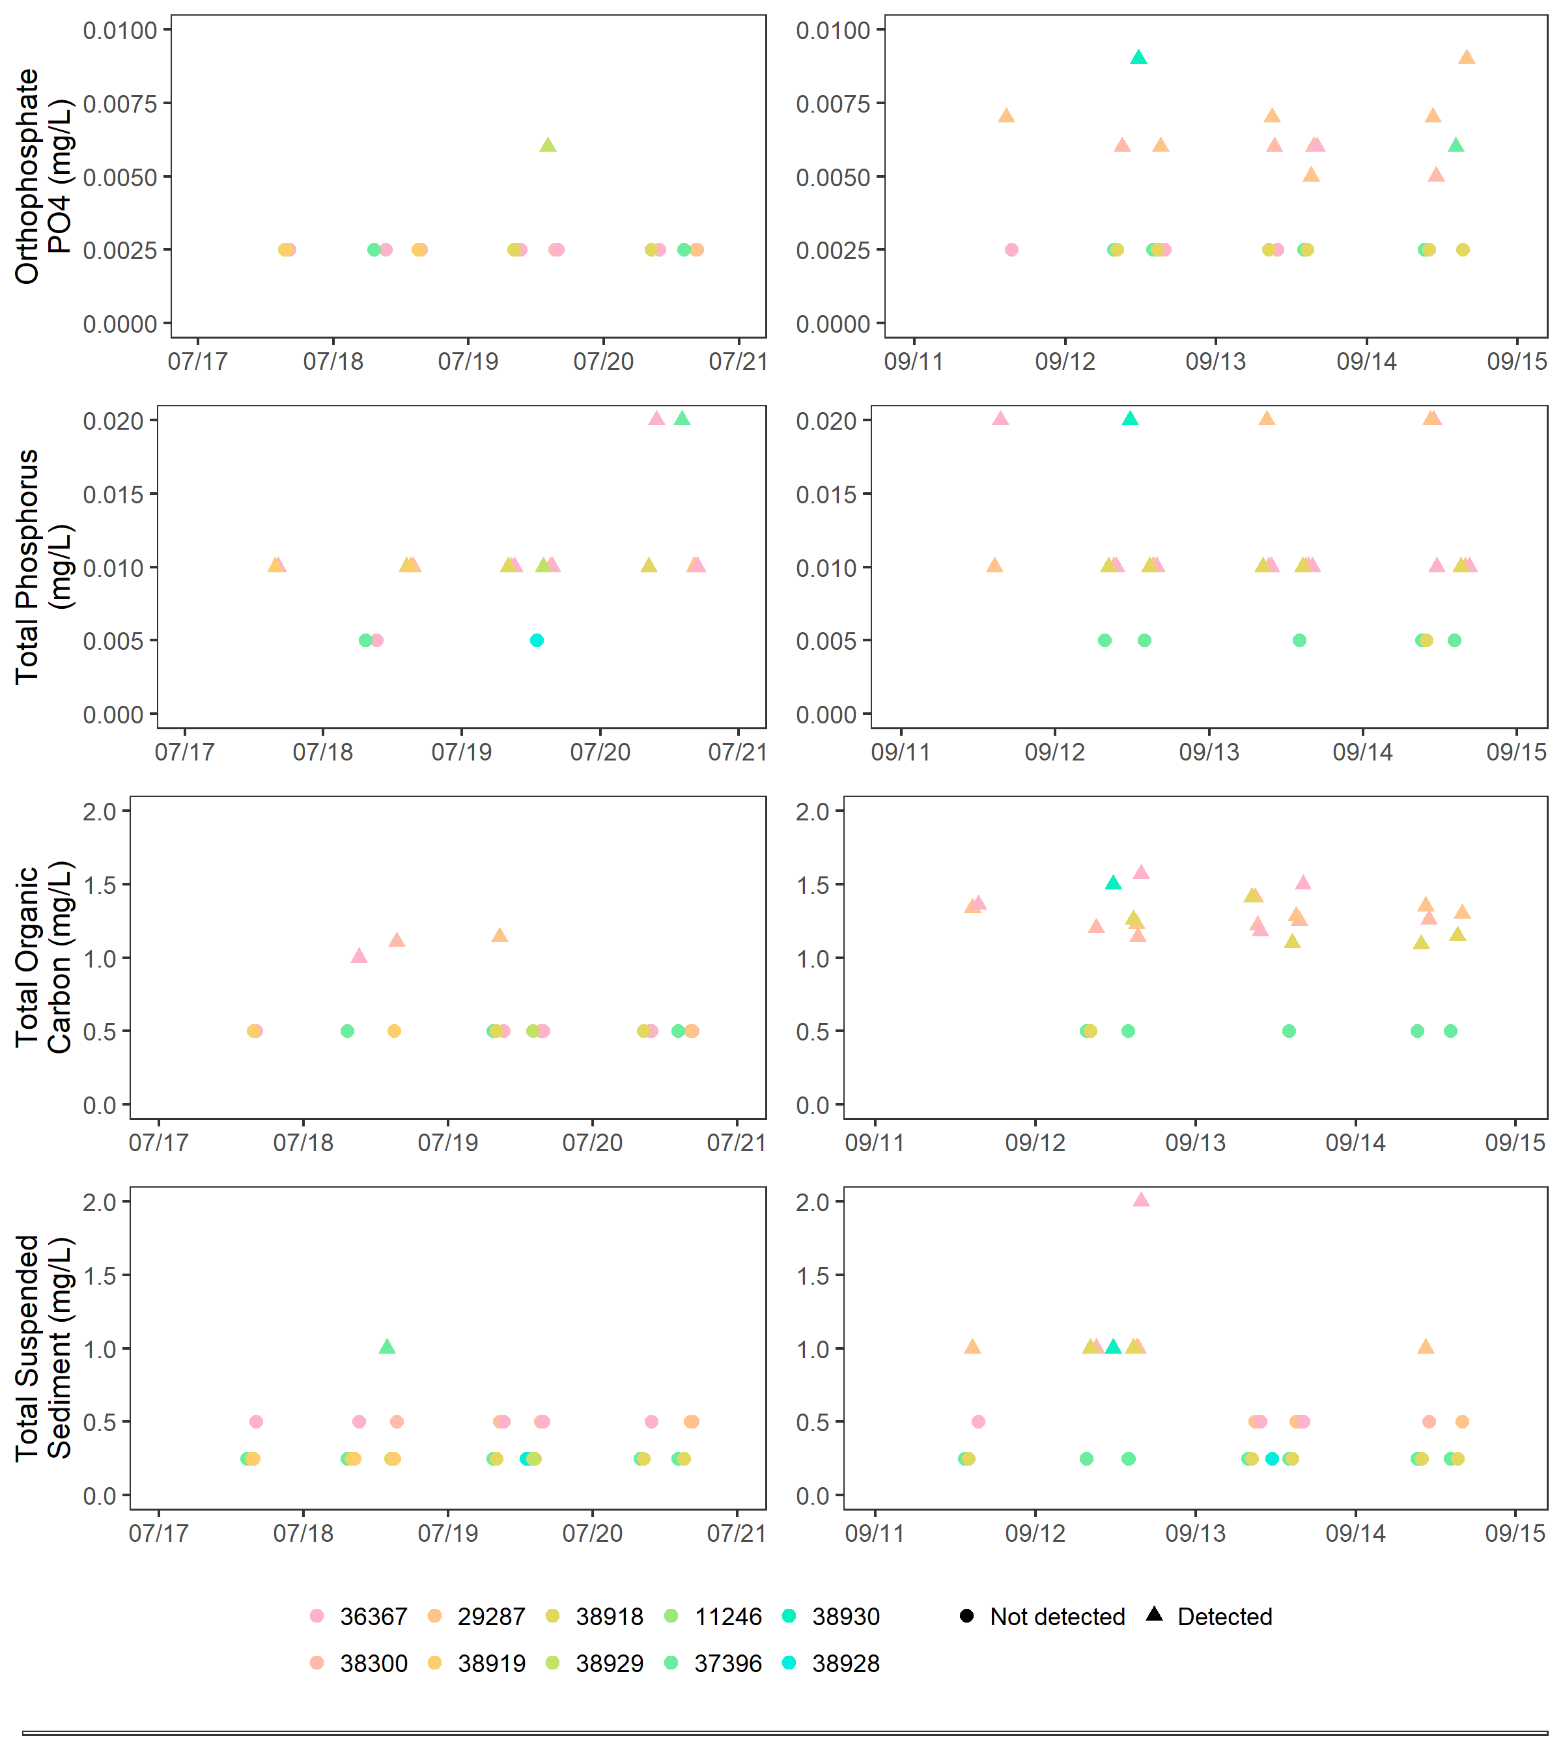

Figure 5. Water quality grab samples – constituent set 2: SPR, TP, TOC, and TSS

## LSWCD Continuous Data

This section presents the continuous DO and temperature data collected by the LSWCD. This data set will for the primary basis of the analysis and evaluation of DO relative to the standards, as well as establishing the foundation of the modeling.

### Time Series

Figure 6, Figure 7, and Figure 8 present the LSWCD continuous DO concentration, DO percent saturation and temperature respectively for both the cold-water and spawning periods. It should be noted that data were not collected for both periods for all sites. Five sites are characterized by two full periods of data: Ojalla Boat Ramp (38300), USGS gage (38919), downstream of Rock Creek (38928), Logsden (11246), and Moonshine Park (37396). The following sections discuss the key points relating to the data and parameters.

#### Cold-water Aquatic Habitat Period

During the cold-water monitoring period, two sites demonstrate periods of significant primary production during the month of August: Ojalla Boat Ramp (38300) and downstream of Rock Creek (38928). The Siletz River at the first bridge site (10391) demonstrated low DO concentrations and is the only site for which DO was recorded to be less than the absolute minimum component of the cold-water criteria of 6 mg/L. On 08/05 the DO concentration was observed to be 5.61 mg/L, and on 08/08 it was observed to be 5.99 mg/L.

The peak diel DO concentrations ranged from around 10 to 13 mg/L with a peak of 13.23 mg/L observed downstream of Rock Creek (38928). Minimum DO concentrations ranged from 7 to 8 mg/L. The site at Moonshine (37396) showed some limited production between 08/05 and 08/22. All of the sites for which cold-water period data were collected demonstrated DO concentration minima around 08/05. Typically, diel maxima DO concentrations were observed in the afternoon between 2 and 6 P.M. while minima were observed in the mornings from 5 to 11 A.M.

DO saturation patterns generally paralleled DO concentrations patterns in terms of location, variation, productivity, and deficits. The absolute maximum DO saturation was observed at downstream of Rock Creek (38928) at 147.3 percent on 08/24, and from 08/02 to 08/28, daily DO saturation maxima were greater than 120 percent and often greater than 130 percent. Minimum DO saturation was observed at the first bridge (10391) at 64.7 on 08/04.

Water temperatures during the cold-water period peaked at all sites on 08/03, with the maximum observed temperature at 26.24°C at the Ojalla Boat Ramp (38300). The minimum water temperature observed was 14.56°C at Moonshine Park (37396) on 07/21.

#### Salmonid Spawning Period

The overall trends of DO and temperature in the spawning season were inversely related: as water temperatures decreased, DO concentrations and saturations increased. Two major storm events within the watershed during this period demonstrated significant influence on temperature and DO in the Siletz River as well.

The maximum DO concentration of 12.23 mg/L observed at Moonshine Park (37396) on 10/15, and the minimum DO concentration of 8.03 mg/L was observed at Jack Morgan Park (36367) on 09/13. The maximum DO saturation of 122.7 percent observed on 09/16, and the minimum DO saturation of 85.8 percent observed on 09/13 both at Jack Morgan Park (36367). The maximum temperature of 21.4°C observed at Jack Morgan Park (36367) on 09/10, and the minimum temperature of 6.84°C was observed at the confluence (38912) on 10/15.

Two storm events occurred during the spawning period that caused significant changes in DO and temperature. Between 09/17 and 09/21, the Newport Municipal Airport meteorological station (NCDC 2018) recorded 1.96 inches of rainfall. During that time, the flow at the USGS gage station (38919) jumps from a low of 68.5 cubic feet per second (cfs) on 09/17 to a peak of 794 cfs at 6:45 P.M. 09/20. While water temperatures were generally decreasing prior to that time, the drop in average daily water was more pronounced, and the diurnal variation decreased. Corresponding DO concentrations increased at a slightly higher rate than before and the diurnal variation decreased. An increase in air temperatures immediately after that (09/25 – 09/28) resulted in increased water temperatures and lower DO concentrations.

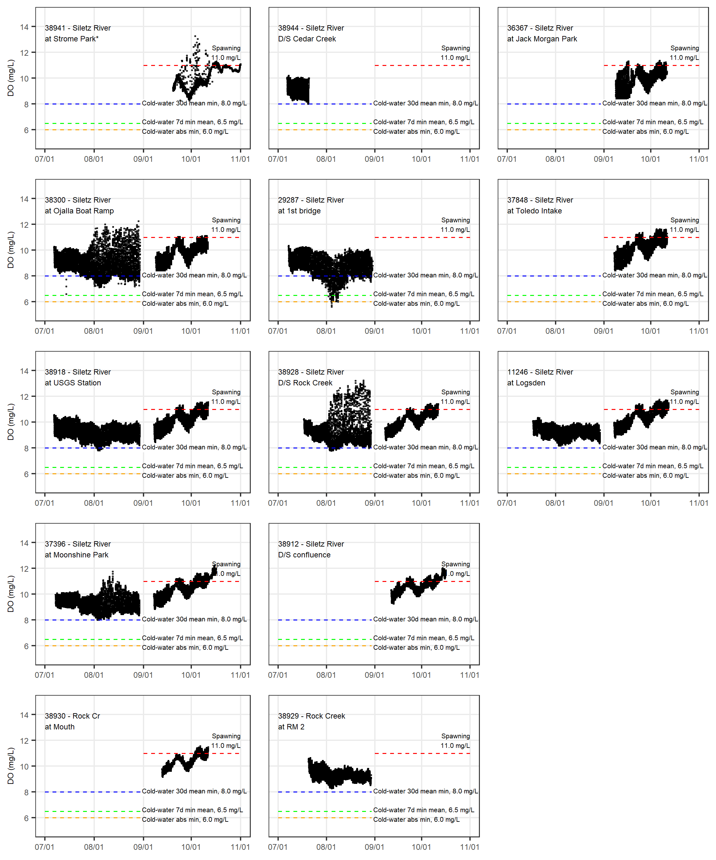

Figure 6. Continuous LSWCD U26 DO concentrations data (*Strome Park included for context only)

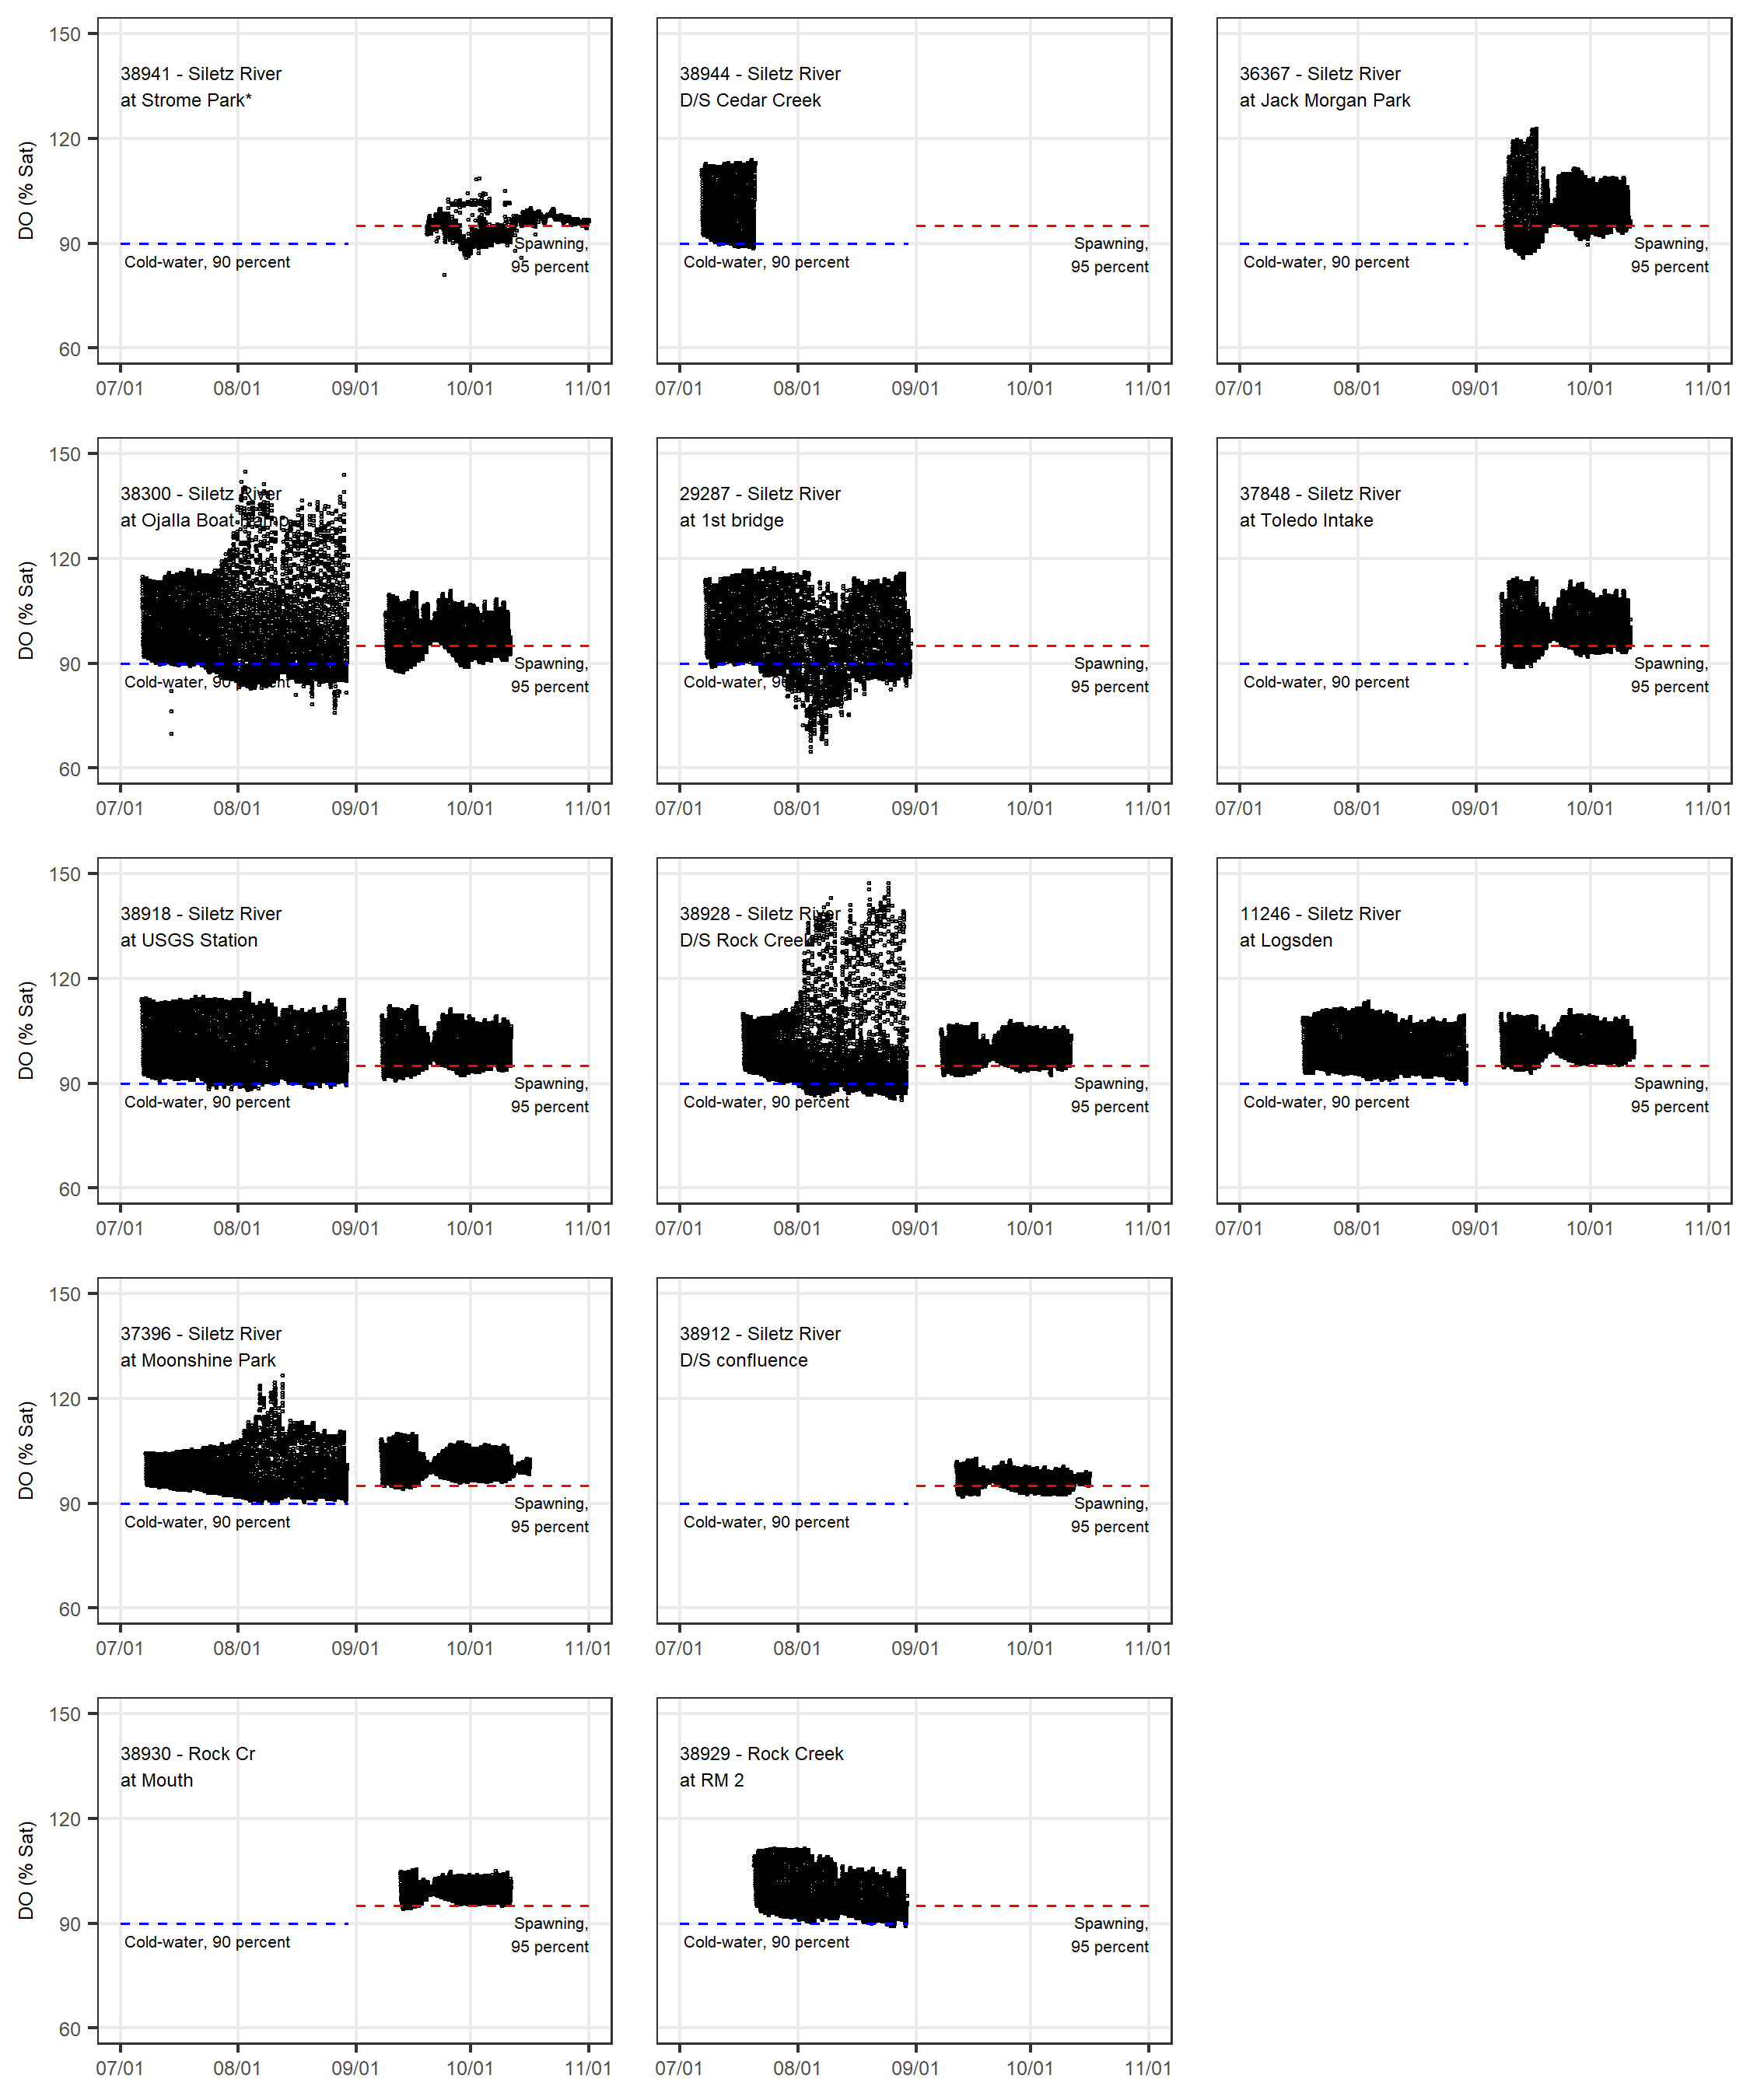

Figure 7. Continuous LSWCD U26 DO Saturation data (*Strome Park included for context only)

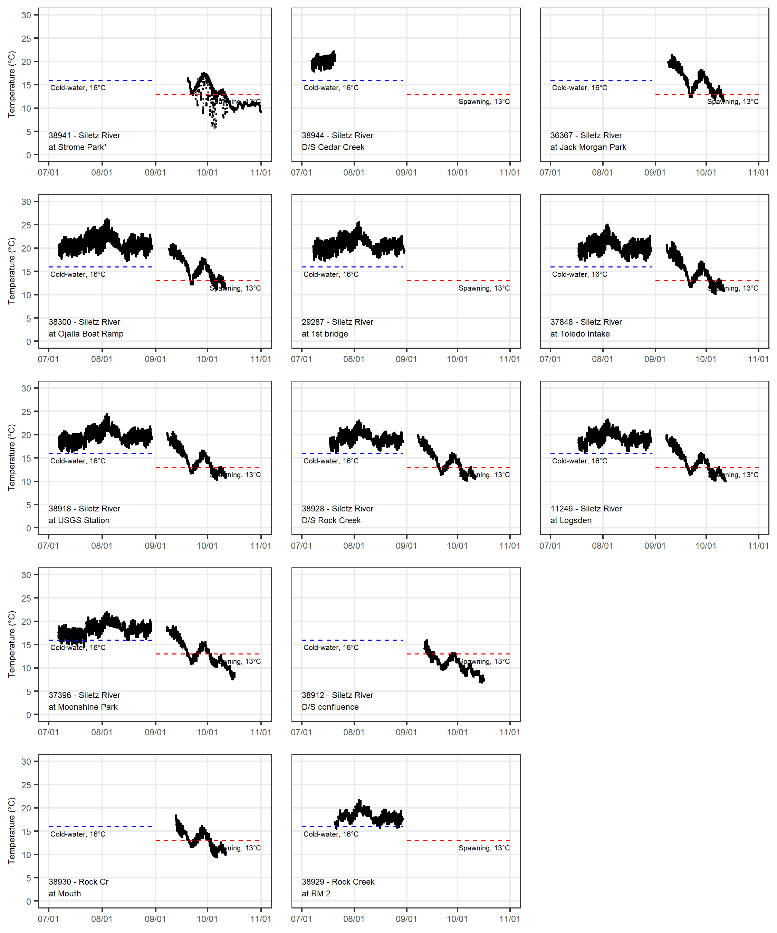

Figure 8. Continuous LSWCD U26 Temperature data (*Strome Park included for context only)

### Longitudinal Profiles of Distributed Data

Figures 9 through 14 show box plots of the data for each monitoring period at each site as a function of distance along the Siletz River:

* Figure 9 and Figure 10 are box plots of DO concentration for each site during the cold-water and spawning period respectively.
* Figure 11 and Figure 12 are box plots of DO saturation for each site during the cold-water and spawning period respectively.
* Figure 13 and Figure 14 are box plots of temperature for each site during the cold-water and spawning period respectively.

Rock Creek data have been separated into a discrete stream reach with the location of its confluence with the Siletz River shown on the Siletz Reach.

Analysis of the data presented in this format yields the following observations:

* Median DO concentrations generally decrease from the Upper Gorge (38912) to the first bridge (10391), and increase the first bridge to downstream of Cedar Creek (38944). One exception to this is downstream of Rock Creek (38928) where median DO concentrations are less than the adjacent upstream and downstream sites. During the cold-water periods, the variation in DO concentrations is greatest at the site downstream of Rock Creek (38928) and the Ojalla Boat Ramp (38300). Median concentrations for all of the sites, including Rock Creek, are greater than the cold-water 30-day mean minimum concentration of 8 mg/L. Variation in the DO concentration data is generally greater during the cold-water period than it is the spawning period.
* Median temperatures generally increase toward the going from upstream to downstream during both monitoring periods. The exceptions to this are during the cold-water period downstream of Cedar Creek (38944) and downstream of Rock Creek (38928). Variation in the temperature data is generally greater during the spawning cold-water period than it is the cold-water period.
* The DO saturation data do not have an apparent trend in direction upstream or downstream. During the cold-water period the 25th percentile of data at all sites is greater than the minimum (90 percent). During the spawning period, only for the Ojalla Boat Ramp (38300) and Upper Gorge (38912) are 25th percentile of data less than minimum (95 percent). At no site during either period, is the median DO saturation less than the applicable minimum.

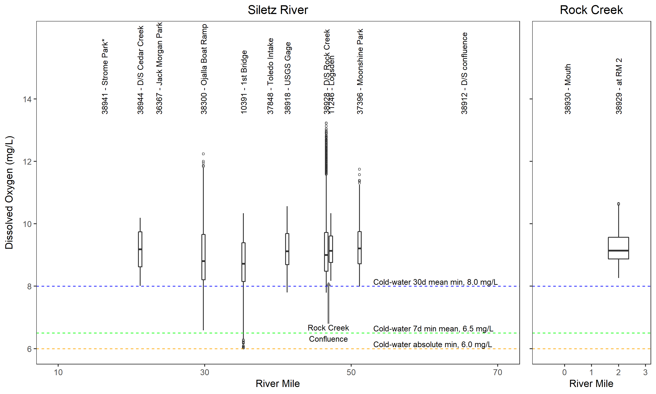

Figure 9. Boxplots of SWCD U26 DO concentration – cold-water (*Strome Park included for context only)

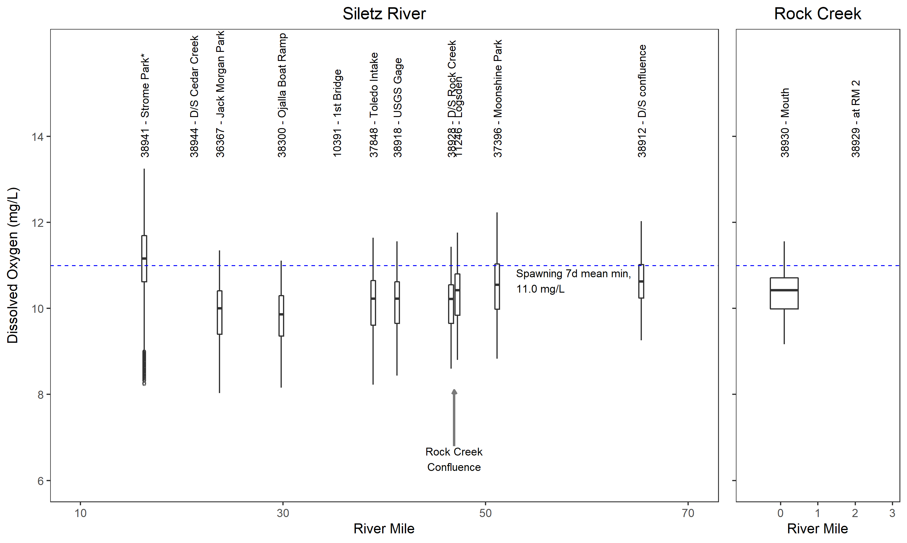

Figure 10. Boxplots of SWCD U26 DO concentration – spawning (*Strome Park included for context only)

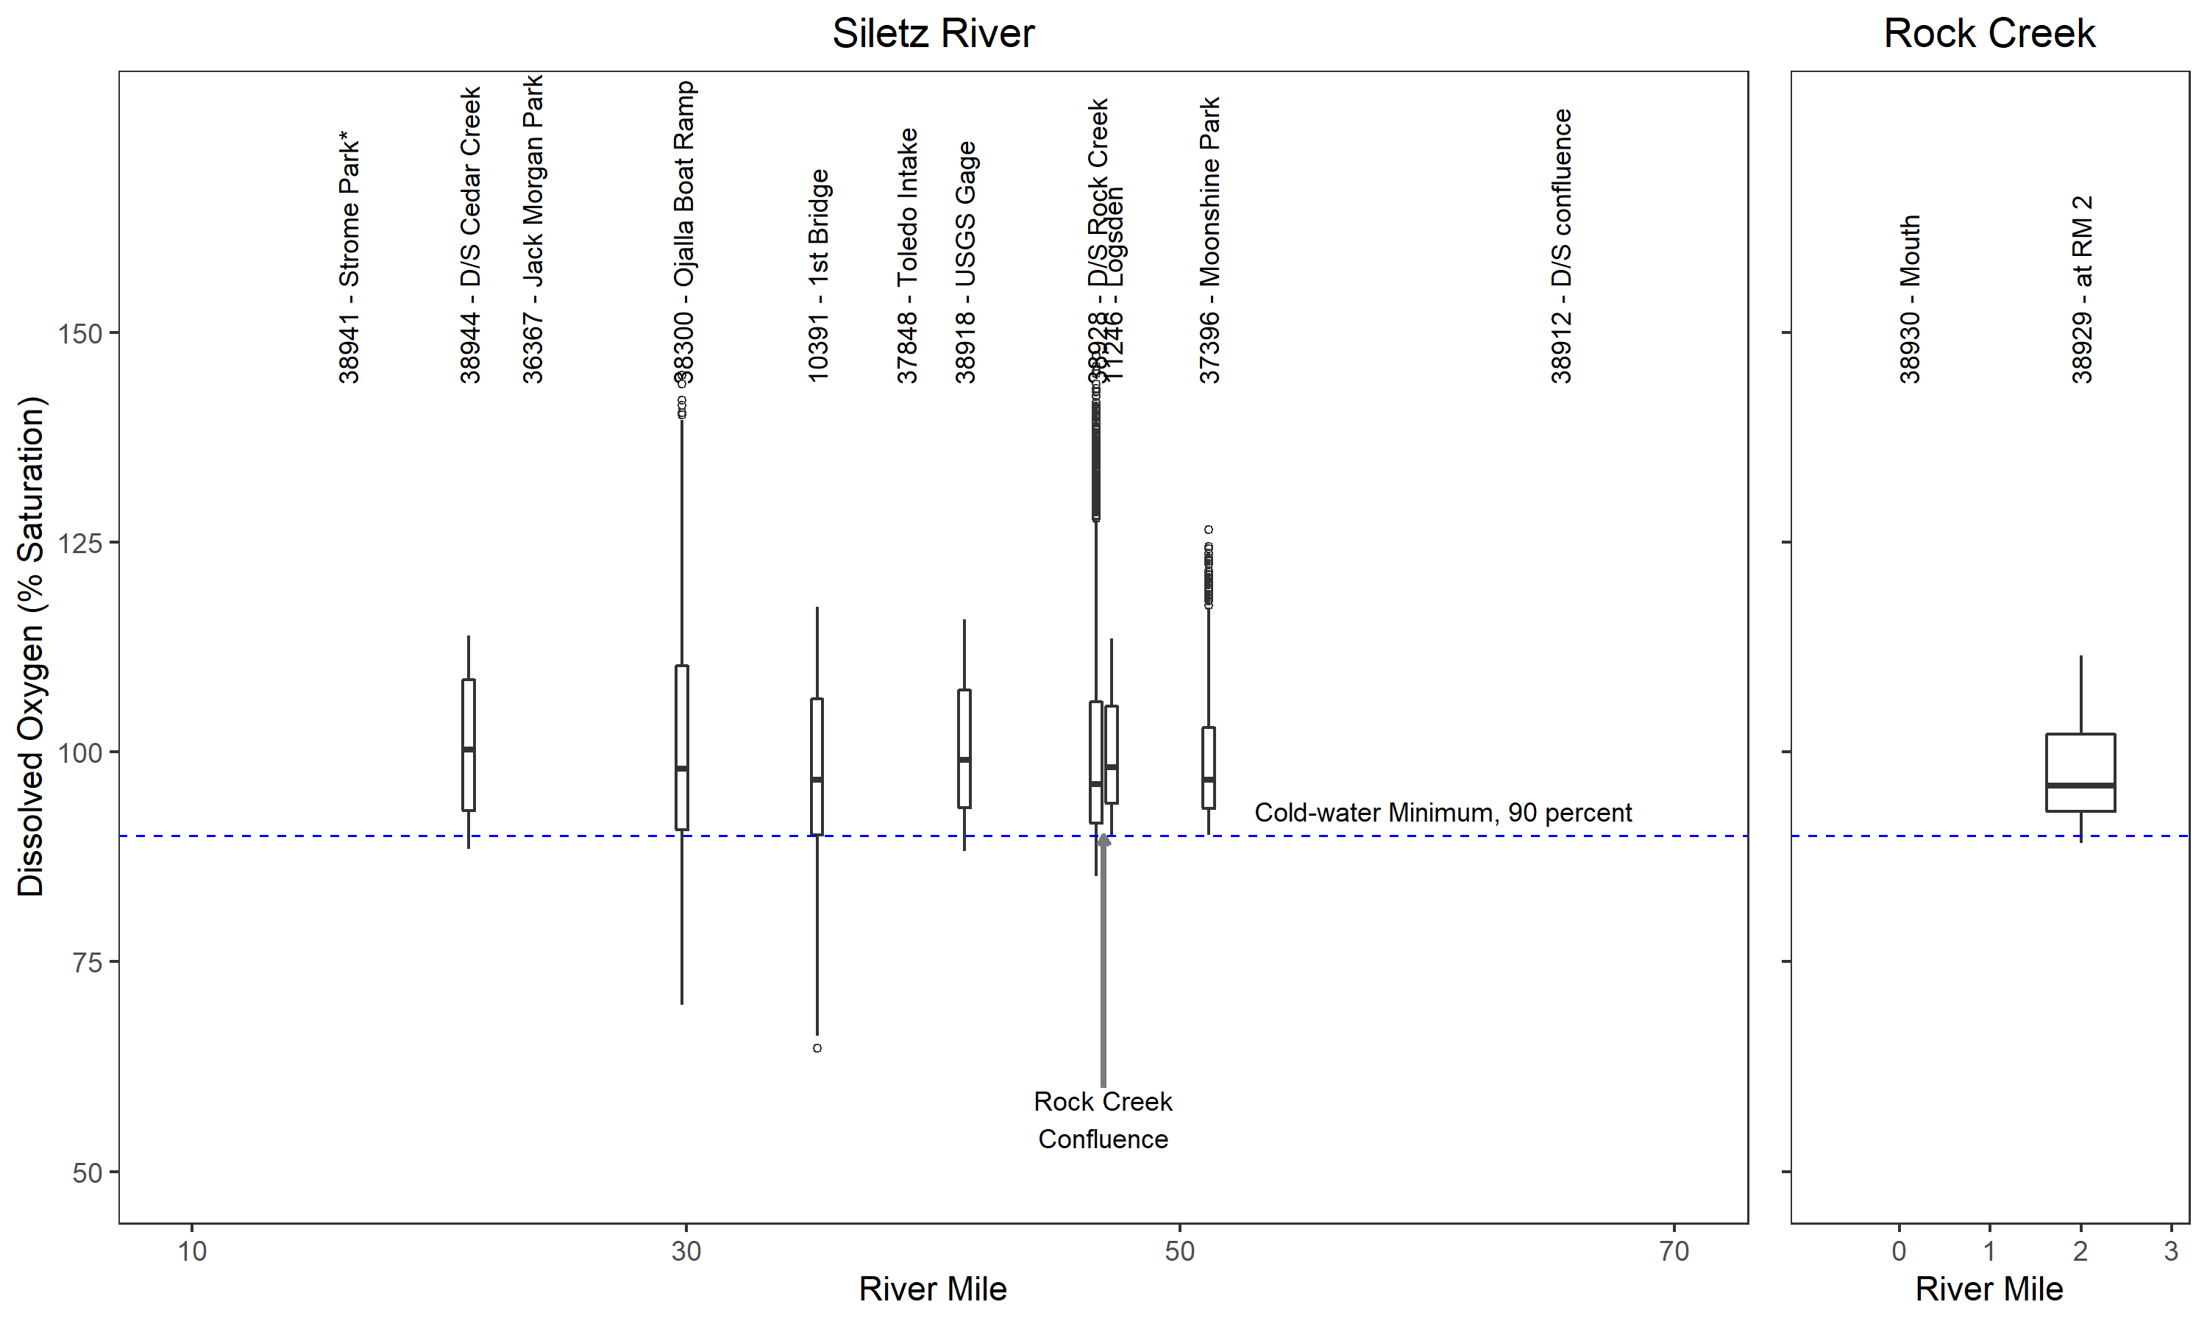

Figure 11. Boxplots of SWCD U26 DO saturation – cold-water (*Strome Park included for context only)

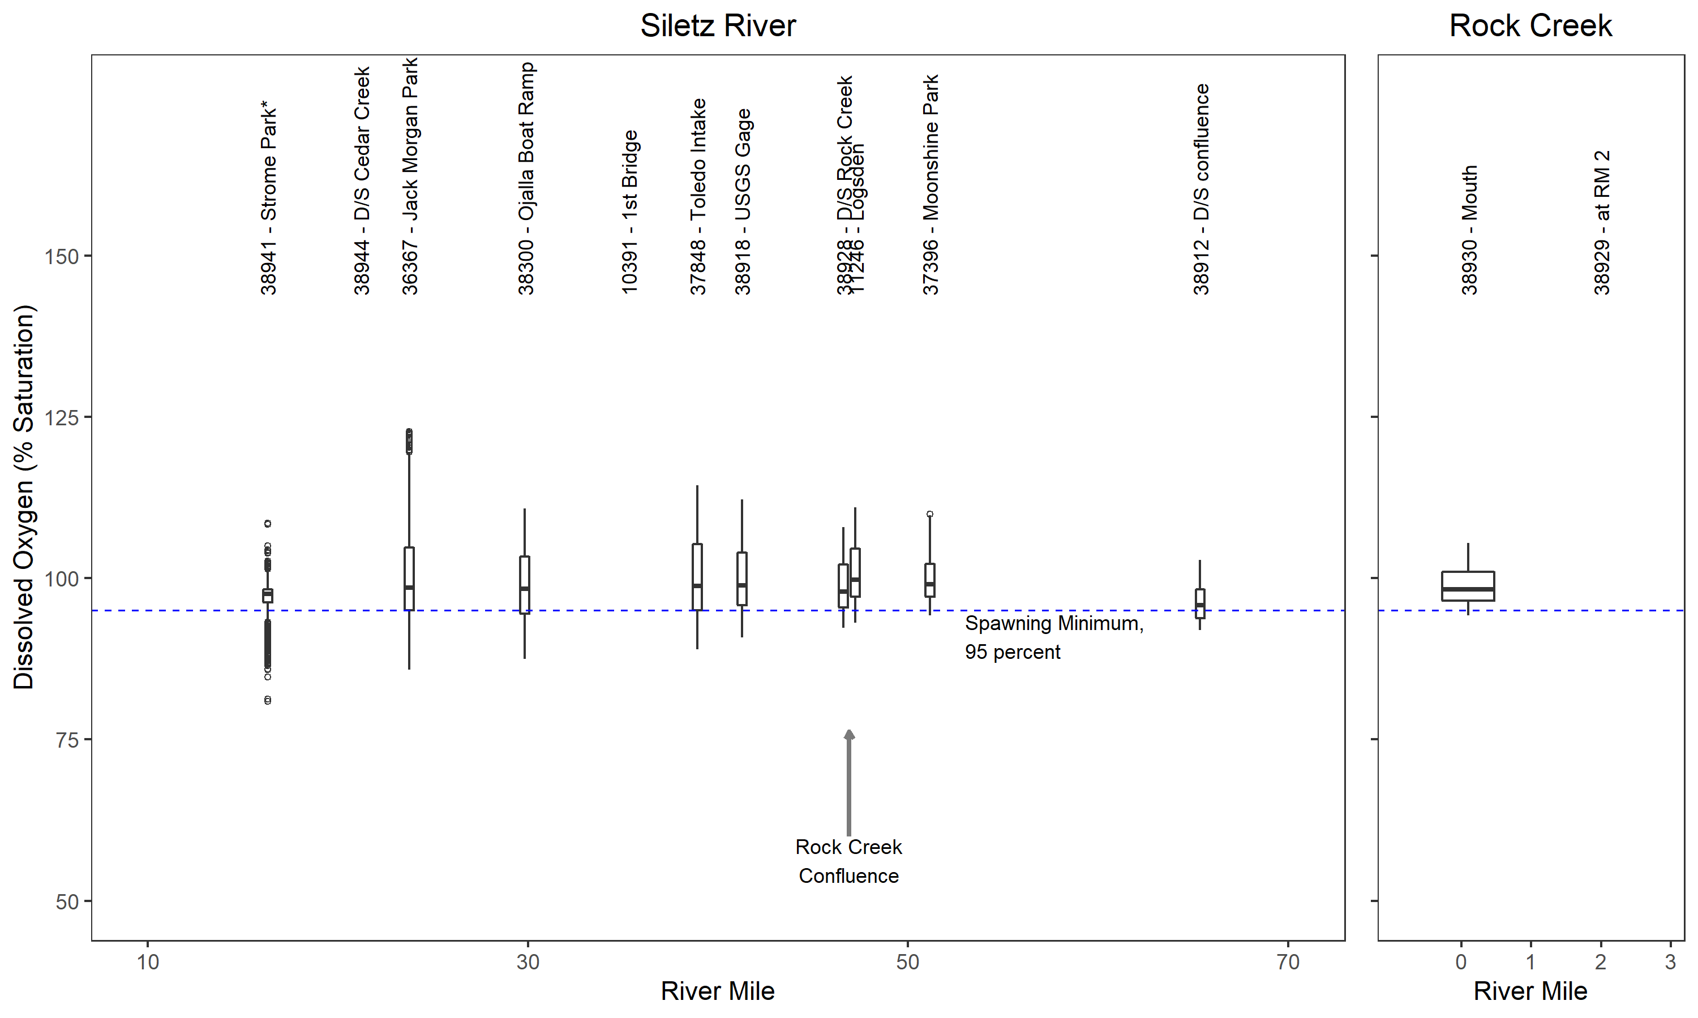

Figure 12. Boxplots of SWCD U26 DO saturation – spawning (*Strome Park included for context only)

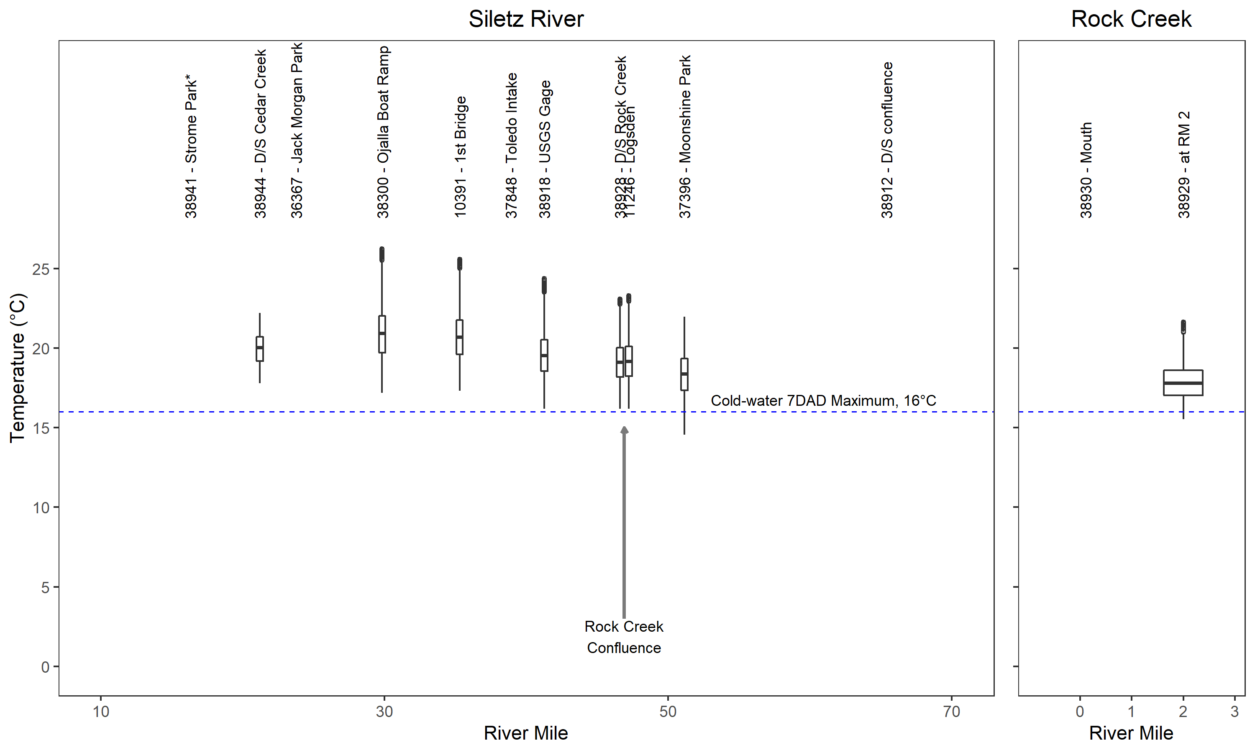

Figure 13. Boxplots of SWCD U26 Temperature – cold-water (*Strome Park included for context only)

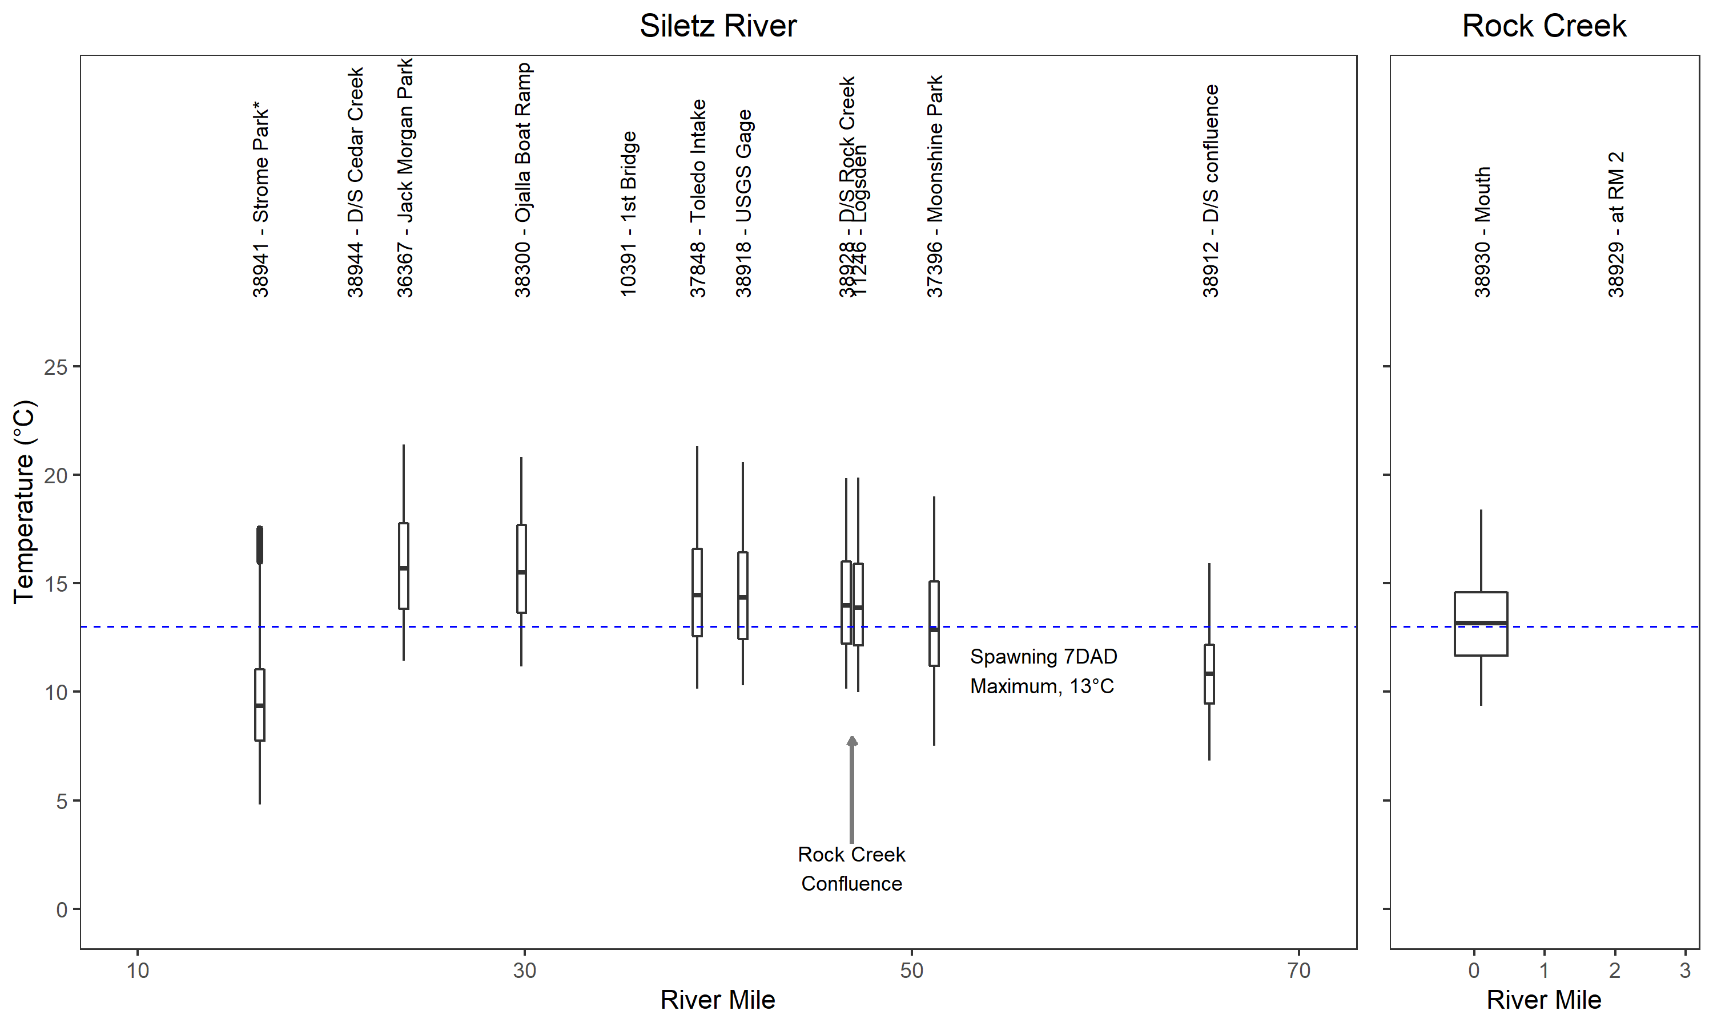

Figure 14. Boxplots of SWCD U26 Temperature – spawning (*Strome Park included for context only)

### Statistical Comparisons to Water Quality Criteria

This section presents the statistical analysis of the LSWCD continuous data as required to the DO criteria. The results of the analysis will be applied to the applicable criteria, which will form the basis of listing the waterbody as impaired, not impaired, partially impaired, or inconclusive.

As per OAR 340-041-0016 the DO criteria for both periods involve step-wise checks where sufficient data exist to support the analysis described in Section 4.4. Comparison of continuous temperature data with OAR 340-041-0028 is also presented. The following figures plot the statistical time series calculations relative to the DO criteria:

* Cold-water Period
  + Figure 15 – Comparison of the 30-day floating averages of the calculated daily mean DO concentration to the minimum of 8 mg/L.
  + Figure 16 – Comparison of the 7-day floating average of the daily minimum DO concentration to the minimum of 6.5 mg/L.
  + Figure 17 – Comparison of the instantaneous DO values to the minimum of 6.6 mg/L.
  + Figure 18 – Comparison of the 30 consecutive-day floating averages of the calculated daily mean DO saturations to the minimum of 90 percent.
* Salmonid spawning Period
  + Figure 19 – Comparison of the 7-day floating averages of the calculated daily mean DO concentration to the minimum of 11 mg/L.
  + Figure 20 – Comparison of the 7-day floating averages of the calculated daily mean DO saturations to the minimum of 95 percent.
* Figure 21 – Comparison of the 7-day floating averages of the daily maximum temperatures to either the cold-water criteria of 16°C or the spawning criteria of 13°C.

Figure 15 and Figure 18 show that the DO concentrations meet the long-term daily average criteria for all sites throughout the monitoring period. Figure 16 and Figure 17 show that DO concentrations are less than the applicable portion of the cold-water DO criteria at one site, the first bridge (29287).

Figure 19 shows 7-day mean minimum DO at all of the sites is less than the 11 mg/L criteria for most, if not all of the monitoring period. Figure 20 demonstrates, however, that 7-day DO saturations, even for data capped at 100 percent saturation values, comply with the minimum of 95 percent saturation for all sites during the entire period of monitoring. Due to stream temperatures above the applicable temperature criteria (Figure 21), the attainment of 7-day mean minimum DO concentrations of 11 mg/L in not possible, and therefore the DO saturation standard supersedes the DO concentration standard. Hence, during the spawning period, the Siletz River is in compliance with the applicable DO criteria.

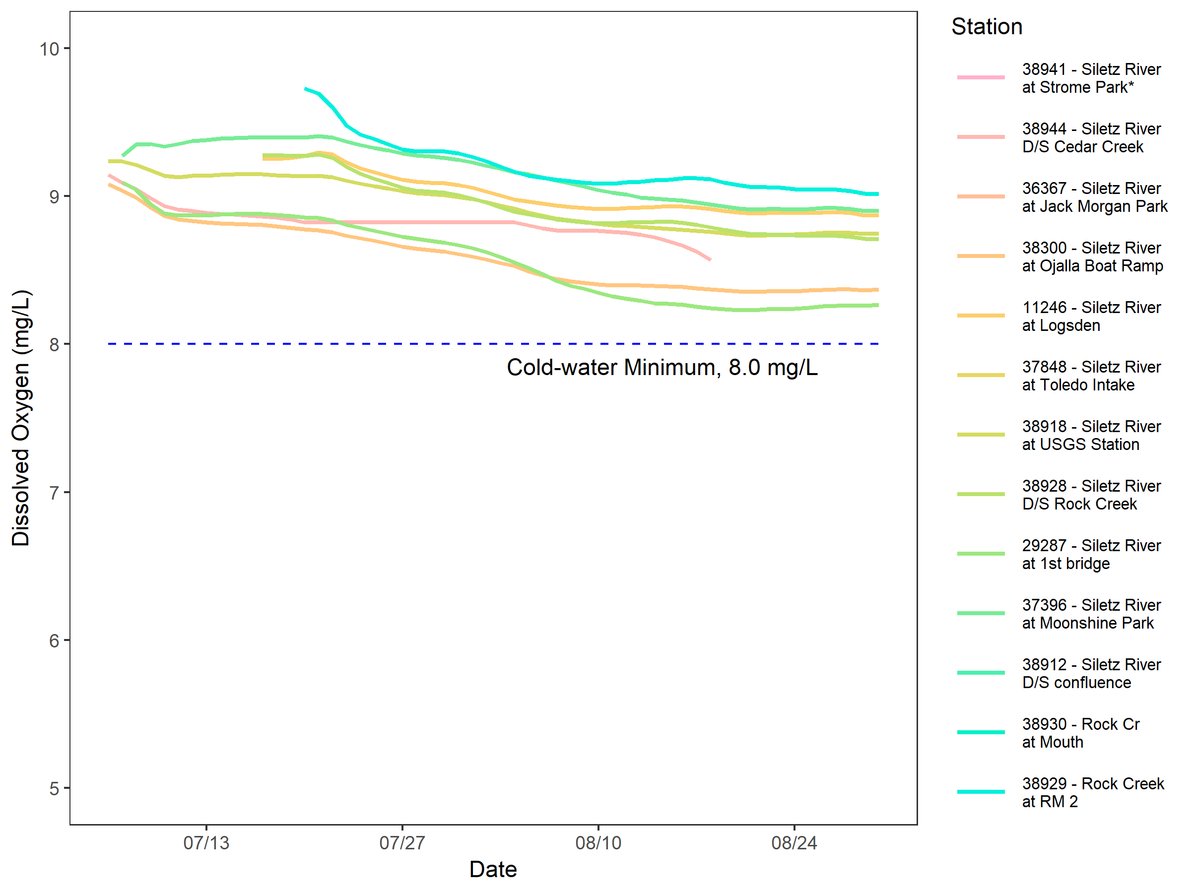

Figure 15. 30-day mean minimum DO concentration – cold-water (*Strome Park included for context only)

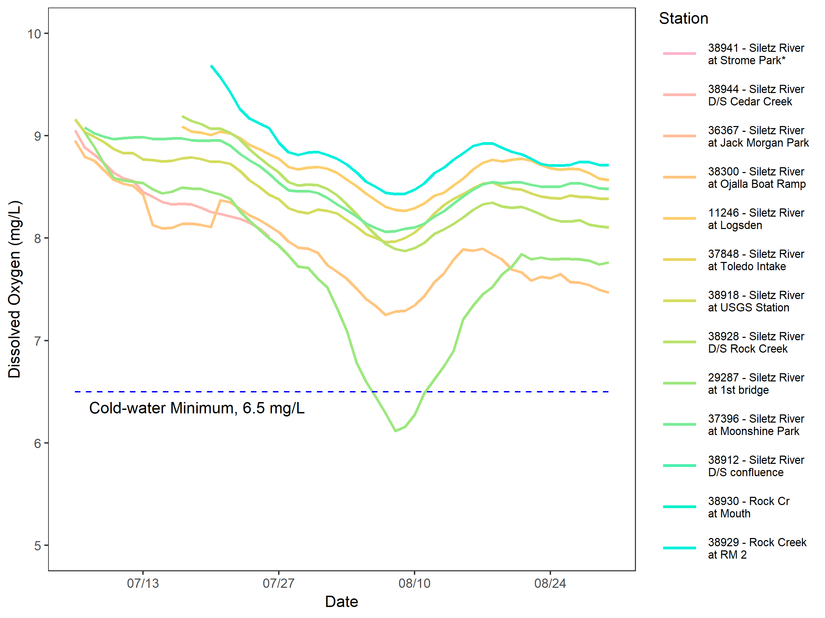

Figure 16. 7-day minimum mean DO concentration – cold-water (*Strome Park included for context only)

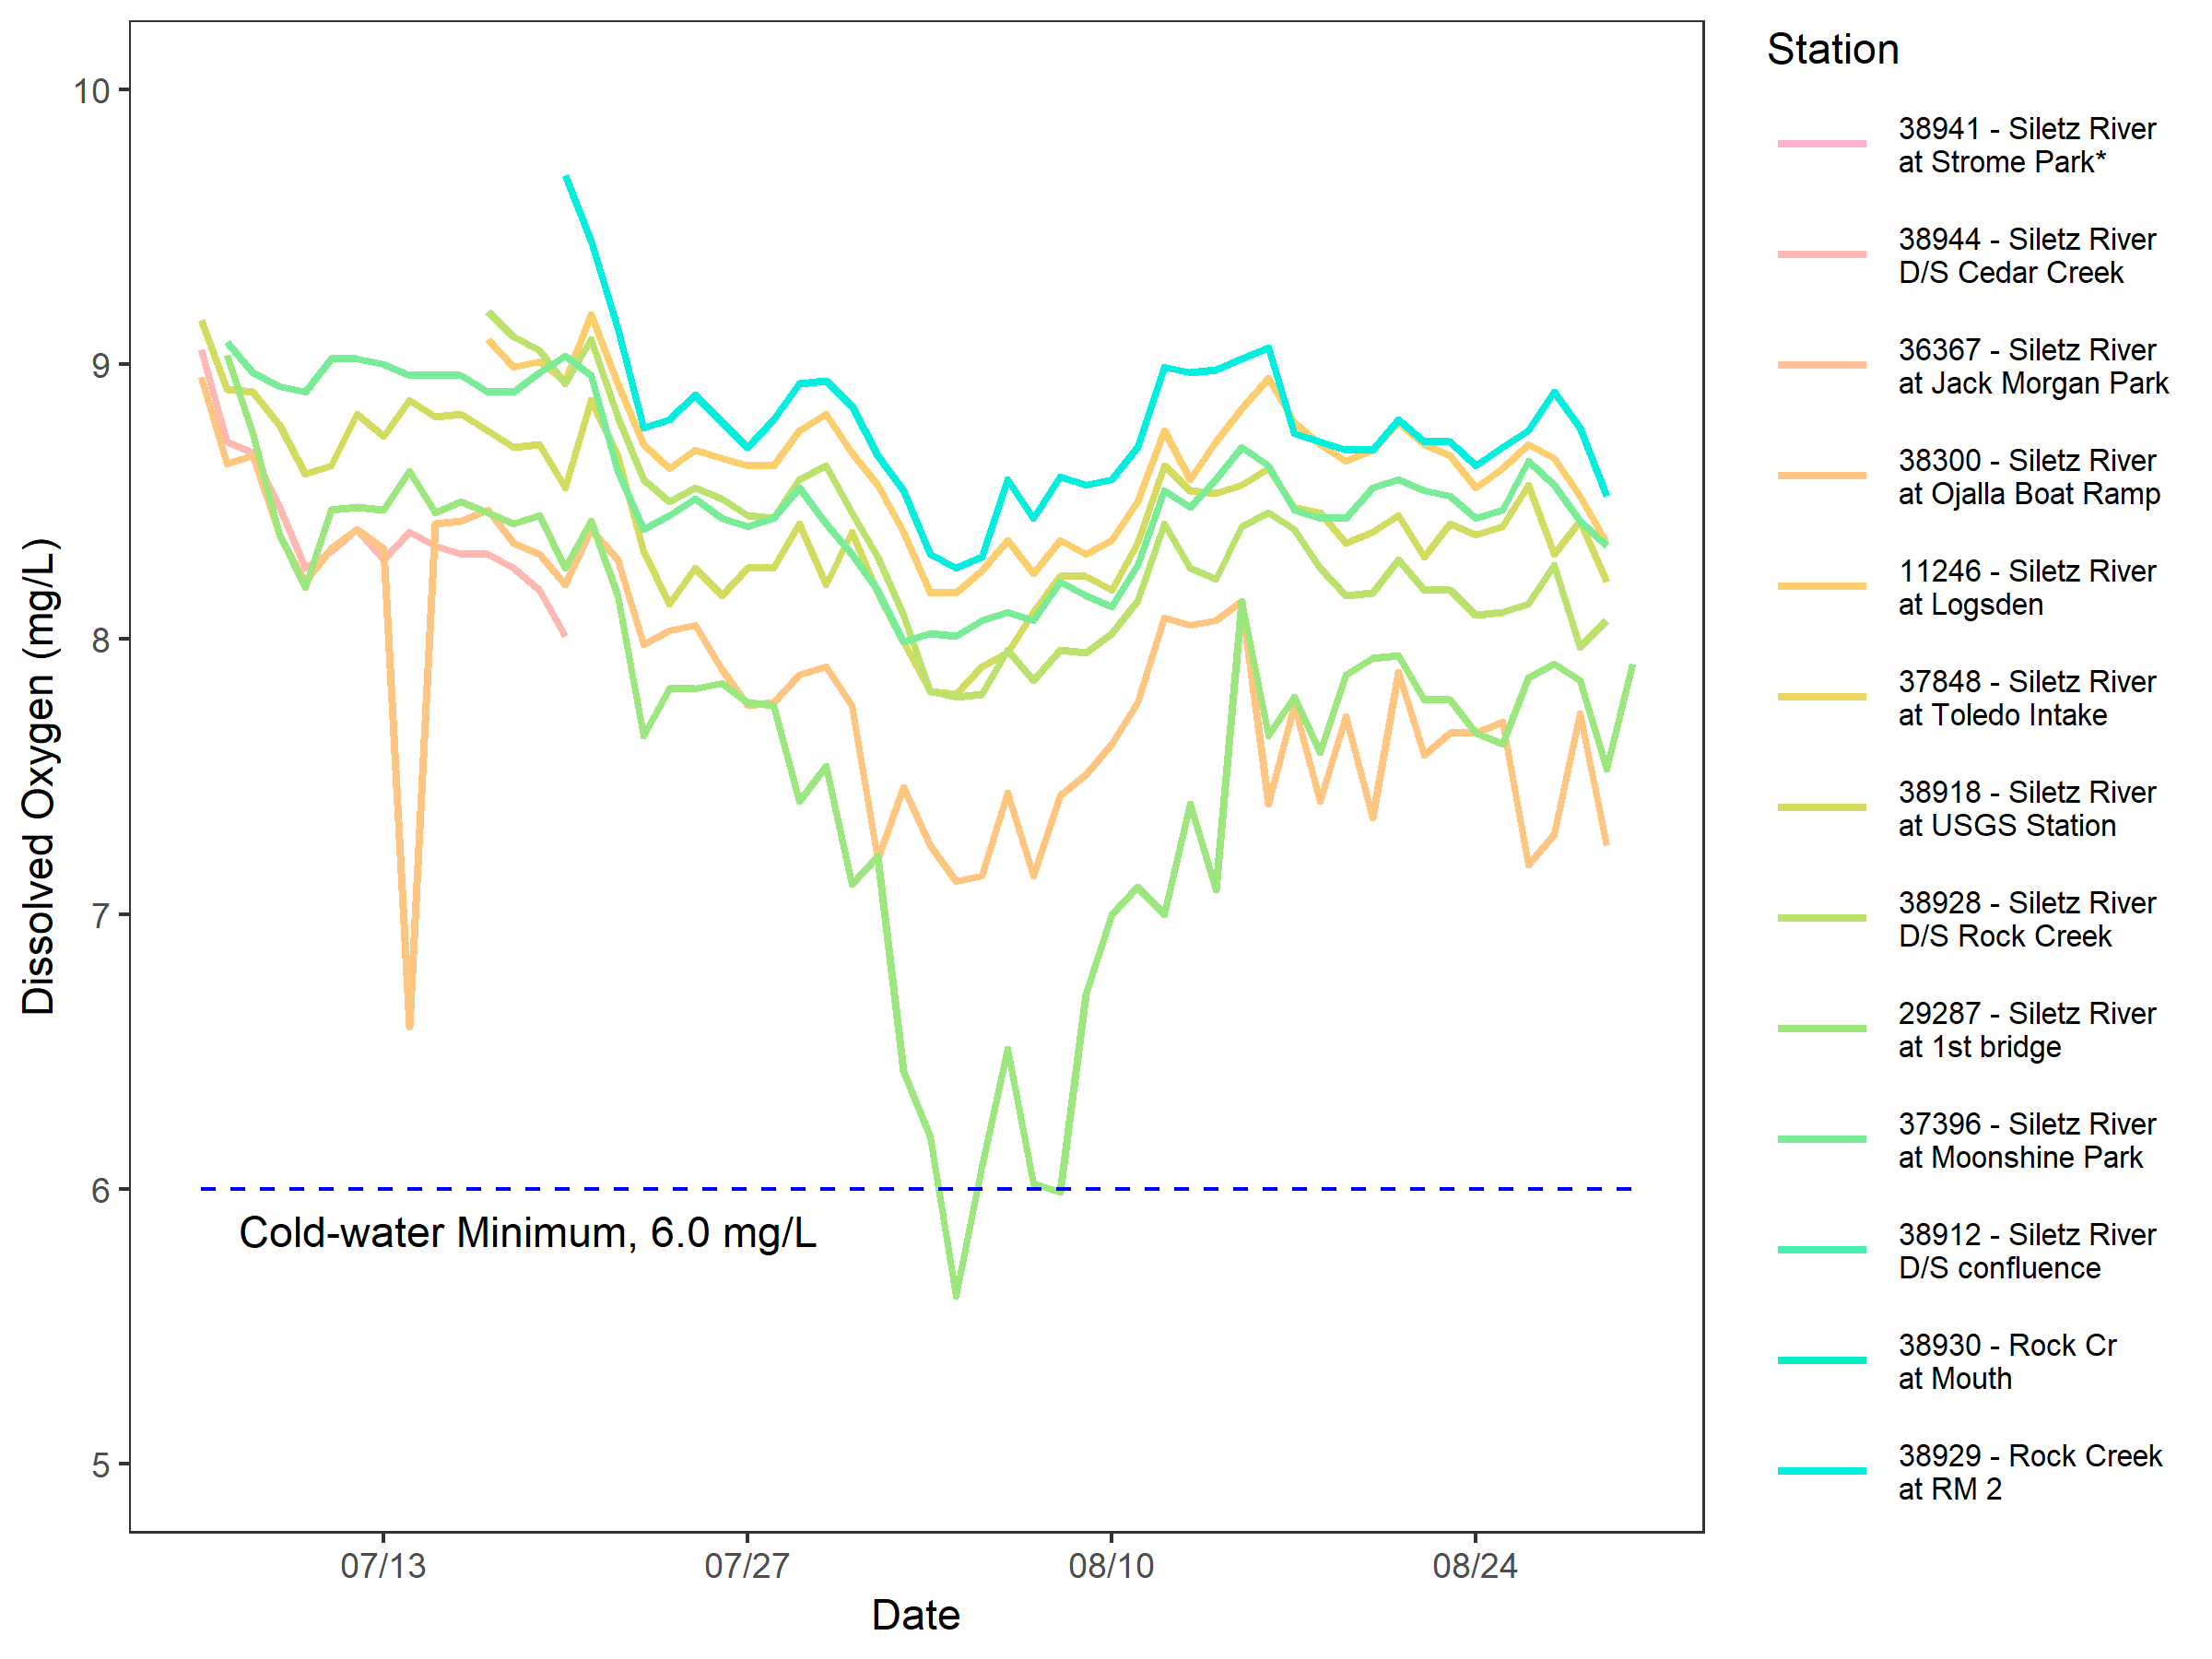

Figure 17. Absolute minimum DO concentration – cold-water (*Strome Park included for context only)

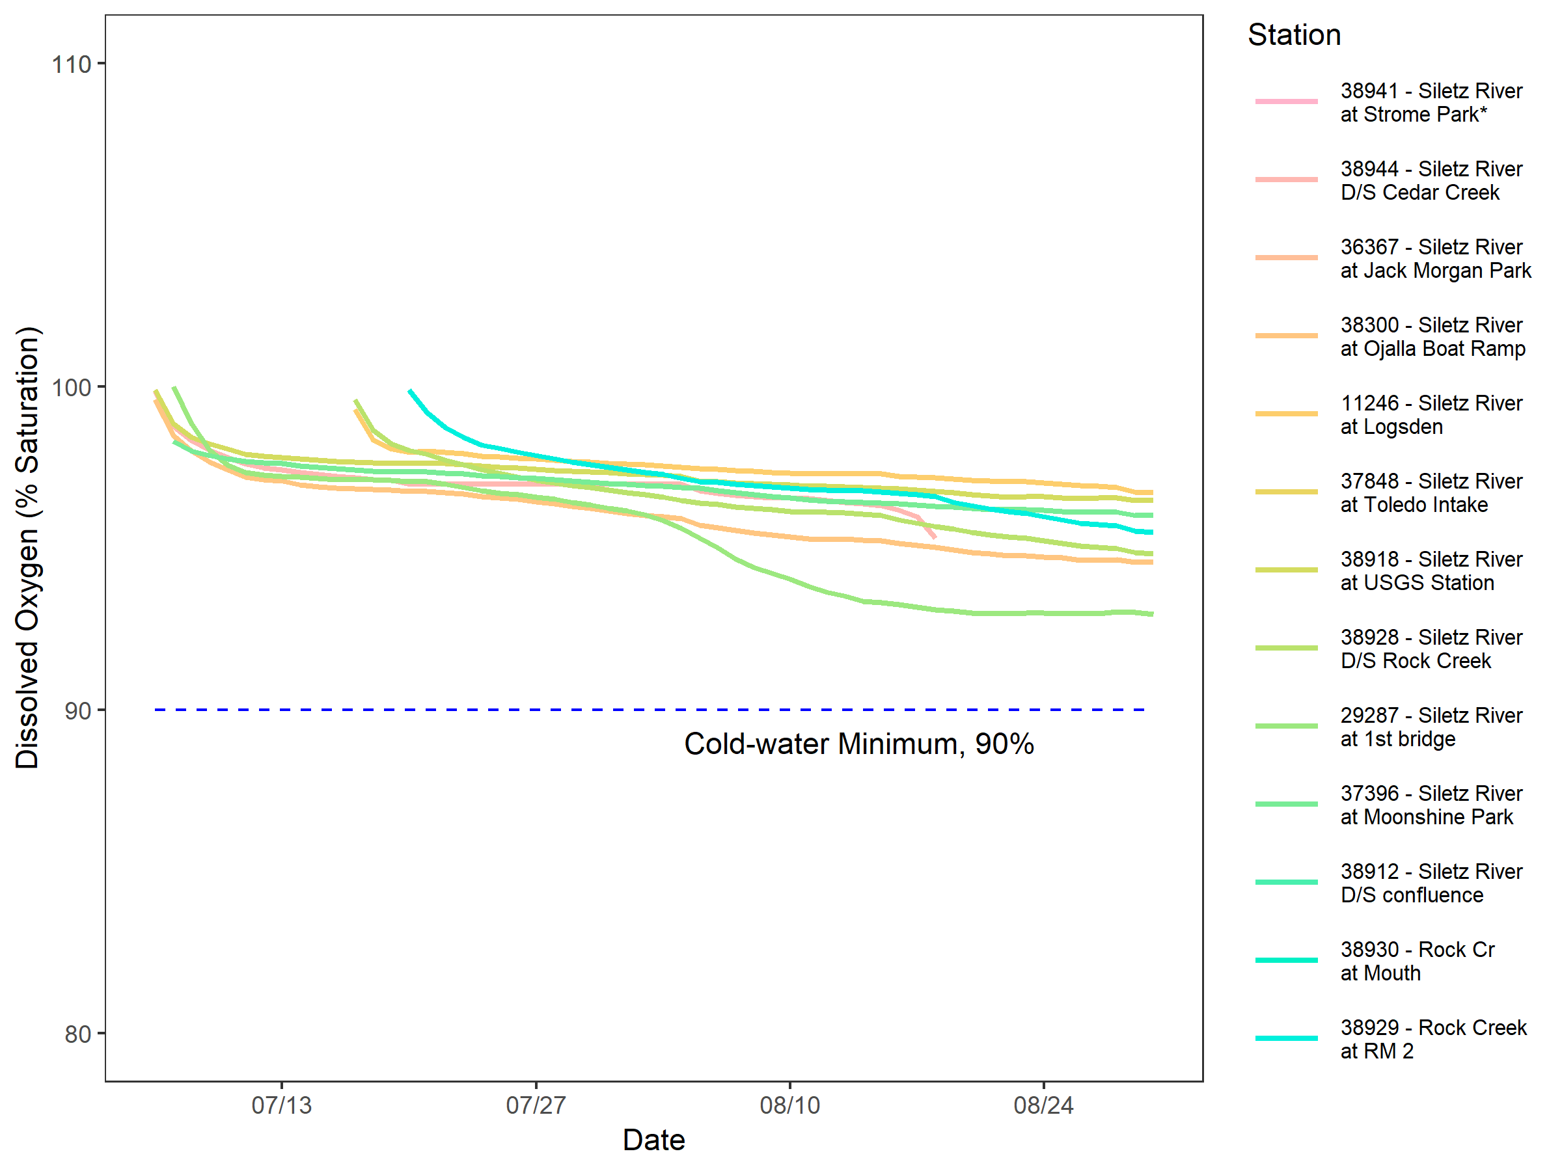

Figure 18. 30-day mean minimum DO saturation – cold-water (*Strome Park included for context only)

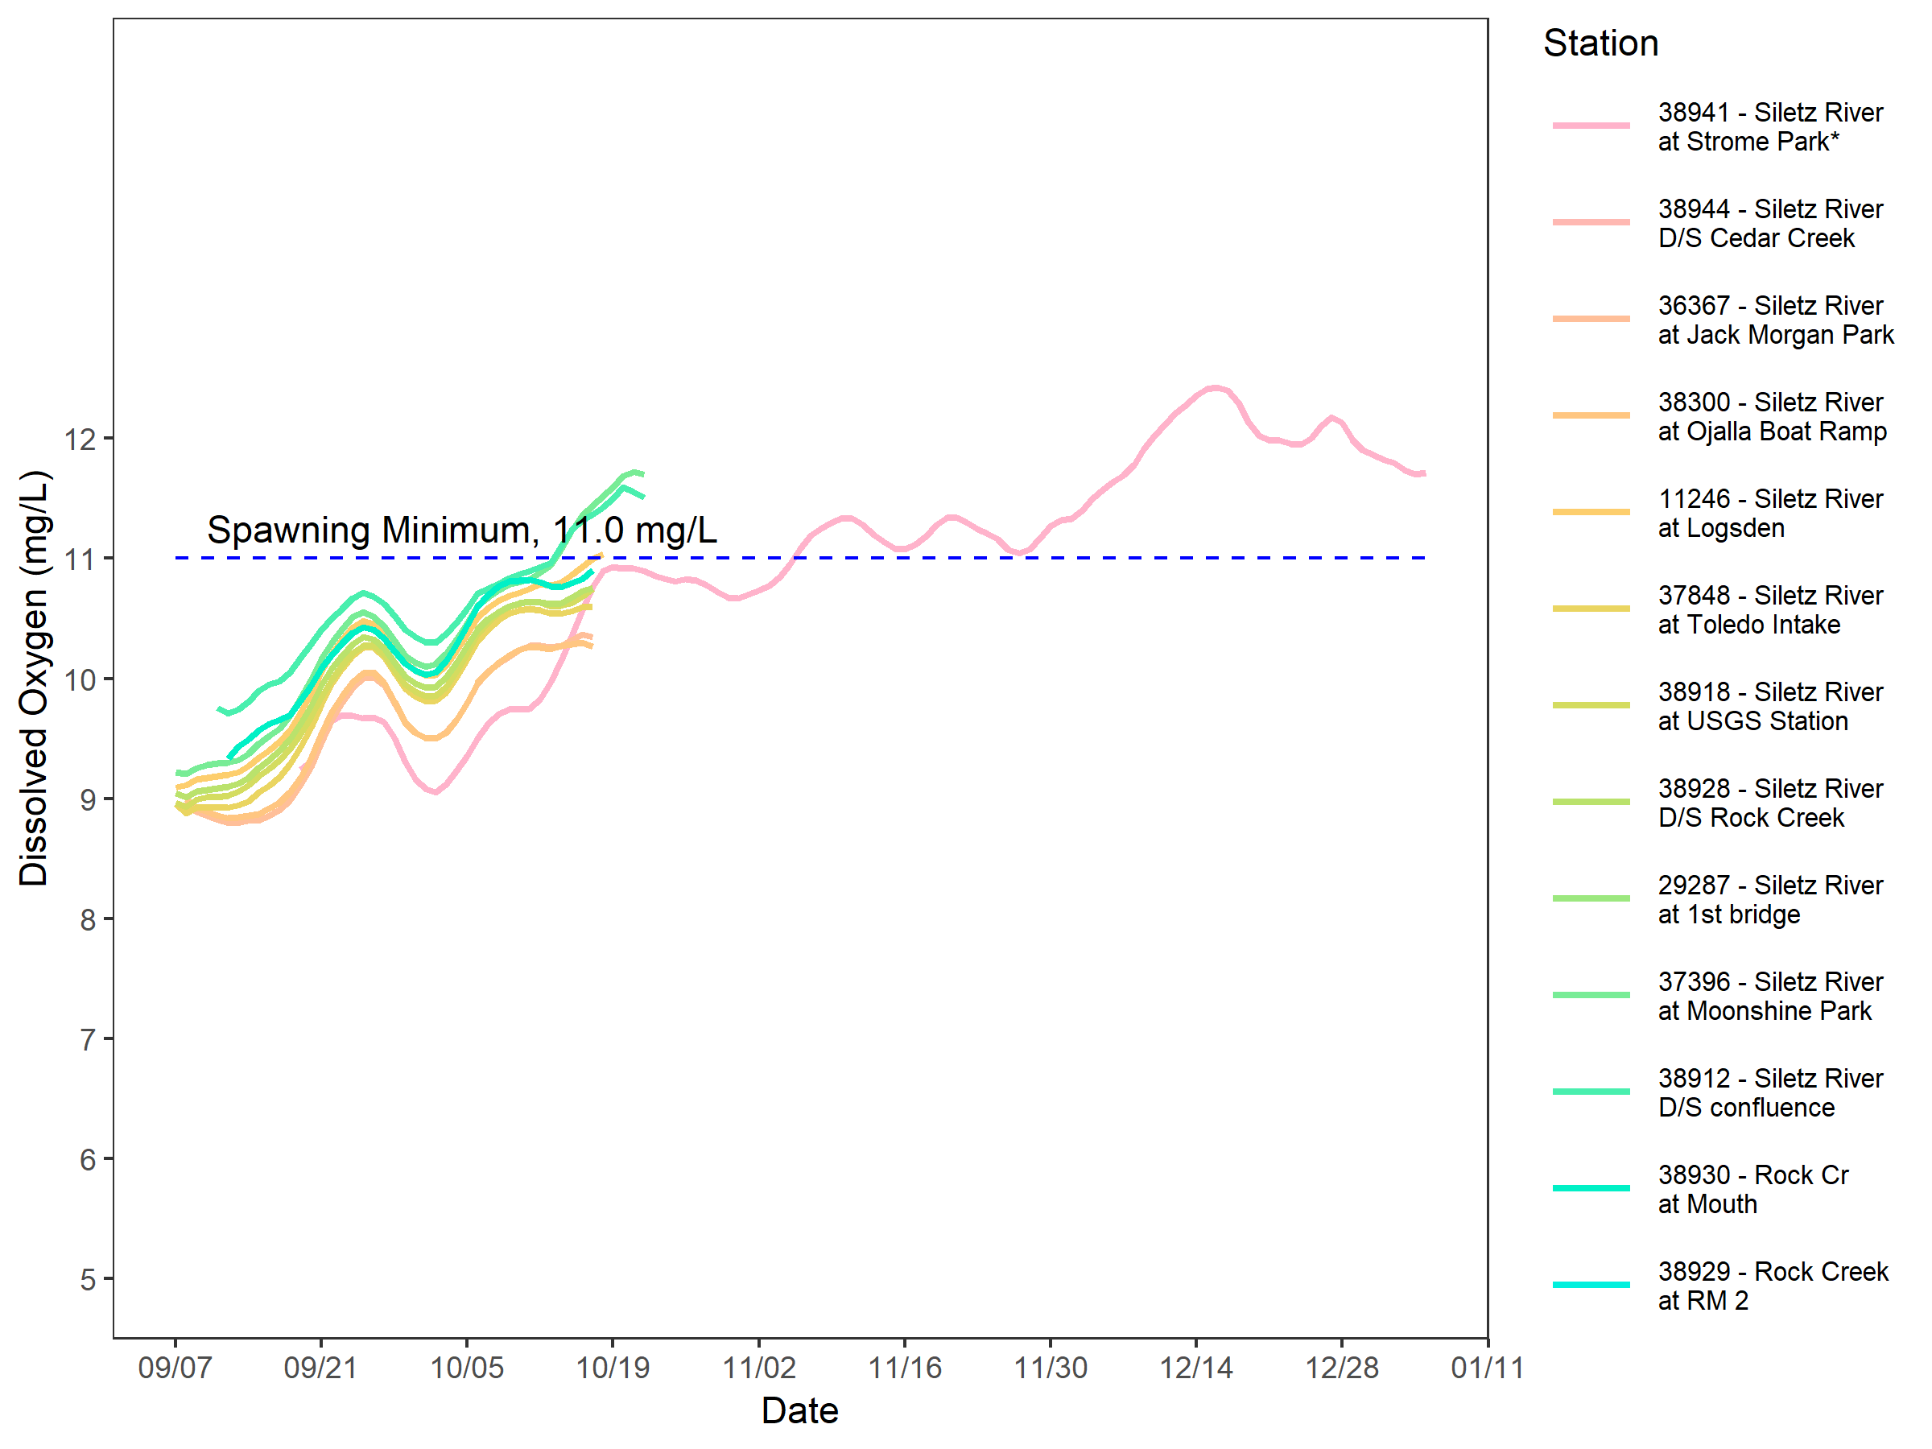

Figure 19. 7-day mean minimum DO concentration – spawning (*Strome Park included for context only)

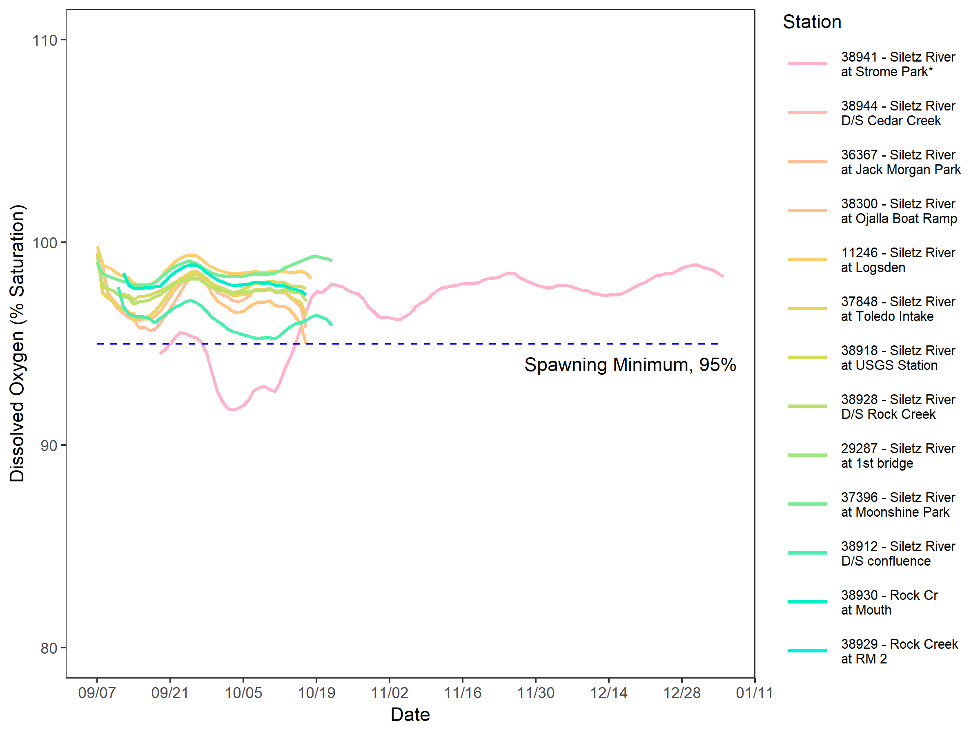

Figure 20. 7-day mean minimum DO saturation – spawning (*Strome Park included for context only)

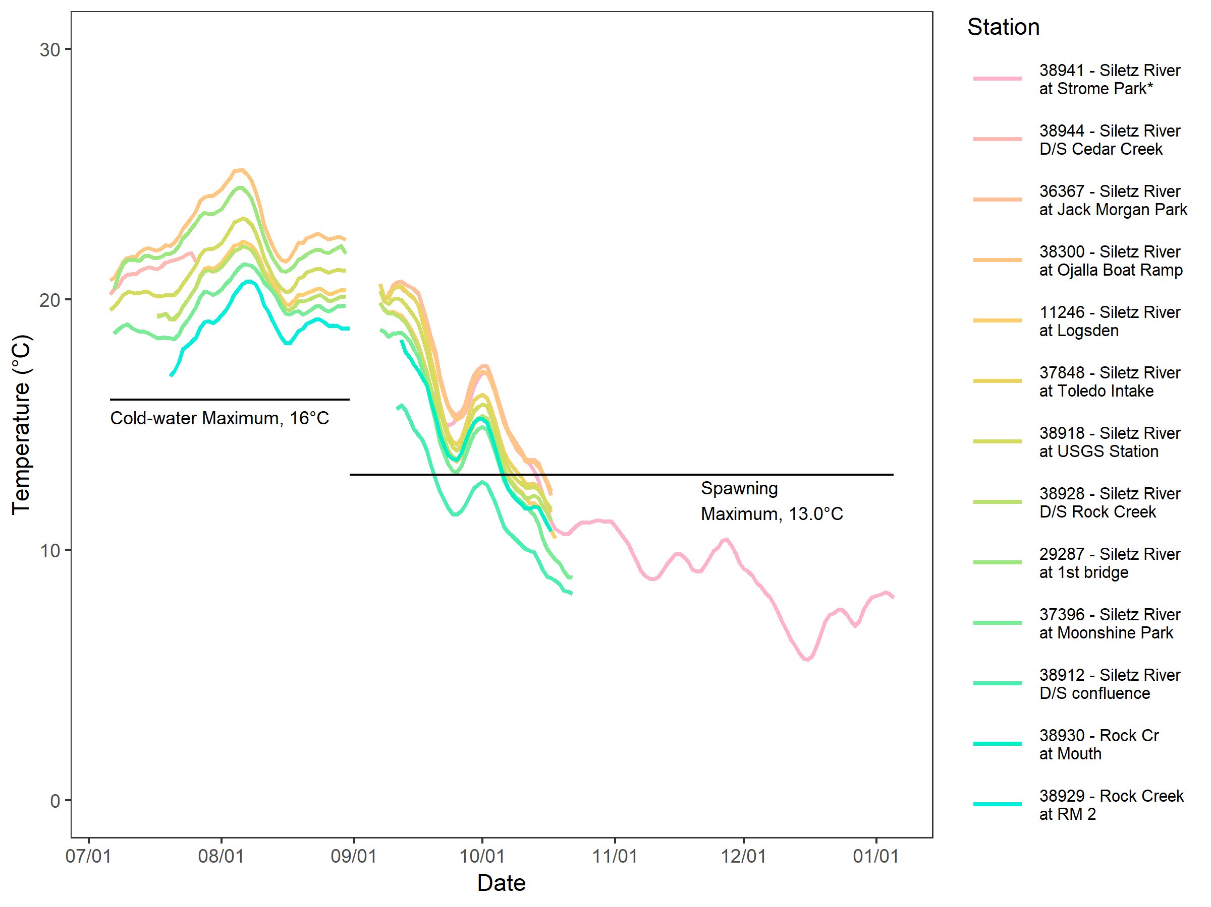

Figure 21. 7-day average daily maximum temperatures – cold-water and spawning (*Strome Park included for context only)

### Comparison of Concurrent DEQ and LSWCD Data

# Discussion

The analysis in Section 5.3.3 demonstrates that during the cold-water period, the 30-day mean minimum DO concentrations were above the 8 mg/L minimum threshold, and the 30-day mean minimum DO saturation values was greater than the 90 percent threshold for the entire cold-water period at all of the sites. For the 7-day minimum mean and absolute minimum, DO concentrations at the first bridge (29287) were less than their respective thresholds (6.5 and 6 mg/L, respectively). From 08/06 to 08/11, the 7-day minimum mean is less than 6.5 mg/L because of the daily minimum observations of 5.61 mg/L observed on 08/04 and 5.99 mg/L observed on 08/08.

For the spawning period, while the Siletz River did not meet the DO concentration minimum of 11 mg/L for all of the sites during most of the spawning period, the percent DO saturation minimum of 95 percent is met at all of the sites.

In light of the above discussion of the DO, the 7-day average daily maximum temperature exceed the criteria at all sites during the entire cold-water period and for a significant portion of the time that data were collected during the spawning period, excluding Strome Park (38941). This phenomenon raises the question: if temperatures were lower, possibly less than the applicable temperature criteria, would the Siletz River meet DO concentrations and/or percent saturations minimums during the spawning period? That is, if stream temperature were lower, by how much would the DO concentrations increase and would the DO saturations still demonstrate compliance with either the cold-water or spawning criteria?

Additional considerations to this discussion include the following points:

* Significant nutrient inputs from Rock Creek appear to have some impact primary production in the river and subsequently on DO concentrations and supersaturated conditions during the cold-water period. One possible factor, at least concerning sources of nitrogen and carbon, includes the composition of land cover and percent contribution of flow just downstream of the Siletz River and Rock Creek confluence. The Rock Creek watershed is 24 percent of the total Siletz River watershed at the confluence with Rock Creek, however the Rock Creek watershed is 30 percent deciduous and mixed forest. Deciduous and mixed forest in the Mid-Coast are made up of, in significant portion, Red alder (*Alnus rubra*) which fixes atmospheric nitrogen in the soil thereby increasing nitrogen within the system (Sigleo and Frick, 2004). This is likely the cause of the elevated nitrate concentrations in Rock Creek, and why production in the Siletz River was observed downstream of Rock Creek (38928) but not at Logsden (11246).
* Data at the Ojalla Boat Ramp (38300) and Moonshine (37396), to a lesser degree, demonstrate primary production characteristics similar to downstream of the Rock Creek confluence. At the First Bridge site (29287), the data show a deficit in DO during the cold-water period. It is unclear at this point what the causes of these phenomena are. Discharge from the Siletz STP could be causing the dip in DO at the first bridge (29287), however there are no apparent contributors to production at Ojalla Boat Ramp at this time.
* Overall, the concentrations of nutrients and sediment are low in July likely representative of baseflow conditions. Elevated concentrations during September relative to July are likely due to storm events from 09/07/2017 to 09/09/2017. Even though the flows were receding during the sampling events during the Spawning period, residual runoff could have been carrying sediment and associated nutrients with it.

# Conclusions and recommendations

Our examination of DO and other water quality data reveal complex, multi-factored system of dynamics that could be affecting DO concentrations in the Siletz River. The two questions in the Discussion section regarding (1) temperatures and DO concentration/saturations, and (2) production and deficit at particular locations, would benefit significantly from numerical modeling which could assess the contribution of various factors for their influence on system dynamics. The quantity and quality of the data collected during 2017 are sufficient for developing mechanistic watershed and water quality models to evaluate flow, temperature, nutrients and other factors’ impact on DO in the Siletz River. We recommend that TMDL development efforts for meeting both cold-water and spawning criteria use a calibrated watershed (HSPF) model coupled with a calibrated water quality model (QUAL2Kw) for both the cold-water and spawning periods.

# References

Davis, Jr., R.A. and Dalrymple, R.W. 2011. Principles of Tidal Sedimentology. Springer Science & Business Media. p. 82. ISBN 978-94-007-0123-6. 20 October 2011.

Di Luzio M., G.L. Johnson, C. Daly, J. Eischeid, J.G. Arnold 2007. Constructing Retrospective Gridded Daily Precipitation and Temperature Datasets for the Conterminous United States. Journal of Applied Meteorology and Climatology.

FGDC 2012. Coastal and Marine Ecological Classification Standard. Federal Geographic Data Committee, Marine and Coastal Spatial Data Subcommittee. FGDC-STD-018-2012. June 2012.

Kottek, M., J. Grieser, C. Beck, B. Rudolf, and F. Rubel, 2006: World Map of the Köppen-Geiger climate classification updated. Meteorol. Z., 15, 259-263. DOI: 10.1127/0941-2948/2006/0130.

MLRC 2017. National land cover database - 2011. Map, Reston, VA: US Geological Survey, Multi-Resolution Land Characteristics Consortium. <https://www.mlrc.gov>.

NCDC 2018. Surface Data Hourly Global. Newport Municipal Airport Station 726950 24285. National Climate Data Center. Accessed July 2018. www.ncdc.noaa.gov.

Oregon Coastal Atlas 2018. Estuary Data Viewer. Accessed August 2018. https://www.coastalatlas.net/estuarymaps/

Oregon Department of Environmental Quality 2017. Data Validation and Qualification. DEQ09-LAB-0006-QAG, v3.0. 03/31/17.

Oregon Department of Environmental Quality 2018. Draft Methodology for Oregon's 2018 Water Quality Report and List of Water Quality Limited Waters. May 2018.

Oregon Water Resources Department. 2018. Oregon Water Resources Department Near Real Time Hydrographics Data. Accessed August 2018. http://apps.wrd.state.or.us/apps/sw/hydro_near_real_time/.

Sigleo, A. and Frick., W 2004. Seasonal Variations in River Flow and Nutrient Concentrations in a Northwestern USA Watershed. First Interagency Conference on Research in the Watersheds, V753, pp370-376. U.S. Department of Agriculture, Agricultural Research Service.

US Department of Agriculture 2016. Soil Survey Geographic (SSURGO) database for Lincoln and Polk Counties. Fort Worth, Texas U.S. Department of Agriculture, Natural Resources Conservation Service.

US Department of Agriculture 2016. Soil Survey Geographic (SSURGO) database for Lincoln County. Fort Worth, Texas U.S. Department of Agriculture, Natural Resources Conservation Service.

US Geologic Survey 2018. USGS Current Water Data for the Nation. Accessed August 2018. https://waterdata.usgs.gov/nwis/rt

Walker, G.W. and Duncan R.A. 1989. Geologic Map of the Salem 1° by 2° Quadrangle, Western Oregon. US Geologic Survey. Miscellaneous Investigations Series Map I-1893.

1. Oregon 2012 Integrated Report 303(d) Category 5 listed waterbodies, https://www.oregon.gov/deq/wq/Pages/2012-Integrated-Report.aspx
2. Oregon Administrative Rule 340-41-0016 for dissolved oxygen, https://sos.oregon.gov/archives/pages/oregon_administrative_rules.aspx
3. Yellow Springs Instruments (YSI) Inc., Yellow Springs, OH; Data points collected every 15 minutes
4. Nitrite typically oxidizes quickly in the environment to nitrate, and nitrate is the predominant component of this parameter. The combined analyte of nitrate and nitrite will be referred to as just nitrate for the remainder of this document.
5. HOBO® Dissolved Oxygen Logger (U26-001); Data points collected every 15 minutes
6. The seven-day mean minimum for dissolved oxygen means the minimum of the seven consecutive-day floating average of the calculated daily mean dissolved oxygen concentration.
7. The 30-day mean minimum for dissolved oxygen means the minimum of the seven consecutive-day floating average of the calculated daily mean dissolved oxygen concentration.
8. The seven-day minimum mean for dissolved oxygen means the minimum of the seven consecutive-day floating average of the daily minimum concentration.
9. The seven-day average maximum temperature means a calculation of the average of the daily maximum temperatures from seven consecutive days made on a rolling basis.