ODEQ HABs Map Application - User Guide

## Overview

The application provides mapping data with time series data visualization for Oregon HABs. This guide describes the application features and steps for using the application.

## Application features and usage

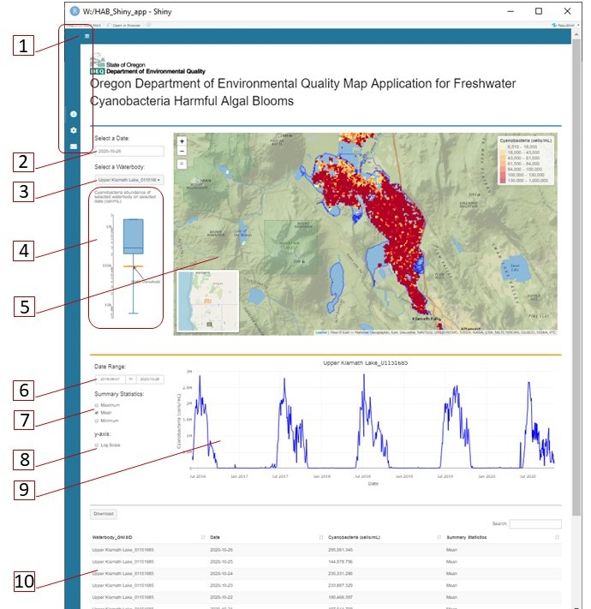

1. Click on the **toggle button**  to extend or collapse the side bar that contains three prompts:  “About”,  “User Guide” and  “Contact”.
2. **Select a Date** from the calendar to display CyAN satellite data on the map for the selected date. Default date selected is the latest day of the available data. On the calendar, only the dates with data are available for selection. On the top of the calendar, click on the title to move up from month to year, and click the left or right arrows to move to previous or later periods.
3. **Select a Waterbody** from the drop-down list to display a map within the extent of the selected waterbody. Default selection on the drop-down list is “Oregon”, which correspons to the Oregon view in the center of the map. The waterbodies are organized into two groups: within drinking water source area and not-within drinking water source area. Each waterbody is named as “waterbody name_GNISID”.
4. **Boxplot** shows the cyanobacteria abundance of the selected waterbody on the selected date. An orange line indicates the World Health Organization (WHO) guideline (100,000 cells/mL) for cyanobacteria in recreational freshwater. When the default waterbody in the field of “Select a Waterbody” is “Oregon” or when a selected waterbody has no data on a selected day, no boxplot shows. Otherwise, hover the mouse icon over the boxplot to display the values of minimum, median, maximum, 1st quartile (25th percentile) and 3rd quartile (75th percentile) of cyanobacterial abundance (cells/mL) of the selected waterbody on the selected date.
5. **Map** provides a visualization of the CyAN satellite data on the selected date. Default map shows Oregon view in the center of the map. The map refreshes in correspondence with the selected date or the selected waterbody. Three control buttons at the upper-left corner of the map allow users to zoom in, zoom out or reset to Oregon map view with regardless of any selection of date or waterbody. An insert map and a legend are also displayed. Double-click on the map to zoom in to the clicked area.
6. **Date Range** allows users to choose a range of dates to display time series plot of cyanobacteria abundance of selected waterbody. Default starting date is the first date of the entire dataset and the default ending date is the last date with available data of the entire dataset.
7. **Summary Statistics**, including daily maximum, daily mean and daily minimum, are available for users to select to display on the time series plot of cyanobacteria abundance of the selected waterbody. Default selection is daily mean of cyanobacteria abundance.
8. Select **y-axis Log Scale** to display the data in log-scale on the time series plot of cyanobacteria abundance for the selected waterbody. Default y-axis is not log-scaled.
9. **Time series plot** displays daily mean, daily maximum and/or daily minimum values of cyanobacteria abundance (cell/mL) for the selected waterbody during the selected date range.
10. **Table** shows the data corresponding to the time series plot based on selections of date range and summary statistics. Click the up-down-arrows next to the table column name to sort the information as desired. Click the **Download** button to download the table in CSV, Excel and PDF format.