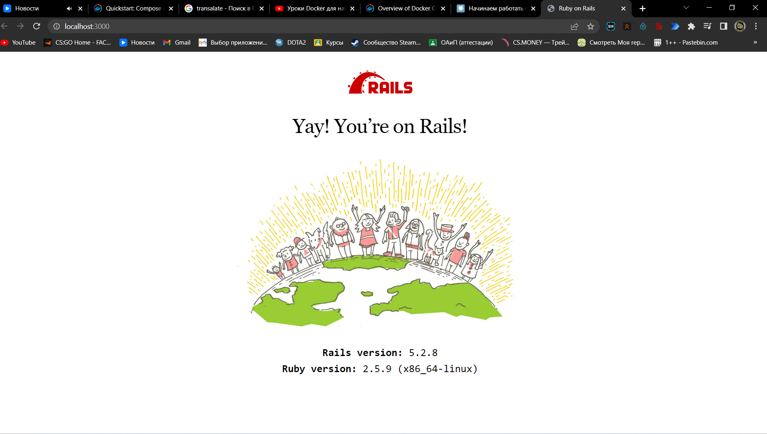

Dockerfile

# syntax=docker/dockerfile:1

FROM ruby:2.5

RUN apt-get update -qq && apt-get install -y nodejs postgresql-client

WORKDIR /myapp

COPY Gemfile /myapp/Gemfile

COPY Gemfile.lock /myapp/Gemfile.lock

RUN bundle install

# Add a script to be executed every time the container starts.

COPY entrypoint.sh /usr/bin/

RUN chmod +x /usr/bin/entrypoint.sh

ENTRYPOINT ["entrypoint.sh"]

EXPOSE 3000

# Configure the main process to run when running the image

CMD ["rails", "server", "-b", "0.0.0.0"]

Docker-compose.yml

version: "3.9"

services:

  db:

    image: postgres

    volumes:

      - ./tmp/db:/var/lib/postgresql/data

    environment:

      POSTGRES_PASSWORD: password

  web:

    build: .

    command: bash -c "rm -f tmp/pids/server.pid && bundle exec rails s -p 3000 -b '0.0.0.0'"

    volumes:

      - .:/myapp

    ports:

      - "3000:3000"

    depends_on:

      - db

Database.yml

default: &default

  adapter: postgresql

  encoding: unicode

  host: db

  username: postgres

  password: password

  pool: 5

development:

  <<: *default

  database: myapp_development

test:

  <<: *default

  database: myapp_test