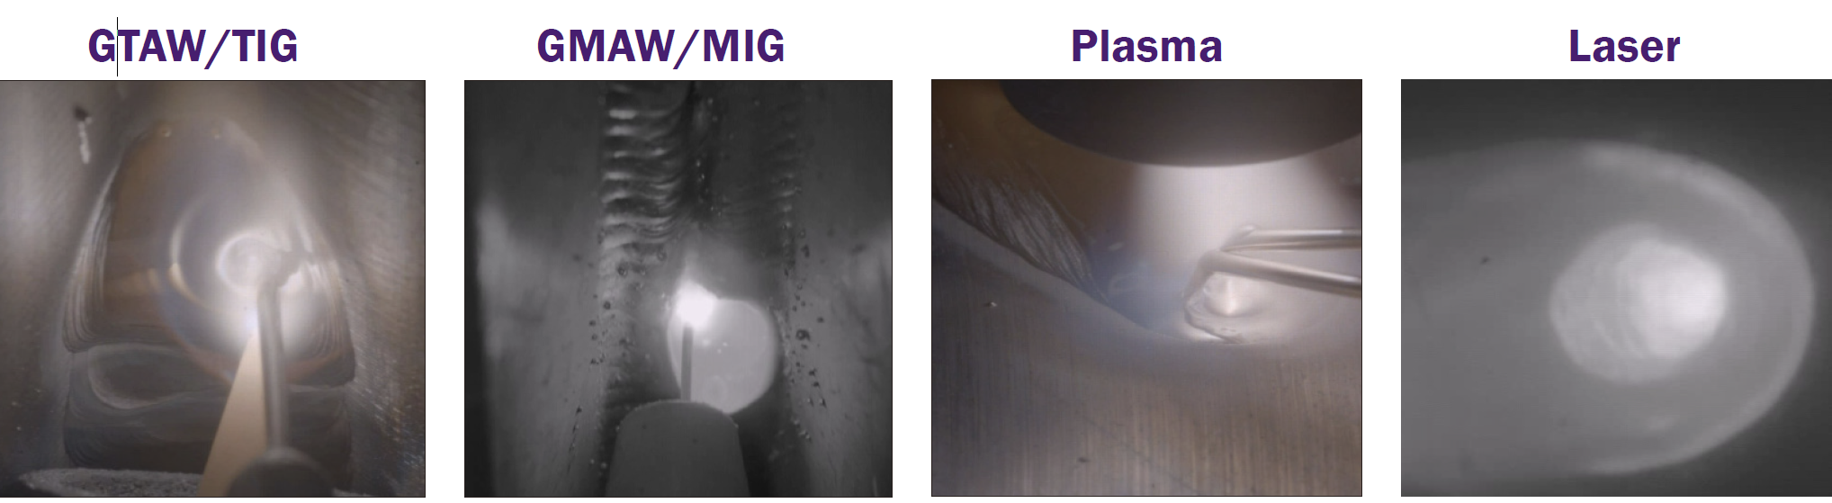



High Dynamic Range (HDR)
With a dynamic range image + 140 dB, the DS30 can acquire images with a greater range of tonal detail than any standard camera.
This is particularly important for welding processes where there is a very bright light source in the image that needs to be seen in great detail as well as the darker surrounding background features.

Color When You Need It
With HDR color imaging, the DS30can acquire color images for various welding processes, such as GTAW, where color provides extra information such as: the boundary of the Heat Affected Zone, oxidation of the melt pool and tip, and shielding gas presence. The very bright weld arc can be seen in color without saturation as well as its darker surround- ing background features.

Welding Specific Functionality
The integrated hardware and intuitive software features such as weld arc photodetector, image triggering, general purpose I/O, crosshairs and image processing control make DS30 ideal for production systems.

Opto-Isolated GPIO
Opto-isolated GPIO protects the camera from noise generated by external devices typically found in a welding environment, such as welding power supplies, motors, etc., as well as power issues caused by malfunctioning devices attached to the camera.

Accessories
Customize your system to meet your needs. All the accessories you need to get up and running, such as HMI/Controllers, camera mounting and cooling options, different cable lengths, and power adapters from DESAN

Low nosie 150Db extended HDR on-chip algorithm auto exposure and auto HDR;
On Chip auto V histogram remapping/
1024*512 pixels 1/3 Optical format for full 1024*512 resolution

Welding cameras traditionally have been employed to aid automated or mechanized welding of inaccessible joints and ensure the integrity of critical welds.
Cameras are practical tools for many other welding applications, too, now that recent advances in electronics have enhanced the image quality and reduced the price of such equipment.
Welding cameras are particularly useful for improving working conditions, weld quality, set-up speed, positioning accuracy, and facilitating quality assurance.
++ Welding Cameras Use In Automated Welding Procedures
From job-shop manual welding to push-button automated welding, fabricators employ a wide range of automation techniques to improve productivity and weld quality, as well as to ensure a welder’s health and safety. Relatively simple circumferential and linear joint-seams are often welded using positioners, rotators, column and booms, seamers, lathes, tractors, orbital welders, etc. Such equipment may use sensors to automatically control the process (automated welding), or the operator may manually control the movement and/or torch (mechanized welding).
In either case, a clear view of the weld pool can significantly benefit the welding operation.
++ Applications and Benefits of Cameras in Automated Welding
The use of camera systems in automated welding arose from necessity. Welding in hazardous environments subject to nuclear radiation, vacuums, lasers, argon, or water entails the use of welding cameras to control the torch head remotely and wire feed positions as well as to monitor the welding process. Welding cameras provide similar benefits in automated applications with restricted access (including bore cladding, orbital welding, and welding at height) or joints subject to preheating
++ Weld Quality Inspection In Real Time
In addition to positioning the torch before and during welding, cameras may be used as a real-time post-weld inspection tool by positioning the camera for views of the solidifying weld pool.In many cases, welding cameras are applied to monitor the welding of critical joints or expensive materials. For these applications, the cost of failure is significant, and the ability to take pre-emptive action is essential.
++ Improving Welding Speed And Accuracy
However, welding cameras are no longer restricted to the most sensitive and expensive welding operations. Advances in camera electronics have improved image quality and reduced purchase costs, such that welding cameras now prove beneficial to many more automated welding applications. For example, a magnified view of the electrode and torch helps improve the set-up speed and accuracy of automated micro TIG and PAW, dabber TIG, and tube mill applications. The performance of mechanical joint tracking systems is enhanced by camera supervision. Cameras applied to carriages facilitate welding upside down, at height, inside confined spaces, and around circumferential joints.
Automated systems with multiple weld-torches, like those used to manufacture turbine shafts, welded I-beams, spiral tubes, and tanks, may be effectively monitored and controlled from a single console.
++ improving Work Conditions and Welders’ Safety
In addition, we live in an age where welding is increasingly seen as an undesirable vocation. Improving the welder’s working conditions is an effective practice for staff retention. Semi-automatic welding with camera systems enables the welder to relocate away from the bright, hot, and smoky welding arc, and the often-cramped conditions. As a result, welding cameras are an effective method for reducing the incidence of accidents and operator fatigue by reducing metal shop hazards.Cameras can also be used to improve the welder’s vision, particularly as eyesight wanes with age, and are especially important for welding applications that require the operator to concentrate on the weld-pool over long periods.
++ How Welding Cameras Visualize The Weld-Pool
Most video cameras cannot provide a meaningful image of both the melt-zone and the joint or solidified weld during welding because of the incredible brightness of the arc and, to a lesser extent, radiation emitted from the molten weld pool.
When a scene is too bright for the pixels on the camera’s sensor, the pixels become saturated (i.e., the sensor suffers from blooming), and the image may exhibit smear as the pixel’s information is recorded.
Cameras with high dynamic range sensors and fast shutter speeds can provide a meaningful image of the bright arc, melt pool, and dark background. For welding, the sensor should have a dynamic range of 120 dB or higher. This dynamic range may be achieved using CMOS or CCD sensors.
In the video, as in photography, reducing the lens aperture and increasing the shutter speed may improve over-exposed scenes. When a scene is still too bright after modifying these parameters, a neutral density (ND) filter positioned in the optical path may be used to evenly reduce the amount of light reaching the sensor.

