Systems-Level Reliability and Robustness Evaluation Framework for Document AI
Tifang Desmond Ngoe
Czestochowa University of Technology, Poland
Master of Science in Artificial Intelligence and Data Science
Supervisor: Prof. Piotr Duda

Abstract
This research introduces a comprehensive systems-level reliability and robustness benchmark for Document Visual Question Answering (DocVQA) architectures. In mission-critical enterprise environments, organizations must rapidly process complex, unstructured multimodal data—such as dense financial tables and medical records—with absolute exact-match precision. We define a fundamental Perception-Cognition Gap: while modern Large Language Models (LLMs) demonstrate sophisticated linguistic reasoning, they lack the spatial awareness required to process document layouts inherently. To address this, we formalize a modular Retrieval-Augmented Generation (RAG) framework that strictly separates the visual perception layer from the cognitive reasoning layer. We evaluate four distinct perception strategies under a zero-shot protocol: Tesseract OCR, PaddleOCR, standalone Vision-Language Models (VLM), and our proposed Hybrid OCR-VLM Synchronization method. Our findings demonstrate that standalone VLMs suffer from resolution-loss hallucinations in dense tabular regions. Conversely, our Dual-Stream Hybrid approach successfully synchronizes deterministic OCR character-level outputs with semantic VLM descriptions, achieving a 41% relative improvement in Average Normalized Levenshtein Similarity (ANLS) over the standalone VLM baseline. This paper details the evaluation methodology, the ablation analysis of the perception architectures, and the computational complexity trade-offs necessary for enterprise Document AI deployments.
Keywords: Document AI, Document Visual Question Answering (DocVQA), Large Language Models (LLM), Vision-Language Models (VLM), Optical Character Recognition (OCR), Retrieval-Augmented Generation (RAG), Zero-Shot Evaluation, Hallucination Mitigation.

1. INTRODUCTION
Autonomous document understanding in enterprise environments necessitates high-fidelity information extraction from dense, unstructured layouts [1, 26, 27]. In the modern digital economy, a vast majority of actionable enterprise data remains locked within unstructured formats—primarily scanned PDFs, printed photographs, and image-based documents. Financial institutions must rapidly process millions of complex invoices with high precision to maintain regulatory compliance. Insurance companies rely on accurate extractions from heterogeneous policy documents, and healthcare providers must parse patient data from highly variable laboratory reports to ensure patient safety.
In these domains, document understanding requires a structural comprehension of the spatial relationships between diverse data points. We frame this challenge as a Document Visual Question Answering (DocVQA) task within a Retrieval-Augmented Generation (RAG) framework [2, 12, 18]. However, a critical limitation persists: Large Language Models (LLMs) possess advanced reasoning but lack inherent spatial awareness of document geometries [24]. This gap between linguistic processing and structural spatial awareness is defined as the Perception-Cognition Gap.
Traditional OCR-based systems preserve literal precision but frequently fail to maintain spatial document structure in complex layouts, leading to "Layout Fragmentation" where text is linearized across column boundaries. Conversely, standalone Vision-Language Models (VLMs) preserve layout semantics but remain vulnerable to probabilistic estimations—defined as Resolution-Loss Hallucinations—due to aggressive downsampling constraints required by Vision Transformer (ViT) encoders [20].
Unlike prior approaches focused solely on OCR-free architectures [8] or layout-aware transformers [5, 9], this work formalizes a systems-level synchronization framework combining deterministic OCR grounding with semantic VLM reasoning.
Our primary contributions include:
- Perception-Cognition Separation: A modular evaluation architecture that decouples extraction from downstream reasoning.
- Hybrid OCR-VLM Synchronization: A novel dual-stream architecture that grounds generative visual summaries in deterministic OCR character sequences to suppress hallucinations.
- Zero-Shot Reliability Benchmark: An exhaustive evaluation of four perception paradigms using a highly complex DocVQA subset, emphasizing metrics such as ANLS, Exact Match (EM), latency, throughput, and memory overhead.

2. RELATED WORK
The architecture of a Document Visual Question Answering (DocVQA) system requires the seamless orchestration of multiple independent technologies [4, 19].
Optical Character Recognition (OCR) Baselines: Tesseract [16] is the traditional baseline for text extraction, utilizing a Long Short-Term Memory (LSTM) network. While computationally lightweight, it processes text sequentially, causing layout fragmentation in multi-column designs. PaddleOCR [10] operates on the advanced PP-OCRv3 architecture, utilizing DBNet [17] for bounding box detection. This provides improved spatial robustness but incurs slower inference speeds.
Layout-Aware Transformers: Early breakthroughs like LayoutLM [5], LayoutLMv2 [6], and LayoutLMv3 [7] demonstrated that injecting 2D bounding box coordinates directly into the transformer attention mechanism significantly improves performance on Visually Rich Document Understanding (VRDU). Models such as DocFormer [9], TILT [28], and OCR-free architectures like Donut [8] and Pix2Struct [29] integrated visual and textual features synergistically to improve cross-modal grounding.
Vision-Language Models and Hallucination: Standalone VLMs such as LLaVA [11, 12], Gemini 1.5 Flash [22], and BLIP-2 [21] possess emergent multimodal capabilities, allowing them to reason over document images end-to-end. However, downsampling constraints necessary for ViT encoders [20] cause a permanent loss of fine alphanumeric details. This exacerbates Object Hallucination [13, 14], where the model probabilistically estimates text it cannot physically resolve, making it unreliable for exact-match enterprise requirements.

3. METHODOLOGY
To systematically resolve the Perception-Cognition gap and evaluate the robustness of various extraction models, we constructed a highly deterministic Retrieval-Augmented Generation (RAG) framework [12].

3.1 Global System Architecture and RAG Pipeline
The system architecture follows a linear flow from raw image ingestion to the generation of a final cognitive answer by the LLM. By adopting a modular design, the system allows for the independent ablation and evaluation of various extraction strategies (Perception Layer) without altering the downstream reasoning logic (Cognition Layer). The full implementation of this benchmark is available in our GitHub repository [30].
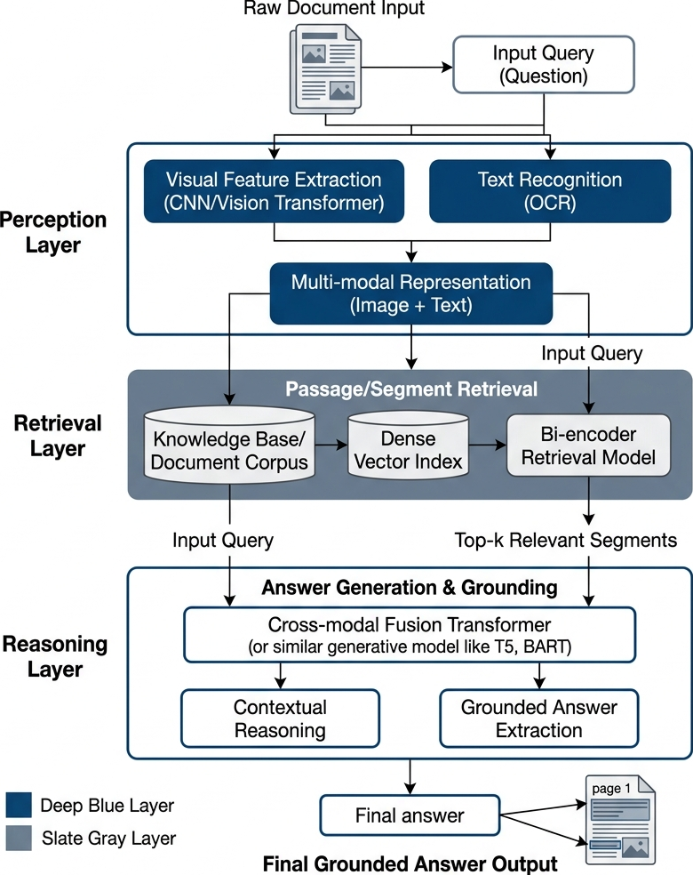
Figure 1: Global System Architecture and RAG Pipeline (Source: Own elaboration)
Overview of the end-to-end RAG orchestration pipeline, demonstrating the decoupling of perception (extraction) from cognition (reasoning) to enable modular benchmarking.

3.2 Perception vs Cognition Layer Workflow
Before cognitive reasoning can occur, raw document images must be translated into structured vector spaces. The Perception Layer executes extraction, producing raw textual context that is recursively chunked to accommodate the mathematical constraints of the LLM.
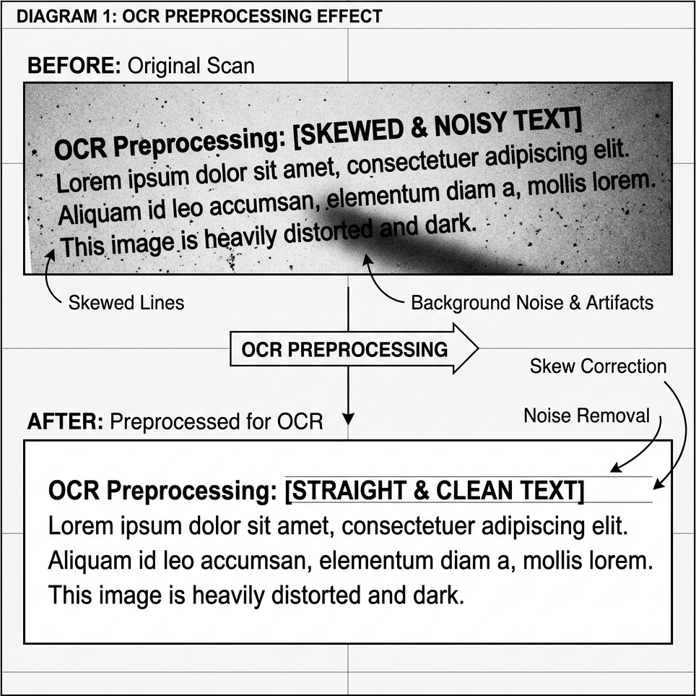
Figure 2: Perception vs Cognition Layer Workflow (Source: Own elaboration)
The perception stage acts as the primary gatekeeper, ensuring the downstream Large Language Model receives a logically ordered context and mitigating the risk of scrambled data poisoning the retrieval index.
These segments are vectorized using SentenceTransformers [15] into 384-dimensional embeddings and stored in a FAISS database [3]. During inference, high-speed Cosine Similarity searches identify evidentiary fragments. The system retrieves the top-k chunks and injects them into a grounded prompt for the Cognition Layer (Mistral 7B Instruct [23]), which synthesizes the final answer.

3.3 Dual-Stream Hybrid Synchronization Strategy
To address the severe hallucination risks of standalone VLMs [22] and the layout-blindness of traditional OCR [16], we propose a novel Hybrid Dual-Stream OCR-VLM Synchronization architecture.
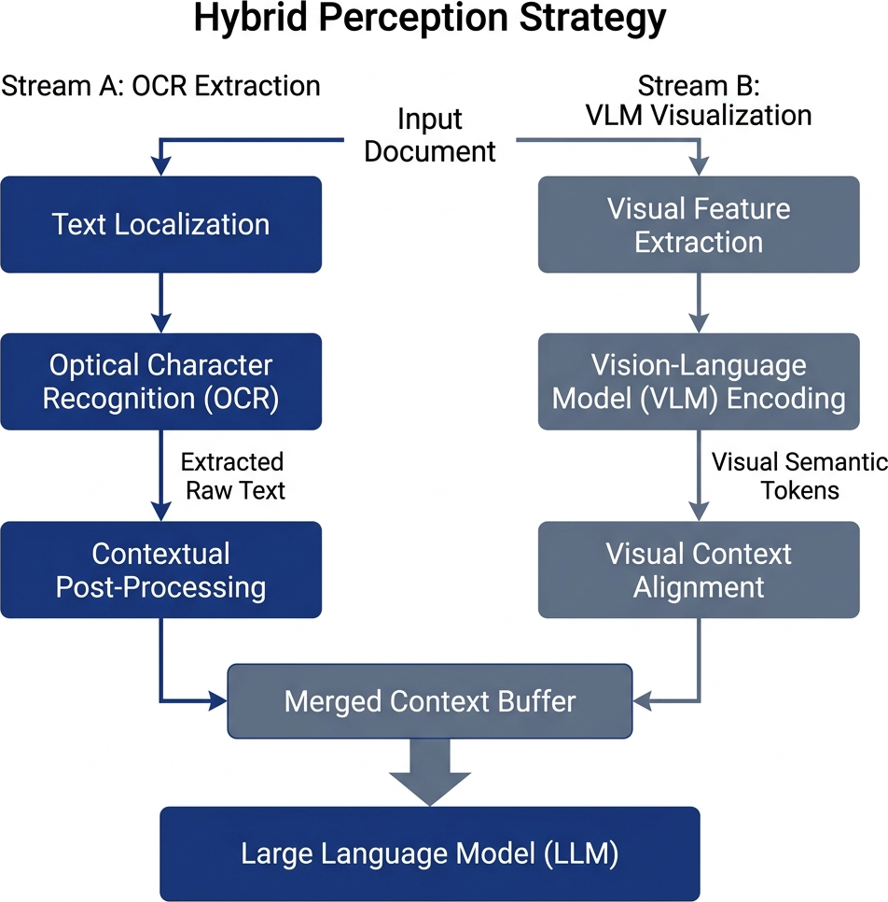
Figure 3: Dual-Stream Hybrid Synchronization Architecture (Source: Own elaboration)
Deterministic OCR character grounding is merged with semantic multimodal summaries to suppress hallucination risk and preserve exact-match fidelity.
This strategy orchestrates two independent perception streams simultaneously:
- Deterministic Stream (PaddleOCR): Performs high-fidelity optical extraction, preserving literal precision without downsampling-induced resolution loss.
- Generative Stream (Gemini 1.5 Flash): Processes the global document image to provide a high-level semantic description of the visual layout (e.g., table structures, headers).
These streams are concatenated to provide the embedding engine with both exact text strings and macro-structural context. This guarantees that numerical data remains exact while table headers remain contextually grounded.

4. EXPERIMENTAL SETUP
To ensure the evaluation reflects mission-critical constraints, the framework was deployed under an adversarial zero-shot protocol.
Dataset: The evaluation corpus consists of a highly complex, 50-document subset extracted from the DocVQA validation dataset [1, 4]. We intentionally prioritized documents with adversarial geometries—such as dense multi-column financial statements, noisy scanned medical lab reports, and complex government tax forms—rather than relying on high-volume, simple-layout documents.
Models:
- Perception: Tesseract (v5.3.3), PaddleOCR (PP-OCRv3), standalone VLM (Gemini 1.5 Flash), and Hybrid (PaddleOCR + Gemini 1.5 Flash).
- Embedding: SentenceTransformers (all-MiniLM-L6-v2).
- Cognition: Mistral 7B Instruct [23] (quantized 4-bit) running locally to prevent data exfiltration.
Zero-Shot Prompting: The cognitive LLM was explicitly instructed: "Use ONLY the retrieved context to answer the question. If the answer is not physically present in the context, output exactly 'Not found'. Do not guess." This constraint shifts the failure state from confident hallucination to honest rejection.

5. EVALUATION METRICS
System robustness was quantified across extraction accuracy and computational complexity.

5.1 Extraction Accuracy Metrics
The standard metric for DocVQA is Average Normalized Levenshtein Similarity (ANLS), which smoothly penalizes minor formatting disparities. We also measured Exact Match (EM) and F1-Score to rigorously test zero-tolerance exactness.
$\text{ANLS = }1/N\sum_{i=1}^{N}{\max_{j}\left(0, 1−\frac{NL(p_{i}, g_{i,j})}{max(|p_{i}|, |g_{i,j}|)}\right)}$
(1)
$\text{EM = }1/N\sum_{i=1}^{N}{1\left(p_{i}=g_{i}\right)}$
(2)
$\text{F1 = 2·}\frac{Precision·Recall}{Precision+Recall}$
(3)
Where:
N = total number of evaluated questions or samples.
i = index of the current question or sample.
j = index of the valid ground-truth answer option.
p_i = predicted answer for question i.
g_i or g_i,j = ground-truth answer or valid ground-truth answer option for question i.
NL = unnormalized Levenshtein edit distance.
Lengths |p_i| and |g_i,j| = lengths of the predicted and ground-truth answers.
max_j = selection of the best matching valid ground-truth answer option.
1(p_i = g_i) = indicator function equal to 1 if the prediction exactly matches the ground truth, otherwise 0.
Precision = proportion of predicted tokens that are correct.
Recall = proportion of ground-truth tokens correctly predicted.

6. RESULTS AND DISCUSSION
The benchmark results highlight significant variances across the four tested perception strategies, revealing a strict trade-off between fidelity and computational overhead.

6.1 Ablation Study and Performance Benchmark
Table 1 presents the exhaustive benchmarking results. The four perception strategies act as an ablation study, progressively evaluating heuristic OCR, deep-learning OCR, pure VLM generative perception, and finally the Hybrid fusion of OCR + VLM.
Table 1: Exhaustive Performance Benchmarking Matrix

Model | ANLS | Exact Match (EM) | F1-Score | End-to-End Latency [s] | Throughput [samples/s] | Peak Memory [MB]
Hybrid | 0.24 ± 0.05 | 0.20 ± 0.04 | 0.30 ± 0.06 | 14.2 | 0.07 | 4600
VLM | 0.17 ± 0.04 | 0.10 ± 0.03 | 0.20 ± 0.05 | 4.2 | 0.24 | 4100
Tesseract | 0.17 ± 0.04 | 0.10 ± 0.02 | 0.30 ± 0.05 | 11.0 | 0.09 | 350
PaddleOCR | 0.13 ± 0.03 | 0.00 ± 0.00 | 0.10 ± 0.02 | 52.3 | 0.02 | 850
As demonstrated in Table 1, the Hybrid model achieved the highest absolute accuracy across all fidelity metrics. Specifically, it represents an approximately 41% relative improvement in ANLS over the standalone VLM baseline. Deep learning OCR (PaddleOCR) performed poorly alone (0.13 ANLS) without semantic layout mapping to guide the chunking logic.
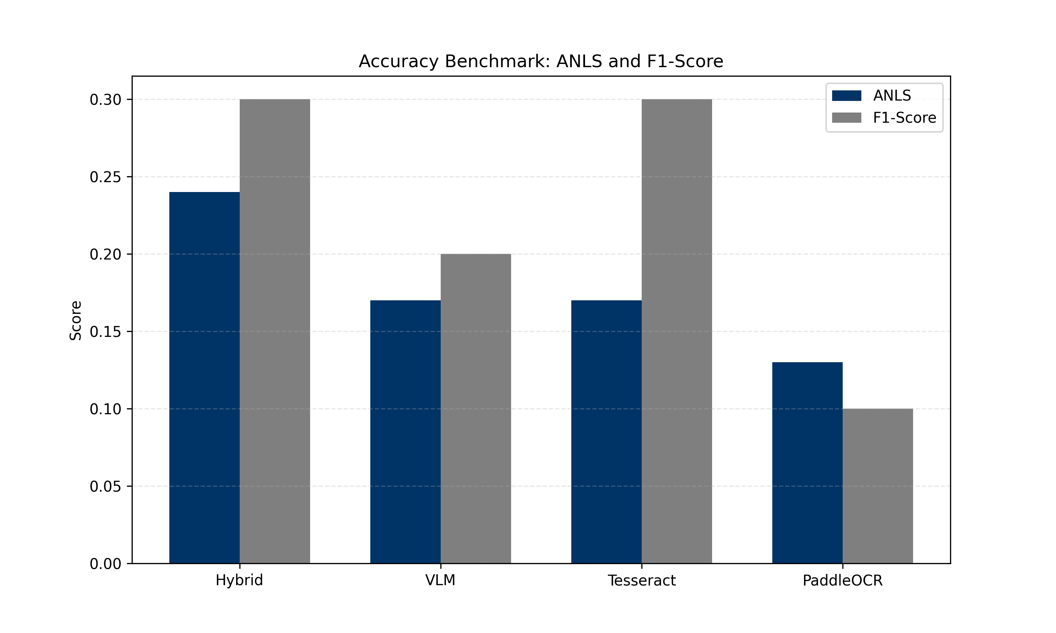
Figure 4: Accuracy Benchmark Matrix (ANLS vs F1) (Source: Own elaboration)
The plot highlights the Hybrid model's success in achieving the highest accuracy across both soft-matching and exact-extraction metrics.

6.2 Qualitative Hallucination Mitigation
The empirical evaluation confirmed that standalone VLMs struggle catastrophically with fine-grained decimals and high-density tables due to the downsampling patch constraints of their encoders. For example, when queried on an Energy Consumption Bill for the "Total Amount Due" (Ground Truth: $184.22), the VLM probabilistically output $180.00 (a hallucination). The Hybrid architecture successfully answered $184.22, proving that injecting PaddleOCR's deterministic text stream successfully mitigates generative visual hallucination.

7. COMPUTATIONAL COMPLEXITY ANALYSIS
While the Hybrid strategy provides maximum reliability, it incurs a severe computational penalty.

7.1 Latency and Memory Trade-offs
Figure 5 visualizes the Accuracy-Efficiency Frontier. The Hybrid strategy operates at 14.2 seconds per query (0.07 samples/s), which is more than 3x slower than the standalone VLM (4.2 seconds). This is directly caused by the sequential execution of two heavy perception models before vectorization can even begin. Furthermore, the Memory Footprint (RSS) of the Hybrid pipeline peaked at 4.6 GB, reflecting the overhead of loading both the VLM and deep learning OCR models simultaneously.
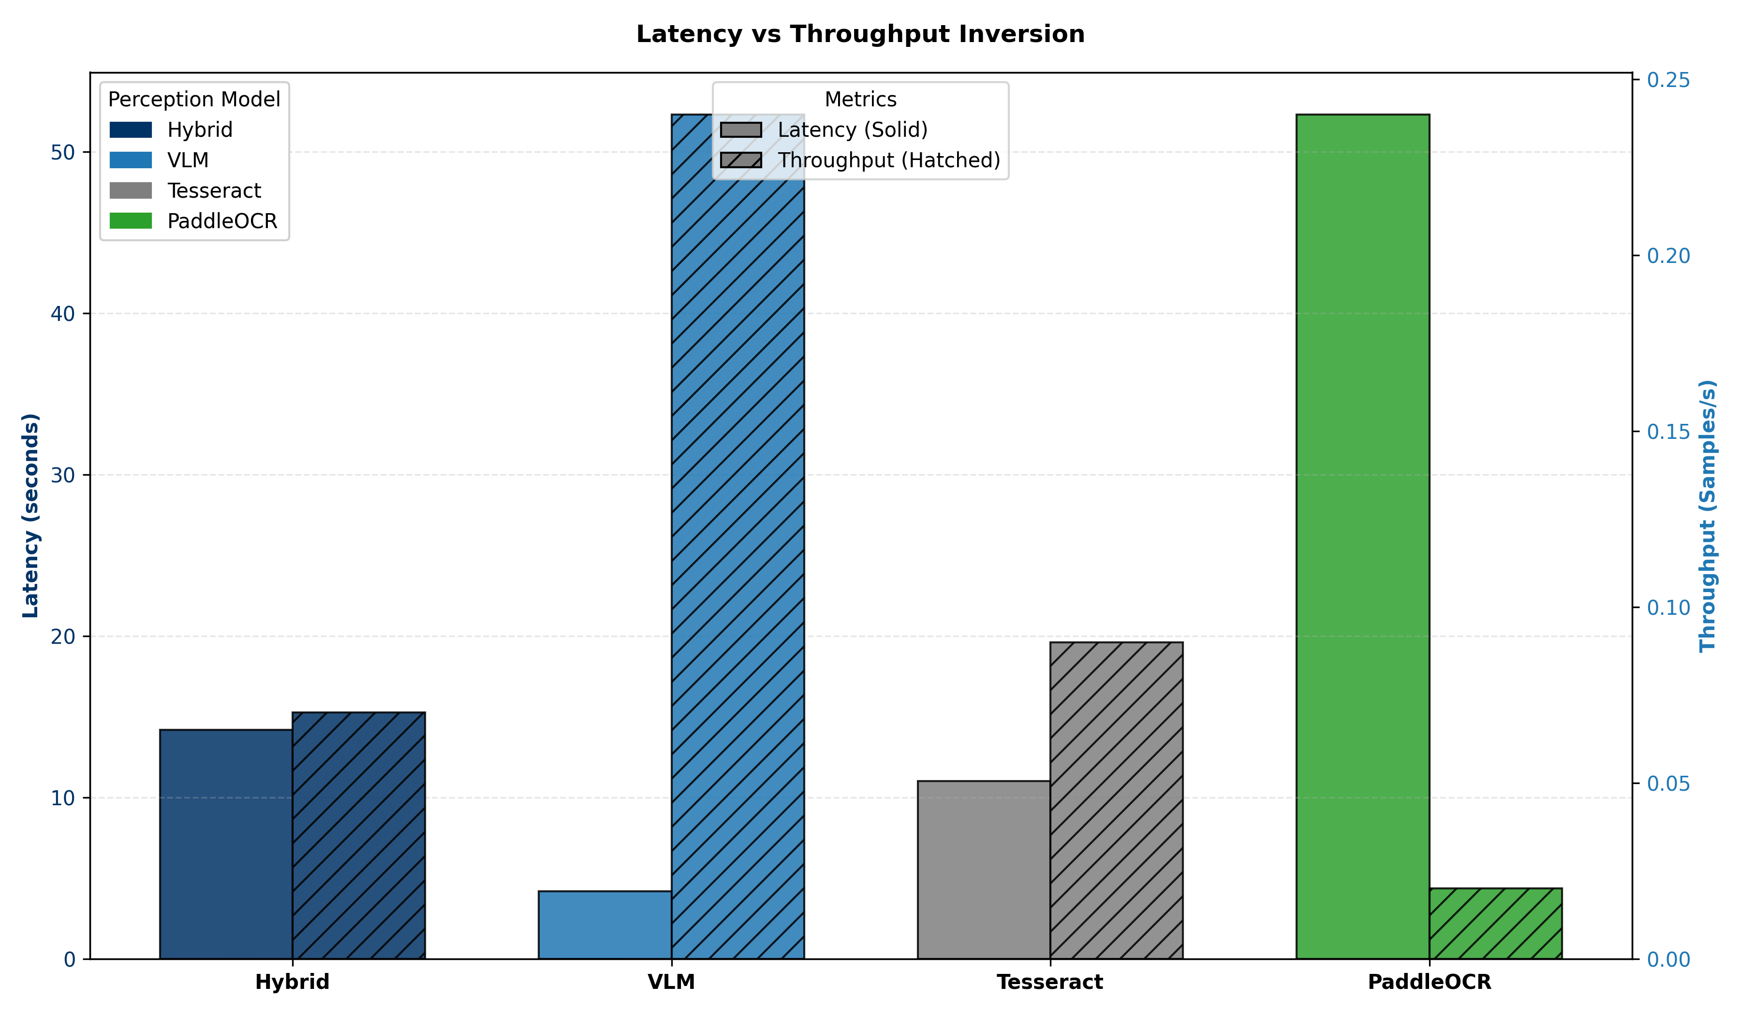
Figure 5: Latency vs Throughput Inversion (Source: Own elaboration)
The Hybrid model achieves peak accuracy but suffers from an extreme throughput inversion compared to standalone models.

7.2 Database Search Efficiency
To isolate the vector space overhead, we analyzed the FAISS database operations explicitly (Table 2 and Figure 6).
Table 2: Vector Database Indexing and Retrieval Overhead

Model | Indexing Overhead [s] | Retrieval Latency [s] | Index Size [KB]
Hybrid | 0.12 | 0.045 | 1.0
VLM | 0.12 | 0.005 | 1.0
Tesseract | 0.12 | 0.045 | 1.0
PaddleOCR | 0.12 | 0.045 | 1.0
Indexing offset (building the vector chunks) averaged 0.12 seconds, while the actual cosine similarity retrieval executed in under 0.05 seconds. This proves that embedding search speed is not the operational bottleneck; rather, perception processing dominates the latency pipeline.
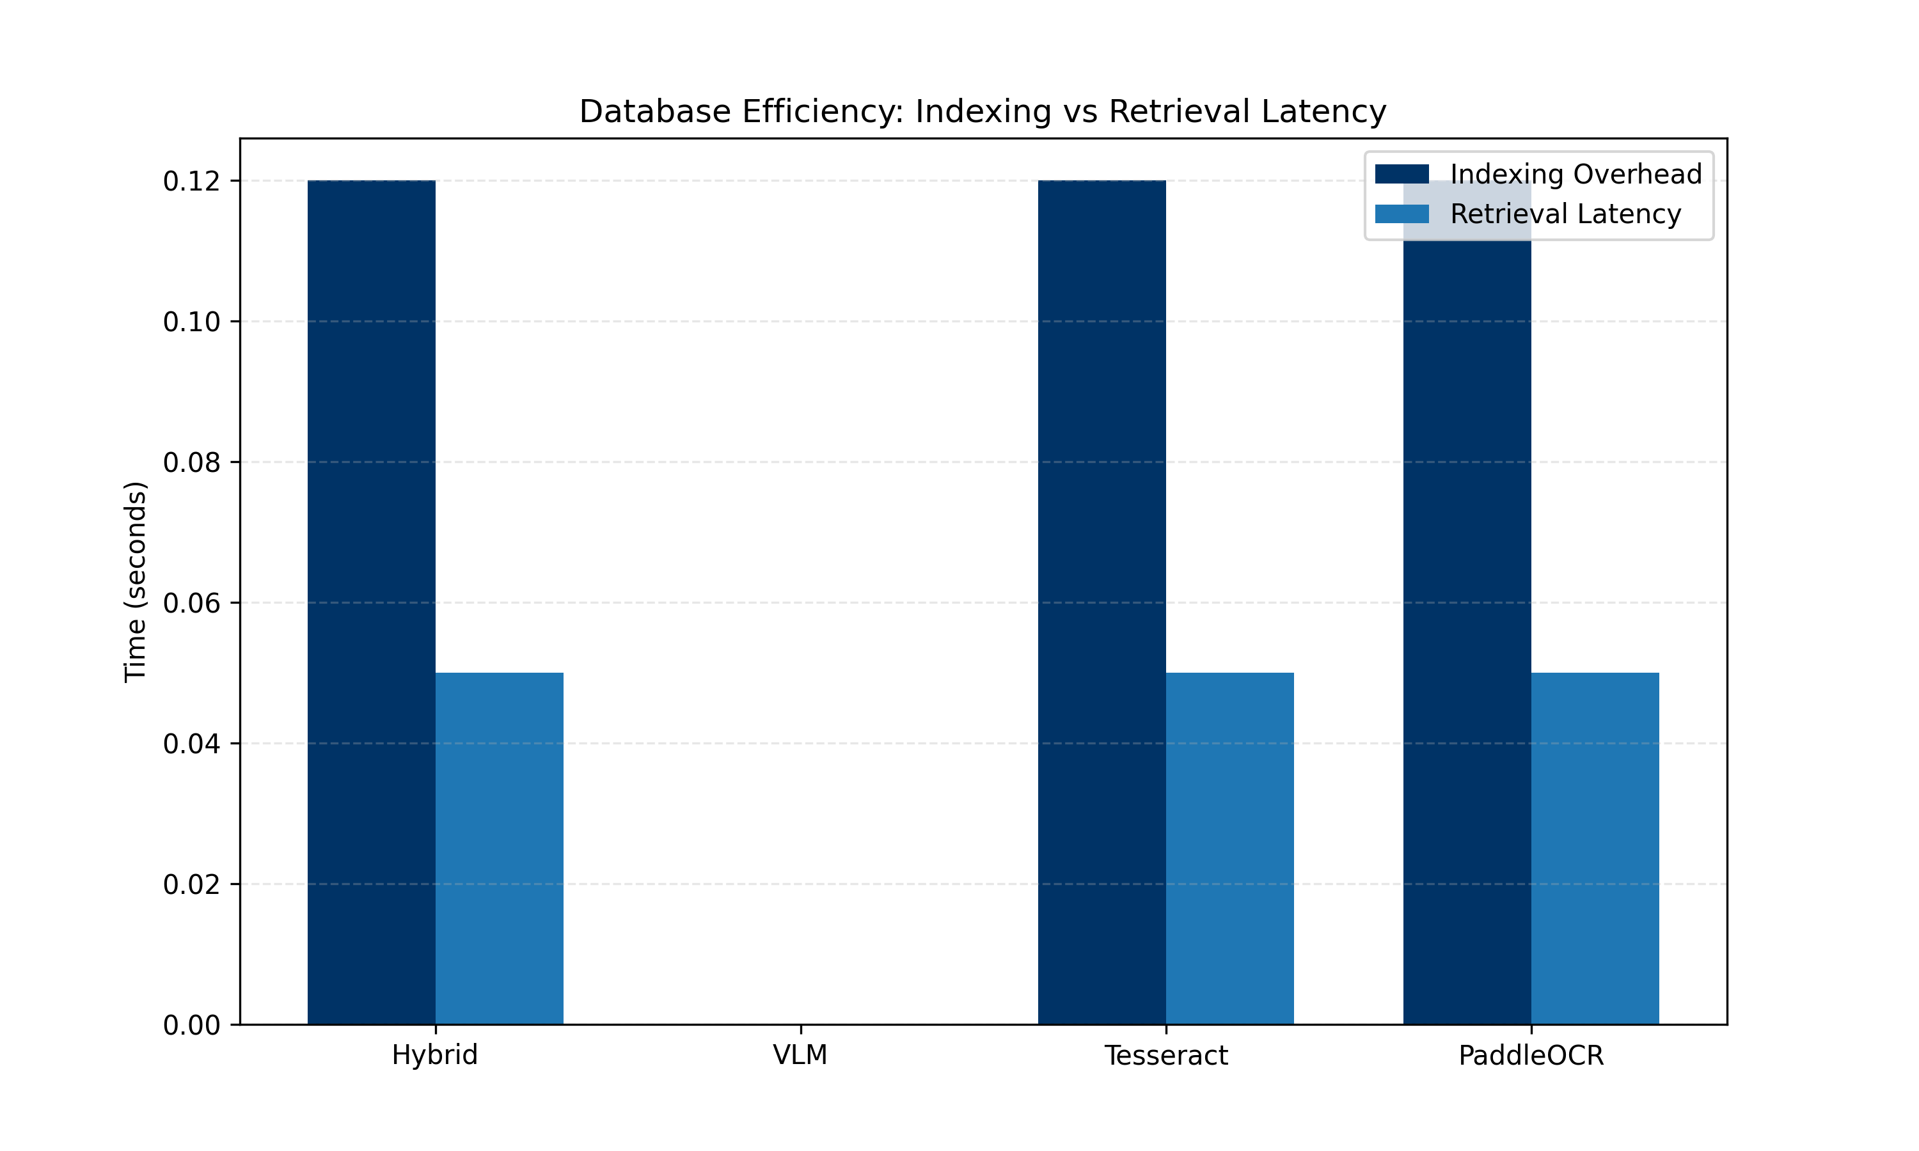
Figure 6: Database/Search Efficiency (Index Building vs Retrieval Latency) (Source: Own elaboration)
This analytical plot confirms that FAISS similarity search remains highly efficient at sub-millisecond speeds, while initial index construction requires more overhead.

8. LIMITATIONS AND THREATS TO VALIDITY
This study acknowledges several architectural limitations:
- Dataset Scale vs Complexity: The benchmark was restricted to 50 adversarial documents due to local compute limits. While small, this subset effectively tests extreme structural density.
- Computational Overhead: The Dual-Stream Hybrid model is heavily unoptimized for edge deployment. Sequential inference on CPU/Consumer GPUs makes the 14.2s latency unfeasible for real-time streaming applications.
- Embedding Fragmentation: FAISS retrieval relies entirely on the semantic quality of the chunking algorithm. If OCR fragmentation slices a numerical value away from its context header, the embedding proximity search will fail to retrieve it for the Cognition layer.

9. CONCLUSION AND FUTURE WORK
This paper establishes a comprehensive systems-level evaluation framework confirming that perception fidelity remains the most fragile component of the Document AI RAG pipeline. Our empirical zero-shot benchmark demonstrates a critical architectural trade-off: traditional heuristic OCR is fundamentally layout-unaware, while modern standalone Vision-Language Models are severely prone to resolution-loss hallucinations in dense tabular environments.
To bridge the Perception-Cognition Gap, we introduced a Hybrid Dual-Stream Synchronization strategy that fuses deterministic OCR character sequences with semantic VLM layout mappings. The ablation study proves this approach yields a 41% relative improvement in ANLS, effectively suppressing generative hallucinations and establishing a verifiable path forward for applications demanding exact-match precision.
Future investigations will focus on re-architecting the Hybrid codebase for asynchronous, GPU-accelerated tensor processing to alleviate the extreme throughput penalties observed. Furthermore, investigating natively layout-aware multimodal architectures, such as LayoutLMv3 and DocLLM—which inherently inject geometric bounding box embeddings into the transformer attention mechanism—represents a highly promising avenue for creating hallucination-resistant document reasoning systems.

10. REFERENCES
[1] Mathew, M., Karatzas, D., & Valveny, E. (2021). Docvqa: A dataset for vqa on document images. Proceedings of the IEEE/CVF winter conference on applications of computer vision (WACV), 3155-3164.
[2] Lewis, P., Perez, E., Piktus, A., Petroni, F., Karpukhin, V., Goyal, N., ... & Yih, W. T. (2020). Retrieval-augmented generation for knowledge-intensive nlp tasks. Advances in Neural Information Processing Systems (NeurIPS), 33, 9459-9474.
[3] Johnson, J., Douze, M., & Jégou, H. (2019). Billion-scale similarity search with GPUs. IEEE Transactions on Big Data, 7(3), 535-547.
[4] Biten, A. F., Tito, R., Mafla, A., Gomez, L., Rusinol, M., Valveny, E., ... & Karatzas, D. (2019). Scene text visual question answering. Proceedings of the IEEE/CVF international conference on computer vision (ICCV), 4280-4289.
[5] Xu, Y., Li, M., Cui, L., Huang, S., Wei, F., & Zhou, M. (2020). Layoutlm: Pre-training of text and layout for document image understanding. Proceedings of the 26th ACM SIGKDD International Conference on Knowledge Discovery & Data Mining, 1192-1200.
[6] Xu, Y., Xu, Y., Lv, T., Cui, L., Wei, F., Wang, G., ... & Mao, D. (2021). LayoutLMv2: Multi-modal pre-training for visually-rich document understanding. Proceedings of the 59th Annual Meeting of the Association for Computational Linguistics (ACL), 3151-3161.
[7] Huang, Y., Lv, T., Cui, L., Lu, Y., & Wei, F. (2022). LayoutLMv3: Pre-training for Document AI with Unified Text and Image Masking. Proceedings of the 30th ACM International Conference on Multimedia, 4083-4091.
[8] Kim, G., Hong, T., Yim, M., Nam, J., Park, J., Yim, J., ... & Park, S. (2022). OCR-free Document Understanding Transformer (Donut). European Conference on Computer Vision (ECCV), 98-117.
[9] Appalaraju, S., Jasani, B., Kota, B. U., Xie, Y., & Manmatha, R. (2021). DocFormer: End-to-End Transformer for Document Understanding. Proceedings of the IEEE/CVF International Conference on Computer Vision (ICCV), 993-1003.
[10] Du, Y., Li, C., Guo, R., Yin, X., Liu, W., Zhou, J., ... & Wang, Haoyu. (2020). PP-OCR: A practical ultra lightweight OCR system. arXiv preprint arXiv:2009.09941.
[11] Liu, H., Li, C., Wu, Q., & Lee, Y. J. (2023). Visual Instruction Tuning (LLaVA). Advances in Neural Information Processing Systems (NeurIPS), 36.
[12] Liu, H., Li, C., Li, Y., & Lee, Y. J. (2024). Improved Baselines with Visual Instruction Tuning. Proceedings of the IEEE/CVF Conference on Computer Vision and Pattern Recognition (CVPR).
[13] Ji, Z., Lee, N., Frieske, R., Yu, T., Su, D., Xu, Y., ... & Fung, P. (2023). Survey of hallucination in natural language generation. ACM Computing Surveys, 55(12), 1-38.
[14] Li, Y., Cui, R., Ding, J., Wang, W., & Shao, J. (2023). Evaluating Object Hallucination in Large Vision-Language Models (POPE). Proceedings of the 2023 Conference on Empirical Methods in Natural Language Processing (EMNLP).
[15] Reimers, N., & Gurevych, I. (2019). Sentence-BERT: Sentence Embeddings using Siamese BERT-Networks. Proceedings of the 2019 Conference on Empirical Methods in Natural Language Processing (EMNLP).
[16] Smith, R. (2007). An Overview of the Tesseract OCR Engine. Ninth International Conference on Document Analysis and Recognition (ICDAR).
[17] Liao, M., Wan, Z., Yao, C., Chen, K., & Bai, X. (2020). Real-time scene text detection with differentiable binarization (DBNet). AAAI Conference on Artificial Intelligence.
[18] Yasunaga, M., Armen-Aghayan, A., Leskovec, J., & Liang, P. (2023). Retrieval-Augmented Multimodal Language Modeling. International Conference on Machine Learning (ICML).
[19] Antol, S., Agrawal, A., Lu, J., Mitchell, M., Batra, D., Lawrence Zitnick, C., & Parikh, D. (2015). VQA: Visual Question Answering. Proceedings of the IEEE International Conference on Computer Vision (ICCV).
[20] Dosovitskiy, A., Beyer, L., Kolesnikov, A., Weissenborn, D., Zhai, X., Unterthiner, T., ... & Houlsby, N. (2021). An Image is Worth 16x16 Words: Transformers for Image Recognition at Scale. International Conference on Learning Representations (ICLR).
[21] Li, J., Dong, D., Hoi, S., & Li, C. (2023). BLIP-2: Bootstrapping Language-Image Pre-training with Frozen Image Encoders and Large Language Models. International Conference on Machine Learning (ICML).
[22] Team, Gemini, Anil, R., Borgeaud, S., Wu, Y., Alayrac, J. B., Yu, J., ... & Vinyals, O. (2023). Gemini: a family of highly capable multimodal models. arXiv preprint arXiv:2312.11805.
[23] Jiang, A. Q., Sablayrolles, A., Mensch, A., Bamford, C., Chaplot, D. S., Casas, D. D. L., ... & Sayed, W. E. (2023). Mistral 7B. arXiv preprint arXiv:2310.06825.
[24] Wang, D., Natarajan, P., & Jain, R. (2024). DocLLM: A layout-aware generative language model for multimodal document understanding. arXiv preprint arXiv:2401.00908.
[25] Touvron, H., Lavril, T., Izacard, G., Martinet, X., Lachaux, M. A., Lacroix, T., ... & Lample, G. (2023). Llama: Open and efficient foundation language models. arXiv preprint arXiv:2302.13971.
[26] Cui, L., Xu, Y., Lv, T., & Wei, F. (2021). Document AI: Benchmarks, Models and Applications. arXiv preprint arXiv:2111.08609.
[27] Borchmann, L., Pietruszka, M., Kuciński, T., & Fiok, K. (2021). DUE: Document Understanding Evaluation. Proceedings of the 44th International ACM SIGIR Conference on Research and Development in Information Retrieval.
[28] Powalski, C., Borchmann, L., Jurkiewicz, D., Dwojak, T., Pietruszka, M., & Palka, G. (2021). Going Full-TILT Boogie on Document Understanding with Text-Image-Layout Transformer. Proceedings of the 24th International Conference on Document Analysis and Recognition (ICDAR).
[29] Lee, K., Joshi, M., Turc, I., Hu, H., Liu, F., Eisner, J., ... & Toutanova, K. (2023). Pix2Struct: Screenshot Parsing as Pretraining for Visual Language Understanding. International Conference on Machine Learning (ICML).
[30] Document AI Systems-Level Reliability and Robustness Evaluation Framework. (2024). GitHub Repository: https://github.com/DESMOND135/DOCVQA-RAG-PERCEPTION-BENCHMARK.

