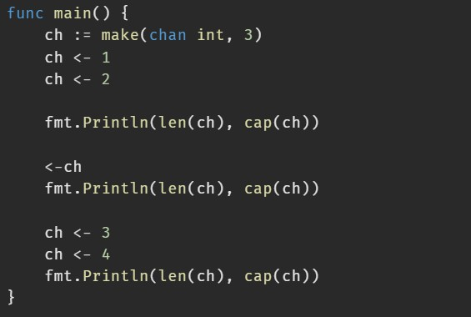
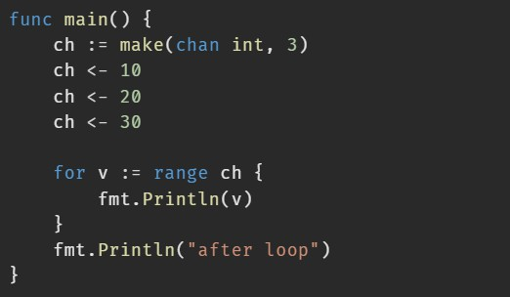
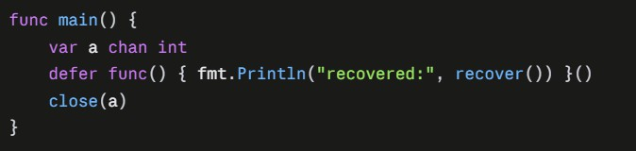
Question 1 : What is the output ?

Question 2 : Write Go Lang Code To Solve These Problems:
- Given a slice nums []int and a window size k, return a slice of the maximum value in each window of size k as it slides from left to right.
Input: nums = [1,3,-1,-3,5,3,6,7], k = 3 → Output:
[3,3,5,5,6,7]

- Given a list of words, group the anagrams together.
Input: ["eat","tea","tan","ate","nat","bat"]
Output: [["eat","tea","ate"],["tan","nat"],["bat"]]

- Define a Student struct (name, id, grades map). Implement:
  - A method Average() float64
  - A function TopStudent(students []Student) *Student
returning a pointer to the student with the highest average.
- Implement sort.Interface for a ByAge []Person type to sort people by age. Then implement a custom Ranker interface to sort any rankable collection.

- Retry with Exponential Backoff .
Write Retry(times int, fn func() error) error that calls fn up to times times, returning the last error if all attempts fail. Wrap the final error with fmt.Errorf("after %d attempts: %w", ...).

- If a goroutine panics and nothing recovers it, what happens to the program?

The whole program crashes — recover only works in the goroutine where the panic occurred. Write a worker pool where each worker recovers its own panics and reports them on an error channel.

- Implement a rate limiter that allows at most rate operations per second using time.Ticker, and process 20 tasks through it.

- Split a large slice into N chunks, sum each in its own goroutine using
sync.WaitGroup, and combine the results. func ParallelSum(nums []int, workers int) int

Question 3 : Mini Project
  - Task struct with ID, Name, Payload map[string]any, and
Priority int.
  - A Handler interface (Handle(ctx context.Context, t Task) error) with at least 3 implementations (e.g. EmailHandler, ResizeImageHandler, ReportHandler), registered in a map keyed by task type.
  - A worker pool consuming tasks from a channel, with a configurable number of workers and graceful shutdown using context.
  - Handlers sometimes return errors; use custom error types and
wrapping. Failures with RetryableError are retried up to 3 times.
  - Handlers sometimes panic; recover them per task so one bad task never kills a worker, and convert them to errors.
  - Collect results into a slice and print a summary: succeeded, failed, retried, and panicked counts, plus average duration.
  - Protect shared stats with a mutex or atomics.
Good Luck 🙂

